INDOOR AIR QUALITY ASSESSMENT

Minnechaug Regional High School
621 Main Street
Wilbraham, Massachusetts

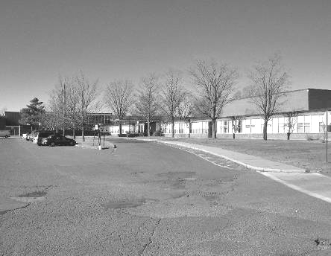

Prepared by:
Massachusetts Department of Public Health
Center for Environmental Health
Emergency Response/Indoor Air Quality Program
February 2007

Background/Introduction
At the request of parents, the Massachusetts Department of Public Health (MDPH), Center for Environmental Health (CEH) provided assistance and consultation regarding indoor air quality at the Minnechaug Regional High School, 621 Main Street, Wilbraham, Massachusetts. On November 21, 2006 and November 22, 2006, visits to conduct an assessment at the Minnechaug Regional High School (MRHS) were made by Michael Feeney, Director of CEH’s Emergency Response/Indoor Air Quality (ER/IAQ) Program. Sharon Lee, an environmental analyst in the ER/IAQ Program, visited the MRHS on January 12, 2007 to complete the assessment of the school.
The MRHS is a multi-wing red brick building constructed in 1958. A single, three story wing contains classrooms (Picture 1). A gymnasium, pool, auditorium, shops and administrative offices are located in a series of one story wings. Windows were openable throughout the MRHS.

Methods
Air tests carbon dioxide, temperature and relative humidity were taken with the TSI, Q-Trak, IAQ Monitor, Model 8551. CEH staff performed a visual inspection of building materials for water damage and/or microbial growth.

Results
This school has a student population of approximately 1,300 and a staff of approximately 80. The tests were taken under normal operating conditions. Test results appear in Table 1.

Discussion

Ventilation
It can be seen from the Table 1 that carbon dioxide levels were considerably higher than 800 parts per million (ppm) in all areas surveyed on November 21, 2006, indicating a lack of adequate air exchange in all areas assessed. On January 12, 2007, twelve of twenty areas had carbon dioxide levels above 800 ppm, indicating less than adequate ventilation in these areas. It is important to note that several areas were empty or sparsely populated at the time of January 2007 assessment. Low occupancy can greatly reduce carbon dioxide levels.
Fresh air in classrooms is supplied by unit ventilator (univent) systems (Figure 1). A univent draws air from the outdoors through a fresh air intake located on the exterior wall of the building and returns air through an air intake located at the base of the unit. Fresh and return air are mixed, filtered, heated and provided to classrooms through an air diffuser located in the top of the unit. Adjustable louvers control the ratio of outside to recirculated air. Univents were found deactivated in some rooms (Table 1). With univents in their current condition, the sole source of fresh air is open windows. Obstructions to airflow, such as items stored on or in front of univents were seen in some areas (Table 1). In order for univents operate as designed, units must be activated while rooms are occupied and air diffusers should remain free of obstructions.
The mechanical exhaust ventilation system in classrooms consists of unit exhaust ventilators. A unit exhaust ventilator appears similar to a univent, but removes air from the classroom and exhausts it out of the building. As with the univents, a majority of the unit exhaust vents were not operating. Without sufficient supply and exhaust ventilation, environmental pollutants can build up, leading to indoor air quality/comfort complaints.
Mechanical ventilation in large areas (e.g., gymnasiums, the auditorium, pool and cafeterias) is provided by air handling units (AHUs) located in mechanical rooms.
To maximize air exchange, the MDPH recommends that both supply and exhaust ventilation operate continuously during periods of school occupancy. In order to have proper ventilation with a mechanical supply and exhaust system, the systems must be balanced to provide an adequate amount of fresh air to the interior of a room while removing stale air from the room. It is recommended that existing ventilation systems be re-balanced every five years to ensure adequate air systems function (SMACNA, 1994). The date of the last balancing of the air conditioning system was not available at the time of the assessment.
The Massachusetts Building Code requires that each area have a minimum ventilation rate of 15 cubic feet per minute (cfm) per occupant of fresh outside air or openable windows (SBBRS, 1997; BOCA, 1993). The ventilation must be on at all times that the room is occupied. Providing adequate fresh air ventilation with open windows and maintaining the temperature in the comfort range during the cold weather season is impractical. Mechanical ventilation is usually required to provide adequate fresh air ventilation.
Carbon dioxide is not a problem in and of itself. It is used as an indicator of the adequacy of the fresh air ventilation. As carbon dioxide levels rise, it indicates that the ventilating system is malfunctioning or the design occupancy of the room is being exceeded. When this happens a buildup of common indoor air pollutants can occur, leading to discomfort or health complaints. The Occupational Safety and Health Administration (OSHA) standard for carbon dioxide is 5,000 parts per million parts of air (ppm). Workers may be exposed to this level for 40 hours/week based on a time weighted average (OSHA, 1997).
The MDPH uses a guideline of 800 ppm for publicly occupied buildings. A guideline of 600 ppm or less is preferred in schools due to the fact that the majority of occupants are young and considered to be a more sensitive population in the evaluation of environmental health status. Inadequate ventilation and/or elevated temperatures are major causes of complaints such as respiratory, eye, nose and throat irritation, lethargy and headaches. For more information concerning carbon dioxide, please see Appendix A.
Temperature measurements ranged from 70º F to 77º F on November 21, 2007 and 66º F to 73º F on January 12, 2007, within or close to the lower end of the MDPH recommended comfort guidelines in all areas surveyed during the assessment. The MDPH recommends that indoor air temperatures be maintained in a range of 70 º F to 78 º F in order to provide for the comfort of building occupants. In many cases concerning indoor air quality, fluctuations of temperature in occupied spaces are typically experienced, even in a building with an adequate fresh air supply.
The relative humidity ranged from 26 to 43 percent on November 21, 2006 and 21 to 35 percent (except in the pool where relative humidity measured 57 percent) on January 12, 2007 during the assessment, below the MDPH recommended comfort range. The MDPH recommends a comfort range of 40 to 60 percent for indoor air relative humidity. Relative humidity levels in the building would be expected to drop during the winter months due to heating. The sensation of dryness and irritation is common in a low relative humidity environment. Low relative humidity is a very common problem during the heating season in the northeast part of the United States.

Microbial/Moisture Concerns
The building has had water infiltration issues through the roof and window systems over the years, as evidenced by water-damaged/missing ceiling tiles (Picture 2) throughout the building and efflorescence on the underside of roof decking (Picture 3). Efflorescence is a characteristic sign of water damage to building materials, but it is not mold growth. As moisture penetrates and works its way through building materials (e.g., plaster), water-soluble compounds dissolve, creating a solution. As this solution moves to the surface, the water evaporates, leaving behind white, powdery mineral deposits. The US Environmental Protection Agency (US EPA) and the American Conference of Governmental Industrial Hygienists (ACGIH) recommend that porous materials be dried with fans and heating within 24 to 48 hours of becoming wet (US EPA, 2001; ACGIH, 1989). If porous materials are not dried within this time frame, mold growth may occur.
Plants were located in a number of areas and in one instance, above the univent air diffuser. Plants, soil and drip pans can serve as sources of mold growth, thus should be properly maintained. Over-watering of plants should be avoided and drip pans should be inspected periodically for mold growth. Plants and related materials should also be located away porous materials (e.g., carpeting, paper products) to prevent damage and potential microbial growth in/on these materials.
Breaches were observed between the countertop and sink backsplashes in some classrooms. If not watertight, water can penetrate through these seams. Water penetration and chronic exposure of porous and wood-based materials can cause these materials to swell and show signs of water damage. As discussed, moistened materials that are not dried within 24 to 48 hours can become potential sources for mold growth.
Pool Area Concerns
Pool treatment odors were detected in the hallways outside of the indoor pool area Hallways B and E during the January 12, 2007 visit (Map 1). These odors are likely the result of breaches in the building envelope in the pool area and a lack of adequate exhaust ventilation to remove moisture from the pool area. CEH staff identified a number of breaches to exterior wall panels of pool area (Picture 4), as well as spaces around the exterior door of the pool (Picture 5). The presence of condensation on the doorframe (Picture 6) indicates that cold air is cooling the doorframe. Condensation is the collection of moisture on a surface with a temperature below the dew point. The dew point is a temperature determined by air temperature and relative humidity. For example, at a temperature of 73º F and relative humidity of 57 percent indoors, the dew point for water to collect on a surface is approximately 57 º F (IICRC, 2000). The outdoor measured temperature was 42 º F on January 12, 2007. Therefore, any surface that had a temperature below 57 º F (e.g., the doorframe) would be prone to condensation generation under these temperature and relative humidity conditions.
Inadequate exhaust ventilation allowing air to penetrate through these breaches will tend to pressurize the pool and force both water vapor and pool treatment odors through doors separating the pool are from other portions of the school. The pressurization of the pool area would be enhanced if a steady southerly wind were present, since air would be forced through breaches in the pool’s exterior walls. On January 12, 2007, wind speed and direction in the greater Wilbraham area was steady 8 to 10 mph from the south-southwest (Weather Underground, 2007). Under these conditions, the pool would become pressurized to force moisture and pool treatment odors into hallways, as observed on January 12, 2007. Of note is the pool’s location relative to the auditorium (Map 1). Under a steady southeasterly wind, pool odors would likely be directed to the C hallway and auditorium, which are northwest of the pool.

Other Concerns
A number of other conditions that can affect indoor air quality were noted during the assessment. A noticeable wood dust odor was detected in the hallway outside of the wood shop. A space was noted beneath the wood shop door, which can allow dusts/odors to migrate into adjacent areas of the school. A number of wood cutting/sanding machines are connected to the ducted wood-dust collection system, other equipment is not. The flexible plastic duct connecting one machine to the wood-dust collection system (Picture 7) was breached, providing a means of egress for wood dust into the classroom environment. Wood dust is a fine particulate, which can be easily aerosolized and become irritating to the eyes, nose, throat and respiratory system. In addition, under certain conditions, wood dust is a fire hazard.
In an effort to reduce noise from sliding chairs, tennis balls had been sliced open and placed on chair legs in some areas. Tennis balls are made of a number of materials that are a source of respiratory irritants. Constant wearing of tennis balls can produce fibers and off gas VOCs. Tennis balls are made with a natural rubber latex bladder, which becomes abraded when used as a chair leg pad. Use of tennis balls in this manner may introduce latex dust into the school environment. Some individuals are highly allergic to latex (e.g., spina bifida patients) (SBAA, 2001). It is recommended that the use of materials containing latex be limited in buildings to reduce the likelihood of symptoms in sensitive individuals (NIOSH, 1997). A question and answer sheet concerning latex allergy is attached as Appendix B (NIOSH, 1998).
Of note was the presence of lead-containing pottery glazes in the art room (Picture 8). During the pottery firing process, lead fumes may emanate from kilns. Lead exposure to women of reproductive age poses a number of risks to developing fetuses (ATSDR, 1999). Lead exposure, particularly in the early stages of pregnancy when a woman may not know that she is pregnant, may result in adverse effects from in utero exposure to lead. Lead exposure in males has been associated with reduced fertility because of effects on sperm (ATSDR, 1999). It is highly recommended that the use of non-lead containing materials be substituted for lead-containing glazes/materials.
A number of turpentine containers were observed in the art room (Picture 9). These products contain volatile organic compounds (VOCs), which readily evaporate and can be irritating to eyes, nose and throat. These products are flammable as well, and should be kept away from heat sources. It is recommended that flammables be stored in a cabinet which meets the criteria set forth by the National Fire Protection Association (NFPA) (NFPA, 1996). This type of material should be used in a well ventilated area. Lack of ventilation can lead to the migration of VOCs from this area to hallways and other classrooms.
Several classrooms contained dry erase boards and dry erase board markers. Materials such as dry erase markers and dry erase board cleaners may contain volatile organic compounds (VOCs), (e.g., methyl isobutyl ketone, n-butyl acetate and butyl-cellusolve) (Sanford, 1999). This configuration will allow dry erase board marker odors to be pulled into the air stream and be distributed throughout the classroom. These products can all be irritating to the eyes, nose and throat.
Upholstered furniture (i.e., couches) was noted in a few classrooms. These upholstered items are covered with fabric that comes in contact with human skin, which can leave oils, perspiration, hair and skin cells. Dust mites feed upon human skin cells and excrete waste products that contain allergens. Furthermore, increased relative humidity levels above 60 percent can also perpetuate dust mite proliferation (US EPA, 1992). In order to remove dust mites and other pollutants, frequent vacuuming of upholstered furniture is recommended (Berry, 1994). It is also recommended that upholstered furniture present in schools be professionally cleaned on an annual basis or every six months if dusty conditions exist (IICRC, 2000).
In some classrooms, items were observed on windowsills, tabletops, counters, bookcases and desks. The large number of items stored in classrooms provides a source for dusts to accumulate. These items (e.g., papers, folders, boxes) make it difficult for custodial staff to clean. Items should be relocated and/or be cleaned periodically to avoid excessive dust build up. Accumulated chalk dust was noted in some classrooms (Table 1). Chalk dust is a fine particulate, which can be easily aerosolized and is an eye and respiratory irritant.
The conditions of chemical storage were examined in the science area was. Storage conditions can be safety hazards and can influence indoor air quality in immediately adjacent classrooms. Conditions of concern include:

Venting of the flammable chemical storage cabinet: Flammable materials in the chemical storeroom are stored in flameproof cabinets (Picture 10). An exhaust vent was installed to each flameproof cabinet. The National Fire Prevention Association (NFPA) does not require venting in flammable storage cabinets; however, if cabinets are vented, it must be vented directly outdoors and in a manner that does not compromise the specific performance of the cabinet (NFPA, 1996). No air backflow device could be identified in this vent pipe. Proper design of exhaust vents should prevent air back flow into the cabinet. Limiting oxygen supply within a flameproof cabinet is important in preventing spread of chemical-related fires. In their current condition, the pipes can provide an oxygen supply to the interior of the flameproof cabinet. If outdoor air back flows into the cabinet through the vent pipe, off-gassing chemicals can also be forced from the flammable storage cabinet into the storeroom.
- Chemical storage shelves: Chemicals in the storeroom were stored on the shelves without any barriers to prevent bottles from falling off shelves.
It is recommended that an ongoing, periodic inventory of chemicals be conducted in the science department to assess chemical conditions and storage, as well as to aid in the disposal of unwanted chemicals. Disposal of unwanted chemicals in a manner consistent with Massachusetts hazardous waste laws is recommended.

Conclusions/Recommendations
The conditions found at the MRHS present issues that require a variety of remedial steps. The deactivation of univents prevents mechanical supply of fresh air to classrooms, which was clearly indicated by carbon dioxide levels. In addition, the deactivation of the unit exhaust vents prevents removal and results in accumulation of normally occurring indoor environmental pollutants. Under these conditions, other pollutants introduced into the building (e.g., pool treatment odors, TVOCs, shop pollutants) do not appear to have a means of exiting the building, which can result in accumulation of these materials within the building. In view of the findings at the time of this visit, the following recommendations are made:
- Remove all blockages from univents and exhaust vents to ensure adequate airflow.
- Consult a ventilation engineer to ascertain the best method for increasing fresh air supply in classrooms. Operate all ventilation systems throughout the building (e.g., gym, auditorium, classrooms) continuously during periods of school occupancy independent of thermostat control to maximize air exchange. To increase airflow in classrooms, set univent controls to “high”.
- Consider adopting a balancing schedule of every 5 years for mechanical ventilation systems, as recommended by ventilation industrial standards (SMACNA, 1994).
- Use openable windows in conjunction with classroom univents and unit exhaust vents to increase air exchange. Care should be taken to ensure windows are properly closed at night and weekends to avoid the freezing of pipes and potential flooding.
- Repair and use exhaust ventilation system for all laboratories and shop activities as needed.
- Consult with a ventilation engineer concerning the repair and operation of the pool exhaust system. The pool exhaust system should be operating 24 hours a day to remove water vapor and chlorine odors from the building. If not operable, repair this system to ensure pool moisture and odors are vented out of the building.
- Seal all breaches to the exterior wall of the pool area with an appropriate material to prevent outdoor air penetration. Consider consulting a building engineer for advice on the best methods for sealing this wall.
- Remove water-damaged ceiling tiles in a manner consistent with recommendations found in “Mold Remediation in Schools and Commercial Buildings” published by the US EPA (US EPA, 2001). This document is available from the US EPA website at: http://www.epa.gov/iaq/molds/mold_remediation.html.
- Discontinue use of lead-containing pottery glazes. Replace glazes with non-lead products. School department officials should contact the MDPH Childhood Lead Poisoning Prevention Program for information concerning remediation of lead contaminated surfaces in the pottery shop.
- Refrain from storing porous items (boxes, papers, books, etc.) in areas of suspected water leaks.
- Ensure all plants are equipped with drip pans. Examine drip pans periodically for mold growth and disinfect with an appropriate antimicrobial where necessary. Remove plants from univents.
- Examine sink countertop and backsplash areas for water damage and/or mold growth. Disinfect and replace as necessary. Seal breaches to prevent damage.
- For buildings in New England, periods of low relative humidity during the winter are often unavoidable. Therefore, scrupulous cleaning practices should be adopted to minimize common indoor air contaminants whose irritant effects can be enhanced when the relative humidity is low. To control for dusts, a high efficiency particulate arrestance (HEPA) filter equipped vacuum cleaner in conjunction with wet wiping of all surfaces is recommended. Drinking water during the day can help ease some symptoms associated with a dry environment (e.g., throat and sinus irritations).
- Relocate or consider reducing the amount of materials stored in classrooms to allow for more thorough cleaning. Clean items regularly with a wet cloth or sponge to prevent excessive dust build-up.
- Clean chalk dust trays and pencil sharpeners periodically to prevent dust aerosolization.
- Clean upholstered furniture on the schedule recommended in this report. If not possible/practical, remove upholstered furniture from classrooms.
- Use VOC-containing products in a properly vent area. Store all flammable materials in a flameproof cabinet.
- Discontinue the use of tennis balls on chair and desk legs. Consider replacing tennis balls with alternative chair glides.
- Disconnect the flammable storage cabinet from the vent pipes and reseal the cabinet with its original bunghole caps.
- Install guard rails along chemical storage area shelves.
- Examine current Material Safety Data Sheets (MSDS) for all products that contain hazardous materials used within the building, including office supplies, in conformance with the Massachusetts Right-To-Know Law, M.G.L. c. 111F (MGL, 1983). Use non-VOC and alkaline-containing materials indoors where feasible.
- Consider adopting the US EPA (2000) document, “Tools for Schools”, to maintain a good indoor air quality environment on the building. This document can be downloaded from the Internet at: http://www.epa.gov/iaq/schools/index.html.
- Refer to resource manuals and other related indoor air quality documents for further building-wide evaluations and advice on maintaining public buildings. These materials are located on the MDPH’s website: http://mass.gov/dph/indoor_air.
References
ACGIH. 1989. Guidelines for the Assessment of Bioaerosols in the Indoor Environment. American Conference of Governmental Industrial Hygienists, Cincinnati, OH.
ASHRAE. 1989. Ventilation for Acceptable Indoor Air Quality. American Society of Heating, Refrigeration and Air Conditioning Engineers. ANSI/ASHRAE 62-1989
ATSDR. 1999. Toxicological Profile for Lead (Update). Agency for Toxic Substances and Disease Registry, Atlanta, GA. July 1999.
Berry, M.A. 1994. Protecting the Built Environment: Cleaning for Health, Michael A. Berry, Chapel Hill, NC.
BOCA. 1993. The BOCA National Mechanical Code-1993. 8th ed. Building Officials & Code Administrators International, Inc., Country Club Hills, IL.
IICRC. 2000. IICRC S001 Reference Guideline for Professional On-Location Cleaning of Textile Floor Covering Materials Institute of Inspection, Cleaning and Restoration Certification. Institute of Inspection Cleaning and Restoration, Vancouver, WA.
MGL. 1983. Hazardous Substances Disclosure by Employers. Massachusetts General Laws. M.G.L. c. 111F.
NFPA. 1996. Flammable and Combustible Liquids Code. 1996 ed. National Fire Prevention Association, Quincy, MA. NFPA 30.
NIOSH. 1997. NIOSH Alert Preventing Allergic Reactions to Natural Rubber latex in the Workplace. National Institute for Occupational Safety and Health, Atlanta, GA.
NIOSH. 1998. Latex Allergy A Prevention. National Institute for Occupational Safety and Health, Atlanta, GA.
OSHA. 1997. Limits for Air Contaminants. Occupational Safety and Health Administration. Code of Federal Regulations. 29 C.F.R 1910.1000 Table Z-1-A.
Sanford. 1999. Material Safety Data Sheet (MSDS No: 198-17). Expo® Dry Erase Markers Bullet, Chisel, and Ultra Fine Tip. Sanford Corporation. Bellwood, IL.
SBAA. 2001. Latex In the Home And Community Updated Spring 2001. Spina Bifida Association of America, Washington, DC.
SBBRS. 1997. Mechanical Ventilation. State Board of Building Regulations and Standards. Code of Massachusetts Regulations. 780 CMR 1209.0
SMACNA. 1994. HVAC Systems Commissioning Manual. 1st ed. Sheet Metal and Air Conditioning Contractors’ National Association, Inc., Chantilly, VA.
US EPA. 1992. Indoor Biological Pollutants. US Environmental Protection Agency, Environmental Criteria and Assessment Office, Office of Health and Environmental Assessment, research Triangle Park, NC. EPA 600/8-91/202 January 1992.
US EPA. 2000. Tools for Schools. Office of Air and Radiation, Office of Radiation and Indoor Air, Indoor Environments Division (6609J). EPA 402-K-95-001, Second Edition. http://www.epa.gov/iaq/schools/tools4s2.html
US EPA. 2001. “Mold Remediation in Schools and Commercial Buildings”. Office of Air and Radiation, Indoor Environments Division, Washington, DC. EPA 402-K-01-001. March 2001. Available at: http://www.epa.gov/iaq/molds/mold_remediation.html
Weather Underground. 2007. Weather History for Chicopee, Massachusetts, January 12, 2007. http://www.wunderground.com/history/airport/KCEF

Picture 1

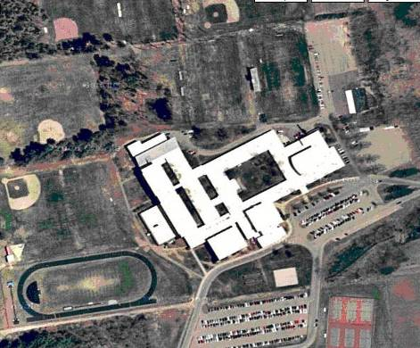

Aerial View of MRHS

Picture 2

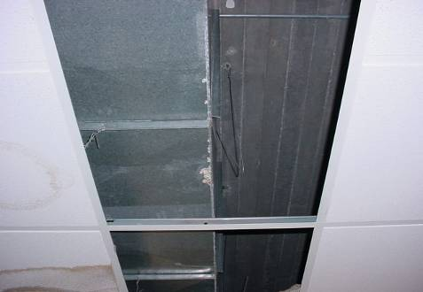

Missing/Water Damaged Ceiling Tiles, Library

Picture 3

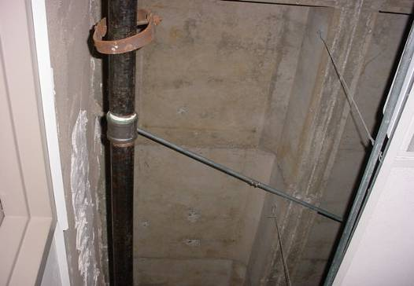

Efflorescence On The Underside Of Roof Decking
Picture 4

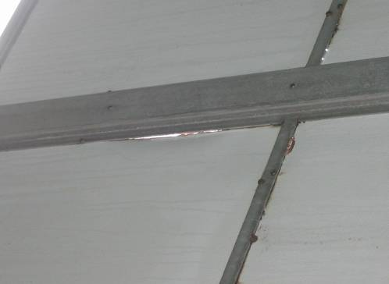

Breaches Around Wall Panels In Pool

Picture 5

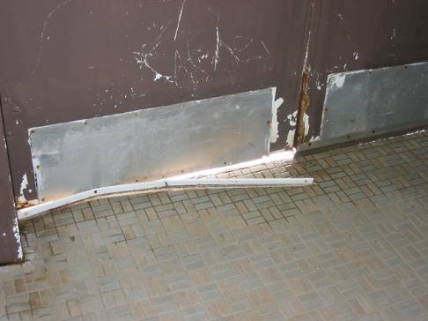

Breaches to Exterior Door in Pool Area
Picture 6

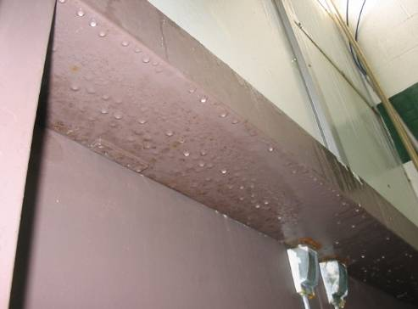

Exterior Door Of Pool, Note Condensation On Doorframe

Picture 7

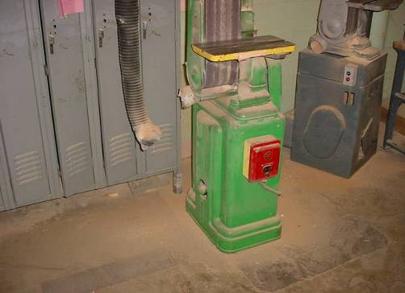

Disconnected Wood Dust Collector Hose
Picture 8

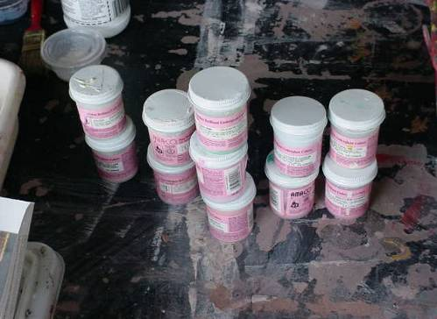

Pottery Glazes Containing Lead

Picture 9

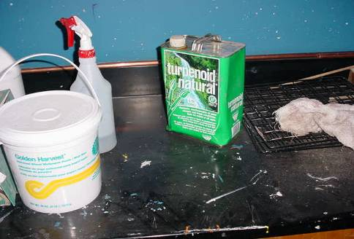

Turpentine Container in Art Room

Picture 10

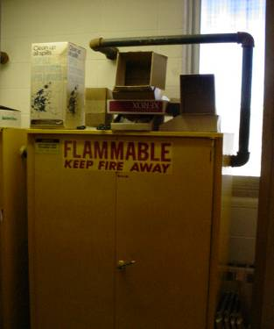

Vented Flameproof Cabinet in Chemical Storeroom
Location | Carbon  Dioxide  (*ppm) | Temp  (°F) | Relative  Humidity  (%) | Occupants  in Room | Windows  Openable | Ventilation |  | Remarks
 |  |  |  |  |  | Supply | Exhaust | Remarks
Outside  (Background) | 355 | 53 | 21
M 1 | 2445 | 71 | 43 | 20 | Y | Y | Y | 1 water damaged ceiling tiles  Bunsen burners in use without exhaust vent operation
M 2 | 2524 | 71 | 42 | 1 | Y | Y | Y | Supply off  1 water damaged ceiling tile  Dry erase board
M 3 | 2475 | 71 | 42 | 24 | Y | Y | Y | Exhaust off  1 water damaged ceiling tile  Door open
K 3 | 3419 | 75 | 41 | 26 | Y | Y | N | Supply off  Dry erase board
J 15 | 3332 | 73 | 41 | 15 | Y | Y | N | 5 water damaged ceiling tiles  Dry erase board
M 4 | 2464 | 71 | 41 | 0 | Y | Y | Y | Supply off  Exhaust off  8 water damaged ceiling tiles  Efflorescence around windows  Dry erase board
M 1 lab | 2149 | 70 | 41 | 0 | Y | Y | Y | Door open
J 8 | 1767 | 73 | 39 | 7 | Y | Y | N | Boxes  Clothes dryer-no vent to outdoors
M 16 | 2427 | 72 | 39 | 21 | Y | Y | N | Supply off  Dry erase board
H 7 | 2811 | 74 | 38 | 25 | Y | Y | Y | Supply off  Exhaust off
H 2 | 2971 | 74 | 38 | 15 | Y | Y | Y | Supply off  Dry erase board
K 5 | 2453 | 73 | 37 | 16 | Y | Y | N | Dry erase board
H 16 | 1461 | 73 | 37 | 24 | Y | Y | Y | Exhaust off  Window open
H 13 | 2866 | 73 | 37 | 24 | Y | Y | Y | Supply off  Exhaust off  Dry erase board
K 14 | 2452 | 72 | 37 | 21 | Y | Y | N | Supply off  Dry erase board
Principle’s office | 1080 | 71 | 37 | 1 | Y | y | N | Supply off
K 4 | 2381 | 75 | 36 | 23 | Y | Y | N | Dry erase board
H 5 | 1983 | 75 | 36 | 18 | Y | Y | Y | Exhaust off  4 water damaged ceiling tiles
M 8 | 1891 | 74 | 36 | 0 | Y | Y | N | 6 water damaged ceiling tiles  Dry erase board  17 computers
H 1 | 2114 | 73 | 36 | 20 | Y | Y | Y | Supply off  Exhaust off  Exhaust blocked with shirt
M 6 | 1733 | 74 | 35 | 1 | Y | Y | N | Students gone from room for 105 minutes  Supply blocked with table  Dry erase board
K 1 | 2439 | 74 | 35 | 18 | Y | Y | N | Dry erase board  Door open
J 1 | 1565 | 74 | 35 | 18 | Y | Y | N | Supply off  Supply blocked with boxes  Dry erase board
H 9 | 2216 | 73 | 35 | 17 | Y | Y | Y | Supply off  Exhaust off
M 14 | 1606 | 72 | 35 | 0 | Y | Y | Y
K 9 | 2194 | 72 | 35 | 15 | Y | Y | N | Dry erase board  Door open
H 14 | 2198 | 72 | 35 | 1 | Y | Y | Y | Supply off  Exhaust off  Dry erase board
K 16 | 2428 | 71 | 35 | 23 | Y | Y | Y | Supply off  Supply blocked with books
Math core resource room | 1680 | 73 | 34 | 2 | Y | N | N | Door open
J 5 | 2114 | 73 | 34 | 13 | Y | Y | N | Upholstered furniture  Dry erase board
H 18 | 1856 | 73 | 34 | 25 | Y | Y | Y
H 10 | 2000 | 73 | 34 | 16 | Y | Y | Y | Supply off  Exhaust off  Door open
K 12 | 2040 | 72 | 34 | 18 | Y | Y | N | Supply off
M Gentlemen’s Restroom | 1555 | 73 | 33 | 0 | Y | N door vent | Y
M 12A | 1634 | 73 | 33 | 13 | Y | Y | Y | 6 water damaged ceiling tiles  1 missing ceiling tile  Door open
Gymnasium | 1062 | 70 | 33 | 40+ | N | Y | Y
J 12 | 1922 | 73 | 32 | 15 | Y | Y | N | Supply blocked wit boxes  Dry erase board
K 17 | 1648 | 72 | 32 | 2 | Y | Y | N | Door open
K 18 | 1788 | 71 | 32 | 0 | Y | Y | N | Dry erase board  Door open
J 6 | 1245 | 71 | 32 | 3 | Y | Y | N
J 17 | 1154 | 74 | 31 | 7 | Y | Y | N
H12 | 1362 | 73 | 31 | 25 | Y | Y | Y | Supply off  Exhaust off  Dry erase board  Door open  Window open
J 9 | 1442 | 72 | 31 | 19 | Y | Y | N | Clutter  Dry erase board
K 10B | 1425 | 73 | 30 | 10 | Y | N | N | Supply off  Dry erase board
J 2 | 1155 | 73 | 30 | 13 | Y | Y | Y | Dry erase board  Chalk dust
H 11 | 1469 | 73 | 30 | 3 | Y | Y | Y | Door open
K 17B | 1304 | 72 | 30 | 1 | Y | N | N | Dry erase board
J 10 | 1253 | 72 | 30 | 10 | Y | Y | N | Supply off  7 water damaged ceiling tiles  Window open  Door open
K 6 | 1350 | 73 | 29 | 13 | Y | Y | N | Supply off  Dry erase board
J 2A | 1043 | 73 | 29 | 10 | Y | Y | Y | Window open  Dry erase board  Door open  Upholstered furniture
H 6 | 1172 | 73 | 29 | 24 | Y | Y | Y | One supply off  Window open
K 11 | 1444 | 72 | 29 | 14 | Y | Y | N | Dry erase board
K 8 | 1349 | 72 | 29 | 24 | Y | Y | N | Supply blocked with books  Dry erase board  Door open
Library | 929 | 73 | 28 | 5 | Y | Y | Y | 20+ water damaged ceiling tiles  20+ missing ceiling tiles  25 computers  Dry erase board
H 4 | 874 | 74 | 26 | 10 | Y | Y | Y | Supply off  Supply blocked with plant
Hall outside M 16 |  |  |  |  |  |  |  | 6 water damaged ceiling tiles
AV room |  |  |  |  |  |  |  | Photocopier odor  3 photocopiers

Location | Carbon  Dioxide  (*ppm) | Temp  (°F) | Relative  Humidity  (%) | Occupants  in Room | Windows  Openable | Ventilation |  | Remarks
 |  |  |  |  |  | Supply | Exhaust | Remarks
Outside  (Background) | 351 | 42 | 50
Pool | 600 | 73 | 57 | 17 | Y | N | Y | Exhaust system drawing weakly  Breached in exterior wall  Condensation on wall system  Water damaged to wall panels  Windows open
G 2 | 1956 | 72 | 35 | 77 | Y | Y | Y | 1 Supply off  Exhaust off  Chalk dust  Door open
Old gym | 647 | 68 | 34 | 50 | Y | Y | Y | Window open
C 4 | 1073 | 70 | 33 | 23 | Y | Y | Y | Exhaust off  Plants over supply vent  Window-mounted air conditioner  Dry erase board  2 hood exhausts
Small gym | 1019 | 64 | 33 | 70 | Y | Y | Y | Window open
Band room | 1406 | 69 | 31 | 60 | Y | Y | Y | Supply off  Exhaust drawing weakly  Personal fan  3 water damaged ceiling tiles  Door open
Cafeteria 2/3 | 1132 | 72 | 30 | 70 | Y | Y | Y | Exhaust off
Cafeteria 1 | 904 | 70 | 29 | 39 | Y | Y | Y | Window open
D 15 | 1516 | 73 | 28 | 1 | Y | Y | Y | Supply off  Window-mounted air conditioner  18 water damaged ceiling tiles  Clutter
Pre-school | 937 | 71 | 28 | 23 | Y | Y | Y | Breach in sink counter  Upholstered furniture
F 4 | 1010 | 71 | 28 | 12 | N | Y | Y | Supply off  Personal fan  Door open
D 11 | 1048 | 73 | 25 | 0 | Y | N | N | 6 water damaged ceiling tiles
E 8 | 1100 | 71 | 25 | 2 | Y | Y | Y | Personal fan  Door open  4 water damaged ceiling tiles  Dry erase board
Assessment center main | 985 | 72 | 24 | 1 | N | N | N | Photocopier
C4 office | 559 | 69 | 24 | 0 | N | Y | Y | Exhaust off  2 water damaged ceiling tiles  Clutter
F 5 auto shop | 725 | 66 | 24 | 0 | Y | Y | Y | 1 supply off
F 3 wood shop | 559 | 65 | 24 | 0 | Y | Y | Y | Supply off  1 ajar ceiling tile  5 water damaged ceiling tiles
C 8 | 744 | 73 | 23 | 1 | Y | Y | Y | Exhaust off  Hoods off  Cleaners  Dry erase marker
F 2 | 451 | 71 | 21 | 0 | Y | Y | Y | Supply off  Breach in sink counter  Washer and dryer  3 missing ceiling tiles
D 4 | 518 | 69 | 21 | 3 | Y | Y | Y | Supply off  Exhaust blocked  Windows open  Hood on  Tennis ba;lls  Personal fan  Window-mounted air conditioner
C4 back storeroom |  |  |  |  |  |  |  | 2 water damaged ceiling tiles  1 mold colonized ceiling tile
Pre-school restroom |  |  |  |  |  | N | Y | Exhaust drawing weakly  2 missing ceiling tiles

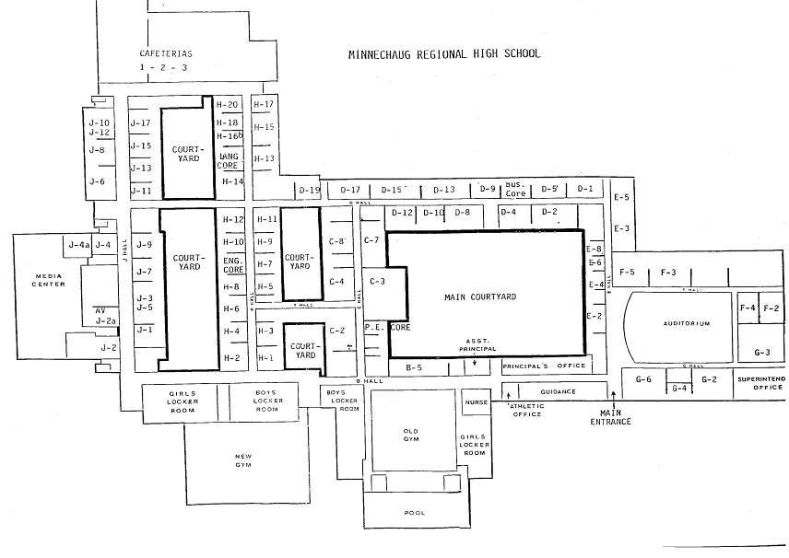
Key

Locations of Pool Treatment Odors on 1/12/2007

Please note that 105 CMR 435.03 (10): Minimum Standards For Swimming Pools (State Sanitary Code: Chapter V) requires that “[a]ll rooms housing indoor swimming pools and all bathhouses dressing rooms, shower rooms, and toilets at both indoor and outdoor pools shall be properly and adequately ventilated.” (emphasis added).

