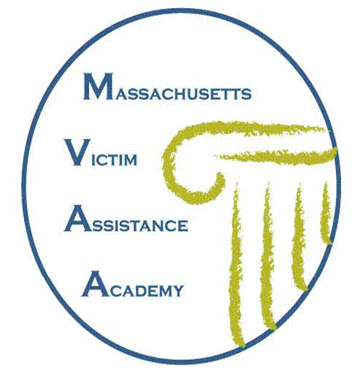

MINTZ LEVIN/PAUL POTH MEMORIAL SCHOLARSHIP

MASSACHUSETTS VICTIM ASSISTANCE ACADEMY

INSPIRATION FOR ESTABLISHMENT OF SCHOLARSHIP: To honor the legacy and memory of attorney Paul P. Poth, the law firm Mintz, Levin, Cohn, Ferris, Glovsky and Popeo, P.C., is awarding scholarships to the MA Victim Assistance Academy (MVAA) sponsored by the MA Office for Victim Assistance (MOVA). Scholarship recipients (to be deemed “Mintz Levin / Paul Poth Scholars”) will have demonstrated a commitment, through their personal, civic and/or professional activities, to furthering the ideals espoused by Paul Poth in his career as an attorney in private practice, as an Assistant District Attorney, and through his daily life and service to victims/survivors, and the victim services community. Recipients will also have shown a compelling financial need for the scholarship to enable them to attend the MVAA.

INTRODUCTION TO PAUL POTH: Paul was known universally for his compassion for those in need, and he dedicated his life to serving those who were most vulnerable in society. A hallmark of Paul’s work as an assistant district attorney involved his efforts on behalf of victims, in particular adolescents coerced into prostitution. Paul believed that working to restore the self-confidence of the victims he assisted was as much a part of his duties as was the successful prosecution of the criminals involved. In private practice and in his personal life, Paul worked closely with MOVA to help further its goals, assisted domestic and sexual assault survivors on a pro bono basis, cycled in support of AIDS research in the Boston-New York AIDS Ride, volunteered for Project Hope, and mentored city youth through hockey leagues and the Boston public schools’ Mock Trial Program. Humor was an integral part of who Paul was, and making people laugh - often through stories about his own experiences - was something in which he took great pleasure, and something from which all those that came to know him, benefited greatly. Paul’s personal and professional lives were inextricably linked because of the values that motivated all that he did. His success in his work and volunteerism was inspired, buoyed and informed by what was most important to him - his devotion to family, particularly to his wife, Kristen, a dedicated victim services professional with whom he shared his passion for advocating for victim rights, and their son.

“It was a big honor to have been chosen for the Mintz Levin/Paul Poth Scholarship. Paul Poth has a tremendous legacy and it was very moving to be considered someone who is carrying forward his vision of empowering survivors. The MVAA was an incredible experience. The knowledge and relationships gained at MVAA really helped me to work more effectively with other systems in service of my clients. I feel very grateful to Mintz Levin and the MVAA for this experience.” - 2011 Mintz Levin/Paul Poth Scholar

Mintz Levin/Paul Poth Scholarship
Massachusetts Victim Assistance Academy
Application Cover Page

APPLICANT’S NAME (PRINT)

APPLICANT’S SIGNATURE

APPLICANT’S TITLE

AGENCY

AGENCY DIRECTOR’S NAME (PRINT)

________________________________________________________________________
AGENCY DIRECTOR’S SIGNATURE DATE

AVAILABLE SCHOLARSHIPS: 3 SCHOLARSHIPS WILL BE AWARDED FOR THE MASSACHUSETTS VICTIM ASSISTANCE ACADEMY

APPLICATION PROCESS/REQUIREMENTS: To be considered, interested applicants must submit (1) a complete, signed MVAA application and (2) a written narrative for this scholarship opportunity of no more than 3 pages that includes the following:

1. A brief description of your current position and scope of work, achievements you are most proud of to date, and your passion and commitment;

2. A narrative detailing how some aspect of your professional work, civic/volunteer experience, and/or other efforts demonstrate the qualities and ideals described above about the person whose life is honored by this scholarship opportunity;

3. A brief explanation of your agency’s need for financial assistance.

APPLICATION DEADLINE IS MARCH 6, 2015
Please submit completed application with cover page signatures to:
MOVA, c/o MVAA
One Ashburton Place, Suite 1101, Boston, MA 02108
Fax: 617-586-1341, E-mail: MOVA@state.ma.us

