**Massachusetts Commission for the Deaf and Hard of Hearing**

**Statewide Advisory Council Meeting**

**April 8, 2021**

**6:15 – 8:15 pm**

**Meeting Minutes**

**Participants:**  
Commissioner Opeoluwa Sotonwa, MCDHH

**SAC Members:**  
Evan Brunell  
Zinma Camelio  
Brock Cordeiro   
Michelle Motta Dardeno  
Stephanie Hakulin  
Barbara Johnson  
Leah McGaughey  
Ellen Perkins  
Linda Sakin  
Lori Seidman  
Kerry Thompson

**Attendees from Community:**Marlene Blackstone, ViAbility  
Brennan Bulger, Bristol County Sheriff’s Office, Canine Officer  
Diane Crouse, MCDHH  
Emily Graves-Harrison, MCDHH  
Tricia Ford, MCDHH  
Ivy Velez, DDS

|  |  |  |
| --- | --- | --- |
| **Agenda Topic** | **Discussion** | **Follow up/Person Responsible** |
| Welcome | * Communication Procedures * Introductions * Review of Agenda |  |
| Review of Minutes from March 11, 2021 | * Update for March minutes: Linda Sakin worked with Advanced Bionics on their announcement on upcoming processor changes. Communication was shared which clarified and addressed concerns. | Minutes will be reviewed at May meeting. |
| Chairperson’s Report | * Proposal for meeting change:  1. 5:15 – 7:15 OR 2. 5:30 – 7:30 * Times and locations for FY22 meetings will be determined in June. Currently [Open Meeting Law](https://www.mass.gov/files/documents/2017/10/12/OML%20Text.pdf) requires SAC groups to meet in person. * Biographies of SAC members: goal is to provide community members with a connection between a face and name and list the affiliations of SAC members. Concerns: privacy and safety. * Potential meeting topics: 1. Technology and medical devices. 2. Legislative process and bills in session. 3. Cultural aspects of community members 4. Medical initiatives. 5. Education. Recommendation to have a Dept. of Education representative present on rights connected to educational plans. * Introductory meeting with the new Speaker of the House [Ronald Mariano](https://malegislature.gov/Legislators/Profile/R_M1). * Recognition for 2020 Deaf and Hard of Hearing Constituents’ Day Awards. Recommendation: inclusion of [DEAFinitely](https://www.deafinitelyinc.com/) dance group for an entertainment aspect to the presentation. Recommendation: recognition of community leaders lost within the last year (ie Jean Healy.) * Communications to and from community members; goal is for increased transparency and collaborative efforts between organizations and state agencies. Decrease ignorance on MCDHH’s offered services, efforts and information connected to COVID19 and vaccinations, improve MCDHH’s messaging in Western MA. | Time change would be for the remainder of FY21.  Please send comments/feedback to Michelle.  Michelle will share her original request with SAC members.  Michelle will survey SAC members for interests and topics to inform potential subcommittee work.  Recommendation: presentation from Councils on Aging on their additional supports for seniors with hearing loss.  Alert Michelle if you’re interested in joining the meeting.  Linda Sakin volunteered.  [Governor’s COVID-19 Order #63.](https://www.mass.gov/doc/appendix-to-covid-19-order-63/download)  MCDHH is working on ways to strategically develop Case Management functions; a Western full-time Adult Case Manager will be hired, MCDHH is working with COVID Command Center and Dept. of Public Health for recommendations for community messaging. |
| Commissioner’s Report | * Meeting 1:1 with MCDHH staff members. Currently 19 have been completed. Staff passion and dedication has been inspiring. * Goal as Commissioner: expand partnership, improve access in Western MA. * March 30: testimony was provided to the Joint Ways and Means Committee Hearing. The Governor has requested a 5% increase to MCDHH’s budget. A proposed $300,000 for vlog production was included for MCDHH messaging. A proposed $530,000 will be dedicated to Workforce Development of ASL and CART providers. Level funding for specific MCDHH programs: Case Management, CATTS, Referral, etc. A request for DHILS support to increase 20% was included in the Governor’s proposal. * FY22 Goals:  1. Workforce Development: ASL and CART. 2. Innovation Technology: improvements in technology for communication access. 3. Early Childhood Education: focusing on language acquisition in collaboration with the Dept. of Elementary and Secondary Education. 4. Substance Use Disorder and recovery with Deaf Recovery Coaches. * MCDHH 35th Anniversary: three awards will be distributed. 1. BJ Wood Trailblazer: for a community leader who has gone above and beyond with their advocacy and work. 2. Gail Sallop Interpreter Award: as the first ASL interpreter in MA, Gail worked to develop screening and qualifications for future interpreters. 3. Lifetime Achievement. |  |
| Legislative Task Force Report | * 38 bills are being tracked. * None have been sent to committee yet and are without action. * Time before committee allows community members to contact legislators and request co-sponsoring bills of interest. | Bills of Interest at end of document. |
| New Business | * Concern: communication access at mass vaccination sites. Disability Policy Consortium (DPC) will be discussing the issue with MCDHH. * Recommendation: printing informational sheets to assist with navigating vaccination sites. |  |
| Announcements | * April 9, 15 and 19th: Disability Law Center (DLC) meetings on accommodations being denied. * CLW workshops * June: [HLAA virtual convention](https://www.hearingloss.org/programs-events/convention/) * ViAbility has hired an intern to work on workshop flyer and public relations. * Upcoming MCDHH vlogs: Self-Care and Victim Service Awareness. | Center for Living and Working (CLW) Newsletter (page 7 – 34)  Center for Living and Working (CLW) Newsletter (page 7 – 30) |
| Next SAC Meeting | * May 13, 6:15 – 8:15 pm. * SAC “Bills of Interest” are at the end of these minutes (pg. 5 – 6.) | Any interested community members wanting SAC information can request to join the distribution list. Please email: [ami.hanigan@mass.gov](mailto:ami.hanigan@mass.gov).  SAC members with requests for additions to the future agendas should share these additions with [ami.hanigan@mass.gov](mailto:ami.hanigan@mass.gov). |

|  |  |  |
| --- | --- | --- |
| **Docket Number** | **Presenter** | **Bill Title** |
| [HD.3038](https://malegislature.gov/Bills/192/HD3038) | [Higgins, Natalie M.](https://malegislature.gov/Legislators/Profile/N_H1) | [An Act An act to eliminate disproportionality and inequities for at-risk children](https://malegislature.gov/Bills/192/HD3038) |
| [HD.1283](https://malegislature.gov/Bills/192/HD1283) | [Miranda, Liz](https://malegislature.gov/Legislators/Profile/L_M2) | [An Act effectuating equity in COVID-19 vaccination](https://malegislature.gov/Bills/192/HD1283) |
| [SD.699](https://malegislature.gov/Bills/192/SD699) | [Rausch, Rebecca L.](https://malegislature.gov/Legislators/Profile/RLR0) | [An Act effectuating equity in COVID-19 vaccination](https://malegislature.gov/Bills/192/SD699) |
| [HD.3607](https://malegislature.gov/Bills/192/HD3607) | [Capano, Peter](https://malegislature.gov/Legislators/Profile/PLC1) | [An Act Enabling Municipal Pre-foreclosure Mediation](https://malegislature.gov/Bills/192/HD3607) |
| [SD.921](https://malegislature.gov/Bills/192/SD921) | [O'Connor, Patrick M.](https://malegislature.gov/Legislators/Profile/PMO) | [An Act establishing a tax credit for the purchase of hearing aids](https://malegislature.gov/Bills/192/SD921) |
| [HD.391](https://malegislature.gov/Bills/192/HD391) | [Livingstone, Jay D.](https://malegislature.gov/Legislators/Profile/J_L1) | [An Act increasing fair housing protections for domestic violence survivors](https://malegislature.gov/Bills/192/HD391) |
| [HD.1049](https://malegislature.gov/Bills/192/HD1049) | [Ayers, Bruce J.](https://malegislature.gov/Legislators/Profile/BJA1) | [An Act increasing the penalties for unfair and deceptive actions perpetrated against persons with disabilities and senior citizens](https://malegislature.gov/Bills/192/HD1049) |
| [HD.843](https://malegislature.gov/Bills/192/HD843) | [Khan, Kay](https://malegislature.gov/Legislators/Profile/K_K1) | [An Act prohibiting discrimination against adults with disabilities in family and juvenile court proceedings](https://malegislature.gov/Bills/192/HD843) |
| [SD.1770](https://malegislature.gov/Bills/192/SD1770) | [Lovely, Joan B.](https://malegislature.gov/Legislators/Profile/JBL0) | [An Act prohibiting discrimination against adults with disabilities in family and juvenile court proceedings](https://malegislature.gov/Bills/192/SD1770) |
| [HD.1990](https://malegislature.gov/Bills/192/HD1990) | [Barber, Christine P.](https://malegislature.gov/Legislators/Profile/CPB2) | [An Act promoting fair housing by preventing discrimination against affordable housing](https://malegislature.gov/Bills/192/HD1990) |
| [SD.2200](https://malegislature.gov/Bills/192/SD2200) | [Chang-Diaz, Sonia](https://malegislature.gov/Legislators/Profile/SCD0) | [An Act promoting fair housing by preventing discrimination against affordable housing](https://malegislature.gov/Bills/192/SD2200) |
| [HD.1960](https://malegislature.gov/Bills/192/HD1960) | [Gordon, Kenneth I.](https://malegislature.gov/Legislators/Profile/KIG1) | [An Act providing affordable and accessible high quality early education and care to promote child development and well-being and support the economy ...](https://malegislature.gov/Bills/192/HD1960) |
| [SD.1307](https://malegislature.gov/Bills/192/SD1307) | [Lewis, Jason M.](https://malegislature.gov/Legislators/Profile/jml0) | [An Act providing affordable and accessible high quality early education and care to promote child development and well-being and support the economy ...](https://malegislature.gov/Bills/192/SD1307) |
| [SD.1225](https://malegislature.gov/Bills/192/SD1225) | [Hinds, Adam G.](https://malegislature.gov/Legislators/Profile/AGH0) | [An Act providing coverage for hearing aids](https://malegislature.gov/Bills/192/SD1225) |
| [SD.89](https://malegislature.gov/Bills/192/SD89) | [DiZoglio, Diana](https://malegislature.gov/Legislators/Profile/D_D0) | [An Act relative to accessible prescription labeling](https://malegislature.gov/Bills/192/SD89) |
| [HD.303](https://malegislature.gov/Bills/192/HD303) | [Durant, Peter J.](https://malegislature.gov/Legislators/Profile/PJD2) | [An Act relative to children's auditory health](https://malegislature.gov/Bills/192/HD303) |
| [HD.2317](https://malegislature.gov/Bills/192/HD2317) | [Ramos, Orlando](https://malegislature.gov/Legislators/Profile/O_R1) | [An Act relative to employment benefits of certain employees of the Department of Developmental Services](https://malegislature.gov/Bills/192/HD2317) |
| [SD.85](https://malegislature.gov/Bills/192/SD85) | [DiZoglio, Diana](https://malegislature.gov/Legislators/Profile/D_D0) | [An Act relative to juvenile violence](https://malegislature.gov/Bills/192/SD85) |
| [HD.3674](https://malegislature.gov/Bills/192/HD3674) | [Madaro, Adrian C.](https://malegislature.gov/Legislators/Profile/ACM1) | [An Act Relative to Language Access and Inclusion](https://malegislature.gov/Bills/192/HD3674) |
| [SD.2251](https://malegislature.gov/Bills/192/SD2251) | [DiDomenico, Sal N.](https://malegislature.gov/Legislators/Profile/SND0) | [An Act relative to language access and inclusion](https://malegislature.gov/Bills/192/SD2251) |
| [HD.2583](https://malegislature.gov/Bills/192/HD2583) | [Khan, Kay](https://malegislature.gov/Legislators/Profile/K_K1) | [An Act relative to newborn screenings for congenital cytomegalovirus](https://malegislature.gov/Bills/192/HD2583) |
| [SD.1810](https://malegislature.gov/Bills/192/SD1810) | [Lovely, Joan B.](https://malegislature.gov/Legislators/Profile/JBL0) | [An Act relative to newborn screenings for congenital cytomegalovirus](https://malegislature.gov/Bills/192/SD1810) |
| [HD.1085](https://malegislature.gov/Bills/192/HD1085) | [Ayers, Bruce J.](https://malegislature.gov/Legislators/Profile/BJA1) | [An Act relative to providing improved access to taxicabs for persons with disabilities](https://malegislature.gov/Bills/192/HD1085) |
| [SD.299](https://malegislature.gov/Bills/192/SD299) | [Creem, Cynthia Stone](https://malegislature.gov/Legislators/Profile/CSC0) | [An Act relative to removing the term hearing impaired from the general laws](https://malegislature.gov/Bills/192/SD299) |
| [SD.64](https://malegislature.gov/Bills/192/SD64) | [DiZoglio, Diana](https://malegislature.gov/Legislators/Profile/D_D0) | [An Act relative to tax abatements for deaf residents](https://malegislature.gov/Bills/192/SD64) |
| [HD.2533](https://malegislature.gov/Bills/192/HD2533) | [Golden, Jr., Thomas A.](https://malegislature.gov/Legislators/Profile/TAG1) | [An Act Relative to Telehealth and Digital Equity for Patients](https://malegislature.gov/Bills/192/HD2533) |
| [SD.2099](https://malegislature.gov/Bills/192/SD2099) | [Gomez, Adam](https://malegislature.gov/Legislators/Profile/A_G0) | [An Act relative to telehealth and digital equity for patients](https://malegislature.gov/Bills/192/SD2099) |
| [HD.1883](https://malegislature.gov/Bills/192/HD1883) | [Cabral, Antonio F. D.](https://malegislature.gov/Legislators/Profile/AFC1) | [An Act relative to the training, assessment, and assignment of qualified school interpreters in educational settings](https://malegislature.gov/Bills/192/HD1883) |
| [SD.392](https://malegislature.gov/Bills/192/SD392) | [Crighton, Brendan P.](https://malegislature.gov/Legislators/Profile/BPC0) | [An Act relative to the training, assessment, and assignment of qualified school interpreters in educational settings](https://malegislature.gov/Bills/192/SD392) |
| [HD.2519](https://malegislature.gov/Bills/192/HD2519) | [Cassidy, Gerard J.](https://malegislature.gov/Legislators/Profile/G_C2) | [An Act requiring reimbursement for the costs of providing competent interpreter services](https://malegislature.gov/Bills/192/HD2519) |
| [SD.1766](https://malegislature.gov/Bills/192/SD1766) | [Moran, Susan L.](https://malegislature.gov/Legislators/Profile/SLM0) | [An Act to eliminate disproportionality and inequities for at-risk children](https://malegislature.gov/Bills/192/SD1766) |
| [HD.155](https://malegislature.gov/Bills/192/HD155) | [Linsky, David Paul](https://malegislature.gov/Legislators/Profile/DPL1) | [An Act to enhance safety and security in courthouses](https://malegislature.gov/Bills/192/HD155) |
| [SD.1844](https://malegislature.gov/Bills/192/SD1844) | [Jehlen, Patricia D.](https://malegislature.gov/Legislators/Profile/PDJ0) | [An Act to ensure quality of care in nursing homes](https://malegislature.gov/Bills/192/SD1844) |
| [HD.2981](https://malegislature.gov/Bills/192/HD2981) | [Balser, Ruth B.](https://malegislature.gov/Legislators/Profile/RBB1) | [An Act to ensure the quality of care in nursing homes](https://malegislature.gov/Bills/192/HD2981) |
| [HD.2938](https://malegislature.gov/Bills/192/HD2938) | [Kelcourse, James M.](https://malegislature.gov/Legislators/Profile/JMK1) | [An Act to provide increased access to hearing aids](https://malegislature.gov/Bills/192/HD2938) |
| [HD.535](https://malegislature.gov/Bills/192/HD535) | [Fiola, Carole A.](https://malegislature.gov/Legislators/Profile/CAF1) | [An Act to provide increased access to hearing aids](https://malegislature.gov/Bills/192/HD535) |
| [SD.13](https://malegislature.gov/Bills/192/SD13) | [DiZoglio, Diana](https://malegislature.gov/Legislators/Profile/D_D0) | [An Act to provide increased access to hearing aids](https://malegislature.gov/Bills/192/SD13) |
| [SD.2047](https://malegislature.gov/Bills/192/SD2047) | [Hinds, Adam G.](https://malegislature.gov/Legislators/Profile/AGH0) | [An Act to provide increased access to hearing aids](https://malegislature.gov/Bills/192/SD2047) |

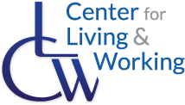***Empowering Independence* April 8, 2021**

**&**

**C L W D H I L S - S P E C I A L E D I T I O N ( *V O L U M E 3 4 )***

## Governor Baker’s COVID-19 Updates

#### REOPENING MASSACHUSETTS: Phase 4, Step 1

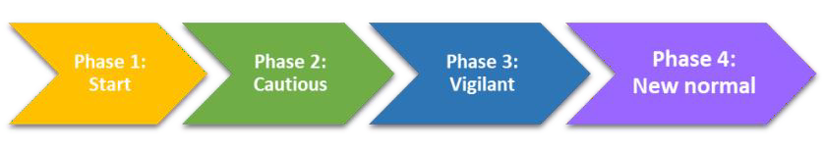

**Vaccine: *Who can get it now?***

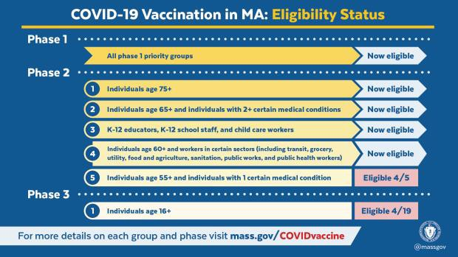

**NOT YET**

**W O R K I N G ,**

**I N C .**

## COVID-19 Vaccine: What to Expect

**F O R**

**L I V I N G**

Watch this ASL video about what to expect when you get a COVID-19 vaccine: click [here.](https://www.youtube.com/watch?v=DUwS3F5jkyo&list=PLvrp9iOILTQatwnqm61jqFrsfUB4RKh6J&index=6)

**C E N T E R**

Check out the CDC’s many other ASL videos there too.

###### Want more information?

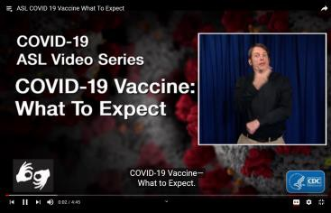

***Visit:*** [***cdc.gov/coronavirus***](https://www.cdc.gov/coronavirus/2019-ncov/index.html?CDC_AA_refVal=https%3A%2F%2Fwww.cdc.gov%2Fcoronavirus%2Findex.html)





**Need COVID-19 information in a different language? Click** [**here!**](https://www.mass.gov/info-details/multilingual-resources-on-covid-19#vaccine-information-)

## When are You Fully Vaccinated?

###### Moderna:



* 2 shots
* 28 days apart

###### Pfizer:

* 2 shots
* 21 days apart

###### Johnson & Johnson/Janssen:

* 1 shot

2 weeks after second shot

###### = PROTECTED



2 weeks after one/only shot

###### = PROTECTED



**Continue to follow guidelines (wear a mask, wash hands, etc.)**

**Less than 2 weeks since your 1-dose shot or waiting for second dose? You are NOT fully protected.**

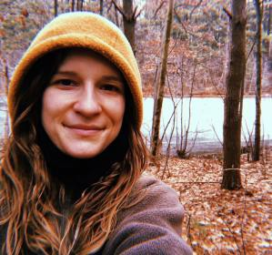

**ODSC Hires Victims Advocate**

**Our Deaf Survivors Center, Inc.** (ODSC) is

thrilled to announce that ODSC received a three (3) year

$450,000 grant from “*Grant for Outreach and Services to Underserved Populations*". With this grant, ODSC has

started searching for an executive director, increased current hours for: Kristen Crossen (Clinical Supervisor) and Samantha Kistner (Cultural Broker—working Mondays, Wednesday, and Fridays), *and* hired a **Victim Advocate**—**Rebecca Szynkowski**. Rebecca recently started and will be working on Tuesdays and Thursdays.

Rebecca was born and raised on the West coast and has moved around to 7 different states before landing in Massachusetts. Her passion is to work with the Deaf community providing mental health and domestic violence services. Rebecca’s 3 plus years of experience began with her studies at Gallaudet University, where she majored in social work. Her goals are to promote working with



victims/survivors of sexual and domestic violence by offering them a supportive, healing, and empowering journey that encourages their self-growth, as well as train the Deaf community on

understanding domestic violence and how to be a supportive ally. Please welcome Rebecca to ODSC and to MASS!

ODSC will continue sending updates with more news about future actions/plans and the search for an Executive Director.

**ODSC website:** [**https://www.odscunity.org/**](https://www.odscunity.org/)

## IRS Videos in ASL

###### Questions about filing taxes? Watch the IRS ASL YouTube Channel:



* Find out what to do if you don’t get your W-2
* Five Things to Know about the Employer Identification Number (EIN)
* Earned Income Tax Credit – Get It Right

[**https://www.youtube.com/channel/UCQwj_3ceiufbeafRPrC83Ig**](https://www.youtube.com/channel/UCQwj_3ceiufbeafRPrC83Ig)

## 2021 Tax Deadlines

**New FEDERAL and MASSACHUSETTS**



**Tax deadlines: May 17, 2021**

Read more [here.](https://www.mass.gov/info-details/2021-dor-tax-due-dates-and-extensions)

## 2021 Tax Filing

**LOWELL AREA**

*Community Teamwork*

Online or drop-off only.

**NO APPOINTMENTS**

Click [here](https://www.commteam.org/how-we-help/finance-business/vita/) for more information about where you can drop off papers.





**WORCESTER AREA**

*Worcester Community Action Council (WCAC)* (in Denholm Building, 2nd floor), Suite 202 484 Main Street, Worcester, MA

Paper drop-off hours (for scanning only)

**NO APPOINTMENTS**

|  |  |
| --- | --- |
| **Mondays** | **5:00 pm—7:00 pm** |
| **Wednesdays** | **3:00 pm—7:00 pm** |
| **Fridays** | **9:00 am—1:00 pm** |
| **Saturdays** | **9:00 am—12:00 pm** |

**Watch VLOG in ASL here:**

[**https://youtu.be/kqicnlm0q9E**](https://youtu.be/kqicnlm0q9E)

## MCDHH Cancellation Requests

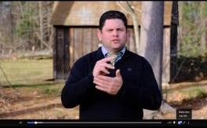

MCDHH Referral Dept announced other options for **Cancellation Re- quests** for Interpreting and CART Services.

**See the VLOG:** [**https://www.facebook.com/MCDHH.MA/**](https://www.facebook.com/MCDHH.MA/videos/126492116111962)[**videos/126492116111962**](https://www.facebook.com/MCDHH.MA/videos/126492116111962)

## 2021 Stimulus Payment

###### How will I get paid?

* + Direct deposit, paper check, or debit card

###### Where is my payment?

* + Look here: [**https://www.irs.gov/coronavirus/get**](https://www.irs.gov/coronavirus/get-my-payment)

###### [-my-payment](https://www.irs.gov/coronavirus/get-my-payment)

***Frequently Asked Questions***—click [here](https://www.irs.gov/coronavirus/get-my-payment-frequently-asked-questions)

**Deaf Future Works VLOG explains IRS an- nouncement in ASL:** [**https://**](https://fb.watch/4Hao6W-ctl/)[**fb.watch/4Hao6W-ctl/**](https://fb.watch/4Hao6W-ctl/)

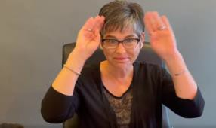

**NOTE: Must log in to FaceBook to watch.**

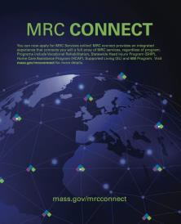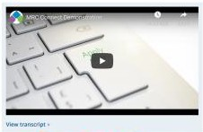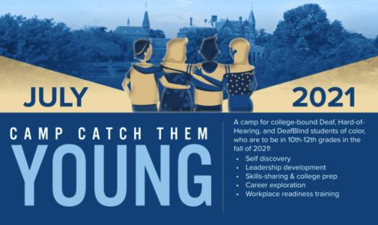

## MRC Connect

**Apply for services online at**: <https://www.mass.gov/mrc-connect>

* + - VR (Vocational Rehabilitation)
    - SHIP (Statewide Head Injury Program)
    - HCAP (Home Care)
    - SL (Supported Living)

**Movie: *Feeling Through***

###### *Feeling Through* is the first film with a DeafBlind individual in the lead role. It is also nominated for an Oscar!

Watch the 93rd Academy Awards on **Sunday, April 25,**

###### 2021 8pm-11pm.

***Feeling Through*** is in the **Live Action Short Film** Category.

**174** Films qualified in this category. Only **10** are on the short list, including ***Feeling Through***.

**Watch the 18 minute film** [**here.**](https://www.feelingthrough.com/)

**Watch a demo** [**here!**](https://www.youtube.com/watch?v=xiQ5cZOjpYg)

**Camp Catch Them Young**

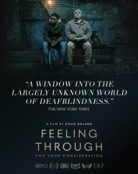

From July 12-23, 2021

**Registration Deadline**: June 30, 2021

###### Register [here!](https://docs.google.com/forms/d/1PwzAYPqbkhkmUwwtTTvyDJmI6G00y82iLfza2wUR9fM/viewform?edit_requested=true)

**Questions?**

[leadership.pipeline@gallaudet.edu](mailto:leadership.pipeline@gallaudet.edu)



**Public Listening Sessions: HST**

**What is HST?** This m eans **Human Service Transportation**—non-emergency

medical transportation for some members of:

* *MassHealth*
* Department of Developmental Services (DDS)
* Department of Public Health (DPH)
* Department of Mental Health (DMH)
* Massachusetts Rehabilitation Commission (MRC)
* Massachusetts Commission for the Blind (MCB)

**EX**: transportation for: m edical, dental, m ental health, or substance use disorder appointments; and to/from Day Habilitation programs.

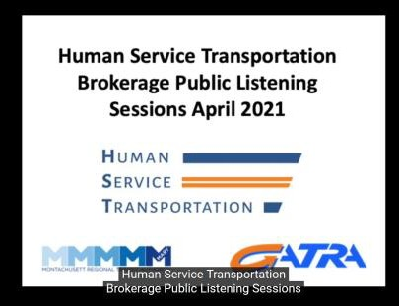

###### What will happen at the Listening Sessions?

Learn about the changes that will start July 1, 2021. Meet the new Brokers, ask them questions, ***and share your comments, suggestions and feedback.***

**See the website:** [**https://www.mass.gov/hstnews**](https://www.mass.gov/hstnews) **If you use MART, BRTA, CATA, or FRTA now -**

**Watch the VLOG:** [**here.**](https://youtu.be/1bT5e4jVj10)

**OR live in Western Mass, Central Mass, Metro Boston, or Northeastern Mass —join**

###### HST and MART at one of these meetings:

**Monday, April 26, 10am-noon**

**Wednesday, April 28, 6-8pm**

[**Zoom link**](https://us02web.zoom.us/j/84826717604?pwd=eGxZbC9EcDlIclc2YjZsbzFESGt4UT09&success)

[**Zoom link**](https://us02web.zoom.us/j/87302300281?pwd=NktPcUZnV3d0NjlOcW4vSVhTckY3UT09&success)

**Phone access,** dial 646 -558-8656

and use Meeting ID 848 2671 7604

Phone access, dial 646-558-8656 and use Meeting ID 873 0230 0281

**One-tap mobile** +16465588656,

84826717604#

**One-tap mobile** +16465588656,

87302300281#

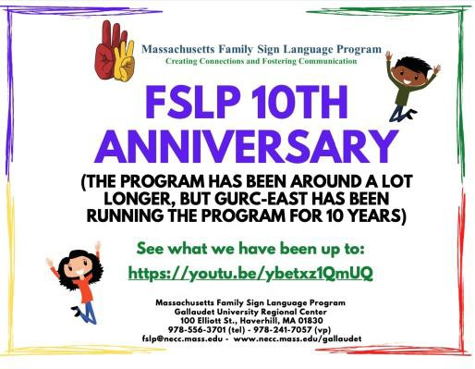**See what we have been up to:** [**https://youtu.be/ybetxz1QmUQ**](https://youtu.be/ybetxz1QmUQ)

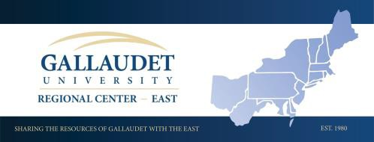

<https://www.necc.mass.edu/gallaudet/>

## Spring Cleaning

###### Budget your Time!



How much time do you have to clean? Pick a space to clean in that time.

###### Use the Right Tools!



Mop, all purpose cleaner, scrub brushes, lint roller, garbage bags, and more...

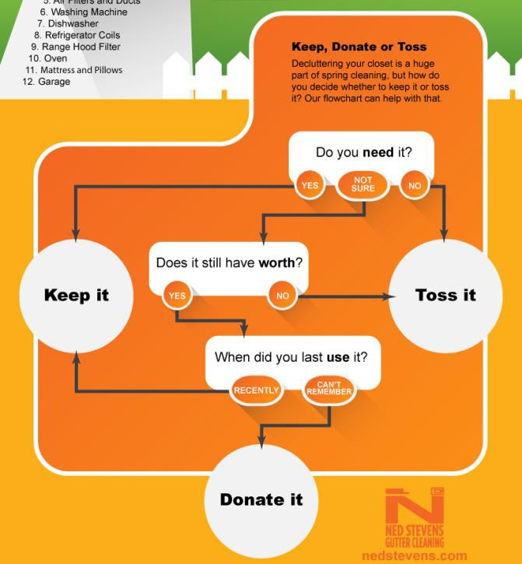

###### Make a Plan!

Use checklists to stay focused and on track.



###### Make a Cleaning Caddy!



Put all the cleaning things you need in a bucket—grab it and start cleaning.

###### Let Fresh Air In!



Open your windows on warm, sunny days. Fresh air comes in and stale air goes out.

# Keep, Donate or Toss?

###### What do I keep or get rid of when I’m spring cleaning?

Use this to help you decide!



###### Clean from Top to Bottom!

Don’t clean the same area twice—clean from top to bottom and from one side to another.

|  |  |
| --- | --- |
| **DHILS Dea** | **f Skills Trainer (P/T 20 hours)**  Provide Independent Living skills training, peer counseling, resources and advocacy to Deaf consumers.   * Part-time – 20 hours. * Fluent in ASL (required).   See the full job description and requirements [here.](https://www.indeed.com/jobs?q=Deaf%20Skills%20Trainer&l=Worcester%2C%20MA&vjk=799a32160e3e08d0)  **Questions? Contact Deb Olson at:** [**dolson@centerlw.org**](mailto:dolson@centerlw.org) |

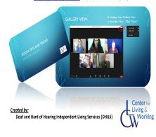***Zoom* Guide**

###### CLW DHILS made a guide for using *Zoom*. Step-by-step instructions and pictures show how to:

* + **Download the *Zoom* app**

###### Join/Leave a meeting

* + **Gallery View vs. Speaker View**

###### Pin a screen

**WANT A COPY? Contact Denise Paro at:** [**dparo@centerlw.org**](mailto:dparo@centerlw.org) **or 508-556-1600 (VP)**

***NOTE: let us know which one(s) you want! (Computer/Cell Phone/iPad)***

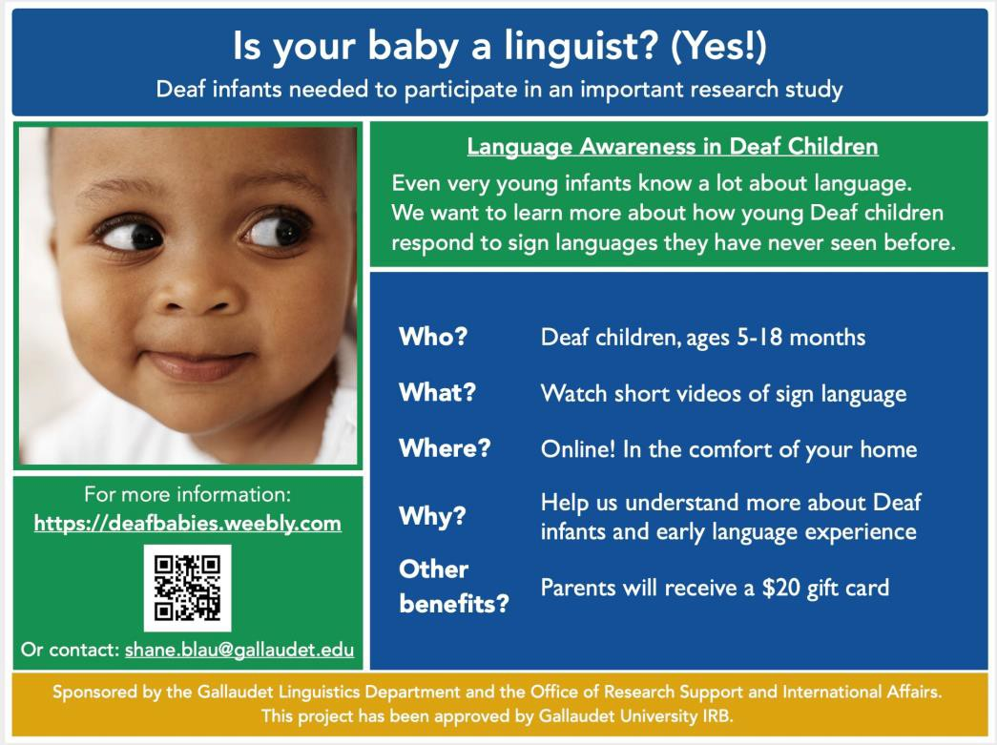

[**https://deafbabies.weebly.com**](https://deafbabies.weebly.com/)

**COVID-19 Resources/Data**

***We will add more sites as needed.***

|  |  |
| --- | --- |
| **Vaccine Information** | <https://www.mass.gov/covid-19-vaccine> |
| **Vaccine Appointments** | <https://vaxfinder.mass.gov/> |
| **Vaccine Appointments for 75+** | [www.mass.gov/info-details/covid-19-vaccinations-for-people-ages-75-and-older](http://www.mass.gov/info-details/covid-19-vaccinations-for-people-ages-75-and-older) |
| **COVID-19 Testing** | [www.mass.gov/covid-19-testing](https://www.mass.gov/covid-19-testing) |
| **US COVID-19 Cases and Deaths**  ***by State*** | <https://covid.cdc.gov/covid-data-tracker/#cases_casesper100klast7days> |
| **COVID-19 Variant in the US** | <https://www.cdc.gov/coronavirus/2019-ncov/transmission/variant-cases.html> |
| **MA COVID-19 town-by-town map** | [https://www.wcvb.com/article/massachusetts-coronavirus-covid-19-community-](http://www.wcvb.com/article/massachusetts-coronavirus-covid-19-community-spread-risk-map-color-coded/33646711) [spread-risk-map-color-coded/33646711](http://www.wcvb.com/article/massachusetts-coronavirus-covid-19-community-spread-risk-map-color-coded/33646711) |
| **MA Travel Order** | <https://www.mass.gov/info-details/covid-19-travel-order#lower-risk-states> |
| **MA Response Reporting** | <https://www.mass.gov/info-details/covid-19-response-reporting> |
| **MA *Stop the Spread*** | <https://www.mass.gov/info-details/stop-the-spread>  ASL Version: <https://www.facebook.com/massgov/videos/434334580929189/> |
| **Re-Opening MA** | [https://www.mass.gov/info-details/covid-19-updates-and-information#reopening-](https://www.mass.gov/info-details/covid-19-updates-and-information#reopening-massachusetts-) [massachusetts-](https://www.mass.gov/info-details/covid-19-updates-and-information#reopening-massachusetts-) |
| **Governor Press Conferences** | Watch here: <https://www.mass.gov/governor-updates>  Press Releases: <https://www.mass.gov/lists/press-releases-related-to-covid-19> |

NOTE*:* See separate *SE Resources* page for more information or contact your Skills Trainer with questions.

## Questions about this Newsletter?

###### Need a website address from your printed newsletter? Contact your Skills Trainer!

|  |  |  |
| --- | --- | --- |
| **Joan Philip** | *DHILS Director* | 508-762-1165 (VP) |
| **VACANT** | *Deaf Skills Trainer* | 508-762-1350 (VP) |
| **Denise Paro** | *Administrative Assistant* | 508-556-1600 (VP) |
| **Ellen Perkins** | *Hard of Hearing Skills Trainer* | 508-502-7576 (Voice); 508-762-1354 (VP) |
| **Joy Spurlin** | *Assistant Manager/Skills Trainer* | 508-762-1166 (VP) |
| **Justina Bailey** | *Deaf Skills Trainer* | 508-762-1021 (VP) |
| **Kim White** | *Staff Interpreter* | 508-755-1042 x5042; 508-283-1036 (VP) |

**Volume 34 Page 9**



**April 9, 2021 at 11:00 AM**

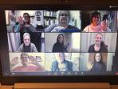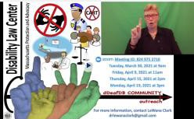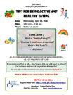

**April 15, 2021 at 2:00 PM**

**April 19, 2021 at 3:00 pm**

**April 9 — 10, 2021**

**Denied Accommodations?**

Have you or someone you know had problems getting access to a sign language interpreter or CART services from doctor's offices, hospitals, courts, police departments, or other service providers? Have you been denied other accommodations?

**Zoom Meeting ID: 824 975 2710**

**Please join a scheduled ZOOM meeting *or***

**Email LeWana at:** [**drlewanaclark@gmail.com**](mailto:drlewanaclark@gmail.com)

**2021 DEN Conference: Innovate & Adapt**

***Deaf Entrepreneurship Network***

***On Zoom***

**Registration:** [**www.goden.org/2021virtualden**](https://www.goden.org/2021virtualden)

**DHILS Consumer Deaf Zoom Chat**

##### Second Tuesday of the month!

**1:00 — 2:00 PM**

**JOIN US!**

**April 13, 2021**

**May 11, 2021**

**June 8, 2021**

**RSVP TO Denise Paro** at:

508-508-556-1600 or

[**DParo@CenterLW.org**](mailto:DParo@CenterLW.org)

**April 14, 2021**

**1:00 - 3:00 PM**

**Watch a VLOG here:** [**https://youtu.be/OBdXcnYlhBo**](https://youtu.be/OBdXcnYlhBo)

**Tips for Being Active & Healthy Eating**

##### See flier on page 13

**April 21, 2021**

**May 5, 2021**

##### First and third Wednesday of the month

**10:00 AM — 12:00 PM**

**April 22, 2021**

**10:00 AM — 2:00 PM**

**Virtual Housing Workshop**

***Boston Center for Independent Living*** (BCIL)’s workshop will teach you

about affordable housing options in your area and how to apply.

##### Register [here.](http://bostoncil.org/event/housing-workshop-3/all/)

**Salute to Patriots Virtual Job Fair**

##### *First hour for Military Service Members and Veterans

**REGISTRATION DEADLINE: Tuesday, 4/20/21**

**Register here:** [**https://masshirecentralcc.com/event/salute-to-**](https://masshirecentralcc.com/event/salute-to-patriots-virtual-job-fair/)[**patriots-virtual-job-fair/**](https://masshirecentralcc.com/event/salute-to-patriots-virtual-job-fair/)

**Page 10 *What’s Up* CLW DHILS - Special Edition**

**April 23, 2021**

**8:00 PM**

**April 28, 2021**

**1:00 — 3:00 PM**

**MSAD Virtual ASL Variety Show**

Come meet Deaf, Hard of Hearing, and DeafBlind local performers! See their stories, learn about their culture, victories and struggles.

ASL poems, jokes, stories, artwork and more!

**Admission is FREE.**

**Zoom Meeting ID: 458 765 5196; Passcode: MSAD Website:** [**https://massdeaf.org/**](https://massdeaf.org/)

**How to Avoid Internet Scams**

##### See flier on page 14

**May — June 2021**

##### First Wednesday of the month

**1:00 — 2:30 PM**

**Healthy Relationship Support Group on Zoom May 5**: Safety Planning

**June 9**: How to be an Ally/Self-care

**RSVP REQUIRED**

**Contact Denise Paro** at: 508-508-556-1600 or

[**DParo@CenterLW.org**](mailto:DParo@CenterLW.org)

**May 19, 2021**

**1:00 — 2:30 PM**

**June 24—26, 2021**

**Watch a VLOG here:** [**https://youtu.be/H8qhsxZoKZk**](https://youtu.be/H8qhsxZoKZk)

**Understanding Health Care Proxy & Living Wills**

**Learn**: What is a Health Care Proxy? What is a Living Will? Why would I need

these? How do I make one?

##### See flier on page 15

**Save-the date: HLAA Virtual Convention 2021 HLAA 2021 Convention is going virtual!**

**Educational workshops, HLAA exhibitors, and networking opportunities.** [**https://www.hearingloss.org/programs-events/convention/**](https://www.hearingloss.org/programs-events/convention/)

**July 19 — 30, 2021**

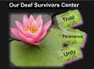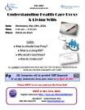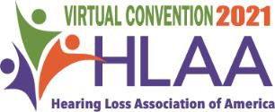

**AMAZON JOBS—Virtual Information Sessions & Recruitments Every Thursday in April from 12:30pm – 1:15pm!**

**Register** [**HERE.**](https://www.eventbrite.com/e/amazon-is-hiring-virtual-info-session-april-ma-warehouse-jobs-tickets-147608518051)



**2021 Annual Conference on Independent Living Keep checking for updates!**

[**https://ncil.org/2021-annual-conference-on-independent-living/**](https://ncil.org/2021-annual-conference-on-independent-living/)

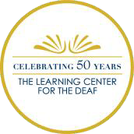



## Parent/Kids Events

|  |  |  |  |
| --- | --- | --- | --- |
| **April 10, 2021**  **10:00 AM** | | | **Shared Reading Saturday — *Maisy’s Bedtime***  **Facebook Live:** [**https://www.facebook.com/SharedReadingSaturday**](https://www.facebook.com/SharedReadingSaturday)  **YouTube Live:** [**http://www.youtube.com/channel/UCih3jEwAdEllywpDLbJTU-A**](http://www.youtube.com/channel/UCih3jEwAdEllywpDLbJTU-A) |
| **April 10, 2021**  **6:45 PM** | | | ***The Learning Center for the Deaf’s* 50th Anniversary Virtual CELEBRATION**  *Streamed Live at no charge on* Facebook *and* YouTube  **See more information at:** [**www.tlcdeaf.org/50th**](http://www.tlcdeaf.org/50th) |
| **Second Tuesday of the month 1:00 — 2:00 PM** | | | ***Mental Health Advocacy Program for Kids***  **Learn more about *MHAP for Kids*** [**here.**](https://www.healthlawadvocates.org/initiatives/mhapforkids)  **April 13: Delinquency Proceedings/CRA Law May 11: C&P Proceedings/CRA Law**  **June 8: School Discipline Rights**  **Register by emailing Michaela:** [**mmacquarrie@hla-inc.org**](mailto:mmacquarrie@hla-inc.org) |
| **Sessions start in April 2021** | | | **Leadership Experience and Adventure Program (LEAP)**  Deaf/HH high school students (ages 14-18) who use spoken language. Online program helps teens gain confidence in virtual environments, develop leadership skills, and connect with new friends.  Applications accepted until June 10, 2021 with sessions starting in April. More information,: [www.agbellleap.com](http://www.agbellleap.com/) |
|  | | | **Boston Children’s Hospital Deaf & Hard of Hearing Program** Visit Facebook for the latest events: [**https://www.facebook.com/BostonChildrensDHHP**](https://www.facebook.com/BostonChildrensDHHP) |
|  |  |  | **Worcester Family Partnership**  **Click** [**here**](https://www.facebook.com/worcesterschools/) **to see their Facebook.** |



**Contact Us!**

**Center for Living & Working, Inc.**

***Deaf and Hard of Hearing Independent Living Services Departme*nt**

Videophone: 508-762-1164

Voice/TTY: 508-755-1003

[**www.CenterLW.org**](http://www.CenterLW.org/)

**Like us on Facebook!**

<https://www.facebook.com/CenterForLivingAndWorking>



**CLW’s DHILS**

***Invites you to join us on Zoom for***

 



Tips for Being Active *and*

Healthy Eating

**Date: ** **Time:** 1:00 pm — 2:30 pm

 

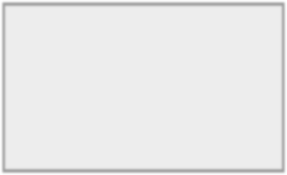

COME LEARN :

* What is “Healthy Eating”?
* What can I do at home to exercise?
  + What is “My Plate”?
    - *And more!*



**ALL CURRENT CONSUMERS WHO RSVP AND STAY FOR THE WHOLE PRESENTATION VIA ZOOM, WILL RECEIVE A WALMART E-GIFT CARD!**

**Presentation will be in ASL**—**Don’t know ASL but still want to attend?**

***Let us know and we will request an interpreter!***

*For any other Communication Access, please contact us* ***by April 1st****.*

#### Please RSVP so we can send you the Zoom link!



**RSVP BY APRIL 12TH**

**Register online here:** [**https://forms.gle/BnXzGEV9vUAS4Kfz5**](https://forms.gle/BnXzGEV9vUAS4Kfz5)

***Questions?* Contact Denise Paro**

**508-762-1164 (VP) Email:** [**dparo@centerlw.org**](mailto:dparo@centerlw.org)

**CLW’s DHILS and the Attorney General Office**

### Invite you to join us for

**How to Avoid Internet Scams**

**Date: ** **Time:** 1:00 pm — 3:00 pm



**Place:**

LEARN:

* + - Risks of Social Media scams
      * Dating App scams
        + Identity Theft
      * Red flags to notice
        + *And more!*



**ALL CURRENT CONSUMERS WHO RSVP AND STAY FOR THE WHOLE PRESENTATION VIA ZOOM, WILL RECEIVE A WALMART E-GIFT CARD!**

#### ASL Interpreters and CDIs will be provided! CART requested.

***For any other Communication Access, please contact us by April 14th!***

#### Please REGISTER so we can send you the Zoom link!

**REGISTER BY APRIL 26TH:**

**ONLINE: *OR***

[**https://forms.gle/rm4VxzL9vEKx8Lgx8**](https://forms.gle/rm4VxzL9vEKx8Lgx8)

**CONTACT DENISE PARO:**

#### 508-762-1164 (VP)

**Email:** [**dparo@centerlw.org**](mailto:dparo@centerlw.org)



**CLW’s DHILS**

***Invites you to join us for***

Understanding Health Care Proxy & Living Wills

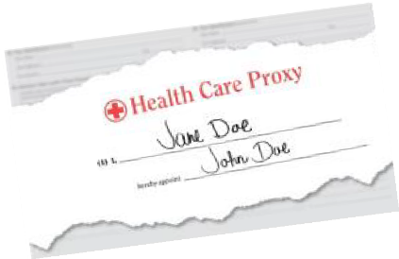

**Date: **

**Time:** 1:00 pm — 2:30 pm

LEARN:

* What is a Health Care Proxy?
  + What is a Living Will?
* Why would I need these?
  + How do I make one?

**ALL CURRENT CONSUMERS WHO RSVP AND STAY FOR THE WHOLE PRESENTATION VIA ZOOM, WILL RECEIVE A WALMART E-GIFT CARD!**



**ASL Interpreters will be provided**! **CART Requested!**

*For any* other *Communication Access, please contact us* ***by April 30, 2021.***

#### Please RSVP so we can send you the Zoom link!



**RSVP BY MAY 17TH, 2021**

**Register online here:** [**https://forms.gle/KsoBRp8x2sGRfzjJ6**](https://forms.gle/KsoBRp8x2sGRfzjJ6)

***Questions?* Contact Denise Paro 508-762-1164 (VP) Email:** [**dparo@centerlw.org**](mailto:dparo@centerlw.org)

