INDOOR AIR QUALITY ASSESSMENT

Miscoe Hill School
148 North Avenue
Mendon, Massachusetts



Prepared by:
Massachusetts Department of Public Health
Bureau of Environmental Health
Indoor Air Quality Program
January 2014

Background/Introduction
At the request of a parent, the Massachusetts Department of Public Health (MDPH), Bureau of Environmental Health (BEH) provided assistance and consultation regarding indoor air quality (IAQ) at the Miscoe Hill School (MHS) located at 148 North Avenue, Mendon, Massachusetts. On November 15, 2013, Cory Holmes, Environmental Analyst/Regional Inspector in BEH’s IAQ Program visited the school to conduct an assessment. The assessment was coordinated through the Mendon Board of Health (BOH). Leonard Izzo, agent for the Mendon BOH, and MHS Principal Ann Meyer accompanied Mr. Holmes during the assessment.
The BEH/IAQ Program had previously visited the building in August of 2011 to investigate mold/water damage concerns. A report was issued based on observations made at that time, with recommendations to improve air quality (MDPH, 2011). Actions taken on recommendations made in that report are listed in Appendix A.

Methods
Air tests for carbon monoxide, carbon dioxide, temperature and relative humidity were conducted with the TSI, Q-Trak, IAQ Monitor, Model 7565. Air tests for airborne particle matter with a diameter less than 2.5 micrometers were taken with the TSI, DUSTTRAK™ Aerosol Monitor Model 8520. BEH/IAQ staff also performed visual inspection of building materials for water damage and/or microbial growth.

Results
The school houses approximately 850 students in grades 5 through 8 with a staff of approximately 120. Tests were taken during normal operations at the school. Results appear in Table 1.

Discussion

Ventilation
It can be seen from Table 1 that carbon dioxide levels were above 800 parts per million (ppm) in twelve of twenty-five areas, indicating a lack of air exchange in approximately half the areas examined. Fresh air in the majority of classrooms is supplied by unit ventilators (univents) (Picture 1). A univent is designed to draw air from outdoors through a fresh air intake located on the exterior wall of the building (Picture 2). Return air is drawn through an air intake located at the base of each unit where fresh and return air are mixed, filtered, heated or cooled and provided to classrooms through an air diffuser located in the top of the unit (Figure 1). Univent return vents (along front/bottom) were found obstructed with classroom items in a few areas at the time of the assessment (Table 1). In order for univents to provide fresh air as designed, diffusers/returns must remain free of obstructions.
Some areas (e.g., gymnasium) are ventilated by air handling units (AHUs) located on the roof or ceiling. The gymnasium AHUs were found deactivated at the time of assessment; therefore there was no means of mechanical air exchange.
Exhaust ventilation in most classrooms is provided by wall-mounted vents. In a number of cases exhaust vents were not drawing air and/or were found obstructed (Table 1; Picture 3). As with univents, in order to function properly, exhaust vents must be activated and allowed to operate while rooms are occupied. Without adequate supply and exhaust ventilation, excess heat and environmental pollutants can build up and lead to indoor air/comfort complaints.
To maximize air exchange, the MDPH recommends that both supply and exhaust ventilation operate continuously during periods of occupancy. In order to have proper ventilation with a mechanical supply and exhaust system, the systems must be balanced to provide an adequate amount of fresh air to the interior of a room while removing stale air from the room. It is recommended that heating, ventilating and air conditioning (HVAC) systems be re-balanced every five years to ensure adequate air systems function (SMACNA, 1994). The date of the last balancing of these systems was not available at the time of assessment.
Minimum design ventilation rates are mandated by the Massachusetts State Building Code (MSBC). Until 2011, the minimum ventilation rate in Massachusetts was higher for both occupied office spaces and general classrooms, with similar requirements for other occupied spaces (BOCA, 1993). The current version of the MSBC, promulgated in 2011 by the State Board of Building Regulations and Standards (SBBRS), adopted the 2009 International Mechanical Code (IMC) to set minimum ventilation rates. Please note that the MSBC is a minimum standard that is not health-based. At lower rates of cubic feet per minute (cfm) per occupant of fresh air, carbon dioxide levels would be expected to rise significantly. A ventilation rate of 20 cfm per occupant of fresh air provides optimal air exchange resulting in carbon dioxide levels at or below 800 ppm in the indoor environment in each area measured. MDPH recommends that carbon dioxide levels be maintained at 800 ppm or below. This is because most environmental and occupational health scientists involved with research on IAQ and health effects have documented significant increases in indoor air quality complaints and/or health effects when carbon dioxide levels rise above the MDPH guidelines of 800 ppm for schools, office buildings and other occupied spaces (Sundell et al., 2011). The ventilation must be on at all times that the room is occupied. Providing adequate fresh air ventilation with open windows and maintaining the temperature in the comfort range during the cold weather season is impractical. Mechanical ventilation is usually required to provide adequate fresh air ventilation.
Carbon dioxide is not a problem in and of itself. It is used as an indicator of the adequacy of the fresh air ventilation. As carbon dioxide levels rise, it indicates that the ventilating system is malfunctioning or the design occupancy of the room is being exceeded. When this happens, a buildup of common indoor air pollutants can occur, leading to discomfort or health complaints. The Occupational Safety and Health Administration (OSHA) standard for carbon dioxide is 5,000 parts per million parts of air (ppm). Workers may be exposed to this level for 40 hours/week, based on a time-weighted average (OSHA, 1997).
The MDPH uses a guideline of 800 ppm for publicly occupied buildings. A guideline of 600 ppm or less is preferred in schools due to the fact that the majority of occupants are young and considered to be a more sensitive population in the evaluation of environmental health status. Inadequate ventilation and/or elevated temperatures are major causes of complaints such as respiratory, eye, nose and throat irritation, lethargy and headaches. For more information concerning carbon dioxide, consult Appendix B.
Indoor temperature measurements ranged on the day of assessment from 70 °F to 78 °F (Table 1), which were within the MDPH recommended comfort range. The MDPH recommends that indoor air temperatures be maintained in a range of 70 °F to 78 °F in order to provide for the comfort of building occupants. In many cases concerning indoor air quality, fluctuations of temperature in occupied spaces are typically experienced, even in a building with an adequate fresh air supply. In addition, it is difficult to control temperature and maintain comfort without operating the ventilation equipment as designed (e.g., univents/exhaust vents deactivated/obstructed).
The relative humidity measured in areas surveyed in the building ranged from 12 to 29 percent, which were below the MDPH recommended comfort range (Table 1). The MDPH recommends a comfort range of 40 to 60 percent for indoor air relative humidity. Relative humidity levels in the building would be expected to drop during the winter months due to heating. The sensation of dryness and irritation is common in a low relative humidity environment. Low relative humidity is a very common problem during the heating season in the northeast part of the United States.

Microbial/Moisture Concerns
Water-damaged ceiling tiles were observed in a few areas (Table 1; Picture 4); these were reportedly from previous leaks. Water-damaged ceiling tiles can provide a source of mold and should be replaced after a water leak is discovered and repaired.
Open seams between the sink countertop and backsplash were observed in several rooms (Table 1; Picture 5). If seams are not watertight, water can penetrate the seam, causing water damage. Water penetration and chronic exposure of porous and wood-based materials can cause these materials to swell, show signs of water damage and lead to potential mold growth.
The US Environmental Protection Agency (US EPA) and the American Conference of Governmental Industrial Hygienists (ACGIH) recommend that porous materials (e.g., carpeting, gypsum wallboard) be dried with fans and heating within 24 to 48 hours of becoming wet (US EPA, 2001; ACGIH, 1989). If not dried within this time frame, mold growth may occur. Once mold has colonized porous materials, they are difficult to clean and should be removed/discarded.
Plants were noted in some classrooms (Table 1). Plants can be a source of pollen and mold which can be respiratory irritants to some individuals. Plants should be properly maintained and equipped with drip pans and should be located away from univents to prevent the aerosolization of dirt, pollen and mold. Aquariums were observed in a few classrooms (Table 1; Picture 6). Aquariums should be properly maintained to prevent microbial/algal growth, which can emit unpleasant odors.
Dehumidifiers were seen in a number of areas that are reportedly used as needed during hot, humid weather (Table 1). Occupants and/or maintenance staff should periodically examine, clean and disinfect these units as per the manufacturer’s instructions to prevent mold/bacterial growth and associated odors.

Other IAQ Evaluations
Indoor air quality can be negatively influenced by the presence of respiratory irritants, such as products of combustion. The process of combustion produces a number of pollutants. Common combustion emissions include carbon monoxide, carbon dioxide, water vapor and smoke (fine airborne particle material). Of these materials, exposure to carbon monoxide and particulate matter with a diameter of 2.5 micrometers (μm) or less (PM2.5) can produce immediate, acute health effects upon exposure. To determine whether combustion products were present in the indoor environment, BEH/IAQ staff obtained measurements for carbon monoxide and PM2.5.

Carbon Monoxide
Carbon monoxide is a by-product of incomplete combustion of organic matter (e.g., gasoline, wood and tobacco). Exposure to carbon monoxide can produce immediate and acute health effects. Several air quality standards have been established to address carbon monoxide and prevent symptoms from exposure to these substances. The MDPH established a corrective action level concerning carbon monoxide in ice skating rinks that use fossil-fueled ice resurfacing equipment. If an operator of an indoor ice rink measures a carbon monoxide level over 30 ppm, taken 20 minutes after resurfacing within a rink, that operator must take actions to reduce carbon monoxide levels (MDPH, 1997).
The American Society of Heating Refrigeration and Air-Conditioning Engineers (ASHRAE) has adopted the National Ambient Air Quality Standards (NAAQS) as one set of criteria for assessing indoor air quality and monitoring of fresh air introduced by HVAC systems (ASHRAE, 1989). The NAAQS are standards established by the US EPA to protect the public health from six criteria pollutants, including carbon monoxide and particulate matter (US EPA, 2006). As recommended by ASHRAE, pollutant levels of fresh air introduced to a building should not exceed the NAAQS levels (ASHRAE, 1989). The NAAQS were adopted by reference in the Building Officials & Code Administrators (BOCA) National Mechanical Code of 1993 (BOCA, 1993), which is now an HVAC standard included in the Massachusetts State Building Code (SBBRS, 2011). According to the NAAQS, carbon monoxide levels in outdoor air should not exceed 9 ppm in an eight-hour average (US EPA, 2006).
Carbon monoxide should not be present in a typical, indoor environment. If it is present, indoor carbon monoxide levels should be less than or equal to outdoor levels. On the day of assessment, outdoor carbon monoxide concentrations were non-detect (ND) (Table 1). No measurable levels of carbon monoxide were detected inside the building (Table 1).

Particulate Matter
The US EPA has established NAAQS limits for exposure to particulate matter. Particulate matter includes airborne solids that can be irritating to the eyes, nose and throat. The NAAQS originally established exposure limits to PM with a diameter of 10 μm or less (PM10). In 1997, US EPA established a more protective standard for fine airborne particulate matter with a diameter of 2.5 μm or less (PM2.5). This more stringent PM2.5 standard requires outdoor air particle levels be maintained below 35 μg/m³ over a 24-hour average (US EPA, 2006). Although both the ASHRAE standard and BOCA Code adopted the PM10 standard for evaluating air quality, MDPH uses the more protective PM2.5 standard for evaluating airborne PM concentrations in the indoor environment.
Outdoor PM2.5 concentrations were measured at 1 to 5 μg/m³ (Table 1). PM2.5 levels measured in the school were between 3 to 10 μg/m³ (Table 1), which were all below the NAAQS PM2.5 level of 35 μg/m³. Frequently, indoor air levels of particulates (including PM2.5) can be at higher levels than those measured outdoors. A number of activities that occur indoors and/or mechanical devices can generate particulate during normal operations. Sources of indoor airborne particulates may include but are not limited to particles generated during the operation of fan belts in the HVAC system, use of stoves and/or microwave ovens in kitchen areas; use of photocopiers, fax machines and computer printing devices; operation of an ordinary vacuum cleaner and heavy foot traffic indoors.

Volatile Organic Compounds
Indoor air concentrations can be greatly impacted by the use of products containing volatile organic compounds (VOCs). VOCs are carbon-containing substances that have the ability to evaporate at room temperature. Frequently, exposure to low levels of total VOCs (TVOCs) may produce eye, nose, throat and/or respiratory irritation in some sensitive individuals. For example, chemicals evaporating from a paint can stored at room temperature would most likely contain VOCs. In an effort to identify materials that can potentially increase indoor VOC concentrations, BEH/IAQ staff examined rooms for products containing these respiratory irritants.
Classrooms contained dry erase boards and related materials. Materials such as dry erase markers and dry erase board cleaners may contain VOCs, such as methyl isobutyl ketone, n-butyl acetate and butyl-cellusolve (Sanford, 1999), which can be irritating to the eyes, nose and throat. Accumulated debris was also observed in dry erase board trays (Table 1).
In an effort to reduce noise from sliding desks/chairs, tennis balls had been sliced open and placed on the base of legs (Table 1). Tennis balls are made of a number of materials that are a source of respiratory irritants. Constant wearing of tennis balls can produce fibers and cause VOCs to off-gas. Tennis balls are made with a natural rubber latex bladder, which becomes abraded when used as a chair leg pad. Use of tennis balls in this manner may introduce latex dust into the school environment. Some individuals are highly allergic to latex (e.g., spina bifida patients) (SBAA, 2001). It is recommended that the use of materials containing latex be limited in buildings to reduce the likelihood of symptoms in sensitive individuals (NIOSH, 1997).

Other Conditions
Other conditions that can affect IAQ were observed during the assessment. In many classrooms, a large number of items were on floors, windowsills, tabletops, counters, bookcases and desks, which provide a source for dusts to accumulate. These items (e.g., papers, folders, boxes) make it difficult for custodial staff to clean. Items should be relocated and/or be cleaned periodically to avoid excessive dust build up. In addition, dust and debris can accumulate on flat surfaces (e.g., desktops, shelving and carpets) in occupied areas and subsequently be re-aerosolized causing further irritation.
A number of univents, air diffusers, exhaust/return vents and personal fans were found to have accumulated dust/debris (Table 1; Pictures 7 and 8). If exhaust vents are not functioning, backdrafting can occur, which can re-aerosolize accumulated dust particles. Re-activated univents, supply vents and fans can also aerosolize dust accumulated on vents/fan blades.
Broken/dislodged ceiling tiles were seen in a few classrooms. Damage or movement of ceiling tiles may create pathways for dust/debris in the ceiling plenum into occupied areas, which may serve as an eye and/or respiratory irritant.

Conclusions/Recommendations
Major repairs such as roof replacement, clean-up/removal of water-damaged/mold colonized materials and the implementation of previous MDPH recommendation (Appendix A) have improved indoor environmental conditions in the building. In view of the findings at the time of the assessment, the following recommendations are made to further improve IAQ:
- Operate all ventilation systems (supply and exhaust) throughout the building (e.g., gym, cafeteria, classrooms) continuously during periods of occupancy to maximize air exchange. If more airflow is needed, operate univent fans in “high” setting.
- Remove blockages/items from the surface of univent air diffusers and return vents (along front/bottom).
- Remove blockages/items from exhaust vents to ensure adequate airflow.
- Ensure classroom doors are closed for proper operation of mechanical ventilation system/air exchange.
- Consider adopting a balancing schedule of every 5 years for all mechanical ventilation systems, as recommended by ventilation industrial standards (SMACNA, 1994).
- Use openable windows in conjunction with classroom exhaust vents to facilitate air exchange. Care should be taken to ensure windows are properly closed at night and on weekends to avoid the freezing of pipes and potential flooding.
- For buildings in New England, periods of low relative humidity during the winter are often unavoidable. Therefore, scrupulous cleaning practices should be adopted to minimize common indoor air contaminants whose irritant effects can be enhanced when the relative humidity is low. To control dusts, a high efficiency particulate arrestance (HEPA) filter equipped vacuum cleaner in conjunction with wet wiping of all surfaces is recommended. Avoid the use of feather dusters. Drinking water during the day can help ease some symptoms associated with a dry environment (throat and sinus irritations).
- Ensure roof/plumbing leaks are repaired and replace any remaining water-damaged ceiling tiles. Examine the area above these tiles for mold growth. Disinfect areas of water leaks with an appropriate antimicrobial, as needed.
- Seal breaches, seams, and spaces between sink countertops and backsplashes to prevent water damage.
- Ensure dehumidifiers are cleaned/maintained as per the manufacturer’s instructions to prevent mold/bacterial growth.
- Ensure indoor plants are equipped with drip pans. Examine drip pans periodically for mold growth and disinfect with an appropriate antimicrobial, as needed. Move plants away from the air stream of mechanical ventilation equipment.
- Clean and maintain aquariums and terrariums to prevent bacterial/microbial growth and associated odors.
- Replace broken ceiling tiles.
- Relocate or consider reducing the amount of materials stored in classrooms to allow for more thorough cleaning of classrooms. Clean items regularly with a wet cloth or sponge to prevent excessive dust build-up.
- Clean univents, personal fans, air diffusers and exhaust/return vents periodically of accumulated dust/debris.
- Clean chalkboards and dry erase board trays regularly to avoid the build-up of particulates.
- Replace tennis balls on chair legs with latex-free glides.
- Continue with long-term plans (as described in Appendix A) to replace carpeting that is past its useful lifespan, as funds become available. Consider replacing carpeting with a non-porous surface such as vinyl tile.
- Clean carpeting annually or semi-annually in soiled high traffic areas as per the recommendations of the Institute of Inspection, Cleaning and Restoration Certification (IICRC). Copies of the IICRC fact sheet can be downloaded at: http://1.cleancareseminars.net/?page_id=185 (IICRC, 2005).
- Consider adopting the US EPA (2000) document, “Tools for Schools”, as an instrument for maintaining a good indoor air quality environment in the building. This document is available at: http://www.epa.gov/iaq/schools/index.html.
- Refer to resource manual and other related indoor air quality documents located on the MDPH’s website for further building-wide evaluations and advice on maintaining public buildings. These documents are available at: http://mass.gov/dph/iaq.

References
ACGIH. 1989. Guidelines for the Assessment of Bioaerosols in the Indoor Environment. American Conference of Governmental Industrial Hygienists, Cincinnati, OH.
ASHRAE. 1989. Ventilation for Acceptable Indoor Air Quality. American Society of Heating, Refrigeration and Air Conditioning Engineers. ANSI/ASHRAE 62-1989.
BOCA. 1993. The BOCA National Mechanical Code/1993. 8th ed. Building Officials and Code Administrators International, Inc., Country Club Hill, IL.
MDPH. 1997. Requirements to Maintain Air Quality in Indoor Skating Rinks (State Sanitary Code, Chapter XI). 105 CMR 675.000. Massachusetts Department of Public Health, Boston, MA.
MDPH. 2011. Indoor Air Quality Assessment/Mold Investigation, Miscoe Hill School, Mendon, MA. Massachusetts Department of Public Health, Bureau of Environmental Health Assessment, Boston, MA. October 2011.
NIOSH. 1997. NIOSH Alert Preventing Allergic Reactions to Natural Rubber latex in the Workplace. National Institute for Occupational Safety and Health, Atlanta, GA.
OSHA. 1997. Limits for Air Contaminants. Occupational Safety and Health Administration. Code of Federal Regulations. 29 C.F.R 1910.1000 Table Z-1-A.
Sanford. 1999. Material Safety Data Sheet (MSDS No: 198-17). Expo® Dry Erase Markers Bullet, Chisel, and Ultra Fine Tip. Sanford Corporation. Bellwood, IL.
SBAA. 2001. Latex In the Home And Community Updated Spring 2001. Spina Bifida Association of America, Washington, DC.
SBBRS. 2011. Mechanical Ventilation. State Board of Building Regulations and Standards. Code of Massachusetts Regulations, 8th edition. 780 CMR 1209.0
SMACNA. 1994. HVAC Systems Commissioning Manual. 1st ed. Sheet Metal and Air Conditioning Contractors’ National Association, Inc., Chantilly, VA.
Sundell, J., H. Levin, W. W. Nazaroff, W. S. Cain, W. J. Fisk, D. T. Grimsrud, F. Gyntelberg, Y. Li, A. K. Persily, A. C. Pickering, J. M. Samet, J. D. Spengler, S. T. Taylor, and C. J. Weschler. 2011. Ventilation rates and health: multidisciplinary review of the scientific literature. Indoor Air, Volume 21: pp 191–204.
US EPA. 2000. Tools for Schools. Office of Air and Radiation, Office of Radiation and Indoor Air, Indoor Environments Division (6609J). EPA 402-K-95-001, Second Edition. http://www.epa.gov/iaq/schools/tools4s2.html.
US EPA. 2001. Mold Remediation in Schools and Commercial Buildings. US Environmental Protection Agency, Office of Air and Radiation, Indoor Environments Division, Washington, D.C. EPA 402-K-01-001. March 2001.
US EPA. 2006. National Ambient Air Quality Standards (NAAQS). US Environmental Protection Agency, Office of Air Quality Planning and Standards, Washington, DC. http://www.epa.gov/air/criteria.html.
Picture 1
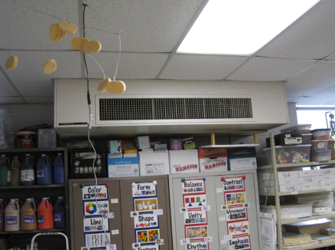
Classroom univent suspended from ceiling
Picture 2
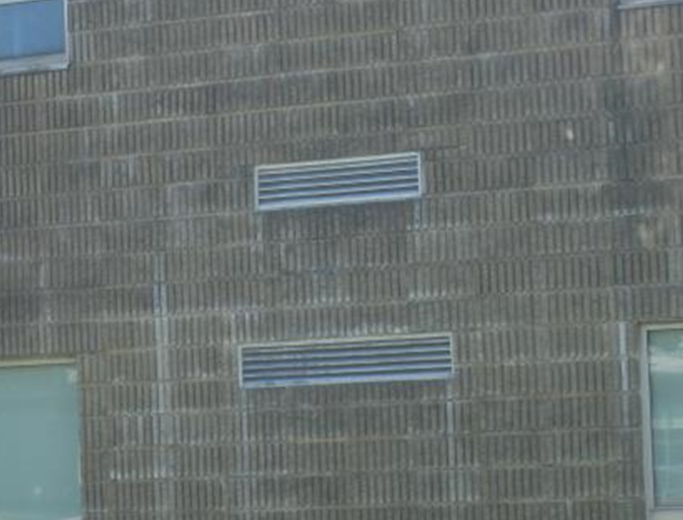
Univent fresh air intakes

Picture 3
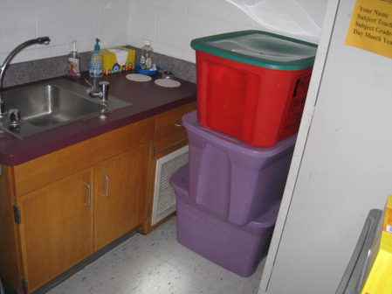
Exhaust vent obstructed by plastic bins
Picture 4
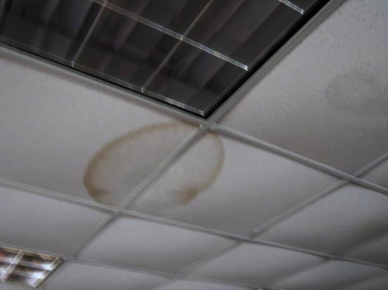
Water-damaged ceiling tiles

Picture 5
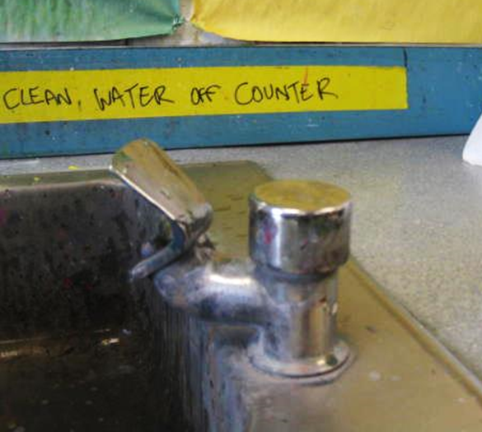
Open seam between sink countertop and backsplash
Picture 6
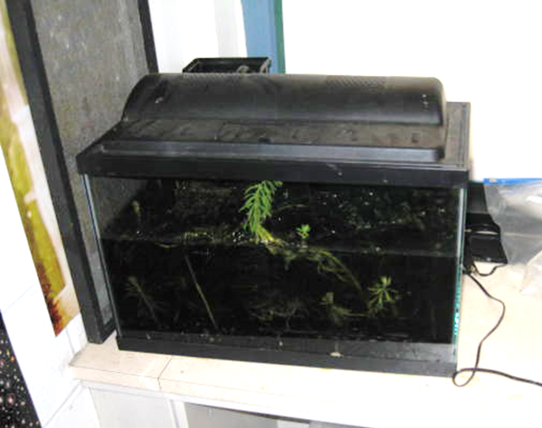
Unplugged aquarium with standing water in classroom

Picture 7
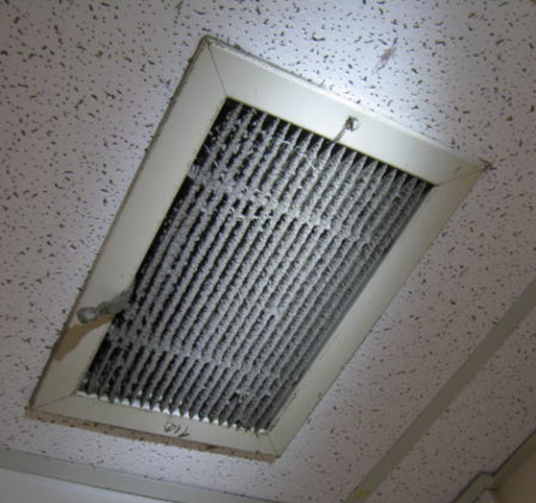
Dust/debris accumulation on exhaust vent

Picture 8
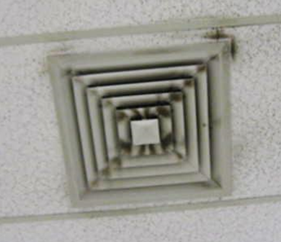
Dust/debris accumulation on supply diffuser
Location | Carbon  Dioxide  (*ppm) | Carbon Monoxide  (ppm) | Temp  (°F) | Relative  Humidity  (%) | PM2.5  (ug/m³) | Occupants  in Room | Windows  Openable | Ventilation |  | Remarks
 |  |  |  |  |  |  |  | Intake | Exhaust | Remarks
Background | 403 | ND | 60 | 15 | 1-5 |  |  |  |  | Scattered clouds, cool
103 | 1009 | ND | 73 | 21 | 6 | 24 | Y | Y | Y
108 | 779 | ND | 76 | 14 | 4 | 24 | Y | Y | Y | Exhaust vent obstructed, DO, PF, dehumidifier-clean filter light “on”
113 Computer Lab | 1828 | ND | 76 | 24 | 4 | 20 | Y | Y | Y
117 Computer Lab | 744 | ND | 77 | 13 | 4 | 22 | Y | Y | Y | 6 WD CT (old leaks)
126 | 981 | ND | 77 | 15 | 5 | 25 | Y | Y | Y | Window open, PF
214 | 451 | ND | 76 | 19 | 3 | 1 | Y | Y | Y | Window open, 23 occupants gone ~20 mins
218 | 440 | ND | 77 | 13 | 4 | 1 | Y | Y | Y | DO, 22 occupants gone ~ 15 mins, PF, plants
220 | 959 | ND | 78 | 14 | 4 | 29 | Y | Y | Y | Exhaust vent obstructed, dry erase particulate in trey, DO
223 | 799 | ND | 78 | 12 | 3 | 3 | Y | Y | Y
229 | 792 | ND | 74 | 14 | 5 | 1 | Y | Y | Y | Exhaust vent obstructed, 20 occupants gone ~5 mins
233 | 946 | ND | 74 | 16 | 4 | 24 | Y | Y | Y | UV obstructed-dusty, PF, space between sink backsplash and countertop
234 | 971 | ND | 75 | 14 | 7 | 27 | Y | Y | Y | Aquariums (3), one was unplugged/standing water, plants, PF
313 Art | 786 | ND | 74 | 16 | 4 | 20 | Y | Y | Y | Window open, dusty return vent on UV, DO, space between sink backsplash and countertop, dehumidifier
317 Art | 1079 | ND | 73 | 19 | 7 | 27 | Y | Y | N | Tennis balls, PF-dusty, return vent of UV obstructed by stored items, space between sink backsplash and countertop
319 | 557 | ND | 72 | 14 | 4 | 0 | Y | Y | Y | DO
431 | 780 | ND | 74 | 17 | 6 | 0 | Y | Y | Y | ~ 25 occupants gone ~ 20 mins, broken CT, dust/debris on exhaust vent
430 | 1833 | ND | 77 | 23 | 6 | 23 | Y | Y | Y | Window open, exhaust off, plants, PF, space between sink backsplash and countertop, birds
433 | 779 | ND | 74 | 16 | 5 | 1 | Y | Y | Y | DO
436 | 1052 | ND | 74 | 17 | 6 | 23 | Y | Y | Y | Window open, PF-dusty, 3 WD CT, plants, exhaust weak
Band Storage Room | 726 | ND | 74 | 15 | 4 | 0 | N | Y | Y | Dust/debris on vents, dehumidifier
Band | 580 | ND | 72 | 15 | 4 | 2 | Y | Y | Y | Dust/debris on vents
Cafeteria | 1056 | ND | 75 | 18 | 5 | 5 | Y | Y | Y | ~200 occupants gone ~ 5 mins, 2 UVs-1 off
Auditorium | 792 | ND | 72 | 24 | 7 | 35-40 | N | Y | Y
Gymnasium | 968 | ND | 70 | 26 | 10 | 17 | N | Y | Y | Supply/exhaust off, ceiling fan on
Nurse | 1125 | ND | 74 | 29 | 4 | 5 | Y | Y | Y

Actions on MDPH Recommendations, Miscoe Hill Middle School,
Mendon, MA

The following is a status report of action(s) taken on MDPH recommendations made in the 2011 MDPH report (in bold) based on reports from school administrative staff, documents, photographs and MDPH staff observations.
- Continue with plans to replace school roof. In the interim, maintenance staff should continue to make minor roof repairs and monitor building materials for water damage.
- Action: The roof was replaced over the summer of 2012
- Remove/replace water-damaged/mold-colonized dropped ceiling tiles. Seal moldy tiles in plastic bags for transport. Examine the area above and around these areas for mold growth. Disinfect areas of water leaks with an appropriate antimicrobial as necessary.
- Action: The majority of ceiling tiles have been replaced.
- Remove/discard water-damaged/mold-colonized items in the “Bowling Alley” storage area. Seal moldy materials in plastic bags for transport. For large items (e.g., tables) cover with plastic sheeting and duct tape for transport.
- Action: Items were removed; the area was cleaned and is currently used for storage of band instruments.
- Once roof repairs are made, remove carpeting in room 224; consider replacing with a non-porous flooring material (e.g., tile).
- Action: Carpeting was removed.
- Clean surface of ceiling panels in room 224 (and any other affected areas) with a vacuum cleaner equipped with a high efficiency particulate arrestance (HEPA) filter using the brush attachment. Once cleaning is complete, seal surface and repaint.
- Action: This action was reportedly completed.
- Ensure classroom furniture and other items are not placed directly against interior walls; allow approximately 2 to 4 inches for airflow.
- Action: Ongoing efforts are made to comply with this action.
- Continue to operate dehumidifiers in below grade areas with portable dehumidifiers as needed during humid, spring/summer months. Ensure dehumidifiers are cleaned and maintained as per the manufacturer’s instructions to prevent standing water and mold growth.
- Action: Ongoing efforts are made to comply with this action.
- The installation of carpeting is generally not recommended in below grade areas (US EPA, 2001). Consider developing a plan for carpet removal in below grade areas as funds/materials become available.
- Action: A plan is reportedly in place to remove these carpets over the next few years as funds become available.
- Operate all ventilation systems throughout the building (e.g., gym, cafeteria, classrooms) continuously during periods of school occupancy to maximize air exchange.
- Action: It was reported that the HVAC system is computerized and that some components are programed to cycle on/off over the course of the day.
- Remove all blockages from univents and exhaust vents to ensure adequate airflow.
- Action: Ongoing efforts are made to comply with this action. More work is needed in this area.

