INDOOR AIR QUALITY ASSESSMENT

Mitchell Elementary School
166 Mount Prospect Street
Bridgewater, Massachusetts

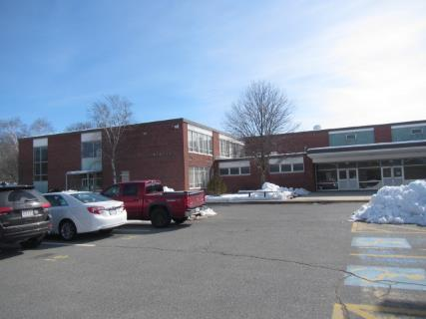

Prepared by:
Massachusetts Department of Public Health
Bureau of Environmental Health
Indoor Air Quality Program
March 2019

Background
Building: | Mitchell Elementary School (MES)
Address: | 166 Mount Prospect Street, Bridgewater, MA
Assessment Requested by: | Paul Fox Jr., Director of Facilities, Bridgewater-Raynham Regional School District
Date of Assessment: | March 7, 2019
Bureau of Environmental Health (BEH) Indoor Air Quality (IAQ) Program Staff Conducting Assessment: | Cory Holmes and Jason Dustin, Environmental Analysts
Date of Building Construction: | The MES is currently located at the former Bridgewater Middle School, which is a two-story red brick building constructed in the early 1960s. An addition was built in the 1970s. The building served as the Bridgewater-Raynham Regional High School until 2006-2007, when it underwent interior renovations to become the middle school.
Reason for Request: | Collaborative effort to perform general indoor air quality (IAQ) assessments throughout the Bridgewater-Raynham School District.
Building Population: | Approximately 970 students grades K-3 and approximately 100 employees
Windows: | Openable

IAQ Testing Results
Please refer to the IAQ Manual for methods, sampling procedures, and interpretation of results (MDPH, 2015). The following is a summary of indoor air testing results (Table 1).
- Carbon dioxide levels were above the MDPH guideline of 800 parts per million (ppm) in 37 of 87 areas surveyed, indicating a lack of air exchange in a number of areas. This is most likely due to deactivated mechanical ventilation components as well as limitations on outside air introduction, which is typical during winter months and explained further in the Ventilation section of this report.
- Temperature was within or close to the MDPH recommended range of 70°F to 78°F in most areas tested. Some occupants expressed temperature control complaints.
- Relative humidity was below the MDPH recommended range of 40 to 60% in all areas tested, which is typical in New England during winter months.
- Carbon monoxide levels were non-detectable (ND) in all areas tested.
- Fine particulate matter (PM2.5) concentrations measured were below the NAAQS limit of 35 μg/m³ in all areas tested.

It is important to note that relative humidity levels in the building would be expected to be low during the winter months due to atmospheric conditions and heating. Low relative humidity can lead to common symptoms such as: dry skin, lips, and scalp; dry/scratchy throats and noses (nose bleeds); exacerbation of asthma, eczema, or allergies; dry/irritated eyes; and irritation of the respiratory tract.

Ventilation
A heating, ventilating, and air-conditioning (HVAC) system has several functions. First it provides heating and, if equipped, cooling. Second, it is a source of fresh air. Finally, an HVAC system will dilute and remove normally-occurring indoor environmental pollutants by not only introducing fresh air, but by filtering the airstream and ejecting stale air to the outdoors via exhaust ventilation. Even if an HVAC system is operating as designed, point sources of respiratory irritation may exist and cause symptoms in sensitive individuals.
Classrooms have a ventilation system consisting of unit ventilators (univents) (Picture 1) and unit exhaust ventilators (unit exhaust; Picture 2) located on the exterior wall of classrooms. The fans of the univents were noted to be off in some classrooms (Table 1). A univent is designed to draw air from outdoors through a fresh air intake located on the exterior wall of the building (Picture 3). Return air is drawn through an air intake located at the base of the unit (Figure 1). Fresh and return air are mixed, filtered, heated and provided to classrooms through an air diffuser located in the top of the unit. Unit exhausts operate in a similar fashion, drawing air into vents located along the bottom front of the unit and exhausting air to the outdoors. Unit exhaust vents and univents were obstructed by furniture/items in some rooms (Table 1), which can limit air exchange (Picture 1 and 4). It is also important to note that outside air is typically limited (by pneumatically adjusting intake louvers) during cold/winter months to provide comfort and prevent the freezing of pipes.
Fresh air for common areas such as the gymnasium, cafeteria, library and administrative areas is provided by rooftop or ceiling-mounted air handling units (AHUs). AHUs draw in air from outdoor air intakes, filtered, heated and/or cooled and distributed to occupied areas via ceiling or wall-mounted air diffusers. Exhaust air is returned back to the AHUs via ceiling-mounted return vents. These systems appeared to be operating during the assessment.
To maximize air exchange, the MDPH recommends that both supply and exhaust ventilation operate continuously during periods of occupancy. It was reported that the system is automated by computer controls but has been manually overridden in some areas. In order to have proper ventilation with a mechanical supply and exhaust system, the systems must be balanced to provide an adequate amount of fresh air to the interior of a room while removing stale air from the room. It is recommended that HVAC systems be re-balanced every five years to ensure adequate air systems function (SMACNA, 1994).

Microbial/Moisture Concerns
In order for building materials to support mold growth, a source of water is necessary. A number of areas had water-damaged ceiling tiles (Pictures 5 through 7, Table 1), which can indicate current or historic building envelope/plumbing leaks. After the source of the leak above the ceiling tiles is repaired, water-damaged ceiling tiles should be removed and replaced. A few tiles had dark stains that were likely mold growth (Room 101; Picture 6) and in the main hallway near the front entrance. BEH IAQ staff recommended that these tiles be replaced, which was confirmed in subsequent conversation with Mr. Fox.
BEH IAQ staff noted that the single-paned windows appear original to the building (Picture 8). In many areas the caulking/gaskets are deteriorated which can allow water to penetrate these areas during driving rain events. As a result, some plaster walls were noted to be water-damaged and had efflorescence (Picture 9). Efflorescence is a characteristic sign of water damage to building materials such as brick, mortar, or plaster, but it is not mold growth. As moisture penetrates and works its way through mortar around brick, water-soluble compounds dissolve, creating a solution. As the solution moves to the surface of the brick or mortar, water evaporates, leaving behind white, powdery mineral deposits. This condition indicates that water from the exterior has penetrated into the building. Plaster and brick do not typically support mold growth because these materials are not carbon-based; however paint, items, or debris near the walls/windows that are moistened may become a mold-colonized. When present, efflorescence can be readily cleaned.
Many classrooms contained either window or portable air conditioners. These devices must be properly cleaned/maintained including the filters to avoid particulates and microbial colonization in occupied areas (Pictures 10 through 12).
Plants, which can be a source of pollen and mold and be respiratory irritants to some individuals, were observed in a number of areas. Plants should be properly maintained and equipped with drip pans to prevent water leaks and damage. They should also be located away from air diffusers to prevent the aerosolization of dirt, pollen, and mold.
Some doors leading to the exterior were noted to have large gaps (Picture 13). This condition may allow unconditioned air/moisture and pests into the building.
Some refrigerators were noted to have debris and microbial colonization on the door gaskets (Picture 14). These gaskets should be cleaned regularly or replaced if they are damaged.
It was reported that due to a water infiltration event, the gym floor had become buckled (Picture 15). At the time of assessment, this area was blocked off and not in use.

Other IAQ Evaluations

Volatile Organic Compounds (VOCs)
Exposure to low levels of total VOCs (TVOCs) may produce eye, nose, throat, and/or respiratory irritation in some sensitive individuals. IAQ staff examined rooms for products containing VOCs. IAQ staff noted air fresheners, scented hand sanitizers, cleaners, and dry erase materials within the building (Picture 16, Table 1). All of these products have the potential to be irritants to the eyes, nose, throat, and respiratory system of sensitive individuals and their use should be minimized. Hand sanitizer products may contain ethyl alcohol and/or isopropyl alcohol, which are highly volatile and may be irritating to the eyes and nose. These products may also contain fragrances to which some people may be sensitive.

Other Conditions
The MDPH recommends pleated filters with a Minimum Efficiency Reporting Value (MERV) of 8, which are adequate in filtering out pollen and mold spores (ASHRAE, 2012). Filters should also be changed two to four times a year, or per the manufacturer’s recommendations. Some univent cabinets were noted to contain accumulated dust/debris within the cabinets (Picture 17, Table 1). These cabinets should be thoroughly vacuumed during filter changes to avoid aerosolizing accumulated debris.
Some personal fans, supply, and exhaust vents were observed to have accumulated dust/debris (Pictures 17 through 19, Table 1). Particulates can be reaerosolized from these items and they should be cleaned regularly. Dust accumulation was also observed on flat surfaces in some areas.
The MES had carpeting or area rugs in several areas. These carpets should be vacuumed regularly with a HEPA-filtered vacuum to avoid particulates from causing further irritation or serving as a reservoir for microbial colonization. Also, carpeting and rugs should be cleaned at least once per year according to IICRC recommendations (IICRC 2012).
In several areas, items were observed on the floor, windowsills, tabletops, counters, bookcases, and desks. The large numbers of stored items provide a source for dusts to accumulate. These items (e.g., papers, folders, boxes) make it difficult for custodial staff to clean. Once aerosolized, they can act as irritants to eyes and the respiratory system. Items should be relocated and/or be cleaned periodically to avoid excessive dust build up.
The library was noted to have some water-damaged ceiling tiles and several missing ceiling tiles (Picture 20) following ongoing work in that area. Missing ceiling tiles should be replaced as soon as the work is completed to avoid them from serving as pathways to unconditioned areas. Items were also noted in a few classrooms hanging from ceiling tile systems. This practice should be discontinued to avoid and damage/disturbance to the ceiling tile system.
It is also important to note that due to the age of the building, asbestos-containing materials (ACM) are likely present. Ensure any remediation work is in compliance all state and federal hazardous materials laws/regulations including the Asbestos Hazard Emergency Response Act (AHERA), which requires inspection of asbestos containing materials every three years as well as a semi-annual walkthrough to determine current conditions of asbestos-containing materials.
Note that the Environmental Protection Agency (EPA) conducted a National School Radon Survey in which it discovered nearly one in five schools had “…at least one frequently occupied ground contact room with short-term radon levels above 4 [picocuries per liter] pCi/L” (US EPA 1993). The BEH/IAQ Program therefore recommends that every school be tested for radon, and that this testing be conducted during the heating season while school is in session in a manner consistent with USEPA radon testing guidelines. Radon measurement specialists and other information can be found at www.nrsb.org and http://aarst-nrpp.com/wp, with additional information at: http://www.mass.gov/eohhs/gov/departments/dph/programs/environmental-health/exposure-topics/iaq/radon.

Conclusions/Recommendations
Some of the conditions listed in this report can be remedied by the actions of building occupants. Other remediation efforts will require alteration to the building structure and equipment. Although it has been reported that the roof was replaced within the last five years, water penetration issues are prevalent around the building, which will require repairs to the building envelope to prevent further water intrusion and damage to building materials. For these reasons, a two-phase approach is recommended. The first consists of short-term measures to improve air quality and the second consists of long-term measures that will require planning and resources to adequately address overall IAQ conditions.
In view of the findings at the time of the visit, the following recommendations are made:

Short-Term Recommendations
In view of the findings at the time of the visit, the following recommendations are made:
- Operate the HVAC system to provide for continuous fresh air ventilation during occupied hours. If possible, the fans in univents and unit exhausts should be reset/programmed to operate continuously, not cycle on and off.
- Implement methods to increase fresh air to classrooms having elevated carbon dioxide levels (Table 1). This may include opening fresh air intake louvres further (weather permitting).
- Remove furniture and items blocking the front and top of univents and the front of unit exhausts.
- Periodically assess whether exhaust vents (classrooms and restrooms) are drawing air and repair as needed.
- Use openable windows to supplement fresh air during temperate weather. Ensure all windows are closed tightly at the end of each day.
- Consider closing classroom doors during occupancy to allow for more effective function of exhaust vents.
- Work with staff to troubleshoot temperature control problems.
- Utilize a system to report and track maintenance issues (e.g., school dude) so that concerns can be reported by staff and maintenance staff can report when issues have been resolved.
- Consider adopting a balancing schedule of every 5 years for all mechanical ventilation systems, as recommended by ventilation industrial standards (SMACNA, 1994).
- As a temporary measure, change water-damaged ceiling tiles. Until this has been completed, avoid storing porous materials in areas of known leaks.
- Once repairs are made, refinish water-damaged ceiling and wall plaster and replace water-damaged ceiling tiles. Inspect the area above the stained tiles for water damage or odors and remediate or clean as necessary.
- Replace any missing ceiling tiles (e.g., library) when work is completed.
- Refrain from hanging materials from suspended ceiling tile systems.
- Install tight-fitting door gaskets and sweeps to doors communicating with the exterior.
- Regularly clean portable and window air conditioners including filters.
- Regularly clean refrigerator gaskets or replace gaskets if necessary.
- Keep classroom/office plants in good condition, avoid overwatering, and keep them away from the airstream of ventilation equipment.
- Reduce or eliminate the use of air fresheners, scented cleaners, hand sanitizers and dry erase materials to reduce irritation.
- Continue to change filters in HVAC units 2 to 4 times a year with MERV 8 or higher filters.
- Clean/vacuum HVAC and univent cabinets of debris and dust when filters are changed, particulary in room 115. Examine sound-proofing/insulation material for breakdown, remove if failing.
- Clean exhaust vents and fans regularly to remove accumulated dust/debris.
- For buildings in New England, periods of low relative humidity during the winter are often unavoidable. Therefore, scrupulous cleaning practices should be adopted to minimize common indoor air contaminants whose irritant effects can be enhanced when the relative humidity is low. To control for dusts, a high efficiency particulate arrestance (HEPA) filter equipped vacuum cleaner in conjunction with wet wiping of all surfaces is recommended. Avoid the use of feather dusters. Drinking water during the day can help ease some symptoms associated with a dry environment (throat and sinus irritations).
- Clean carpeting and rugs at least once per year according to IICRC recommendations (IICRC 2012). Area carpets too worn to be effectively cleaned should be replaced. Roll up and store area rugs in a clean, dry place during the summer.
- Relocate or consider reducing the amount of materials stored in classrooms to allow for more thorough cleaning of classrooms. Clean items regularly with a wet cloth or sponge to prevent excessive dust build-up.
- Utilize the US EPA’s (2000), “Tools for Schools”, as an instrument for maintaining a good IAQ environment in the building available at: http://www.epa.gov/iaq/schools/index.html.
- For more information on mold refer to the US EPA’s “Mold Remediation in Schools and Commercial Buildings” (US EPA, 2008). Available at: http://www.epa.gov/mold/mold-remediation-schools-and-commercial-buildings-guide.
- The school should be tested for radon by a certified radon measurement specialist during the heating season when school is in session. Radon measurement specialists and other information can be found at: www.nrsb.org, and http://aarst-nrpp.com/wp.
- Refer to resource manuals and other related IAQ documents for further building-wide evaluations and advice on maintaining public buildings. Copies of these materials are located on the MDPH’s website: http://mass.gov/dph/iaq.

The following long-term measures should be considered:
- Work with a building envelope specialist/building engineer to investigate and provide recommendations to prevent water intrusion. This measure should include a full building envelope evaluation (windows, flashing, etc.).
- If warranted, contact an HVAC engineering firm for an assessment of the ventilation system’s control system (e.g., controls, air intake louvers, thermostats).
- Consider replacing original single-paned window systems to prevent air infiltration and water penetration.
- Continue with plans to make repairs/replace water-damaged gymnasium floor.

References
ASHRAE. 2012. American Society of Heating, Refrigeration and Air Conditioning Engineers (ASHRAE) Standard 52.2-2012 -- Method of Testing General Ventilation Air-Cleaning Devices for Removal Efficiency by Particle Size (ANSI Approved). 2012.
IICRC. 2012. Institute of Inspection Cleaning and Restoration Certification. Institute of Inspection, Cleaning and Restoration Certification. Carpet Cleaning: FAQ.
MDPH. 2015. Massachusetts Department of Public Health. Indoor Air Quality Manual: Chapters I-III. Available at: http://www.mass.gov/eohhs/gov/departments/dph/programs/environmental-health/exposure-topics/iaq/iaq-manual/.
SMACNA. 1994. HVAC Systems Commissioning Manual. 1st ed. Sheet Metal and Air Conditioning Contractors’ National Association, Inc., Chantilly, VA.
US EPA. 1993. Radon Measurement in Schools, Revised Edition. Office of Air and Radiation, Office of Radiation and Indoor Air, Indoor Environments Division (6609J). EPA 402-R-92-014. https://www.epa.gov/sites/production/files/2014-08/documents/radon_measurement_in_schools.pdf
US EPA. 2000. Tools for Schools. Office of Air and Radiation, Office of Radiation and Indoor Air, Indoor Environments Division (6609J). EPA 402-K-95-001, Second Edition. http://www.epa.gov/iaq/schools/index.html.
Picture 1
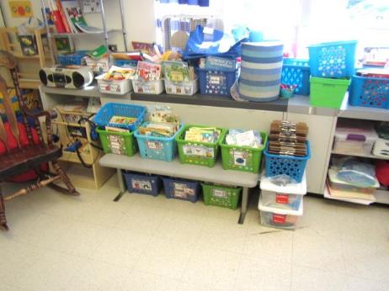
Univent in classroom (note items on top & in front of unit)
Picture 2
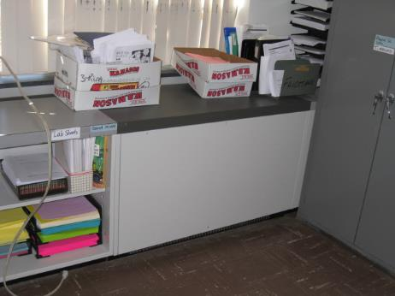
Unit exhaust
Picture 3
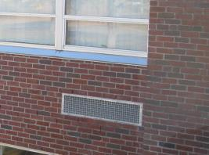
Univent fresh air intake vent
Picture 4
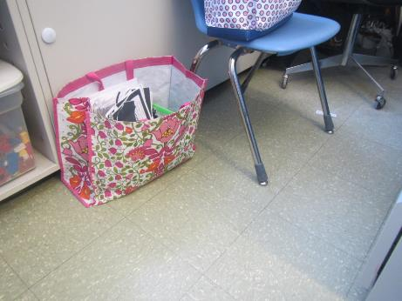
Unit exhaust vent partially obstructed by items at base
Picture 5
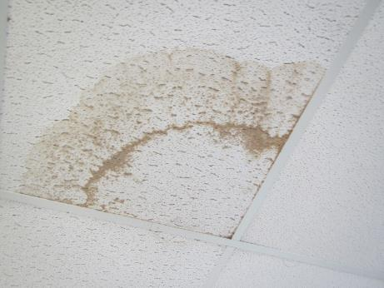
Water-damaged ceiling tile
Picture 6
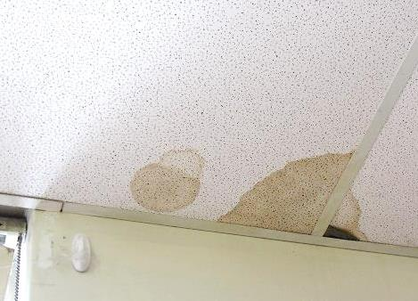
Water-damaged ceiling tile, note dark stain indicating possible mold growth in room 101
Picture 7
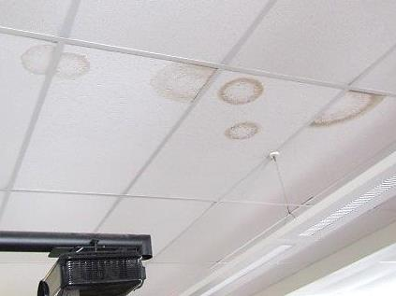
Water-damaged ceiling tiles
Picture 8
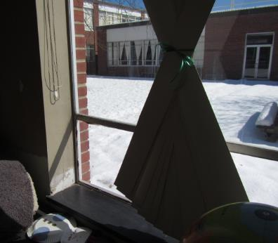
Original single-paned windows
Picture 9
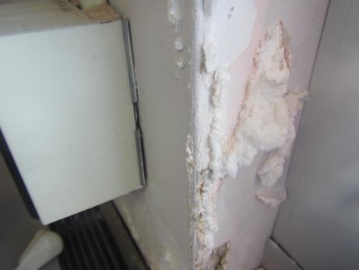
Water-damaged plaster wall near windows showing efflorescence
Picture 10
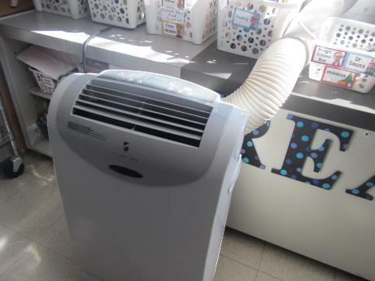
Portable air conditioning unit in classroom
Picture 11
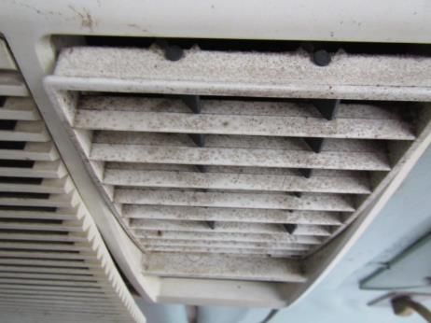
Window AC unit showing debris accumulation
Picture 12
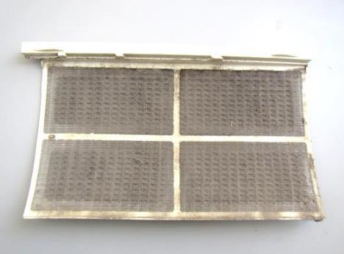
Window AC unit filter occluded with dust/debris
Picture 13
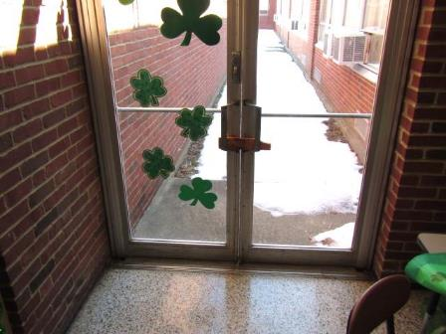
Exterior doors showing large gaps between them (light penetrating)
Picture 14
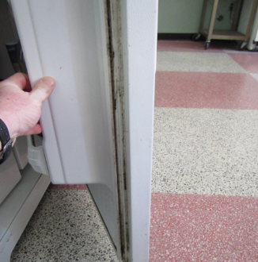
Refrigerator door gasket with debris/microbial growth
Picture 15
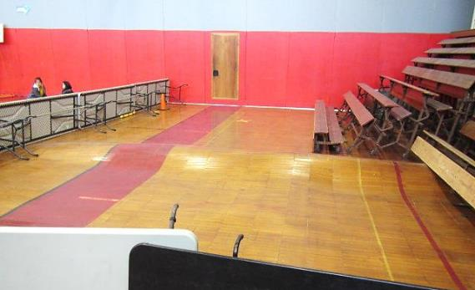
Buckling of gymnasium floor due to water damage
Picture 16
Plug-in air freshener in occupied space
Picture 17
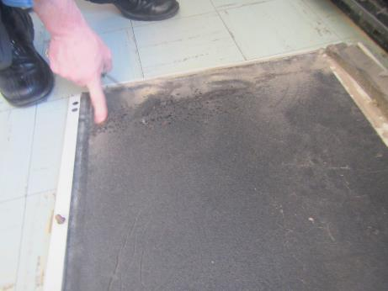
Accumulated dust/debris within univent cabinet and cover
Picture 18
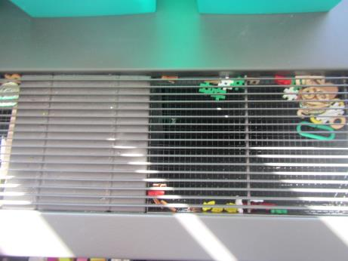
Univent supply air vent with accumulated debris
Picture 19
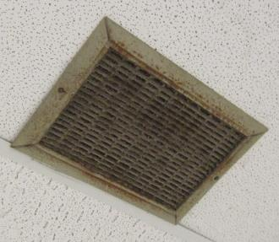
Dusty exhaust vent
Picture 20
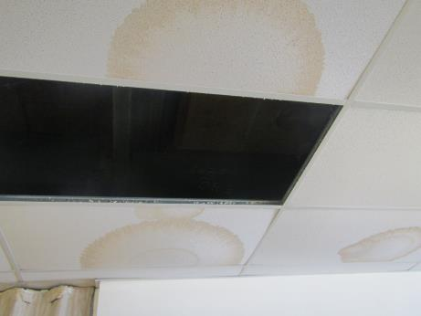
Water-damaged and missing ceiling tiles in Library
Location | Carbon  Dioxide  (ppm) | Carbon Monoxide  (ppm) | Temp  (°F) | Relative  Humidity  (%) | PM2.5  (µg/m³) | Occupants  in Room | Windows  Openable | Ventilation |  |  | Remarks
 |  |  |  |  |  |  |  | Intake | Exhaust
Background (outside) | 411 | ND | 37 | 11 | 18 |  |  |  |  |  | Cold, clear/sunny
Main Office Break Room | 633 | ND | 71 | 14 | 6 | 0 | N | N |  | N | WD CT, carpet
Safe Place Room | 610 | ND | 71 | 12 | 5 | 0 | Y | N |  | Y | Carpet, recommend drill holes in door (passive door vent), exhaust dusty
School Psychologist | 627 | ND | 71 | 13 | 5 | 0 | Y | N |  | N | Carpet
Copy Room | 594 | ND | 71 | 12 | 6 | 0 | N | Y  Passive |  | N | Photocopier, carpet
Conference Room/Guidance Library | 559 | ND | 78 | 8 | 5 | 0 | Y | Y |  | Y | 6 WD CTs, MTs, AC-filter dirty, carpet
Auditorium | 488 | ND | 70 | 12 | 3 | 0 | N | Y |  | Y | WD ceiling plaster, WD ceiling panels Stage Area
PTO Office | 530 | ND | 69 | 11 | 5 | 0 | N | N |  | Y | Dusty vent, photocopier
101 | 1187 | ND | 70 | 19 | 6 | 21 | Y | Y |  | Y | Plug-in AF, 2 WD CT near window (possible mold), holes in CT
102 | 1023 | ND | 70 | 13 | 6 | 20 | Y | Y |  | Y | UV-obstructed top/front, DO, area rugs, AI
103 | 1149 | ND | 70 | 16 | 6 | 23 | Y | Y |  | Y | 2 WD CT, PF
104 | 847 | ND | 72 | 12 | 6 | 25 | Y | Y |  | Y | DO, ajar CT, area rug
105 | 1198 | ND | 70 | 17 | 5 | 20 | Y | Y |  | Y | AI
106 | 957 | ND | 71 | 13 | 6 | 24 | Y | Y |  | Y | AI
Records Room | 448 | ND | 72 | 7 | 8 | 1 | N | Y |  | Y | DO
107 | 727 | ND | 69 | 11 | 6 | 19 | Y | Y |  | Y | AI, WD CT x2, bowed CT
108 | 1095 | ND | 72 | 11 | 15 | 20 | Y | Y |  | Y | Exhaust partially blocked in front, UF, AI
109 | 1043 | ND | 71 | 16 | 6 | 14 | Y | Y |  | Y | UV blocked, HS, PF, AI, WD CT, CP
110 | 864 | ND | 71 | 14 | 6 | 19 | Y | Y |  | Y | DEM, area rug, HS
111 | 474 | ND | 68 | 8 | 5 | 0 | Y | Y |  | Y | CPs, HS, DEM, exhaust blocked
112 | 1044 | ND | 70 | 14 | 16 | 22 | Y | Y |  | Y | UV-obstructed, area rug, items on UV
113 | 422 | ND | 73 | 8 | 5 | 1 | Y | Y |  | Y | AC
Lunch Room | 450 | ND | 72 | 7 | 6 | 1 | N | N |  | Y
114 | 747 | ND | 70 | 13 | 13 | 26 | Y | Y |  | Y | PF, 2 WD CT, area rug, holes in CT
115 | 1062 | ND | 69 | 14 | 5 | 23 | Y | Y |  | Y | Particulates reported coming from UV (dirt/debris), UV, HS
116 | 438 | ND | 72 | 12 | 6 | 5 | Y | Y off |  | Y | DEM, photocopier x 3, WD CT
117 | 720 | ND | 71 | 10 | 5 | 22 | Y | Y |  | Y | 11 WD CTs, ACs
118 | 526 | ND | 71 | 10 | 5 | 24 | Y | Y |  | Y
Faculty Dining | 424 | ND | 68 | 11 | 7 | 5 | Y | Y |  | Y | Exhaust off, AC-dirty housing/filters, WD CTs, WD plaster/efflorescence near windows, visible mold on refrigerator gaskets
120 | 633 | ND | 70 | 12 | 5 | 0 | Y | Y |  | Y
Hallway outside 121 | 787 | ND | 71 | 16 | 5 | 28 | Y | Y |  | Y | WD CT, area rugs
122 | 562 | ND | 72 | 8 | 9 | 0 | Y | Y |  | Y | PF
123 | 691 | ND | 72 | 11 | 8 | 24 | Y | Y |  | Y | DO
125 | 731 | ND | 71 | 11 | 7 | 0 | Y | Y |  | Y | UV-off, peeling paint efflorescence window plaster, area rugs, 25 occupants gone ~5 mins
Exterior Door near 125 |  |  |  |  |  |  |  |  |  |  | Gaps/spaces between/around doors
127 | 673 | ND | 70 | 10 | 10 | 9 | Y | Y |  | Y | DO
Adjustment Councilor High School | 630 | ND | 70 | 10 | 7 | 2 | N | N |  | Y | Exhaust off, DO
128 | 462 | ND | 73 | 7 | 7 | 2 | Y | Y |  | Y | AC
129 | 462 | ND | 71 | 7 | 7 | 4 | Y | Y |  | N | AC
130 | 490 | ND | 71 | 8 | 8 | 0 | Y | N |  | N | AC, PF, area rugs
130A | 459 | ND | 75 | 6 | 6 | 1 | Y | N |  | Y | WD CT
130B | 440 | ND | 74 | 5 | 6 | 1 | Y | Y |  | N | AC
131 | 473 | ND | 72 | 8 | 6 | 3 | Y | Y |  | Y | Photocopier, hole in CT, cardboard boxes on floor
141 | 795 | ND | 67 | 16 | 3 | 27 | Y | Y |  | Y | Exhaust off, UV near open classroom door, DO
142A | 525 | ND | 70 | 10 | 4 | 0 | N | N |  | Y
142B | 558 | ND | 70 | 11 | 4 | 0 | Y | Y |  | Y
Nurse Suite | 449 | ND | 70 | 8 | 5 | 4 | Y | Y |  | Y | Exhaust off, restroom exhaust not functioning/dusty
Gym | 646 | ND | 64 | 15 | 4 | ~50 | Y | Y |  | Y | Warped/WD floor
PE Office | 442 | ND | 71 | 8 | 5 | 0 | Y | N |  | N | Carpet-stained
Staff/Visitors Restroom |  |  |  |  |  |  | Y | Y  passive |  | Y | Exhaust-off
Main Office | 661 | ND | 71 | 13 | 6 | 4 | Y | N |  | N | Carpet, photocopier
Principal Office | 595 | ND | 70 | 14 | 5 | 0 | Y | N |  | N | AC, carpet
Small Cafeteria | 965 | ND | 73 | 15 | 6 | 50+ | N | Y |  | Y | Skylights
Large Cafeteria | 1075 | ND | 73 | 16 | 8 | 80+ | Y | Y |  | Y
Library | 411 | ND | 72 | 6 | 5 | 1 | Y | Y |  | Y | HS, carpet, MT x 3, WD CTs
Library office | 454 | ND | 71 | 8 | 8 | 0 | N | N |  | Y off | Carpet/kitchen
201 | 1437 | ND | 68 | 25 | 2 | 22 | Y | Y |  | Y | UV blocked, AI, DEM, HS
202 | 870 | ND | 69 | 14 | 1 | 17 | Y | Y |  | Y | UV blocked, HS
203 | 1420 | ND | 69 | 17 | 4 | 14 | Y | Y |  | Y | HS, CPs, UV fan off- may be broke per occupant
204 | 701 | ND | 70 | 13 | 3 | 19 | Y | Y |  | Y | HS, area carpet
205 | 748 | ND | 70 | 12 | 3 | 1 | Y | Y |  | Y | HS
206 | 846 | ND | 71 | 13 | 7 | 21 | Y | Y |  | Y | AI
207 | 670 | ND | 71 | 12 | 6 | 9 | Y | Y |  | Y | HS, AI, DEM
208 | 979 | ND | 76 | 11 | 6 | 17 | Y | Y |  | Y | UV blocked, WD CT x 2, AI, HS
209 | 1050 | ND | 70 | 14 | 6 | 20 | Y | Y |  | Y | PF, area rug
210 | 1077 | ND | 74 | 13 | 4 | 23 | Y | Y |  | Y | WD CT, UV blocked
211 | 635 | ND | 75 | 10 | 5 | 11 | Y | Y |  | Y | DEM, noisy UV fan, heat complaints
212 | 1283 | ND | 75 | 12 | 5 | 18 | Y | Y |  | Y | AI, DEM, HS, UV blocked
213 | - | - | - | - | - | - | - | - |  | - | Room locked- nobody there
214 | 802 | ND | 73 | 11 | 4 | 1 | Y | Y off |  | Y | 2 portable AC units, CPs, UV fan off, WD paper near window (water intrusion)
214B | 648 | ND | 77 | 9 | 7 | 0 | Y | N |  | N | DEM, AI/storage, radiators, reported plumbing leak in bath off this room
215 | 721 | ND | 71 | 15 | 8 | 1 | Y | N |  | Y | CPs, WAC, radiators
216 | 814 | ND | 73 | 11 | 3 | 12 | Y | Y |  | Y | HS, DEM, CT hangings, HS, CPs, AI
217 | 559 | ND | 77 | 10 | 4 | 1 | Y | Y |  | Y | Debris in UV supply vent
217A | 572 | ND | 77 | 8 | 8 | 0 | Y | N |  | N | Radiators, old carpet
218 | 817 | ND | 73 | 11 | 4 | 11 | Y | Y |  | Y | DEM, HS
219 | 930 | ND | 73 | 11 | 4 | 19 | Y | Y |  | Y | AI, DEM, HS, UV blocked
220 | 818 | ND | 74 | 10 | 5 | 0 | Y | N |  | N | AC, radiators, personal heater (dusty)
221 | 615 | ND | 73 | 9 | 5 | 0 | Y | Y |  | Y | Computer lab, carpet, photocopier x 2
222 | 1023 | ND | 77 | 12 | 18 | 21 | Y | Y |  | Y | DEM, CPs, AI
223 | - | - | - | - | - | - | - | - |  | - | Room locked- no occupants
224 | 952 | ND | 69 | 10 | 11 | 19 | Y | Y |  | Y | DO
225 | 820 | ND | 73 | 10 | 5 | 19 | Y | Y |  | Y | DEM, HS, AI
226 | 964 | ND | 73 | 11 | 8 | 26 | Y | Y |  | Y | HS, DEM, area rug, UV blocked
227 | 935 | ND | 75 | 11 | 4 | 1 | Y | N |  | N | Radiators, HS, DEM
228 | 753 | ND | 72 | 9 | 8 | 0 | N | Y |  | Y | Computer lab
229 | 937 | ND | 73 | 12 | 7 | 0 | Y | Y |  | Y | Computer lab, PF x 3, DEM, old window gaskets/caulking
231 | 988 | ND | 75 | 13 | 7 | 23 | Y | Y |  | Y | Plant, CPs, temperature complaints
233 | 1139 | ND | 75 | 15 | 8 | 18 | Y | Y |  | Y | UV blocked, PF, plants, CPs
235 | 1034 | ND | 73 | 15 | 9 | 20 | Y | Y |  | Y | DEM, CPs
237 | 1350 | ND | 72 | 16 | 6 | 20+ | Y | Y |  | Y | UV blocked, HS, DEM, PF, area rug
239 | 1368 | ND | 74 | 10 | 6 | ~15 | Y | Y |  | Y | UV fan on low, HS, AC, AF odor

