INDOOR AIR QUALITY ASSESSMENT
MOLD INVESTIGATION

George H. Mitchell Elementary School
500 South Street
Bridgewater, Massachusetts

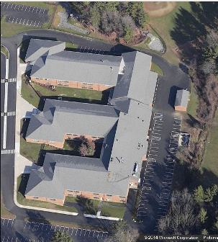

Prepared by:
Massachusetts Department of Public Health
Bureau of Environmental Health
Indoor Air Quality Program
November 2014

Background/Introduction
At the request of Mr. Al Baroncelli, Facilities Director, Bridgewater-Raynham Public Schools (BRPS), the Massachusetts Department of Public Health (MDPH), Bureau of Environmental Health (BEH) provided assistance and consultation regarding indoor air quality concerns at the George H. Mitchell Elementary School (MES) located at 500 South Street, Bridgewater, Massachusetts. On October 30 and November 4, 2014, the school was visited by Cory Holmes, Environmental Analyst/Regional Inspector in BEH’s Indoor Air Quality (IAQ) Program. Concerns about mold growth on building materials related to water-damaged countertops prompted the request.

Methods and Results
MDPH staff performed a visual inspection of building materials for water damage and/or microbial growth. Moisture testing of gypsum wallboard in classroom 123 was conducted with a Delmhorst, BD-2100 Model Moisture Detector. All areas of GW tested were dry (i.e., normal moisture content) at the time of testing.

Discussion
Open seams between sink countertops and backsplashes in classrooms have been observed in a number of IAQ assessments conducted by MDPH. Improper drainage or sink overflow can lead to water penetration into the countertop, cabinet interior and areas behind cabinets. If not watertight, moisture can penetrate through the seam, causing water damage and potential mold growth; this appears to be the case at MES in classroom 123. At the time of the October 30th visit, BRPS maintenance staff had reportedly removed the backsplash and cleaned surface mold off of GW behind the backsplash (Picture 1). BEH/IAQ staff recommended removal of the countertop in order to observe conditions behind it. The countertop was removed and BEH/IAQ staff returned to the MES on November 4, 2014 and observed a small area that appeared to be surface mold on the wall (Picture 2). At that time, a verbal recommendation to remove the material and then clean and disinfect the area with an antimicrobial solution was made. Mr. Baroncelli also reported that damaged backsplashes were removed in a number of other classrooms for repair/replacement.
BEH/IAQ staff were asked to examine a sink cabinet in classroom 128. In this case it appeared that moisture had been trapped between failing laminate covering on the cabinet, creating mold growth conditions on the particle board substrate (Picture 3). At the time of the assessment the failing laminate was sealed with tape until the cabinet could be removed later that day (Picture 4). In subsequent correspondence with BRPS maintenance staff the cabinet was removed from the classroom and discarded.
It is important to note that the MES was originally designed to have air conditioning (AC) capabilities, however due to lack of control resulting in wide-spread mold growth, the AC components were removed. In addition, portions of the ground floor of the MES are below grade, which adds to chronic moisture conditions, particularly during summer months.
The US Environmental Protection Agency (US EPA) and the American Conference of Governmental Industrial Hygienists (ACGIH) recommend that porous materials (e.g., carpeting, gypsum drywall) be dried with fans and heating within 24 to 48 hours of becoming wet (US EPA, 2001; ACGIH, 1989). If not dried within this time frame, mold growth may occur. Once mold has colonized porous materials, they are difficult to clean and should be removed/discarded.

Conclusions/Recommendations
In view of the findings at the time of the visit, the following recommendations are made. These recommendations were communicated at the time of the assessment and are reiterated below. The MDPH document Preventing Mold Growth in Massachusetts Schools during Hot, Humid Weather is included in Appendix A.
- Continue to monitor backsplashes and countertops for failing caulking/laminate and make repairs or replace as needed.
- Examine surfaces behind/around these areas for water damage and/or mold growth and clean/disinfect with an appropriate antimicrobial agent.
- Consider replacing existing countertops with a one-piece molded countertop.
- Prior to the 2015 summer vacation, teachers should be instructed to remove all pictures, posters and wall-hangings, as well as area rugs and/or floor mats, to prevent trapping moisture, which also contribute to mold growth. In addition, all portable classroom furniture (e.g., book cases, shelving) should be moved out from walls approximately 1 to 2 inches to allow airflow to prevent “moisture trapping”.

References
ACGIH. 1989. Guidelines for the Assessment of Bioaerosols in the Indoor Environment. American Conference of Governmental Industrial Hygienists, Cincinnati, OH.
US EPA. 2001. Mold Remediation in Schools and Commercial Buildings. US Environmental Protection Agency, Office of Air and Radiation, Indoor Environments Division, Washington, D.C. EPA 402-K-01-001. March 2001.

Picture 1
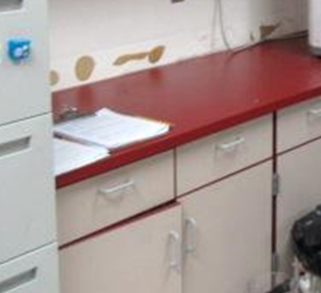
Damaged backsplash removed from classroom 123

Picture 2
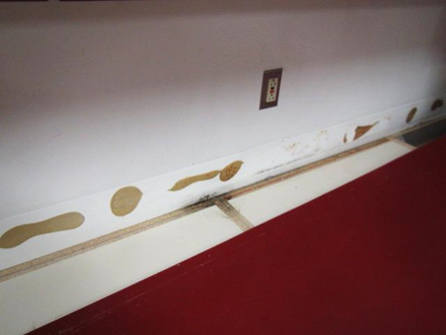
Small area of mold growth (arrow) behind countertop
Picture 3
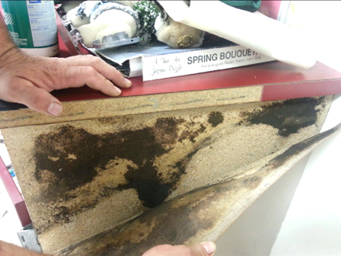
Likely mold growth behind failing laminate on counter in classroom 128

Picture 4
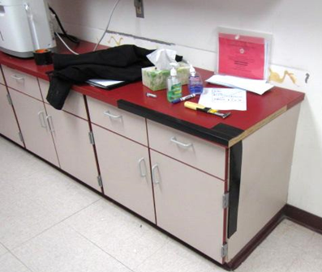
Edges of failing laminate in classroom 128 temporarily sealed with tape prior to removal

