Appendix A

Actions on Previous MDPH Recommendations

The following is a status report of actions taken on MDPH recommendations (in bold). The summary is based on reports from Town Officials, Mixter Municipal Office Building personnel, photographs and observations made by MDPH staff.

- Remove and replace any mold contaminated/water damaged materials (e.g. carpeting/padding, cork board, gypsum wallboard). This measure will remove actively growing mold colonies that may be present.
Action Taken: The cork board in the main lobby was still in place and may be providing a continued source of musty odors (Picture A-1). In addition, visible mold and water damaged materials were observed in the Coast Guard room, however the room was unoccupied and a sign was posted restricting access (Pictures A-2 and A-3).
- Inspect rooftop exhaust motors and belts for proper function. Repair and replace as necessary.
Action Taken: None of the exhaust vents for the general exhaust system were operating. Exhaust vents for restrooms appeared to be operating.
- Once rooftop motors are reactivated, remove all blockages from exhaust vents to ensure adequate airflow.
Action Taken: Obstructions to airflow continued to be observed in several areas.
- Ensure that abandoned exhaust and supply vents are properly sealed to eliminate pathways for movement of odors and particulates into occupied areas, if original mechanical ventilation systems are not restored to original function. This includes all former classroom vents as well as openings on the roof.
Action Taken: Openings on the roof could not be examined during the assessment; however vents were not sealed at their terminus in occupied areas.
- Ensure roof leaks are repaired. Once repaired replace any water-stained ceiling tiles. Disinfect areas of water leaks with an appropriate antimicrobial.
Action Taken: The roof is reportedly patched as needed by the West Boylston Streets and Parks Department, however, water damaged building materials (e.g., carpeting, walls, ceilings) and active leaks were observed and/or reported by building occupants in a number of areas, most notably in the Town Administrator’s office (Pictures A-4 through A-11).
  - Replace/repair broken windows to prevent water leaks and subsequent microbial growth.
Action Taken: In some cases broken windows were not replaced but boarded-up with plywood (Picture 12). In addition, condensation was observed on several windows which can provide another source of moisture within the building (Picture 13).
- Replace any missing ceiling tiles and fill utility holes, to prevent the migration of odors, dust and particulate matter between rooms.
Action Taken: In a number of areas tiles have been permanently removed due to chronic roof leaks; open utility holes were observed in a few areas (Pictures A-6 and A-14).
- Relocate or consider reducing the amount of materials stored in office space to allow for more thorough cleaning. Clean items regularly with a wet cloth or sponge to prevent excessive dust build-up.
Action Taken: More work is needed in several areas to reduce clutter and improve dust control/cleaning (Picture A-15).
  - Remediate any damaged/friable asbestos containing materials in conformance with all applicable Massachusetts’ asbestos abatement and hazardous materials disposal laws.
Action Taken: Damaged/loose floor tiles were observed in several areas due to current roof leaks (Pictures A-16 and A-17).

  - Change filters for window-mounted air conditioners and air-handling equipment as per the manufacturer’s instructions or more frequently if needed. Vacuum interior of units prior to activation to prevent the aerosolization of dirt, dust and particulates.
Action Taken: Filters appeared clean with the exception of the filter in the south meeting room, which was difficult to access (Picture A-18). However the interiors of several univents had cobwebs or accumulated dust build-up (Picture A-19).

Picture A-1

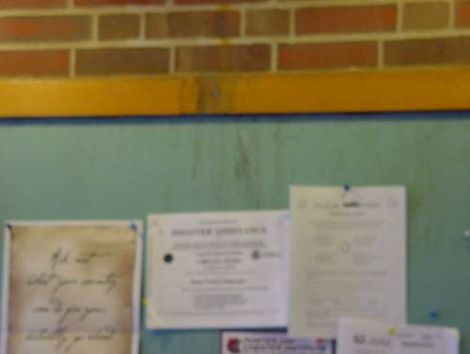

Water Damaged Cork Board in Main Hallway
Picture A-2

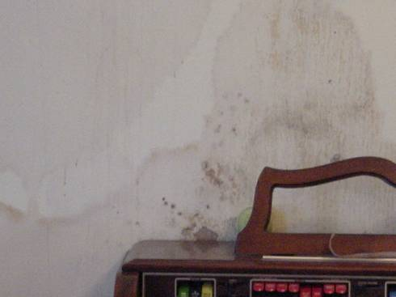

Mold-Colonized Cork Board in Coast Guard Room

Picture A-3

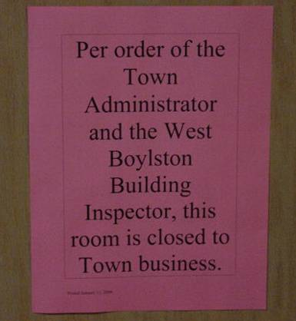

Sign Posted Restricting Access to Coast Guard Room

Picture A-4

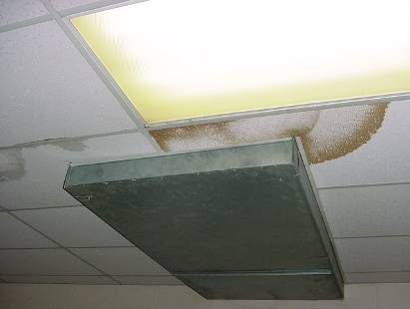

Water Damaged Ceiling Tiles

Picture A-5

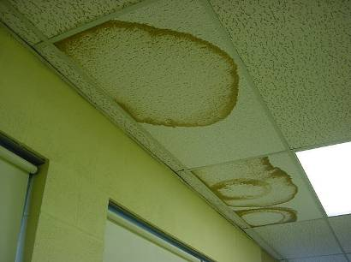

Water Damaged Ceiling Tiles

Picture A-6

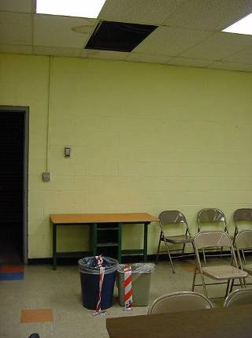

Buckets Catching Rain Water in South Meeting Room

Picture A-7
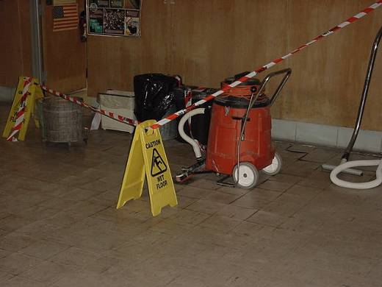

Buckets Catching Rain Water in Main Hallway

Picture A-8

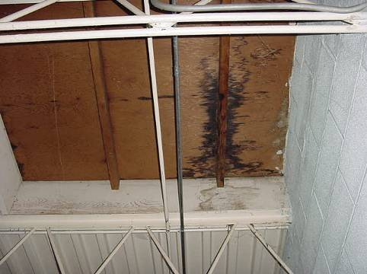

Water Damaged Wood Plug in Former Skylight Main Hallway, Dark Stain Indicates Water Penetration

Picture A-9

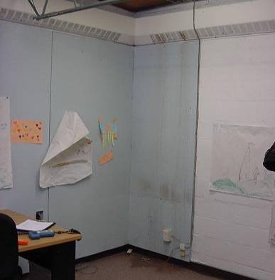

Active Roof Leak, Water Damaged Gypsum Wallboard and Carpeting in Town Manager’s Office, Note Carpet and Wall were Moistened at the Time of the Assessment

Picture A-10

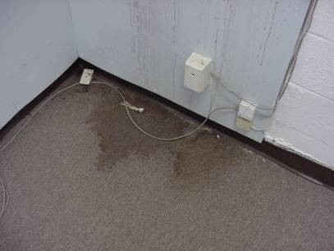

Close-Up of Water Damaged Carpet in Town Manager’s Office, Note Carpet and Wall were Moistened at the Time of the Assessment

Picture A-11

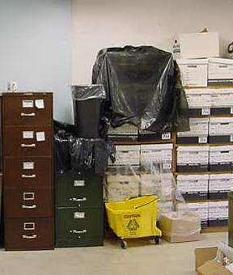

Buckets and Trash Bags Covering/Protecting Stored Porous Items in Office from Leaks

Picture A-12

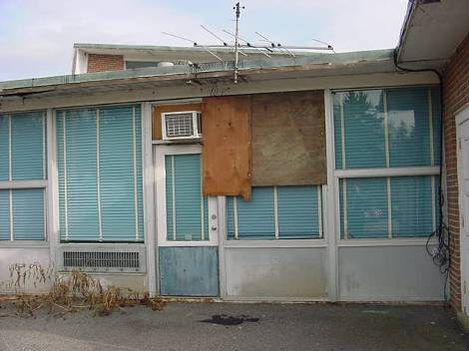

Windows Boarded-Up with Plywood

Picture A-13

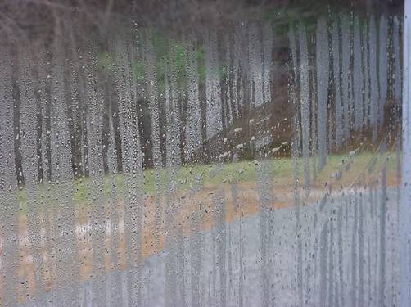

Condensation on Interior of Window

Picture A-14

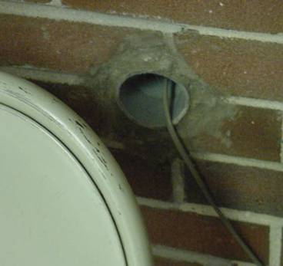

Open Utility Hole in Main Hallway

Picture A-15

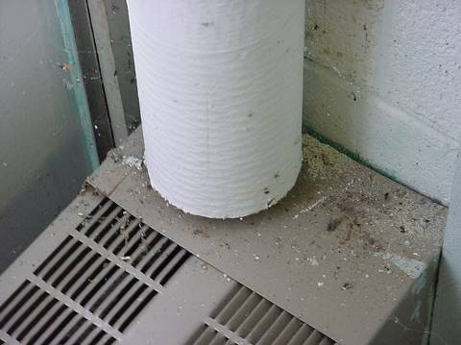

Dust/Debris on Flat Surfaces in Office

Picture A-16

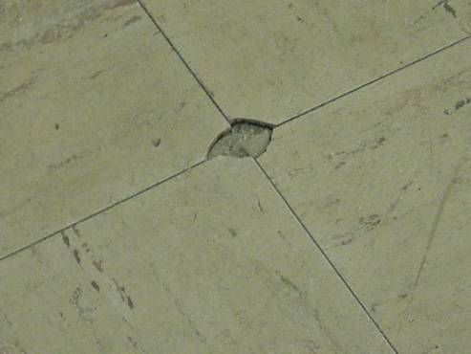

Damaged Floor Tile

Picture A-17

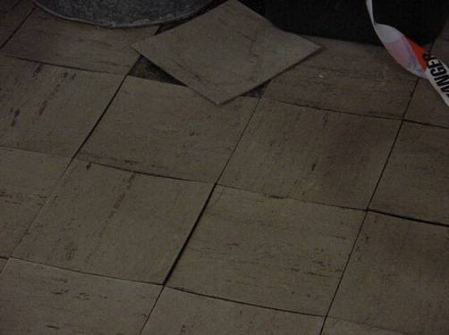

Loose/Lifting Floor Tiles

Picture A-18

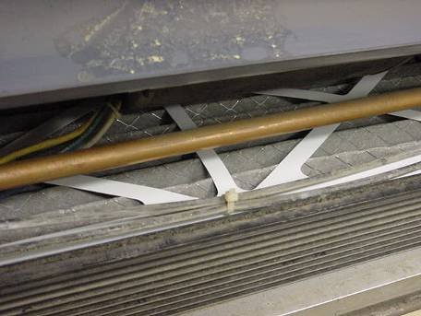

Dirty Filter Inside Univent-South Meeting Room

Picture A-19

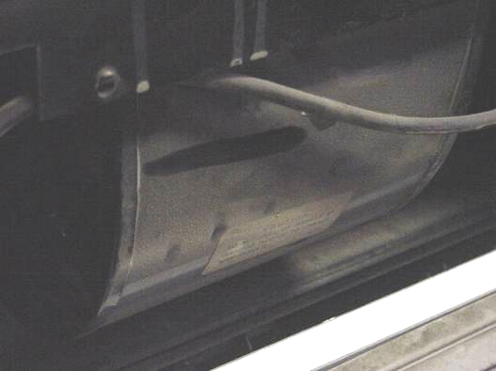

Dust Build-Up on the Interior of Univent

