INDOOR AIR QUALITY REASSESSMENT

Mixter Municipal Office Building
120 Prescott Street
West Boylston, Massachusetts



Prepared by:
Massachusetts Department of Public Health
Center for Environmental Health
Emergency Response/Indoor Air Quality Program
March 2007

Background/Introduction
At the request of Leon A. Gaumond, Jr., Town Administrator for the community of West Boylston, the Massachusetts Department of Public Health (MDPH), Center for Environmental Health (CEH) provided assistance and consultation regarding indoor air quality concerns at the Mixter Municipal Office Building (MMOB), 120 Prescott Street, West Boylston, MA.
A previous IAQ assessment at the MMOB was conducted in July, 2003. A report was issued by CEH that described conditions observed in the building at that time (MDPH, 2006). On December 12, 2006, a follow-up visit was made to the building by Michael Feeney, Director of CEH’s Emergency Response/Indoor Air Quality (ER/IAQ) Program. Mr. Feeney was accompanied by Cory Holmes, an Environmental Analyst in CEH’s ER/IAQ Program.
The MMOB is a one-story, flat roofed, brick building originally built as a school in 1950. Mr. Gaumond reported to MDPH that town offices were relocated to the MMOB in 1983 as a temporary measure. Although minor interior renovations (such as removal of unit ventilators from some rooms) were conducted to convert the former school into office space, it appears that the building has not undergone any major capital improvements. The MMOB also contains the West Boylston Senior Center. Windows are openable throughout the building. At the time of the assessment, a Municipal Building Committee was reportedly formed to examine building issues/needs.

Actions on Previous MDPH Recommendations
As mentioned, MDPH staff had previously visited the building and issued a report with recommendations to improve indoor air quality (MDPH, 2003). A summary of actions taken on previous recommendations is included as Appendix A.

Methods
Air tests for carbon dioxide, temperature and relative humidity were taken with the TSI, Q-Trak, IAQ Monitor, Model 8551. Water content of porous building materials (e.g., carpet, ceiling tiles, gypsum wallboard) was measured with Delmhorst, BD-2000 Model, Moisture Detector with a Delmhorst Standard Probe.

Results
The building has a staff of approximately 20 with approximately 40-50 individuals visiting the building daily. The tests were taken under normal operating conditions. Test results appear in Table 1.

Discussion
Ventilation
It can be seen from Table 1 that carbon dioxide levels were below 800 parts per million (ppm) in all areas surveyed, indicating adequate ventilation in occupied areas of the building. However, it is important to reiterate that in the majority of areas throughout the building components of the mechanical ventilation system have been removed or deactivated. The mechanical ventilation system is described in detail in the previous report (MDPH, 2003).
To maximize air exchange, the MDPH recommends that both supply and exhaust ventilation operate continuously during periods of occupancy. In order to have proper ventilation with a mechanical supply and exhaust system, the systems must be balanced to provide an adequate amount of fresh air to the interior of a room while removing stale air from the room. It is recommended that HVAC systems be re-balanced every five years to ensure adequate air systems function (SMACNA, 1994). The mechanical ventilation system in its current condition cannot be balanced.
The Massachusetts Building Code requires that each area have a minimum ventilation rate of 20 cubic feet per minute (cfm) per occupant of fresh outside air or openable windows (SBBRS, 1997; BOCA, 1993). The ventilation must be on at all times that the room is occupied. Providing adequate fresh air ventilation with open windows and maintaining the temperature in the comfort range during the cold weather season is impractical. Mechanical ventilation is usually required to provide adequate fresh air ventilation.
Carbon dioxide is not a problem in and of itself. It is used as an indicator of the adequacy of the fresh air ventilation. As carbon dioxide levels rise, it indicates that the ventilating system is malfunctioning or the design occupancy of the room is being exceeded. When this happens, a buildup of common indoor air pollutants can occur, leading to discomfort or health complaints. The Occupational Safety and Health Administration (OSHA) standard for carbon dioxide is 5,000 parts per million parts of air (ppm). Workers may be exposed to this level for 40 hours/week, based on a time-weighted average (OSHA, 1997).
The MDPH uses a guideline of 800 ppm for publicly occupied buildings. A guideline of 600 ppm or less is preferred in schools due to the fact that the majority of occupants are young and considered to be a more sensitive population in the evaluation of environmental health status. Inadequate ventilation and/or elevated temperatures are major causes of complaints such as respiratory, eye, nose and throat irritation, lethargy and headaches. For information concerning carbon dioxide, please see Appendix B.
Temperature readings ranged from 66º F to 76 º F, which were below the MDPH recommended comfort guidelines in several areas on the day of the assessment. The MDPH recommends that indoor air temperatures be maintained in a range of 70 º F to 78 º F in order to provide for the comfort of building occupants. In many cases concerning indoor air quality, fluctuations of temperature in occupied spaces are typically experienced, even in a building with an adequate fresh air supply. In addition, it is difficult to control temperature and maintain comfort without operating the ventilation equipment as designed (e.g., univents removed/deactivated or obstructed, exhaust vents not operating).
The relative humidity measured in the building ranged from 20 to 44 percent, which was below the MDPH recommended comfort range in most areas the day of the assessment. The MDPH recommends a comfort range of 40 to 60 percent for indoor air relative humidity. It is important to note that the relative humidity in the Town Administrator’s office was 14 % higher than background levels, due to moisture accumulation in the carpet, GW and window condensation (Pictures 1 through 3). Relative humidity levels in the building would be expected to drop during the winter months due to heating. The sensation of dryness and irritation is common in a low relative humidity environment. Low relative humidity is a very common problem during the heating season in the northeast part of the United States.

Microbial/Moisture Concerns
Upon entering the building, a distinct musty odor was detected inside the front lobby that extended to the area outside the Town Administrator’s office. The most prominent source of musty odors was traced to the Town Administrator’s office. CEH staff observed evidence of a current roof leak in the form of stained gypsum wallboard (GW) and carpeting (Pictures 1 and 2) within the Town Administrator’s Office. Moisture measurements were taken of the GW and carpeting and both were found to have elevated moisture content at the time of the visit. The means for this odor travel from the Town Administrator’s office to the lobby at the front door appears to be components of the heating, ventilating and air-conditioning (HVAC) system. A bank of univents exists in a large room (presumably originally used as the school’s gymnasium). Each univent draws air from the floor through their return vents (Picture 4). It is likely that these univents are drawing air from the Town Administrator’s office and distributing odors into other areas of the building via main hallways. Odors can then be drawn to the front lobby by a functioning exhaust vent located near the front entrance (likely the former nurse’s office). It is worthy to note that no similar odor was detected in the former cafeteria on the opposite side of the building, now used as the senior center.
The building has a well-documented history of roof leaks. As indicated in Appendix A, attempts are reportedly made to patch/repair leaks; however active leaks continue to persist. Severely water-damaged wood along the eaves of the roof was observed (Pictures 5 through 7). In order for building materials to support mold growth, a source of water exposure is necessary. Identification and elimination of water moistening building materials is necessary to control mold growth (in this case leaks through the building envelope). Materials with increased moisture content over normal concentrations may indicate the possible presence of mold growth.
The American Conference of Governmental Industrial Hygienists (ACGIH) recommends that porous materials (e.g., corkboard, carpeting, ceiling tiles) be dried with fans and heating within 24 hours of becoming wet (US EPA, 2001, ACGIH, 1989). If porous materials are not dried within this time frame, mold growth may occur. Water-damaged porous building materials can provide a source of mold and mildew and should be replaced after a water leak is repaired.
Other Concerns
Several other conditions that can affect indoor air quality were observed during the assessment. As indicated in Appendix A, current roof leaks have loosened floor tiles in several areas (Pictures 8 and 9). Due to the age of the building it is likely that the floor tiles contain asbestos. Intact asbestos-containing materials do not pose a health hazard. If damaged, asbestos-containing materials can be rendered friable and become aerosolized. Where asbestos-containing materials are found damaged, these materials should be removed or remediated in a manner consistent with Massachusetts asbestos remediation laws (MDLI, 1993).
As indicated in the previous report the building has experienced infestation of hornets/wasps (MDPH, 2003). During a perimeter inspection of the exterior of the building as part of the current assessment, CEH staff observed over seventy hornets/wasps nest along the rear of the building alone (Picture 10). CEH staff observed several spray cans of pesticides in work areas. Insecticides contain chemicals that can be irritating to the eyes, nose and throat. Under current Massachusetts law the principles of integrated pest management (IPM) must be used to remove pests in state buildings and grounds (Mass Act, 2000). Although not a state office building, it is highly recommended that town officials contact a licensed exterminator to design and implement an IPM plan to address this issue.
Finally, occupants reported periodic sewer gas odors in the main hallway. Although no odors were detected or reported at the time of the reassessment, several potential sources were identified:
- A water fountain in the main hallway;
- Floor drains in restrooms; and
- Plumbing fixtures in the restroom located in the boiler room.
Water fountains, sinks and floor drains are usually designed with traps in order to prevent sewer odors/gases from penetrating into occupied spaces. When water enters a drain, the trap fills and forms a watertight seal. Without periodic input of water (e.g., every other day), traps can dry, preventing a watertight seal. Without traps, odors and other material can travel up the drain and enter occupied spaces. Sewer gas can be irritating to the eyes, nose and throat of some individuals.

Conclusions/Recommendations
The restriction of access to the Coast Guard room, which was identified as an area of concern in the previous assessment (MDPH, 2003), has eliminated exposure opportunities associated with mold in this area. However concerns remain due to water infiltration in other areas of the building. During the course of the assessment, CEH staff identified water-damaged carpeting, GW and corkboards, which all should be removed/replaced. This measure will remove actively growing mold colonies that may be present. However, due to the likely presence of asbestos containing floor tiles, the removal of carpeting should be done with caution.
Although some progress has been made to improve IAQ, a large number of outstanding issues remain. In a document provided to the CEH by town officials in October of 2003, it is stated that the town of West Boylston Townwide Planning Committee is investigating a long-term comprehensive plan to address existing and future needs for municipal facilities, which calls for vacating of the Mixter Building as the town hall (Guida, 2003). This correspondence concludes that it is not prudent to make a substantial monetary commitment to the existing building, except when required by generally accepted standards and law (Guida, 2003). Given that three and a half years have passed since that correspondence, further consideration of remedial measures should be considered to ensure the health and comfort of building occupants.
In view of these findings at the time of the visit, the following recommendations are made to improve indoor air quality:
- Continue to implement previous MDPH recommendations (MDPH, 2003).
- For advice/assistance regarding the structural integrity of the building/public safety consider contacting the Department of Public Safety, Board of Building Regulations and Standards Phone: (617) 727-3200; e-mail: DPSInfo@state.ma.us.
- Remove and replace any mold contaminated/water damaged materials (e.g., carpeting, cork board, GW). This measure will remove actively growing mold colonies that may be present. Remove mold contaminated materials in a manner consistent with recommendations found in “Mold Remediation in Schools and Commercial Buildings” published by the US Environmental Protection Agency (US EPA, 2001). Copies of this document can be downloaded from the US EPA website at:http://www.epa.gov/iaq/molds/mold_remediation.html
- Schedule projects that produce large amounts of dusts, odors and emissions during unoccupied periods or periods of low occupancy when possible.
- Use local exhaust ventilation and isolation techniques (i.e., barriers) to control for renovation pollutants.
- Remediate any damaged/friable asbestos containing materials in conformance with all applicable Massachusetts’ asbestos abatement and hazardous materials disposal laws.
- Supplement airflow in the building by using openable windows to control for comfort. Care should be taken to ensure windows are properly closed at night and weekends to avoid the freezing of pipes and potential flooding.
- Remove all blockages from univent air diffusers and return vents (bottom front of units) to facilitate airflow.
- For buildings in New England, periods of low relative humidity during the winter are often unavoidable. Therefore, scrupulous cleaning practices should be adopted to minimize common indoor air contaminants whose irritant effects can be enhanced when the relative humidity is low. To control for dusts, a high efficiency particulate arrestance (HEPA) filter equipped vacuum cleaner in conjunction with wet wiping of all surfaces is recommended. Avoid the use of feather dusters. Drinking water during the day can help ease some symptoms associated with a dry environment (throat and sinus irritations).
- Contact a licensed extermination firm to design and implement an integrated pest management (IPM) plan to rid this building of pests. A copy of the IPM recommendations can be downloaded from the Internet at http://www.state.ma.us/dfa/pesticides/publications/IPM_kit_for_bldg_mgrs.pdf.
- Ensure water is poured into traps for the water fountain, restroom floor drains and plumbing fixtures in the boiler-room. If not in use, consider permanently sealing to eliminate potential pathways of odors into the building.
- For further building-wide evaluations and advice on maintaining public buildings, see the resource manual and other related indoor air quality documents located on the MDPH’s website at: http://mass.gov/dph/indoor_air.

References
ACGIH. 1989. Guidelines for the Assessment of Bioaerosols in the Indoor Environment. American Conference of Governmental Industrial Hygienists, Cincinnati, OH.
BOCA. 1993. The BOCA National Mechanical Code/1993. 8th ed. Building Officials and Code Administrators International, Inc., Country Club Hill, IL. Section M-308.1.1.
Guida. 2003. Memorandum To: the West Boylston Board of Health From: Paul J. Guida, Town Administrator Re: Mixter Municipal Office Building Indoor Air Quality Assessment Response Plan. Dated October 18, 2003.
Mass. Act. 2000. An Act Protecting Children and families from Harmful Pesticides. 2000 Mass Acts c. 85 sec. 6E.
MDPH. 2003. Indoor Air Quality Assessment. Mixter Municipal Office Building, West Boylston, MA. Massachusetts Department of Public Health, Center for Environmental Health, Boston, MA. September 2003.
OSHA. 1997. Limits for Air Contaminants. Occupational Safety and Health Administration. Code of Federal Regulations. 29 C.F.R. 1910.1000 Table Z-1-A.
SBBRS. 1997. Mechanical Ventilation. State Board of Building Regulations and Standards. Code of Massachusetts Regulations. 780 CMR 1209.0
US EPA. 2001. Mold Remediation in Schools and Commercial Buildings. US Environmental Protection Agency, Office of Air and Radiation, Indoor Environments Division, Washington, D.C. EPA 402-K-01-001. March 2001. http://www.epa.gov/iaq/molds/mold_remediation.html

Picture 1

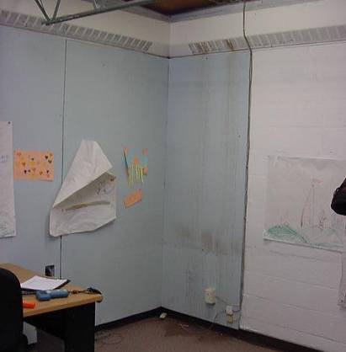

Active Roof Leak, Water Damaged Gypsum Wallboard and Carpeting in Town Manager’s Office, Note Carpet and Wall were Moistened at the Time of the Assessment

Picture 2

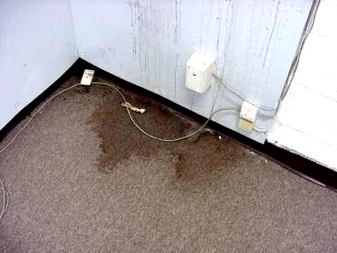

Close-Up of Water Damaged Carpet in Town Manager’s Office, Note Carpet and Wall were Moistened at the Time of the Assessment

Picture 3



Condensation on Interior of Window of Town Administrator’s Office

Picture 4

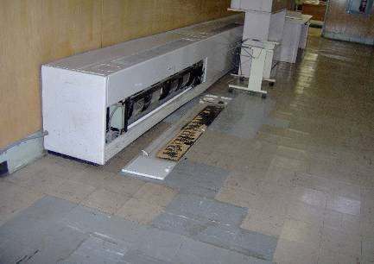
Return Vent

Univent outside Town Administrator’s Office

Picture 5

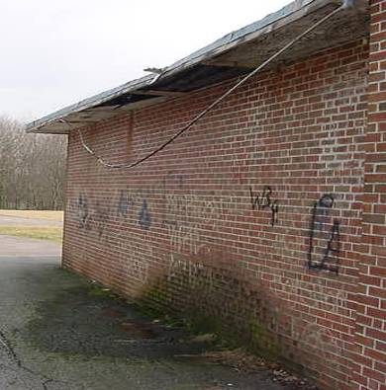

Severely Rotted Roof Eave and Backsplash/Moss Growth on Exterior Brick

Picture 6

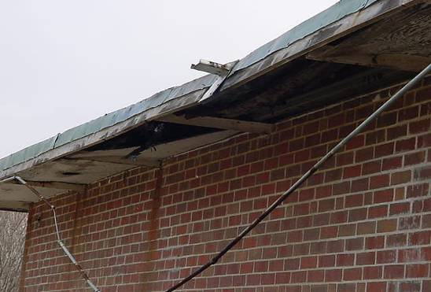

Severely Rotted Roof Eave, Note Hanging Utility Cable

Picture 7

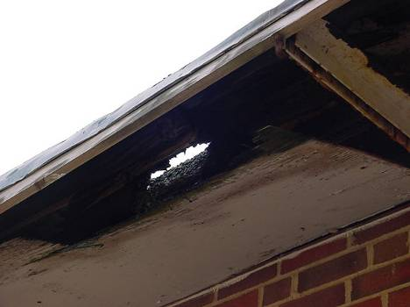

Severely Rotted Roof Eave

Picture 8

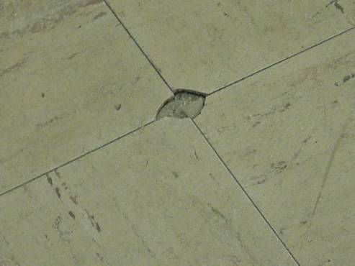

Damaged Floor Tile

Picture 9

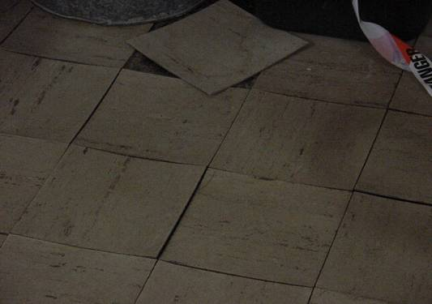

Loose/Lifting Floor Tiles

Picture 10

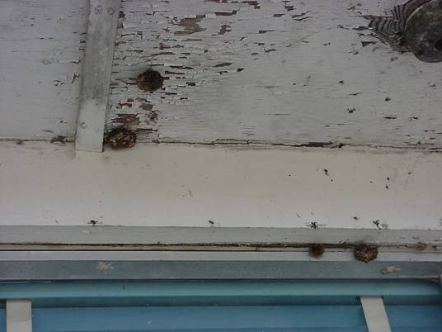

Hornets/Wasps Nests on Exterior of Building (Rear)
Location | Carbon  Dioxide  (*ppm) | Temp  (°F) | Relative  Humidity  (%) | Occupants  in Room | Windows  Openable | Ventilation |  | Remarks
 |  |  |  |  |  | Supply | Exhaust | Remarks
Outside  (Background) | 328 | 40 | 31
Meeting Room South | 505 | 70 | 30 | 0 | Y | Y | N | 13 CT removed to catch rain water, filters grey/dirty
Main Hallway |  |  |  |  |  | Y | N | Active roof leaks reported, lifting floor tiles, UV return vents obstructed by furniture
Town Administrator | 431 | 67 | 44 | 0 | Y | N | N | Water damaged carpet/GW-high/elevated moisture readings, active roof leak-corner, musty odors, condensation inside windows, lifting floor tiles-edges of floor
Selectman | 469 | 66 | 39 | 1 | Y | N | N
Board of Health | 484 | 67 | 31 | 2 | Y | N | N
Town Accountant | 430 | 72 | 26 | 1 | Y | Y | N | Cardboard boxes covered with plastic to protect from roof leaks
Tax Collector/Treasurer | 515 | 76 | 24 | 4 |  | Y | N | Loose floor tiles near exterior wall/door, roof leak reported in corner during ice build-up
Building Inspector | 637 | 75 | 24 | 3 | Y | Y | N | Damaged carpeting, 2 ACs, historic water damage-wall
Assessors | 425 | 72 | 20 | 1 | Y | N | N | AC
Town Clerk | 420 | 68 | 27 | 0 | Y | Y | Y | Ozone generator, bees/flying insects reported, no draw from exhaust vent, bees nests-windows
Main Hallway (near main foyer) |  |  |  |  |  |  |  | Musty odors-corkboard?  Bathroom in boiler room sign “out of order” possible source of odors
Senior Center Main Area | 585 | 70 | 28 | 45 | N | Y | N
PR-2 | 611 | 69 | 30 | 0 | Y | Y | Y | Open utility hole-wall
Coast Guard Room |  |  |  |  |  |  |  | Closed for business, visible mold growth on cork board-efflorescence cinderblock, water damaged carpet
Senior Center Room | 797 | 71 | 42 | 11 | Y | N | N
Senior Center Computer Room | 440 | 73 | 29 | 0 | Y | N | N
Senior Center Lounge | 599 | 76 | 27 | 0 | Y | N | N
Planning Board | 599 | 76 | 27 | 0 | Y | N | N

