Job Aid: Eligibility Verification – Upload/Download Batch Files

This job aid describes how to upload batch eligibility verification requests and download the corresponding eligibility response. Providers may submit HIPAA compliant Eligibility Inquiry transactions (270) and receive Eligibility Response transactions (271) from MassHealth.
This feature is helpful to providers, such as hospitals or large group practices, that need to verify the eligibility of multiple members on a daily basis. Batch processing is an alternative to processing separate eligibility verification requests for each member on the Provider Online Service Center (POSC).

Access Upload Batch Files

From the POSC home panel:
- Click Manage Batch Files.
- Click Upload Batch File.

Access the Batch Upload Panel to Upload Your File
- Select the applicable Provider ID from the dropdown list.
- Select the Transaction Type (270 – Eligibility Inquiry) from the dropdown list.
- Click Choose a File to select the file that you want to upload to the POSC.
- Click Upload File.
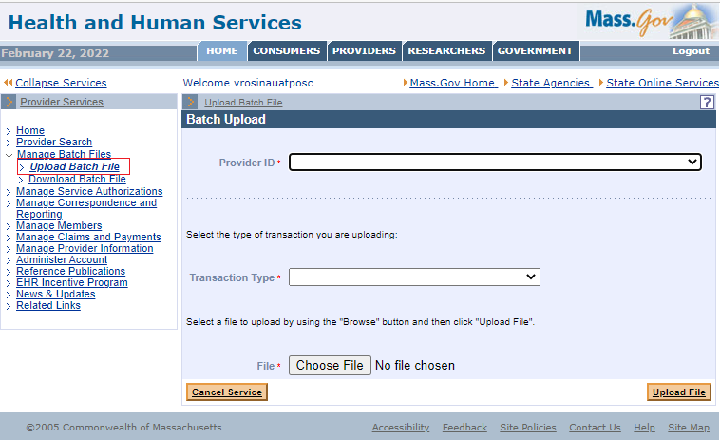

Review the Batch Upload Confirmation Panel
- Review the Batch Upload Confirmation message.
MassHealth also issues a HIPAA 999 Acknowledgement for every uploaded HIPAA batch transaction file. This confirms that the file was either accepted for processing or rejected. Please view the 999 Acknowledgement via the Download Batch Files function.
- Make a note of your tracking number.
- Upload another file, if needed.

Access Download Batch Files
From the MassHealth POSC home page:
- Click on Manage Batch Files.
- Click on Download Batch File.
MassHealth issues a response to all HIPAA batch transaction file submissions within 24 hours (e.g., 999 Acknowledgment and the appropriate response transactions).

Access the Search Criteria Panel
- Select the applicable Provider ID from the dropdown list.
- Enter the Tracking Number or select the 271 Transaction Type from the dropdown list.
- Enter From Date.
- Enter To Date.
- Click Search.
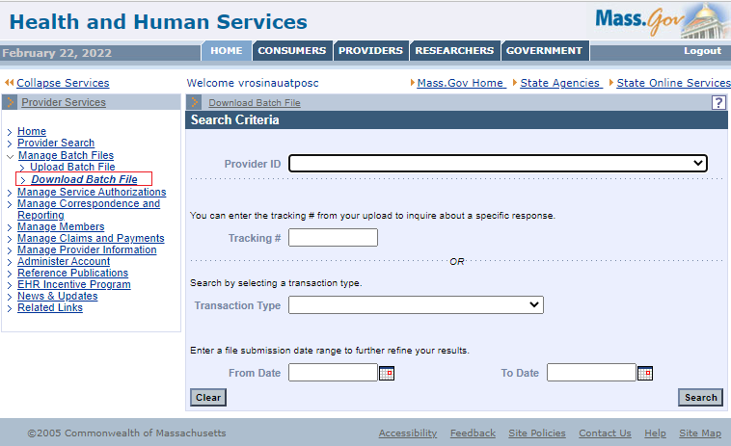

Access the Search Results Panel
- Click the File Name link of the 271 transaction file you wish to view.
- Open the file or click Save.

Save the Transaction File
From the Save As window:
- Determine where you want to save the downloaded file on your computer.
- Click Save.
- Click Close.

