Mobile Devices (Apple iOS)
If you encounter issues with your mobile device, please follow the instructions below to re-configure your device.
Steps | Process | Image
 | First you will need to delete your account:  Start by going to Settings Accounts & Passwords (may be slightly different depending on iOS version) and tap the exchange account that is associated with your work Email. | 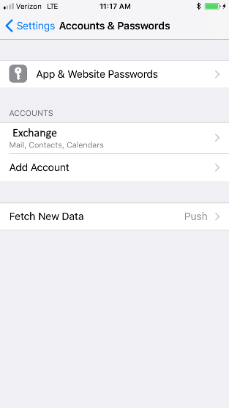
 | Under Exchange, tap Delete Account. | 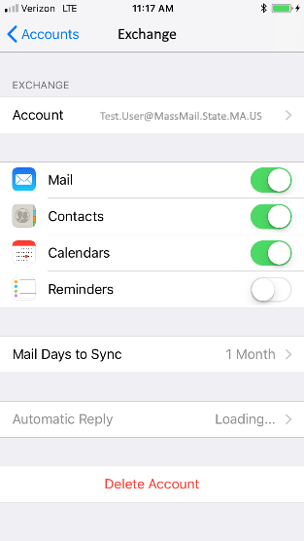
 | Now you will begin the process of re-adding the account:  Start by going to Settings Accounts & Passwords (may be slightly different depending on iOS version) and tap Add Account. | 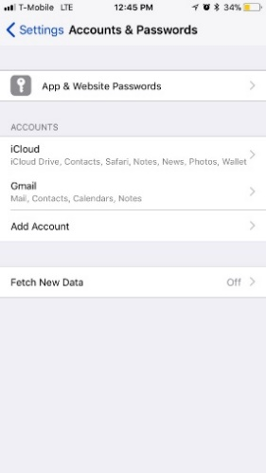
 | Under Add Account, tap Exchange. | 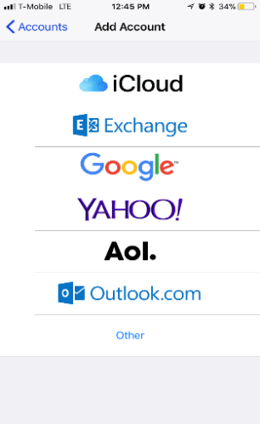
 | Enter your email address with @mass.gov and in Description enter ‘MassCloud’ and click Next. | 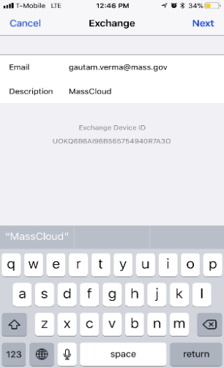
 | Enter your network password and tap Next. | 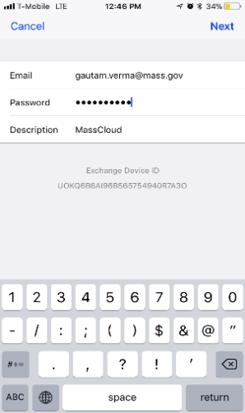
 | Enter outlook.office365.com as the Server name. Enter your email address with @mass.gov extension in Username and your network Password then tap Done. | 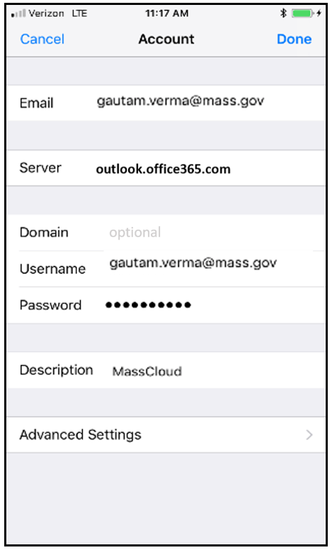
 | You will see all check marks once the email account is configured. | 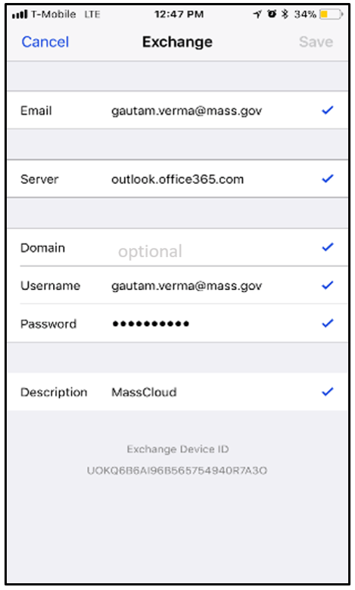
 | Open your email app and swipe down to start downloading your email. | 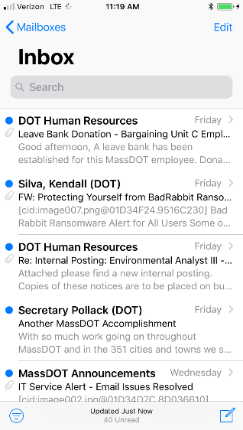

Mobile Devices (Android)
If you encounter issues with your mobile device, please follow the instructions below to re-configure your device. Note: Due to the wide variety of Android devices and customized versions available, the steps may not be labelled with the same captions or be performed in the same order as below, but should be similar.

Steps | Process | Image
 | First you will need to delete your account:  Start by going to Settings Accounts and tap the account that is associated with your Agency Email | 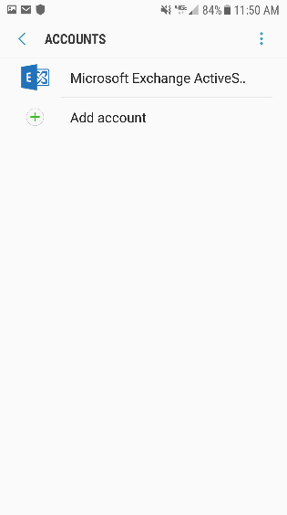
 | In the upper right hand corner tap the 3 dots and choose ‘Remove account’ | 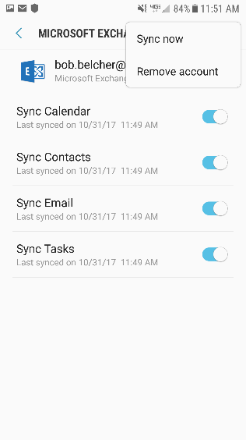
 | Tap REMOVE ACCOUNT when prompted. | 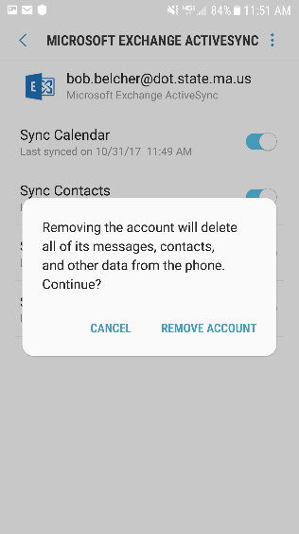
Now you will begin the process of re-adding the account:
Start by going to Settings, then Accounts. Tap Add account.

 | Tap Microsoft Exchange ActiveSync. | 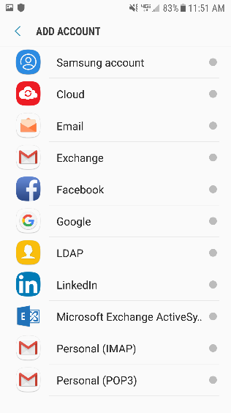
 | On the EXCHANGE ACTIVESYNC screen enter your email address (i.e. peter.smith@mass.gov) and password then tap ‘MANUAL SETUP’ | 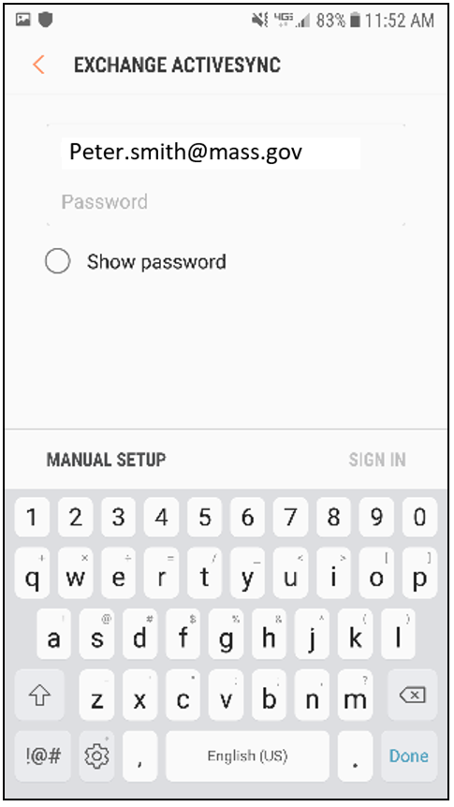
 | For Domain\username use your email address, and then move the screen down to SERVER SETTINGS and click NEXT. | 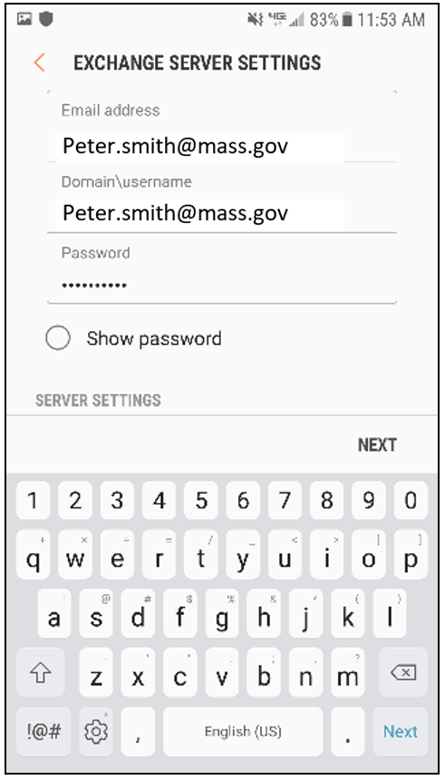
 | Enter outlook.office365.com in Exchange Server and make sure ‘Use Secure Connection (SSL)’ is checked. Click NEXT. | 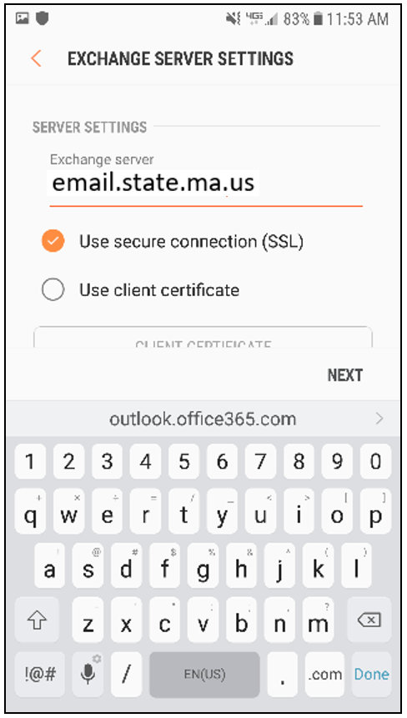
 | You will see dialog box that it is ‘Checking incoming server settings’ | 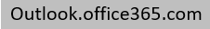  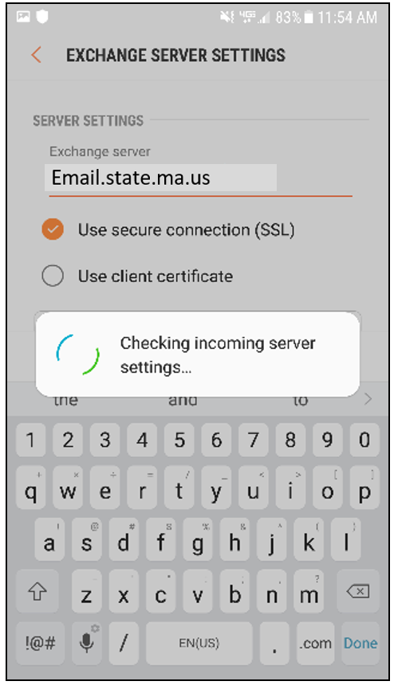
 | Your next prompt will be to allow Remote security administration. Tap OK to allow “Server outlook.office365.com must be able to remotely control some security features on your device.” | 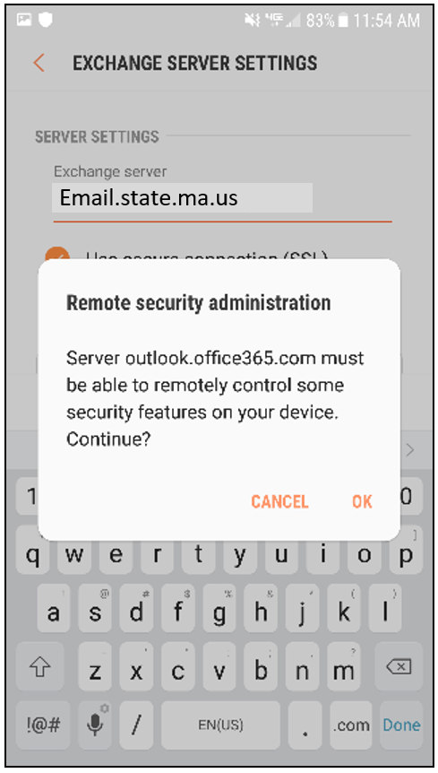
 | The next screen in MANUAL SETUP are settings that you can adjust. Android does not enable synchronizing of messages by default. Swipe the toggle button for Sync Messages and tap NEXT. | 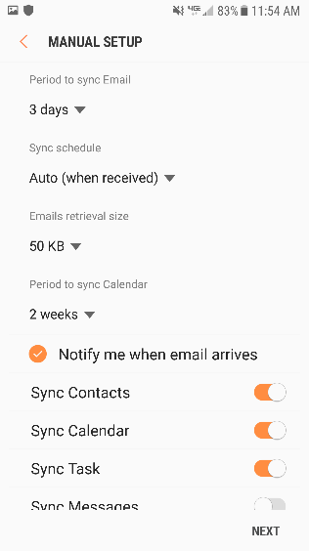
 | You will receive a notification message that the ‘Email account added.’ | 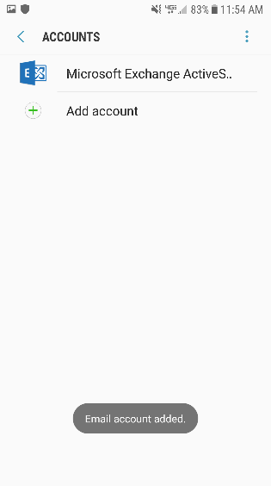
 | Open your email app and email will start to download. | 