Massachusetts Office on Disability

FY 2022 Annual Report
July 1, 2021 – June 30, 2022

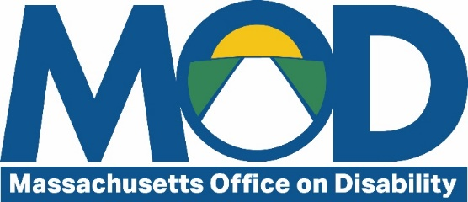
One Ashburton Place, Room 1305
Boston, MA 02108
617-727-7440
mass.gov/mod

Massachusetts Office on Disability: Creating a more accessible and inclusive Commonwealth
Massachusetts General Law Chapter 6, Sections 185-189 establishes MOD and outlines its mission to “bring about full and equal participation of people with disabilities in all aspects of life in a manner that fosters dignity and self-determination.”
Through Executive Order 592, MOD is established as the Executive Branch’s designated ADA and Rehabilitation Act Coordinator responsible for advising, overseeing, and coordinating compliance with state and federal laws protecting the rights of persons with disabilities.

Table of Contents
Letter from the Executive Director 3
MOD by the numbers in FY22 3
The MOD team 4
The Disability Rights Unit (DRU) 4
Massachusetts residents with disabilities 5
Municipalities 5
State employees 5
Client Assistance Program (CAP) 5
Spotlight on: Elevator outages in housing 7
Community Services Unit (CSU) 8
Architectural accessibility 8
Supporting local Commissions on Disability 9
Disability emergency preparedness training 9
Spotlight on: Municipal ADA Improvement Grant 10
Accessibility support for state agencies 12
Digital accessibility consulting for Commonwealth agencies 12
Spotlight on: Information Technology/Assisted Technology Working Group 13
Trainings and events 14
Level Up to Equality training 14
Work Experience Program 14
Trainings at a glance 15
Partnerships and collaborations 16
FY22 budget 18

Letter from the Executive Director
Dear MOD Stakeholders:
MOD continued to grow its presence and impact this year, connecting with Massachusetts residents, municipalities, and our fellow state agencies to build a more inclusive and accessible Commonwealth. The ongoing COVID-19 pandemic continued to shine a brighter spotlight on the importance of digital access. Digital spaces for socializing and working became a universal need, in turn benefitting the disability community.
In response, MOD continued to make progress with the AT/IT Working Group in partnership with several other agencies and secretariats to improve understanding and communication about IT accessibility. We also formalized our accessible technology consulting service for the Executive Branch, published an updated Disability Handbook for the Executive Branch, and trained all ADA Coordinators and General Counsels across the Secretariat on issues related to disability and access.
This report outlines those successes and many more. We are proud to serve the people of Massachusetts and work alongside community members to improve inclusion and access for all. We wish you the best in the year to come.

Mary Mahon McCauley
Executive Director
Massachusetts Office on Disability

MOD by the numbers in FY22
- 4,359 questions answered
- 145 trainings and presentations provided
- 254 cumulative monthly collaborations and partnerships
- 15 publications

The MOD team

Executive Director
Mary Mahon McCauley

Executive Assistant
Charlene Cashman

Administration and Finance
Michael Dumont, Assistant Director for Administration and Finance

Communications and Training
Lilia Melikechi, Communications and Training Manager

Community Services Unit (CSU)
Jeffrey Dougan, Assistant Director for Community Services
Evan George, Emergency Preparedness Program Coordinator
Ashley Santana, Access Specialist

Disability Rights Unit (DRU)
Naomi Goldberg, Assistant Director for Disability Rights Unit and Director of Client Assistance Program (CAP)
Susanne Agerbak, Information Specialist
Camille Karabaich, Information Specialist
Sarah Wiles, CAP Advocate
Inez Canada, CAP Advocate

General Counsel and Technical Information Specialist
Julia O’Leary, General Counsel
Rob Dias, Assistive Technology Information Specialist

The Disability Rights Unit (DRU)
The Disability Rights Unit (DRU) is an integral part of MOD and a critical source of information for many individuals and groups across the Commonwealth. Through interactions with the public, DRU identifies systemic issues that impact the disability community and seeks informal ways of resolving them, including collaboration with other state agencies and creating clear and easy to understand written guidance documents and presentations. This proactive resolution of issues has the double benefit of protecting constituents’ rights and saving the Commonwealth’s valuable resources.
“I appreciate all your help. I couldn’t have done this without you. Thank you so much and continue your good work!”
– DRU Caller navigating fair and accessible housing

Massachusetts residents with disabilities
The DRU informs Massachusetts residents with disabilities of their rights and provides technical guidance that allows people to obtain reasonable accommodations to maintain and equally enjoy employment and housing. Our team responds to approximately 200 inquiries on average each month.

Municipalities
The DRU also provides technical guidance to municipalities, informing them of their obligations under disability laws and partnering to identify solutions for serving their residents with disabilities. Issues we consulted on this year included obligations to make digital content accessible, guidance on analyzing requests to modify zoning rules, and making city-run summer camp programs and town halls accessible to children and adults with disabilities.

State employees
The DRU serves as a neutral third-party advocate for employees with disabilities, including those working for the Commonwealth, to navigate the reasonable accommodation process at work, making the Commonwealth – and all workplaces – more inclusive.

Client Assistance Program (CAP)
The Client Assistance Program (CAP), a part of MOD’s Disability Rights Unit (DRU), provides support and advocacy for people who are interested in or are currently accessing Vocational Rehabilitation (VR) and Independent Living (IL) services. The CAP team serves a critical role in assisting Massachusetts residents with disabilities with improving their job seeking skills, move out of institutions and into the community, and much more.
Members of MOD’s CAP staff chair the overall Statewide Rehabilitation Councils for the Massachusetts Rehabilitation Commission (MRC) and the Policy Subcommittee of the Massachusetts Commission for the Blind’s (MCB’s) State Rehabilitation Council. Through this collaborative work, CAP improves outcomes for clients of VR and IL services.
CAP also allows state governmental programs to better serve the community through informing potential VR and IL clients of their eligibility and legal rights, guiding clients through the process, resolving disputes clients may have with their service providers, and advocating for system-wide improvements.
This program is funded through the federal Rehabilitation Services Administration. Funding to state VR and IL agencies from RSA is dependent on CAP’s critical neutral role.

Disclosure in Employment Training Series
This year, CAP launched an interactive Disability Disclosure in Employment Workshop Series, which consists of three separate workshops over Zoom. The series helps employees and jobseekers with disabilities and their advocates navigate disclosing a disability at different stages of the employment process, best practices for requesting a reasonable accommodation, and recognizing and addressing disability discrimination in the workplace.
Participants in these workshops are challenged to think ahead and strategize about how they would like to address their disability related needs in the workplace. This preparation gives employees with disabilities the confidence and the tools to be successful in their employment. Approximately 300 people have been trained through this series.

DRU at a glance
- 5 employees
- 1,883 questions answered
- 33 trainings and presentations provided
- 88 cumulative monthly collaborations and partnerships
- 4 publications

Spotlight on: Elevator outages in housing
This year, the DRU noticed an uptick in calls related to elevator outages in housing complexes – both from residents with disabilities facing barriers in accessing their homes, and from housing providers unsure about their obligations and solutions for serving their residents.
In response, the DRU team released an Elevator Outages in Housing guidance to address housing provider obligations, best practices, emergency preparedness and planning, and disability-related civil rights. The guidance was written in collaboration with Office of the Attorney General, Department of Housing and Community Development, Board of Elevator Regulations, and the Massachusetts Architectural Access Board. It is one example of the many ways the DRU responds directly to community concerns.

Community Services Unit (CSU)
The Community Services Unit (CSU) is a critical arm of MOD’s work, supporting towns and cities across the Commonwealth in their efforts to be inclusive of and accessible to residents with disabilities. This happens through several different projects and initiatives:

Architectural accessibility
The CSU makes cities and towns more accessible by conducting site visits, providing ongoing technical assistance, and conducting Community Access Monitor (CAM) training, which equips volunteers with the knowledge and information they need to advocate for improved accessibility in their local communities.

Site visits and technical assistance
This year, the CSU team visited several private businesses, schools, libraries, and other buildings to evaluate them for accessibility and ensure compliance with relevant laws and regulations. In many cases, CSU’s site visits identify accessibility issues early in the new building or renovation project, increasing efficiency and cost-effectiveness. One such visit identified missing curb cuts, crucial for wheelchair accessibility, at a new elementary school construction in Worcester County. By identifying this issue early in the building process, the city saved valuable resources and avoided use of their contingency fund. In addition to site visits, the CSU team responds to hundreds of inquiries each month for expert technical assistance related to architectural accessibility.

Community Access Monitor (CAM) training
The Community Access Monitor (CAM) Program trains Massachusetts residents to survey buildings for accessibility. The training covers structural barriers, unequal policies and practices, inaccessible communication, and advocacy techniques for partnering with organizations and individuals to be successful in making communities more accessible to people with disabilities. This year, CSU trained 108 advocates, building inspectors, ADA coordinators, Commission on Disability members, architects, designers, and others with a personal or professional interest in advocating for accessibility in their communities.
“Interesting and informative. Thorough and clear. I look forward to future trainings and reviewing and sharing the handouts with colleagues as I acclimate myself to the task of evaluating accessibility within my sphere of responsibility.”
– CAM Training Attendee

The Massachusetts Architectural Access Board (MAAB)
The Massachusetts Architectural Access Board (MAAB) is an independent entity that develops and enforces regulations designed to make public buildings accessible to, functional for, and safe for use by persons with disabilities. Mary Mahon McCauley serves as an ex officio member of the Board, attending MAAB meetings every two weeks with Jeff Dougan, Assistant Director for Community Services, who chairs the Regulation Review subcommittee. The subcommittee meets monthly to update the board’s 2006 regulations to bring them into alignment with other accessibility regulations.

Supporting local Commissions on Disability
Commissions on Disability (CODs) serve an important role in ensuring accessibility in cities and towns across the Commonwealth. As of June 30, 2022, there were over 200 active CODs across Massachusetts, with eight new CODs established within FY22.
MOD supports CODs through training and technical guidance, both for the commissions and for municipal ADA coordinators. MOD’s trainings help new commissions get started, support the maintenance and functionality of existing commissions, and raise awareness of their role. The CSU often meets with CODs to discuss pending issues, orient new members, or assist new or recently reactivated CODs in their mission.

Disability emergency preparedness training
MOD’s Disability Emergency Preparedness Training brings together seniors, people with disabilities, local emergency planners, and first responders to get information and tools for preparing for different emergency situations. Members of the disability community learn about the personal steps they can take and are given planning guides to help develop their own emergency plans. First responders and emergency planners learn about making more accessible community preparedness plans, including tips on interacting with people with disabilities in an emergency.
This program is funded through a grant from the U.S. Department of Homeland Security, Office of Grants and Training, through the Executive Office of Public Safety and Security, Homeland Security Division.
“Lots of great new information. I feel prepared for an emergency.”
– Emergency Preparedness trainee from Dover, MA

CSU at a glance
- 3 employees
- 2,274 questions answered
- 88 trainings and presentations provided
- 92 cumulative monthly collaborations and partnerships

Spotlight on: Municipal ADA Improvement Grant
This year marked the fifth anniversary of MOD’s Municipal Americans with Disabilities Act (ADA) Improvement Grant Program. This program provides funding directly to municipalities for planning and implementation of projects that improve the accessibility of their services, programs, and activities. Since its inception, MOD has awarded over $7.3 million in funding and seen a significant increase in ADA Title II compliance and community accessibility.
One of this year’s grant winners was the Town of Dighton. MOD awarded the town $151,250 for a variety of projects, including widespread accessibility improvements to the Town Hall, Old Town Hall, town website, and parks and recreation areas. Projects were selected based on the results of an ADA compliance self-evaluation also made possible by a municipal ADA grant awarded to Dighton in 2019.
With these improvements, Dighton residents with disabilities have greater access to important public meetings and can equally enjoy taxpayer-funded sports facilities, gardens, and playgrounds alongside their nondisabled neighbors. The updates also present an exciting opportunity for Dighton to build relationships with Special Olympics of Massachusetts, Best Buddies, and other programs for children and adults with disabilities, making Dighton an increasingly accessible and inclusive place for all.

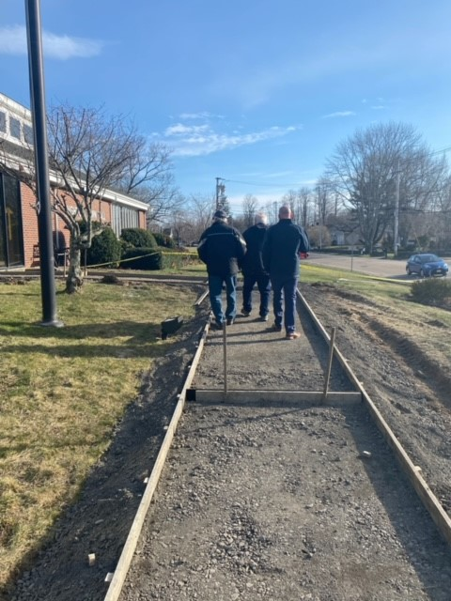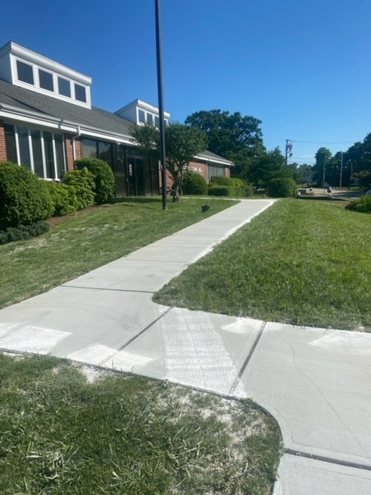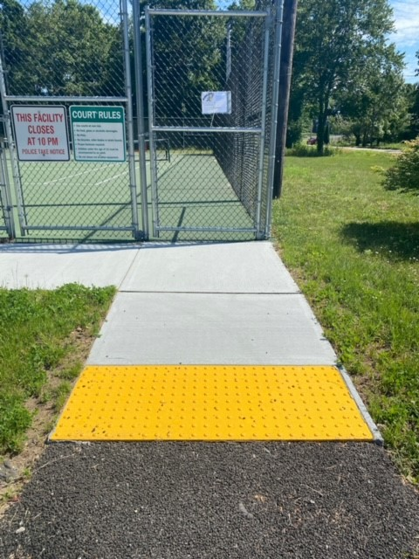
Left to right: Path to Dighton Town Hall under construction; completed new, wheelchair-accessible concrete path to Town Hall; wheelchair-accessible short concrete path with yellow truncated domes leading to door of a fenced-in tennis court
“We’re a small town with limited resources. The Municipal ADA Improvement Grant from MOD allowed us to make a broad range of major accessibility improvements we’ve dreamed of completing for a long time. Everything we do to make our town more accessible opens doors for every resident in the community: the many residents we have with a range of disabilities, parents wheeling children in strollers, cyclists riding their bikes around town, and senior citizens with mobility challenges sitting on park benches to watch their grandchildren play. Did I mention our fully inclusive new town website that will even require alt text (descriptive narrative) for pictures and videos?
These grants are not just about improving life for people with disabilities; they’re about making all our towns, public spaces, and resources fully inclusive for all our residents, families, and friends to enjoy and feel welcomed. As our town’s ADA Coordinator, and as a person who is totally blind myself, I can personally and truly say that. We’ll be enjoying and expanding on the success of this project for decades to come.”
–– Jonathan Gale, ADA Coordinator
Town of Dighton

Accessibility support for state agencies
MOD acts as the Americans with Disabilities Act (ADA) coordinator for the Executive Branch. Within this capacity, we serve as an important resource to fellow state agencies to ensure their compliance with the Americans with Disabilities Act (ADA).
Each state agency is required to designate an ADA Coordinator to review and approve reasonable accommodation requests from staff and members of the public, and to oversee agency compliance with state and federal disability rights laws. MOD provides training and ongoing technical assistance to all 64 ADA Coordinators in the Executive Office of the Commonwealth and ensures that accessibility standards are applied consistently across agencies.
With the assistance of MOD, the Commonwealth can attract and retain a diverse and stable workforce where employees with disabilities are supported, and maintain accessible government programs, services, and facilities for Massachusetts residents with disabilities.

Digital accessibility consulting for Commonwealth agencies
This year, MOD began formally offering free digital accessibility consulting services to state agencies to ensure compliance with the Enterprise Information Technology Accessibility Policy and offer guidance to state agencies for making their events, communications, and IT resources more accessible for Massachusetts residents with disabilities.

At a glance:
- 136 questions answered
- 22 trainings and presentations provided
- 52 cumulative monthly collaborations and partnerships
- 5 publications

Spotlight on: Information Technology/Assisted Technology Working Group
In March 2021, the MOD convened an Information Technology/Assisted Technology Working Group originating from the Executive Office of Technology Services and Security (EOTSS) and the Executive Office of Administration & Finance (EOAF) with the objective of improving accessibility and consistency in accessibility practices in Commonwealth IT resources.
The group is composed of members from across the executive branch of state government, drawing from a range of secretariats and agencies. Members also bring a diversity of subject matter expertise, including information technology, assisted technology, state procurement, training, and contract law.
The IT working group has published three guidance documents for state agencies: 1) Best Practices for Ensuring Accessibility in IT Resources—Procurement through Maintenance; 2) Mandatory Contract Language for Information Technology Resources; and 3) Sample Bid Solicitation Questions on Accessibility for IT Contracts. These documents provide practical, clear guidance for state agencies on how to ensure accessibility for users with disabilities in IT procurement. Beginning in FY 2023, the IT/AT working group will be strategizing on how to proceed with the dissemination and training required to ensure these three documents become a routine part of any IT procurement.

Trainings and events

Level Up to Equality training
This year, MOD continued its new “Level Up to Equality” training series to tailor our training content to the quickly changing needs of our community and to provide a live, virtual forum to answer questions. In FY22, Level Up trainings addressed effective communication with people with disabilities, apprenticeship as a pathway to employment during Disability Employment Awareness Month, and effective training for municipal ADA coordinators.

Work Experience Program
In June 2022, MOD and the Human Resources Division (HRD) cohosted the Work Experience Program in collaboration with several other Commonwealth agencies. The program provided an opportunity for people with disabilities to gain real-world exposure to work experience in state government. Commonwealth “host agencies” had the opportunity to meet job-ready candidates and expose them to the important work of their agencies.
Over the four-day program, participants received valuable career guidance and training. Both host agencies and participants also benefitted from attending a panel of Commonwealth employees with disabilities sharing their experiences. MOD hopes to continue this program in the future, collaborating with other agencies to close the disability employment gap and uphold the Commonwealth’s place as a model inclusive employer.
"The Work Experience Program provided me the opportunity to learn about state jobs directly from the people working in them. I'm so grateful for and inspired by the supportive connections I've made, both with my host agency…and beyond. The experience was transformative to me as a person with an invisible disability, and I hope that the Work Experience Program continues and hopefully serves as a workforce pipeline for the state in the future."
– Work Experience Program participant

Trainings at a glance
MOD regularly offers a variety of trainings on disability-related civil rights and obligations. Some of our most popular trainings include:

Introduction to Disability and Disability Etiquette
This training provides a basic overview of disability and disability etiquette. Topics include how disability is defined, communicating respectfully with and about people with various disabilities, and accommodations people with disabilities may use for communication or other daily tasks. Attendees leave this training with more knowledge about disability and confidence interacting with people with disabilities.

The Americans with Disabilities Act (ADA)
The Americans with Disabilities Act (ADA) is a comprehensive disability rights law covering employment, housing, architectural accessibility, telecommunications, and more for government agencies, organizations and companies that serve the public, and others.
MOD’s ADA trainings can cover a basic overview of the ADA, or information specific to its first three Titles (Employment, State Agencies and Public Accommodations). MOD’s ADA trainings are customized to audience needs.
Other MOD trainings include the Client Assistance Program’s (CAP) Disability Disclosure in Employment workshop series, beginner and advanced Community Access Monitor (CAM) training, training for ADA Coordinators at the state and municipal levels, disability emergency preparedness training, and orientation and support for municipal Commissions on Disability.

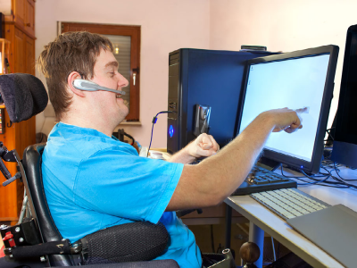

Partnerships and collaborations

MOD initiatives

Information Technology/Assisted Technology (IT/AT) Working Group
Executive Office for Administration and Finance, Executive Office of Health and Human Services, Executive Office of Labor and Workforce Development, Executive Office of Technology Services and Security, Human Resources Division, Massachusetts Commission for the Blind, Massachusetts Commission for the Deaf and Hard of Hearing, Massachusetts Department of Transportation, Massachusetts Rehabilitation Commission, Office of the Comptroller of the Commonwealth of Massachusetts, Operational Services Division, Supplier Diversity Office

Work Experience Program
Human Resources Division, Massachusetts Commission for the Blind, Massachusetts Commission for the Deaf and Hard of Hearing, Massachusetts Department of Correction, Massachusetts Department of Developmental Services, Massachusetts Department of Revenue, Massachusetts Developmental Disabilities Council, Massachusetts Division of Ecological Restoration, Massachusetts Rehabilitation Commission

Collaborations

Affiliations
New England ADA Center

Boards, Councils, and Commissions
Department of Public Health Disability Council, Massachusetts Architectural Access Board, Massachusetts Commission for the Blind Statewide Rehabilitation Council, Massachusetts Developmental Disabilities Council, Massachusetts Rehabilitation Commission Statewide Rehabilitation Council, Massachusetts Statewide Independent Living Council, MassMatch Advisory Council, Municipal Commissions on Disability, State 911 Commission, State Mental Health Planning Council

Committees
Massachusetts Architectural Access Board Regulation Review Subcommittee (Chair), Massachusetts Emergency Management Agency Functional Needs Committee, Massachusetts Department of Transportation Accessible Technology Advisory Committee, National Association of Governors’ Committees on People with Disabilities, Reasonable Accommodations Committee for Service Employees International Union Local 509

Other Projects
Business Enterprise Systems Transformation (BEST) Program in collaboration with the Office of the Comptroller, Consultation with Supplier Diversity Office, Massachusetts Electric Vehicle Incentive Program (MassEVIP) in collaboration with the Massachusetts Department of Environmental Protection

FY22 budget

State appropriated funds $937,681

Federal grants $353,563
Client Assistance Program (CAP) $228,063
Emergency Preparedness Program $125,500

Trust funds $24,900
Americans with Disabilities Act (ADA) Access and Training $24,900

Municipal ADA Improvement Grant (capital funds) $2,000,000

Total $3,316,144
