Massachusetts Office on Disability Annual Report: FY23
July 1, 2022 – June 30, 2023
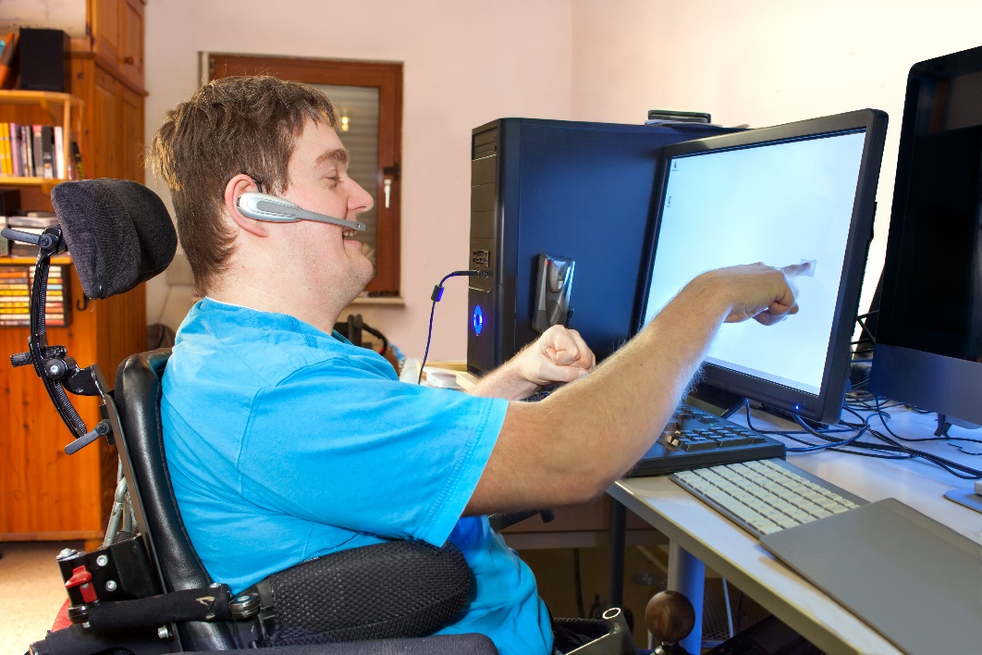

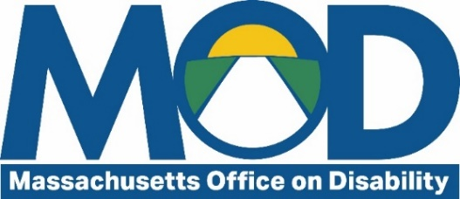

One Ashburton Place, Room 1305
Boston, MA 02108
(617) 727-7440
mass.gov/mod

Table of Contents

About MOD 3
Letter from the Executive Director 4
The MOD team 5
Empowering residents with disabilities and their communities 6
New workshops: Navigating vocational rehabilitation (VR) 6
Technical assistance 6
Reasonable Accommodations and Modifications in Housing 7
Emergency preparedness for people with disabilities 7
Quarterly Tea with MOD 8
Improving accessibility at the local level 9
Municipal ADA Improvement Grant 9
Community Access Monitor (CAM) training 10
Site visits and technical assistance 10
Massachusetts Architectural Access Board (MAAB) 11
Trainings for municipal ADA Coordinators 11
Building an inclusive Commonwealth workforce 12
Accessibility in a Digital World 12
Accessible information technology 13
Work Experience Program 13
Trainings for executive branch ADA Coordinators 14
Boards, councils, and commissions 15
Budget 15

About MOD
The Massachusetts Office on Disability (MOD) was created in 1981 under Chapter 6, Section 185 of the Massachusetts General Laws to “bring about full and equal participation in all aspects of life by all persons with disabilities in the Commonwealth.”
Through Executive Order 592, MOD is established as the Executive Branch’s designated ADA and Rehabilitation Act Coordinator responsible for advising, overseeing, and coordinating compliance with state and federal laws protecting the rights of persons with disabilities.
MOD fulfills its mission by providing information, guidance, and training on disability-related civil rights and obligations to state agencies, municipalities, and the public.

Letter from the Executive Director
Dear MOD Stakeholders:
I’m proud of the vital service MOD provides to the Commonwealth. Massachusetts has a wide range of rights and obligations on the books designed to create a more accessible and inclusive Commonwealth for residents and visitors with disabilities. But those only work if people and institutions know and understand where they fit in the maze of laws, regulations, and services.
In FY23, we continued to “answer the call” from individuals, municipalities, housing providers, employers, our fellow Commonwealth agencies, and more to provide the information, guidance, and training needed to make our laws effective. We expanded our training offerings and online resources, provided almost $3 million in funding directly to cities and towns for accessibility improvements, and laid the groundwork for an unprecedented expansion of digital accessibility initiatives at the state level.
We look forward to continuing this work and thank you for sharing our vision of an accessible, inclusive Commonwealth for all.
Mary Mahon McCauley
Executive Director
Massachusetts Office on Disability

The MOD team

Executive Director
Mary Mahon McCauley

Executive Assistant
William Noonan

Administration and Finance
Michael Dumont, Assistant Director for Administration and Finance

Assistive Technology Support
Rob Dias, Assistive Technology Information Specialist

Communications and Training
Lilia Melikechi, Communications and Training Manager
Sadie Chase-Tatko, Outreach and Communications Intern

Community Services Unit (CSU)
Jeffrey Dougan, Assistant Director for Community Services
Ashley Santana, Access Specialist
Evan George, ADA Municipal Grant Compliance Coordinator
Abigail Shneyder, Emergency Preparedness Program Coordinator

Disability Rights Unit (DRU)
Naomi Goldberg, Assistant Director for Disability Rights Unit and Director of Client Assistance Program (CAP)
Susanne Agerbak, Information Specialist
Camille Karabaich, Information Specialist
Sarah Wiles, CAP Advocate
Inez Canada, CAP Advocate

General Counsel
Julia O’Leary, General Counsel

Empowering residents with disabilities and their communities

New workshops: Navigating vocational rehabilitation (VR)
In FY23, MOD’s Client Assistance Program (CAP) launched two new online workshops to educate interested applicants, consumers, and stakeholders of VR services about how to make the most of these services. The workshops were modeled after CAP’s three-part Disability in Employment online workshop series, which continues to be a success.
Navigating VR: For Parents and Youth is designed for youth ages 14-22 with disabilities, their families, pre-employment transition services (ETS) stakeholders, and special education personnel and discusses how parents can support the VR process, the unwritten expectations of the consumer and the VR agency, how to recognize when something might be going wrong, and how to get back on track.
Navigating VR: For Applicants and Consumers is designed for individuals with disabilities applying for or currently receiving vocational rehabilitation services, their families, and VR stakeholders and covers the purpose of the VR program and the role of each party (consumer and VR agency staff) in implementing services to reach an employment goal, how to recognize when something might be going wrong, and how to get back on track.

Technical assistance
“I see the care you took in giving me the advice you have and I am so grateful…thank you for your kindness and diligence.”
– MOD Caller
MOD responds to over 200 inquiries each month from individuals with disabilities, municipal officials, ADA Coordinators at the local and state level, business owners, housing providers, and more. MOD staff provide expert information and guidance to help people understand their legal rights and obligations so that people with disabilities can equitably live, work, and enjoy their communities alongside their neighbors.
In FY23, the most frequent call topics were legal rights and obligations related to:
- Service and emotional support animals,
- Fair housing,
- Employment, and
- Municipal programs.
In response to constituent needs, MOD developed new online resources and trainings related to assistance animals, housing rights, and more. MOD also worked with the Trial Court Library to update and simplify online information about a wide range of disability rights laws.

Reasonable Accommodations and Modifications in Housing
In response to growing concerns and inquiries related to accessible housing, MOD piloted a new training for Massachusetts residents with disabilities and their advocates. The training gave a plain language overview of housing providers’ obligations to provide reasonable accommodations (RAs) and modifications (RMs), including when providers are allowed to deny a request, the process and evaluation criteria for RA/RM requests, how to submit a good quality RA/RM request, and recourse options when RA/RM needs are not met.
The pilot was held on May 3, 2023 and brought in over 100 participants.

Emergency preparedness for people with disabilities
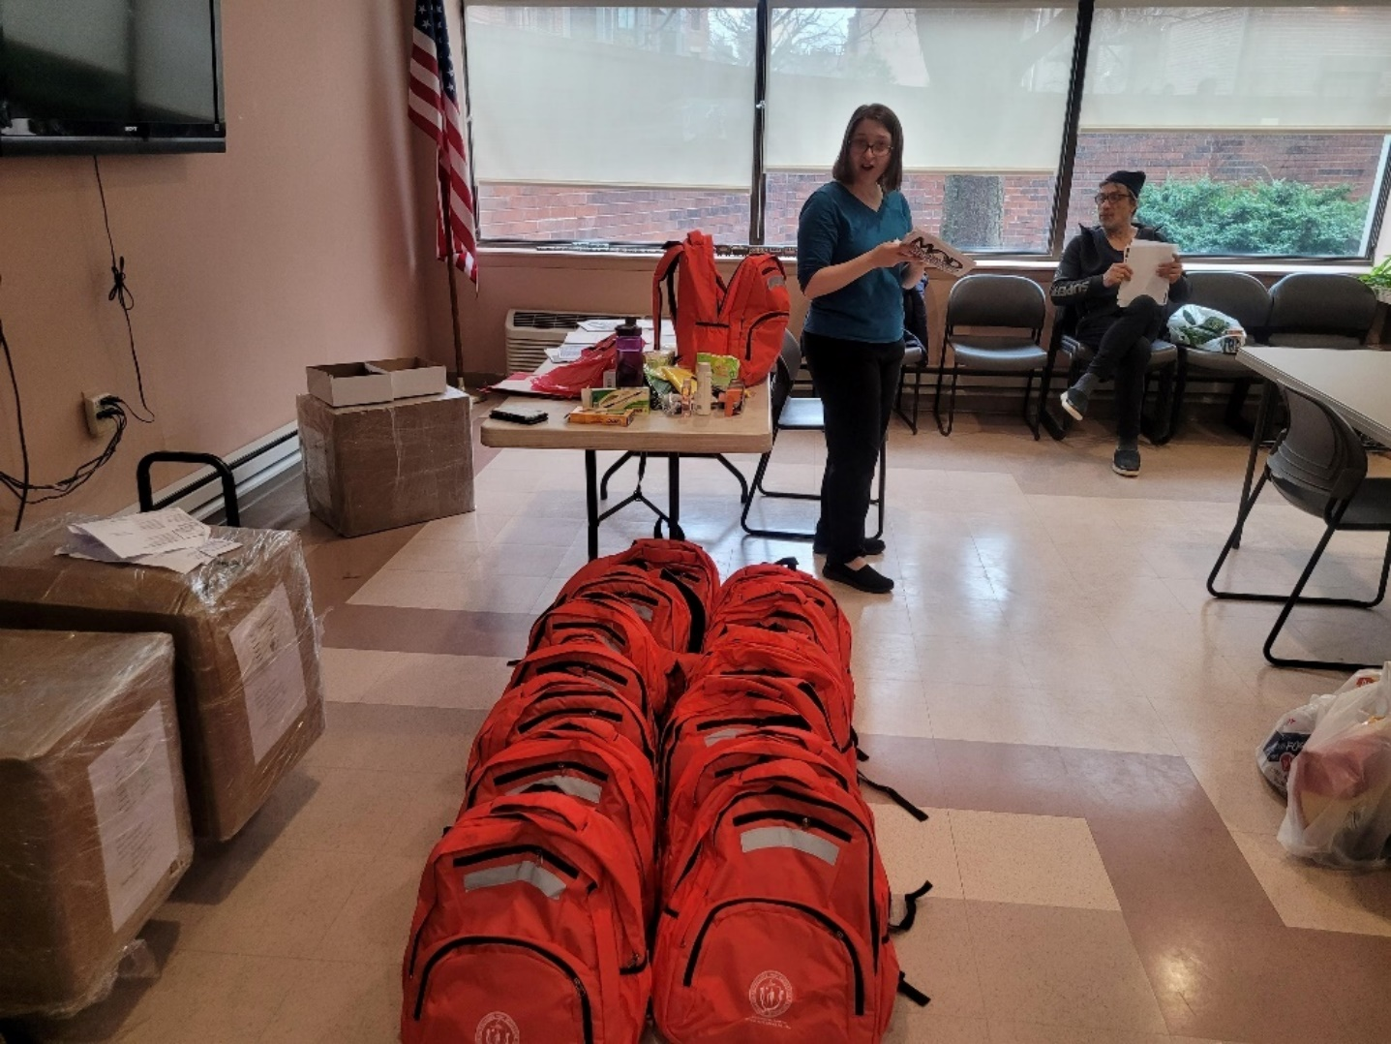
MOD Emergency Preparedness Program Coordinator Abby Shneyder provides an Emergency Preparedness Training alongside several of MOD’s “emergency go packs”
MOD’s Emergency Preparedness training brings together seniors, people with disabilities, local emergency planners, and first responders to get information and tools for preparing for different emergency situations. These trainings ensure people with disabilities have the assistance and appropriate resources needed in times of emergency.
During FY23, the program held a total of 28 meetings throughout the Commonwealth. These meetings were attended by over 800 people with disabilities, over 30 first responders, and more than 100 guests. As a result of these meetings, the program was able to distribute more than 570 emergency go-kits to attendees. In addition, the program was able to achieve its initial goal of holding 30% of its trainings in historically marginalized communities by achieving 35% overall.
Throughout the year, the program has become more involved in fostering existing and new partnerships with partners throughout state government such as the Massachusetts Emergency Management Agency (MEMA) and Department of Public Health (DPH) to further its efforts. These efforts include developing new initiatives to promote emergency preparedness on a community-wide scale.

Quarterly Tea with MOD
This year, MOD launched “Quarterly Tea with MOD”, a regular live webinar series to address our most frequently asked questions and concerns related to hot topics in the disability community. Topics included:
- FAQs about Digital Accessibility: November 16, 2022
- Navigating Support Options to Resolve Disability-Related Issues: February 15, 2023
- Service Animals in Public Settings: June 7, 2023
The Quarterly Tea series has provided a valuable platform to address residents’ pressing questions on a wider scale, leading to more streamlined and effective constituent service calls. Due to its success, MOD plans to continue this series in FY24.

Improving accessibility at the local level

Municipal ADA Improvement Grant
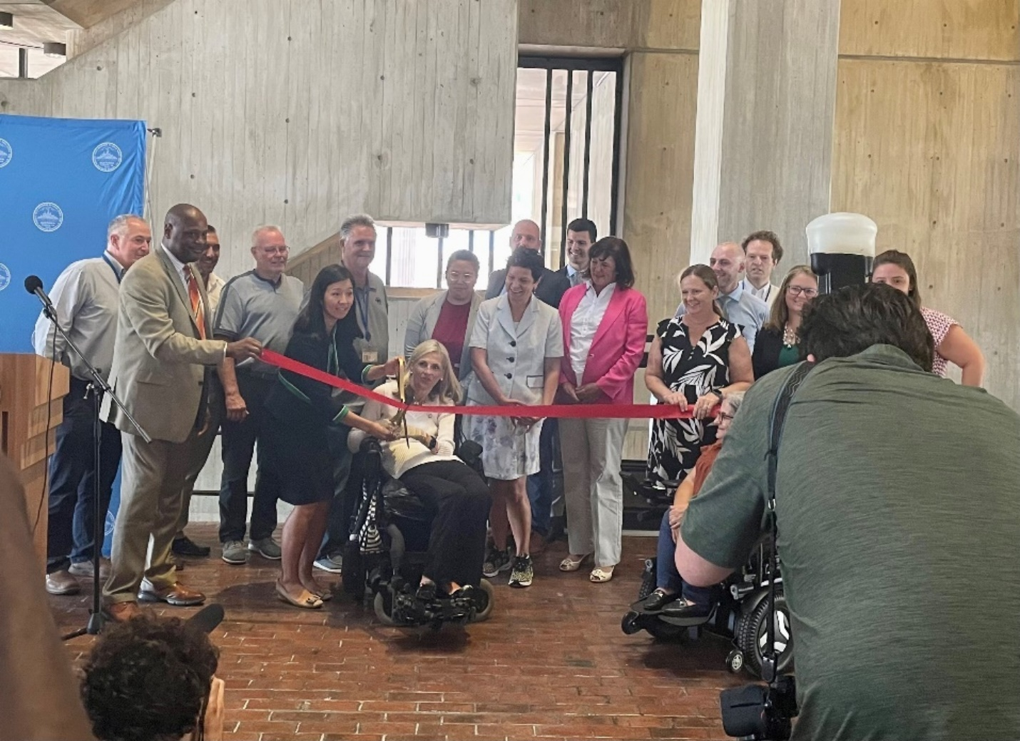
Boston Mayor Michelle Wu and Mayor’s Commission for Persons with Disabilities Commissioner Kristen McCosh cut a ribbon at Boston City Hall to officially open the new vertical lift
The FY23 Municipal ADA Improvement Grant cycle successfully awarded $2,924,998 in funding to 43 communities across the Commonwealth. This included awards for creating and improving 19 ADA Self-Evaluation and Transition Plans and developing 27 new projects to increase accessibility in cities and towns.
One of these projects replaced an outdated stair lift at Boston City Hall with a new, state of the art vertical lift accessible to wheelchair users as well as older adults, people with gait limitations, people with temporary disabilities like a broken leg, and many others. The lift allows access to the mezzanine level of Boston City Hall, its main public space.
With the new lift, Boston’s 80,000+ residents with disabilities – plus the many others who visit Boston regularly and benefit from this improved access – can meaningfully and more easily participate in social and cultural events, public meetings, and lunch and coffee with colleagues and friends.
“The City of Boston is delighted to partner once again with MOD on a project that will increase access to government for all residents. Boston City Hall is both an architectural gem and the People's Building. We're grateful for MOD's funding to install a vertical lift in the Hall to make one of its most unique features - the mezzanine in the 3rd floor lobby – accessible to all."
– Kristen McCosh, Disability Commissioner & ADA Title II Coordinator, Mayor's Commission for Persons with Disabilities

Community Access Monitor (CAM) training
MOD’s Community Access Monitor (CAM) training program trains community members to survey buildings for accessibility and advocate for compliance with various access rules and regulations.
The complete CAM program includes a two-day Beginner CAM Training and a one-day Advanced CAM Training. The program covers structural accessibility, equal policies and practices, accessible communication, and advocacy techniques for partnering with organizations and individuals to be successful in making communities more accessible to people with disabilities.
In FY23, MOD provided:
- Four 2-day Community Access Monitor trainings that trained over 170 people, and
- Advanced Community Access Monitor trainings that trained over 70 people.
In FY24, MOD plans to develop a new CAM Site Visit training and expand CAM training opportunities.

Site visits and technical assistance
In addition to support for individual members of the public, MOD supports municipal accessibility through technical assistance, site visits, and networking opportunities. MOD responds to over 200 inquiries a month related to architectural access, local Commissions on Disability (CODs), accessibility in state and local government programs, and more. In some cases, MOD also conducts site visits across the Commonwealth to assess accessibility concerns in the built environment.
In FY23, MOD provided:
- Two half-day Statewide COD Meetings that brought together over 75 Commissions,
- Eleven individual COD meetings to provide support and assistance to members,
- Six site visits assisting CODs and municipalities with understanding access obligations within the built environment, and
- Technical assistance to several cities and towns, including:
  - A small town that wanted to ensure their public library was compliant with the access codes while also creating more universal access opportunities,
  - An historic church wishing to understand their obligations as they prepared for a major renovation, and
  - A tourist community wishing to understand the accessibility considerations needed as they began an improvement project for a public park and its accessible connection to the beach.
In FY24, MOD plans to expand its resources for CODs to continue to build accessibility across the Commonwealth at the municipal level and beyond.

Massachusetts Architectural Access Board (MAAB)
MOD is a member of the Massachusetts Architectural Access Board (MAAB). The board adjudicates variance requests, complaints, and advisories. MOD also provides expert insight and technical knowledge as a member of the MAAB Regulation Review Subcommittee, which meets monthly to discuss proposed changes to the MAAB for future revisions.

Trainings for municipal ADA Coordinators
Municipal ADA Coordinators play a vital role in building an inclusive and accessible Commonwealth at the local level and are a close partner to MOD. They ensure municipal compliance with the ADA and work directly with individuals with disabilities to resolve disability-related barriers to municipal programs. MOD provides critical training and technical assistance to new and experienced municipal ADA Coordinators.
In FY23, MOD provided the following trainings to municipal ADA Coordinators:
- Public Meetings and Town Meeting: March 8, 2023
- Municipal ADA Coordinator Basics: December 19, 2022
In FY24, MOD plans to expand our training and resources for municipal ADA Coordinators through the creation of a new Municipal ADA Coordinator Peer Resource Group.

Building an inclusive Commonwealth workforce

Accessibility in a Digital World
MOD hosted a hybrid Disability Summit in October 2022. The theme was Accessibility in a Digital World, spotlighting the growing movement for improved accessibility in digital communications.
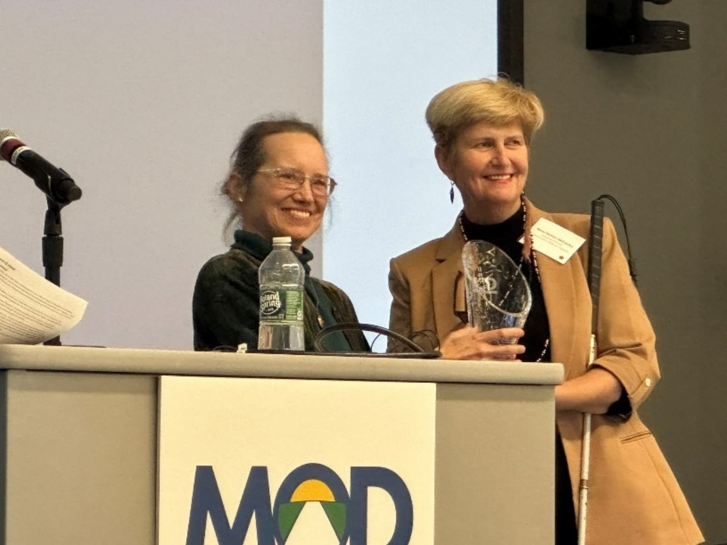
MOD Executive Director Mary Mahon McCauley awards Sarah Bourne, former Commonwealth Director of IT Accessibility, with the Tom Hopkins Disability Access Award for her pioneering work advancing digital accessibility at the state level
The Summit brought in over 400 state and municipal employees, residents with disabilities, professionals in the disability services and tech fields, and more. Keynote speaker Lainey Feingold, a disability rights lawyer and author, spoke on the successful history of digital accessibility efforts in Massachusetts and path forward for continued success. Speakers from the Town of Arlington shared how they were able to use grant funding from MOD to expand access to town meetings, hearings, and other activities for their residents with disabilities. A tech panel featuring experts from Microsoft, Webex, and Zoom showcased lessons learned from accessibility efforts in professional settings, while a speaker from The AbleGamers Charity shared about accessibility and assistive technology in the world of gaming.
Over 400 people attended in-person and online.
“I thoroughly enjoyed the guest speakers, the venue, the networking opportunities, and, most importantly, the valuable information shared throughout the Summit…The impressive and down to earth guest speakers reinforced the importance of the work we all perform to ensure full accessibility for everyone in our Commonwealth community.”
– Summit attendee

Accessible information technology
MOD has continued to partner with the Executive Office of Technology Services and Security (EOTSS) and other Commonwealth agencies and secretariats to advance the digital accessibility of the Commonwealth’s digital resources. MOD worked closely with EOTSS as an advisor on their IT accessibility planning project and continues to work with EOTSS and other state agencies to ensure that the Commonwealth’s web offerings are accessible to all.

Work Experience Program
“Through this program, I have been able to overcome any lingering fear and doubt I had about finding a job as a blind person. The unwavering support and resources provided by your agencies have instilled in me the fortitude and courage to navigate my career path with unwavering confidence, knowing that meaningful and gainful employment is within reach…The impact you have made on my life is immeasurable.”
– Work Experience Program participant
MOD and the Human Resources Division (HRD) held their annual Work Experience Program on June 26-29, 2023. This program introduces job-ready candidates with disabilities to the world of state government through four days of online career workshops and job shadowing with Executive Branch agencies. The program also included a virtual panel of Commonwealth employees with disabilities who shared their experiences.
More than 20 individuals participated and were hosted by over 14 agencies across several secretariats. Participants were individuals with disabilities receiving vocational rehabilitation services from the Massachusetts Rehabilitation Commission (MRC) or the Massachusetts Commission for the Blind (MCB).
“The jobseekers were an impressive group and any state agency would be lucky to have many of them. We had a wonderful and very engaged jobseeker…All in all, a great experience and we thank you for the opportunity.”
– Work Experience Program Host Agency Representative

Trainings for executive branch ADA Coordinators
MOD trains and approves all executive branch ADA Coordinators for the Commonwealth. In addition to basic training, MOD provides ongoing guidance to assist ADA Coordinators with understanding their roles and resolving disability-related barriers. This valuable service creates a more inclusive and accessible work environment for Commonwealth employees with disabilities and Massachusetts residents and visitors with disabilities enjoying state government programs, services, and buildings.
In FY23, MOD provided the following specialized trainings directly to executive branch ADA Coordinators:
- Service and Emotional Support Animals in the Workplace: February 16, 2023
- Title II of the ADA: A Closer Look: May 18, 2023
- Mental Health-Related Accommodations: April 19, 2023
MOD plans to continue this work in FY24 with expanded training offerings and guidance.

Boards, councils, and commissions
- Department of Public Health Disability Council
- Massachusetts Architectural Access Board
- Massachusetts Commission for the Blind Statewide Rehabilitation Council
- Massachusetts Developmental Disabilities Council
- Massachusetts Rehabilitation Commission Statewide Rehabilitation Council
- Massachusetts Statewide Independent Living Council
- MassMatch Advisory Council
- Municipal Commissions on Disability
- National Association of Governors’ Committees on People with Disabilities
- Special Commission on State Institutions
- State 911 Commission
- State Disability Agencies Collaborative (National)
- State Mental Health Planning Council

Budget
- State Appropriated Funds $1,088,326
- Federal Grants
  - Client Assistance Program $229,482
- Trust Funds
  - ADA Access and Training $22,917
- Capital Funds
  - Municipal ADA Improvement Grant $3,000,000
- Total $4,340,725

