

Model EMS Contract

INSTRUCTIONS FOR USE OF
MODEL CONTRACT
FOR COMPREHENSIVE PROJECT
UNDER BOTH
225 CMR 10.00 AND 225 CMR 19.00

Disclaimer

This document is a model Energy Management Services Agreement (Contract) with provisions to use in procuring Energy Management Services (EMS) for comprehensive projects under 225 CMR 10.00 or 225 CMR 19.00. The information contained within is general and subject to change. The document is not intended to provide legal advice; it is intended to serve as an introduction to the elements pertaining to the development of an EMS project and should not be used as a substitute for a thorough analysis of facts and the law. When procuring for EMS, it is the sole responsibility of each governing body to consult with legal counsel in preparing any documents and to ensure compliance with all applicable federal, state, and local laws, rules, regulations, and procurement procedures.

The users of this document are strongly encouraged to search actively for the most recent updates of governmental regulations. Readers may check for recent updates to Energy Management Services at www.mass.gov/doer or by calling (617) 626-7305.

ACKNOWLEDGEMENTS

This document was prepared by Eileen McHugh, Program Coordinator (DOER). DOER would like to thank Robert Sydney, former General Counsel (DOER); Rachel Evans, Deputy General Counsel (DOER); Natalie Andrews, former Renewable Energy Project Coordinator (DOER); Beth Greenblatt, Managing Director, Beacon Integrated Solutions; and the Energy Services Coalition for their contribution to this document.

This model Contract contains provisions for the installation of Energy Conservation Measures and Energy Conservation Projects under 225 CMR 10.00 and 225 CMR 19.00.

All Contracts must be submitted to DOER as detailed below.

- Use this model Contract as a foundation for the solicitation. The document is intended as guidance to ensure compliance with the statute and the regulation.

- Change the Contract to fit the specific procurement. For example, adding details applicable to the particular project or standard language required by the awarding authority.
- A Local Governmental Body shall only award a contract for EMS if all the requirements of 225 CMR 10.00 or 225 CMR 19.00 have been met. At least 15 Business Days prior to execution of an EMS contract, the Local Governmental Body shall file with DOER a final copy of the contract along with DOER’s EMS Annual Report with projected energy and water cost savings estimates. To file EMS documents with the DOER, email one complete electronic copy to: EMS.DOER@state.ma.us and mail one complete copy to:
Massachusetts Department of Energy Resources
Attn: NOTIFICATION OF EMS PROCUREMENT
100 Cambridge St., Suite 1020
Boston, MA 02114
Include the name of the Local Governmental Agency (LGA), the physical address, the name and contact information for the Chief Procurement Officer, if applicable, or an alternative local governmental official with equivalent responsibilities and authority, and the current phone number & email address for the person responsible for the Contract. DOER will notify the LGA if the contract meets all the requirements.
Within 15 Business days after the contract is executed, the Local Governmental Body shall file an electronic copy of the executed contract with the Commissioner of DOER under the terms of EMS Contract Submission Guideline.

Energy Management Services (EMS)
EMS provides for a program of services, including Energy Audits, Energy Conservation Measures, Energy Conservation Projects or a combination thereof, and building maintenance and financing services, primarily intended to reduce the cost of energy and water in operating public buildings. This method provides for a limited exemption from M.G.L. c.149 for construction. Elements of the EMS contract include:
- Construction and installation terms to implement the projects identified (and later negotiated) in the investment grade audit report including all labor and material costs.
- Long-term provisions for guaranteed energy and water cost savings that typically meet the annual lease-purchase payments or debt payments.
- Long-term provisions to monitor and verify performance plus any additional annual fees related to the project.
- A financing agreement with a financial client is signed at the same time, unless other funding arrangements are made
Savings Guarantee
- Energy and water efficiency savings guarantees
- Baseline energy consumption
- Efficiency savings measurement and verification plan; methodology to adjust baseline
Payments and Schedule
- Final project cost and project cash flow analysis
- Financing agreement and payment schedule
- Compensation to ESCO for annual services
Construction Phase
- Description of project sites
- Equipment to be installed by ESCO (labor and materials)
- Construction and installation schedule
- Systems start-up and commissioning; operating parameters of installed equipment
- Standards of comfort
- ESCO’s training responsibilities
Post-Construction
- Guaranteed energy savings measurement and verification
- ESCO’s maintenance responsibilities
- Client’s maintenance responsibilities
- Facility maintenance checklist
Administration
- Annual reporting requirements

The model contract begins on the next page

Preamble

This Energy Management Services Agreement (hereinafter “Agreement”) is made and entered into as of (“Effective Date”) by and between (hereinafter “Contractor”), a based Corporation having its principal offices at , and (hereinafter the “Owner”), having its principal offices at (address), for the purpose of furnishing certain equipment and work specified herein (“Work”), and assuring the performance of said Work, for design, construction, guarantee, and follow-up measurement and verification of energy savings. The project will improve thermal efficiency, conserve energy, conserve water, reduce waste water, and, when specified, generate electrical power at Owner properties included in the RFP.

Section 1: Definitions

Key terms used within this Agreement are defined as follows:

Adjusted Energy Baseline. An energy baseline adjusted to compensate for factors that would have changed energy consumption in the absence of any energy conservation measures, such as increases or decreases in conditioned or illuminated space, changes in occupancy or building use, facility renovation, or extremes in weather.

Business Day. A business day shall mean Monday through Friday, exclusive of state and federal legal holidays.

Commissioning. The process for achieving, verifying, and documenting the performance of the energy and water conservation measures to meet the operational capabilities of the project as designed including documentation of checklists, systematic functional testing of equipment and systems, oversight of training for operations and maintenance staff, and follow-up on any warranty issues.

DCAM. The Division of Capital Asset Management and Maintenance, established by M.G.L. c. 7, § 4A.

DOER. The Department of Energy Resources, established by M.G.L. c. 25A, §1.
EMS Annual Report. A report form required by DOER that must be completed by the Local Governmental Body summarizing the energy or water unit and dollar cost savings. The initial report providing estimated savings must be filed along with the EMS contract and thereafter within 90 days after the anniversary of the Guaranteed Energy Performance Period.
Energy Audit. A systematic inspection, verification, and determination of the energy consumption characteristics of a building or facility which:
(a) identifies the type, size, and rate of energy consumption of such building or facility and the major energy using systems of such building or facility;
(b) determines appropriate energy conservation maintenance and operating procedures; and
(c) indicates the need, if any, for the acquisition and installation of Energy Conservation Measures or On-site Energy Generation.

Energy Conservation. A modification of, or change in, the operation of real or personal property in a manner likely to improve the efficiency of energy use, and shall include Energy Conservation Measures and any Energy Audits to identify and specify energy and cost savings.

Energy Conservation Measures. Measures involving modifications of maintenance and operating procedures of a building or facility and installations therein, which are designed to reduce energy consumption in such building or facility, or the installation or modification of an installation in a building or facility, which is primarily intended to reduce energy consumption.
Energy Conservation Projects. Projects to promote Energy Conservation, including but not limited to energy conserving modification to windows and doors; caulking and weather stripping; insulation, automatic energy control systems; hot water systems; equipment required to operate variable steam, hydraulic and ventilating systems; plant and distribution system modifications, including replacement of burners, furnaces or boilers; devices for modifying fuel openings; electrical or mechanical furnace ignition systems; utility plant system conversions; replacement or modification of lighting fixtures; energy recovery systems; on-site electrical generation equipment using new renewable generating sources as defined in section 11F; and cogeneration systems.
Energy Management Services (EMS). A program of services, including Energy Audits, Energy Conservation Measures, Energy Conservation Projects or a combination thereof, and building maintenance and financing services, primarily intended to reduce the cost of energy and water in operating buildings, which may be paid for, in whole or in part, by cost savings attributable to a reduction in energy and water consumption that result from such services. The EMS contract may extend for a term not to exceed twenty years. The allowable length of the contract may also reflect the useful life of the cost savings measures.
Energy Savings. A measured reduction in fuel and its costs, energy and its costs, water and its costs, or operating or maintenance costs resulting from the implementation of Energy Conservation Measures or Projects; provided, however, that any payback analysis to evaluate the energy savings of a geothermal energy system to provide heating, cooling or water heating over its expected lifespan shall include gas and electric consumption savings, maintenance savings and shall use an average escalation rate based on the most recent information for gas and electric rates compiled by the Energy Information Administration of the United States Department of Energy.
Established Baseline. A written description of previous fuel, energy, and water consumption data and operating and maintenance costs for the past three years, including, but not limited to, future capital replacement expenditures avoided as a result of equipment installed or services performed. The description shall be included in the Request for Proposals.
Escalation Rate. The escalation rate is the rate of increase in price that is based on the most recent information for gas and electric rates compiled by the Energy Information Administration of the United States Department of Energy (see Energy Savings).
Estimated Energy Cost Savings. The Contractor-estimated energy cost savings in dollars per year for each Energy Conservation Measure (ECM), and equal the estimated energy savings multiplied by the established energy prices in appropriate units. For ECMs with multiple energy type impacts, energy cost savings equals the sum of the products of the energy savings by energy type and established energy prices.

Excess Savings. Actual savings realized that are over and above guaranteed savings.

FEMP. The Federal Energy Management Program.

Final Completion. Final Acceptance by the owner that the Contractor has fulfilled all of its obligations under the Contract including construction, installation, inspection, testing, measuring initial performance and commissioning, and that all punch list items are reconciled and subcontractors, laborers, and suppliers are paid in full.

Guarantee of Generation. The written guarantee of a Contractor warranting the particular electrical energy generation to be derived from the On-site Electrical Generation unit. Such written guarantee shall:
(a) include a detailed description of the equipment to be installed; and
(b) state the annual amount of electrical energy to be generated in kilowatt hours per year.

Guarantee of Savings. The written guarantee of a Contractor, warranting the energy savings to be derived from a particular Energy Conservation Measure, Energy Conservation Project, Energy Management Services, or Energy Savings. Such written guarantee shall include a detailed description of the cost of the energy or water conservation or usage measures, all causally connected work, and ancillary improvements provided for in the contract. The guarantee shall state the annual savings expressed in applicable energy units or (if water savings) in gallons per year and be based on dollars saved by reference to established unit rates.

Guaranteed Energy Savings Contract. A contract for the evaluation, recommendation or implementation of one or more energy management services in which payments are based, in whole or in part, on any energy savings attributable to the contract.

Guaranteed Maximum Cost. The fixed maximum cost of the Energy Management Services, including:
(a) the cost of each energy conservation measure, after installation, startup, and testing; and
(b) the total payments made by a Local Governmental Body to a contractor, including but not limited to, the total capital investment and the contractor’s costs. Utility sponsored rebates, tax credits or other incentives, any direct governmental subsidies, interest payments, and energy and water cost savings shall not be deducted from the Guaranteed Maximum Cost.

Guaranteed Savings Year. The 365 day period beginning on the Final Completion Date and each consecutive 365 day period thereafter during the contract period.

Guidelines. A set of clarifications, interpretations, and procedures, including forms and model documents, developed and issued by DOER to assist it in determining compliance with 225 CMR 10.00. Each Guideline shall be effective on its date of issuance or on such date as is specified therein, except as otherwise provided in 225 CMR 10.00 and 225 CMR 19.00.

Implementation Period. The implementation period is the period between the date the Agreement is executed to the date that all energy conservation measures (ECMs) are operational and accepted.

Investment Grade Audit (IGA). An Energy Audit that includes a detailed evaluation of the Energy Conservation Project cost, including but not limited to the investment opportunities for Energy Conservation Measures, operations and maintenance. The IGA shall provide a return on investment that represents an optimized bundle of short-term payback Energy Conservation Measures combined with long-term payback Energy Conservation Measures to meet Local Governmental Body Energy Savings and financial goals.

Measurement and Verification (M&V). The process of measuring and verifying the performance of the project to assure that guaranteed energy, water and related cost savings are being realized.

Notice to Proceed. Letter from an Owner to a Contractor stating the date the Contractor may begin the Work subject to the conditions of the agreement.

On-site Energy Generation. The generation of Renewable Energy or the cogeneration of electricity and heating or cooling of a generation unit located on or adjacent to a building or structure owned by a Local Governmental Body that utilizes some or all of the energy so generated either directly or indirectly though net metering, as defined in M.G.L. c 164, §138.

Payment Bond. A type of construction bond (bid, payment, and performance bonds) that provides assurance that specified subcontractors, laborers and suppliers associated with the project will be paid in the event of default by the contractor.

Performance Bond. A type of construction bond (bid, payment, and performance bonds) that provides protection from financial loss to the project owner should the contractor or subcontractor fail to perform according to the terms and conditions of the contract (not to be confused with “guaranteed performance).

Punch List. A list of disputed energy conservation measures.

Renewable Energy. The electrical energy output of an RPS Class I Renewable Generation Unit, Solar Carve-Out Renewable Generation Unit, or Solar Carve-Out II Renewable Generation Unit as defined under 225 CMR 14.00: Renewable Energy Portfolio Standards – Class I.

Request for Proposals (RFP). A written document issued by a Local Governmental Body that invites potential Responsive Offerors to submit proposals outlining their qualifications to perform the Energy Management Services for the Local Governmental Body, a cost proposal, and other information required by 225 CMR 10.03(1) and (2) and the Local Governmental Body.

Request for Qualifications (RFQ). A written document issued by a Local Governmental Body that invites qualified providers to submit responses outlining their qualifications, the desire to perform the EMS for the Local Governmental Body, and other information required by 225 CMR 19.00 and the Local Governmental Body.

Substantial Completion Date. The date on which the Contractor warrants by written notice that the ECMs are substantially complete and producing savings equal to or greater that the guaranteed savings.

Shortfall. The deficiency in energy cost savings that the Contractor guaranteed and the actual savings in any one Guaranteed Savings Year.

Section 2: Price and Terms

2.1 Agreement Price

As payment for the Work, Owner shall pay Contractor a firm, fixed price for which the total maximum contract value is not to exceed $_________ (“Guaranteed Maximum Cost”). To the extent that materials and supplies are used or incorporated in the performance of Agreement, the Contractor is considered an exempt purchaser under the Massachusetts Sales Act, Chapter 14 of the Acts of 1966. Contractor shall be responsible for paying all other taxes and tariffs of any sort related to the Work. This Agreement is conditional upon the Owner obtaining financing from a regulated lender or municipal lessor in an amount not less than the Agreement Price under such terms as are satisfactory to the Owner, provided Owner shall diligently pursue such financing and such terms are customary, reasonable and in compliance with pertinent laws and regulations.

2.02 Payment Terms

- Initial Payment: Upon receiving funds from its lender or municipal lessor, an amount of _____________________________ dollars ($ ) shall be paid for performance under the Investment Grade Audit Agreement (“Agreement”), mobilization and other costs incurred prior to commencement of Work.

- Progress and Final Payments: A Payment Schedule is attached hereto in Attachment X: Payment Schedule, Payment Application, and Certification. The Contractor will invoice on a progress basis all Work using the Application and Certification for Payment form.
All Payment Applications will be based on the Schedule of Contract Values, which will allocate the entire Project Install Price among the various portions of the Installation Services on a per ECM basis and be supported by sufficient data to substantiate its accuracy. Stored materials and pre-purchased equipment must be accompanied by written pre-authorization from the Owner. The Owner will make progress payments to the Contractor within 45 days of all amounts due upon receipt of such properly executed form.

- Payment Application: Progress payments will be calculated using the Payment Application and Certification Summary and Current Earnings form in Attachment 8 as follows:

- Current Earnings
Determine the per ECM Installation Service charge for the current billing period as the percentage of work completed of the total ECM project cost allocated to that portion of the Installation Services in the Schedule of Contract Values, less Retainage of ten percent (10%), which shall be held as additional security for the faithful performance of all the work required under this Agreement. The Owner will pay retainage within forty-five (45) days after Final Acceptance;
Add that portion of the ECM project cost for pre-approved materials and equipment delivered and suitably stored at the site for subsequent incorporation in the completed construction, less Retainage of ten percent (10%);
Deduct any utility or third-party rebates, withheld, or nullified earnings and any other adjustments to determine revised contract value to determine Payment for current Application.
- Contract Payment Status
Complete information in Application Summary bringing forward aggregate of data from Current Earnings. The Owner will review, approve, or reject Payment Application within ten business days.

- Substantial Completion
Upon Substantial Completion, the Contractor will provide a Delivery and Acceptance Certificate in the form of Exhibit 4 for each ECM. Within ten business days of receipt, the owner will sign and return the Certificate for each completed ECM indicating either acceptance or rejection of Substantial Completion.
Other than as a result of circumstances beyond the reasonable control and without the fault or negligence of the parties (see Section 3.2), if the Contractor fails to substantially complete a specific ECM by the scheduled ECM Substantial Completion Date stated in Attachment 7: Project Schedule (or an adjusted date approved by the owner in writing) then for each 30 days (or portion thereof) that the Substantial Completion Date is behind schedule, liquidated damages will be calculated and assessed. The monetary value of damages will equal that portion of the ECM remaining incomplete multiplied by the product of the number of days late divided by 30, multiplied by 3%, which calculation shall serve to reduce the Project Install Price. The assessment of liquidated damages shall cease as of the date of submission of a Delivery and Acceptance Certificate for such ECM. This reduction in the Project Install Price, if imposed, shall constitute the sole monetary recourse for the previously mentioned delay(s).

The Contractor will submit a Payment Application and Certification Summary and Current Earnings, adding a sum sufficient to increase the balance to 90% of the ECM project cost, less any amounts disputed as incomplete Work or unsettled claims.

- Final Completion
At least thirty days in advance of the scheduled date of Final Completion, the Contractor will meet with the Owner to assess the progress and remaining work to complete the Scope of Services. If the Contractor is unable to complete the Scope of Services within the schedule time remaining then the Owner may request that the Contractor accelerate the Work.
- Performance Period
Following the date that the owner executes a Final Delivery and Acceptance Certificate (Attachment x), the owner will pay the current Performance Period Fee set forth in Attachment 4 for each successive twelve (12) month period.

- Retainage
In addition to any other amounts to be retained hereunder, the owner may retain any sums otherwise owed to the ESCO sufficient to cover the full costs of any of the following:
- The ESCO’s failure to comply with any provision of the Scope of Services, or because of negligent acts or omissions in the performance of any part of the Agreement, including, but not limited to, violation of any applicable law, order, rule or regulation, including those regarding safety, hazardous materials or environmental requirements;

- Correction of defective or nonconforming work by redesign, repair, rework, replacement or other appropriate means when the ESCO states, or by its actions indicates, that it is unable or unwilling to proceed with corrective action in a reasonable time and/or if the ESCO fails to take action within thirty (30) calendar days after receiving written notice and the owner is required to take action or perform work such as cleanup or completion of incomplete work.

- Charge Backs
The owner may also back charge the ESCO for work done or cost incurred to remedy the aforementioned or any other ESCO defaults, errors, omissions or failures to perform or observe any part of the Scope of Services. The owner shall give written notice, and the ESCO will have thirty calendar days to remedy the reported problem before the owner performs such actions or work or incurs such cost.
The cost of back charge work shall include:
- Labor costs including all payroll additives;
- Net delivered material costs;
- Lower-tier supplier costs directly relating to performing the corrective action;
- Equipment and tool rentals at prevailing rates;
- Alternative temporary equipment; and
- A factor of 15% applied to the total of Items (1) through (5) for overhead, supervision, and administrative costs. The back charge notice will request ESCO concurrence for the owner to proceed with the required action or work. The ESCO’s failure to concur shall not impair the owner’s right to proceed with the action or work under this or any other provision of this Agreement.

The owner will separately invoice or deduct from payments otherwise due to the ESCO the costs as provided herein. The owner’s right to back charge is in addition to any and all other rights and remedies provided in this Agreement or by the Commonwealth of Massachusetts. The performance of back charge work by the owner shall not relieve CES of any of its responsibilities under this Agreement.

- Final Payment
The entire unpaid balance of the Project Install Price, shall be made when (1) the Installation Services have been fully performed, including all training, commissioning and delivery of Project documentation, (2) a Final Delivery and Acceptance Certificate has been executed and (3) an Application for Final Payment has been issued and approved.
The owner will make final payment not more than thirty days after the issuance of the Application for Final Payment of any balance remaining that is not disputed.
2.4 Agreement Termination

This Agreement shall terminate ________ ( ) years after Acceptance and Final Completion unless otherwise agreed to in writing (with twenty years being the maximum allowed).

Section3: General Provisions

3.01 Dispute Resolution

Disputes regarding changes in and interpretations of the terms or scope of the Agreement and denials of or failures to act upon claims for payment for extra work or materials shall be resolved according to the following procedures:

- All claims by either party shall be made in writing and submitted to the Owner for a written decision.

- Contractor shall not delay, suspend, or curtail performance under the Agreement because of any dispute subject to this section.

- Within sixty days of submission of the dispute to the Owner, the Owner shall issue a written decision stating the reasons thereof, and shall notify the parties of their right of appeal under this section. If the official or his designee is unable to issue a decision within sixty days, he shall notify the parties to the dispute in writing of the reasons and of the date by which the decision shall issue.

- Arbitration to commence w/in 60 days

Failure to issue a decision within one hundred and twenty-days (or within the additional period specified in such written notice) shall give the petitioner the right to pursue any legal remedies available to him without further delay.

3.02 Conditions beyond Control of the Parties

Except as otherwise provided herein, if either party shall be unable to carry out any material obligation under this Agreement due to events beyond its control, such as acts of God, governmental or judicial, insurrections, riots, extended labor disputes, fires, explosions or floods, this Agreement shall remain in effect but the affected party's obligations shall be suspended until the uncontrollable event terminates or is resolved, unless the Agreement is terminated by mutual consent, in which event, Owner shall pay Contractor for all parts of the Work furnished to the date of termination or as otherwise agreed.

3.03 Labor Laws

The Contractor shall obey and abide by all laws and regulations of the Commonwealth relating to the employment of labor and public work.

Contractor shall comply with all federal and state laws, rules, and regulations promoting fair employment practices or prohibiting employment discrimination and unfair labor practices. Contractor shall not discriminate in the delivery of services against any person who otherwise meets the eligibility criteria for services, or in the hiring of any applicant for employment nor shall any qualified employee be demoted, discharged or otherwise subject to discrimination in the tenure, position, promotional opportunities, wages, benefits or terms and conditions of their employment because of race, color, national origin, ancestry, age, sex, religion, disability, status as a Vietnam Era Veteran, sexual orientation or for exercising any rights or benefits afforded by law.

3.04 Prevailing Wage Rate

The Division of Occupational Safety has established a Schedule listing the prevailing minimum wage rates that must be paid to all workers employed on the Agreement by either the Contractor or its subcontractors. Such Schedule shall continue to be the minimum rate of wages payable to workers on this Agreement throughout the term of this Agreement. The Contractor shall not have any claim for extra compensation from the Owner if the actual wages paid to employees on the Agreement exceeds the rates listed on the Schedule. The Contractor shall cause a copy of the Schedule to be kept in a conspicuous place at the project site during the term of this Agreement (see MGL c. 149 § 27). If reserve police officers are employed by the Contractor they shall be paid the prevailing wage rate of regular police officers (see MGL c. 149 § 34B).

3.05 Appropriations

The Owner reasonably believes that funds can be obtained sufficient to make all payments due to Contractor under this Agreement. The Owner hereby covenants that it will make reasonable and diligent efforts to obtain and maintain funds from which such payments may be made, including making provisions for such payments to the extent necessary in each annual or supplementary budget submitted for the purpose of obtaining funds, and using reasonable efforts to have such portion of the budget approved. Nothing herein shall obligate the Owner to institute legal action before any court, to commence proceedings before any forum, or to institute proceedings in the nature of mandamus against any public official in attempting to obtain said funds.

In the event that the Owner is unable to obtain an appropriation of funds sufficient to discharge the Owner’s obligations under this Agreement (insert language citing municipal contracting/appropriation authority. See M.G.L. chapter 44, section 31).

3.06 Laws, Regulations, Ordinances, and Standard Practices

Contractor shall perform its obligations hereunder in compliance with all applicable federal, state, and local laws, regulations, ordinances and by-laws, including applicable licensing and permitting requirements, in accordance with sound engineering and safety practices, and in compliance with all reasonable rules or policies of the Owner relative to the properties. Contractor shall be responsible for obtaining all governmental permits, licenses, consents, and authorizations as may be required to perform its obligations hereunder (see Section 4.10 regarding permits and fees pertaining to the Work).

This Agreement is made and shall be interpreted and enforced in accordance with the laws of the Commonwealth of Massachusetts. If any provision of this Agreement shall be determined to be invalid or unenforceable under applicable law, such provision shall, insofar as possible, be construed or applied in such manner as will permit enforcement; otherwise this Agreement shall be construed as if such provision had never been made part thereof.

The Parties agree to notify each other as promptly as is reasonably possible but in no event more than 3 business after becoming aware of an inspection under, or any alleged violation of, the Occupational Safety and Health Act or any other provision of Federal, State or local law, relating in any way to the undertakings of either Party under this Agreement.

3.07 Patents and Patent Rights

The Contractor shall indemnify and hold the Owner harmless from all claims and actions due to any actual or asserted infringement upon patent rights in any equipment, material, or process used by Contractor in connection with this Agreement.

3.08 Access and Inspection

Owner shall have access to inspect the Work and the books, records, and other compilations of data that pertain to this Agreement. Records shall be kept on a generally recognized accounting basis and calculations kept on file in legible form. Records shall be saved or archived for a period of three (3) years after the termination of this Agreement and shall be kept or made available within Massachusetts.

Contractor shall have access (upon reasonable notice to the Owner) to inspect the property to assess the condition and operation of material and equipment installed and shall maintain an adequate inspection system and perform such inspections as will ensure that the work performed under the Agreement conforms to Agreement requirements. The Contractor shall maintain complete inspection records and make them available to the Owner.

All work is subject to inspection and testing at all places and at all reasonable times before acceptance to ensure strict compliance with the terms of the Agreement. Contractor shall replace or correct work, without charge, found not to conform to the Agreement. If the Contractor does not promptly replace or correct rejected work, the Owner may, by contract or otherwise, replace or correct the work and charge the cost to the contractor or terminate for default the Contractor's right to proceed.

Notwithstanding inspection and acceptance by the Owner or any provision concerning the conclusiveness thereof, the Agreement warrants that all services performed will, at the time of acceptance, be free from defects in workmanship and conform to the requirements of this Agreement.

3.09 Ownership of Documents

All drawings, reports and other materials prepared by Contractor specifically in performance of this Agreement shall become the property of the Owner. Said documents will be available as needed by the Owner or, if not so requested, prior to acceptance of the project.

3.10 Sales Tax Exemption

Owner is exempt from the assessment of Massachusetts sales and use taxes. Owner shall issue Contractor a tax exemption certificate to use for the purchases of new equipment/systems for the Owner’s benefit to complete the Work. Contractor shall not pay any sales or use taxes on any item exempt from Massachusetts sales and use taxes unless authorized by Owner or is ordered by an appropriate taxing authority to remit sales and use taxes.

3.11 Certificates

Contractor certifies as follows:

- Certificate of Authorization: If Contractor is a corporation, each person executing this Agreement on behalf of the Contractor hereby covenants, represents and warrants that Contractor is a duly incorporated or duly qualified (if foreign) corporation and is authorized to do business in the Commonwealth of Massachusetts (a copy of evidence thereof to be supplied to the Owner upon request); and that each person executing this Agreement on behalf of the Contractor is an officer of Contractor and that he or she is duly authorized to execute, acknowledge and deliver this Agreement to the Owner, a copy of a corporate resolution to this effect is attached hereto as Attachment _.
- Tax Compliance Certification: Pursuant to M.G.L. c. 62C § 49A(b), each person signing this Agreement on behalf of the Contractor hereby certifies, under the penalties of perjury, that to the best of his/her knowledge and belief, the Contractor has complied with any and all applicable state laws.

- Certificate of Non-collusion: The undersigned certifies under penalties of perjury that this Agreement has been made in good faith and without collusion or fraud with any other person. As used in this certification, the word “person” shall mean any natural person, business, partnership, corporation, union, committee, club, or other organization, entity of group of individuals.
- Foreign Corporation: Contractor, if a foreign corporation, hereby certifies that it complies with M.G.L. c. 181 § 4 and that the name and address of the resident agent is attached hereto with Exhibit _.
- Covenants: Contractor covenants that: (1) it presently has no financial interest and shall not acquire any such interest direct or indirect, which would conflict in any manner or degree with the performance of services required to be performed under this Agreement or which would violate M.G.L. c. 268A, as amended from time-to-time, (2) in the performance of this Agreement, no person having such an interest shall be employed by the Contractor, and, (3) no partner or employee of the Contractor is related by blood or marriage to any Commissioner or employee of the Owner.
- Owner Certification: The Owner certifies that it is duly authorized to execute, acknowledge and deliver this Agreement under the provisions of M.G.L. Chapter 25A § 11C or § 11I, to retain Contractor to design, acquire, install and assist in the maintenance of the installed equipment to accomplish the energy conservation measures and to provide other services, as more fully set forth herein, subject to all the terms and conditions of this Agreement.

3.12 Assignment

Contractor shall not assign, transfer, convey, or otherwise dispose of this Agreement, or any part hereof, or his right, title or interest in the same or any part thereof, without the prior written consent of the Owner. Contractor shall not assign by power-of-attorney, or otherwise, any of the moneys due or to become due and payable under this Agreement, without the prior written consent of the Owner.

3.13 Audit Report and Project Development

The Contractor has prepared the complete Audit Report of the Project Site(s) that has been approved and accepted by Owner (Exhibit 4: Certificate of Acceptance—Technical Energy Audit Report). The Final Audit Report set forth in Attachment 3: Scope of Work and dated __________ includes all energy conservation measures agreed upon by the parties.

3.14 Complete Agreement

This Agreement, together with any documents incorporated herein by attachment or by reference, shall constitute the entire and exclusive Agreement between both parties. This Agreement may not be amended or modified except in writing and executed by the Owner and the Contractor.

It is understood and agreed that the following documents, attachments, exhibits, schedules and any amendments and/or addenda, comprise the total Agreement:

Attachment X: Property Description
Attachment X: Baseline Energy Consumption
Attachment X: Scope of Work
Attachment X: Project Cost and Savings (Available in excel spreadsheet)
Attachment X: Measurement & Verification Plan
Attachment X: Commissioning Plan
Attachment X: Project Schedule
Attachment X: Payment Schedule, Application and Certification (Available in excel spreadsheet)
Attachment X: Equipment Submittals
Attachment X: Training

Exhibit X: Notice to Proceed
Exhibit X: Certificate of Acceptance Final Audit Report
Exhibit X: Certificate of Acceptance Forms
Exhibit X: Payment and Performance Bonds
Exhibit X: DOER Annual Report Form

The failure of either the Contractor or the Owner to insist upon the strict performance of any term or condition hereof shall not constitute or be construed as a waiver or relinquishment of either party’s right to thereafter enforce the same in accordance with this Agreement.

Section 4: The Work

4.01 Time for Performance and Final Completion

Contractor shall commence Work within sixty days of Owner sending the Contractor a Notice to Proceed, which Owner shall send upon closing financing. Contractor shall substantially complete Work within __________ ( ) days after commencing said Work. Extension of dates to commence or complete Work is at the sole discretion of the Owner. Approval for an extension of dates to commence or complete Work shall not be unreasonably withheld if the cause for an extension is pursuant to Sections 4.03, 4.06, 4.08, 4.12, 4.13, or 9.02.
If Contractor is delayed in the commencement or completion of any part of the Work due to events beyond Contractor’s control and without the fault or negligence of the Contractor, including but not limited to fire, flood, extended labor disputes, unusual delays in deliveries, unavoidable casualties, abnormal adverse weather, war, and acts of God, or due to Owner’s actions or failure to perform its obligations under this Agreement or to cooperate with the Contractor in the timely completion of the Work, then Contractor will notify Owner in writing of the existence, extent of, and reasons for such delay. Contractor shall have no claim for additional compensation because of such delays but Contractor and Owner may extend the Agreement time by revision to the Technical Audit for such reasonable time, as they shall agree.

4.02 Specifications of Work

Contractor’s obligations hereunder are specified in Attachment 3: Final Accepted Technical Audit, which shall include the Scope of Work and related drawings and plans and any subsequent revisions thereto , as approved by the Owner. Excluded from the Work are any modifications or alterations to the properties not expressly included within the Work. The requirements of all applicable laws, regulations and codes of federal, state, and local town or city government shall be met at all times. All Work shall be performed in a professional and competent manner.

4.03 Construction Procedures, Changes to Work and Coordination

Contractor shall supervise and direct the Work using its best ability, skill, attention, and oversight. Contractor, in consultation with Owner, shall be responsible for the construction means, methods, techniques, sequences, and procedures. The Owner will review all proposed modifications to the building and systems and must approve of them prior to commencement of any work; such approval will not be unreasonably withheld. No change to the scope or specifications of Work shall be made without the written consent of the Owner, in the form of a revision to the Technical Audit. If Contractor fails to correct Work that is not in accordance with the specifications or persistently fails to meet specifications herein, Owner, by written order signed personally or by its authorized agent, may order Contractor to stop the Work, or any portion thereof, until the cause for such order has been eliminated.

Contractor shall perform the Work in such a manner as to not harm the structural integrity or operating systems of any building and shall repair and restore any damage caused by the Work at Contractor’s expense.

Contractor shall not create or allow to continue any condition deemed to endanger health or safety as defined in Section 5.01 and if such a condition exists Owner shall have the right to exercise the remedies described therein.

Contractor shall supply to the Owner the telephone number of a responsible person who may be contacted during non-work hours for emergencies arising in connection with or affecting the Work.

Contractor shall coordinate any utility hookups provided by others under a separate agreement at no additional cost or expense to the Owner.

Contractor and its employees, subcontractors and agents shall not smoke within any building, including basements.

4.04 Relationship with Maintenance Staff

Contractor shall cooperate with Owner’s operating and maintenance personnel, train said personnel in operation and maintenance of any equipment installed as part of the Work, and coordinate the Work on a planned and programmed basis. Contractor shall deliver a preventive maintenance schedule and procedures for any equipment installed as part of the Work. No equipment shall be installed which will require additional personnel to be hired by the Owner for the operation or maintenance of said equipment without prior approval of the owner in the form of a revision to the Technical Audit.

4.05 Material and Equipment Installed

The Owner shall make the final determination whether any material or equipment installed is as specified in Contractor’s Response to the RFP/RFQ, which is incorporated in this Agreement by Section 3.15, and the Technical Audit. No substitution of any material or equipment specified shall be made without the written consent of the Owner in the form of a revision to the Technical Audit, and any such substitution shall be at least equal in quality, finish, durability, serviceability and performance for the purpose intended.

Contractor shall install and, when applicable, operate and maintain, or, if specified in the Technical Audit, train Owner personnel to operate and maintain equipment in a manner that will provide standards of service to meet requirements of Section 4.02 and equipment manufacturers’ literature, specifications and instructions.

Prior to the installation of any major mechanical systems, the Contractor shall submit design documents. The installation of such ECM shall not commence until the Owner accepts the design documents in writing. All mechanical, electrical, and structural design drawings shall be stamped by a Massachusetts registered professional engineer for each corresponding trade if applicable.

Contractor will prepare and furnish at least three Maintenance Manuals that include product data and, which are subject to acceptance by the Owner for all equipment installations at each property.

4.06 Disposal

Contractor will be responsible for proper disposal of all non-hazardous materials and construction demolition debris.

The Contractor will be responsible for proper disposal of all ballast’s containing or suspected of containing PCBs and fluorescent lamps containing mercury. Disposal plans must be documented and appropriate transportation and disposal documents prepared before disposal commences, and actual disposal must be documented immediately after disposal.

Demolition debris can only be disposed of at a DEP and Town Board of Health licensed municipal sanitary landfill or DEP/EPA licensed recycling facility. The landfill or recycling facility must be permitted to receive the type of waste involved.

Hazardous waste can only be disposed of by a contractor licensed for special waste disposal.

In the event that friable asbestos is encountered and must be disturbed during the course of this Agreement, the Contractor will notify the Owner immediately. All work in the affected area shall cease until the Parties agree upon a remediation plan. This will not affect the savings allocation, but an extension of the completion date may be granted equal to the time lost. Contractor will take into account all available asbestos studies provided by the Owner during the audit phase of the project.

4.07 Subcontracting

Contractor may subcontract part of the Work to others provided any subcontractors are identified in Contractor’s Response to the RFP/RFQ or in the Technical Audit. Contractor may, with the written consent of the Owner in the form of a revision to the Technical Audit, substitute a subcontractor for one so identified or, if no subcontractor for a certain trade or task has been so identified, engage one. Contractor shall be responsible for the conduct, acts, and omissions, whether intentional or unintentional, of its subcontractors, employees, agents, invitees or suppliers. Nothing in this Agreement shall create any contractual relationship between any subcontractor, employee, agent, invitee or supplier and the Owner.

4.08 Equipment Location and Access

Buildings may be occupied during construction. Contractor shall take all necessary precautions to ensure the public safety and convenience of the occupants during construction. The Contractor shall complete the Work in accordance with the schedule in Attachment 7: Project Schedule. Contractor must use sufficient personnel and adequate equipment to complete the Work pursuant to Section 4.01. The Work must be completed in a continuous uninterrupted operation between the hours of 8:00 AM and 4:30 PM on Monday through Friday, unless otherwise authorized in writing by the Owner. No Work is to be done on holidays, Saturdays, or Sundays other than for emergencies or unless agreed to in writing.

The Contractor is responsible for the security of partially completed work and for materials or equipment stored at Owner properties. Only materials and equipment intended and necessary for immediate use shall be brought into the buildings. Equipment and unused materials shall be removed from each building by the end of each workday. The Owner shall provide if available, without charge, a mutually satisfactory location, or locations for the storage and operation of materials and equipment and the performance of the Work, including a location for staging and mobilization.

Flammables and combustibles shall be stored only in accordance with Fire Prevention Regulations (527 CMR 1.00-50.00). In the event that the Owner is unable to provide a satisfactory location then Contractor shall provide and pay for suitable storage.

4.9 Permits and Fees

Contractor shall secure and pay for building and other permits and governmental fees, licenses, and inspections that are required by federal, state, or town or city governments for proper performance and completion of the Work. In the event that fees for any permits are reduced or waived by request, standing, or intervention of the Owner, then, at the Owner’s option, the amount of the savings of the fee shall be deducted from the line item in the Work budget and added to the contingency line item or the Agreement Price reduced by that amount.

Subsequent to receipt of a Notice to Proceed, the Contractor shall provide a listing of all anticipated permits required to implement the Scope of Work described in Attachment 3.

4.10 Utilities

The Owner shall provide and pay for water, heat, and utilities consumed by the Contractor during performance of the Work. The Contractor shall install and pay for any facilities or modifications not already in existence that is necessary to access such water, heat, and utilities during the Work.

4.11 Concealed or Unknown Conditions

If Contractor finds conditions during the Work that are subsurface or otherwise concealed physical conditions that differ materially from those indicated on the drawings or are unknown physical conditions of an unusual nature that differ materially from those conditions ordinarily found to exist and generally recognized as inherent in similar construction activities, Contractor shall notify Owner of such conditions promptly, prior to significantly disturbing the same, and in no event later than one (1) business day after first observing the conditions. Such conditions may include, but are not limited to, water damage, termite damage, or structural building defects. If such conditions differ materially and cause an increase in the Contractor’s cost of, or time required for, performance of any part of the Work, the Contractor shall submit a written estimate of the material and labor cost increase and time delay. If the Owner concurs with the need, cost estimate, and time delay, Owner and Contractor shall make an equitable adjustment in the Agreement Price or Time for Performance and Final Completion, or both. Pursuant to Section 4 above, Contractor shall not be entitled to damages for delay. In no event shall the Agreement Price be increased by more than ten percent (10%) of the applicable ECM at the applicable building.

4.12 Casualty, Condemnation, Damage

If any fire, flood, other casualty, or condemnation renders a portion of any property described in Attachment 1 unsuitable for habitation or destroys a substantial part of the area within which the Work is to be performed or which the Work affects, the Owner and Contractor may terminate or modify this Agreement by mutual agreement. The Owner shall pay Contractor for all Work completed to the date of termination. If any material or equipment is damaged by the negligence or willful misconduct of an employee, agent or invitee of Owner, Owner shall repair or replace said item within a reasonable period, or, adjust the Agreement Price to pay for repair or replacement or adjust Time for Performance and Final Completion, or both.

4.13 Standards of Service and Comfort

The following facility performance requirements of service and comfort shall apply throughout the Agreement term:

 | Type of Service | Environmental Requirement
 | Heating
 | - Occupied  - Unoccupied  - Storage | 70^{ο} F  55^{ο} F  55^{ο} F
 | Cooling  - Occupied | 72-76^{ο} F
 | Hot Water Heaters | 140^{ο} F (Must meet 248 CMR, Board of State Examiners Plumbers and Gasfitters)
 | Hot Water Distribution | 110^{ο}F (Maximum)
 | Ventilation | Within Code at all times
 | Lighting | Within code at all times

4.14 Shutdown of Services

Contractor hereby acknowledges that continuous operation of services, including but not limited to heat, water, domestic hot water, electricity, gas, sanitary facilities, elevators, fire alarms, or protections, and access to the property or common areas is essential to the operation of the Owner’s properties. If any such service, or access to the property, or any common area is to be discontinued for any period of time in order to perform the Work, Contractor shall give the Owner as much notice in writing as is practicable, but in no event less than seven (7) days in which event the Owner shall, by written response, approve unconditionally or with conditions such shutdown of services. Such conditional approval may include a requirement for the Contractor to provide and pay for temporary services, may limit the time for which services or access may be shut down, or may require other actions, accommodations, or expenditures on the part of the Contractor. With respect to fire alarm or other fire protections, Contractor shall also notify the local fire department of any shutdown of service and notify the fire department when such service is restored.

The Owner acknowledges that such shutdowns may be necessary to perform the Work from time to time and will not withhold approval unreasonably. The Owner agrees to communicate with occupants on plans to shut down services or access and temporary measures, if any, which will be made.

4.15 Indemnification and Limitation of Liability

Contractor shall be responsible for the Work and take all precautions for preventing injuries to persons and property in or about the Work and shall bear the costs of all losses or damages resulting from or because of the Work. The Contractor shall pay or cause payment to be made for all labor performed or furnished and for all material used or employed in carrying out this Agreement. Contractor shall assume the defense of, indemnify and hold harmless the Owner, their officers and agents from all claims relating to the following:

- Labor performed or furnished and materials used or employed for the Work,
- Inventions, patents and patent rights used in and in doing the Work,
- Injuries to any person received or sustained by or from the Contractor and its employees, subcontractors and its employees, any agents, suppliers and invitees in doing the Work, or as a consequence of any improper materials, implements of labor used or employed therein, and
- Any act, omission, or neglect of the Contractor and any employees, subcontractors and employees, agents, suppliers and invitees.

Nothing herein shall relieve or limit the Contractor of liability for losses and damages to person or property because of its operations. The Contractor shall indemnify and hold the Owner harmless from all liability, including attorneys’ fees and legal costs, associated with or resulting from the Contractor’s operations.

Section 5: Performance and Evaluation Subsequent to Work

5.01 Workmanship and Equipment Warranty

Contractor hereby assigns to the Owner all warranties of all equipment and materials used in the Work. Attachment 3 lists equipment and material warranties, however, failure to include any equipment or materials having a warranty neither excludes said equipment or materials from the provisions of neither this section nor Contractor’s responsibilities hereunder.

Contractor warrants that, for a period of one year from the date of the Certificate of Final Completion (“Warranty Period”), all equipment, materials and Work shall be free from defects in material, manufacture, workmanship and performance as set forth by the catalogs, bulletins and specifications included within Contractor’s Response to the RFP/RFQ, Technical Audit, or this agreement, whichever is appropriate. If such defect occurs within the Warranty Period, Contractor shall correct and pay for correction of all defects including replacement or repair and all parts and labor.

Contractor warrants that, for any equipment or materials used in the Work with a warranty period in excess of one year, Contractor shall correct all defects including replacement or repair provided that Contractor’s obligation is limited to the terms of the warranty and provided further that the Owner, by mutual consent with Contractor, may correct said defect.

No warranty liability shall attach to the Contractor until Work has been substantially completed and payment has been made. Contractor’s warranties expressly exclude any remedy for damage or defect caused by abuse, improper operation, unapproved modifications or improper repairs not performed by Contractor.

If Contractor, upon written notice from the Owner, fails to correct defective equipment, materials or Work within a reasonable period of time, but no less than seventy two (72) hours, unless such defect is a condition deemed to endanger health or safety or is a fire hazard, Owner may correct any defect and Contractor shall reimburse Owner for its reasonable expenses incurred in performing such correction subject to any limitations contained within this section. Conditions which are deemed to endanger under the State Sanitary Code (105 CMR 410.000) or are fire hazards under Fire Prevention Regulations (527 CMR 1.00-50.00) shall be addressed promptly and jointly, if necessary, by Contractor and Owner assuring that immediate precautions are taken to avoid risk to persons or property, imminent measures are taken to prevent deterioration of condition, occupants are alerted to any dangers or hazards, and steps for final correction taken within twenty four (24) hours.

5.02 Evaluation of Savings Achieved

The energy and water savings that occur after the Final Completion Date shall be determined by the difference between actual consumption and baseline consumption as shown in Attachment 2: Baseline Data and Projection and as adjusted for occupancy, changes in the manner in which energy or water may be used other than manner of use which has been incorporated as part of the Work, and in the case of heating energy, substantial differences in heating degree days for the pertinent periods. For the duration of this agreement, the Contractor shall monitor Owner’s energy and water bills at properties subject to the Work for energy and water usage and shall report quarterly, within fifteen (15) business days after receiving bills for said period, comparing actual usage to the baseline and projections with detailed explanations of variations in savings, including shortfalls, to the Owner. The determination and evaluation of savings shall be consistent with procedures and methods described in the RFP/RFQ and the Audit Report.

Contractor shall prepare an annual report pursuant to 225 CMR 10.07: Monitoring; Reporting Requirements or 225 CMR 19.08: Monitoring; Reporting Requirements for submission to the Owner in a form suitable for review, and shall simultaneously forward the submission electronically to DOER at EMS.Doer@state.ma.us.

The Owner shall notify Contractor of substantive changes in the properties or the operation or occupancy thereof that could effect energy or water use within 48 hours or as soon as is reasonably possible. Such substantive change will be incorporated in the determination and evaluation of savings.

The obligations under this section are also described in the RFP/RFQ and the Contractor’s response thereto, and incorporated herein by reference as described in Section 3.14: Complete Agreement. Contractor shall be compensated at the rate of ___________________________ dollars ($_________) per quarter for monitoring and reporting services, payable no later than forty-five (45) days after receipt of the quarterly report as described above, provided such compensation shall be payable only if available from savings after any scheduled financing expenses or interest are paid. [Note: The regulations do not require quarterly monitoring, however, we encourage that energy usage be monitored quarterly.]

5.03 Performance and Guarantees

Contractor guarantees to the Owner the following:

- Products provided by the Contractor meet or exceed the published catalog ratings and that these ratings were accurately used in the calculation of energy and water savings estimates,
- Representations made concerning energy or water consumption in its estimates are accurate, and
- Based on the projected use of energy and water for the equipment, conditions and operations in place at the time of completion of the Work, which the Owner and the Contractor have agreed to and documented in Attachment 2: Baseline Data and Projection, the Owner will save at least _______________________________ dollars ($_________) per year during the term of this Agreement.

- Calculations for Verified Unit and Cost Savings will be made in the same manner as the savings analysis set forth in the IGA, measured, and verified pursuant to Attachment 5: Measurement and Verification Plan and subject to adjustments as set forth in this Agreement.

5.04 Performance Remedies

Contractor shall be bound to both the yearly and total guaranteed savings. If, in any guaranteed savings year, , during the term of this Agreement, the utility savings (in native units) are less than the guaranteed amount (shortfall), Contractor shall be required to implement one or more of the following remedies, such remedies to be at the sole and exclusive discretion of the Owner:

- Within forty five (45) days after determination that actual savings are less than guaranteed, modify the installation at no cost to the Owner so that the guaranteed savings rate as projected in Attachment 6 is attained, and pay or credit, at the Owner’s option, to the Owner an amount equal to the difference in the actual savings, if any, and the guaranteed savings, and/or
- Pay or credit the Owner, at the Owner’s option, an amount equal to the difference between the actual savings, if any, and the guaranteed savings, as projected in Attachment 6.

The value of any shortfall in the specific year will be assessed using the utility rates calculated for the specific year (Refer to Attachment 6), in which the shortfall exists. Any excess savings will remain the property of the Owner.

5.05 Independent Audit

The Owner shall have the right to retain, at its own expense, an independent auditor to complete and submit to the parties an audit of the calculations of Energy Cost Savings made pursuant to this Agreement. Any audit so performed must use and incorporate the same methods, procedures, and assumptions as contained in this Agreement and used by Contractor to perform the calculations undergoing an audit pursuant to this Section. Any payments between the parties necessary to resolve an irregularity identified in the audit shall be made within thirty days after submission of the audit to the parties. If, after thirty days, the parties are unable to agree upon the adjustment, the matter shall be submitted to resolution pursuant to Section 3.01.

5.06 Other Performance Terms and Conditions

All actions taken under Section 6, including but not limited to correction of warranties, remedy of performance shortfalls and maintenance of equipment by Contractor, shall conform to sections 5.02 through 5.16 inclusive.

5.07 Agreement Closeout Responsibility

Prior to any final payment made pursuant to Section 4, Contractor shall perform commissioning as stipulated in Attachment 8 of the equipment covered by this Agreement and prepare an assessment of the condition of the equipment and materials installed as part of the Work.

- Conduct a thorough and systematic performance test of each element and total system of the installed equipment detailed in Attachment X: Equipment Submittals in accordance with the commissioning procedures as defined in Attachment 8. Prior to Substantial Completion of each ECM, the Contractor will determine if (1) equipment is functioning in accordance with both its published specifications and, (2) in accordance with the terms of this Agreement, and all building systems, subsystems or components are functioning properly with the new integrated environment.
- Conduct the training program described in Attachment X: Training Program, including software, prior to Final Delivery and Acceptance. The cost of such training shall be included in the Performance Period Fee set forth in Attachment X.
- Prepare a closeout report that includes (but is not limited to as appropriate) the operating and maintenance recommendations during the remaining life of equipment installed, if any changes in technology or procedures affecting the equipment could extend the useful life of the equipment or increase the conservation efficiency, and an overview of new technology or additional conservation measures for the Owner to consider.

Section 6: Obligations of the Parties

6.01 Obligations of the Contractor

Contractor acknowledges and agrees that Contractor’s obligations hereunder are in the capacity of providing professional services for the purposes described in the Preamble to this Agreement and in said capacity is expected to provide energy and water auditing, engineering, design and monitoring services, construction management including general contracting as necessary, and other related services as solicited in the RFP/RFQ and as may normally be incidental to these types of professional services. Contractor acknowledges and agrees that any other functions including but not limited to manufacturer’s representative, dealer or distributor of equipment, materials or commodity specified herein or as subcontractor, or ownership in whole or in part or financially affiliated with a Contractor which performs such other function shall constitute a conflict of interest which shall constitute a material breach of this Agreement unless 1) fully disclosed in the Contractor’s Response to the RFR, and 2) accepted by the Owner under terms which are specified in the Technical Audit. Contractor acknowledges and agrees that this paragraph applies to all its officers and employees.

The following events or conditions shall constitute a breach by the Contractor and shall give the Owner the right, without an election of remedies, to proceed pursuant to Section 3.01 and/or terminate this Agreement by delivery of written notice declaring termination, upon which event the Contractor shall be liable to the Owner for any and all damages sustained by the Owner:

- Any attempt by the Contractor to increase the Agreement price for reasons other than those related to changes in the Work pursuant to Section 5.03,
- Any failure by the Contractor to provide quarterly monitoring reports pursuant to Section 6.02,
- Any failure by the Contractor to remedy a shortfall in the yearly guaranteed savings pursuant to Section 6.04,
- Any representation or warranty furnished by the Contractor in Contractor’s Response to the RFR, the Technical Audit or this Agreement which is false or misleading in any material respect when made,
- The filing of bankruptcy by the Contractor or by Contractor’s creditors, an involuntary assignment for the benefit of creditors, or the liquidation of the Contractor,
- Any failure by the Contractor to perform or comply with any other material term or condition of this Agreement, including breach of any covenant contained herein, provided that such failure continues for thirty (30) days after written notice to Contractor demanding that such failure be cured or, if cure cannot be effected in thirty (30) days, the Contractor fails to begin to cure and proceed to completion thereof as quickly as is reasonably possible.

6.02 Obligations of the Owner

The Owner acknowledges and agrees that the implementation of the maximum conservation of energy and water practical within any pertinent regulatory, operational, or physical constraints is of the essence to this Agreement. Owner agrees to respond to all audits, proposed revisions and related requests on a timely basis for the expeditious design, implementation and monitoring of conservation measures.

Each of the following events or conditions shall constitute a breach by Owner and shall give the Contractor the right, without an election of remedies to proceed pursuant to Section 3.01 and terminate this Agreement by delivery of written notice declaring termination, upon which event the Owner shall be liable to the Contractor for all Work furnished to date:
- Any failure by the Owner, without cause, to authorize payment due more than forty-five (45) days after receipt of the invoice therefore,
- Any representation by Owner in the RFP/RFQ and this Agreement is false or misleading in any material respect when made,
- Any failure by the Owner to perform or comply with any other material term or condition of this Agreement, including breach of any covenant contained herein, provided that such failure continues for thirty (30) days after written notice to the Owner demanding that such failure be cured or, if cure cannot be effected in thirty (30) days, the Owner fails to begin to cure and proceed to completion thereof as quickly as is reasonably possible.

Section 7: Insurance and Bond Requirements

7.01 Worker’s Compensation Insurance

Workers Compensation Coverage A Statutory Minimum

Employer’s Liability Coverage B $500,000 each accident
$500,000 disease per employee
$500,000 disease policy

7.02 Comprehensive General Liability

Bodily Injury and Property Damage $2,000,000 each occurrence,
$4,000,000 aggregate

Products & Completed Operations $2,000,000 aggregate

Personal & Advertising Injury $2,000,000 each occurrence

This policy shall include coverage relating to explosion, collapse, and underground property damage and contractual liability coverage. Contractor shall provide a separate “Owners and Contractor’s Protective Liability” policy in the name of the Owner at the same limits listed above. The completed operations coverage shall be maintained for a period of two (2) years after Substantial Completion as defined in Attachment 3.

7.03 Vehicle Liability

Contractor shall provide the following minimum coverage with respect to the operations of the any employee, including coverage for owned, non-owned, and hired vehicles:

Bodily Injury $2,000,000 each person
Property Damage $2,000,000 each accident
$4,000,000 aggregate

7.04 Property Coverage

Contractor shall provide the following coverage against loss or damage by fire and against loss or damage covered by the special perils insurance endorsement on all Work:

Special Perils 80% of Agreement Price minimum

Upon completion of Work at Owner buildings, Contractor shall provide an installation floater, in the full amount of the Agreement Price, for the requirements set forth above. The policy or policies shall specifically state that they are for the benefit and payable to the Owner, the Contractor, and all persons furnishing labor or labor and materials for the Work, as their interests may appear.

7.05 Owner as Additional Insured

The Owner shall be named as additional insured on the Contractor’s Liability Policies.

7.06 Certificates of Insurance, Policies

Certificates of insurance, acceptable to the Owner, shall be submitted to the Owner upon the execution of this Agreement and shall be renewed upon expiration of the policies. Certificates shall indicate that the coverage required by section 7.01 through 7.05 is in effect. If the Owner is damaged by Contractor’s failure to maintain such insurance, then Contractor shall be responsible for all reasonable costs or damages attributable thereto. Certificates shall note the thirty-day cancellation notice requirement of Section 7.07. All policies shall be issued by companies authorized to write that type of insurance under the laws of the Commonwealth of Massachusetts.

7.07 Cancellation

Cancellation of any insurance required by this Agreement, whether by the insurer or the insured, shall not be valid unless written notice thereof is given by the party proposing cancellation to the other party and the Owner at least thirty days prior to the effective date thereof.

7.08 Bonds

Contractor shall provide the Owner with 100 % payment and performance within 30 days of award of the contract. The contractor shall furnish a certified copy and duplicate of a performance bond, with project financier as co-beneficiary along with the owner. Performance and payment bonds shall secure 100% of the Agreement Price for all ECMs cited. Work will not commence until the Owner receives the certified copy of the bonds.
The performance bond shall remain in effect until the Final Completion Date. The payment bond shall be released upon receipt of satisfactory evidence that all subcontractors, laborers, etc., have been paid in full.

Agreement Signatures

IN WITNESS THEREOF, the parties have each caused this Agreement to be executed in triplicate on the dates set forth below (the last of which shall be considered the date of execution hereof) by their duly authorized representatives.
[Contractor] [Owner]
Name _____________________ Name _________________________

Title ______________________ Title __________________________

Date ______________________ Date __________________________

[Agency]

Name ________________________

Title _________________________

Date _________________________

Approved as to Form: ____________________
Office of General Counsel

ATTACHMENT X: PROPERTY DESCRIPTION
Provide description of properties included in the scope of work.

ATTACHMENT X: BASELINE ENERGY CONSUMPTION

Describe in general terms how the baseline for each ECM is defined. Describe variables affecting baseline energy or water use. Include variables such as weather, operating hours, set point changes, etc.

Describe how each variable will be quantified, i.e., measurements, monitoring, assumptions, manufacturer data, maintenance logs, engineering resources, etc.

Define key system performance factors characterizing the baseline conditions. Include factors such as comfort conditions, lighting intensities, temperature set points, etc.

Provide details of baseline data collected, including:
- Parameters monitored
- Details of equipment monitored, i.e., location, type, model, quantity, etc.
- Sampling plan, including details of usage groups and sample sizes
- Duration, frequency, interval, and seasonal or other requirements of measurements
- Personnel, dates, and times of measurements
- Monitoring equipment used
- Installation requirements for monitoring equipments (test plug for temperature sensors, straight pipe for flow measurement etc.)
- Certification of calibration/calibration procedures followed
- Expected accuracy of measurements/monitoring equipment
- Quality control procedures used
- Results of measurements (attach appendix and electronic forma as necessary)
- Completed data collection forms

Provide details of baseline data analysis performed, including:
- Analysis using results of measurements
- Weather normalized regressions
- Weather data used and source of data
- The effective utility rate schedules used for calculating energy cost savings.

ATTACHMENT X: SCOPE OF WORK

ATTACHMENT X: PROJECT COSTS AND SAVINGS
The Excel version may be found at http://www.mass.gov/eea/energy-utilities-clean-tech/green-communities/ems.html
Project Costs:
 | Project Install Price: |  | $0.00 | (Customer's total obligation to Contractor
 | Project Contingency: |  | $0.00 | (Customer controlled contingency)
 | Total Financed Cost: |  | $0.00
Project Credits:
 | Third-Party Funds: |  | $0.00 | (Estimated utility rebates or incentives)
 | Grants: |  | $0.00 | (State or Federal grant funds)
 | Other: |  | $0.00 | (Include any other funds used to buy-down the Total Finance Cost)
 | Total Project Credits: |  | $0.00
Net Project Cost: |  |  | $0.00
Performance Period Fee: (The fee includes the Operations and Maintenance Oversight Fee and Measurement & Verification Fee)
 | Year | O&M Fee | M&V Fee | Total Performance Period Fee
 | 1 | $0.00 | $0.00 | $0.00
 | 2 | $0.00 | $0.00 | $0.00
 | 3 | $0.00 | $0.00 | $0.00
 | 4 | $0.00 | $0.00 | $0.00
 | 5 | $0.00 | $0.00 | $0.00
 | 6 | $0.00 | $0.00 | $0.00
 | 7 | $0.00 | $0.00 | $0.00
 | 8 | $0.00 | $0.00 | $0.00
 | 9 | $0.00 | $0.00 | $0.00
 | 10 | $0.00 | $0.00 | $0.00
 | 11 | $0.00 | $0.00 | $0.00
 | 12 | $0.00 | $0.00 | $0.00
 | 13 | $0.00 | $0.00 | $0.00
 | 14 | $0.00 | $0.00 | $0.00 |  | Summary |  | Amount
 | 15 | $0.00 | $0.00 | $0.00 |  | Total Financed Cost |  | $0.00
 | 16 | $0.00 | $0.00 | $0.00 |  | Total Credits |  | $0.00
 | 17 | $0.00 | $0.00 | $0.00 |  | Net Project Cost |  | $0.00
 | 18 | $0.00 | $0.00 | $0.00 |  | Total Fees |  | $0.00
 | 19 | $0.00 | $0.00 | $0.00 |  | Total Costs & Fees |  | $0.00
 | 20 | $0.00 | $0.00 | $0.00
 | Totals | $0.00 | $0.00 | $0.00

Estimated Annual Savings Overview

Year | Energy/Utility Savings/$ | Operational Savings/$ | Total Savings/$
1
2
3
4
5
6
7
8
9
10
11
12
13
14
15
16
17
18
19
20
 |  | Total Savings | $

ATTACHMENT X: MEASUREMENT AND VERIFICATION PLAN

The contractor will prepare and submit a site-specific M&V plan that includes a schedule indicating M&V activities and post-award M&V reporting milestones for each ECM. Prior to installation of ECMs, the owner will witness measurements and review calculations, records (e.g., utility bills) and other elements of the baseline, to confirm its accuracy and to confirm that methods are consistent with the approved M&V plan. Include detailed energy savings calculation methodologies with supporting data and analysis; include interactions with other building energy measures.

M&V Plan Summary [Specify the M&V Option for each ECM]

ECM No. | ECM Description | Option* | Summary of M&V Plan

[*M&V options A, B, C, and D and methods proposed for each ECM must comply with the most recent version of the “DOE/FEMP M&V Guidelines: Measurement and Verification for Federal Energy Projects]

ECM-Specific M&V Plan and Savings Calculation Methods

[Develop section for each ECM]

- Summarize the scope of work, location, and how cost savings are generated. Describe source of all savings including energy, water, O&M, and other (if applicable).

- Specify the M&V guideline and option used from the most current Federal Energy Management Program Measurement and Verification Guidelines.
- Provide an overview of M&V Activities for ECM. Explain intent of M&V plan, including what is being verified.
- Provide an overview of savings calculations methods for ECM. Provide a general description of analysis methods used for savings calculations.

ATTACHMENT X: COMMISSIONING PLAN

[Attach approved commissioning plan.]

ECM Commissioning - The contractor shall assure the agency, through the ECM Commissioning, that the ECMs performance achieves facility and/or process performance requirements as set out in the contract. The ECM Commissioning shall be accomplished through a process of verification and documentation, in accordance with the “Commissioning Guidance for DOE Super ESPCs,” for which the link is located at http://www1.eere.energy.gov/femp/financing/superespcs_espcbasicsp4.html.
- ECM Commissioning Approach - The contractor shall submit in its final proposal, a severable ECM Commissioning Approach document, which utilizes data and factors derived from the IGA, needed to achieve facility performance requirements in accordance with the contract.

- ECM Commissioning Plan - After the agency reviews and accepts the design and construction package, the contractor shall provide a Commissioning Plan to the agency for acceptance that finalizes the Commissioning Approach and addresses each ECM with specific steps that will be taken during the commissioning process.

- ECM Commissioning Report - The contractor shall submit to the agency a Commissioning Report documenting the ECM’s affect upon facility performance requirements in accordance with the Commissioning Plan and agency requirements.

ATTACHMENT 7: PROJECT SCHEDULE

Within 45 days from the execution of this agreement, the Contractor will, for each ECM in each of the buildings, provide a detailed schedule for equipment delivery, when access is needed to perform construction work, building & public safety inspections, date equipment brought on-line, testing and government witnessing, and substantial completion.

ATTACHMENT X: PAYMENT APPLICATION AND CERTIFICATION
Excel version is available at http://www.mass.gov/eea/energy-utilities-clean-tech/green-communities/ems.html

PAYMENT APPLICATION AND CERTIFICATION
 | TO: |  |  |  |  |  |  |  | PAYMENT APPLICATION #
 | ADDRESS: |  |  |  |  |  |  |  | INVOICE #
 |  |  |  |  |  |  |  |  | PAYMENT PERIOD FROM:
 |  |  |  |  |  |  |  |  | PAYMENT PERIOD TO:
 | PROCUREMENT # |  |  |  |  |  |  |  | VOUCHER # (for use by owner)
 | PROJECT NAME
 | PROJECT ID #
 | I certify that, to the best of my knowledge and belief, this Application for Payment along with the attached Schedule of Values, represents a true and reasonable estimate of the work performed during the stated period and I further certify that the work completed to date under this contract is in full accordance with the terms of the Contract. |  |  |  |  |  |  |  | Contract Payment Status
 |  |  |  |  |  |  |  |  |  |  |  |  |  | Total Contract |  | Previous Activity |  | Current Application
 |  |  |  |  |  |  |  |  | a) Original Contract Amount |  |  |  |  | $
 |  |  |  |  |  |  |  |  | b) Previous Change Orders
 |  |  |  |  |  |  |  |  | No |  |  | (Net + or-) |  | $
 | Contractor: |  |  |  |  |  |  |  | c) New Change Orders
 |  |  |  |  |  |  |  |  | No. |  |  | (Net + or-) |  | $ -
 |  |  |  |  |  |  |  |  | No. |  |  | (Net + or-) |  | $ -
 |  |  |  |  |  |  |  |  | No. |  |  | (Net + or-) |  | $ -
 | Signature |  |  |  | Date |  |  |  | d) Adjusted Total Contract |  |  |  |  | $
 |  |  |  |  |  |  |  |  | d=(a + b + c)
 | Engineer/Architect/Project Manager Certification: |  |  |  |  |  |  |  | e) Total Completed to Date |  |  |  |  | $ -
 | I certify that, to the best of my knowledge, this payment application represents a true and correct statement of the work performed and is in conformance with the terms of the Contract. |  |  |  |  |  |  |  | f) Previous Earnings |  |  |  |  |  |  | $ -
 |  |  |  |  |  |  |  |  | g) Earnings This Application |  |  |  |  |  |  |  |  | $ -
 |  |  |  |  |  |  |  |  | g=(e - f)
 |  |  |  |  |  |  |  |  | h) Balance to Finish |  |  |  |  | $ -
 |  |  |  |  |  |  |  |  | h=(d - e)
 | City Project Manager/Engineer/Architect |  |  |  | Date |  |  |  | i) Total Retainage
 |  |  |  |  |  |  |  |  |  | Percent: |  | 0.00% |  | $ -
 | Checked and Approved: |  |  |  |  |  |  |  |  |  |  | $ - |  | $ -
 |  |  |  |  |  |  |  |  | j) Previous Retainage |  |  |  |  |  |  | $ -
 |  |  |  |  |  |  |  |  | k) Retainage This Application |  |  |  |  |  |  |  |  | $ -
 | Project Supervisor |  |  |  | Date |  |  |  | k=(I - j)
 |  |  |  |  |  |  |  |  | l) Other Previous Deductions |  |  |  |  | $ - |  | $ -
 |  |  |  |  |  |  |  |  | m) Other Current Deductions |  |  |  |  |  |  |  |  | $ -
 | Approved: |  |  |  |  |  |  |  | n) Balance Due on Contract |  |  |  |  | $ -
 |  |  |  |  |  |  |  |  | n=(h + I + l)
 |  |  |  |  |  |  |  |  | o) Total Previous Payments |  |  |  |  |  |  | $ -
 |  |  |  |  |  |  |  |  | o=(f - j -l)
 | Director |  |  |  | Date |  |  |  | p) Payment This Application |  |  |  |  |  |  |  |  | $ -
 |  |  |  |  |  |  |  |  | p=(g - k - m)

PAYMENT APPLICATION AND CERTIFICATION
 | TOTAL PREVIOUS PAYMENTS |  |  |  |  |  |  |  |  |  |  |  | PAYMENT APPLICATION #
 | TOTAL PAYMENT THIS INVOICE |  |  |  |  |  |  |  |  |  |  |  | INVOICE #
 | PROCUREMENT # |  |  |  |  |  |  |  |  |  |  |  | PAYMENT PERIOD FROM:
 | PROJECT NAME |  |  |  |  |  |  |  |  |  |  |  | PAYMENT PERIOD TO:
 | PROJECT ID # |  |  |  |  |  |  |  |  |  |  |  | VOUCHER # (for use by owner)
Energy Conservation Measure # |  | Building |  |  | Original Contract Amount |  |  |  |  |  | Change Order Adjustment (+ or-) |  |  |  | Revised Contract Value |  |  | Percentage Complete |  |  | Amount Requested |  |  |  |  | Initials (for internal use only)
 |  |  |  |  | $0.00 |  |  |  |  |  | $0.00 |  |  |  | $0.00 |  |  | % |  |  | $0.00
 | The undersigned certifies that the information contained on this page is true and accurate.
 | Contractor: |  |  |  |  |  |  |  |  |  |  |  |  |  |  |  |  |  | Date:

ATTACHMENT X: EQUIPMENT SUBMITTAL

ATTACHMENT X: TRAINING

EXHIBIT X: NOTICE TO PROCEED

EXHIBIT X: CERTIFICATE OF ACCEPTANCE, FINAL AUDIT REPORT

The undersigned hereby accepts the content and form of the Energy Study Report.

IN WITNESS WHEREOF, the parties have executed this Form, the day of , 20

[ESCO] [MUNICIPALITY]

Name _____________________ Name _________________________

Title ______________________ Title __________________________

Date ______________________ Date __________________________

[MUNICIPAL AGENCY]

Name ________________________

Title _________________________

Date _________________________

Approved as to Form:

____________________
Office of General Counsel

EXHIBIT X: CERTIFICATE OF ACCEPTANCE FORMS: DELIVERY AND ACCEPTANCE UPON SUBSTANTIAL COMPLETION

[Use this form to accept or reject ECMs or group of ECMs as they are substantially completed. Execute separate certificates for each ECM or group of ECMs.]

The Contractor warrants the ECM(s) for a period of one (1) year beginning on the substantial completion date printed below.

Substantial Completion Date: _______________

ECMs:
[List each ECM or group of ECMs separately.]

[Contractor]
Name ____________________________ By _____________________________

Title _____________________________ Date ____________________________
Owner acknowledges receipt of the following Energy Conservation Measure(s) listed below as fully installed, inspected, and in good working condition.

ECMs:
[List each ECM or group of ECMs separately.]

[Owner]
Name ____________________________ By _____________________________

Title _____________________________ Date ____________________________

Owner does not accept that the ECMs listed below are substantially complete.

ECMs/OCMs:

[List each ECM/OCM or group of ECMS/OCMs separately.]

[Owner]
Name ____________________________ By _____________________________

Title _____________________________ Date ____________________________

3.2: CERTIFICATE OF FINAL PROJECT ACCEPTANCE
Owner acknowledges Final Acceptance of all Energy Conservation Measures (the “ECMs”) described in Attachment 3: Scope of Work.

Checklist for Owner Acceptance of Completed Project

Task | Initials
All ECMs have been installed.

All ECMS have been through inspection, start-up, testing, and interactive commissioning.

Commissioning Report reviewed and approved.

All discrepancies noted have been corrected; all punch list items are completed in accordance with the Agreement.
Appropriate training on operations and maintenance (O&M) was conducted for each ECM

O&M manuals and procedures have been provided.

Recommended spare parts lists and spares have been provided.

As-built drawings have been received and approved.

Customer witnessing of M&V activities documentation completed.

Post-installation M&V report received and approved.

Utility rebate inspections and paperwork approved and submitted.

Manufacturer warranty and registration paperwork submitted.

All ECMs have performed properly for 30 days as of ___________.

Customer final inspection and acceptance is confirmed as of ____________.

[Contractor] [Owner]

Name _____________________ Name _________________________

Title ______________________ Title __________________________

Date ______________________ Date __________________________

EXHIBIT X: PERFORMANCE AND PAYMENT BONDS
[Performance and payment bonds must be in place prior to the start of any work. Provide proof of construction bonds to DOER.]

EXHIBIT X: DOER ANNUAL SAVINGS REPORT
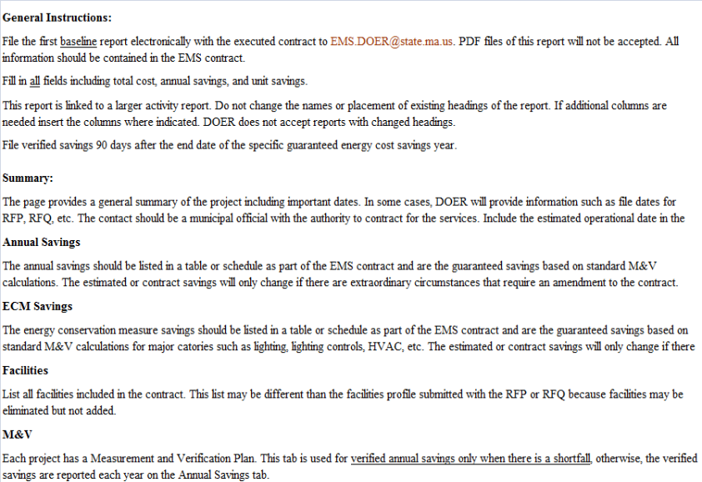
[An Annual Savings Report for baseline information must accompany a copy of the contract when filing with DOER. The Annual Savings Report may be found on the EMS web page at http://www.mass.gov/eea/energy-utilities-clean-tech/green-communities/ems.html]

EXHIBIT X: DOER ANNUAL SAVINGS REPORT-SUMMARY
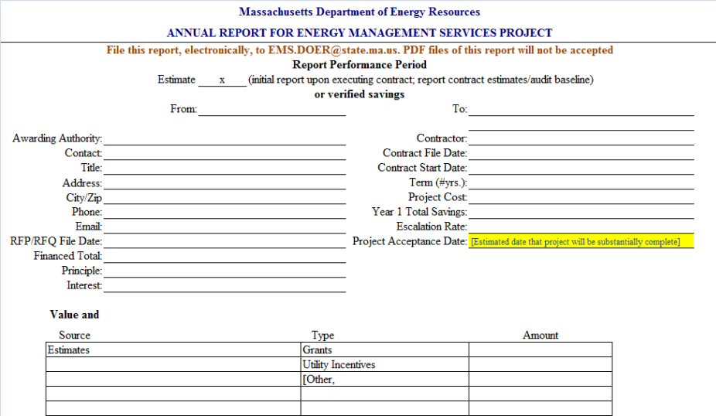

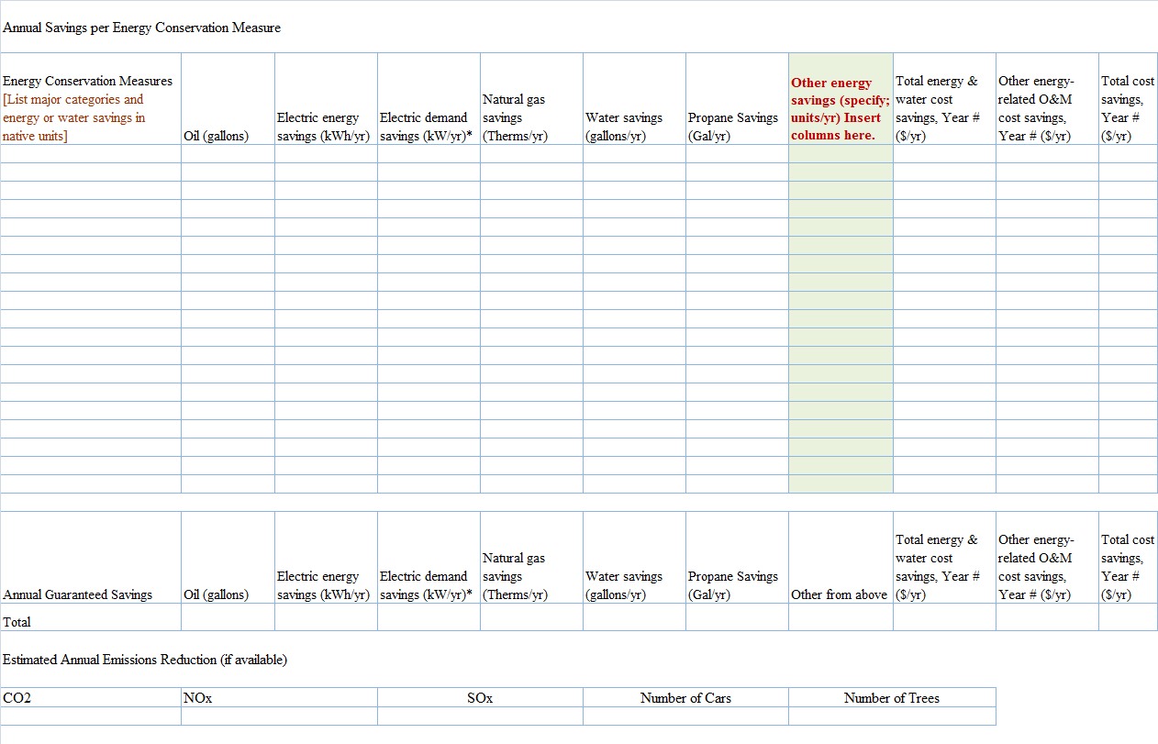
EXHIBIT X: DOER ANNUAL SAVINGS REPORT-ANNUAL ECM SAVINGS FIRST YEAR

EXHIBIT X: DOER ANNUAL SAVINGS REPORT- ONSITE ENERGY GENERATION
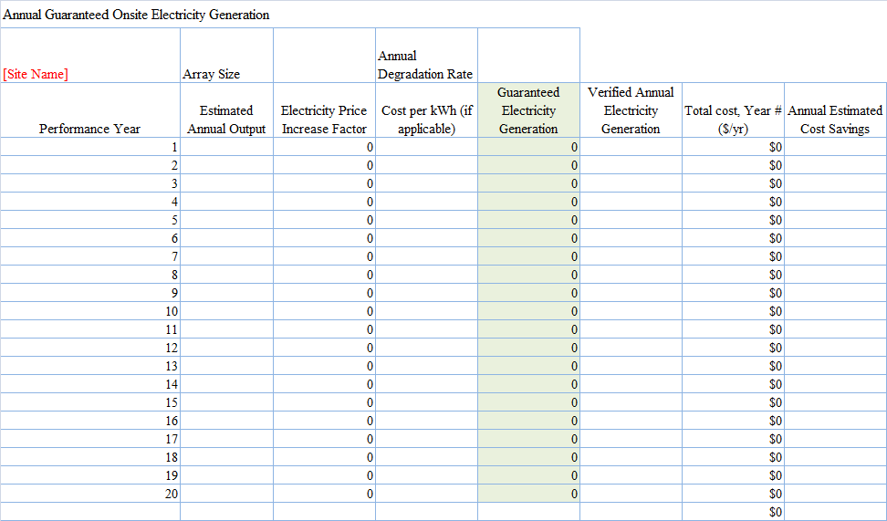

EXHIBIT X: DOER ANNUAL SAVINGS REPORT- FACILITIES
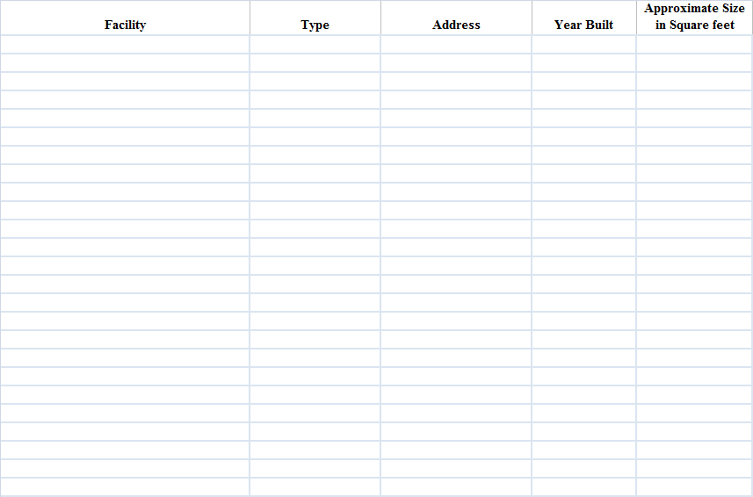

EXHIBIT X: DOER ANNUAL SAVINGS REPORT- FACILITIES
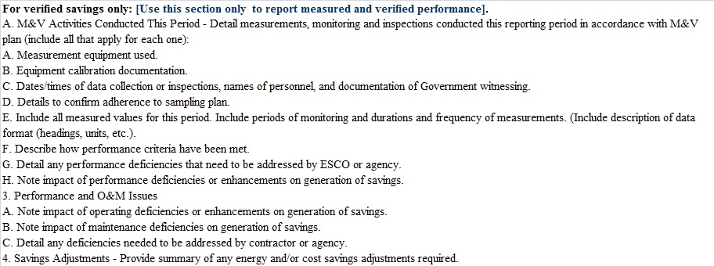

Same as Energy Management Services Agreement or Contract
See Federal Energy Management Program Measurement and Verification Guidelines here

