Medicaid 101: For Local Education Agency (LEA) Random Moment Time Study (RMTS) Participants performing School-Based Direct Health-Related Services
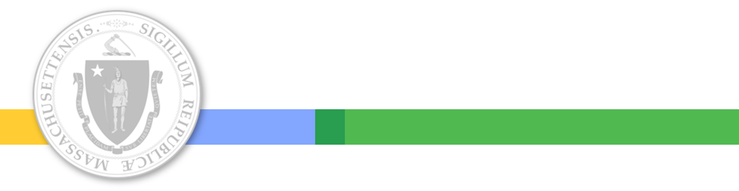
Executive Office of Health and Human Services
August 2023

Distributed August 2023
This training was distributed in August 2023 and was accurate at the time of distribution. As always, Local Education Agencies are responsible for reviewing information on the School-Based Medicaid Program website (www.mass.gov/masshealth/schools) to determine whether subsequent guidance has superseded the content shared here. MassHealth plans to update these trainings periodically as needed.

Introduction to Medicaid 101 Training Series
The Medicaid 101 training series is designed to provide the essentials to understanding the MassHealth School-Based Medicaid Program (SBMP). Some modules are designed for a broad, general audience. Other modules are targeted to the learning needs of a specific audience within each Local Education Agency (LEA).
Other modules in the Medicaid 101 training series of particular interest to school-based health care providers:
Training Module | Intended Audience
Module 1: Introduction to School-Based Medicaid | Anyone interested in gaining a better overall understanding of the School-Based Medicaid Program (SBMP)
Module 4: SBMP for LEA Clinical Leadership | LEA staff who are team leaders, supervisors or administrators with oversight responsibility for the provision of health-related services to students
Module 8: SBMP for Direct Service Practitioners | LEA staff who participate in the Direct Medical Services reimbursement portion of the SBMP

A note on this training…
This module explains the “Why” of the Random Moment Time Study (RMTS). It covers important concepts that will deepen your understanding of the role of the RMTS plays in LEA Medicaid reimbursement and will assist you in responding to your moments.

The School Based Medicaid Program website has several additional pertinent resources:
- RMTS Quick Reference Guide
- Top 5 Things Providers Need to Know
- Other trainings are routinely being updated, including links to external training resources as well on our Training Resources page: https://www.mass.gov/info-details/school-based-medicaid-program-sbmp-trainings

Training Agenda
- Training Objectives
- I don’t do anything Medicaid-related…Or do I?
  - Direct Services
  - Administrative Activities, aka, Indirect Services
- What is the RMTS?
- How the RMTS Works
- RMTS Questions
- Key Concepts for Direct Service Providers
- What Constitutes a Sufficient “Narrative” Response?
- Best Practices
- Avoid Common RMTS Mistakes/Overcome Common Misperceptions
- Next Training Steps
- Resources

Training Objectives
By the conclusion of this training, participants will be able to:
- Explain the kinds of work activities school staff perform that are partially reimbursable through the School-Based Medicaid Program (SBMP) and why you have been included in the Random Moment Time Study (RMTS).
- Explain the RMTS process and why it matters.
- Accurately document work activities when selected to respond to a random moment.

What is Expected of School Staff Participating in SBMP?
- Maintain an active license as required by the Massachusetts Department of Elementary and Secondary Education, and where appropriate, through the Massachusetts Department of Public Health Bureau of Health Professions. (Provider qualifications are outlined in the “SBMP Covered Services and Qualified Practitioners” document published on the SBMP Resource Center.)
Participate in the Random Moment Time Study.
- Maintain documentation of direct services provided, including evaluations, treatment plans and treatment/therapy sessions, as necessary, per your license practice standards.
- Complete your LEA’s process for Medicaid billing, following the instructions and procedures established by your LEA.

I don’t do anything Medicaid-related… Or do I?
- There is a crucial link between student health and well-being and student academic success.
- You provide critical physical and behavioral health services that help keep kids in school, where they can learn and grow.
- MassHealth’s mission is to improve the health outcomes of our diverse members and their families by providing access to integrated health care services that sustainably and equitably promote health, well-being, independence, and quality of life.
- The common goal shared by school health staff and the MassHealth School-Based Medicaid Program (SBMP) is to ensure access to health care services for all students, particularly those students who are affected by health inequities.

I don’t do anything Medicaid-related… Or do I?
- Much of the work that school-based “related service” providers and other trained health care professionals do every day is eligible for Medicaid reimbursement.
- This Medicaid reimbursement is a sustainable funding source to support programs, resources and staff that positively impact student health outcomes.
- The work activities performed by school staff fall into 2 general categories of Medicaid reimbursement:
1) Direct Services and 2) Medicaid Administration (also referred to as Indirect Services)

Key Concept for School-Based Direct Service Providers
- School-based “related services” providers, nurses, counselors, psychologists, social workers, behavior analysts and others are clinically licensed health care professionals who bring clinical expertise to the rest of a school’s educational team, working together to support the needs of students.
- Your school district hired you to perform your job because you have clinical skills and training that allow you to provide health care services that cannot be safely or effectively provided by other types of school staff.
- Educational needs and health care needs can and often do overlap!
- Health care services have a clinical basis and may also help students achieve educational goals and access the curriculum.

Medicaid Direct Service Reimbursable Work Activities Performed in Schools
It’s all about PROVIDING educationally relevant health care services:
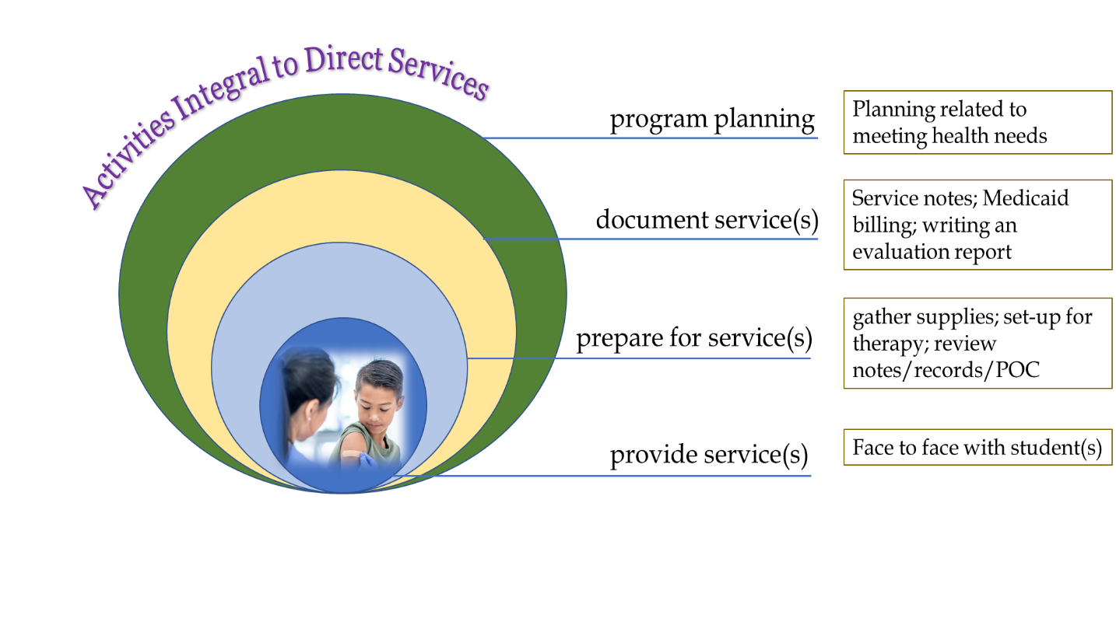

Medicaid Administrative (Indirect Service) Reimbursable Work Activities Performed in Schools
It’s all about ACCESS to health care services:
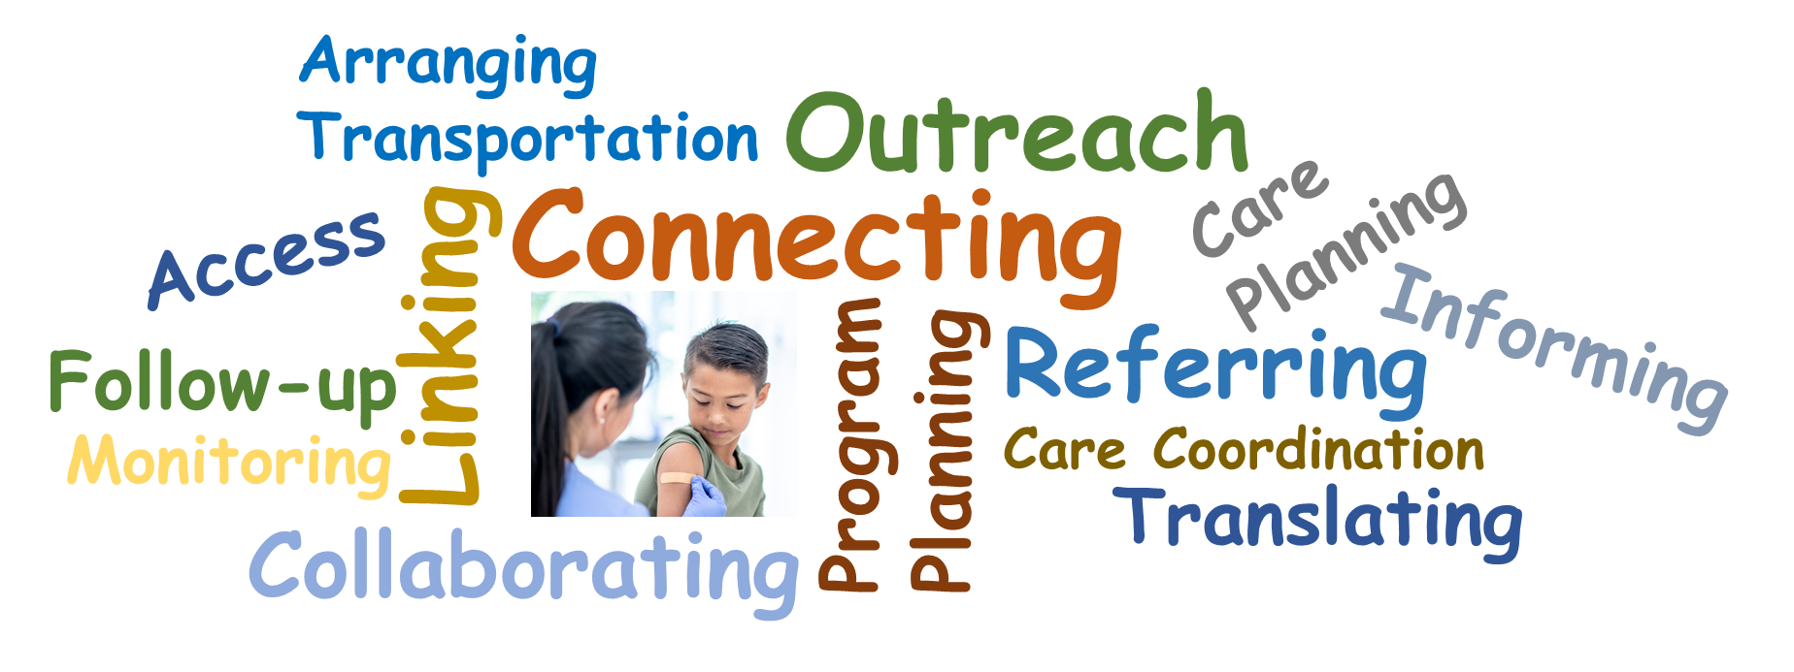

What is the Random Moment Time Study?
- The RMTS is a series of “snap shots” of the working days of school health staff.
- MassHealth samples a small number of school staff each quarter to determine at the state level how much time school staff spend doing Medicaid reimbursable activities (direct and indirect services).
- By asking what you’re doing during a randomly assigned working moment, MassHealth can predict (within a 95% confidence level) how your time is spent all day, every day.

How the RMTS Works
- LEAs from across the state submit lists of staff (participants) who perform any of the wide variety of work activities that support student health, from provision of direct health care services, to referral and care coordination activities within school and with community care providers.
- These school-based staff are grouped into statewide pools with other similar staff from districts across the state.

How the RMTS Works
- RMTS works like randomly selecting a candy from a jar, where our statewide RMTS candy jar is filled with all the working minutes from all the school staff across the state.
- A participant receives an RMTS request to document what is happening at the randomly assigned “snapshot” in their day.
- Based on their response, the activity is categorized for Medicaid purposes.

As an RMTS participant, you are part of a statewide group project!
- The RMTS captures important work you and your peers are doing.
- It helps MassHealth determine the reimbursement your LEA is eligible to receive from the federal government.
- Your RMTS responses have a real impact not just for your LEA, but for every participating LEA because the RMTS pools are statewide—we are all in this together!
- RMTS responses must clearly indicate that a reimbursable work activity has, or has not, occurred during the assigned minute snapshot.

RMTS Questions
If you are selected for an RMTS moment, you will be asked 5 questions:
- What type/category of activity were you doing?
- What were you doing more specifically?
  - What was the primary focus of your activity?
  - If health-related, what type of service or treatment?
- Where were you?
- Who were you working or interacting with?
- Why were you performing this activity?
  - Was it pursuant to an IEP?
  - How was it authorized?
  - Did the service meet Medicaid medical necessity requirements?
  - Were you acting within the scope of your clinical license?
There is also a required Narrative (250 characters max) to provide supporting detail for your responses.

Key RMTS Concepts: Medicaid Enrollment
- Medicaid enrollment information about any student is never needed.
- In fact, you never need to identify any student specifically.
- If your work activity was directly with, or on behalf of, a particular student, your response should simply indicate that you were working with “a student.”

Key RMTS Concepts for Direct Services Providers
- Keep in mind that the RMTS is trying to categorize your work activity as being primarily health-related vs. primarily educational.
- From Medicaid’s perspective, school-based health professionals are primarily addressing underlying health-related concerns that may be impacting a student’s ability to achieve academically/educationally.
- So, if you’re performing an activity that does not require your skills, training and expertise as a health professional (such as duty periods, MCAS test proctoring, etc.) then it’s an educational activity.
- But when you’re applying the skills and training of your clinical license, you’re likely addressing student health.

Key RMTS Concepts for Direct Services Providers
Let’s apply this key concept to our RMTS responses:
- Approach to Question 2a: What were you doing more specifically - What was the primary focus of your activity?
  - EDUCATION, ACADEMICS or SOCIAL skills / issues / needs
  - EVALUATION for a HEALTH-RELATED SERVICE (e.g., PT, OT, SLP, ABA, mental and/or behavioral health)
  - HEALTH-RELATED SERVICE OR TREATMENT - OTHER THAN an evaluation or screening (e.g., PT, OT, SLP, Nursing, ADLs, ABA, dental, vision, mental and/or behavioral health)
  - HEALTH-RELATED SCREENING service
  - GENERAL SCHOOL-RELATED STUDENT ACTIVITIES not listed above, such as attendance, student discipline, guidance activities, athletics, etc.
  - OTHER activity not categorized above

Key RMTS Concepts for Direct Services Providers
Question 5 comes with subparts that apply when your moment activity involved any of the integral components of providing services. For each, providers should apply their understanding of these concepts, discussed in detail in Medicaid 101 Module 8 and in the School-Based Medicaid Program Direct-Service Claiming (DSC) Program Guide.
5b. Why were you performing this activity? - How was it authorized?
- In the context of SBMP, service authorization refers to the evidence or record that a qualified practitioner has determined that a service is necessary and appropriate. Authorization is documented in a written plan of care, treatment plan, intervention plan or order or other similar evidence. Qualified providers acting within the scope of their licenses authorize services (e.g., a service is not authorized because a parent gave permission, or it was agreed upon by an IEP team).
5c. Why were you performing this activity? - Did the service meet Medicaid medical necessity requirements?
- Services provided must require your skill level of your licensure, i.e., the student’s condition requires the treatment/intervention of a level of complexity and sophistication that can only be safely and effectively performed by a licensed professional.

5d . Why were you performing this activity? - Were you acting within the scope of your clinical license?
- Services provided must be within your scope of practice.
- Services must be considered reasonable by professionally recognized standards of practice for your discipline.

Key RMTS Concepts for Direct Services Providers
5b. Why were you performing this activity? - How was it authorized?
Examples:
An SLP completing an initial evaluation with a student
Options:
- The evaluation was necessary in my clinical opinion, and I am a qualified practitioner
- The evaluation was authorized by a qualified practitioner
- The evaluation was not authorized
- Other, not described above
A nurse providing a skilled nursing assessment and treatment to a sick or injured student
Options:
- The nursing service was authorized by a qualified practitioner
- The service was authorized under a standing or other order
- The service was UNPLANNED for a student without a care plan or physician order. Therefore, I utilized a skilled nursing assessment and provided nursing intervention(s) according to standard practice
- The nursing service was not authorized
- Other, not described above

Key RMTS Concepts for Direct Services Providers
5c. Why were you performing this activity? - Did the service meet Medicaid medical necessity requirements?
Examples:
A LABA providing ABA therapeutic interventions
Options:
- The ABA Therapy was a MEDICALLY NECESSARY therapeutic intervention provided to a student with an AUTISM SPECTRUM DISORDER (ASD) diagnosis that met program guidelines
- The ABA service DID NOT MEET program guidelines for medical necessity (including services provided to a student who does NOT have an Autism Spectrum Disorder diagnosis)
- OTHER not categorized above
A licensed counselor providing BH counseling services
Options:
- The behavioral health service was a MEDICALLY NECESSARY service that met program guidelines
- The behavioral health service DID NOT MEET program guidelines for medical necessity
- Other, not categorized above

Key RMTS Concepts for Direct Services Providers
5d . Why were you performing this activity? - Were you acting within the scope of your clinical license?
Example:
An OTA providing OT services to a student
Options:
- Yes, this was within the scope of my CLINICAL license as determined by the Massachusetts Board of Registration of Allied Health Professionals. This includes supervision and a treatment plan if required.
- No, this was outside the scope of my CLINICAL license as determined by my licensing board. This service may have been provided without the required supervision or outside of a required treatment plan.
- No, I am NOT CLINICALLY LICENSED to provide Occupational Therapy services (although I may hold a DESE license).
- Other, not categorized above

What Constitutes a Sufficient “Narrative” Response?
The narrative should be brief (no more than 250 characters) and should describe what work was occurring and who was involved in enough detail that your school district should be able to use this information to connect your RMTS moment response to supporting documentation on file at your LEA in case of an audit or review. Consider the following examples:
1 | I was responding to an email. | This is not sufficient.
2 | I was responding to an email from a parent. | Topic of the conversation is needed - was it “health” focused or “educational” focused?
3 | I was responding to an email from a parent who had questions about sharing their child’s psych eval report with a neuropsychologist at Children’s Hospital. | This is a sufficient description.
4 | I was responding to an email from a teacher about scheduling time to pull a student out of class to complete an evaluation. | This is a sufficient description.

Best Practices for completing an RMTS Moment
- Before responding to your moment, look at the date and time that it was assigned for and think about what you were doing at that specific minute. The pre-defined responses cover most work activities as well as non-working time. If you were multitasking, identify the primary activity.
- If the options do not sufficiently describe your activity, you may choose “Other” and use the free-text section to provide adequate detail.
- Remember that the RMTS is asking you to describe what was happening during a one-minute snapshot. You do not need to describe the scope of your job or list everything you worked on that day.
- Before submitting your moment, please review your answers to ensure that they make sense and do not contain any contradictions, since many of the options are similar.
- Avoid using acronyms in your response or be sure to define them.
- A sufficient response will provide adequate detail on the topic, context, purpose, and content of the activity being performed.
- An insufficient response will only provide a literal/physical description of the activity.
- If you were engaged in communication at the time of your moment (either in person or via email or on the telephone), please describe the topic and purpose of the conversation/communication.

Avoid Common RMTS Mistakes
Provide more than just a “physical description” of your work activity by explaining purpose, intent and context:
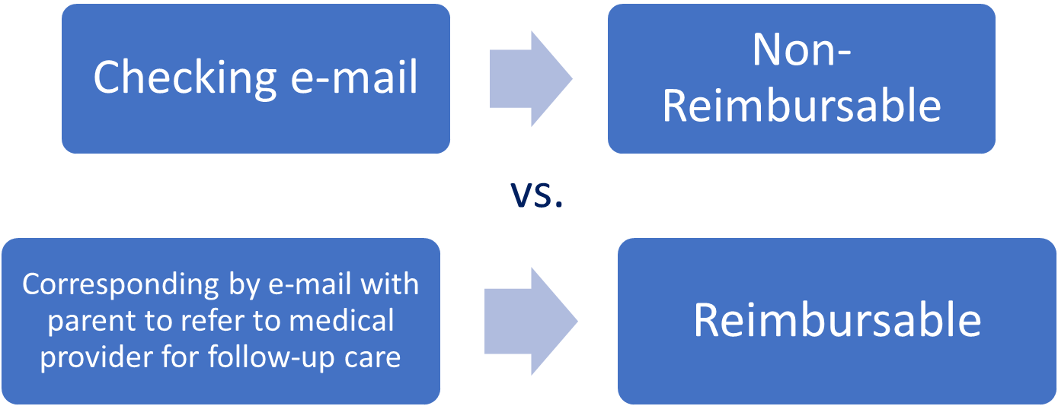

Avoid Common RMTS Mistakes
Provide sufficient detail so that your responses clearly indicate that a reimbursable activity occurred:
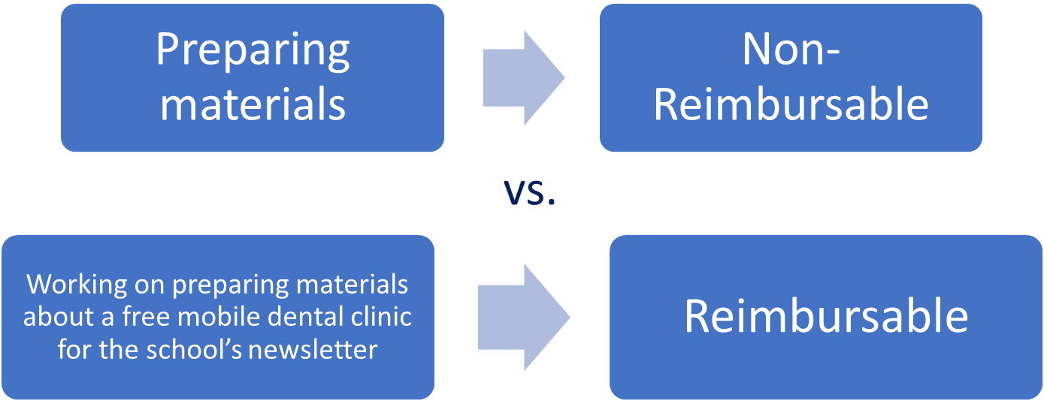

Avoid Common RMTS Mistakes
Clearly document your work activity. Don’t tell us what you weren’t doing, tell us what you were doing:
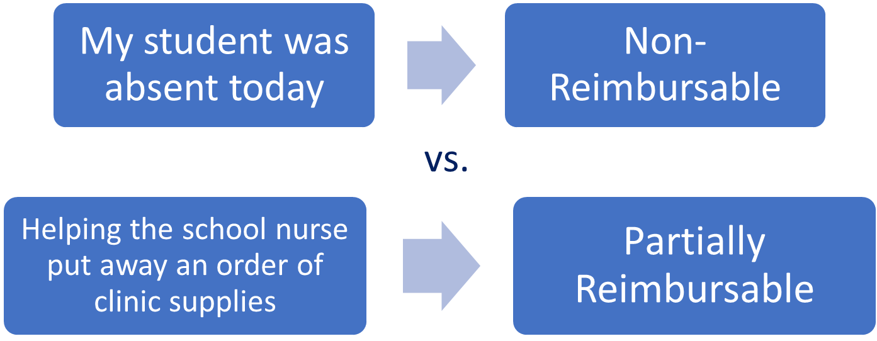

Overcome Common Misperceptions
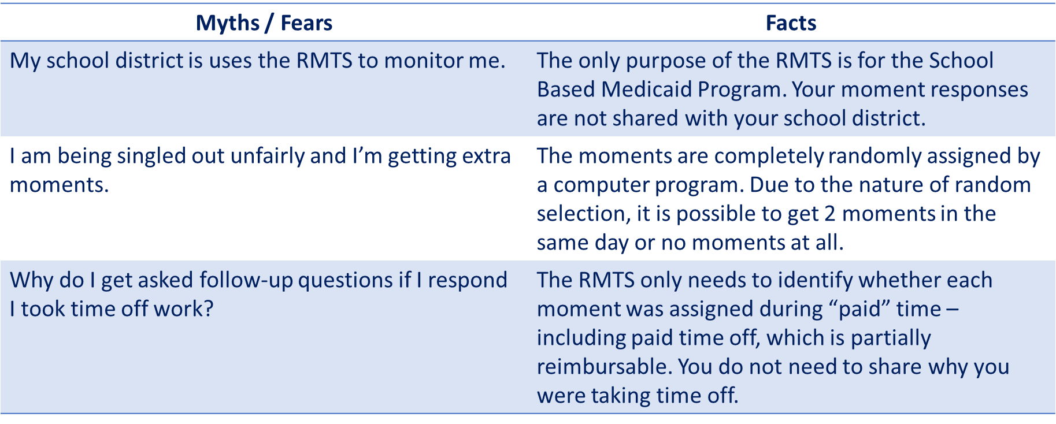

Overcome Common Misperceptions
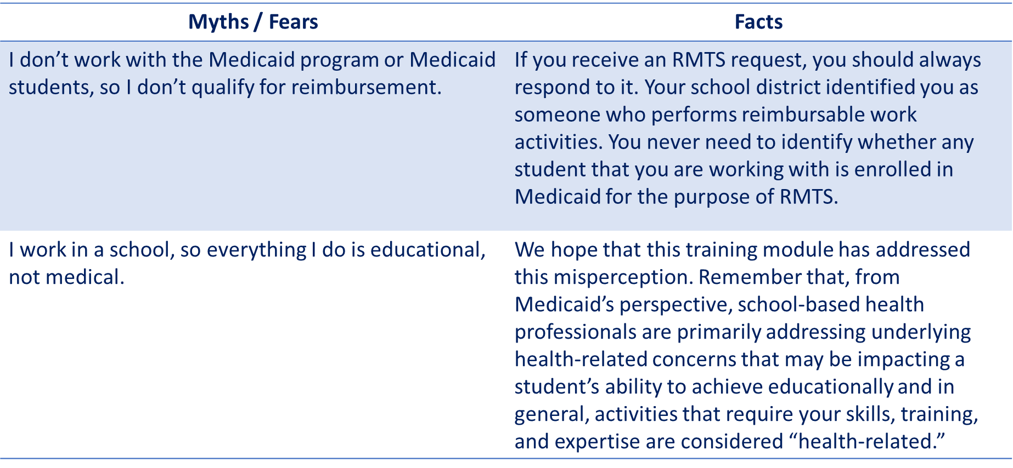

Next Training Steps
The Medicaid 101 training series includes additional information and details about the Direct Service reimbursement program in these modules listed below:
Training Module | Intended Audience
Module 1: Introduction to School-Based Medicaid | Anyone interested in gaining a better overall understanding of the School-Based Medicaid Program (SBMP)
Module 4: SBMP for LEA Clinical Leadership | LEA staff who are team leaders, supervisors or administrators with oversight responsibility for the provision of health-related services to students
Module 8: SBMP for Direct Service Practitioners | LEA staff who participate in the Direct Medical Services reimbursement portion of the SBMP

Additionally, your LEA has an RMTS Coordinator who should have additional school-specific training and information for you.

SBMP Resources
SBMP Website: All SBMP information, including program guidance, covered services and qualified providers, and announcements, can be found on website.
SBMP 101 Training Modules: In addition to recorded trainings you can download transcripts and copies of the presentations. Module 1 provides a general overview for all audiences and Modules 4 and 8 are most relevant to school health providers.
Top Five Things Providers Need to Know This a one-pager of the most important, and often misunderstood, SBMP concepts.
RMTS Training
- RMTS Quick Reference Guide
- Required training for RMTS Coordinators is available at www.chcf.net/chcfweb/
- Training for RMTS participants that gives an overview of the RMTS and walks through the mechanics of responding to moments is available within the RMTS Moments application, https://cbe-rmts.chcf-umms.org/

Contact Information & Resources

MassHealth School-Based Medicaid Program information:
www.mass.gov/masshealth/schools

UMass Chan Medical School-Based Help Desk:
SchoolBasedClaiming@umassmed.edu
1-800-535-6741
M-F 7:30 a.m. – 7:30 p.m.

