

District Data Team Toolkit

MODULE 2: INQUIRY
Table of Contents
Introduction—1
Where Are We Now?—1
Module Objectives—1
Culture of Inquiry—2
The Data-Driven Inquiry and Action Cycle—2
Asking the Right Questions—3
Types of Questions—3
Question Formulation—4
Alignment With District Priorities—7
Data Overview Process—8
Anatomy of a Data Overview—8
Preparing a Data Overview—11
Building a Data Display—11
Designing the Data Overview—12
Module Summary—13

 | Tools and Resources for Inquiry |  | 
2.1.1T: Question Formulation Protocol  2.2.1T: Inventory of District and School Initiatives  2.3.1T: Data Overview Checklist  2.3.2R: Data Overview Example  2.4.1T: Building Data Displays Protocol |  | 2.4.2R: Data Display Rubric  2.4.3R: Types of Data Displays  2.4.4R: More Data Display Resources  2.5.1T: Data Overview Brainstorming Protocol  2.5.2T: Focusing Question Investigation Template

 | Introduction

Where Are We Now?
The District Data Team Toolkit is based on the Data-Driven Inquiry and Action Cycle. The Cycle provides the structure that takes data use within the district from asking the right questions to getting results. It is an iterative process in which the district acts on data to support continuous improvement. The Toolkit uses the steps of the Cycle to structure a progression through the model—you are now in Module 2: Inquiry.
Module 2: Inquiry explores the inquiry process first introduced in Module 1: Getting Ready. The activities in this module build the capacity of the District Data Team and key stakeholders to formulate hypotheses about problems identified through an initial review of data displays and develop clarifying questions to dig deeper into the data. Techniques for the acquisition of these data and their analysis are addressed in Module 3: Information and Module 4: Knowledge.

Module Objectives
The Inquiry module will help a District Data Team:
- Formulate questions to drive an inquiry process
- Create and present effective data displays and data overviews
- Identify the data needed to answer the questions

 | Culture of Inquiry

The Data-Driven Inquiry and Action Cycle
The Data-Driven Inquiry and Action Cycle drives the effective use of data to answer critical questions about teaching and learning that result in school improvement and higher achievement for all students. If the Team asks the right questions, collects and analyzes appropriate data to address the questions, views the information it has gathered in the context of findings on research and practice to form an appropriate knowledge base, and takes action on the knowledge it has gained, the district and its schools will improve and its students will perform at higher levels.
The modules in this Toolkit take you step-by-step through the Data-Driven Inquiry and Action Cycle and provide you with the tools and resources necessary to effectively implement this collaborative data use framework. Module 2: Inquiry initiates this activity.
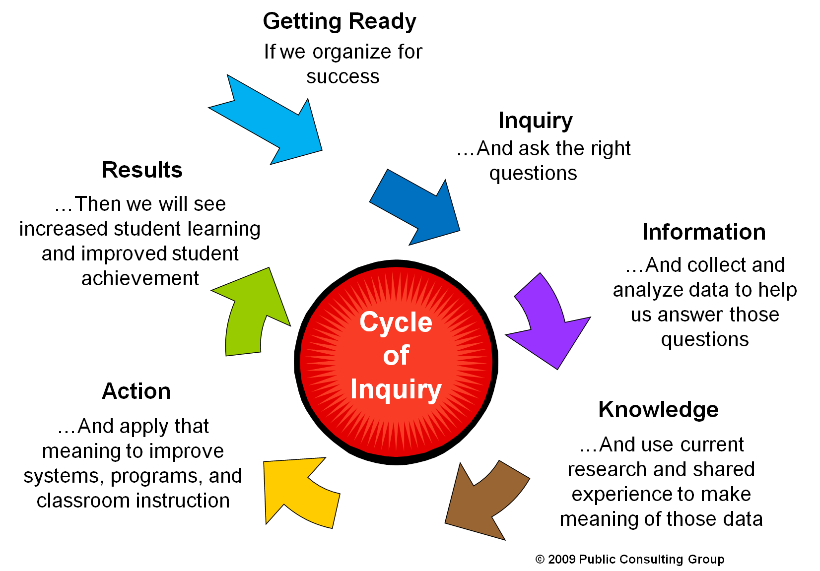

Data-Driven Inquiry and Action Cycle

Asking the Right Questions

Types of Questions
Educators ask questions about their district, schools, and students all the time. The questions are based on their observations, experience, gut, and hopefully, on data. The challenge is to craft meaningful questions to drive the inquiry process that are based on all of these sources and that, if answered, will significantly improve teaching and learning in the district.
As the Team formulates questions that will have a direct impact on teaching and learning in the district, it should consider two things.
- Does the question relate to something over which the district or school has control?
- Does the question relate to something which, if improved, will have a significant impact on teaching and learning?
Questions about factors that districts and schools can influence form the basis for the action step of the Data-Driven Inquiry and Action Cycle.
Questions about factors that districts and schools can influence form the basis for the action step of the Data-Driven Inquiry and Action Cycle.
The Team may also ask questions about factors that can have an effect on teaching and learning, but that cannot be influenced or changed by districts and schools. These questions are more descriptive in nature and help educators develop a better understanding of their students. This understanding can provide insight into structures and strategies that can be implemented which place teaching and learning in the context of students’ experiences.
For example, the size and distribution of the low-income student population in a district is not a factor a district can control. However, knowing the size and distribution of this population may suggest that professional development activities are needed to help teachers better understand the student population and what support they need to learn.
As the Team goes through the question formulation process, it will discover that starting with broad questions to focus its inquiry will lead to the development of narrower questions that will deepen the inquiry process. The broad questions are called focusing questions, while the narrower questions are called clarifying questions. Focusing questions provide a starting point to help the Team identify the data it will need to begin its inquiry. Clarifying questions are generated in response to the analysis of the initial data set and often require the collection and analysis of additional data. In turn, based on this subsequent data collection and analysis, original clarifying questions can become focusing questions for the next phase of inquiry.
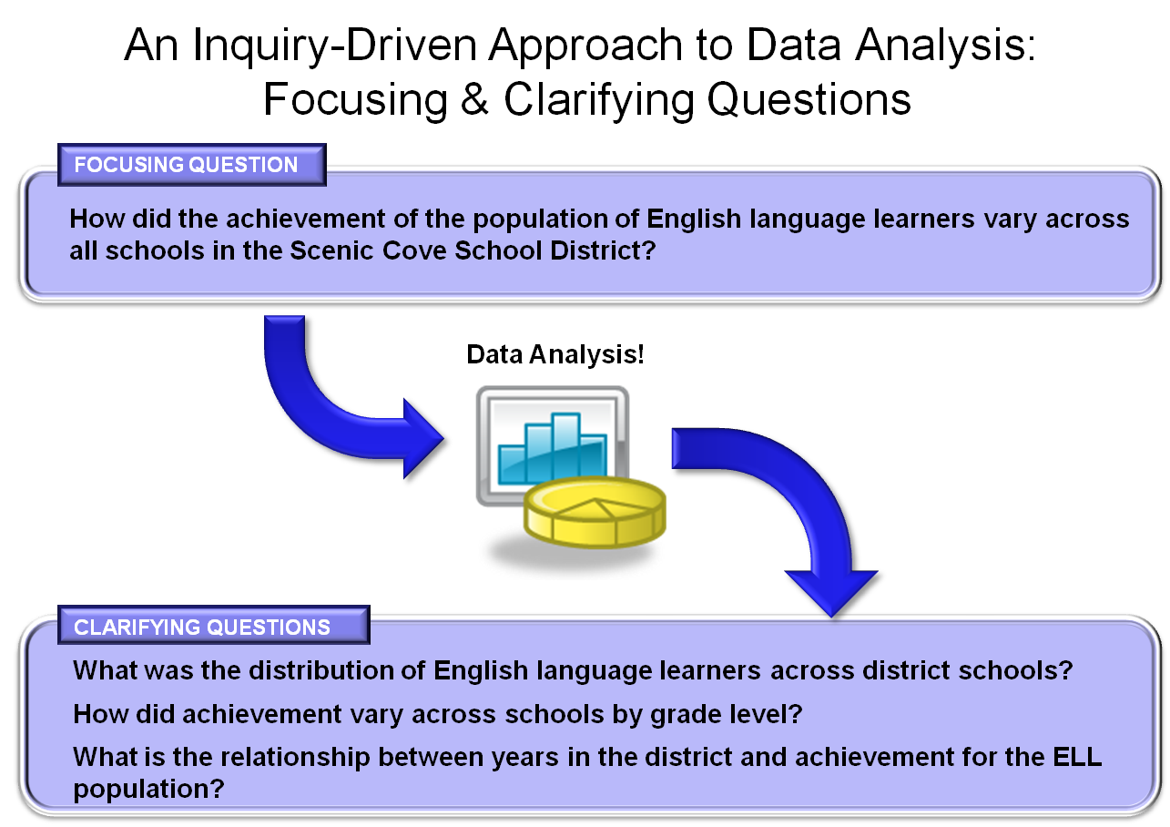

Question Formulation
Questions that a Team might want to explore can be formulated based on some of the following considerations: demographics, perceptions, school processes, and student outcomes. Each category provides the district a framework for which it can begin to craft both focusing and clarifying questions from the data gathered. Districts can then use those questions to guide the next steps in the data review process.
Demographics | Perceptions | School Processes | Student Outcomes
Race  Gender  Special education  Grade level  Lunch status | Values  Beliefs  Perceptions teachers, parents, and students have of the learning environment | Programs  Instruction  Curriculum  Processes  Policies  Procedures  Practices | Assessments  Course grades  GPA  Teacher observations  Attendance  Dropout rate

Focusing Questions
Broad questions are called focusing questions. Focusing questions provide a starting point to help a Team identify the data it will need to begin its inquiry. By beginning with the broad categories above, a district can begin the process of looking at data across sets of schools.

Sample Focusing Questions
Are the district’s teachers utilized in the most effective and efficient manner to meet the needs of its students?

Are teachers throughout the district committed to high levels of learning for all types of learners?

Are the programs for special populations effectively meeting their goals?
Activity 2.1 Question Formulation Protocol  Throughout this Toolkit, the Team will use protocols to guide productive discussions on a variety of topics. The Question Formulation Protocol will help the District Data Team develop, organize, and prioritize questions to structure its inquiry.  (2.1.1T: Question Formulation Protocol) | 
What are the characteristics and performance levels of students with high absence rates?

Clarifying Questions

Narrower questions are called clarifying questions. Focusing questions provide a starting point to help a Team identify the data it will need to begin its inquiry. Clarifying questions are generated in response to the analysis of the initial data set and often require the collection and analysis of additional data. In turn, based on this subsequent data collection and analysis, original clarifying questions can become focusing questions for the next phase of inquiry.

Sample Clarifying Questions
Focusing Question #1: Are the district’s teachers utilized in the most effective and efficient manner to meet the needs of its students?

Potential Clarifying Questions:
- What is the ratio between special education students and special education teachers in each of the district’s schools?
- Are the “highly qualified teachers” equitably distributed across schools in the district?
- Are teachers assigned to classes in their area of certification?
- Are the district’s neediest students taught by the most effective teachers?

Focusing Question #2: Are teachers throughout the district committed to high levels of learning for all types of learners?

Potential Clarifying Questions:
- Are teachers asking all students questions that would foster higher level thinking skills?
- Are students placed in least restrictive environments with modifications and accommodations being followed?
- Do students receive instruction in varied ways that meet their individual learning styles?

Focusing Question #3: Are the programs for special populations effectively meeting their goals?

Potential Clarifying Questions:
- Are students in inclusion programs and substantially separate programs achieving proficiency on the state assessment?
- Over the past three years, has the performance of English language learners improved by the end of grade 6?
- Has growth within special populations equaled the growth of the general population?
Focusing Question #4: What are the characteristics and performance levels of students with high absence rates?

Potential Clarifying Questions:
- What is the relationship between absenteeism and performance on state assessments?
- Which subgroups and grade levels have the highest absence rates? Lowest?
- When does high absenteeism occur throughout the school year?
- How does the district’s absence rate compare to the state?

Alignment With District Priorities
The Question Formulation Protocol from the previous activity has helped the Team to define the high-priority starting point for its inquiry. But before the Team begins gathering data to answer its questions, it is important to determine if there are initiatives currently underway in the district that relate to the Team’s focusing question, and how further investigation of these questions can be coordinated with these existing initiatives. The Inventory of District and School Initiatives tool will help the Team identify and create an inventory of district and/or school initiatives. The Team should follow the instructions in the tool to help it relate those initiatives to its focusing question. This information can serve three key purposes:
- Help the Data Team coordinate efforts with other existing teams
- Help the Team identify data that might be available to inform the inquiry process
- Help the Team avoid redundancy when it gets to the point of developing strategies and action steps (Module 5)
Activity 2.2 What Current Initiatives Relate to the Focusing Question?

Districts and schools have many initiatives in place at one time. Adding a new initiative that addresses a focusing question may be redundant if the question is already being effectively addressed by an existing initiative. The Inventory of District and School Initiatives will identify current initiatives and will provide data on the effectiveness of the implementation of those initiatives.

(2.2.1T: Inventory of District and School Initiatives)

Data Overview Process

After completing the Inventory of District and School Initiatives activity in the previous section, the Team should be ready to proceed with its inquiry. The next step in the collaborative inquiry process is to share the focusing question and related data with an appropriate audience by creating and presenting a data overview.
The primary objective of a data overview is to enable stakeholders to collaboratively interact with data related to the focusing question in order to generate clarifying questions that will drive the inquiry process forward. These clarifying questions will serve to focus subsequent efforts in data collection and analysis.
To achieve this objective, the District Data Team must build user-friendly data displays that tell a valid and interesting story about the focusing question. The District Data Team must then involve stakeholders in the collaborative analysis of the data and the creation of clarifying questions.

Anatomy of a Data Overview
The data overview is a presentation (usually accompanied by PowerPoint) designed to introduce to stakeholders preliminary data related to a focusing question.
The specific content of a data overview will vary based on the audience (administrative team, full faculty, department faculty, specialists), but the purpose and structure remain constant. A typical data overview meeting will contain the following sections.
Typical Agenda of a Data Overview Meeting
Welcome and Introductions | - Outline the data overview presentation so that the audience understands the purpose, structure, and outcomes of the meeting.  - A quick roll call or introductions so everyone knows who is in the audience, e.g., who here is a teacher, family member, or district administrator.
Purpose | - Clearly state the purpose for the data overview in terms of the focusing question(s) that is being explored.
Data Displays | - Use well-developed data displays that clearly tell a story related to the focusing question(s) and stimulate constructive conversations.  - Collectively make factual observations (no inferences) about each data display.
Brainstorming Session | - Formulate hypotheses that might explain the data.  - Pose clarifying questions to guide the exploration of the hypotheses.  - Identify the kinds of data needed to answer the questions and suggest ways to collect the additional data.
Next Steps | - Discuss next steps, such as action items from the meeting, e.g., who will collect additional data and by when, and the date and time of the next meeting.

When planning a data overview, it is important for the Data Team to consider the audience and context and adjust the presentation accordingly. To do this, the Team might consider:
When planning a data overview, it is important for the Data Team to consider the audience and context and adjust the presentation accordingly.
- What is the level of data literacy of the audience, e.g., principals, teachers, students, families, union representatives, school committee, or community members?
- What questions might these stakeholders already be considering in relation to the focus of inquiry?
- What barriers to data use (from 1.1.1T) might be relevant to this audience, and how could the data overview help address them?

The data overview should result in at least two specific outcomes. The set of clarifying questions developed through the brainstorming protocol and the identification of related data help guide the next steps in the inquiry process. Additionally, as the group engages with the data and formulates hypotheses and clarifying questions, they increase their capacity for inquiry and become invested in the process. This buy-in is critical for subsequent processes and is crucial toward creating a district-wide culture of inquiry.
 | Activity 2.3 Anatomy of a Data Overview  In this activity, you will review and critique a sample data overview presented by the Scenic Cove District Data Team. Review the PowerPoint presentation and use the Data Overview Checklist to determine if all of the essential elements are present. As a District Data Team, discuss how the Scenic Cove School District ELA Data Overview could be improved.  (2.3.1T: Data Overview Checklist)  (2.3.2R: Data Overview Example)

Preparing a Data Overview

Building a data overview starts with articulating a focusing question. To prepare, return to the Team’s work in 2.1 Question Formulation Protocol. Select one of the focusing questions the Team developed and identify and gather high-level data necessary to begin exploring it. This focusing question will guide the creation of a data display. By creating a well thought out focusing question, engaging in collaborative discussion around that question, and by skillfully using data, the Team will begin to build a story, and ultimately, this should also help the Team identify and refine the clarifying questions and accompanying data displays.

Building a Data Display
At the center of any data overview sit quality data displays. Constructing these displays requires careful thought and effort to ensure that the data are displayed in a way that connect to the focusing question and inspire clarifying questions that will drive deeper inquiry by the audience.
Quality data displays need to:
- Tell the whole story
- Have complete, accurate, and timely data
- Contain all relevant and pertinent data
- Be readable and understandable

Activity 2.4 Building a Data Display
The Building Data Displays Protocol enables District Data Team members to apply the principles of data display construction to tell a story related to a focusing question. The Data Display Rubric provides a framework for the Team to assess the quality of the data displays it creates. The Types of Data Displays and More Data Display Resources provide some ideas for different ways that data can be represented.
(2.4.1T: Building Data Displays Protocol)
(2.4.2R: Data Display Rubric)
(2.4.3R: Types of Data Displays)
(2.4.4R: More Data Display Resources)

Designing the Data Overview
Once the data displays are built and designed, the data overview will begin to take shape and the Team will be ready to craft the rest of the presentation. The agenda should follow the model outlined earlier.
- Purpose
- Agenda
- Data displays driven by a focusing question and additional clarifying questions that tell a story
- Make observations about the data (no inferences)
- Record observations on chart paper
- Structured brainstorming session
- What might lie behind what the group is seeing in the data? (careful inferences)
- What additional questions does the group have?
- What additional data are needed to answer those questions?
- Identify next steps
- What data need to be collected?
- Who will collect it?
- When will a follow-up meeting occur?
Working with the Team, construct a presentation in PowerPoint using the data displays that have been built. It may be helpful to first storyboard the presentation on chart paper with the Team. Return as necessary to Activities 2.3 and 2.5 to create and refine data displays that support the Team’s central theme.
With the data displays freshly made and assessed and the presentation assembled, the Team is ready to engage a larger audience in the inquiry process. Plan the meeting and deliver the data overview that the Team has created.
Activity 2.5 Delivering the Data Overview

These tools will help the Team deliver a data overview and follow up afterwards. The results of this work will lead the Team into Module 3: Information and serve as the foundation for the rest of the inquiry cycle throughout this Toolkit.

(2.5.1T: Data Overview Brainstorming Protocol)
(2.5.2T: Focusing Question Investigation Template)

Module Summary

This module provides an overview of the Data-Driven Inquiry and Action Cycle, which can serve as the foundation for conducting an inquiry process. It launches the inquiry process by helping a District Data Team formulate a meaningful focusing question that is of high interest to the district and that will guide its inquiry process.
The module includes tools to help a District Data Team build its capacity to design meaningful data displays and present them in an effective data overview to targeted audiences. This approach can help engage stakeholders in the inquiry process, as well as inform the process of generating clarifying questions that refine the focus of the inquiry and identifying the data needed to provide insight on those questions.
A District Data Team should emerge from this stage of the process with clearly articulated focusing and clarifying questions, as well as a list of data it plans to collect and analyze to answer those questions.
Answers to the clarifying questions generated through this process will require the collection and analysis of additional data—the subject of the next module in the District Data Team Toolkit—Module 3: Information.

References

Sagor, R. (1992). How to conduct collaborative action research. Alexandria, VA: Association for Supervision and Curriculum Development (ASCD).

For more information on this and other district support resources, or to share feedback on this tool, visit http://www.doe.mass.edu/sda/ucd/ or email districtassist@doe.mass.edu.

