Massachusetts Level 4 and Level 5 School Monitoring Site Visit Procedural PROTOCOL
October 2016


201 Jones Road
Waltham, Massachusetts
781-373-7000 | TTY 877.334.3499
www.air.org

7694_10/16

Contents
Page
Introduction 1
Purpose 1
Turnaround Practices and Indicators: Evidence Collection Framework 2
Turnaround Practices and Coherent Implementation 2
Monitoring Site Visit Process—Key Components 4
Monitoring Site Visit Process Steps for Schools 7
Roles and Responsibilities 10
Confidentiality 12
Reporting 13
Schoolwide Instructional Observation Report 13
Annual Monitoring Site Visit Report 13
References 14
Appendix A. Turnaround Practices and Indicators A–1
Appendix B. Monitoring Site Visit Instructional Observation Day B–1
Appendix C. Instructional Observations (Staff Information Sheet) C–1
Appendix D. Overview of CLASS Observation D–1
Appendix E. Instructional Staff Survey Overview E–1
Appendix F. Monitoring Site Visit Interviews and Focus Groups Day F–1
Appendix G. Student Focus Group Permission Slip G–1
Appendix H. Monitoring Site Visit Checklist H–1
Appendix I. Monitoring Site Visit Overview for Participants (School Staff Information Sheet) I–1
Appendix J. Monitoring Site Visit Principal Pre-Visit Questionnaire J–1

Introduction
The Massachusetts Department of Elementary and Secondary Education (ESE) Monitoring Site Visits of Level 4 schools, Level 5 schools, and participating Level 3 schools provide critical information and feedback on the progress districts and schools are making toward improving students’ outcomes. The Monitoring Site Visit process uses baseline and benchmark data collected through an initial visit and subsequent annual visits to assess progress toward schools’ improvement goals. The data are analyzed and findings are reported to schools, their districts, ESE, and the public once reports become available on the state’s website. These annual reports provide schools and districts with an external review of the school as well as inform decisions about strategies and midcourse corrections in meeting school improvement goals. In addition, Monitoring Site Visit findings are part of the evidence base ESE uses to make decisions about supports and accountability for schools and their districts.

Purpose
The purpose of the Monitoring Site Visit is to provide participating schools with formative feedback in support of turnaround efforts. The Monitoring Site Visit is intended to help districts and schools understand the status of the implementation of their turnaround plans. The Monitoring Site Visits are designed to obtain information about each school’s progress across a common set of research questions and four turnaround practices based on research on Massachusetts schools, along with specific questions related to each school’s individual turnaround plan.

Turnaround Practices and Indicators: Evidence Collection Framework
The turnaround practices come from the latest research from the Institute for Strategic Leadership and Learning documented in Turnaround Practices in Action: A Practice Guide and Policy Analysis (Lane, Unger, & Souvanna, 2014). This research shows that Massachusetts schools that achieved dramatic improvements in academic and nonacademic student outcomes during the past three or more years have actively used the authorities afforded to them through Level 4 accountability status, aligned funding to their needs, provided targeted instruction to students, and embedded district systems of support and monitoring to maximize the impacts of these fundamental conditions. With those conditions in place, the schools focused their work in the following areas, which in turn have shaped the new Monitoring Site Visit process:
- Leadership, shared responsibility, and professional collaboration
- Intentional practices for improving instruction
- Student-specific supports and instruction to all students
- School culture and climate
Members of the Monitoring Site Visit team will assess the school’s progress in each of the four turnaround practices using a set of indicators within each turnaround practice. Data to support these conclusions will include qualitative examples from interviews, classroom observation scores, and instructional staff survey data. The indicators are presented in a continuum on a 4-point scale ranging from limited evidence to sustaining. The indicator continuum allows schools and districts to recognize current status and to clarify improvements still to be made. Overarching turnaround practices are rated on a 5-point scale described below. The Annual Monitoring Site Visit Report will provide information about the school’s placement on each indicator continuum as well as examples and evidence that support this finding.

Turnaround Practices and Coherent Implementation
For each turnaround practice area, there will be a subsequent determination of the level of implementation at the school based on the ratings of the constituent indicators. Each turnaround practice will be rated on a 5-point continuum from limited evidence to sustaining, with an added fifth level called coherent implementation. Coherent implementation designations will be determined based on advanced, sustaining-level scores on most or all of the indicators in that practice area. In addition, school-specific information and whole-school classroom observation reports will provide information to inform future planning. The reports from the Monitoring Site Visit also are used to support ESE’s recommendations to the Massachusetts Board of Education about participating schools, as well as the continuation of School Redesign Grants annually. Figure 1 provides an example of two indicators and the 4-point continuum within Turnaround Practice 1 (Leadership, Shared Responsibility, and Professional Collaboration). For a full list of the practices and indicators implementation continuum, see Appendix A.
Figure 1. Example of Indicators Within Turnaround Practice 1: Leadership, Shared Responsibility, and Professional Collaboration
Turnaround Practice 1. Leadership, Shared Responsibility, and Professional Collaboration
Item Number | Indicators | Limited Evidence | Developing | Providing | Sustaining
1.4 | Monitoring Implementation and School Progress | School leaders rarely prioritize improvement initiatives for implementation nor are there processes or protocols in place for systemic implementation. | School leaders prioritize improvement initiatives for implementation; however, processes and protocols for systemic implementation are emerging or not well defined. | School leaders prioritize improvement initiatives; processes and protocols for systemic implementation are well defined. A majority of staff members are aware of the priorities, and some monitoring of these initiatives takes place. | School leaders are actively engaged in monitoring implementation of turnaround efforts, use this information to prioritize initiatives and strategies, communicate progress and challenges and seek input from staff, and continuously and systematically monitor progress.
1.5⁴ | Trusting Relationships | Relationships between teachers and instructional supports (e.g., coaches) are not guided by trust; teachers feel coaching and instructional support is judgmental, and evidence of collaboration among staff is limited. | Some relationships between teachers and instructional supports (e.g., coaches) are guided by trust, and some teachers feel instructional support is nonjudgmental, but this is inconsistent throughout the school. Some groups of teachers may collaborate with colleagues to share strategies, such as developing standards-based units, examining student work, analyzing student performance, and planning appropriate interventions. However, this is not consistent among all staff. | Most relationships between teachers and instructional supports (e.g., coaches) are guided by trust, and most teachers feel that instructional support is nonjudgmental. There is evidence that most staff at least occasionally use collegial relationships to share strategies in such work as developing standards-based units, examining student work, analyzing student performance, and planning appropriate interventions. | Most staff members share a relational, trust-focused culture with each other and their instructional supports (e.g., coaches) that is solution oriented and focused on improvement as exemplified by frequent collaboration in developing standards-based units, examining student work, analyzing student performance, and planning appropriate interventions. Educators regularly share their strengths and struggles, in the spirit of helping each other continually improve their practice.

Monitoring Site Visit Process—Key Components
The Monitoring Site Visit process is designed to provide information about a school’s progress in the four turnaround practice areas. ESE has contracted with American Institutes for Research (AIR) as an independent third party to conduct annual Monitoring Site Visits at selected schools, analyze the data collected during these visits, and develop reports to be disseminated to schools, districts, ESE, and the public. Communication from AIR is facilitated through an AIR site lead staff member who will coordinate all Monitoring Site Visit activities.
- Site Lead. As the primary contact for a school, the AIR site lead is available for questions before, during, and after the visit. To the extent possible, the designated site lead will continue managing the Monitoring Site Visit for the school on an annual basis.
A Monitoring Site Visit includes three distinct phases through which the site lead will support the school: (1) Monitoring Site Visit Preparation and Preliminary Data Collection (scheduling, document requests, a principal phone interview, and a district-level interview, instructional staff survey administration); (2) On-Site Data Collection; and (3) Reporting. The following provides a brief overview of the components of each phase. The Monitoring Site Visit Process Steps for Schools in Detail section of this protocol provides detailed information, and Appendix H provides a school checklist detailing responsibilities of the principal or designee.
Phase 1: Monitoring Site Visit Preparation and Preliminary Data Collection. The preparation and preliminary data collection phase for the Monitoring Site Visit helps with establishing a relationship between the principal or designee and the site lead and collecting necessary information about the school. Principal and district interviews, as well as the online instructional staff survey are part of this phase, allowing site visitors to understand the specific context of the school prior to on-site data collection. The following activities occur during Phase 1 Monitoring Site Visit Preparation and Preliminary Data Collection.
- Scheduling. The principal and the site lead will plan the on-site data collection, including scheduling dates for the two days of data collection and determining the best way to administer the staff survey and to schedule interviews and focus groups with staff.
- Principal Questionnaire. The principal questionnaire asks for some basic information that is helpful to have prior to the Monitoring Site Visit on-site data collection. This questionnaire may be completed electronically or over the phone with the site lead. See Appendix J for the questionnaire.
- Document Requests. Before the on-site data collection, the principal must provide the following documents: a master schedule, daily schedules, floor maps, and staff lists (including staff e-mail addresses). As an option, the principal may provide additional documents that supply context for current or planned school improvement work. Please note that the site lead already has copies of the school’s turnaround plans and previous years’ Monitoring Site Visits Reports.
- Principal Phone Interview. Prior to the on-site data collection, the principal participates in a phone interview with the site lead. This interview will ensure that the site visitors are prepared and understand the context of the school prior to the visit.
- Monitoring Site Visit District Interview. Prior to the on-site data collection, the district representative (e.g., superintendent, assistant superintendent) and the site lead will participate in a one-hour interview.
- Instructional Staff Survey. The survey is an electronic instrument and will be administered by e-mail at least a week prior to the first day of on-site data collection. The survey takes less than 15 minutes for each participant to complete. Staff who need to participate include all teachers, coordinators, counselors, instructional coaches, and paraprofessionals. These data ensure that a majority of the staff have a voice in specific indicators related to the Monitoring Site Visit. Information from the survey responses start the turnaround practice and indicator ratings and will be reported as part of the Monitoring Site Visit Report.
Phase 2: On-Site Data Collection. On-site data collection includes classroom observations, interviews, and focus groups. Phase 2 takes place throughout two days. In each case, site visitors do not provide individual feedback or immediate feedback to the school staff. The data are reviewed and analyzed prior to finalizing the two reports: the Schoolwide Instructional Observation Report (one week after Monitoring Site Visit Instructional Observation Day) and the Monitoring Site Visit Report (one month after Monitoring Site Visit Interviews and Focus Groups Day).
- Monitoring Site Visit Instructional Observation Day. During the first day of the Monitoring Site Visit, site visitors will conduct classroom observations in a sample of classrooms using the Classroom Assessment Scoring System (CLASS) observation tool, a research-based instrument published by Teachstone. Two or three CLASS-certified observers, all of whom are AIR staff, conduct brief observations in a representative sample of classrooms throughout the school day. Each classroom observation takes approximately 20 minutes; observers are trained to be as unobtrusive as possible during the observation and do not provide individual feedback. Findings from the observations are provided to the school principal and district contact or receiver, within one week of the Monitoring Site Visit Instructional Observation Day, in the Schoolwide Instructional Observation Report.
- Monitoring Site Visit Interviews and Focus Groups Day. Together, the principal and the site lead develop the schedule for staff interviews and focus groups. The site lead and one or two additional site visitors (depending on the size of the school) conduct these interviews and focus groups. Each interview and focus group takes approximately 45 minutes. Typically, the Interviews and Focus Group Day closes with a brief (approximately 15- to 30-minute) session with the principal to follow up and ask questions about any outstanding items. Appendix F provides a sample Monitoring Site Visit Interviews and Focus Groups Day schedule.
Phase 3: Reporting. After the Monitoring Site Visit on-site data collection, each school and its district or receiver will be provided with two reports.
- Schoolwide Instructional Observation Report. The first report provides aggregate data on the classroom observations along with guidance on how to interpret these results. The Schoolwide Instructional Observation Report is available to schools within one week from the date on which the Monitoring Site Visit Instructional Observation Day occurred.
- Annual Monitoring Site Visit Report. The second report provides information about the status of the school with regard to the four turnaround practices and indicators, as determined through the qualitative and quantitative analyses of all the collected data (including classroom observations, instructional staff survey results, interviews, focus groups, and document reviews). This report is provided to the school within one month of the final Phase 2 data collection date. The principal and district representative review the first draft for factual correctness and then provide feedback before the report is finalized and sent to ESE.

Monitoring Site Visit Process Steps for Schools
Principals, district representatives, and receivers all have roles to play in the Monitoring Site Visit. The site lead will be the district and school’s primary contact, assisting school leaders and district representatives through the Monitoring Site Visit process. The following provides a detailed overview of each of the three phases of the process. These duties are summarized in Figure 2, and a checklist is provided in Appendix H.
Phase 1: Monitoring Site Visit Preparation and Preliminary Data Collection
Scheduling the Monitoring Site Visit
Introductory Phone Meeting. The AIR site lead will schedule an initial phone call with the school’s principal (or designee). During this call, the school principal and the AIR site lead will discuss the Monitoring Site Visit and share information about preparation for the visit. The principal (or designee) can use this time to ask any questions about the process. The site lead and the principal (or designee) schedule dates and times for both on-site data collection Monitoring Site Visit days. In addition, the site lead and school contact will discuss details about the visit, including the following:
Instructional Staff Survey Administration. Discuss collection of e-mail addresses and best date for administering the electronic survey. Discuss with the principal how he or she will inform staff about the survey. Provide documents to explain the survey to staff and provide follow-up and updates on response rates.
Document Request. The site lead will request documents, including the following (schools may submit additional optional documents):
    - Staff lists, with e-mail addresses (for staff survey)
    - School schedules
    - School map
    - Principal questionnaire
    - Additional documents, at school’s discretion (e.g., leadership team agenda, minutes; professional development calendars)
Principal Interview. The one-hour principal interview will be conducted by phone in advance of the Monitoring Site Visit on-site data collection. This phone interview may coincide with the introductory phone call (if convenient) or be made at a later date, at least one week before the interviews and focus groups on-site data collection. Topics will include the school’s progress on the four turnaround practices as well as the principal’s background and context of the school’s current turnaround efforts.
District or Lead Partner Interview. The district representative will be interviewed for one hour by phone in advance of the Monitoring Site Visit as well. Topics will include the school’s progress on the four turnaround practices as well as the district context for the school’s current turnaround efforts. If the school is working with a lead partner, this interview will be conducted prior to on-site data collection.
Instructional Staff Survey. The instructional staff survey will be administered by e-mail prior to the visit. These data must be collected before the Monitoring Site Visit interviews and focus groups day. All instructional staff will participate in the survey, which takes less than 15 minutes. For responses to be usable, the response rate must exceed 80 percent. The site lead will request the principal’s assistance if the response rate is lower than this minimum threshold.
Schedule Confirmation. The site lead will confirm the dates and times for both days of the Monitoring Site Visit on-site data collection. The on-site data collection consists of two days. There is a Monitoring Site Visit Instructional Observation day, which includes classroom observations conducted by certified observers. The Monitoring Site Visit Interviews and Focus Groups day includes a predetermined schedule of interviews and focus groups with staff and partners (if applicable). As noted earlier, the two days do not need to be consecutive. If it is easier for the school to schedule nonconsecutive days, then the site lead will make every effort to accommodate this request. Note: In the event of inclement weather (e.g., snow storm) and the potential of school cancellation, the site lead will contact the school principal the day prior to the Monitoring Site Visit on-site data collection day to make a decision about whether to reschedule the Monitoring Site Visit.
Preparing for Monitoring Site Visit Instructional Observation Day. To prepare for the Monitoring Site Visit Instructional Observation Day, the school principal must do the following:
Notify teachers of the visit and its purpose (see Appendix B for an overview of the observations)
Communicate any check-in or parking procedures to the site lead
Finalizing the Monitoring Site Visit Interviews and Focus Groups Day Schedule. Following the initial phone conversation and any subsequent communications, the site lead will e-mail a draft Monitoring Site Visit Interviews and Focus Groups Day schedule to the principal (or designee), including the names of participants to be interviewed and time slots. The school leader may then offer feedback, including changing when participants meet with the Monitoring Site Visit team or proposing additional participants for interviews and focus groups. The site lead will confirm the schedule with the principal once all of the requirements of the Monitoring Site Visit are met.
Preparing for Monitoring Site Visit Interviews and Focus Groups Day. To prepare for Monitoring Site Visit Interviews and Focus Groups Day, the school principal must do the following:
Confirm the schedule of interviews and focus groups
Ensure that all staff who are scheduled for an interview or focus group are available on the scheduled date at the designated time
Designate two rooms for the site lead and site visitor to conduct interviews and focus groups
Communicate any check-in or parking procedures to the site lead
Phase 2: On-Site Data Collection
- Monitoring Site Visit Instructional Observation Day. A team of two to three certified observers (depending on the size of the school) will develop a schedule for observations based on the master schedule and daily schedule provided by the school prior to the visit. Each observation will take approximately 20 minutes, and observers are trained to be as unobtrusive as possible during the observations. A sample of classrooms will be observed, and thus every teacher will not be observed during this visit. It is important to note that data and ratings from individual observations are kept confidential. Only the observation team has access to individual observation forms, and data from the observations are purposely designed to be reported in aggregate only.
Monitoring Site Visit Interviews and Focus Groups Day. The site lead and one or two additional team members (depending on the size of the school) conduct on-site interviews and focus groups with individuals, such as school leaders, administrators, teachers, and students (in middle schools and high schools only), as well as district staff members and external partners. For student focus groups, we seek six to eight students who represent a cross-section of the student body (i.e., all grades are represented). All student participants in a student focus group must have a signed parent permission form to participate (included in Appendix G). During the interviews and focus groups, the site visit team members will need two rooms to accommodate simultaneous interviews. Each room must have a door for privacy. Note that it is not necessary for the school to provide the same rooms throughout the day; site visitors can move as needed.
Phase 3: Reporting
- Schoolwide Instructional Observation Report. The Schoolwide Instructional Observation Report offers school leaders, district leaders, and ESE an aggregate account of the classroom observations conducted during Monitoring Site Visit Instructional Observation Day. The Schoolwide Instructional Observation Report is designed specifically to provide usable and customized feedback for school leaders to use with their staff. The Schoolwide Instructional Observation Report will be sent to the school within one week of the day on which the classroom observations occurred.
Annual Monitoring Site Visit Report. The Annual Monitoring Site Visit Report (Monitoring Site Visit Report) documents the findings from all data sources, including the classroom observations and instructional staff survey responses as well as interviews and focus groups. The Monitoring Site Visit Report focuses on school progress in the four turnaround practices and their component indicators. This report is provided to school leaders within one month of the last on-site data collection day. The principal and district representatives then have one week to review the initial draft of the Monitoring Site Visit Report for factual correctness and to communicate with the site lead. After the report has been reviewed by the school and district, AIR submits the final version to ESE.

Roles and Responsibilities
To collect accurate information during the Monitoring Site Visit, it is critical that the visit is coordinated and seamless and that the site lead and team members are respectful and earnest about the pursuit of evidence on the school’s progress.
To be clear about expectations for the school leader and staff members, partners, the site visit team, and ESE staff, Figures 2–5 provide an overview of the roles and responsibilities of each party during the Monitoring Site Visit process.
Figure 2. School Leader Monitoring Site Visit Roles and Responsibilities
School Leaders
PHASE 1. MONITORING SITE VISIT PREPARATION AND PRELIMINARY DATA COLLECTION
- Understand the intent of the Monitoring Site Visit is to provide feedback on the school’s progress.
- Serve as the point of contact for the Monitoring Site Visit (or appoint a designee to do so).
- Coordinate Monitoring Site Visit logistics with the site lead, including scheduling dates for the interviews and focus groups as well as the classroom observations in a timely fashion.
- Complete the school leader’s questionnaire (if new) or update last year’s questionnaire (provided by site lead).
- Provide the following requested documents:
- Master schedule
- Daily school schedule
- School map
- Staff list (names, roles, and e-mail addresses)
- Optional documents the school wishes to provide
- Communicate the purpose and process for the Monitoring Site Visit to the faculty and staff members and share information provided by the site lead (see Confidentiality in the next section). The summary document in Appendix I may be distributed to staff in advance of the visit.
- Facilitate administering the staff survey, which includes providing e-mail addresses of staff and reminding staff to complete the survey.
- Identify students and obtain parental permission for participation in a focus group (at the middle school and high school levels only).
- Encourage staff to participate in the survey.
PHASE 2. ON-SITE DATA COLLECTION
- Participate in the school leader pre-visit interview and end-of-visit interview.
- Provide and designate space for administering the stakeholder interviews and focus groups (Monitoring Site Visit Interviews and Focus Groups Day).
- Provide access to classrooms for observers.
- Actively participate in interviews and focus groups.
PHASE 3. REPORTING
- Review draft Annual Monitoring Site Visit Report with district liaison and other necessary staff. Provide feedback to site lead on draft Annual Monitoring Site Visit Report; schedule call with site lead, if necessary, to discuss questions or comments
- Review Observation Report with school staff.
Figure 3. School Staff Monitoring Site Visit Roles and Responsibilities
School Staff Members
- Understand that the intent of the Monitoring Site Visit is to provide feedback on the
school’s progress.
- Participate in the schoolwide staff survey (administered prior to the on-site data collection).
- Actively participate in interviews and focus groups.
- Allow AIR observers to observe classroom instruction.
Figure 4. District Representatives and Receivers Monitoring Site Visit Roles and Responsibilities
District Leaders and Receivers
- Support and facilitate the Monitoring Site Visit through all phases.
- Communicate with school leaders and site lead.
- Participate in the Monitoring Site Visit process, including an interview.
Figure 5. Site Lead and ESE Monitoring Site Visit Roles and Responsibilities
Site Lead (AIR)
- Serves as primary contact for the school contact and the district leader or receiver.
- Coordinates scheduling and logistics with the school contact.
- Prepares for and understands the school-specific improvement efforts and context.
- Oversees the analysis and coding of data and the writing of the Monitoring Site Visit Reports.
- Provides school leaders with a draft report and discusses feedback with school leaders if requested.
- Leads data collection efforts at the school site.

ESE Staff Members
- Act as essential partners in the school improvement process.
- Communicate with AIR, school, and district leaders.
- Review reports and collaborate with AIR and school leaders in discussions of draft reports.

Confidentiality
Because the Monitoring Site Visit assesses school progress and provides feedback to inform future decisions, it is essential that the school leaders and staff are forthright in responding to survey, interview, and focus group questions. In each case, the AIR site visit team maintains a strict code of confidentiality that prohibits the sharing of information with school or district staff and does not identify individuals by name in verbal or written reports. In addition, the AIR site visit team is trained to review reports for identifiable information in order to protect the privacy and limit the risk to individuals. The value of the Monitoring Site Visit Report is in its ability to provide an objective assessment of the school’s progress toward improving student outcomes. The report therefore relies on the information from school leaders, staff members, district representatives, and partners, as well as classroom observations and survey responses to present this feedback in the findings. Thus, it is in the interest of school leaders and staff members to present a realistic picture of the school and its successes and challenges.

Reporting
Findings and feedback from the Monitoring Site Visit are provided to schools and districts in two reports: the Schoolwide Instructional Observation Report and the Monitoring Site Visit Report. Both of these reports will provide feedback to inform the school’s continuous improvement efforts.

Schoolwide Instructional Observation Report
The Schoolwide Instructional Observation Report provides aggregate ratings of a sample of classrooms within a school in each of the CLASS dimensions at the appropriate school level (lower elementary, upper elementary, and secondary). In addition to schoolwide scores that summarize the classroom observations, the report will provide notes from the observations. To date, studies have shown that higher ratings on CLASS are associated with greater student achievement, adjusted for family background, school, and classroom characteristics, using the versions of CLASS for prekindergarten (Pianta, La Paro, & Hamre, 2008), elementary (Hamre & Pianta, 2005), upper elementary (Pianta, Belsky, et al., 2008), and middle-secondary grades (Allen et al., 2011). The Schoolwide Instructional Observation Report will be provided within one week of the Monitoring Site Visit Instructional Observation Day. The report is designed to offer site-specific feedback, with examples, to school leaders and staff members. See Appendix D for an overview of the CLASS domains by level. Appendix C provides a short information sheet that can be distributed to staff.

Annual Monitoring Site Visit Report
The Annual Monitoring Site Visit Report is organized by the four turnaround practices and indicators within these practices. The report provides an overview of the school’s progress on the turnaround practices and indicators as well as offers evidence of and explanation for these ratings. To determine these ratings, AIR draws on data from both site visit days, including classroom observations, the instructional staff survey, and data from the interviews and focus groups, along with any additional documentation provided by the school. These sources are triangulated to determine progress on each of the 26 indicators, and this progress is identified on the continuum within each turnaround practice. In each case, indicator ratings are mapped to appropriate stakeholders; writers connect multiple, informant-appropriate perspectives on school practices related to these indicators. For example, information about the system for conducting classroom observations primarily comes from the principal and leadership team members who are engaged in observations, as well as teachers, who are asked about their experience as recipients of classroom observations. Information from this report will offer summary scores in each of the four turnaround practice areas (based on indicator progress) as well. In addition to scores and ratings, each report will provide site-specific findings and examples as they relate to the Monitoring Site Visit. The Monitoring Site Visit Report is provided to the school and district within one month of the final Monitoring Site Visit day, at which point school contacts have a one-week review period to comment before the report is finalized and made public.

References
Allen, J. P., Gregory, A., Mikami, A. Y., Lun, J., Hamre, B. K., Le Floch, K., et al. (2011). Observations of effective teaching in secondary school classrooms: Predicting student achievement with the CLASS-S. Unpublished manuscript, University of Virginia.
Hamre, B. K., & Pianta, R. C. (2005). Can instructional and emotional support in the first grade classroom make a difference for children at risk of school failure? Child Development, 76, 949–967.
Lane, B., Unger, C., & Souvanna, P. (2014). Turnaround practices in action: A three-year analysis of school and district practices, systems, policies and use of resources contributing to successful turnaround efforts in Massachusetts Level 4 schools. Malden, MA: Massachusetts Department of Elementary and Secondary Education. Retrieved from http://www.mass.gov/edu/docs/ese/accountability/turnaround/practices-report-2014.pdf
Pianta, R. C., Belsky, J., Vandergrift, N., Houts, R., Morrison, F., & NICHD Early Child Care Research Network. (2008). Classroom effects on children’s achievement trajectories in elementary school. American Educational Research Journal, 49, 365–397.
Pianta, R. C., La Paro, K. M., & Hamre, B. K. (2008). Classroom Assessment Scoring System. Baltimore, MD: Brookes.

Appendix A. Turnaround Practices and Indicators
Massachusetts Monitoring Site Visits
Turnaround Practices Indicators and Continuum
October 2016
This document identifies a set of indicators within Massachusetts’ four key turnaround practices, which are based on research on Massachusetts schools that have experienced rapid improvements in student outcomes. The four key turnaround practices are:
- Leadership, Shared Responsibility, and Professional Collaboration
- Intentional Practices for Improving Instruction
- Student-Specific Supports and Instruction to All Students
- School Climate and Culture
The indicators within these turnaround practices are described in a continuum of implementation, and data from the Level 4 and Level 5 school Monitoring Site Visits (interviews, focus groups, document review, and classroom observations) will inform the status of implementation for each of these turnaround practices.
Introduction
Table 1 lists the four key turnaround practices. The four turnaround practices are based on research on Massachusetts schools that have experienced rapid improvements in student outcomes.
Table 1. Key Turnaround Practices
Key Turnaround Practice
- Leadership, Shared Responsibility, and Professional Collaboration
- Intentional Practices for Improving Instruction
- Student-Specific Supports and Instruction to All Students
- School Climate and Culture
These turnaround practices and related indicators are used to monitor the progress of Level 4 and Level 5 schools implementing key turnaround practices. Each indicator is described on a
4-point continuum of implementation (no evidence, developing, providing, or sustaining). The sustaining point on each indicator continuum aligns with the findings from research on Massachusetts Level 4 schools that have experienced rapid improvement in student outcomes. Massachusetts schools that achieved dramatic academic and nonacademic improvements during their first three years of turnaround have actively used the authorities afforded to them through Level 4 accountability status, used funding that was directly aligned to their needs, provided targeted instruction to students, and embedded district systems of support and monitoring to maximize the impacts of these fundamental conditions. With those conditions in place, the schools focused their work on each of the turnaround practices.
Background. Each indicator and the points in each indicator’s implementation continuum have been reviewed to ensure alignment and connection with Massachusetts Department of Elementary and Secondary Education initiatives and supports. Specifically, the indicators and continuum points were cross-walked with the Educator Evaluation Rubrics, the Massachusetts Tiered Systems of Support Rubric, the Wraparound Zone Initiative Implementation Rubric, the Learning Walkthrough guidance, the Conditions for School Effectiveness, The Partnership Project Universal Design for Learning, Academic Tiered Systems of Support, and Behavioral Systems of Support rubrics. Each of these resources supports in-depth implementation of each of these strategies. The turnaround practice indicators purposely do not go into the same depth that a school may need to operationalize one or more of these strategies but, rather, are designed to obtain information about the school’s progress in implementing research-based strategies identified in Level 4 schools that have realized rapid improvements in student outcomes.
Definitions for Indicator Implementation Continuum
The indicator implementation levels provide an overview of the process of developing, providing, and ultimately sustaining specific practices within each of the turnaround practice areas. Each of the indicators has a unique 4-point implementation continuum, specific to the indicator, which generally corresponds to the generic implementation levels described in Table 2.
Table 2. Indicator Implementation Continuum
Limited Evidence | Developing | Providing | Sustaining
Necessary organizational practices, structures, and/or processes are nonexistent, evidence is limited, or practices are so infrequent that their impact is negligible. For example, common planning time is not scheduled, or instructional leaders are unaware of research and promising practices. | Organizational practices, structures, and/or processes exist on paper or are being tried but are not yet fully developed or implemented consistently. For example, the practice may be implemented by only some teachers or with a target group of students or may intermittently be used but is not part of a consistent approach. Processes are inconsistent or operate in silos. For example, data might be collected, but only a few people are looking at or effectively using the information. | Systems are functional, and their structures and processes have been implemented consistently throughout the school; however, either communication between systems may be lacking or systems do not contribute to systemic decision making. For example, an assessment system is in place and data are tracked, but results are not used in collaboration with other systems, such as teacher effectiveness or instructional guidance. | The organizational practices, structures, and processes are functioning effectively, and timely feedback systems are embedded to identify potential problems and challenges. Feedback systems include progress checks to inform timely course corrections. The practice is embedded into the school culture.
Turnaround Practice Area Implementation Continuum and Coherent Implementation
Each of the indicators is in support of the overall turnaround practice area. Evidence from the Monitoring Site Visit will inform decisions about the implementation level of a school within each of these indicators. Then, these indicators will be examined within each turnaround practice as a whole, and a holistic implementation designation for each turnaround practice will be provided. The turnaround practice area ratings are holistic ratings of the extent to which the indicators within that turnaround practice area are coherently implemented. The turnaround practice area ratings are not a sum or average of the indicator ratings within that turnaround practice area.
The continuum for this overall designation is similar to the indicator continuum described previously but has an additional level: coherent implementation. When a school is performing at the sustaining level across the indicators within a turnaround practice area, and these indicators are working together to support one another, the school will be designated at the coherent implementation level for the turnaround practice. A school may be implementing all indicators within a turnaround practice area at the sustaining level without yet demonstrating coherent implementation of those indicators, with all indicators working together to support one another in a way that is meaningful for staff and students.
Table 3. Turnaround Practice Area Implementation Continuum
Limited Evidence | Developing | Providing | Sustaining | Coherent Implementation
Indicators for this turnaround practice area show limited or no evidence of implementation of the organizational practices, structures, and/or processes. | Indicators for this turnaround practice area demonstrate that all or most of the organizational practices, structures, and/or processes related to this area exist on paper or are being tried but are not yet fully developed or implemented. | Indicators for this turnaround practice area demonstrate that related systems are functional, and their structures and processes are implemented consistently throughout the school; however, either communication or systemic decision making is limited. | Indicators for this turnaround practice area demonstrate that the organizational practices, structures, and processes are functioning effectively, and timely feedback systems are embedded to identify potential problems and challenges. | The organizational practices across all indicators within a turnaround practice are at the sustaining level and are working together to support one another in a way that is meaningful for staff and students.

Turnaround Practice 1. Leadership, Shared Responsibility, and Professional Collaboration
The school has established a community of practice through leadership, shared responsibility for all students, and professional collaboration.
Turnaround Practice 1. Leadership, Shared Responsibility, and Professional Collaboration
 | Indicators | Limited Evidence | Developing | Providing | Sustaining
1.1 | Use of Autonomy | School leaders  have little to no autonomy (e.g., staffing, school schedule) to make decisions about key elements of the school, such as staffing, length of the school day. | School leaders have some autonomy to make decisions about key elements of the school (e.g., staffing, school schedule) but have not yet used this autonomy or are uncertain how best to use it. | School leaders have the autonomy (e.g., staffing, school schedule) to make decisions about key elements of the school day and have begun to use this autonomy to make changes in the school. | School leaders use the autonomy (e.g., staffing, school schedule) and authority to focus work on implementing their turnaround plan or other improvement efforts to improve the quality of teaching and learning at the school.
1.2 | High Expectations and Positive Regard | There is little to no evidence that the school makes high expectations and positive regard between leadership, staff, and students a priority. | School leaders understand the importance of high expectations and positive regard between leadership, staff, and students but do not implement any strategies or activities to ensure that these elements are in fact in place. | School leaders understand the importance of high expectations and positive regard between leadership, staff, and students and implement strategies or activities to ensure that these elements are in fact in place. | School leaders understand the importance of high expectations and positive regard between leadership, staff, and students and implement strategies or activities to ensure that these elements are in fact in place. A majority of staff believe leadership, staff, and students have high expectations and demonstrate positive regard.
1.3 | Vision/  Theory of Action and Buy-In | School leaders have a loosely defined theory of action or vision along with established goals and interim benchmarks to guide dramatic school improvement, but the goals and benchmarks are not used to inform the school’s work. There is little to no sense of urgency or collective responsibility for realizing school improvement. | School leaders have a defined theory of action or vision along with established goals, and interim benchmarks have been communicated to some staff. A common sense of urgency and shared ownership for the success of all students exists among some staff and leaders, but not all staff members share this responsibility. | School leaders have a defined and communicated theory of action or vision along with established goals and interim benchmarks to drive priorities related to turnaround efforts, and these goals and benchmarks are understood and implemented consistently by most staff. A common sense of urgency and purpose for improvement is evident among a majority of staff members, but ownership and responsibility for success of all students may still be centralized at the principal or leadership team level. | School leaders and most staff members understand the theory of action or vision driving the priorities related to turnaround efforts, are familiar with the goals and interim benchmarks used to consistently monitor progress (e.g., at least once a month), and identify and prioritize the next level of work. A common sense of urgency and ownership for the success of all students is shared among most staff, as demonstrated through staff discourse and actions.
1.4 | Monitoring Implementation and School Progress | School leaders rarely prioritize improvement initiatives for implementation nor are there processes or protocols in place for systemic implementation. | School leaders prioritize improvement initiatives for implementation; however, processes and protocols for systemic implementation are emerging or not well defined. | School leaders prioritize improvement initiatives; processes and protocols for systemic implementation are well defined. A majority of staff members are aware of the priorities, and some monitoring of these initiatives takes place. | School leaders are actively engaged in monitoring implementation of turnaround efforts, use this information to prioritize initiatives and strategies, communicate progress and challenges and seek input from staff, and continuously and systematically monitor progress.
1.5 | Trusting Relationships | Relationships between teachers and instructional supports (e.g., coaches) are not guided by trust; teachers feel coaching and instructional support is judgmental, and evidence of collaboration among staff is limited. | Some relationships between teachers and instructional supports (e.g., coaches) are guided by trust, and some teachers feel instructional support is nonjudgmental, but this is inconsistent throughout the school. Some groups of teachers may collaborate with colleagues to share strategies, such as developing standards-based units, examining student work, analyzing student performance, and planning appropriate interventions. However, this is not consistent among all staff. | Most relationships between teachers and instructional supports (e.g., coaches) are guided by trust, and most teachers feel that instructional support is nonjudgmental. There is evidence that most staff at least occasionally use collegial relationships to share strategies in such work as developing standards-based units, examining student work, analyzing student performance, and planning appropriate interventions. | Most staff members share a relational, trust-focused culture with each other and their instructional supports (e.g., coaches) that is solution oriented and focused on improvement as exemplified by frequent collaboration in developing standards-based units, examining student work, analyzing student performance, and planning appropriate interventions. Educators regularly share their strengths and struggles, in the spirit of helping each other continually improve their practice.
1.6 | Use of Time for Professional Development and Collaboration | The schedule includes little or no time for professional development or collaboration between teachers. | The schedule does not include adequate time for professional development opportunities, collaboration time for teachers is limited, and/or the available time is not used effectively to improve teaching and learning. | The schedule includes adequate time for professional development opportunities and collaboration for most teachers. Use of time is generally used well to improve teaching and learning. | The schedule includes adequate time for professional development opportunities and collaboration for most teachers. There is a process in place for evaluating the schedule based on collected data to maximize opportunities for teacher professional development and ensure it helps all educators continually improve their practice (e.g., targeted coaching, peer observations) and collaboration time.
1.7 | Communication With Staff | Structures and opportunities for fostering staff input into school decisions and initiatives are informal, are not well defined, or do not exist. | Formal structures and opportunities for fostering staff input into school decisions and initiatives are defined but may not be used to effectively build relationships and two-way communication across staff and school teams. | Formal structures and opportunities for fostering staff input into school decisions and initiatives are in place and are used effectively to build relationships and two-way communication across staff and school teams. However, there are some barriers to communication between administrators and staff. | Formal structures are in place to build effective staff relationships balanced with transparency and open, two-way communication across staff and school teams and between administrators and staff.
1.8 | Sustainability | There is little to no evidence that school leadership prioritizes building staff capacity to sustain improvement efforts. | School leadership is aware of the importance of planning for sustainability. However, there is little to no evidence that improvement efforts will be sustained over time or under new leadership. | School leadership implements specific strategies (e.g., succession plan, distributed leadership, new funding streams) for ensuring improvement efforts will be sustained over time or under new leadership. | School leadership implements strategies (e.g., succession plan, distributed leadership, new funding streams) for ensuring improvement efforts will be sustained over time or under new leadership. Majority of staff believe and can describe specific strategies that will enable the school to continue to improve, even with changes in staff or school leadership.
Turnaround Practice 2. Intentional Practices for Improving Instruction
The school employs intentional practices for improving teacher-specific and student-responsive instruction.
Turnaround Practice 2. Intentional Practices for Improving Instruction
 | Indicators | Limited Evidence | Developing | Providing | Sustaining
2.1 | Instructional Expectations | Expectations for teachers’ classroom practices are not articulated by school leaders. | Expectations for teachers’ classroom practices are communicated, but the expectations may not be specific, are not understood by most staff, and/or may not be actively monitored by school leaders. | Specific or precise expectations for teachers’ classroom practices are consistently communicated, understood by most staff and faculty, and monitored throughout the school year. | Specific or precise expectations for high-quality instruction are communicated and understood by most staff, monitored by school leaders, and consistently implemented by most teachers.
2.2 | Instructional Schedule | Existing instructional schedules lack consistency or do not include uninterrupted blocks of schoolwide learning time for students. | Existing instructional schedules include uninterrupted blocks of schoolwide learning time. However, instructional support staff are not coordinated and aligned across grade levels and content areas to provide students with differentiated access to high-quality core instruction. | Existing instructional schedules include uninterrupted blocks of schoolwide learning time. Content instruction and instructional support staff are coordinated or systematically organized and aligned across grade levels and content areas. | Instructional schedules are developed in collaboration with teachers and ensure that instructional support staff are coordinated and aligned across grade levels and content areas to provide students with differentiated access to high-quality core instruction. There is an effective process in place for evaluating the schedule based on collected data related to the quality of instruction and student needs across grade levels and content areas.
2.3 | Identifying and Addressing Student Academic Needs | No formal data collection process is in place for identifying individual students’ academic needs. Specific protocols for using data and identifying actions to address student academic needs are not in place. | Formal strategies and processes (e.g., instructional leadership team, collaborative planning, professional learning communities) are in place, with protocols for using data and identifying actions to address individual students’ academic needs. However, the protocols may not be consistently used or followed. | Formal strategies and processes (e.g., instructional leadership team, collaborative planning, professional learning communities) and protocols for using data and identifying actions to address individual students’ academic needs are in place and consistently used, but communication among all staff about action steps is limited. | Formal teaming and collaboration strategies, processes (e.g., instructional leadership team, collaborative planning, professional learning communities), and protocols are consistently used to address individual students’ academic needs by: (1) using data, (2) identifying actions to address student learning needs, and (3) regularly communicating action steps among all staff and teams to build and sustain a professional culture of learning.
2.4 | Classroom Observation Data Use | Instructional leaders rarely or never conduct class observations (e.g., learning walkthroughs). Evidence that specific and actionable feedback on the quality and effectiveness of instruction is being provided to individual teachers is limited or nonexistent. | Instructional leaders conduct occasional or routine classroom observations (e.g., learning walkthroughs), primarily as a function of the principal role and with little to no timely feedback focused on strengthening teachers’ instructional practices. Observation and feedback may be focused only on a few grades or subject areas. | Instructional leaders conduct regular classroom observations (e.g., learning walkthroughs) to gauge the quality of instructional practices and provide specific and actionable feedback on the quality and effectiveness of instruction. However, this information or data do not inform instructional conversations or the provision of targeted and individualized supports (e.g., coaching) for teachers, as needed. | Instructional leaders conduct weekly or daily classroom observations (e.g., learning walkthroughs) focused on strengthening teachers’ instructional practices and provide specific and actionable feedback on the quality and effectiveness of instruction to individual teachers and teacher teams. These data inform instructional conversations and the provision of targeted and individualized supports (e.g., coaching) for teachers, as needed.
2.5 | Student Assessment Data Use (for schoolwide decision making) | Building and teacher leaders use limited to no student assessment data to make decisions related to schoolwide practices. | Building and teacher leaders consider only student results on state assessments when making decisions regarding schoolwide practices. | Building and teacher leaders occasionally consider student results on benchmark and common assessments in addition to state assessments when making decisions regarding schoolwide practices. | Building and teacher leaders consistently use student results on benchmark and common assessments and state assessments to make decisions regarding schoolwide practices.
2.6 | Student Assessment Data Use (for classroom instruction) | There is little or emerging awareness of best practices for analyzing student performance data to inform instruction and assessing progress toward intended student outcomes, or the effect of these practices is negligible. | Some teachers are aware of the importance of using a variety of assessment data to inform instruction and for employing research-based instructional strategies to determine progress toward intended student outcomes. However, not all staff consistently use this practice. | Most teachers are aware of their roles and responsibilities for using a variety of assessment data to inform instruction and for employing research-based instructional strategies to determine progress toward intended student outcomes. However, there are some barriers to using data effectively to improve instruction. | Most teachers work individually and collaboratively to use a variety of assessment data (e.g., common assessment data, student work) to determine progress toward intended student and school outcomes, determine appropriate action steps, and monitor the results of those actions.
2.7 | Structures for Instructional Improvement | Structures, practices, and use of resources (e.g., collaborative meeting time, coaching, supports for implementing the Massachusetts Curriculum Frameworks) to support the use of assessment data, research-based instructional strategies, and differentiation and to ensure rigor and relevance are limited, do not exist, or are having negligible impact. | Structures, practices, and use of resources (e.g., collaborative meeting time, coaching, supports for implementing the Massachusetts Curriculum Frameworks) to support the use of assessment data, research-based instructional strategies, and differentiation to ensure rigor and relevance are in place but may be poorly defined, inefficient, or ineffective. | Structures, practices, and use of resources (e.g., collaborative meeting time, coaching, supports for implementing the Massachusetts Curriculum Frameworks) to support the use of assessment data to guide and select research-based instructional strategies and differentiation are clearly defined but are not always used consistently throughout the school. | Structures, practices, and use of resources (e.g., collaborative meeting time, coaching, supports for implementing the Massachusetts Curriculum Frameworks) to support data-driven instruction, the use of research-based instructional strategies, and differentiation are in place and consistently implemented, resulting in rigorous instruction, reflective of the shifts in cognitive demand for the Massachusetts Curriculum Frameworks, that meets the needs of each student.
Turnaround Practice 3. Student-Specific Supports and Instruction to All Students
The school is able to provide student-specific supports and interventions informed by data and the identification of student-specific needs.
Turnaround Practice 3. Student-Specific Supports and Instruction to All Students
 | Indicators | No Evidence | Developing | Providing | Sustaining
3.1 | General Academic Interventions and Enrichment | Structured academic interventions and enrichment opportunities (e.g., tiered system of support) are not in place. Or, if interventions and enrichment are provided, they are not based on research or promising practices. | Specific, research-based interventions and enrichment experiences are defined and planned but may not be consistently or systematically implemented (e.g., tiered system of support) or available to all students. | Specific, research-based interventions and enrichment experiences are defined and planned and regularly provided, although student participation is not systematic (e.g., tiered system of support), or interventions are not comprehensive (e.g., available for both English language arts and mathematics). Barriers may include scheduling conflicts or other structural challenges. | All students experience research-based academic interventions appropriate for their specific needs. These best practices and enrichment opportunities are implemented systematically during regularly scheduled school time and for all core content areas through a robust tiered system of support.
3.2 | Teacher Training to Identify Student Needs (Academic and Nonacademic) | Staff members are provided with little to no training or support on how to identify and address student needs. | Some staff members are provided with training and support regarding how to identify and address at least one area of student need. However, training is not provided to all appropriate staff members or is not provided for all areas of student need (e.g., both academic and nonacademic). | Most staff members are provided with training and support to ensure that they can identify both academic and nonacademic student needs. However, staff do not receive training or support on how to respond appropriately to those cues, or staff fail to consistently respond to those cues despite training. | Most staff members are provided with training and support to ensure that they: (1) identify cues when students need additional assistance (both academic and nonacademic) and (2) respond appropriately to those cues.
3.3 | Determining Schoolwide Student Supports (Academic Interventions and Enrichment) | Specific student academic intervention and enrichment needs are neither identified nor diagnosed. | Specific student academic intervention and enrichment needs are diagnosed and identified annually or once a semester. | Student academic performance is reviewed regularly throughout the school year to monitor progress and to identify emerging needs; however, students are not reassigned to interventions as needed throughout the school year. | Student learning and academic performance is regularly reviewed (at least once a month) throughout the school year, using a wide array of ongoing assessments to identify student-specific and schoolwide emerging needs. Students are reassigned to interventions, enrichment, and supports, as needed, throughout the school year.
3.4 | Multitiered System of Support (Academic and Nonacademic) | No system is in place to guide how to identify students in need of support or the necessary interventions and supports for those students. Leaders have not defined entry and exit criteria to identify struggling students in interventions. Students are assigned to interventions, using a wide range of information and processes that are not consistent across the school. | Leaders have defined but not clearly communicated entry and exit criteria for identified struggling students. Students are assigned to interventions with a limited application of the entry criteria, and student progress is not consistently or systemically monitored during the school year. The system meets one of the following three conditions: (1) Staff members follow consistent rules and procedures that identify when students are in need of additional assistance; (2) a team of appropriate staff and stakeholders makes decisions about needed interventions and supports; or (3) staff members follow consistent rules and procedures when monitoring the delivery and effectiveness of interventions and supports. | Leaders and teachers understand and use systems with criteria and protocols for identifying students for interventions and enrichment. Students are assigned to interventions, but this system meets only two of the following three conditions: (1) Staff members follow consistent rules and procedures when identifying students in need of additional assistance; (2) a team of appropriate staff and stakeholders makes decisions about needed interventions and supports; or (3) staff members follow consistent rules and procedures when monitoring the delivery and effectiveness of interventions and supports. | Leaders and teachers actively use established systems with criteria and protocols for identifying students for interventions and enrichment. This system meets all of the following conditions: (1) staff members follow consistent rules and procedures when identifying students in need of additional assistance; (2) a team of appropriate staff and stakeholders makes decisions about needed interventions and supports; and (3) staff members follow consistent rules and procedures when monitoring the delivery and effectiveness of interventions and supports.
3.5 | Academic Interventions for English Language Learners | Specific, research-based interventions for English language learners are not in place. Or, if interventions are provided, they are not based on research or promising practices. | Specific, research-based interventions for English language learners are defined and planned but may not be consistently or systematically implemented (due to staffing, scheduling, or other barriers) or designed to meet students’ specific needs. | Specific, research-based interventions for English language learners are defined and planned and regularly provided. However, student participation is not always systematic, and supports are not always aligned for students’ specific needs. | All English language learners experience research-based academic interventions appropriate for their specific needs. These supports are implemented systematically in the school.
3.6 | Academic Interventions for Students With Disabilities | Specific, research-based interventions for students with disabilities are not in place. Or, if interventions are provided, they are not based on research or promising practices. | Specific, research-based interventions for students with disabilities are defined and planned but may not be consistently or systematically implemented (due to staffing, scheduling, or other barriers) or designed to meet students’ specific needs. | Specific, research-based interventions for students with disabilities are defined and planned and regularly provided. However, student participation is not always systematic, and supports are not always aligned for students’ specific needs. | All students with disabilities experience research-based academic interventions appropriate for their specific needs. These supports are implemented systematically in the school.
Turnaround Practice 4. School Climate and Culture
The school provides a safe, orderly, and respectful environment for students and a collegial, collaborative, and professional culture among teachers.
Turnaround Practice 4. School Climate and Culture
 | Indicators | Limited Evidence | Developing | Providing | Sustaining
4.1 | Schoolwide Behavior Plan | No schoolwide behavior plan guides the consistent implementation of behavior management procedures. Or, if there is a behavior plan, it is not implemented consistently. | The schoolwide behavior plan includes a defined set of behavioral expectations, but there is not a clear system or set of structures for positive behavioral supports that is aligned to those expectations. In addition, there is limited evidence that any staff implement the procedures outlined in the schoolwide behavior plan. | The schoolwide behavior plan includes a defined set of behavioral expectations, and a system and set of structures for positive behavioral supports are aligned to those expectations. However, either there is no evidence that any staff implement the procedures outlined in the schoolwide behavior plan, or there is evidence that only some staff members implement the procedures outlined in the schoolwide behavior plan. | The schoolwide behavior plan includes a defined set of behavioral expectations, and the system and set of structures for positive behavioral supports are aligned to those expectations. In addition, most staff members implement the procedures outlined in the schoolwide behavior plan. Leaders monitor implementation using data.
4.2 | Adult–Student Relationships | Structures (e.g., structured advisories, mentor programs) to support the development of strong, supportive relationships between adults and students are not in place or are inadequate. | Structures (e.g., structured advisories, mentor programs) to support the development of strong relationships are defined but may not be used consistently or may not be available to all students. | Structures (e.g., structured advisories, mentor programs) are in place to support relationships among students and adults and deliver social-emotional supports. | Structures (e.g., structured advisories, mentor programs) are in place to support relationships among students and adults and deliver social-emotional supports. These supports are monitored actively to determine whether they are meeting the needs of the school.
4.3 | Expanded Learning | Students have limited to no opportunities to participate in expanded learning programs. | Opportunities for students to participate in expanded learning programs exist but may not be well defined, or awareness of and participation in the programs may be limited. | Structured opportunities for students to participate in expanded learning programs are in place and are well defined. | All students have access to expanded learning opportunities that are well defined and well supported. High-need students are targeted for participation in these programs.
4.4 | Wraparound Services and External Partners | There is little or emerging leadership and staff awareness of strategies to increase the capacity of families to support education in the home through wraparound services (e.g., health, housing referrals). | Leaders and staff are aware of the needs of families to support education through wraparound services (e.g., health, housing referrals). However, there is no system to provide these services consistently. | Leaders and staff are aware of the needs of families to support education through wraparound services (e.g., health, housing referrals) and provide these resources to families, as needed. | Leaders and staff share individual and mutual responsibility for building the capacity of families to support education through a systemic system of wraparound services (e.g., health, housing referrals). Leaders and staff assess the needs of students and families throughout the school year.
4.5 | Family and Community Engagement | There is little to no evidence that the school makes family and community engagement a priority. | The school makes family and community engagement a priority, but only one or two of five conditions are met: (1) One or more staff members coordinate family and community engagement activities; (2) regular social events are planned throughout the year to engage families and community members; (3) regular activities are planned throughout the year to engage families and community members in planning for and collaborating in the implementation of academic and nonacademic supports; (4) staff members routinely reach out to families to communicate information about their children’s progress and needs; and/or (5) communications with families are made available in multiple languages, as needed. | The school makes family engagement a priority, but only three or four of five conditions are met: (1) One or more staff members coordinate family and community engagement activities; (2) regular social events are planned throughout the year to engage families and community members; (3) regular activities are planned throughout the year to engage families and community members in planning for and collaborating in the implementation of academic and nonacademic supports; (4) staff members routinely reach out to families to communicate information about their children’s progress and needs; and/or (5) communications with families are made available in multiple languages, as needed. | The school makes family and community engagement a priority and all of the following five conditions are met:  (1) One or more staff members coordinate family and community engagement activities; (2) regular social events are planned throughout the year to engage families and community members; (3) regular activities are planned throughout the year to engage families and community members in planning for and collaborating in the implementation of academic and nonacademic supports;  (4) staff members routinely reach out to families to communicate information about their children’s progress and needs; and (5) communications with families are made available in multiple languages, as needed.

Appendix B. Monitoring Site Visit Instructional
Observation Day
The following provides an overview and sample schedule for Monitoring Site Visit Instructional Observation Day. In addition, an overview of the Classroom Assessment Scoring System (CLASS) observation dimensions is provided.
Overview
Monitoring Site Visit Instructional Observation Day focuses on collecting data through classroom observations using the CLASS observation protocol. Each observer is trained and certified to conduct observations at the lower elementary, upper elementary, and secondary levels. Each observation takes approximately 20 minutes. Prior to the visit, the site visitor lead will work with the observers to develop a schedule for observation. The observation data collected are reported in aggregate and will provide information about instruction throughout the school. The observation protocol is not designed to provide feedback to individual teachers.
Sample Schedule: Monitoring Site Visit Instructional Observation Day
Table 1 includes a sample site visit schedule. Note the following as you develop this schedule:
- There will be two to four observers present during the visit, depending on the size of the school.
- Monitoring Site Visit Instructional Observation Day does not need to be scheduled the day following Monitoring Site Visit Interviews and Focus Groups Day, but it should be scheduled within two weeks of the Interviews and Focus Groups visit.
- The site lead will determine the final schedule of observations. The schedule is designed to be a sample of the instruction in the school, and the schedule will not be shared with the principal prior to Monitoring Site Visit Instructional Observation Day.
- The start and end times can be adjusted based on the school start and end times.
Table 1. Monitoring Site Visit Instructional Observation Day: DATE
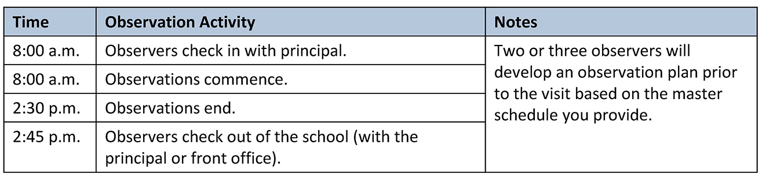

Appendix C. Instructional Observations (Staff Information Sheet)


Appendix D. Overview of CLASS Observation

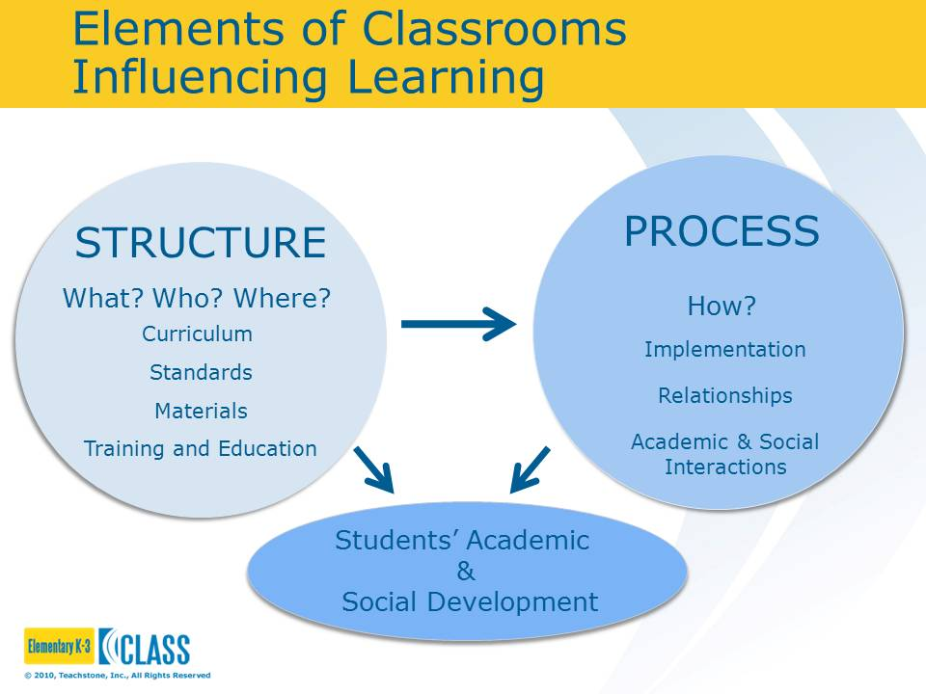
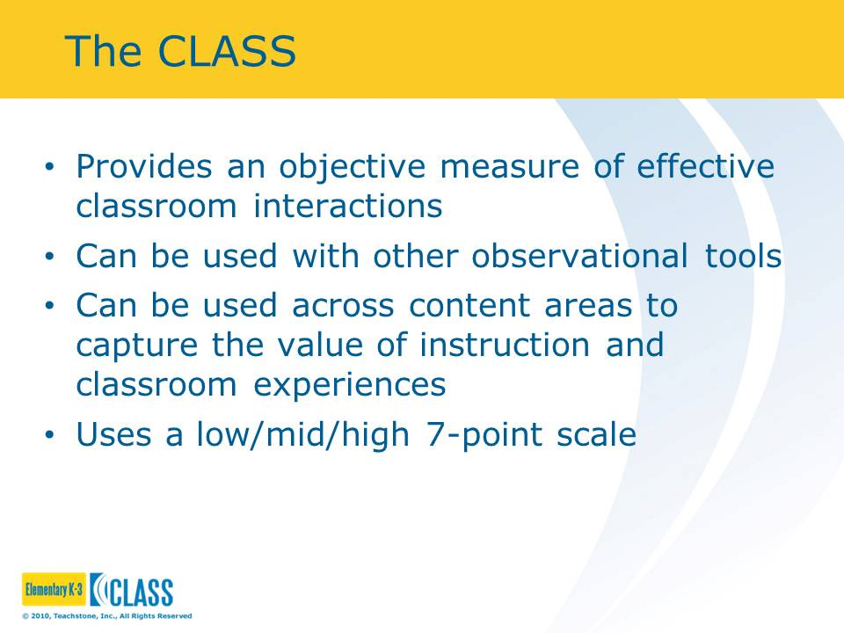
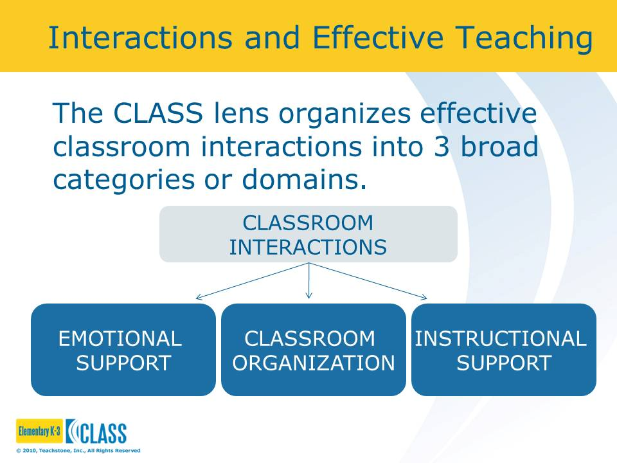
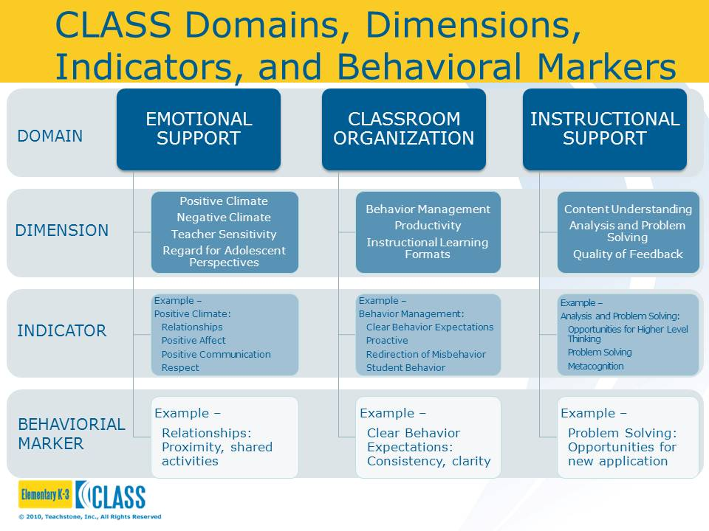
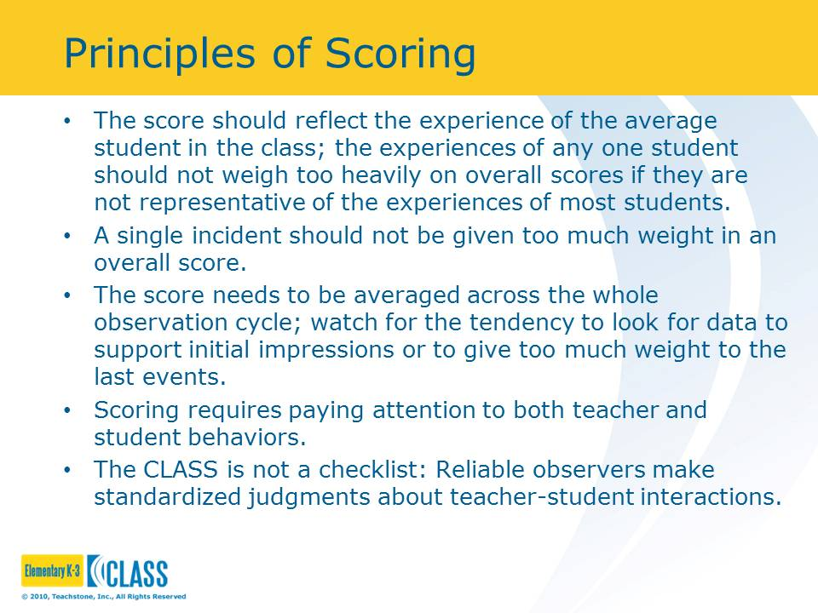
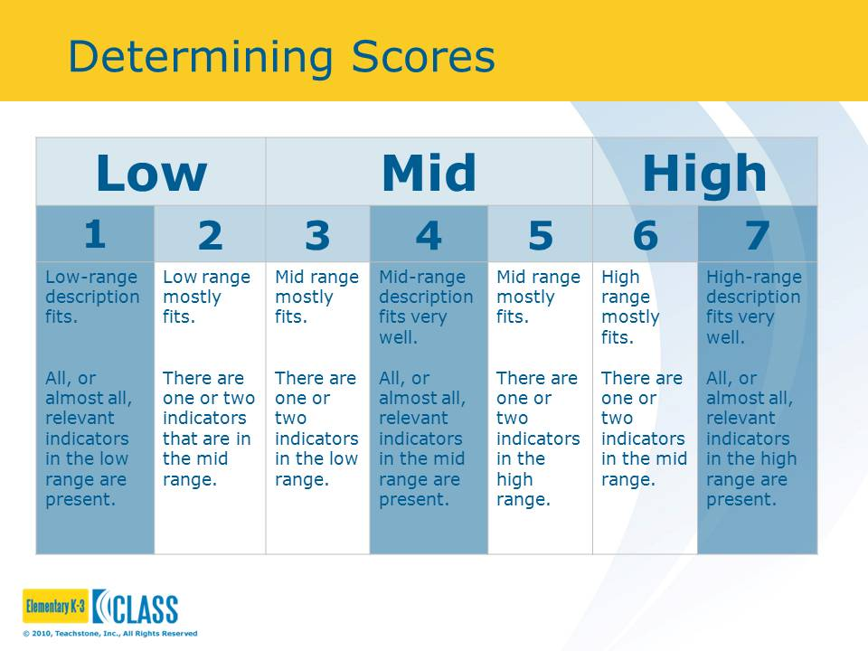
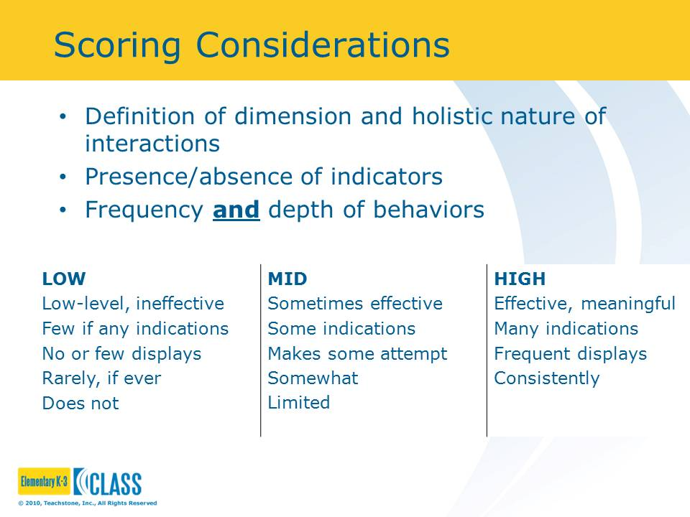

Appendix E. Instructional Staff Survey Overview
Massachusetts Monitoring Site Visit
Instructional Staff Survey
The Massachusetts Department of Elementary and Secondary Education Monitoring Site Visits of Level 4 schools, Level 5 schools, and participating Level 3 schools provide critical information and feedback on the progress districts and schools are making toward improving students’ outcomes. The Monitoring Site Visit process in 2016–17 includes:
- Pre-visit data collection, including some administrator interviews and the instructional staff survey
- Classroom observation data reported in aggregate from a representative sample of classes
- Interview and focus group data
The 2016–17 Monitoring Site Visit will still be two days. The first day includes classroom observation, and the second day includes interviews and focus groups. The survey is conducted before the Monitoring Site Visit teams come on-site to collect data.
Monitoring Site Visit Instructional Staff Survey. The instructional staff survey, which is administered by e-mail prior to the Monitoring Site Visit, will provide crucial data from a broad range of staff with regard to key turnaround practices and indicators. The survey data will be part of the information used to triangulate findings in the Monitoring Site Visit Report. In addition to serving as a critical piece of evidence in the report, the survey allows for more instructional staff to provide feedback and information in a confidential and private setting. The survey is designed using validated survey items (from prior surveys) that are aligned to key components of the turnaround practices and indicators.
Rationale. There are several turnaround practices and indicators on which it is important to have the perspective of all or most of the instructional staff within the school. The data from the survey will ground findings from the interviews and focus groups and will ensure a broader participation in the Monitoring Site Visit process. This survey is in direct response to district and school stakeholders who expressed concern that the interviews and focus groups, in particular, included the perspectives of only a select group of school staff and that many more staff were missing from the Monitoring Site Visit account.
Who Will Be Surveyed? All instructional staff will be surveyed, including teachers, specialists, student support providers, and paraprofessionals. In some instances, teacher responses will be reported in aggregate, without other staff included.
Reporting Survey Data. Survey data will be reported in aggregate with careful attention to anonymity. These data will be reported consistently across all Monitoring Site Visits and will be part of the data used to determine school ratings in the appropriate indicators.
Burden. The survey is purposefully designed to limit the burden of data collection on staff and maximize the opportunity for staff to have input into the Monitoring Site Visit process. The survey takes less than 15 minutes to complete. The timeline for administration is flexible and can be determined in collaboration with the principal.
Survey Administration. We will administer the survey by e-mail, so staff can complete the survey at their convenience. Our aim is to achieve a minimum of 80 percent response rate.
American Institutes for Research (AIR) staff will send a survey link to staff by e-mail so that those staff may complete the survey at their convenience within an established time period. The survey must be administered prior to the Monitoring Site Visit and can be sent to participants as much as a few weeks prior to the visit. In addition, the site lead will provide suggestions for successfully administering the survey in order to realize the 80 percent response rate. For AIR staff to administer the survey by e-mail, the school leader will need to:
- Provide a full list of staff as well as e-mail addresses
- Determine a timeframe for completing the survey that is convenient to staff
- Announce the survey and encourage staff to participate; remind staff not to forward their unique survey links to other staff members
The site lead will work with the principal to determine the best strategy for administering the e-mail survey. If the response rate does not meet the 80 percent threshold, the site lead will work with the principal to create options for raising the response rate.

Appendix F. Monitoring Site Visit Interviews and Focus Groups Day
The following provides an overview of and sample schedule for Monitoring Site Visit Interviews and Focus Groups Day.
Overview
Monitoring Site Visit Interviews and Focus Groups Day focuses on collecting data through interviews and focus groups with key stakeholders in the school. Although there will be some variation in the interviews and focus groups conducted across schools, based on the specific turnaround plans and areas of emphasis within the school, a core set of stakeholders will participate. These stakeholders include the following:
- Principal
- District representative or receiver
- Lead partner
- School leadership team
- Teachers (interviews and focus groups)
- Students (middle school and high school only)
- English language learner and special education specialists
- Instructional coaches
Sample Data Collection: Monitoring Site Visit Interviews and Focus Groups Day
Table 1 includes a list of stakeholder interviews and focus groups conducted during Monitoring Site Visit Interviews and Focus Groups Day.
Table 1. Interviews and Focus Groups
Data Collection | Details | Scheduling Notes
Principal Interview | Prior to Monitoring Site Visit Interviews and Focus Groups Day, an initial interview may be scheduled for 60 to 70 minutes, by phone.  During Monitoring Site Visit Interviews and Focus Groups Day, a closing interview will be scheduled with the principal and will take approximately 30 to 45 minutes. | Conduct an initial interview prior to Monitoring Site Visit Interviews and Focus Group Day and a closing interview the day of the site visit
District Representative or Receiver Interview | District representative or receiver (This interview will include the individual or individuals who are most familiar with the school’s turnaround efforts.) | This interview may be conducted by phone prior to the visit or in person during Monitoring Site Visit Interview and Focus Groups Day.
Lead Partner Interview | Individuals or groups who are directly supporting the school’s turnaround plan in an ongoing collaboration (e.g., receiver, leadership coaching partner, professional development provider) | Optional
Leadership Team Focus Group | School administrators and other leaders (This focus group does not include the principal.) | Especially in smaller schools, these participants may be covered by other interviews. Consider using the instructional leadership team protocol for one participant so that other areas of expertise are still covered and no participant is scheduled twice.
Teacher Focus  Group 1* | A mix of teachers by grade level, primarily teachers who teach mathematics and English language arts (ELA) | The site lead may provide further guidance on the selection of teachers.
Teacher Focus  Group 2* | A mix of teachers by grade level, primarily teachers who teach mathematics and ELA | The site lead may provide further guidance on the selection of teachers.
Student Focus Group (middle school and high school only) | A mix of middle school or high school students across grade levels | Parental permission forms must be signed for students to participate.
Instructional Coaches Interview or Focus Group | An individual or individuals who spend at least 50 percent of his or her time providing instructional support to teachers | blank
Special Education Teachers and Specialists Focus Group | Teacher or teachers who serve special education students | blank
English Language Learner Specialist Interview or Focus Group | Teacher or teachers who serve English language learners | blank
Counselor Interview or Focus Group | School guidance counselors, school adjustment counselors, student service coordinators, or other staff who help to provide mental health services, connections to community services, and student service assessments | blank
Teacher Interview 1 | ELA teacher | At least two teachers will be interviewed individually.
Teacher Interview 2 | Mathematics teacher | blank
* In small schools, one teacher focus group may be sufficient.
Sample Schedule: Monitoring Site Visit Interviews and Focus Groups Day
Table 2 includes a proposed site visit schedule. Note the following as you develop this schedule:
- Note that the times and order of interviews are flexible and will be scheduled in advance by the site lead in collaboration with the principal or a designee.
- Each interview or focus group is designed to take 45 minutes.
- Depending on the size of the school, an additional site visitor may be added.
- When only one interview or focus group is scheduled at a time, one visitor will serve as note taker.
- Monitoring Site Visit Instructional Observation Day has to be completed within two weeks of Monitoring Site Visit Interviews and Focus Groups Day.
Table 2. Monitoring Site Visit Interviews and Focus Groups: DATE
Time | Activity | Site Lead | Site Visitor | Notes
7:30 a.m. | Team Arrival | x | x | blank
8:00 a.m. | Principal Check-In | x | blank | blank
9:00 a.m. | Lead Partner Interview | blank | x | blank
 | District Liaison | x |  | blank
10:00 a.m. | Leadership Team Focus Group | x | blank | blank
blank | Teacher Focus Group 1 | blank | x | Mathematics or ELA professional learning community
11:00 a.m. | Teacher Focus Group 2 | x | blank | blank
blank | Student Focus Group (middle school and high school only) | blank | x | Parental permissions slips will need to be collected prior to the visit.
12:00 p.m. | Instructional Coaches Interview or Focus Group | x | blank | If there is more than one instructional coach, then we will conduct a focus group.
blank | Special Education Teachers and Specialists Focus Group | blank | x | blank
1:00 p.m. | English Language Learner Specialist Interview or Focus Group | x | blank | blank
blank | Teacher Interview 1 | blank | x | ELA or reading teacher
2:00 p.m. | Teacher Interview 2 | blank | x | Mathematics teacher
2:30 p.m. | Principal Closing Interview | x | blank | Approximately 30 minutes, closing interview to ask clarification questions

Appendix G. Student Focus Group Permission Slip
American Institutes for Research
Massachusetts Monitoring Site Visits for Level 4, Level 5, and Level 3 Schools
Focus Group Participant Consent Form—Student Focus Group
Purpose. American Institutes for Research (AIR) is an independent, nonprofit research organization that has been selected by the Massachusetts Department of Elementary and Secondary Education to conduct school Monitoring Site Visits.
There are two purposes for these visits. First, AIR will use the information gathered from interviews, focus groups, classroom observations, and a teacher survey to provide school leaders with feedback to help them improve your child’s school. Second, AIR will report its findings to the Massachusetts Department of Elementary and Secondary Education, who will use the findings to inform accountability decisions about the school.
Confidentiality and Privacy. All information obtained in this focus group will be used only for the purposes of this study. We will not use your child’s name and will not attribute any quotes to individuals. We also will not share your child’s comments with other people in the school or the district. The reports will identify participating schools but will not disclose the names of individuals. Your name and personal information will not be used in the reporting of these data. A completed consent form is necessary for your child to participate in the focus group.
Risks and Discomfort. There are no known risks to participating in this interview.
Benefits. Students will have the opportunity to share perspectives, provide valuable input about the overall performance of the school, and inform future improvement plans, an opportunity not always available to students.
Freedom to Withdraw. Your consent for your child to participate in this research study is completely voluntary. Students may pass on any question, and a parent or the parent’s child may choose to withdraw from the study at any time, without penalty.
Permission to Record. To ensure accuracy of the information we report, we would like to record the focus group. The recording allows us to check the accuracy of our findings. Please know that no one outside of our research team and the transcribing service has access to the recording. Recordings and transcriptions are stored on a secure server that can be accessed only by team members.
More Information. If you would like more information about this study, you may contact Dr. Susan Therriault, the Project Director, at AIR at 781-373-7007 or stherriault@air.org. For questions regarding your rights as a subject participating in this research, please contact AIR’s Institutional Review Board (IRB) at IRBChair@air.org or toll free at 1–800–634–0797.
Informed Consent. I have read and understand the above information. I consent to participate in the study.
Parent Signature: Date:
Child’s Name: Grade:

Appendix H. Monitoring Site Visit Checklist
The following is a checklist for the school or district lead, the site lead and team, and the Massachusetts Department of Elementary and Secondary Education. The list is organized into preparation and day-of activities.
PREPARING FOR THE MONITORING SITE VISIT
School or District Lead
- Schedule and participate in an introductory phone meeting with the site lead.
- Schedule the Monitoring Site Visit Instructional Observation Day and the Monitoring Site Visit Interviews and Focus Groups Day.
- Provide the following documents to the site lead:
- Master schedule
- List of instructional staff members (with e-mail addresses, to allow for survey administration)
- Daily schedule
- Map of the school
- Principal questionnaire (provided by the Monitoring Site Visit site lead; principal may edit last year’s version)
- Optional: Other documents pertinent to the school’s turnaround efforts
- School principal: Schedule and participate in a pre-visit phone interview (45–60 minutes).
- District liaison: Schedule and participate in pre-visit phone interview (45–60 minutes). (Optional: This interview can be conducted the day of the Monitoring Site Visit.)
- Facilitate the administration of the staff survey, including informing staff about the survey and its purpose.
- Finalize interviews and focus groups schedule for Monitoring Site Visit Interviews and Focus Groups Day.
- Designate rooms for interviews and focus groups on Monitoring Site Visit Interviews and Focus Groups Day.
- For middle and high school principals, recruit students for student focus group and distribute permission forms (see Appendix G).
- Provide information about the Monitoring Site Visit to staff (see Appendix I for process overview and Appendix C for observation overview handout).
- Communicate parking or preferred check-in procedures to the site lead.
Massachusetts Department of Elementary and Secondary Education
- Send out notification e-mail to districts.
- Provide school turnaround plan and past Monitoring Site Visit Reports to AIR.
School Site Lead and Team
- Send an introductory e-mail to the district or school.
- Schedule and participate in an introductory phone meeting with the district or school.
- Ensure Instructional Staff Survey is administered to school prior to site visits.
- Schedule the Monitoring Site Visit Instructional Observation Day.
- Schedule the Monitoring Site Visit Interviews and Focus Groups Day and observations and provide the school with a list of interviews and focus groups that need to be scheduled.
- Provide the sample schedule.
- Ensure the district and school understand the Monitoring Site Visit process and the documents that are needed to prepare for the visit.
- Schedule and conduct a pre-visit phone interview with the school principal (45–60 minutes).
- Schedule and conduct a pre-visit phone interview with the district liaison (45–60 minutes). (Optional: This interview can be conducted the day of the Monitoring Site Visit.)
- Review school documents, including the turnaround plan, past Monitoring Site Visit Reports, and other documentation.
- Review principal questionnaire.
- Finalize interviews and focus groups schedule for Monitoring Site Visit Interviews and Focus Groups Day.

DAY OF MONITORING SITE VISIT
School or District Lead
- Confirm the schedule and identify any adjustments that may need to be made. For example, on Monitoring Site Visit Instructional Observation Day, inform the observers or teachers who are absent or otherwise cannot be observed, and on Monitoring Site Visit Interviews and Focus Groups Day, inform the interviewers of staff who cannot participate in scheduled interviews.
- Provide a private and quiet space for interviews and focus groups throughout the day.
- Participate in an end-of-day close-out interview at the end of the interviews and focus groups day.
Site Visit Team
- Check-in with the front office and the principal or designee at the beginning of the visit.
- Confirm the schedule and identify any adjustments that may need to be made, such as noting staff who are absent and cannot participate in observations or interviews.
- Check in with the front office and the principal (or designee) at the end of the visit.

Appendix I. Monitoring Site Visit Overview for Participants (School Staff Information Sheet)
Overview of the Monitoring Site Visits
Introduction. Your school will be going through a Monitoring Site Visit; as a staff member of the school, you may be asked to participate in interviews and focus groups or may have your class observed by a certified observer. You also will have the option of participating in the instructional staff survey. In each instance, we strive to limit the burden in terms of time and distraction of this visit on you and the important work you are doing in the school. The site visit team values your perspective because it is critical to the accuracy of the resulting Monitoring Site Visit Report. If, at any time during the Monitoring Site Visit, you have a question about the visit, please feel free to ask the site visit team members. Thank you in advance for your participation.
The following provides a brief overview about the background, purpose, and structure of the Monitoring Site Visit.
Background. The Massachusetts Department of Elementary and Secondary Education (ESE) conducts Monitoring Site Visits of Level 4 schools, Level 5 schools, and participating Level 3 schools to provide critical information and feedback on the progress districts and schools are making toward improving students’ outcomes. The Monitoring Site Visit process uses baseline data collected through an initial visit and subsequent annual visits to assess schools’ progress toward their improvement goals. The data are analyzed, and findings are reported to schools, their districts, ESE, and the public.
Purpose. The purpose of the Monitoring Site Visit is to provide participating schools with formative feedback in support of turnaround efforts. In addition, Monitoring Site Visit findings are part of the evidence base ESE uses to make decisions about supports and accountability for the schools and their districts. The annual Monitoring Site Visit Reports are intended to help districts and schools understand the status of turnaround implementation based on the four evidence-based turnaround practice areas: (1) Leadership, Shared Responsibility, and Professional Collaboration; (2) Intentional Practices for Improving Instruction; (3) Student-Specific Supports and Instruction to all Students; and (4) School Culture and Climate. The Monitoring Site Visit is designed to obtain information about a school’s progress across a common set of research questions and four turnaround practices based on research on Massachusetts schools, along with specific questions related to each school’s individual turnaround plan.
Monitoring Site Visit Overview. A Monitoring Site Visit typically takes two days, along with a pre-visit survey. In certain situations (e.g., larger schools, more complex turnaround plans), the Monitoring Site Visit may take longer than two days. A description of the entire process follows:
- Instructional Staff Survey (Pre-Visit). Before the site visits, all staff will receive an e-mail invitation to participate in the staff survey. All staff are invited to participate to ensure that a majority of the staff have a voice in specific indicators related to the Monitoring Site Visit. Information from the survey responses will be used to inform the turnaround practice and indicator ratings and will be reported as part of the Monitoring Site Visit Report. Responses are anonymous, and the survey should take less than 15 minutes to complete.
- Monitoring Site Visit Day 1—Instructional Observations Day. The first day of the Monitoring Site Visit focuses on classroom observations. Two or three CLASS-certified observers will conduct observations during the entire school day. The number of observers depends on factors such as the size of the school and number of classrooms selected to be observed. Each classroom observation will take approximately 20 minutes, and observers are trained to be as unobtrusive as possible during the observation. At the beginning and the end of the day, the lead CLASS observer(s) (who may not be the site lead) will check in with the office before beginning observations. However, no information will be shared at that time, and the process is not designed to provide feedback to individual teachers. Findings from the observations will be provided to the school, within one week of the Monitoring Site Visit Observation Day, in the Schoolwide Instructional Observation Report.
- Monitoring Site Visit Day 2—Interviews and Focus Groups Day. This day of the Monitoring Site Visit will be conducted by the site lead and one or two other members of the team. Teachers as well as counselors, administrators, coaches, and other staff will be invited to participate either individually or as part of a small group. In middle and high schools, students also will participate in a focus group. Each of the interviews and focus groups will follow a loosely structured interview protocol. The interviews and focus groups are designed to take approximately 45 minutes. Please note that multiple interviews and focus groups can be scheduled at the same time. As noted earlier, the site visit team will not provide any feedback or guidance on the progress of the school during the site visit. This information will be provided only in the Monitoring Site Visit Report, after further analysis, within one month of the last day of the visit.

Appendix J. Monitoring Site Visit Principal
Pre-Visit Questionnaire
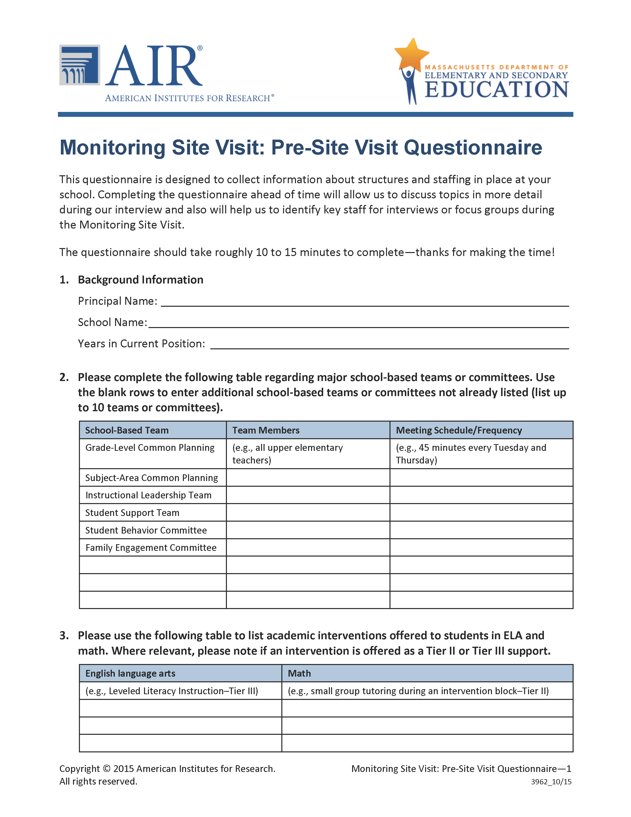
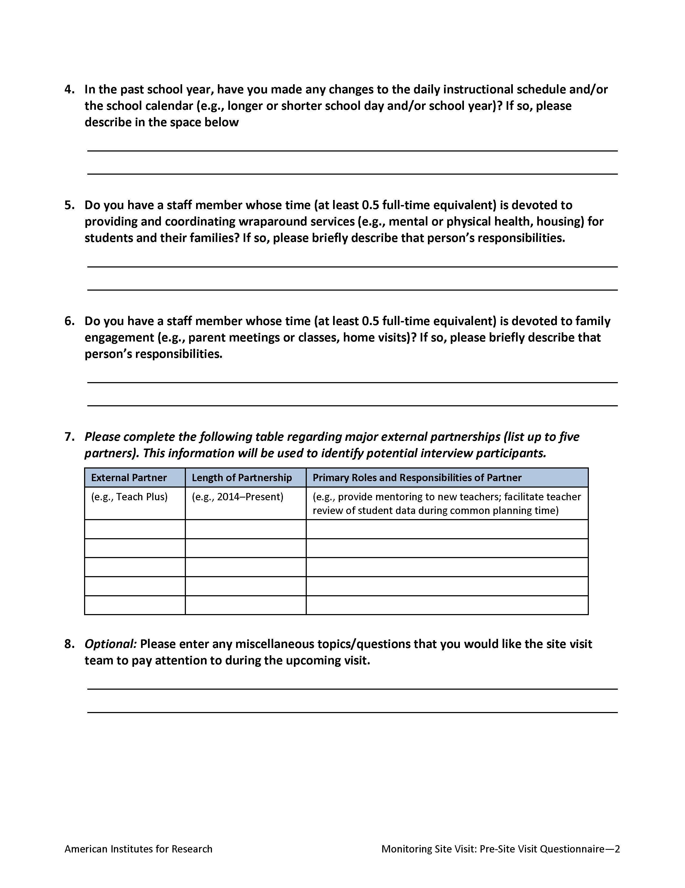

For more information, see: Turnaround Practices in Action: A Three-Year Analysis of School and District Practices, Systems, Policies, and Use of Resources Contributing to Successful Turnaround Efforts in Massachusetts Level 4 Schools http://www.mass.gov/edu/docs/ese/accountability/turnaround/practices-report-2014.pdf
For the purposes of this document, the school turnaround plan refers to the most recent plan developed by Level 4 or Level 5 schools and submitted to ESE (e.g., School Redesign Plan).
ESE is required to report on the status of Level 4 and Level 5 schools annually. The Monitoring Site Visit is one artifact of data along with student outcomes data, which informs these reports.
In cases in which a district may have more than one school in the Monitoring Site Visit process, the site lead and district liaison may choose to conduct a longer, more involved interview about multiple schools.
It is not essential that the two days of visits be consecutive. It may be less of a burden on school staff if the days are not consecutive.
The site lead with the school-designated observers will design an observation schedule using the master schedule, a list of staff members and their responsibilities (with contact information), and the daily schedule provided by the school. Besides providing these documents, the school leader will not need to provide any further coordination support.
The exact number of observers and observations depends on the number of classrooms and classes.
Some teachers may be observed more than once, such as in smaller schools with self-contained classrooms where the same teacher might be teaching several different subjects throughout the day.
Prior to the visit, the site visit lead and the school leader will establish a schedule with locations for interviews and focus groups. Individuals will be selected for participation based on the list of staff members (with their roles and teaching assignments) provided by the school. The site visit lead will identify the individuals with whom the team will meet and coordinate the schedule with the school leader. In preparation for these data collection activities, the site visit team will review documents and develop site-specific questions. Principals and district representatives will be interviewed in advance of the visit.
Please note that multiple interviews and focus groups may be scheduled to run at the same time.
All members of the site visit team will be checked for Criminal Offender Record Information prior to the visit. ESE will coordinate this process.
For more information, see: Turnaround Practices in Action: A Three-Year Analysis of School and District Practices, Systems, Policies, and Use of Resources Contributing to Successful Turnaround Efforts in Massachusetts Level 4 Schools http://www.mass.gov/edu/docs/ese/accountability/turnaround/practices-report-2014.pdf
For more information, see: Turnaround Practices in Action: A Three-Year Analysis of School and District Practices, Systems, Policies, and Use of Resources Contributing to Successful Turnaround Efforts in Massachusetts Level 4 Schools http://www.mass.gov/edu/docs/ese/accountability/turnaround/practices-report-2014.pdf
The indicators draw from Implementation Continuum for School Turnaround and Transformation from American Institutes for Research, which serves as a self-guided implementation monitoring tool for schools. See: Barbour, C., Karageorge, T., Bates, R., Meyer, C., Burdette, J., Newell, K., et al. (2014). Implementation continuum for school turnaround and transformation. Washington, DC: American Institutes for Research.
For more information, see: Turnaround Practices in Action: A Three-Year Analysis of School and District Practices, Systems, Policies, and Use of Resources Contributing to Successful Turnaround Efforts in Massachusetts Level 4 Schools http://www.mass.gov/edu/docs/ese/accountability/turnaround/practices-report-2014.pdf
For the purposes of this document, the school turnaround plan refers to the most recent plan developed by schools and submitted to ESE (e.g., School Redesign Plan).
Observers will design an observation schedule using the master schedule, a list of staff members and their responsibilities (with contact information), and the daily schedule and map provided by the school. Besides providing these documents, the school leader will not need to provide any further coordination support.
Prior to the visit, the site visit lead and the school leader will establish a schedule with locations for interviews and focus groups. Individuals will be selected for participation based on the list of staff (with their roles and teaching assignments) provided by the school. The site lead will identify the individuals with whom the team will meet and coordinate the schedule with the school leader. In preparation for these data collection activities, the site visit team will review documents and develop site-specific questions of interest.

