INDOOR AIR QUALITY ASSESSMENT

Monson Town Offices
29 Thompson Street
Monson, Massachusetts



Prepared by:
Massachusetts Department of Public Health
Bureau of Environmental Health
Indoor Air Quality Program
March 2014

Background/Introduction
At the request of Lori McCool, Health Agent for the Town of Monson, the Massachusetts Department of Public Health (MDPH), Bureau of Environmental Health (BEH) provided assistance and consultation regarding indoor air quality (IAQ) at the Monson Town Offices (MTO) building, located at 29 Thompson Street, Monson. The request was prompted by concerns of odors and potential mold growth inside the building that reportedly occurs after rain storms and overall IAQ. On September 20, 2013, a visit to conduct an indoor air assessment was made by Mike Feeney, Director of BEH’s IAQ Program. He was accompanied by Kathleen Gilmore, Environmental Analyst/Regional Inspector in BEH’s IAQ Program.
The MTO is currently being used as temporary office space for town employees that were displaced following a severe storm and historic tornado that touched down in Western Massachusetts on June 1, 2011, ravaging many communities, including Monson. Monson town offices moved into its current location, the vacant school building (the building), as a temporary measure after the destruction of the original Monson Town Hall by the tornado. Construction of a new town building/police station was scheduled to begin in the fall of 2013 and estimated to be completed in the fall of 2014, at which time all town departments will move to the new location.
The MTO was formerly the Hillside School, a one-floor brick building constructed in the mid-1950s that was used as a school until it was closed in 2001. From 2001 to 2011, the school was not actively used by the town other than for school transportation offices located in the basement level of the building. The building currently contains office space and conference/meeting rooms in former classrooms and school administrative offices. The building has a dirt crawlspace under the building for utilities. Many areas have wall-to-wall carpeting and most windows are openable throughout the building.
Town officials report that no major renovations have been done to the MTO building since before it was closed as a school, and that it has significant capital maintenance needs, including a new roof, a new heating system and boiler, replacement windows, and extensive repairs to the masonry exterior walls.

Methods
Air tests for carbon dioxide, temperature, relative humidity and carbon monoxide were conducted with the TSI, Q-Trak, IAQ Monitor, Model 7565. Air tests for airborne particle matter with a diameter less than 2.5 micrometers were taken with the TSI, DUSTTRAK™ Aerosol Monitor Model 8520. BEH/IAQ staff also performed visual inspection of building materials for water damage and/or microbial growth.

Results
The MTO has an employee population of approximately 10 and is visited by up to 50 members of the public daily. Tests were taken during normal operations and results appear in Table 1.

Discussion

Ventilation
It can be seen from Table 1 that carbon dioxide levels were below 800 parts per million (ppm) in all areas assessed. It is important to note that several areas were empty/sparsely populated, which can greatly reduce carbon dioxide levels. Carbon dioxide levels would be expected to increase with higher occupancy.
Fresh air to the MTO is supplied by a unit ventilator (univent) system (Picture 1). A univent draws air from the outdoors through a fresh air intake located on the exterior wall of the building (Picture 2). Return air from the room is drawn through an air intake located at the base of the unit (Figure 1). Fresh and return air are mixed, filtered, heated or cooled and provided to offices through an air diffuser located in the top of the unit. Univents were found deactivated/non-functional; therefore, the ventilation system is not able to draw fresh air from outdoors. The sole means for introducing fresh air into the building is through openenable windows. In order for univents to provide fresh air as designed, they must remain “on” and operating while rooms are occupied.
Of note, univents in the MTO were installed when the school building was constructed, over 50 years ago. The age of the equipment makes service and repairs of these units difficult. According to the American Society of Heating, Refrigeration and Air-Conditioning Engineers (ASHRAE), the service life for a unit heater using hot water or steam is 20 years, assuming routine maintenance of the equipment (ASHRAE, 1991). Despite attempts to maintain the univents, the operational lifespan of the equipment has been exceeded. Maintaining the balance of fresh air to exhaust air will become more difficult as the equipment ages and as replacement parts become increasingly difficult to obtain.
Exhaust ventilation is provided by ducted, grated wall vents (Picture 3) located in storage closets powered by roof-top motors (Picture 4). At the time of assessment, BEH/IAQ staff could not detect any draw of air by the mechanical exhaust systems. It was reported that the exhaust motors had not been operable since the MTO has occupied the space. As with supply ventilation, in order to function properly, exhaust vents must be activated and allowed to operate while rooms are occupied. Without adequate supply and exhaust ventilation, excess heat and environmental pollutants can accumulate, leading to indoor air/comfort complaints.
The heating, ventilation and cooling (HVAC) system in some areas (i.e. former cafeteria, gymnasium) is provided by a roof-top air handling unit (AHU) (Picture 5). The AHU is designed to draw in fresh, outdoor air through air intakes; filter, heat and/or cool the air; then distribute it to occupied areas via ceiling-mounted air diffusers (Picture 6); air would be returned via ducted exhaust vents. As BEH/IAQ staff did not access the roof, it was not known if this system was functioning at the time of the assessment.
To maximize air exchange, the MDPH recommends that both supply and exhaust ventilation operate continuously during periods of occupancy. In order to have proper ventilation with a mechanical supply and exhaust system, the systems must be balanced to provide an adequate amount of fresh air to the interior of a room while removing stale air from the room. It is recommended that HVAC systems be re-balanced every five years to ensure adequate air systems function (SMACNA, 1994). The date of the last balancing of these systems was not available at the time of the assessment.
Minimum design ventilation rates are mandated by the Massachusetts State Building Code (MSBC). Until 2011, the minimum ventilation rate in Massachusetts was higher for both occupied office spaces and general offices, with similar requirements for other occupied spaces (BOCA, 1993). The current version of the MSBC, promulgated in 2011 by the State Board of Building Regulations and Standards (SBBRS), adopted the 2009 International Mechanical Code (IMC) to set minimum ventilation rates. Please note that the MSBC is a minimum standard that is not health-based. At lower rates of cubic feet per minute (cfm) per occupant of fresh air, carbon dioxide levels would be expected to rise significantly. A ventilation rate of 20 cfm per occupant of fresh air provides optimal air exchange resulting in carbon dioxide levels at or below 800 ppm in the indoor environment in each area measured. MDPH recommends that carbon dioxide levels be maintained at 800 ppm or below. This is because most environmental and occupational health scientists involved with research on IAQ and health effects have documented significant increases in indoor air quality complaints and/or health effects when carbon dioxide levels rise above the MDPH guidelines of 800 ppm for schools, office buildings and other occupied spaces (Sundell et al., 2011). The ventilation must be on at all times that the room is occupied. Providing adequate fresh air ventilation with open windows and maintaining the temperature in the comfort range during the cold weather season is impractical. Mechanical ventilation is usually required to provide adequate fresh air ventilation.
Carbon dioxide is not a problem in and of itself. It is used as an indicator of the adequacy of the fresh air ventilation. As carbon dioxide levels rise, it indicates that the ventilating system is malfunctioning or the design occupancy of the room is being exceeded. When this happens, a buildup of common indoor air pollutants can occur, leading to discomfort or health complaints. The Occupational Safety and Health Administration (OSHA) standard for carbon dioxide is 5,000 parts per million parts of air (ppm). Workers may be exposed to this level for 40 hours/week, based on a time-weighted average (OSHA, 1997).
The MDPH uses a guideline of 800 ppm for publicly occupied buildings. A guideline of 600 ppm or less is preferred in schools due to the fact that the majority of occupants are young and considered to be a more sensitive population in the evaluation of environmental health status. Inadequate ventilation and/or elevated temperatures are major causes of complaints such as respiratory, eye, nose and throat irritation, lethargy and headaches. For more information concerning carbon dioxide, consult Appendix A.
Indoor temperature measurements ranged from 73º F to 78º F, which were within the MDPH recommended comfort range (Table 1). The MDPH recommends that indoor air temperatures be maintained in a range of 70º F to 78º F in order to provide for the comfort of building occupants. In many cases concerning indoor air quality, fluctuations of temperature in occupied spaces are typically experienced, even in a building with an adequate fresh air supply.
Temperature control complaints (primarily heat complaints) were reported by some occupants. The windows in the building are single pane with metal frames (Picture 7) which can allow heat to escape in the winter, creating drafts, and for sunlight to create a condition of solar gain and glare making temperature control difficult. Shades should be used to reduce solar gain as needed.
It was reported that the building HVAC system is controlled by an off-sight management company. No adjustments have been made to the HVAC system that accounts for the reduction of building population from a fully occupied school (estimated 200+ occupants) to the current building population of 10 employees. Without adjusting the HVAC system, temperature extremes will be experienced in this building.
The relative humidity in the building ranged from 42 to 51 percent, which was within the MDPH recommended comfort range in all areas evaluated on the day of the assessment (Table 1). The MDPH recommends a comfort range of 40 to 60 percent for indoor air relative humidity. Relative humidity levels in the building would be expected to drop during the winter months due to heating. The sensation of dryness and irritation is common in a low relative humidity environment. Low relative humidity is a very common problem during the heating season in the northeast part of the United States.

Microbial/Moisture Concerns
BEH/IAQ staff examined building materials for water damage and/or microbial growth. In order for building materials to support mold growth, a source of water exposure is necessary. Identification and elimination of the source of water moistening building materials is necessary to control mold growth.
Upon entering the building, BEH/IAQ staff noted a musty/wet cellar-like odor, which was pervasive throughout the entire building. The building was constructed with a dirt crawlspace below most occupied areas of the building. Porous materials including boxes, wood and cardboard were observed inside the crawlspace (Picture 8). BEH/IAQ staff did not observe any visible moisture or water accumulation in readily accessible areas of the crawlspace. Building staff reported that the crawlspace below the west wing was subject to chronic moisture due to water penetration following heavy storms. The northwest location of the building which is shaded and surrounded by a forested area (Picture 9), may subject this below-grade area of the building to more water penetration and moisture than other parts of the building.
Mold spores would be expected to be present in an unconditioned dirt floor crawlspace that is subjected to moisture. Efforts should be made to reduce moisture and circulate air to reduce mold growth in this area and to reduce/eliminate potential pathways for mold, spores, and associated odors to migrate into occupied areas. The means for odors and pollutants to migrate between the crawlspace and occupied areas are holes and spaces that were open in the floor (e.g., space around utility pipes, plumbing, electrical, uninvent) (Pictures 10 and 11). Airflow tends to rise due to the stack effect and these breaches can serve as pathways to draw air, odors and particulates from the crawlspace into ground floor hallways and office spaces. All holes and gaps should be sealed with fire-rated sealant foam or other appropriate material. In addition, the access hatch to the crawlspace entrance should be closed and sealed to prevent the penetration of odors and particulates into occupied spaces.
The means for crawlspace odors to migrate into occupied areas are also related to the HVAC exhaust system and the installation of fan-cooled water heaters in each room. The building is equipped with a mechanical ventilation system to provide exhaust ventilation for occupied areas. This system was not operating. If it were operating, closets in rooms would be depressurized, which would limit the migration of crawlspace odors to the area around the exhaust vent. While the HVAC system exhaust vent system was deactivated, the fan-cooled water heaters were activated. The operation of the water heater fans depressurized the closet, which then drew air from the crawlspace along spaces around the ductwork in closets. Enhancing this draw was the use of industrial-sized dehumidifiers in the building. Dehumidifiers should only be used in this type of building after a flood incident or during periods of weather-related high relative humidity. During the inspection, BEH/IAQ staff advised building staff to deactivate the industrial humidifiers. Once deactivated, the musty odors dissipated.
As previously noted, room closets contained small unit water heaters equipped with a motorized fan (Picture 12) which were designed to provide hot water to sinks located in the same office space (Picture 13). In Room 7, the water heater had leaked resulting in water damage to the cabinet and surrounding areas including visible mold on wood surfaces (Picture 14). The leaking water heater was removed, the area cleaned and sealant was used to fill holes from the crawlspace (Pictures 15). All water heaters and associated plumbing should be examined for leaks and repaired as needed to prevent future water leaks. As shown in Picture 15, spaces around the water heaters are subject to cracks/holes that connect the crawlspace to occupied areas, and fans needed for proper operation of the water heaters also tend to draw air from the crawlspace and distribute it to occupied areas. Spaces and breaches were also observed around pipes in the interior cabinet of univents (Picture 16).
Since MTO contains numerous sinks (Table 1), routine inspection of these fixtures should be done to avoid dry drain traps which can occur as these fixtures are infrequently utilized. The purpose of a drain trap is to prevent sewer gases and crawlspace odors from entering the occupied space. When water is poured into a trap, an air tight seal is created by the water in the U-bend section of the pipe. These drains must have water poured into them on a regular basis to maintain the integrity of the seal and eliminate sewer gas from entering the building. If these sinks are not regularly needed, it is recommended that they be removed along with the associated water heaters.
Water-damaged ceiling tiles were found in several rooms (Table 1, Picture 17). Water-damaged ceiling tiles indicate leaks from either the roof or plumbing system. If repeatedly moistened, ceiling tiles can be a medium on which mold can grow. Water-damaged tiles should be replaced after a water leak is discovered and repaired.
Numerous plants were observed in one room (Picture 18). Plants, soil and drip pans can serve as sources of mold growth. Plants can also be a source of pollen. Plants should not be placed on porous materials, since water damage to porous materials may lead to microbial growth. Over-watering of plants should be avoided and drip pans should be inspected periodically for mold growth.
Caulking/sealing gaskets around interior/exterior window frames were missing or damaged (Picture 19). Air infiltration was noted around windows, which can result in water penetration through the window frames. Water penetration through window frames can lead to mold growth under certain conditions. Repairs of window leaks are necessary to prevent further water penetration.
BEH/IAQ staff conducted a perimeter inspection of the building’s exterior to identify potential sources of water penetration. Basement windows and crawlspaces are below grade and surrounded by grass, plant growth and debris (Picture 20), which can result in the accumulation of rainwater and potential water penetration into the crawlspace/basement. In addition, the growth of grass and roots against exterior walls can bring moisture in contact with the foundation, eventually leading to cracks and/or fissures in the below ground level. Over time, these conditions can undermine the integrity of the building envelope and provide a means of water entry into the building via capillary action through foundation concrete and/or masonry (Lstiburek & Brennan, 2001).
Other IAQ Evaluations
IAQ can be negatively influenced by the presence of respiratory irritants, such as products of combustion. The process of combustion produces a number of pollutants. Common combustion emissions include carbon monoxide, carbon dioxide, water vapor and smoke (fine airborne particle material). Of these materials, exposure to carbon monoxide and particulate matter with a diameter of 2.5 micrometers (μm) or less (PM2.5) can produce immediate, acute health effects upon exposure. To determine whether combustion products were present in the indoor environment, BEH/IAQ staff obtained measurements for carbon monoxide and PM2.5.

Carbon Monoxide
Carbon monoxide is a by-product of incomplete combustion of organic matter (e.g., gasoline, wood and tobacco). Exposure to carbon monoxide can produce immediate and acute health effects. Several air quality standards have been established to address carbon monoxide and prevent symptoms from exposure to these substances. The MDPH established a corrective action level concerning carbon monoxide in ice skating rinks that use fossil-fueled ice resurfacing equipment. If an operator of an indoor ice rink measures a carbon monoxide level over 30 ppm, taken 20 minutes after resurfacing within a rink, that operator must take actions to reduce carbon monoxide levels (MDPH, 1997).
The American Society of Heating Refrigeration and Air-Conditioning Engineers (ASHRAE) has adopted the National Ambient Air Quality Standards (NAAQS) as one set of criteria for assessing indoor air quality and monitoring of fresh air introduced by HVAC systems (ASHRAE, 1989). The NAAQS are standards established by the US EPA to protect the public health from six criteria pollutants, including carbon monoxide and particulate matter (US EPA, 2006). As recommended by ASHRAE, pollutant levels of fresh air introduced to a building should not exceed the NAAQS levels (ASHRAE, 1989). The NAAQS were adopted by reference in the Building Officials & Code Administrators (BOCA) National Mechanical Code of 1993 (BOCA, 1993), which is now an HVAC standard included in the Massachusetts State Building Code (SBBRS, 2011). According to the NAAQS, carbon monoxide levels in outdoor air should not exceed 9 ppm in an eight-hour average (US EPA, 2006).
Carbon monoxide should not be present in a typical, indoor environment. If it is present, indoor carbon monoxide levels should be less than or equal to outdoor levels. The day of assessment, outdoor carbon monoxide concentrations were non-detect (ND) (Table 1). No measurable levels of carbon monoxide were detected in the building during the assessment (Table 1).

Particulate Matter (PM2.5)
The US EPA has established NAAQS limits for exposure to particulate matter. Particulate matter is airborne solids that can be irritating to the eyes, nose and throat. The NAAQS originally established exposure limits to particulate matter with a diameter of 10 μm or less (PM10). According to the NAAQS, PM10 levels should not exceed 150 microgram per cubic meter (μg/m³) in a 24-hour average (US EPA, 2006). These standards were adopted by both ASHRAE and BOCA. Since the issuance of the ASHRAE standard and BOCA Code, US EPA established a more protective standard for fine airborne particles. This more stringent PM2.5 standard requires outdoor air particle levels be maintained below 35 μg/m³ over a 24-hour average (US EPA, 2006). Although both the ASHRAE standard and BOCA Code adopted the PM10 standard for evaluating air quality, MDPH uses the more protective PM2.5 standard for evaluating airborne particulate matter concentrations in the indoor environment.
Outdoor PM2.5 concentrations measured 13 μg/m³ on the day of the visit (Table 1). PM2.5 levels measured inside the MTO ranged from 5 to 11 μg/m³ (Table 1) which were below the NAAQS PM2.5 levels. Frequently, indoor air levels of particulates (including PM2.5) can be at higher levels than those measured outdoors. A number of mechanical devices and/or activities that occur in buildings can generate particulate during normal operations. Sources of indoor airborne particulates may include but are not limited to particles generated during the operation of fan belts in the HVAC system, use of stoves and/or microwave ovens in kitchen areas; use of photocopiers, fax machines and computer printing devices; operation of an ordinary vacuum cleaner and heavy foot traffic indoors.
Volatile Organic Compounds
Indoor air concentrations can be greatly impacted by the use of products containing volatile organic compounds (VOCs). VOCs are carbon-containing substances that have the ability to evaporate at room temperature. Frequently, exposure to low levels of total VOCs (TVOCs) may produce eye, nose, throat and/or respiratory irritation in some sensitive individuals. For example, chemicals evaporating from a paint can stored at room temperature would most likely contain VOCs. In an effort to identify materials that can potentially increase indoor VOC concentrations, BEH/IAQ staff examined the office space for products containing respiratory irritants.
Cleaning products were found in a number of areas throughout the building (Table 1). Cleaning products contain chemicals that can be irritating to the eyes, nose and throat of sensitive individuals.
Hand sanitizer was observed in some areas (Picture 21). Hand sanitizer products may contain ethyl alcohol and/or isopropyl alcohol which are highly volatile and may be irritating to the eyes and nose, and may also contain fragrances to which some people may be sensitive.
Air fresheners and deodorizing materials were observed in some areas. Air deodorizers contain chemicals that can be irritating to the eyes, nose and throat of sensitive individuals. Many air fresheners contain 1,4-dichlorobenzene, a VOC which may cause reductions in lung function (NIH, 2006). Furthermore, deodorizing agents do not remove materials causing odors, but rather mask odors that may be present in the area.
There are several photocopiers in the building. Photocopiers can be sources of pollutants such as VOCs, ozone, heat and odors, particularly if the equipment is older and in frequent use. Both VOCs and ozone are respiratory irritants (Schmidt Etkin, 1992). Photocopiers and laminators should be kept in well ventilated rooms, and should be located near windows or exhaust vents.

Other Concerns
Window-mounted air conditioners (ACs) were observed in some areas (Table 1, Picture 22). These units are normally equipped with filters, which should be cleaned or changed as per manufacturer’s instructions.
A number of air diffusers, exhaust vents and personal fans (Picture 23) were observed to have accumulated dust/debris. These diffusers, vents and fans should be cleaned periodically in order to prevent dust/debris from being aerosolized and redistributed throughout the room.
In several rooms, items were observed on the floors, windowsills, tabletops, counters, bookcases and desks. Large number of items stored in occupied areas provides a source for dusts to accumulate. These items (e.g., papers, folders, boxes) make it difficult for custodial staff to clean. Items should be relocated and/or be cleaned periodically to avoid excessive dust build up.
Floors in most rooms are covered by wall-to-wall carpeting. It was not clear whether a carpet cleaning program in place at the MTO. The Institute of Inspection, Cleaning and Restoration Certification (IICRC), recommends that carpeting be cleaned annually (or semi-annually in soiled high traffic areas) (IICRC, 2005). If the carpeting is beyond its service life, consideration should be given towards replacement.

Conclusions/Recommendations
Based on the inspection by BEH/IAQ staff, HVAC equipment at the MTO appears to consist of univents that have exceeded their expected service lifespan and an exhaust ventilation system that is deactivated/non-functional. In occupied spaces, normally-occurring environmental pollutants and excess heat can build up and lead to indoor air/comfort complaints. The existing capacity of mechanical ventilation equipment to provide adequate fresh air and exhaust to offices is limited. Problems existing in the building are compounded by the water issues in the crawlspace, as well as other structural concerns. The following measures should be considered for use of the building as town offices:
- Discontinue the use of industrial dehumidifiers unless building experiences a flood event or extended weather-related high relative humidity indoors.
- Seal all utility pipes, conduit and other penetrations in the ceiling and walls of the crawlspace, in the floor of ground floor rooms, inside unit ventilators and utility pipes using an expandable, fire-rated sealing compound.
- Given the age of the univent system, and questions as to whether this system has the capacity to operate, it is suggested that the univent fans be disconnected so the system can provide heat as a radiant heat system only if the building is used as town offices. If this is done, disconnect the building from the energy control system that is used by the school system and control heat manually within the building.
- Consider installing window mounted air-conditioners in occupied offices to reduce heat in hot weather. Use window shades to modulate room temperature as needed.
- Open windows (weather permitting) to temper rooms and provide fresh outside air. Care should be taken to ensure windows are properly closed at night and weekends during winter months to avoid the freezing of pipes and potential flooding. In addition, keep windows closed during hot, humid weather to maintain indoor temperatures and to avoid condensation problems when air conditioning is activated.
- For buildings in New England, periods of low relative humidity during the winter are often unavoidable. Therefore, scrupulous cleaning practices should be adopted to minimize common indoor air contaminants whose irritant effects can be enhanced when the relative humidity is low. To control for dusts, a high efficiency particulate arrestance (HEPA) filter equipped vacuum cleaner in conjunction with wet wiping of all surfaces is recommended. Avoid the use of feather dusters. Drinking water during the day can help ease some symptoms associated with a dry environment (throat and sinus irritations)
- Remove all porous materials from crawlspace (boxes, cardboard, wood etc.) Seal the crawlspace access hatch with weather-stripping/sealant. Inspect all exterior doors for light and/or drafts and repair as needed.
- Continue to monitor for leaks and/or water damage due to malfunctioning portable water heaters, and disconnect and/or repair as warranted.
- Routinely inspect sinks in offices. Pour water into drains on a regular basis (2 -3 times per week). If possible, disconnect and remove unneeded sinks and associated water heaters.
- Remove water-damaged ceiling tiles and examine for source of water. Replace all missing and ajar ceiling tiles and monitor for future leaks.
- Ensure plants have drip pans and avoid over-watering. Examine drip pans periodically for mold growth. Disinfect with an appropriate antimicrobial where necessary. Remove plants from univent air diffusers.
- Continue inspection of windows and the building envelope and repair/replace missing or damaged caulking and seal all cracks and holes in walls to prevent water penetration.
- Remove grass, plants and debris away from the exterior wall/foundation of the building to prevent water penetration into basement and crawlspace.
- Refrain from use of air deodorizers/fresheners.
- Relocate or reduce the amount of stored materials to allow for more thorough cleaning.
- Consider cleaning carpeting annually (or semi-annually in soiled high traffic areas).
- Refer to resource manuals and other related indoor air quality documents for further building-wide evaluations and advice on maintaining public buildings. Copies of these materials are located on the MDPH’s website: www.mass.gov/dph/iaq.

References
ASHRAE. 1989. Ventilation for Acceptable Indoor Air Quality. American Society of Heating, Refrigeration and Air Conditioning Engineers. ANSI/ASHRAE 62-1989.
ASHRAE. 1991. ASHRAE Applications Handbook, Chapter 33 “Owning and Operating Costs”. American Society of Heating, Refrigeration and Air Conditioning Engineers, Atlanta, GA.
BOCA. 1993. The BOCA National Mechanical Code/1993. 8th ed. Building Officials and Code Administrators International, Inc., Country Club Hill, IL.
IICRC. 2005. Carpet Cleaning FAQ 4 Institute of Inspection, Cleaning and Restoration Certification. Institute of Inspection Cleaning and Restoration, Vancouver, WA.
Lstiburek, J. & Brennan, T. 2001. Read This Before You Design, Build or Renovate. Building Science Corporation, Westford, MA. U.S. Department of Housing and Urban Development, Region I, Boston, MA.
MDPH. 1997. Requirements to Maintain Air Quality in Indoor Skating Rinks (State Sanitary Code, Chapter XI). 105 CMR 675.000. Massachusetts Department of Public Health, Boston, MA.
NIH. 2006. Chemical in Many Air Fresheners May Reduce Lung Function. NIH News. National Institute of Health. July 27, 2006. http://www.nih.gov/news/pr/jul2006/niehs-27.htm
OSHA. 1997. Limits for Air Contaminants. Occupational Safety and Health Administration. Code of Federal Regulations. 29 C.F.R 1910.1000 Table Z-1-A.
Schmidt Etkin, D. 1992. Office Furnishings/Equipment & IAQ Health Impacts, Prevention & Mitigation. Cutter Information Corporation, Indoor Air Quality Update, Arlington, MA.
SBBRS. 2011. Mechanical Ventilation. State Board of Building Regulations and Standards. Code of Massachusetts Regulations, 8th edition. 780 CMR 1209.0
SMACNA. 1994. HVAC Systems Commissioning Manual. 1st ed. Sheet Metal and Air Conditioning Contractors’ National Association, Inc., Chantilly, VA.
Sundell. 2011. Sundell, J., H. Levin, W. W. Nazaroff, W. S. Cain, W. J. Fisk, D. T. Grimsrud, F. Gyntelberg, Y. Li, A. K. Persily, A. C. Pickering, J. M. Samet, J. D. Spengler, S. T. Taylor, and C. J. Weschler. Ventilation rates and health: multidisciplinary review of the scientific literature. Indoor Air, Volume 21: pp 191–204.
US EPA. 2006. National Ambient Air Quality Standards (NAAQS). US Environmental Protection Agency, Office of Air Quality Planning and Standards, Washington, DC. http://www.epa.gov/air/criteria.html.
Picture 1
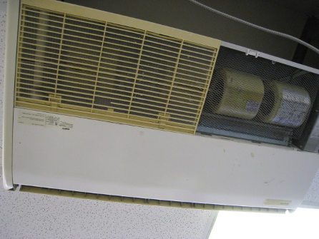
Example of uninvent in MTO
Picture 2
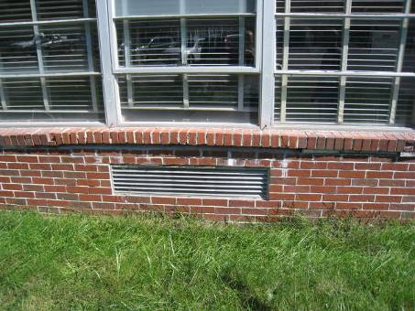
Univent air intake on exterior wall
Picture 3
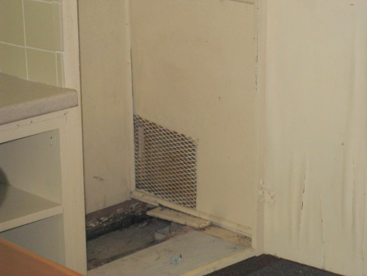
Exhaust vent located in storage closet
Picture 4
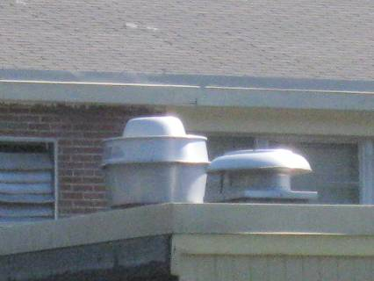
Roof-top exhaust vent

Picture 5
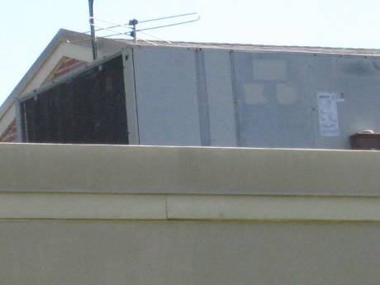
Roof-top AHU
Picture 6
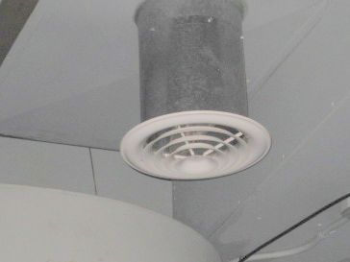
Supply diffuser in gymnasium/stage area

Picture 7

Single pane windows with blinds open
Picture 8
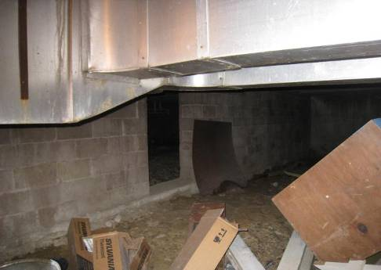
Boxes and wood stored in crawlspace
Picture 9

Wooded area surrounding northwest side of building
Picture 10
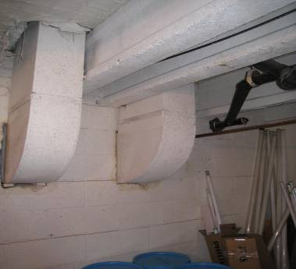
Holes/breaches around ductwork and utility pipes in crawlspace (arrows)
Picture 11
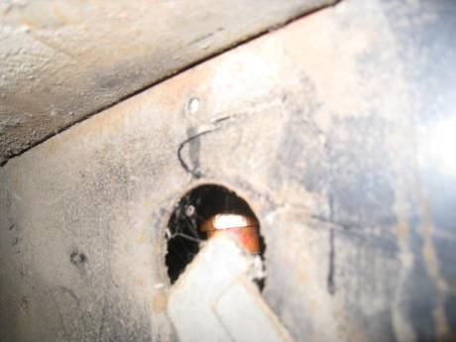
Hole surrounding utility pipe
Picture 12
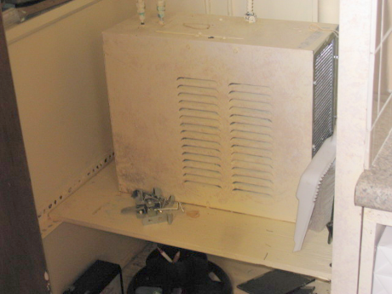
Fan-cooled water heater
Picture 13
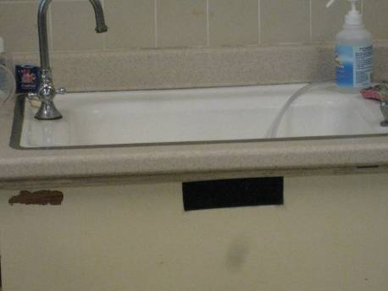
Example of sink located in office space
Picture 14
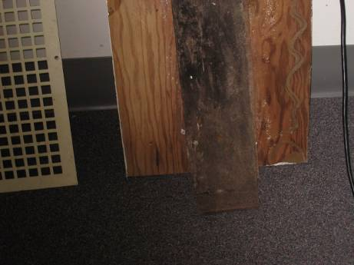
Mold on wood surface as a result of water heater leak
Picture 15
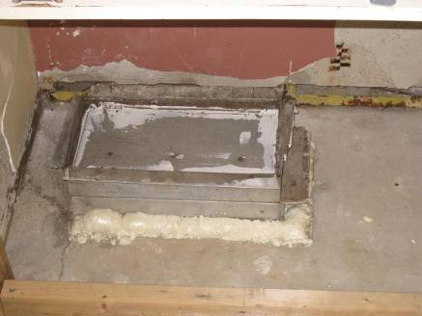
Example of sealant used to fill gaps from removed water heater
Picture 16
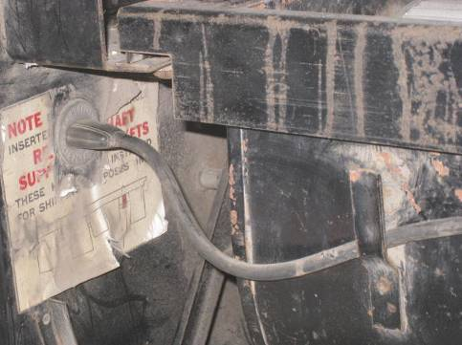
Interior of univent (note electrical outlet)
Picture 17
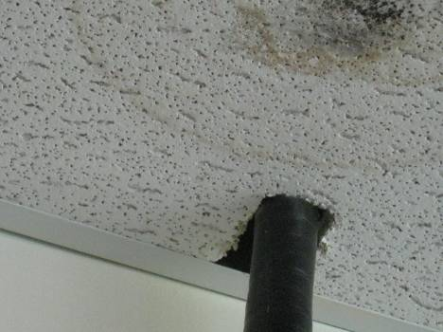
Water-damaged ceiling tile
Picture 18
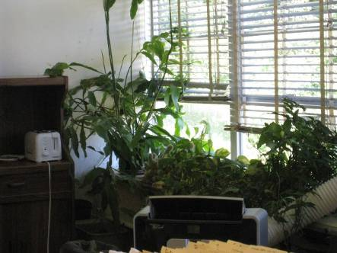
Plants in office space
Picture 19
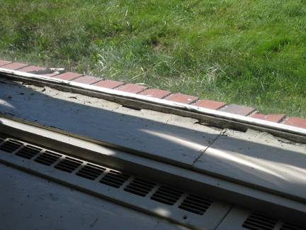
Water-damaged window frames/sills
Picture 20
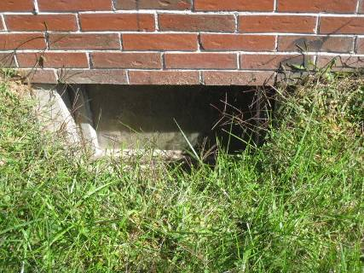
Basement window surrounded by grass/plants

Picture 21
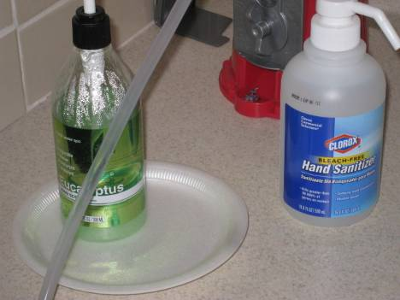
Hand sanitizer
Picture 22
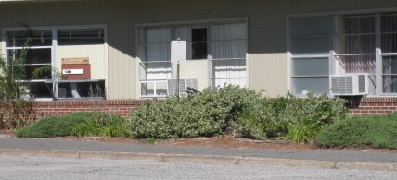
Window-mounted air-conditioners

Picture 23
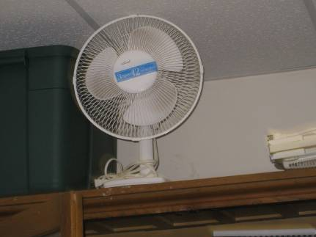
Dusty personal fan
Location/ Room | Carbon  Dioxide  (ppm) | Carbon Monoxide  (ppm) | Temp  (°F) | Relative Humidity  % | PM2.5  (µg/m³) | Occupants  In Room | Windows  Openable | Ventilation |  | Remarks
 |  |  |  |  |  |  |  | Supply | Exhaust | Remarks
Background | 375 | ND | 67 | 51 | 13 |  |  |  |  | Sunny
Assessor’s office | 555 | ND | 76 | 49 | 9 | 1 | Y  open | Y | Y | WD CTs, window AC
Gym | 443 | ND | 77 | 42 | 9 | 0 | N | Y | N | WD ceiling
Restroom (men’s) | 498 | ND | 73 | 47 | 8 | 0 | N | N | Y | Exhaust not functioning
Restroom  (women’s) | 486 | ND | 74 | 43 | 8 | 0 | N | N | Y | Exhaust not functioning, hand sanitizer, AD
Room 10  Park/  Recreation | 507 | ND | 73 | 48 | 7 | 0 | Y  open | Y | Y  off | DO, window open, clutter
Room 12 (storage) | 432 | ND | 74 | 51 | 7 | 0 | N | Y | N | Cleaning supplies, clutter, sink
Room 2 | 459 | ND | 76 | 51 | 11 | 1 | Y | Y | Y | DO, window AC, WD-CTs, AT, sink
Room 3 | 544 | ND | 75 | 47 | 7 | 0 | Y | Y | Y | Window AC, MT, WD-CTs, sink
Room 4 | 599 | ND | 76 | 48 | 7 | 1 | Y | Y | Y | DO, window open, sink
Room 5 (BOH) | 665 | ND | 78 | 51 | 6 | 4 | Y | Y | Y | DO, WD CTs, sink, dehumidifiers running
Room 6 | 639 | ND | 76 | 44 | 7 | 0 | Y | Y | Y | Window AC, cleaning items below sink, PC, PF
Room 7 | 431 | ND | 78 | 47 | 9 | 0 | Y | Y | Y | DO, WD CT, WD from water heater leak, sink, mold on wood, dehumidifier running
Room 8 | 608 | ND | 76 | 45 | 8 | 2 | Y | Y | Y | 10 – 15 plants, clutter, window open, PC, PF, sink, hand sanitizer
Room 9 | 510 | ND | 75 | 46 | 7 | 0 | Y | Y | Y | Window AC, sink
Selectman’s meeting room | 502 | ND | 74 | 49 | 7 | 0 | Y | Y | Y | DO, window AC
Staff lunch room | 511 | ND | 74 | 48 | 7 | 0 | Y  open | Y | Y | Microwave, refrigerator, Window AC, sink, hand sanitizer,
Stage area | 609 | ND | 74 | 46 | 6 | 0 | N | Y | Y | clutter
Town Administrator’s office | 467 | ND | 74 | 49 | 7 | 1 | Y  open | Y | N | Window AC on, PC
Town Collector | 546 | ND | 76 | 47 | 9 | 1 | Y  open | Y | Y | Fax/copier, portable AC
Transportation  (basement) | 639 | ND | 74 | 49 | 5 | 0 | N | N | N | DO, clutter, PC

The service life is the median time during which a particular system or component of …[an HVAC]… system remains in its original service application and then is replaced. Replacement may occur for any reason, including, but not limited to, failure, general obsolescence, reduced reliability, excessive maintenance cost, and changed system requirements due to such influences as building characteristics or energy prices (ASHRAE, 1991).

