INDOOR AIR QUALITY ASSESSMENT

Montague Town Hall
1 Avenue A
Montague, Massachusetts

Prepared by:
Massachusetts Department of Public Health
Bureau of Environmental Health
Indoor Air Quality Program
November 2014

Background/Introduction
At the request of Gina McNeely, Health Director for the Town of Montague, the Massachusetts Department of Public Health (MDPH), Bureau of Environmental Health (BEH) provided assistance and consultation regarding indoor air quality (IAQ) at the Montague Town Hall, (MTH), 1 Avenue A, Montague, MA. The request was prompted by health concerns (e.g., respiratory illness) thought to be associated with IAQ. On September 10, 2014, a visit to conduct an IAQ assessment was made by Kathleen Gilmore, Environmental Analyst/Regional Inspector and Ruth Alfasso Environmental Engineer/Inspector for the BEH/IAQ Program.
The MTH is a brick building with a sloped roof originally constructed in the 1800s as a power company. The building has two occupied floors and a basement, some portions of which are occupied and others are used for storage. The basement previously housed the Montague Police Department (MPD) until 2009, when those activities/staff were relocated to a new site. Floors are carpeted in some areas; windows are openable.

Actions on MDPH Recommendations
As mentioned, MDPH staff had previously visited the building and issued a report with recommendations to improve IAQ (MDPH, 2006). A summary of actions taken on previous recommendations is included as Appendix A.

Methods
Air tests for carbon dioxide, carbon monoxide, temperature and relative humidity were conducted with the TSI, Q-Trak, IAQ Monitor, Model 7565. Air tests for airborne particle matter with a diameter less than 2.5 micrometers were taken with the TSI, DUSTTRAK™ Aerosol Monitor Model 8520. Air tests for total volatile organic compounds (TVOCs) were conducted using a Mini-RAE 2000 photoionization detector. BEH/IAQ staff also performed visual inspection of building materials for water damage and/or microbial growth.

Results
The MTH has an employee population of approximately 40 and can be visited by over 20 members of the public on a daily basis. Tests were taken under normal operating conditions and results appear in Table 1.

Discussion

Ventilation
It can be seen from Table 1 that carbon dioxide levels were below 800 parts per million (ppm) in 15 out of 19 areas surveyed, indicating adequate air exchange in most areas. It is important to note that several areas were empty/sparsely populated at the time tests were taken, which can greatly reduce carbon dioxide levels. Carbon dioxide levels would be expected to increase with full occupancy.
The MTH is equipped with three air handling units (AHUs), which supply cooled air to offices and other areas. These AHUs are located in hallways (Picture 1) and are not equipped with fresh air intakes outside the building. The intake vents on the AHUs draw return air from the hallways, cool it, and supply the cooled air via ceiling-mounted vents. The sole means of introducing fresh air into the building is through the use of openable windows and doors, however during use of the air conditioning system, the opening of windows is discouraged to prevent hot, humid air from entering the building. Heating during the winter is supplied by forced hot water radiators.
The ventilation system at the MTH does not appear to be designed to provide either mechanical fresh air supply or general exhaust ventilation. With a lack of fresh air supply and/or exhaust ventilation, air pollutants can build up leading to IAQ/comfort complaints.
Local exhaust ventilation is located in restrooms. Two exhaust vents were found to be off/inoperable and one was activated via a light switch (Table 1). It is recommended that exhaust ventilation in restrooms be continuous during occupied hours rather than in response to a light switch.
Minimum design ventilation rates are mandated by the Massachusetts State Building Code (MSBC). Until 2011, the minimum ventilation rate in Massachusetts was higher for both occupied office spaces and general classrooms, with similar requirements for other occupied spaces (BOCA, 1993). The current version of the MSBC, promulgated in 2011 by the State Board of Building Regulations and Standards (SBBRS), adopted the 2009 International Mechanical Code (IMC) to set minimum ventilation rates. Please note that the MSBC is a minimum standard that is not health-based. At lower rates of cubic feet per minute (cfm) per occupant of fresh air, carbon dioxide levels would be expected to rise significantly. A ventilation rate of 20 cfm per occupant of fresh air provides optimal air exchange resulting in carbon dioxide levels at or below 800 ppm in the indoor environment in each area measured. MDPH recommends that carbon dioxide levels be maintained at 800 ppm or below. This is because most environmental and occupational health scientists involved with research on IAQ and health effects have documented significant increases in indoor air quality complaints and/or health effects when carbon dioxide levels rise above the MDPH guidelines of 800 ppm for schools, office buildings and other occupied spaces (Sundell et al., 2011). The ventilation must be on at all times that the room is occupied. Providing adequate fresh air ventilation with open windows and maintaining the temperature in the comfort range during the cold weather season is impractical. Mechanical ventilation is usually required to provide adequate fresh air ventilation.
Carbon dioxide is not a problem in and of itself. It is used as an indicator of the adequacy of the fresh air ventilation. As carbon dioxide levels rise, it indicates that the ventilating system is malfunctioning or the design occupancy of the room is being exceeded. When this happens, a buildup of common indoor air pollutants can occur, leading to discomfort or health complaints. The Occupational Safety and Health Administration (OSHA) standard for carbon dioxide is 5,000 parts per million parts of air (ppm). Workers may be exposed to this level for 40 hours/week, based on a time-weighted average (OSHA, 1997).
The MDPH uses a guideline of 800 ppm for publicly occupied buildings. A guideline of 600 ppm or less is preferred in schools due to the fact that the majority of occupants are young and considered to be a more sensitive population in the evaluation of environmental health status. Inadequate ventilation and/or elevated temperatures are major causes of complaints such as respiratory, eye, nose and throat irritation, lethargy and headaches. For more information concerning carbon dioxide, please see Appendix B.
Temperature readings during the assessment ranged from 71° F to 77° F, which were within the MDPH recommended comfort range (Table 1). The MDPH recommends that indoor air temperatures be maintained in a range of 70° F to 78° F in order to provide for the comfort of building occupants. In many cases concerning indoor air quality, fluctuations of temperature in occupied spaces are typically experienced, even in a building with an adequate fresh air supply.
The relative humidity in the building during the assessment ranged from 44 to 57 percent, which was also within the MDPH recommended comfort range (Table 1). The MDPH recommends a comfort range of 40 to 60 percent for indoor air relative humidity. Relative humidity levels in the building would be expected to drop during the winter months due to heating. The sensation of dryness and irritation is common in a low relative humidity environment. Low relative humidity is a very common problem during the heating season in the northeast part of the United States.

Microbial/Moisture Concerns
There have been a variety of concerns associated with this building related to recurring water infiltration and resulting damage. Recently the building had been subject to a sewer pipe break inside the ceiling. Due to the design and materials the building is composed of, including cement block/brick ceiling/pipe enclosures, leaks from plumbing are not often detected quickly and are very difficult to repair. It was reported that one leak had probably been ongoing for over a month. At the time of the visit, the ceiling and some walls had been opened and the piping had been repaired. Water-damaged items had reportedly been removed. The wall and ceiling in the affected area had not yet been repaired at the time of the visit (Picture 2).
The US EPA and the American Conference of Governmental Industrial Hygienists (ACGIH) recommend that porous materials be dried with fans and heating within 24 to 48 hours of becoming wet (US EPA, 2001; ACGIH, 1989). If porous materials are not dried within this time frame, mold growth may occur. Once mold has colonized porous materials, they are difficult to clean and should be removed and discarded.
In addition, the vault and other basement areas are impacted by water infiltration from outside due to chronic/poor drainage issues. Reportedly, during the spring, a combination of high groundwater levels and rainfall produces conditions where water pools/flows into areas of the basement (Picture 3). Without significant repairs, including foundation work and improving drainage away from the building, these conditions render the affected portions of the building unsuitable for occupancy and/or storage.
Other issues compound the water intrusion, including the following observed outside the building:
- The slope adjacent to the north side of the building has a tarmac that directs rainwater away from the foundation. The tarmac and sealant were damaged/deteriorated and the foundation was cracked, which can allow water to penetrate into the basement (Picture 4).
- A concrete trough is located along the foundation on the south side, of the MTH which is sloped towards the rear of the building and was likely installed to collect and drain rainwater away from the foundation (Picture 5). This is no longer functioning as intended and needs extensive repair or redesign.
- As previously mentioned, the roof of the building is sloped and is not equipped with gutters or downspouts. This will direct water from the roof directly against the foundation where it is likely to penetrate the building. This is particularly true for areas where there are below-grade surfaces.
- The roof of the garage area is in very poor condition (Picture 6). The roof has been patched, reportedly several times, by an application of roofing tar, which has leaked into the building (Picture 7). This roof needs to be repaired in a more permanent manner.
- Plants were observed in close proximity to the building (Pictures 6 and 8). The growth of roots against exterior walls can bring moisture in contact with brick, eventually leading to cracks and/or fissures in the foundation below ground level. Over time, this process can undermine the integrity of the building envelope and provide a means of water entry into the building through capillary action through foundation concrete and/or masonry (Lstiburek & Brennan, 2001).
- In addition, debris was accumulated inside exterior vents of the building with evidence of possible nesting materials (i.e., bird or rodent) (Picture 9). These vents should be cleaned and sealed if not needed or enclosed with screens to prevent birds, rodents, insects and other pests from entering the building.
Some areas of the basement, including the former vault area, are used for storage. These areas are reportedly known to have humidity and dampness issues. Several dehumidifiers are located in this area, which is recommended to assist with humidity control (Picture 10). Dehumidifiers are equipped with a drain or receptacle for collected water. Receptacles should be regularly emptied and cleaned to prevent stagnant water/odors and spills and any drains should be regularly checked to make sure they are functioning.
The recommendations in the previous MDPH 2006 report included removing/cataloguing and restoring stored materials in the vault and other areas. At the time of the September 10, 2014 visit, there were still significant amounts of porous materials (papers, etc.) stored in the vault and adjacent areas (Pictures 11 through 14). The vault area and other chronically damp areas are not suitable for storage of these materials. Furthermore, items stored there may be damaged from exposure to chronic dampness. New items should not be moved to this area and the previous recommendations regarding cataloguing and restoration should be followed. In the vault and other areas of the basement, items were found stored directly on the floor, which is likely to be subject to either condensation or flooding and has already lead to water damage of both boxes and contents (Picture 15). Any porous items stored in the basement and elsewhere in the building should be in cabinets, on shelving or otherwise elevated off the floor. Water-damaged furniture was also observed in the basement areas of the building (Picture 16).
One area of the basement is the River Cultural Office. This office has been subject to water infiltration and is currently in a state of disrepair (Picture 17) due to remediation. In addition, carpeting was observed in this office (Picture 18) and other areas in the basement. Carpeting is not recommended in basement areas. The occupant of this office should be moved to an area outside of the basement if possible.
Also, the former MPD space contains several areas (the lockup area, restroom and a former shower), which have floor drains and it could not be determined if all of them had been capped. When the traps of floor drains dry out, sewer gases, odors and moisture can be drawn into occupied spaces. Unneeded floor drains should be properly capped and all unneeded plumbing (e.g., showers) should be properly disconnected (cut and capped) to prevent future leaks/odors.
Plants were observed in several offices (Table 1). Plant soil, standing water and drip pans can be potential sources of mold growth. Drip pans should be inspected periodically for mold growth and over watering should be avoided.
Refrigerators and water coolers were found on carpeted areas (Picture 18). These appliances can spill or leak, leading to water damage to carpeting and other adjacent items. Refrigerators and water coolers should be placed in non-carpeted areas or on a waterproof mat.
In the custodial closet a mop was found to be wet and the mop bucket contained standing water. Both standing water and wet mops can serve as mediums for bacteria, mold growth and result in odors. Mop buckets should be emptied and dried after use. Mop heads should be dried as soon as practicable following use and cleaned/changed regularly to prevent mold growth and associated odors.

Other Indoor Air Evaluations
Indoor air quality can be negatively influenced by the presence of respiratory irritants, such as products of combustion. The process of combustion produces a number of pollutants. Common combustion emissions include carbon monoxide, carbon dioxide, water vapor, and smoke (fine airborne particle material). Of these materials, exposure to carbon monoxide and particulate matter with a diameter of 2.5 micrometers (μm) or less (PM2.5) can produce immediate, acute health effects upon exposure. To determine whether combustion products were present in the indoor environment, BEH/IAQ staff obtained measurements for carbon monoxide and PM2.5.

Carbon Monoxide
Carbon monoxide is a by-product of incomplete combustion of organic matter (e.g., gasoline, wood and tobacco). Exposure to carbon monoxide can produce immediate and acute health affects. Several air quality standards have been established to address carbon monoxide and prevent symptoms from exposure to these substances. The MDPH established a corrective action level concerning carbon monoxide in ice skating rinks that use fossil-fueled ice resurfacing equipment. If an operator of an indoor ice rink measures a carbon monoxide level over 30 ppm, taken 20 minutes after resurfacing within a rink, that operator must take actions to reduce carbon monoxide levels (MDPH, 1997).
The American Society of Heating Refrigeration and Air-Conditioning Engineers (ASHRAE) has adopted the National Ambient Air Quality Standards (NAAQS) as one set of criteria for assessing indoor air quality and monitoring of fresh air introduced by HVAC systems (ASHRAE, 1989). The NAAQS are standards established by the US EPA to protect the public health from six criteria pollutants, including carbon monoxide and particulate matter (US EPA, 2006). As recommended by ASHRAE, pollutant levels of fresh air introduced to a building should not exceed the NAAQS levels (ASHRAE, 1989). The NAAQS were adopted by reference in the Building Officials & Code Administrators (BOCA) National Mechanical Code of 1993 (BOCA, 1993), which is now an HVAC standard included in the Massachusetts State Building Code (SBBRS, 2011). According to the NAAQS, carbon monoxide levels in outdoor air should not exceed 9 ppm in an eight-hour average (US EPA, 2006).
Carbon monoxide should not be present in a typical, indoor environment. If it is present, indoor carbon monoxide levels should be less than or equal to outdoor levels. Outdoor carbon monoxide concentrations were non-detect (ND) on the day of the assessment (Table 1). No measureable levels of carbon monoxide were detected in the building during the assessment (Table 1).

Particulate Matter
The US EPA has established NAAQS limits for exposure to particulate matter. Particulate matter includes airborne solids, which can result in eye and respiratory irritation if exposure occurs. The NAAQS originally established exposure limits to particulate matter with a diameter of 10 μm or less (PM10). According to the NAAQS, PM10 levels should not exceed 150 micrograms per cubic meter (μg/m³) in a 24-hour average (US EPA, 2006). These standards were adopted by both ASHRAE and BOCA. Since the issuance of the ASHRAE standard and BOCA Code, US EPA established a more protective standard for fine airborne particles. This more stringent PM2.5 standard requires outdoor air particle levels be maintained below 35 μg/m³ over a 24-hour average (US EPA, 2006). Although both the ASHRAE standard and BOCA Code adopted the PM10 standard for evaluating air quality, MDPH uses the more protective PM2.5 standard for evaluating airborne particulate matter concentrations in the indoor environment.
Outdoor PM2.5 was measured at 10 to 12 μg/m³ (Table 1) on the day of the assessment. PM2.5 levels measured indoors ranged from 9 to 15 μg/m³ (Table 1), which were below the NAAQS PM2.5 level of 35 μg/m³. Frequently, indoor air levels of particulate matter (including PM2.5) can be at higher levels than those measured outdoors. A number of mechanical devices and/or activities that occur in buildings can generate particulate matter during normal operations. Sources of indoor airborne particulates may include but are not limited to particles generated during the operation of fan belts in the HVAC system, use of stoves and/or microwave ovens in kitchen areas; use of photocopiers, fax machines and computer printing devices; operation of an ordinary vacuum cleaner and heavy foot traffic indoors.

Volatile Organic Compounds
Indoor air concentrations can be greatly impacted by the use of products containing volatile organic compounds (VOCs). VOCs are carbon-containing substances that have the ability to evaporate at room temperature. Frequently, exposure to low levels of total VOCs (TVOCs) may produce eye, nose, throat and/or respiratory irritation in some sensitive individuals. For example, chemicals evaporating from a paint can stored at room temperature would most likely contain VOCs. In an effort to identify materials that can potentially increase indoor VOC concentrations, BEH/IAQ staff conducted measurement of TVOCs and examined the office space for products containing respiratory irritants. Outdoor air samples were taken for comparison. Outdoor TVOC concentrations were ND. No measureable levels of TVOCs were detected in the building during the assessment (Table 1).
Numerous potential sources of VOCs and irritating odors were found in the garage, which is reportedly occupied by maintenance staff on occasion, and in other areas including fuels, paints and other chemicals (Picture 19). As mentioned previously and shown in Picture 7, the roof of the garage has been patched with roofing tar, which has penetrated through gaps in the roofing material into long strings that give off a characteristic odor and can easily break and fall into work areas. This method of roof repair is not adequate, and this tar material needs to be removed/cleaned.
There are photocopiers in the building (Table 1). Photocopiers can be sources of pollutants such as VOCs, ozone, heat and odors, particularly if the equipment is older and in frequent use. Both VOCs and ozone are respiratory irritants (Schmidt Etkin, 1992). Photocopiers should be kept in well ventilated rooms, and should be located near windows or exhaust vents.
Cleaning products, air fresheners and deodorizing materials were observed in some areas (Table 1; Picture 20). Air deodorizers contain chemicals that can be irritating to the eyes, nose and throat of sensitive individuals. Many air fresheners contain 1,4-dichlorobenzene, a VOC which may cause reductions in lung function (NIH, 2006). Furthermore, deodorizing agents do not remove materials causing odors, but rather mask odors that may be present in the area.
Hand sanitizer was also found in some spaces. Hand sanitizer products may contain ethyl alcohol and/or isopropyl alcohol which are highly volatile and may be irritating to the eyes and nose, and may also contain fragrances to which some people may be sensitive (GOJO, 2007).

Other Conditions
Other conditions which may affect IAQ were observed during the assessment. In a number of areas, items were observed on the floors, windowsills, bookcases and desks (Table 1; Pictures 18 and 21). The large number of items stored provides a source for dusts to accumulate. These items (e.g., papers, folders, boxes) make it difficult for custodial staff to clean. Items should be relocated and/or be cleaned periodically to avoid excessive dust build up. Storage of paper records and similar materials in this office may be creating a significant problem with cleaning and dust control. As recommended previously, existing paper records need cataloguing and options for long-term storage, and planning for future records, or paper reduction strategies, is also warranted.
Dust was also observed accumulated on the blades of personal fans and supply vents (Table 1). Vents and fans should be cleaned periodically in order to prevent them from serving as a source of aerosolized particulates.
As mentioned, floors in many rooms of the MTH are covered by wall-to-wall carpeting. It was not clear whether a carpet cleaning program is in place. The Institute of Inspection, Cleaning and Restoration Certification (IICRC), recommends that carpeting be cleaned annually (or semi-annually in soiled high traffic areas) (IICRC, 2012). It was reported that the carpeting was installed in the 1970s. The average lifespan of carpeting is approximately 11 years; therefore, consideration should be given to planning for new flooring (Bishop, 2002). Disintegrating textiles can be a source of airborne particulates, which can be irritating to the eyes, nose and throat.
Some areas contained used furniture, which may carry insects as well as allergens and irritants such as pet hair and tobacco smoke (Picture 22). For this reason, the use of second-hand upholstered furniture is not recommended in an office environment. Upholstered furniture, pillows and cushions are covered with fabric that comes in contact with human skin. This type of contact can leave oils, perspiration, hair and skin cells. In addition to being a source for fleas, upholstered furniture may accumulate dust mites, which feed upon human skin cells and excrete waste products that contain allergens. In addition, if relative humidity levels increase above 60 percent, dust mites tend to proliferate (US EPA, 1992). In order to remove dust mites and other pollutants, frequent vacuuming of upholstered furniture is recommended (Berry, M.A., 1994). It is also recommended that upholstered furniture be professionally cleaned on an annual basis. If an excessively dusty environment exists due to outdoor conditions or indoor activities (e.g., renovations), cleaning frequency should be increased (every six months) (IICRC, 2000).
The attic area was also examined during the September 10, 2014 visit. According to staff, the building had undergone some recent energy retrofits, including insulation. One area of the attic, directly above occupied space had been insulated with a variety of materials arranged in a seemingly haphazard formation (Picture 23) with exposed edges of materials, which may allow for the release of irritating particles of fiberglass and other materials when disturbed. It was observed that in at least some cases, the areas where the tall windows had been bisected by the flooring (Picture 24), was sealed with an expandable foam. However the construction of this celling/floor and the methods used is likely to have left gaps where particulate matter from insulation can enter occupied areas. Any gaps/holes found should be sealed.
Some of the basement areas are equipped with window air conditioners. These can be helpful in providing cooling, dehumidification and some air exchange. Air conditioners are typically equipped with filters that need to be cleaned in accordance with manufacturer’s instructions. In addition, as shown in Picture 25, gaps around some of these units were observed to have cloth or items of clothing set around them, presumably to reduce infiltration of outside air. Cloth is not water or air resistant and can become mold-colonized if repeatedly moistened and may also provide access and/or harborage for pests from outside.
Finally, some fluorescent bulbs, it is unknown if they were new or used, were improperly stored (Picture 26). These items can release glass, dusts and mercury if broken. They should be stored in a sturdy container and/or properly disposed of.

Conclusions/Recommendations
In view of the findings at the time of the assessment, the following recommendations are made.
- Implement remaining recommendations from the 2006 MDPH IAQ report.
- Open windows (weather permitting) to temper rooms and provide fresh outside air. Care should be taken to ensure windows are properly closed at night and weekends during winter months to avoid the freezing of pipes and potential flooding. However do not use open windows when the air conditioning system is on.
- Maintain and operate existing AHUs in accordance with manufacturer’s instructions, including filter changes.
- Ensure that exhaust fans for restrooms are operable and consider having them operate on a timer while offices are occupied rather than in response to a light switch.
- Finish repairs to plumbing, remove any remaining water-damaged materials, and close/finish openings in walls and ceilings. If possible, leave hatch openings to allow for easier access in case of a new plumbing problem, but ensure that any coverings/access doors fit tightly to prevent odors or particulate matter from entering occupied spaces.
- Investigate reports of unexplained moisture or odors promptly to find any new leaks as they are occurring.
- As recommended in the 2006 MDPH report, remove and catalog items remaining in the vault area and remove them for restoration or disposal. Storage of items in the vault should be limited and new porous items should not be brought into the area. Use shelving or drawers for items so that nothing is on the floor.
- Consider consulting with an expert in building/landscape drainage issues to determine how to direct water away from the foundation.
- Do not store items in or otherwise use areas of the basement subject to seasonal water infiltration until drainage problems can be remedied.
- Consider adding gutters and downspouts to direct water away from the foundation.
- Have the roof of the garage professionally repaired. Remove/clean roofing tar from the interior of the garage.
- Remove plants within five feet of the building’s foundation.
- Clean debris from exterior vents and seal them if not needed or install screens to prevent birds, rodents, insects and other pests from entering the building.
- Empty and clean dehumidifiers regularly and maintain in accordance with manufacturer’s instructions.
- Consider moving the River Culture Office from the basement to an upper floor.
- Avoid the use of carpeting in below-grade areas.
- Ensure that unused drains such as those in the former MPD area are properly sealed to prevent the infiltration of sewer gas, odors and additional moisture.
- Ensure that all indoor plants are properly maintained.
- Consider placing waterproof mats under refrigerators and water coolers to prevent leaks/spills from damaging carpet.
- Ensure that mops and mop buckets are dry when they are stored to prevent odors.
- Ensure that VOC-containing materials are kept in tightly-sealed containers and appropriately stored. Dispose of unneeded products promptly.
- Keep photocopiers in well-ventilated areas and away from occupants.
- Avoid the use of scented products and air fresheners.
- Reduce the amount of paper and other items stored in occupied spaces to allow for more thorough cleaning. Consolidate items as appropriate and store files/papers in cabinets or on shelving to keep them contained and off the floor. Consider a building-wide paper/file management effort to deal with day to day and historic records that are required to be stored in the building.
- Clean vents and fans of dust and debris.
- For buildings in New England, periods of low relative humidity during the winter are often unavoidable. Therefore, scrupulous cleaning practices should be adopted to minimize common indoor air contaminants whose irritant effects can be enhanced when the relative humidity is low. To control for dusts, a high efficiency particulate arrestance (HEPA) filter equipped vacuum cleaner in conjunction with wet wiping of all surfaces is recommended. Avoid the use of feather dusters. Drinking water during the day can help ease some symptoms associated with a dry environment (throat and sinus irritations).
- Clean carpeting annually (or semi-annually in soiled high traffic areas) as per the recommendations of the Institute of Inspection, Cleaning and Restoration Certification (IICRC, 2012). Consider a schedule for replacing worn carpeting that is beyond its service life. Copies of the IICRC fact sheet are available at: http://www.iicrc.org/consumers/care/carpet-cleaning/#faq.
- Clean upholstered furniture regularly and have professionally cleaned on an annual basis.
- Ensure that any gaps/spaces between the insulated attic space shown in Pictures 23 and 24 are sealed to prevent migration of particulate matter from insulation into occupied areas.
- Clean air conditioner filters and maintain them in accordance with manufacturer’s instructions. Replace the cloth/clothing around these units with a suitable water and mold-resistant material.
- Store new and spent fluorescent bulbs in sturdy containers to prevent breakage. Dispose of spent fluorescent bulbs properly.
- Refer to resource manuals and other related indoor air quality documents for further building-wide evaluations and advice on maintaining public buildings. These materials are located on the MDPH’s website: http://mass.gov/dph/iaq.

References
ACGIH. 1989. Guidelines for the Assessment of Bioaerosols in the Indoor Environment. American Conference of Governmental Industrial Hygienists, Cincinnati, OH.
ASHRAE. 1989. Ventilation for Acceptable Indoor Air Quality. American Society of Heating, Refrigeration and Air Conditioning Engineers. ANSI/ASHRAE 62-1989.
Berry, M.A. 1994. Protecting the Built Environment: Cleaning for Health, Michael A. Berry, Chapel Hill, NC.
Bishop. 2002. Bishop, J. & Institute of Inspection, Cleaning and Restoration Certification. A Life Cycle Cost Analysis for Floor Coverings in School Facilities.
BOCA. 1993. The BOCA National Mechanical Code/1993. 8th ed. Building Officials and Code Administrators International, Inc., Country Club Hill, IL.
GOJO. 2007. Material Safety Data Sheet for Purell® Instant Hand Sanitizer. GOJO Industries, Akron, OH. October 15, 2007.
IICRC. 2000. IICRC S001 Reference Guideline for Professional On-Location Cleaning of Textile Floor Covering Materials Institute of Inspection, Cleaning and Restoration Certification. Institute of Inspection Cleaning and Restoration, Vancouver, WA.
IICRC. 2012. Institute of Inspection, Cleaning and Restoration Certification. Carpet Cleaning: FAQ. Retrieved from http://www.iicrc.org/consumers/care/carpet-cleaning/#faq.
Lstiburek, J. & Brennan, T. 2001. Read This Before You Design, Build or Renovate. Building Science Corporation, Westford, MA. U.S. Department of Housing and Urban Development, Region I, Boston, MA.
MDPH. 1997. Requirements to Maintain Air Quality in Indoor Skating Rinks (State Sanitary Code, Chapter XI). 105 CMR 675.000. Massachusetts Department of Public Health, Boston, MA.
NIH. 2006. Chemical in Many Air Fresheners May Reduce Lung Function. NIH News. National Institute of Health. July 27, 2006. http://www.nih.gov/news/pr/jul2006/niehs-27.htm
OSHA. 1997. Limits for Air Contaminants. Occupational Safety and Health Administration. Code of Federal Regulations. 29 C.F.R 1910.1000 Table Z-1-A.
SBBRS. 2011. Mechanical Ventilation. State Board of Building Regulations and Standards. Code of Massachusetts Regulations, 8th edition. 780 CMR 1209.0
Schmidt Etkin, D. 1992. Office Furnishings/Equipment & IAQ Health Impacts, Prevention & Mitigation. Cutter Information Corporation, Indoor Air Quality Update, Arlington, MA.
Sundell. 2011. Sundell, J., H. Levin, W. W. Nazaroff, W. S. Cain, W. J. Fisk, D. T. Grimsrud, F. Gyntelberg, Y. Li, A. K. Persily, A. C. Pickering, J. M. Samet, J. D. Spengler, S. T. Taylor, and C. J. Weschler. Ventilation rates and health: multidisciplinary review of the scientific literature. Indoor Air, Volume 21: pp 191–204.
US EPA. 1992. Indoor Biological Pollutants. US Environmental Protection Agency, Environmental Criteria and Assessment Office, Office of Health and Environmental Assessment, research Triangle Park, NC. EPA 600/8-91/202. January 1992.
US EPA. 2001. Mold Remediation in Schools and Commercial Buildings. US Environmental Protection Agency, Office of Air and Radiation, Indoor Environments Division, Washington, D.C. EPA 402-K-01-001. March 2001.
US EPA. 2006. National Ambient Air Quality Standards (NAAQS). US Environmental Protection Agency, Office of Air Quality Planning and Standards, Washington, DC. http://www.epa.gov/air/criteria.html.
Picture

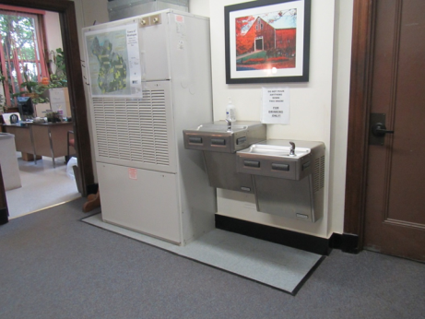

AHU in hallway
Picture 2

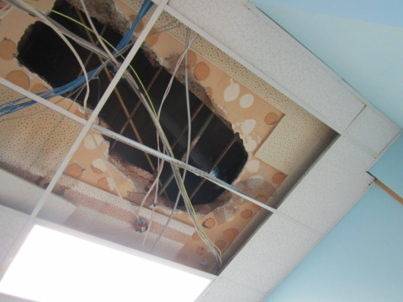

Hole in ceiling where leak was repaired. Note construction of ceiling above dropped ceiling tiles
Picture 3

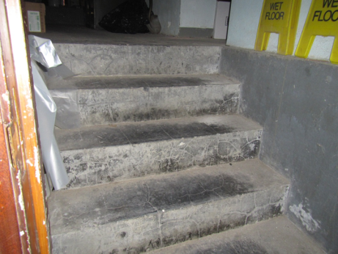

Water-stained stairs where infiltration and flow is reported during springtime

Picture 4

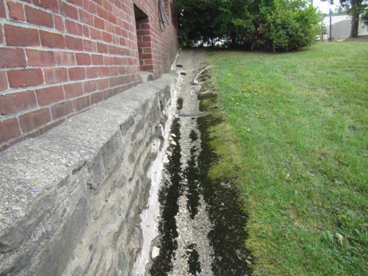

Concrete trough with moss growth, cracked foundation
Picture 5

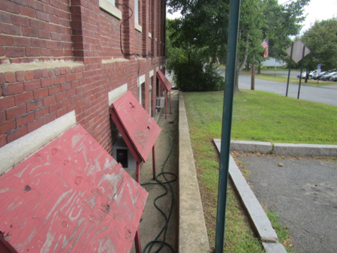

Concrete drainage system for below-grade basement with deteriorated rain covers over window air conditioners

Picture 6

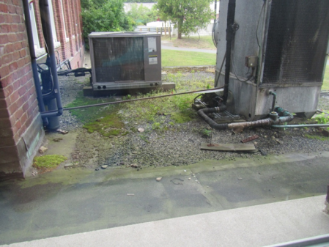

Top view of low roof showing plant growth and deterioration
Picture 7

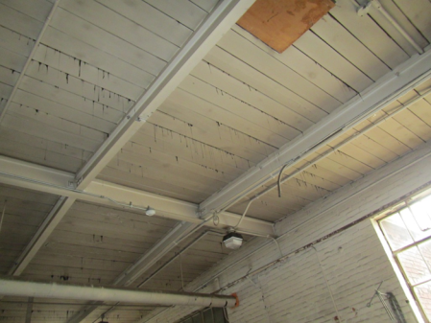

Roofing tar leaks into the garage area

Picture 8

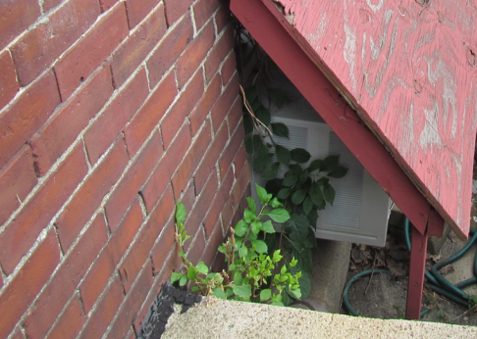

Plant growth against building foundation
Picture 9

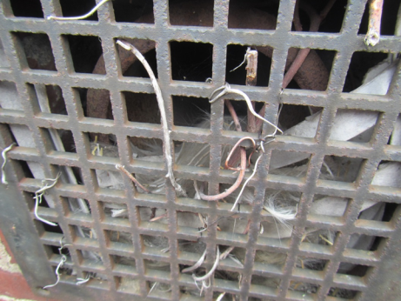

Exterior vent with debris and possible nesting materials

Picture 10

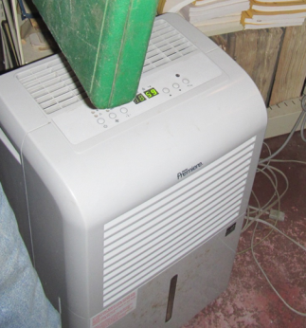

Dehumidifier in vault area
Picture 11

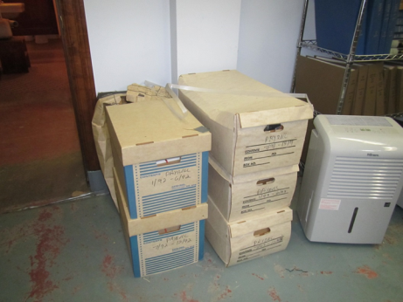

Dehumidifier and boxes on the floor in basement

Picture 12

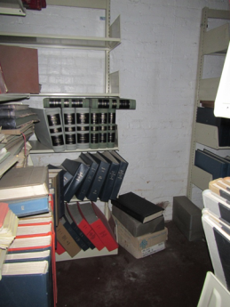

Books and items stored in the vault, including items on the floor
Picture 13

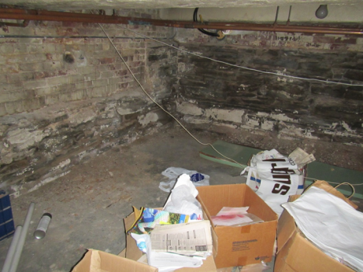

Items stored on the floor in below grade area

Picture 14

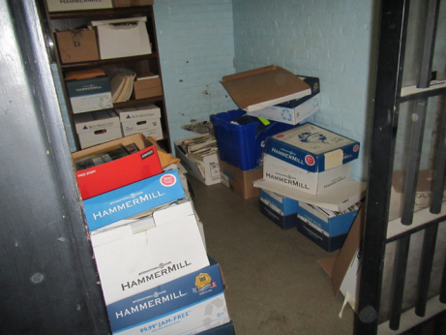

Items stored on the floor in the old lockup area
Picture 15

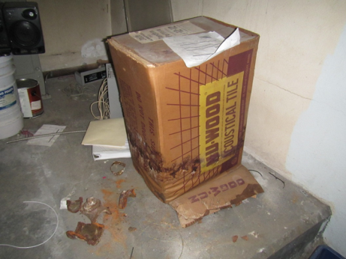

Water-damaged box in basement

Picture 16

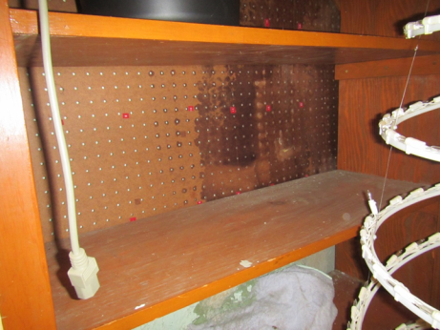

Water-damaged furniture in basement
Picture 17

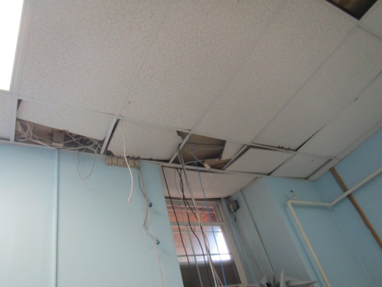

Ceiling repairs in the River Culture Director’s office

Picture 18

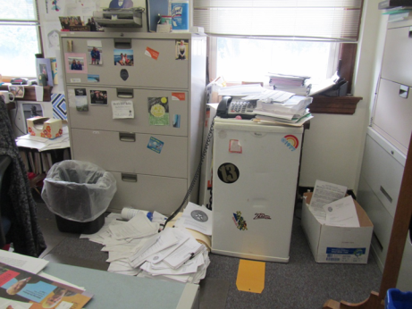

Refrigerator on carpet, note also papers and items
Picture 19

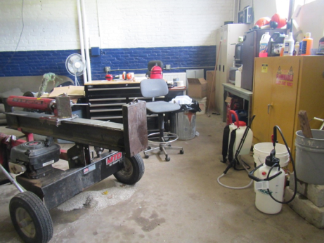

Items in garage area, including chemicals and fuels that may give off VOCs

Picture 20

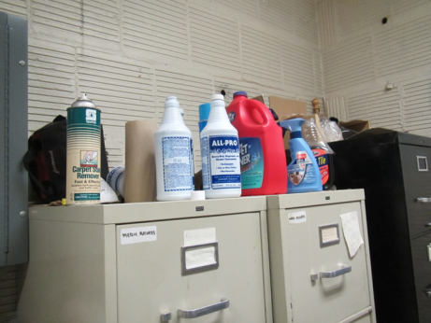

Cleaning and sanitizing products in an office
Picture 21

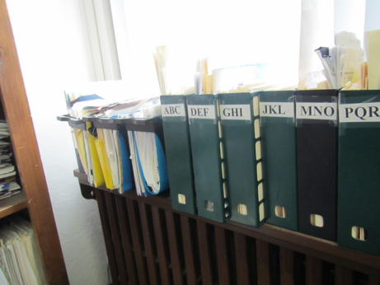

Items stored near a window

Picture 22

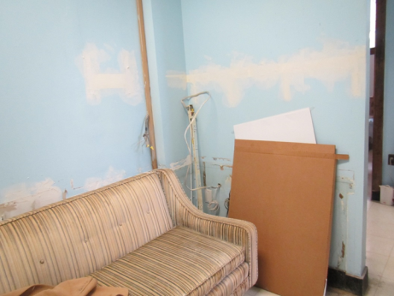

Upholstered couch in River Culture office
Picture 23

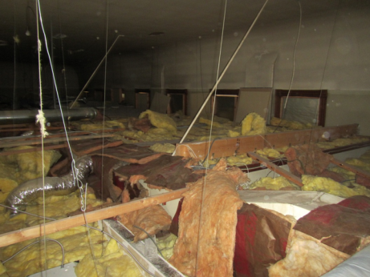

Insulation in attic

Picture 24

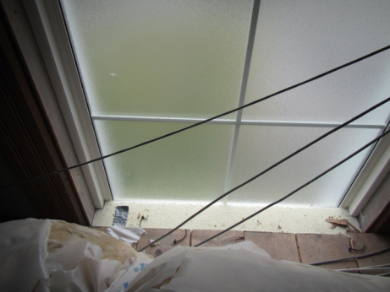

Foam sealing gap between attic and floor below
Picture 25

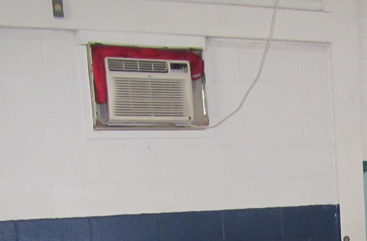

Window air conditioner with cloth/clothing around it

Picture 26

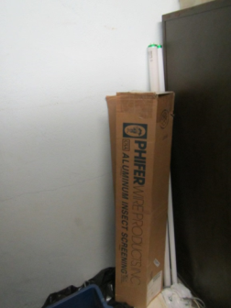

Improperly stored fluorescent bulbs

Location | Carbon  Dioxide  (ppm) | Carbon Monoxide  (ppm) | Temp  (°F) | Relative  Humidity  (%) | TVOCs  (ppm) | PM2.5  (µg/m³) | Occupants  in Room | Windows  Openable | Ventilation |  | Remarks
 |  |  |  |  |  |  |  |  | Supply | Exhaust
Background | 387 | ND | 67 | 60 | ND | 10-12 |  |  |  |  | Cloudy, breezy
Assessor’s Office | 836 | ND | 72 | 48 | ND | 10 | 2 | Y | Y | N | DO, NC, plants, PF dirty
Board of Health | 814 | ND | 71 | 48 | ND | 9 | 1 | Y | Y | N | WD-CT, DO, NC, HS, plant
Break Room | 768 | ND | 72 | 48 | ND | 10 | 0 | Y | Y | N | DO, NC, refrigerator, toaster, cleaners
Building Plant Office | 600 | ND | 75 | 52 | ND | 10 | 1 | Y  (open) | Y | N | PC, AF, HS, PF dirty, clutter
Building Inspector’s Office | 789 | ND | 73 | 52 | ND | 11 | 1 | Y | Y | N | DO, NC, PC, PF dirty, clutter
Conference Room | 831 | ND | 71 | 49 | ND | 10 | 1 | Y | Y | N | WD-CT, plant
Conservation Office | 799 | ND | 71 | 51 | ND | 10 | 0 | Y | Y | N | NC, plants, HS
Copy Room | 595 | ND | 72 | 54 | ND | 11 | 0 | N | Y | N | DO, PC, scanner
Custodial Closet | 472 | ND | 77 | 57 | ND | 15 | 0 | Y | N | N | Cleaning products, chemicals, bucket with mop in standing water
Planning Office | 818 | ND | 73 | 44 | ND | 11 | 1 | Y  (open) | Y | N | DO, NC, plants, clutter
Restroom (basement) | 639 | ND | 75 | 56 | ND | 11 |  | N | N | Y  (off) | DO, vent dirty, floor drain
Restroom 1 | 765 | ND | 72 | 51 | ND | 11 |  | N | N | Y | DO, exhaust on light switch, vent dirty, AF
Restroom 2 | 770 | ND | 71 | 48 | ND | 10 |  | N | N | Y  (off) | AF
Retirement Board | 605 | ND | 74 | 56 | ND | 11 | 1 | Y | Y | N | DO, PC, plants
River Cultural Office | 435 | ND | 76 | 55 | ND | 15 | 1 | N | Y | N | DO, NC, WD-CT, MT, WAC, holes/gaps around pipes, PC, scanner, upholstered couch
Selectmen’s Office | 603 | ND | 74 | 52 | ND | 12 | 0 | Y | Y | N | Clutter, HS, plush toys
Town Administrator’s Office | 629 | ND | 73 | 51 | ND | 10 | 2 | Y | Y | N | DO, PC, PF dirty, clutter
Town Clerk’s Office | 605 | ND | 73 | 52 | ND | 10 | 1 | Y  (open) | Y | N | DO, PC, HS, plants
Treasurer’s Office | 590 | ND | 74 | 53 | ND | 10 | 1 | Y | Y | N | Plants, clutter, PC, PF dirty

Actions on MDPH Recommendations

Montague Town Hall

1 Avenue A, Montague, MA

The following is a status report of action(s) taken on recommendations made in the September 2006 MDPH IAQ report (in bold) based on reports by town officials, facilities staff, documents, photographs and observations of the MDPH BEH/IAQ staff during the September 10, 2014 assessment. Of specific concern during the 2006 visit was the vault area, therefore recommendations from the report were divided into mold remediation for the vaults and general recommendations to improve indoor air quality in the MTH.
Vault Mold Remediation
- Determine future preservation, handling and/or storage actions for materials currently stored in the vault areas. The inherent conditions of aged/vintage materials (e.g. ledgers/records) have created an environment conducive to eye, skin and respiratory irritations. These boxes, documents, books and other stored materials will continue to be a source of mold and/or particulates and ventilation alone cannot serve to reduce or eliminate these airborne exposure opportunities. As an initial step, options concerning the preservation of materials stored in this area should be considered. Since many historical records appear to be stored in these areas, an evaluation concerning disposition of these materials must be made. Porous materials that are judged unworthy of preservation, restoration or transfer to another media (e.g., microfiche or computer scanning) should be discarded. Where stored materials are to be preserved, restored or otherwise handled, an evaluation should be done by a professional book/records conservator. This process can be rather expensive, and may be considered for conservation of irreplaceable documents that are colonized with mold. Due to cost of book conservation, disposal or replacement of moldy materials may be the most economically feasible option.
- Action: It did not appear as though a comprehensive program for record cataloguing and restoring had been put in place. While some items had been removed from the vault, there were still considerable items stored in the area, including records, some of which may have had water or age damage, and some odors of mold/mildew in the basement areas.
- Use local exhaust ventilation and isolation techniques to control remediation pollutants. Precautions should be taken to avoid the re-entrainment of these materials into the building's HVAC system. The design of each system must be assessed to determine how it may be impacted by renovation activities. Specific HVAC protection requirements pertain to the return, central filtration and supply components of the ventilation system. This may entail shutting down systems (when possible) during periods of heavy construction and demolition, ensuring systems are isolated from contaminated environments, sealing ventilation openings with plastic and utilizing filters with a higher dust spot efficiency where needed (SMACNA, 1995).
- Action: Town officials reported that it was unknown if this recommendation had been followed during the construction/remediation activities following the 2006 MDPH visit.
- Seal all utility holes and spaces in the vaults to eliminate pollutant paths of migration.
- Action: There were a few utility holes/gaps present between the vault/basement areas and occupied areas.
- Seal vault doors polyethylene plastic and duct tape. Consider creating an air lock of a second door inside the remediation spaces to reduce migration.
- Action: Vault doors were not sealed at the time of the September 2014 visit and it could not be determined if any work in the area had been conducted since the previous visit.
- If possible, relocate susceptible persons and those with pre-existing medical conditions (e.g., hypersensitivity, asthma) away from the vaults until remediation is completed.
- Action: The police department was moved from the basement area of the MTH and the majority of the basement area is not regularly occupied.
- Establish communications between all parties involved with remediation efforts (including building occupants) to prevent potential IAQ problems. Develop a forum for occupants to express concerns about remediation efforts as well as a program to resolve IAQ issues.
- Action: Town officials reported that communication mechanisms are established during remediation activities.
- When possible, schedule projects which produce large amounts of dusts, odors and emissions during unoccupied periods or periods of low occupancy.
- Action: Town officials reported that this recommendation has been implemented and large projects are scheduled during periods when the building is unoccupied or during periods of low occupancy as needed.
- Disseminate scheduling itinerary to all affected parties. This can be done in the form of meetings, newsletters or weekly bulletins.
- Action: Town officials reported that the scheduling of construction/remediation activities are posted on the town website and employees directly affected are notified via email.
- Obtain Material Safety Data Sheets (MSDS) for all remediation/decontamination materials used during renovations and keep them in an area that is accessible to all individuals during periods of building operations as required by the Massachusetts Right-To-Know Act (MGL, 1983).
- Action: Town officials reported that following this recommendation, MSDS are utilized during all construction/remediation activities in town buildings as required by MGL, 1983.
- Consult MSDS' for any material applied to the effected area during renovation(s) including any sealant, carpet adhesive, tile mastic, flooring and/or roofing materials. Provide proper ventilation and allow sufficient curing time as per the manufacturer's instructions concerning these materials.
- Action: Town officials reported that this recommendation had been implemented.
- Implement prudent housekeeping and work site practices to minimize exposure to spores. This may include constructing barriers, sealing off areas, and temporarily relocating furniture and supplies. To control for dusts, a high efficiency particulate air filter (HEPA) equipped vacuum cleaner is recommended. Non porous materials (e.g., linoleum, cement) should be disinfected with an appropriate antimicrobial agent is recommended. Non-porous surfaces should also be cleaned with soap and water after disinfection.
- Action: Routine cleaning housekeeping/work practices are in place at the MTH and a HEPA filter vacuum is used.

General Recommendations
- Seal the vents connecting the vaults to the south exterior wall.
- Action: This work appeared to have been conducted.
- Use dehumidifiers in hot/humid weather to reduce moisture within the vaults.
- Action: Several dehumidifiers were observed operating in the vault and other basement areas.
- Remove caulking compound from exterior wall and repoint bricks with an appropriate material.
- Action: Caulking compound was not observed on the exterior of the building.
- Replace water damaged ceiling tiles. Examine the area above these tiles for mold growth. Disinfect areas of water leaks with an appropriate antimicrobial.
- Action: Few water-damaged ceiling tiles were observed in the building.
- Prohibit the use of candles within the building.
- Action: No candles were observed in the building.
- For buildings in New England, periods of low relative humidity during the winter are often unavoidable. Therefore, scrupulous cleaning practices should be adopted to minimize common indoor air contaminants whose irritant effects can be enhanced when the relative humidity is low. To control for dusts, a high efficiency particulate arrestance (HEPA) filter equipped vacuum cleaner in conjunction with wet wiping of all surfaces is recommended. Drinking water during the day can help ease some symptoms associated with a dry environment (e.g., throat and sinus irritations).
- Action: A HEPA filtered vacuum is used in the building.

