MOLD/ODOR ASSESSMENT

Monterey Library
452 Main Road
Monterey, Massachusetts

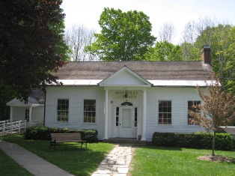

Prepared by:
Massachusetts Department of Public Health
Bureau of Environmental Health
Indoor Air Quality Program
February 2011

Background/Introduction
At the request of Mr. Mark Makuc, Library Director in Monterey, the Massachusetts Department of Public Health (MDPH), Bureau of Environmental Health (BEH) conducted an indoor air quality (IAQ) assessment at the Monterey Library (ML) located at 452 Main Road, Monterey Massachusetts. On May 11, 2010, Lisa Hébert, an Environmental Analyst/Regional Inspector within BEH’s IAQ Program, visited the library to conduct an assessment. Michael Feeney, Director of BEH’s IAQ Program, and Ms. Hébert revisited the building to conduct further evaluations on June 4, 2010. Staff and visitor concerns regarding air quality (mold/moisture) within one wing of the building prompted the request.
The ML is a one-story complex composed of a main section and two small wings. It was constructed as a library in 1931. In 1975, the Knox Wing was added to the east side of the building. Both the main building and the Knox Wing have basements, and a crawlspace is located beneath the other wing. Currently, the basement of the main section is utilized as a work room. In 1998, a second addition at the rear of the main building was constructed which created a crawlspace that enclosed the original basement exterior windows (Pictures 1 through 4). The building has a ducted, forced hot air heating system. Windows are openable throughout the building.

Methods
Air tests for temperature and relative humidity were conducted with the TSI, Q-Trak, IAQ Monitor, Model 7565. Selected materials were tested for moisture by a Delmhorst BD-2100 moisture meter. BEH staff also performed visual inspection of building materials for water damage and/or microbial growth.

Results
The library houses three staff and receives up to 25 visitors daily. The building was not open to the public on the day of the MDPH assessment. Test results appear in Table 1.

Discussion

Microbial/Moisture Concerns
As previously stated, the primary concerns expressed were mold and odors associated with the Knox Wing (KW). In 1975, the wing was constructed for use by the local Historical Society as a museum (Picture 5). The museum was initially open to the public for approximately four hours a week. BEH was informed that over the years, it has remained closed for extended periods of up to two years. Upon entering the museum, a slight musty odor was detected. Mold colonization was observed on the underside of a chair stored in this area (Picture 6).
On the day of the assessment, indoor temperature measurements of occupied areas ranged from 61º F to 66º F with relative humidity ranging from 31 to 40 percent. Since the ML does not have mechanical ventilation system that is capable of chilling air in the summer months and since the KW is seldom utilized, moisture that develops may accumulate within the building during hot, humid weather. This condition may result in relative humidity concentrations indoors above 70 percent which can foster mold growth in susceptible materials (ASHRAE, 1989). Materials that can foster mold growth include cardboard, paper, books, cloth and other materials in addition to carpeting. Therefore, it may be prudent to remove carpeting from this area of the library and replace it with impervious flooring such as tile.
The interior windows throughout the KW were covered with a dark material which may also be mold colonization of dust coating the windowpanes (Picture 7). A condition of high relative humidity coupled with condensation on dusty window panes could result in mold colonization. These windows should be thoroughly cleaned. Water damage was evident at the bottom of the entry door to the KW basement and to the adjacent door casing (Picture 8).
Dark staining, similar in appearance to mold colonization was observed on numerous floor joists and on the subfloor in the basement of the KW during the initial assessment (Picture 9). It was determined during the subsequent evaluation that the staining was likely due to the seepage of pitch from the wood itself rather than from mold colonization. Moisture content of selected basement floor joists and subfloors were measured with a Delmhorst Moisture Detector equipped with a Delmhorst Standard Probe. All areas tested were dry (Table 1).
Efflorescence was observed on the interior surface of the KW basement wall. Efflorescence is a characteristic sign of water damage but it is not mold growth. As moisture penetrates and works its way through foundation concrete, water-soluble compounds dissolve, creating a solution. As the solution moves to the surface of the material, the water evaporates, leaving behind white, powdery mineral deposits.
In the attic of the main library, water damage of gypsum wallboard (GW), a window frame, and the wood floor were observed (Pictures 10 and 11). On the first floor of the main library, gaps were observed on both sides of the fireplace flue. This can result in unconditioned air entering the library, potentially causing condensation to occur.
ML staff reported that seepage into the work room in the basement occurs on occasion. Stored boxes of books are placed on pallets to prevent damage from seepage (Picture 12). Despite this effort, water-damaged porous materials were observed in the area (e.g., magazines, cardboard boxes, Picture 13). Numerous porous materials were found stored in contact with the foundation wall, which may allow moisture to contact these materials.
The US Environmental Protection Agency (US EPA) and the American Conference of Governmental Industrial Hygienists (ACGIH) recommend that porous materials be dried with fans and heating within 24 to 48 hours of becoming wet (US EPA, 2001; ACGIH, 1989). If not dried within this time frame, mold growth may occur. Once mold has colonized porous materials, they are difficult to clean and should be removed and discarded.
BEH staff examined the exterior of the building to identify breaches in the building envelope and other conditions that could provide a source of water penetration. A number of sources were identified:
- Heavy moss growth was observed on the roof. The presence of moss shown in Picture 14 is indicative of repeated water exposure. In addition, moss hold moisture against the shingles which increases the potential for roof leaks;
- Gutter and downspout system were missing from sections of the building. Several roof surfaces converge on the south side of the building and deposit water on the ground in close proximity to the foundation (Picture 15);
- A gap exists between the roof line and the soffit. In addition to moisture penetration, the gap is large enough to allow insects, bats or rodents access into the building (Picture 16);
- Gaps in flashing were observed, particularly adjacent to the chimney;
- A sizable gap was observed at the bottom of the exterior door leading to the basement;
- Mortar in chimney was broken (Picture 17);
- Cracks were observed in the foundation (Picture 18);
- Large open utility holes were evident on exterior of the building (Picture 19); and
- Plants, shrubs were located in close proximity to the building. Trees were observed providing shade over portions of the roof, likely contributing to the moss growth seen in Picture 14.
The aforementioned conditions represent potential water penetration sources. Over time, these conditions can undermine the integrity of the building envelope and provide a means of water entry into the building via capillary action through foundation concrete and masonry (Lstiburek & Brennan, 2001). The freezing and thawing action of water during the winter months can create cracks and fissures in the foundation. In addition, these breaches may provide a means for pests/rodents to enter the building.
Plants were noted in the main library. Plants can be a source of pollen and mold which can be respiratory irritants to some individuals. Plants should be properly maintained and equipped with drip pans. In order to prevent mold growth, drip pans should be cleaned on a routine basis.

Other IAQ Evaluations
Other conditions that can affect indoor air quality were observed during the assessment. The dehumidifier located in the work room was observed to have a heavy accumulation of ice on its coils, inhibiting the device from removing moisture from the room. This may have been due to an improper setting on the dehumidifier. As previously mentioned, a crawlspace was created when the most recent addition was constructed. As can be seen in Picture 3, the windows in the work room, which had previously been exterior windows, now open into the crawlspace. In order to reduce moisture in the basement and supplement air movement, a duct and blower fan could be positioned in the workroom window and pass through the crawlspace to direct stale air out of the building.
Bat feces as well as a live bat were observed around the basement entrance at the rear of the building. Although evidence of bats was not observed within the building, it would be prudent to examine the exterior of the building and seal all breaches through which a bat can gain entry. Since bat waste often contains mites and exposure to bat waste may result in respiratory illnesses such as histoplasmosis, staff may wish to conduct routine examinations of the attic to ensure that bats do not gain access to the building (ATSDR, 1998).
In the basement workroom and in the attic, items were observed on the floor, tabletops, book cases and in closets. The large number of items stored in these areas provides a source for dusts to accumulate (Picture 20). These items (e.g., magazines, books, boxes) make it difficult for staff to clean. Items should be relocated and/or be cleaned periodically to avoid excessive dust build up. In addition, these materials can accumulate on flat surfaces in occupied areas and subsequently be re-aerosolized causing further irritation.
Utility holes in the basement were observed. These holes may allow odors, vapors and particulate to move throughout the building. Breaches in the exhaust and heating ducts were observed as well. Breaches in the exhaust duct could lead to products of combustion entering the occupied space. These should be properly sealed.
Portable air conditioners (ACs) are used in the summer months. ACs are normally equipped with filters, which should be cleaned or changed as per manufacturer’s instructions to avoid the build-up and re-aerosolization of dirt, dust and particulate matter.
The chimney cleanout appears to be sealed. This condition inhibits the ability to perform routine maintenance of the heating/ventilation system.

Conclusions/Recommendations
In view of the findings at the time of the visit, the following recommendations are provided:
- Remove and properly dispose of mold colonized chair from KW.
- Examine stored materials in KW for evidence of mold colonization. If present, contact a document restoration firm to assess and/or remediate.
- Consider removing carpeting in KW and installing a floor covering that is impervious to moisture.
- Clean windows in KW.
- Repair door to KW basement to eliminate water from entering the building.
- Repair any existing leaks and replace any remaining water-damaged gypsum wallboard (GW). Examine the area above GW for mold growth. Disinfect areas of water leaks with an appropriate antimicrobial, as needed.
- Assess used books and all materials coming into the ML to ensure no water-damaged or mold colonized materials are brought into the building.
- Ensure materials stored in workroom are not in contact with basement walls or floor.
- Repair/replace attic window as necessary to eliminate water infiltration.
- Ensure chimney flue in fireplace of main library is properly closed/sealed.
- Repair/replace roof as necessary to eliminate leaks.
- Design and install gutter and downspout system that will eliminate water from draining immediately adjacent to the foundation.
- Repair sizable gap between roof line and soffit.
- Repair cracked, broken mortar and loose flashing in chimney.
- Seal cracks in foundation.
- Seal open utility holes on exterior of building.
- Ensure plants and shrubs are located at least five feet from the foundation. Consider trimming tree over KW roof.
- Ensure plants are equipped with drip pans. Examine drip pans periodically for mold growth and disinfect with an appropriate antimicrobial, as needed.
- Consider reducing the amount of materials stored in attic and basement to allow for more thorough cleaning of these areas. Remove items that are no longer in use. Clean items regularly with a wet cloth or sponge to prevent excessive dust build-up.
- Clean accumulated dust and debris periodically from the surface of heating vents.
- Seal open utility holes in mechanical room and elsewhere in the building.
- Consider providing ventilation from work room to outdoors.
- Consider installing operational cleanout door for chimney.
- Refer to resource manual and other related indoor air quality documents located on the MDPH’s website for further building-wide evaluations and advice on maintaining public buildings. These documents are available at: http://mass.gov/dph/iaq. .

References
ACGIH. 1989. Guidelines for the Assessment of Bioaerosols in the Indoor Environment. American Conference of Governmental Industrial Hygienists, Cincinnati, OH.
ASHRAE. 1989. Ventilation for Acceptable Indoor Air Quality. American Society of Heating, Refrigeration and Air Conditioning Engineers. ANSI/ASHRAE 62-1989.
ATSDR. 1998. Indoor Air and Health Issues – Bat Guano. Public Health Assessments and Consultations. Agency For Toxic Substances and Disease Registry, Atlanta GA.
Lstiburek, J. & Brennan, T. 2001. Read This Before You Design, Build or Renovate. Building Science Corporation, Westford, MA. U.S. Department of Housing and Urban Development, Region I, Boston, MA
US EPA. 2001. “Mold Remediation in Schools and Commercial Buildings”. Office of Air and Radiation, Indoor Environments Division, Washington, DC. EPA 402-K-01-001. March 2001. Available at: http://www.epa.gov/iaq/molds/mold_remediation.html
Picture 1

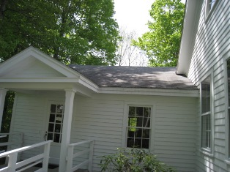

Knox Wing

Picture 2

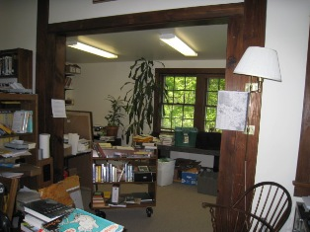

Small Addition behind Main Desk

Picture 3

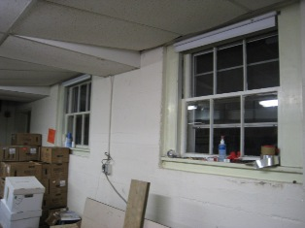

Former Exterior Windows that Open to Crawlspace

Picture 4

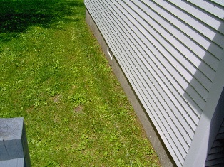

Concrete Foundation of Crawlspace

Picture 5

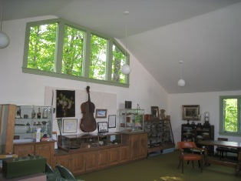

Interior of Knox Wing Historical Society Museum

Picture 6

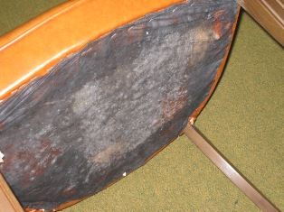

Mold Colonization on Underside of Chair

Picture 7

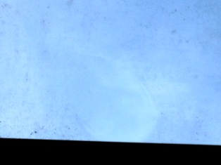

Possible Mold Colonization on Window Pane; Note Clear Area in Center
which has been Cleaned (Arrow)
Picture 8

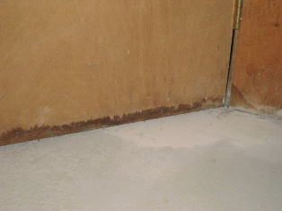

Evidence of Water Infiltration into Basement by
Water Stains on Door and Door Casing

Picture 9

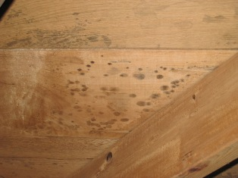

Staining on Wood in KW Basement, Likely due to Seepage of Pitch
Picture 10

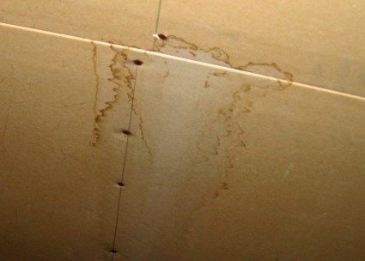

Water-Damaged GW in Attic

Picture 11

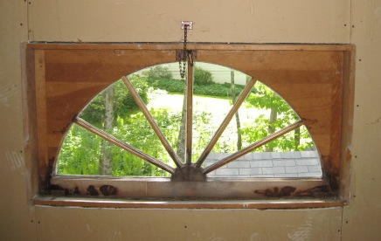

Water-Damaged Window

Picture 12

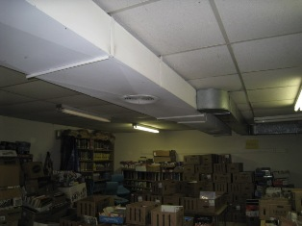

Boxes of Books Stored in Workroom

Picture 13

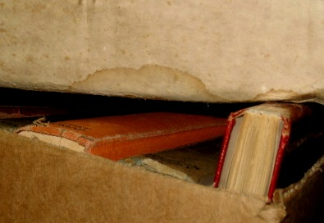

Water-Damaged Cardboard Box

Picture 14

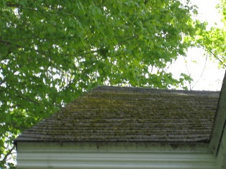

Heavy Moss Growth on Roof; Note Shade Provided by Tree

Picture 15

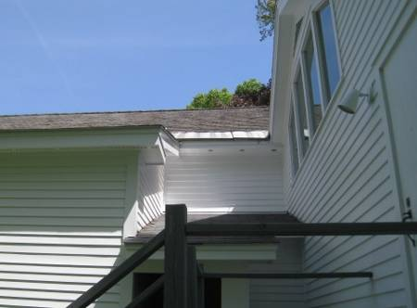

Lack of Gutters on Rear of ML
Results in Rain Deposition between ML and KW
Picture 16

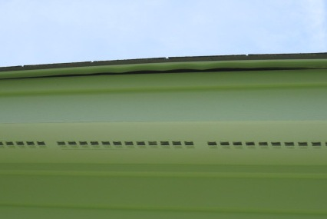

Gap between Roof and Top of Soffit/Fascia Board (Arrow)
Picture 17

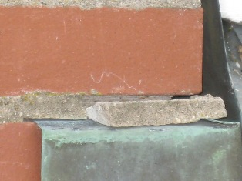

Cracked, Loose Mortar above Flashing

Picture 18

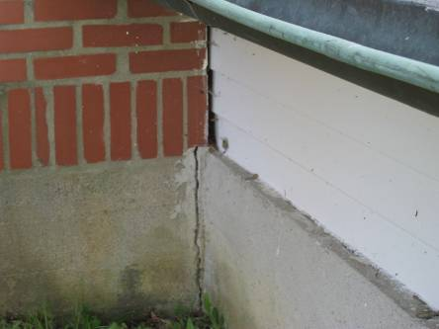

Crack in Foundation; Large Gap Between
Exterior Wall and Chimney
Picture 19

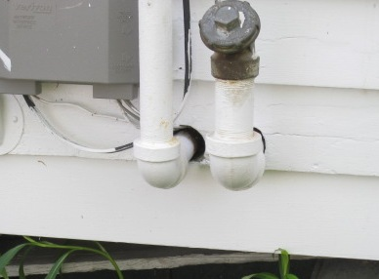

Open Utility Holes (Arrows)

Picture 20

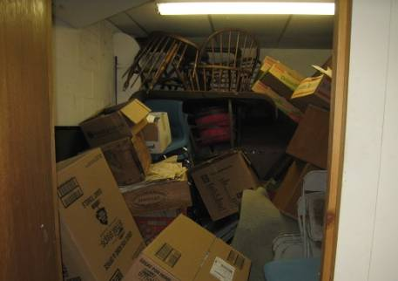

Closet Off Basement Work Room Showing Clutter
Location | Occupants  in Room | Carbon  Dioxide  (ppm) | Temp  (°F) | Relative  Humidity  (%) | Carbon Monoxide  (ppm) | Windows  Openable | Ventilation |  | Remarks
 |  |  |  |  |  |  | Supply | Exhaust | Remarks
Outside  (Background) |  | 436 | 55 | 25 | ND-0.5 |  |  |  | Sunny, clear, wind speed 3mph (west) – weather underground
Main Library | 3 | 676 | 64 | 38 | ND | Y | N | N | Exhaust blocked, carpet
Front Desk | 3 | 730 | 66 | 35 | ND | Y | N | N | Exhaust blocked, carpet
Knox Wing | 0 | 558 | 63 | 31 | ND | Y | N | N | Carpet, mold colonization on bottom of upholstered chair
Office | 0 | 640 | 61 | 40 | ND | Y | N | N | Plants, carpet
Basement Workroom | 0 | 659 | 63 | 34 | ND | N | N | N | Exhaust blocked by books
Furnace Room | 0 | 544 | 61 | 30 | ND | Y | N | N
Basement 2 | 0 | 464 | 54 | 41 | ND | Y | N | N | Floor joists and subfloor tested dry
Attic (used for storage) |  |  |  |  |  |  |  |  | WD GW

