INDOOR AIR QUALITY ASSESSMENT

Monument Mountain Regional High School
600 Stockbridge Road
Great Barrington, MA 01230

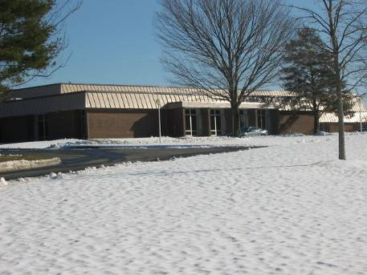

Prepared by:
Massachusetts Department of Public Health
Bureau of Environmental Health
Indoor Air Quality Program
April 2008

Background/Introduction

At the request of Steven Soule, Assistant Business Manager for the Berkshire Hills Regional School District, the Massachusetts Department of Public Health (MDPH), Bureau of Environmental Health (BEH) was asked to provide assistance and consultation regarding indoor air quality concerns at Monument Mountain Regional High School (MMRHS), 600 Stockbridge Road, Great Barrington, MA. Mr. Soule and his staff recently discovered that portions of fresh air intakes of the ventilation system were not functioning. Mr. Soule requested an indoor air quality assessment to evaluate the effectiveness of the repairs.
On January 18, 2008, a visit was made to conduct an assessment at the MMRHS by Mike Feeney, Director, and Lisa Hébert and James Tobin, Inspectors in BEH’s Indoor Air Quality (IAQ) Program. During the assessment, BEH staff were accompanied by Mr. Soule.
The school is a single story brick building constructed on a slab in 1968. The building contains general classrooms, science areas, art rooms, band room, an auditorium, library, cafeteria and a vocational wing, which includes wood, automotive and metal shops.

Methods
Air tests for carbon dioxide, temperature, relative humidity and carbon monoxide were taken with the TSI, Q-Trak™, IAQ Monitor Model 8551. MDPH staff also performed visual inspection of building materials for water damage and/or microbial growth.

Results
This school houses approximately 750 students with approximately 75 staff members. The tests were taken during normal operations at the school and results appear in Table 1.
Discussion
Ventilation
It can be seen from Table 1 that carbon dioxide levels were elevated above 800 parts per million (ppm) in 35 of the 68 areas surveyed, indicating poor air exchange in approximately half of the areas evaluated. It is also important to note that several classrooms had open windows and/or were empty or sparsely occupied. Typically, open windows and low occupancy can greatly reduce carbon dioxide levels. Carbon dioxide levels would be expected to be higher with full occupancy and with windows closed.
Rooftop air-handling units (AHUs) intake fresh air, then distribute it via ductwork to classrooms. Air is supplied to each classroom through vents located on either side of the light fixtures (Picture 1). Exhaust vents located in storage closets remove air from the classrooms (Picture 2). These vents are at the top of the closet and ducted to exhaust motors where return air is dispersed outside. Additionally, wall-mounted vents provide exhaust in some classrooms (Picture 3). In many classrooms, the exhaust vents were obstructed by shelving, books, tools and stored materials (Picture 4).
The exhaust system used in the general classrooms was employed in the woodshop. In particular, a heavy amount of sawdust had accumulated at the base of the storage closet (Picture 5). The exhaust vent can draw the sawdust up into the exhaust system. A shared system exhausts the vocational wing of MMRHS; therefore, sawdust can be distributed into areas of the wing, posing a fire hazard.
To maximize air exchange, the MDPH recommends that both supply and exhaust ventilation operate continuously during periods of school occupancy. In order to have proper ventilation with a mechanical supply and exhaust system, the systems must be balanced to provide an adequate amount of fresh air to the interior of a room while removing stale air from the room. It is recommended that HVAC systems be re-balanced every five years to ensure adequate air systems function (SMACNA, 1994). According to Mr. Soule, the servicing and balancing of these systems is an ongoing process.
The Massachusetts Building Code requires that each room have a minimum ventilation rate of 15 cubic feet per minute (cfm) per occupant of fresh outside air or openable windows (SBBRS, 1997; BOCA, 1993). The ventilation must be on at all times that the room is occupied. Providing adequate fresh air ventilation with open windows and maintaining the temperature in the comfort range during the cold weather season is impractical. Mechanical ventilation is usually required to provide adequate fresh air ventilation.
Carbon dioxide is not a problem in and of itself. It is used as an indicator of the adequacy of the fresh air ventilation. As carbon dioxide levels rise, it indicates that the ventilating system is malfunctioning or the design occupancy of the room is being exceeded. When this happens, a buildup of common indoor air pollutants can occur, leading to discomfort or health complaints. The Occupational Safety and Health Administration (OSHA) standard for carbon dioxide is 5,000 parts per million parts of air (ppm). Workers may be exposed to this level for 40 hours/week, based on a time-weighted average (OSHA, 1997).
The MDPH uses a guideline of 800 ppm for publicly occupied buildings. A guideline of 600 ppm or less is preferred in schools due to the fact that the majority of occupants are young and considered to be a more sensitive population in the evaluation of environmental health status. Inadequate ventilation and/or elevated temperatures are major causes of complaints such as respiratory, eye, nose and throat irritation, lethargy and headaches. For more information concerning carbon dioxide, consult Appendix A.
Temperature measurements in the school ranged from 69° F to 75° F, which were, within the MDPH recommended range in the majority of areas surveyed (Table 1). The MDPH recommends that indoor air temperatures be maintained in a range of 70º F to 78º F in order to provide for the comfort of building occupants. In many cases concerning indoor air quality, fluctuations of temperature in occupied spaces are typically experienced, even in a building with an adequate fresh air supply.
The relative humidity measured in the building ranged from 21 to 30 percent at the time of the assessment, which was below the MDPH recommended comfort range (Table 1). The MDPH recommends a comfort range of 40 to 60 percent for indoor air relative humidity. Relative humidity levels in the building would be expected to drop during the winter months due to heating. The sensation of dryness and irritation is common in a low relative humidity environment. Low relative humidity is a very common problem during the heating season in the northeast part of the United States.

Microbial/Moisture Concerns
Several potential sources of water damage and mold growth were observed. Numerous areas had water-damaged ceiling tiles, which appear to be the result of water penetration through the roof system. The ceiling tiles in these classrooms are interlocking, making tile replacement difficult. Ceiling tiles are made of porous material that can serve as a medium for mold growth when wetted. Further, mold colonization was observed on a pipe located in the Detention Room, located in the shop wing (Picture 6).
The US Environmental Protection Agency (US EPA) and the American Conference of Governmental Industrial Hygienists (ACGIH) recommend that porous materials be dried with fans and heating within 24 to 48 hours of becoming wet (US EPA, 2001; ACGIH, 1989). If not dried within this time frame, mold growth may occur. Once mold has colonized porous materials, they are difficult to clean and should be removed.
A humidifier was observed in room B20. Humidifiers can aerosolize particles and odors. In addition, the water reservoirs can provide a source for mold growth. Water reservoirs for humidifiers should be cleaned as per manufacturer’s directions to prevent microbial growth and odors. The air diffusers should also be cleaned periodically to prevent dust collection and aerosolization of materials.

Other IAQ Evaluations
Indoor air quality can be negatively influenced by the presence of respiratory irritants, such as products of combustion. The process of combustion produces a number of pollutants. Common combustion emissions include carbon monoxide, carbon dioxide, water vapor and smoke (fine airborne particle material).
Carbon monoxide is a by-product of incomplete combustion of organic matter (e.g., gasoline, wood and tobacco). Exposure to carbon monoxide can produce immediate and acute health affects. Several air quality standards have been established to address carbon monoxide and prevent symptoms from exposure to these substances. The MDPH established a corrective action level concerning carbon monoxide in ice skating rinks that use fossil-fueled ice resurfacing equipment. If an operator of an indoor ice rink measures a carbon monoxide level over 30 ppm, taken 20 minutes after resurfacing within a rink, that operator must take actions to reduce carbon monoxide levels (MDPH, 1997).
The American Society of Heating Refrigeration and Air-Conditioning Engineers (ASHRAE) has adopted the National Ambient Air Quality Standards (NAAQS) as one set of criteria for assessing indoor air quality and monitoring of fresh air introduced by HVAC systems (ASHRAE, 1989). The NAAQS are standards established by the US EPA to protect the public health from six criteria pollutants, including carbon monoxide and particulate matter (US EPA, 2006). As recommended by ASHRAE, pollutant levels of fresh air introduced to a building should not exceed the NAAQS levels (ASHRAE, 1989). The NAAQS were adopted by reference in the Building Officials & Code Administrators (BOCA) National Mechanical Code of 1993 (BOCA, 1993), which is now an HVAC standard included in the Massachusetts State Building Code (SBBRS, 1997). According to the NAAQS, carbon monoxide levels in outdoor air should not exceed 9 ppm in an eight-hour average (US EPA, 2006).
Carbon monoxide should not be present in a typical, indoor environment. If it is present, indoor carbon monoxide levels should be less than or equal to outdoor levels. On the day of assessment, outdoor carbon monoxide concentrations were non-detect (ND) (Table 1). Carbon monoxide levels measured in the general classroom areas of the school were ND; however, in the vocational wing, two classrooms had detectable CO levels. Carbon monoxide levels in both the auto (Room A1) and metal (Room A3) shops measured at 1 ppm (Table 1). These levels were caused by vehicle exhaust and grinding metal; normal activities in these shops.
As previously mentioned, the classrooms and shops of the vocational wing share an exhaust system. This exhaust configuration is prone to drawing a pollutant from one area and distributing it to another area as the wood shop serves as a potential example. In order to alleviate this situation, the general exhaust system should be disconnected from each shop. Therefore, it is important that each local and specialized exhaust system in each shop must be in good standing and have the ability to operate continuously during school hours.

Metal Shop (Room A3)
A metallic taste in the mouth was noted by BEH staff upon entering the metal shop. This metallic taste is associated with exposure to aerosolized metal fumes. Cutting and grinding machines in the metal shop did not have dedicated local exhaust ventilation to remove metal fumes produced during operation (Picture 7). As each of these machines grind and cut metal, heated metal particles (called fume) are produced and aerosolized.
Metal fumes are a respiratory irritant. Both the Occupational Safety and Health Administration (OSHA) and the American Conference of Governmental Industrial Hygienists (ACGIH) have established Permissible Exposure Limits (PELs) (OSHA, 1997) and Threshold Limit Values (TLVs) (ACGIH, 1999) for various metal fumes. An evaluation of the contents of the material producing fume must be done in order to ascertain which PEL or TLV applies in this situation. This evaluation, as well as an evaluation of the concentration of materials being aerosolized, should be done by a certified industrial hygienist. Please note that these exposure standards apply to healthy adult employees in the workforce. Students who are in this environment are not considered employees for the purposes of OSHA regulations or ACGIH TLVs. In this case, levels of airborne fumes should be reduced to minimally feasible levels in order to prevent student exposure to metal fumes. The ACGIH has recommended standards for local exhaust ventilation for specific operations such as surface grinders, grinding wheels, lathes, and metal band saws (ACGIH, 1998). If this is not practicable, individual personal protective equipment that is fit-tested for each individual should be considered. No personal protective equipment (respirators) was observed in the shop at the time of the assessment.

Automotive Shop (Rooms A1, A11)
It was observed that welding may have been occurring several yards away from where the exhaust hood was located in the automotive shop (Picture 8). Exposure to welding fumes is associated with a number of health effects. “Acute exposure to welding fumes can result in eye, nose, and throat irritation, fever, chills, headache, nausea, shortness of breath, muscle pain, and a metallic taste in the mouth. Chronic exposure to welding fumes can result in respiratory effects including coughing, wheezing, and decreased pulmonary function” (OSHA, unknown). The National Institute for Occupational Safety and Health (NIOSH) has established a recommended exposure limit (REL) for welding fumes (and total particulates) of the “lowest feasible concentration,” since NIOSH considers welding fumes potential occupational carcinogens (NIOSH, 1992). For this reason, exhaust ventilation for welding operations should be designed in a manner to draw fumes away from the welder. The repair garage welding exhaust ventilation system did not appear to be equipped with flexible ducts of adequate length to provide an adequate means to draw welding pollutants away from the operator. To reduce exposure, a flexible hose connected to a fume venting system should be placed in a location opposite the operator and point of welding, otherwise, welding should be done under the welding hood. For additional information concerning welding occupational safety, consult Appendix B.
Also in the automotive shop, space exists under the hallway door (Picture 9). Since the shop has large exterior garage doors that may be left open during school hours, wind or cold air entering the shops can cause over-pressurization, which can result in shop odors and particulates being forced under the door space into hallways.

Wood Shop (Room A15)
Sawdust was noted on the surfaces and floor throughout the wood shop, including within the storage cabinet, leading to the exhaust ventilation. The planer exhibited one outlet for expelling wood dust that was not connected to a hose, allowing wood dust to easily enter the wood shop (Picture 10). In addition to being an irritant, wood dust is a fire hazard that needs to be cleaned from surfaces on a regular schedule.

Chemical Storeroom for Science Labs
The chemical storeroom has a number of conditions that can adversely affect indoor air quality. Chemicals were improperly stored posing fire and safety hazards and should be addressed promptly. This cabinet is connected to PVC pipes at the top and the bottom of the cabinet, with both pipe lines exhausting directly to the outdoors (Pictures11, 12, 13, 14).
The National Fire Prevention Association (NFPA) does not require venting in flammable storage cabinets, however, if venting is done, it must be vented directly outdoors and in a manner not to compromise the specific performance of the cabinet (NFPA, 1996). If outdoor air backflowing into the cabinet occurs, off-gassing chemicals can be forced from the flammables cabinet into the storeroom. Proper design of exhaust vents should prevent air backflow into the cabinet.
Further, the installation of the exhaust vent piping has compromised the fire integrity of the flammables cabinet at MMRHS. A flameproof cabinet has air tight, solid outer and inner walls, which form an enclosed inner space that reduces the transfer of heat from a fire outside of the cabinet to the interior of the cabinet. The airtight space of this cabinet was breached with the installation of the PVC pipes, which opened holes to the interior of the cabinet. With this breach, it would not be expected that this cabinet would perform as designed in the case of a fire.
Other fire and/or safety hazards noted in the science area include:
- A bottle of Ethyl Ether was observed in the flammables cabinet. Ethyl Ether is a potentially explosive compound that should not be found in the school’s chemical inventory. It should be removed and disposed of in a manner that meets Massachusetts Hazardous Waste Regulations (Picture 15).
- Within the flammables cabinet, it was observed that a chemical container exhibited a rusty metal cover, indicating potential improper storage of incompatible chemicals (Picture 16).
- A shelving unit in the chemical storeroom appears to be corroded from off-gassing materials coating the shelf with oxidized metal (Picture 17). This corrosion can undermine the structural integrity of the metal shelves. Materials should be removed from the shelves and relocated.
- Corrosion of cabinet handles in chemical storage room may indicate the presence of improperly stored chlorine solvents.
- Flammable chemicals were stored on wooden shelves. Flammable chemicals should be stored inside a flammables cabinet.
- Shelves do not have guardrails to prevent accidental slippage of chemical containers.
- Shelves are overloaded with chemicals, so that container labels cannot be seen without moving bottles.
- Containers of some materials were found upended in the chemical storage closet.
- Chemicals in storage closet are stored beneath operational exhaust vent, potentially causing odors or chemicals to enter the air handling unit (Picture 18).
- Bottles of chemicals are stored on shelving above eye level.
- Chemicals are stored beneath deactivated fume hoods in classroom.
- Chemistry classroom and chemical storage rooms were accessible to students when class was not in session.
It is highly recommended that a thorough inventory of chemicals in the science department be done to assess chemical storage and disposal in an appropriate manner consistent with Massachusetts hazardous waste laws.
Moreover, chemistry classrooms were equipped with fume hoods. The efficacy of the draw of air through this equipment could not be determined. In addition, no record of the last date of calibration/inspection of the hoods was readily apparent. Chemical hoods should be recalibrated on an annual basis or as recommended by the manufacturer to ensure proper function.
Indoor air concentrations can be greatly impacted by the use of products containing volatile organic compounds (VOCs). VOCs are carbon-containing substances that have the ability to evaporate at room temperature. Frequently, exposure to low levels of total VOCs (TVOCs) may produce eye, nose, throat and/or respiratory irritation in some sensitive individuals. For example, chemicals evaporating from a paint can stored at room temperature would most likely contain VOCs. In an effort to identify materials that can potentially increase indoor VOC concentrations, BEH staff examined classrooms for products containing these respiratory irritants.
Several classrooms contained dry erase boards and markers. Materials such as dry erase markers and cleaners may contain VOCs, (e.g., methyl isobutyl ketone, n-butyl acetate and butyl-cellusolve) (Sanford, 1999).
Other conditions that can affect indoor air quality were observed during the assessment. In several classrooms, items were observed on the floor, windowsills, tabletops, counters, bookcases and desks. The large number of items stored in classrooms provides a source for dusts to accumulate. These items (e.g., papers, folders, boxes) make it difficult for custodial staff to clean. Items should be relocated and/or be cleaned periodically to avoid excessive dust build up. In addition, these materials can accumulate on flat surfaces (e.g., desktops, shelving and carpets) in occupied areas and subsequently be re-aerosolized causing further irritation.
A number of exhaust vents and personal fans were observed to have accumulated dust. If exhaust vents are not functioning, backdrafting can occur, which can re-aerosolize accumulated dust particles. Re-activated fans can also aerosolize dust accumulated on fan blades.
An accumulation of chalk dust, pencil shavings and dry erase particulate was observed in some classrooms. When windows are opened, these materials can become airborne. Once aerosolized, they can act as irritants to eyes and the respiratory system.
Aquariums located in some classrooms had murky water. Aquariums should be properly maintained to prevent microbial/algal growth, which can emit unpleasant odors.
In an effort to reduce noise from sliding chairs and tables, tennis balls were sliced open and placed on chair legs in some classrooms. Tennis balls are made of a number of materials that are a source of respiratory irritants. Constant wearing of tennis balls can produce fibers and off-gas VOCs. Tennis balls are made with a natural rubber latex bladder, which becomes abraded when used as a chair leg pad. Use of tennis balls in this manner may introduce latex dust into the school environment. Some individuals are highly allergic to latex (e.g. spina bifida patients) (SBAA, 2001). It is recommended that the use of materials containing latex be limited in buildings to reduce the likelihood of symptoms in sensitive individuals (NIOSH, 1997). A question and answer sheet concerning latex allergy is attached as Appendix C (NIOSH, 1998).
The consumer science room (Room K07) contains gas stoves that do not have local exhaust ventilation. Gas stoves can produce water vapor and carbon monoxide as products of combustion. In addition, cooking can distribute cooking odors and additional water vapor into the classroom and adjacent areas.
Upholstered furniture was observed in one classroom (H05) (Picture 19). Upholstered furniture is covered with fabric that comes in contact with human skin. This type of contact can leave oils, perspiration, hair and skin cells. Dust mites feed upon human skin cells and excrete waste products that contain allergens. In addition, if relative humidity levels increase above 60 percent, dust mites tend to proliferate (US EPA, 1992). In order to remove dust mites and other pollutants, frequent vacuuming of upholstered furniture is recommended (Berry, M.A., 1994). It is also recommended that upholstered furniture (if present in schools), be professionally cleaned on an annual basis. If an excessively dusty environment exists due outdoor conditions or indoor activities (e.g., renovations), cleaning frequency should be increased (every six months) (IICR, 2000). Elevated outdoor levels of airborne particulates can result in increased levels of indoor particulates via open windows, doors and filter bypass.
A strange odor was noted in some classrooms. This odor was found to be associated with the window curtains at times when the sun was shinning directly upon them. These curtain odors can be a potential irritant for sensitive individuals.
A kiln located in the art room was exhausted by a hood. The outside vent to where the kiln is exhausted is located in close proximity to an openable window. This vent is also loose and in danger of falling to the ground.
Lastly, a number of students were observed consuming food in the hallways of the building. This is a concern due to food products falling to the floor. Additionally, in the men’s locker room, garbage bags full of water bottles and other recyclables were found stored in the deactivated shower area. Exposed food products and food containers can attract a variety of pests. The presence of pests inside a building can produce conditions that can degrade indoor air quality. For example, rodent infestation can result in indoor air quality related symptoms due to materials in their wastes. Mouse urine is known to contain a protein that is a known sensitizer (US EPA, 1992). A sensitizer is a material that can produce symptoms in exposed individuals, including nose irritations and skin rashes. Pest attractants should be reduced/eliminated.

Conclusions/Recommendations
The conditions related to indoor air quality problems at the MMRHS raise a number of issues. The general building conditions, maintenance, work hygiene practices and the condition of HVAC equipment, if considered individually, present conditions that could degrade indoor air quality. When combined, these conditions can serve to further degrade indoor air quality. Some of these conditions can be remedied by actions of building occupants. Other remediation efforts will require alteration to the building structure and equipment. For these reasons, a two-phase approach is required for remediation. The first consists of short-term measures to improve air quality and the second consists of long-term measures that will require planning and resources to adequately address the overall indoor air quality concerns.
The following short-term measures should be considered for implementation:
- Inventory all chemicals in all storage areas and classrooms. Inventory consists of the name of the chemical, how much and where it is stored.
- Properly store chemicals below eye level in such a manner to allow visual access to chemical containers without having to move other bottles out of the way.
- Ensure each chemical container is labeled with the chemical name of the material store within.
- Ensure chemically incompatible materials are separated and stored in an appropriate manner according to the manufacturer’s recommendations.
- Properly store flammable materials in a manner consistent with the local fire code. All flammable materials should be stored inside a flammables storage cabinet.
- Discard hazardous materials or empty containers of hazardous materials in a manner consistent with environmental statutes and regulations. Follow proper procedures for storing and securing hazardous materials.
- Acquire, update and maintain Material Safety Data Sheets (MSDS) for all chemicals from manufacturers or suppliers. Train individuals in the proper use, storage and protective measures for each material in a manner consistent with the Massachusetts Right-To-Know Law, M.G.L. c. 111F (MGL, 1983).
- Ensure shelving in the chemical storeroom is intact and able to support the weight of stored materials.
- Install guardrails along the edge of shelving to prevent accidental spillage.
- Remove and properly store chemicals stored in chemical hood areas. Chemical hoods should not be used to store chemicals.
- Ensure chemical exhaust hoods in science areas are operating properly. Science staff should work with school administration and their HVAC vendor to develop a preventative maintenance program for all local exhaust equipment (e.g., lab hoods, prep rooms).
- Secure chemical storage area from unauthorized access.
- To maximize air exchange, the BEH recommends that both supply and exhaust ventilation operate continuously during periods of school occupancy.
- Inspect exhaust motors and belts for proper function. Repair and replace as necessary.
- Use openable windows in conjunction with classroom supply and exhaust ventilation systems to increase air exchange. Care should be taken to ensure windows are properly closed at night and weekends to avoid freezing of pipes and potential flooding.
- Consider adopting a balancing schedule of every 5 years for all mechanical ventilation systems, as recommended by ventilation industrial standards (SMACNA, 1994).
- For buildings in New England, periods of low relative humidity during the winter are often unavoidable. Therefore, scrupulous cleaning practices should be adopted to minimize common indoor air contaminants whose irritant effects can be enhanced when the relative humidity is low. To control for dusts, a HEPA filter equipped vacuum cleaner in conjunction with wet wiping of all surfaces is recommended. Drinking water during the day can help ease some symptoms associated with a dry environment (throat and sinus irritations).
- Change filters for air-handling units (AHUs) as per the manufacturer’s instructions or more frequently if needed. Ensure filters fit flush in their racks with no spaces in between allowing bypass of unfiltered air into the unit.
- Replace water-stained ceiling tiles. Examine the area above and around these areas for mold growth. Disinfect areas of water leaks with an appropriate antimicrobial.
- Install weather-stripping and sweeps on shop hallway doors and keep hallway doors closed to minimize fume/odor/dust migration into the hallway and/or classrooms.
- Seal penetrations of pipes and conduits through walls in accordance with the Massachusetts Building Code, including but not limited to detention room in shop wing.
- Secure cover to exterior portion of old ventilation system to kiln. Grate is loose and in danger of falling onto the ground.
- In the wood shop, either add a second flexible hose to exhaust wood dust/particulates from the planer or seal the opening to eliminate wood dust from entering the classroom.
- Remove old recyclables from men’s locker room.
- Disconnect wood shop closet and metal and auto shops from the exhaust ventilation system.
- All gas cylinders must be properly secured and stored in a manner consistent with state and local fire codes.
- Ensure all students in shops are provided with appropriate personal protective equipment.
- Periodically examine floor drains to ensure traps are not dry. A dry drain trap was noted off the chemical storage room.
- Relocate or consider reducing the amount of materials stored in classrooms to allow for more thorough cleaning of classrooms. Clean items regularly with a wet cloth or sponge to prevent excessive dust build-up.
- Clean personal fans and exhaust vents periodically of accumulated dirt and dust.
- Clean chalk trays, dry erase board trays and areas around pencil sharpeners to prevent accumulation of materials.
- Clean and maintain aquariums to prevent mold growth and associated odors.
- Eliminate the widespread practice of eating outside of the cafeteria.
- Re-seal sinks in lab tables that no longer have adequate seals.
- Remove obstructions and maintain a clear path to eyewash station (Picture 20).
- For more advice on mold please consult the document “Mold Remediation in Schools and Commercial Buildings” published by the US Environmental Protection Agency (US EPA, 2001). Copies of this document can be downloaded from the US EPA website at: http://www.epa.gov/iaq/molds/mold_remediation.html.
- Consider adopting the US EPA (2000) document, “Tools for Schools”, as an instrument for maintaining a good indoor air quality environment in the building. This document is available at: http://www.epa.gov/iaq/schools/index.html.
- Refer to resource manual and other related indoor air quality documents located on the MDPH’s website for further building-wide evaluations and advice on maintaining public buildings. These documents are available at: http://www.state.ma.us/dph/MDPH/iaq/iaqhome.htm.

The following long-term measures should be considered:
- A ventilation engineer should be consulted to resolve air supply/exhaust ventilation building-wide. With regard to the shop areas, it is highly recommended that a certified industrial hygienist be consulted to evaluate the industrial hygiene practices and procedures in all shop areas and appropriate ventilation practices for the science area chemical storage rooms.
- Contact an experienced hazardous waste removal consultant to evaluate the chemical preparation room (off room F21) for proper chemical storage and recommendations for removal of hazardous waste.
- Provide local exhaust ventilation consistent with recommendations of the American Conference of Governmental Industrial Hygienists (ACGIH) for all metal fume producing procedures (e.g., see metal shop, automotive repair) (ACGIH, 1998). The construction of local exhaust ventilation for the machinery in the chemical storage area, automotive, metal shops and blueprint printer in the graphics area are all highly recommended for shop activities to continue. Examine the feasibility of providing local exhaust ventilation for all metal fume-producing machinery in the metal shop.
- Vent from kiln is located below openable window in art room. Consider alternate placement of exhaust pipe.

References
ACGIH. 1989. Guidelines for the Assessment of Bioaerosols in the Indoor Environment. American Conference of Governmental Industrial Hygienists, Cincinnati, OH.

ACGIH. 1998. Industrial Ventilation A Manual of Recommended Practice. 23rd ed. American Conference of Governmental Industrial Hygienists, Cincinnati, OH.

ACGIH. 1999. Guide to Occupational Exposure Values-1999. American Conference of Governmental Industrial Hygienists, Cincinnati, OH.

ASHRAE. 1989. Ventilation for Acceptable Indoor Air Quality. American Society of Heating, Refrigeration and Air Conditioning Engineers. ANSI/ASHRAE 62-1989.
Berry, M.A. 1994. Protecting the Built Environment: Cleaning for Health, Michael A. Berry, Chapel Hill, NC.

BOCA. 1993. The BOCA National Mechanical Code/1993. 8th ed. Building Officials and Code Administrators International, Inc., Country Club Hill, IL.
IICR. 2000. IICR S001 Reference Guideline for Professional On-Location Cleaning of Textile Floor Covering Materials Institute of Inspection, Cleaning and Restoration Certification. Institute of Inspection Cleaning and Restoration, Vancouver, WA.

MDPH. 1997. Requirements to Maintain Air Quality in Indoor Skating Rinks (State Sanitary Code, Chapter XI). 105 CMR 675.000. Massachusetts Department of Public Health, Boston, MA.
MGL. 1983. Hazardous Substances Disclosure by Employers. Massachusetts General Laws. M.G.L. c. 111F.

NIOSH. 1997. NIOSH Alert Preventing Allergic Reactions to Natural Rubber latex in the Workplace. National Institute for Occupational Safety and Health, Atlanta, GA.

NIOSH. 1998. Latex Allergy A Prevention. National Institute for Occupational Safety and Health, Atlanta, GA.

NIPA. 1996. Flammable and Combustible Liquids Code. 1996 ed. National Fire Prevention Association, Quincy, MA. NFPA 30.

OSHA. 1997. Limits for Air Contaminants. Occupational Safety and Health Administration. Code of Federal Regulations. 29 C.F.R 1910.1000 Table Z-1-A.

Sanford. 1999. Material Safety Data Sheet (MSDS No: 198-17). Expo® Dry Erase Markers Bullet, Chisel, and Ultra Fine Tip. Sanford Corporation. Bellwood, IL.

SBAA. 2001. Latex In the Home And Community Updated Spring 2001. Spina Bifida Association of America, Washington, DC. Http://www.sbaa.org/html/sbaa_mlatex.html.

SBBRS. 1997. Mechanical Ventilation. State Board of Building Regulations and Standards. Code of Massachusetts Regulations. 780 CMR 1209.0.

SMACNA. 1994. HVAC Systems Commissioning Manual. 1st ed. Sheet Metal and Air Conditioning Contractors’ National Association, Inc., Chantilly, VA.

US EPA. 1992. Indoor Biological Pollutants. US Environmental Protection Agency, Environmental Criteria and Assessment Office, Office of Health and Environmental Assessment, Research Triangle Park, NC. ECAO-R-0315. January 1992.

US EPA. 2001. Mold Remediation in Schools and Commercial Buildings. US Environmental Protection Agency, Office of Air and Radiation, Indoor Environments Division, Washington, D.C. EPA 402-K-01-001. March 2001.
US EPA. 2006. National Ambient Air Quality Standards (NAAQS). US Environmental Protection Agency, Office of Air Quality Planning and Standards, Washington, DC. http://www.epa.gov/air/criteria.html.
Picture 1

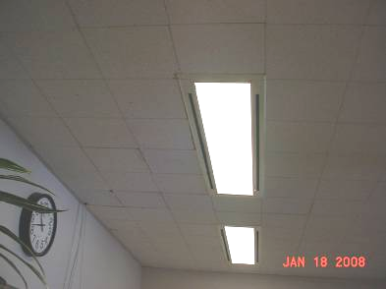

Air Supply located on either side of light fixtures

Picture 2



Classroom Storage Closets, Note Exhaust Vent Location

Picture 3

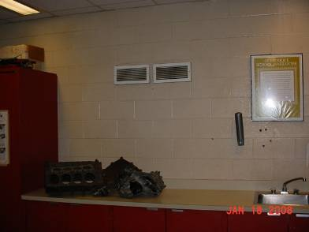

Wall-mounted Exhaust Vents

Picture 4

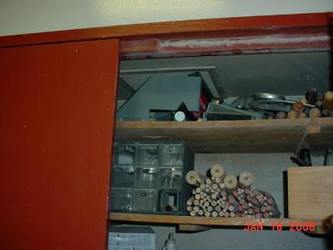

Vent in Storage Cabinet Blocked by Tools

Picture 5

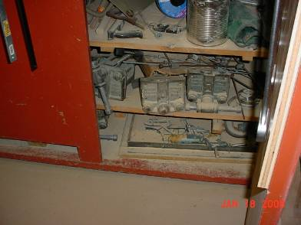

Heavy Accumulation of Sawdust at Base of Storage Cabinet

Picture 6

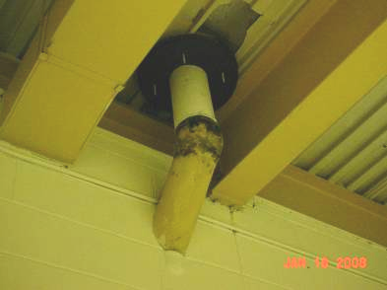

Mold Growth Pipe Exterior

Picture 7

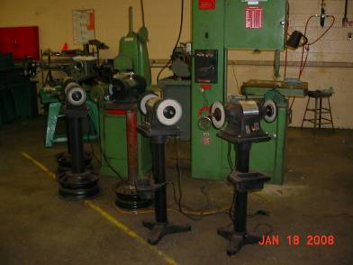

Cutting and Grinding Equipment Lacking Local Exhaust

Picture 8

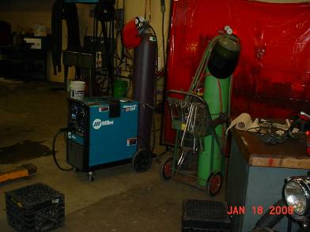

Welding Equipment Located Outside of Exhaust Hood Area

Picture 9

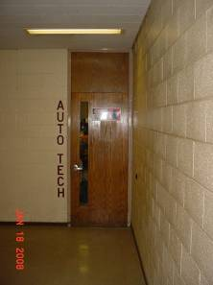

Space Under Hallway Door

Picture 10

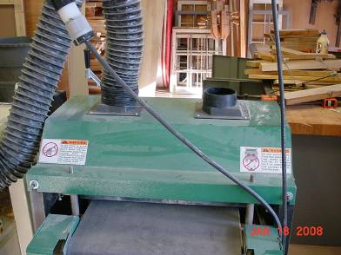

Planer Outlet Lacking Hose to Exhaust Sawdust

Picture 11

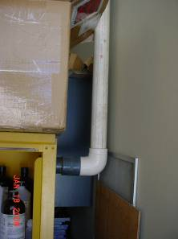

PVC Pipe Connected to Top of Flameproof Cabinet

Picture 12

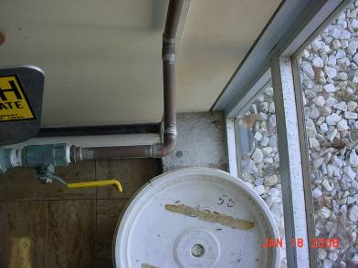

From the Bottom of the Flameproof Cabinet PVC Pipe Exits Through Wall to Outside

Picture 13

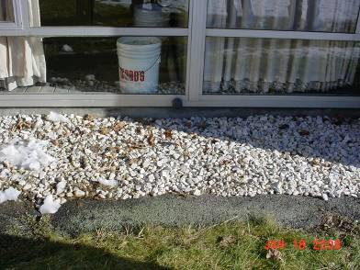

End of PVC Pipe from Bottom of Flameproof Cabinet

Picture 14

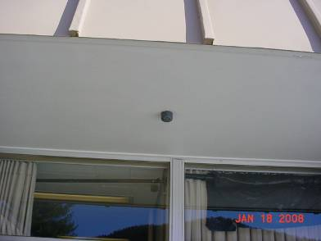

End of PVC Pipe from Top of Flameproof Cabinet

Picture 15



Bottle of Ethyl Ether in Chemical Storeroom

Picture 16

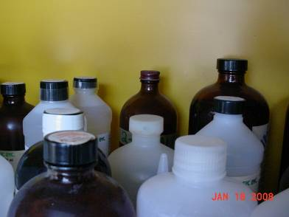

Oxidation of Metal Cover

Picture 17

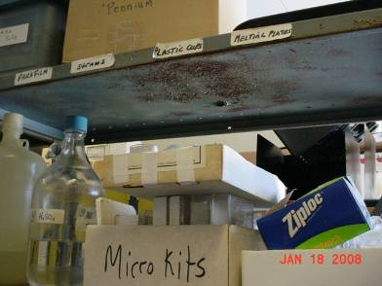

Oxidation of Metal Shelf

Picture 18

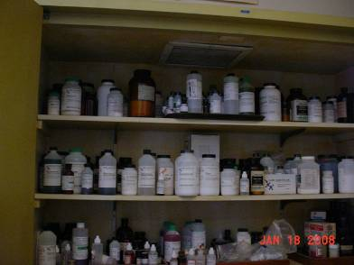

Chemicals Stored in Cabinet Under Exhaust Vent

Picture 19

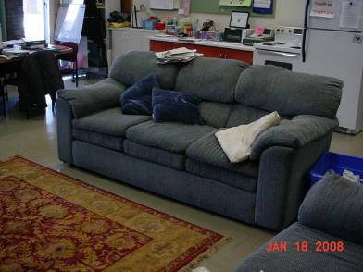

Upholstered Furniture

Picture 20

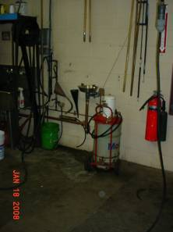

Obstructed Eyewash Station in Automotive Shop

Location | Carbon  Dioxide  (*ppm) | Carbon  Monoxide  (*ppm) | Temp  °(F) | Relative  Humidity  (%) | Occupants  in Room | Windows  Openable | Ventilation |  | Remarks
 |  |  |  |  |  |  | Supply | Exhaust | Remarks
Background | 304 | ND | 45 | 42 | - | - | - | -
H03 | 1342 | ND | 72 | 30 | 0 | Y | Y | Y | DO
H04 | 1252 | ND | 72 | 29 | 6 | Y | Y | Y | WO, 18 Computers, Plant
H04A | 1334 | ND | 72 | 29 | 7 | Y | Y | Y | DO, 15 Computers
H05 | 1285 | ND | 71 | 28 | 0 | Y | Y | Y | DO
H08 | 1027 | ND | 72 | 28 | 1 | N | Y | N | DO
H09 | 1005 | ND | 71 | 27 | 0 | N | Y | Y | DO
H12 | 1031 | ND | 71 | 29 | 0 | N | Y | Y | DO
H13 | 1269 | ND | 71 | 29 | 0 | N | Y | Y | DO
H13 | 1065 | ND | 71 | 30 | 19 | N | Y | Y | DO, Partially blocked exhaust
H15 | 1301 | ND | 71 | 29 | 5 | Y | Y | Y | DO, Clutter, 4 comp.
H18 | 1094 | ND | 72 | 28 | 0 | Y | Y | Y | DO, WD ceiling tile
H19 | 1148 | ND | 72 | 28 | 0 | Y | Y | N | DO, WD ceiling tile
H20 | 1142 | ND | 72 | 29 | 2 | Y | Y | Y | DO
H21 | 1042 | ND | 72 | 28 | 2 | Y | Y | Y | DO
Faculty Room | 1099 | ND | 72 | 27 | 4 | Y | Y | Y | DO, WD ceiling tile
F02 | 1187 | ND | 73 | 29 | 21 | N | Y | Y | DO, 2 aqua – murky, dirty
F05/06 | 1178 | ND | 73 | 28 | 19 | Y | Y | Y | Plants, aqua – murky, dirty
F07 | 1045 | ND | 73 | 27 | 4 | Y | Y | Y | DO
F10 | 1029 | ND | 74 | 27 | 7 | N | Y | Y | DO
F12 | 1177 | ND | 72 | 28 | 0 | N | Y | Y | 6 CT-WD, Bubbler, 3 comp.
F14 | 1054 | ND | 74 | 25 | 20 | N | Y | Y | PF, DEM
F15 | 926 | ND | 75 | 25 | 17 | N | Y | Y | DO
F16 | 1073 | ND | 75 | 25 | 21 | N | Y | Y | DO
F17 | 1275 | ND | 72 | 32 | 20 | Y | Y | Y | DO
F18 | 1320 | ND | 69 | 35 | 16 | Y | Y | Y | DEM
F21 | 998 | ND | 73 | 26 | 0 | N | Y | Y | DO
F22 | - | - | - | - | 0 | - | - | - | Dry drain
F24 | 954 | ND | 75 | 24 | 0 | Y | Y | Y | DO
F25 | 560 | ND | 70 | 25 | 14 | Y | Y | Y | Door half open, to outdoors
B03 | 953 | ND | 71 | 28 | 0 | Y | Y | Y | TB, Clutter near exhaust, CD
B04 | 758 | ND | 72 | 26 | 0 | Y | Y | Y | DO, WD ceiling tile and light fixture.
B05 | 667 | ND | 71 | 26 | 0 | Y | Y | Y | DO, Carpet
B06 | 690 | ND | 70 | 28 | 0 | Y | Y | Y | DO
B09 | 777 | ND | 71 | 27 | 3 | Y | Y | Y | UF, PF, DEM
B10 | 947 | ND | 73 | 26 | 4 | Y | Y | Y | DO
B11 | 754 | ND | 74 | 26 | 0 | N | Y | Y | DO
B12 | 733 | ND | 73 | 26 | 0 | N | Y | Y | DO
B13 | 792 | ND | 70 | 28 | 5 | Y | Y | Y | PF, Clutter
B19 | 720 | ND | 73 | 25 | 0 | Y | Y | Y | DO
B20 | 749 | ND | 72 | 27 | 0 | Y | Y | Y | DO, humidifier
B21 | 892 | ND | 73 | 28 | 0 | Y | Y | Y | DO, Curtains exhibit odor when sun shines on them.
B22 | 781 | ND | 73 | 26 | 3 | Y | Y | Y | DO, Closet exhaust blocked by books and shoes.
K01 | 633 | ND | 70 | 27 | 8 | N | Y | Y | DO, Kilns exhibit poor exhaust design
K07 | 678 | ND | 71 | 29 | 12 | Y | Y | Y | Dryers, washers, stoves w pilot lights
A01 Automotive shop | 635 | 1ppm | 73 | 25 | 0 | N | Y | Y | DC, Eyewash is blocked; Garage doors (2)
A01 Automotive shop | 590 | 0 | 72 | 26 | 2 | N | Y | Y | Eyewash is blocked; Garage doors
A02 | 816 | 0 | 73 | 25 | 0 | Y | Y | Y | DO, blueprint machine
A03 Metal Shop | 735 | 1ppm | 74 | 24 | 0 | Y | Y | Y | Metallic taste in mouth upon entering room; no hearing/eye protection evident; Metal shop exhausts into HVAC system. Re-using food containers
A03 Metal Shop | 619 | 0 | 71 | 25 | 0 | Y | Y | Y | Non vented metal grinding; Re-using food containers.
A11 | 688 | 0 | 71 | 27 | 0 | N | Y | Y | Brake dust; no local exhaust
A15 Wood Shop | 744 | 1ppm | 75 | 25 | 12 | Y | Y | Y | VL in closet; Closet cluttered with tools and exhibits sawdust at bottom. Wood shop exhaust tied into HVAC system.
A15 Wood Shop | 699 | 0 | 74 | 25 | 12 | Y | Y | Y | Sawdust, exhaust in closet
A16 – Former dark room | - | - | - | - | - | - | - | - | Exhaust is backwards; Exhaust supplies air
A18 | 816 | ND | 75 | 28 | 13 | N | Y | Y | DO, 15 computers
A18 | 804 | 1ppm | 73 | 28 | 9 | Y | Y | Y | DO, Fire-stopping lacking in numerous penetrations.
A19 | 777 | ND | 71 | 29 | 0 | N | Y | Y | DO, WD to drain
Women’s Locker Room | 660 | ND | 72 | 24 | 0 | N | Y | Y | Exhaust above toilet nonfunctioning
Men’s Locker Room | 820 | ND | 73 | 25 | 0 | N | Y | Y | DO, Exhaust in toilet area nonfunctioning; Numerous recyclables in shower enclosure
Small Room Outside Gym | 727 | ND | 73 | 25 | 4 | N | N | N | DO, Large, unsealed penetrations in wall
C40 Weight Room | 845 | ND | 73 | 28 | 3 | N | Y | Y | DO
Gym | 672 | ND | 72 | 27 | 27 | N | Y | Y
D9 Band Room | 586 | ND | 72 | 21 | 0 | N | Y | Y | DO
Auditorium | 575 | ND | 72 | 21 | 21 | N | Y | Y | DO
Library | 616 | ND | 71 | 21 | 4 | N | Y | Y | DO
Library | 497 | ND | 69 | 23 | 6 | N | Y | Y | 8 Computers
Copy Room | 621 | ND | 72 | 22 | 1 | N | Y | Y | DO, Carpet
Main Office | 536 | ND | 74 | 21 | 3 | N | Y | N | DO
Guidance Office | 708 | ND | 71 | 25 | 5 | N | Y | Y
Asst. Principal | 510 | ND | 72 | 23 | 0 | Y | Y | N | Plants

Technical Links > Health Guidelines > Welding Fumes
Disclaimer: The information contained in these guidelines is intended for reference purposes only. It provides a summary of information about chemicals that workers may be exposed to in their workplaces. The information may be superseded by new developments in the field of industrial hygiene. Readers are therefore advised to regard these recommendations as general guidelines and to determine whether new information is available.
OCCUPATIONAL SAFETY AND HEALTH GUIDELINE FOR WELDING FUMES
INTRODUCTION
This guideline summarizes pertinent information about welding fumes for workers and employers as well as for physicians, industrial hygienists, and other occupational safety and health professionals who may need such information to conduct effective occupational safety and health programs. Recommendations may be superseded by new developments in these fields; readers are therefore advised to regard these recommendations as general guidelines and to determine whether new information is available.
SUBSTANCE IDENTIFICATION
* Formula
Varies.
* Structure
(For Structure, see paper copy)
* Synonyms
Synonyms vary depending on the specific components of the fumes.
* Identifiers
1. CAS No.: None.
2. RTECS No.: ZC2550000
3. Specific DOT number: None
4. Specific DOT label: None
* Appearance and odor
Welding fumes are the fumes that result from various welding operations. The primary components are oxides of the metals involved such as zinc, iron, chromium, aluminum, or nickel. Welding fumes typically have a metallic odor, and their specific composition varies considerably.
CHEMICAL AND PHYSICAL PROPERTIES
* Physical data
1. Molecular weight: Varies.
2. Boiling point: Varies.
3. Specific gravity: Varies.
4. Vapor density: Varies.
5. Melting/Freezing point: Varies.
6. Vapor pressure: Varies.
7. Solubility: Varies.
8. Evaporation rate: Not applicable.
* Reactivity
1. Conditions contributing to instability: None reported.
2. Incompatibilities: None reported.
3. Hazardous decomposition products: None reported.
4. Special precautions: None reported.
* Flammability
The National Fire Protection Association has not assigned a flammability rating to welding fumes.
1. Flash point: Not applicable.
2. Autoignition temperature: Not applicable.
3. Flammable limits in air: Not applicable.
4. Extinguishant: Use an extinguishant that is suitable for the materials involved in the surrounding fire.

EXPOSURE LIMITS
* OSHA PEL
The Occupational Safety and Health Administration (OSHA) does not currently regulate welding fumes.
* NIOSH REL
The National Institute for Occupational Safety and Health (NIOSH) has established a recommended exposure limit (REL) for welding fumes (and total particulates) of the lowest feasible concentration. NIOSH considers welding fumes potential occupational carcinogens [NIOSH 1992].
* ACGIH TLV
The American Conference of Governmental Industrial Hygienists (ACGIH) has assigned welding fumes (not otherwise classified) a threshold limit value (TLV) of 5 milligrams per cubic meter (mg/m(3)) as a TWA for a normal 8-hour workday and a 40-hour workweek [ACGIH 1994, p. 36].
* Rationale for Limits
The NIOSH limit is based on the risk of cancer and respiratory disease [NIOSH 1992].
The ACGIH limit is based on the risk of toxic effects caused by welding fumes [ACGIH 1991, p. 1726].
HEALTH HAZARD INFORMATION
* Routes of Exposure
Exposure to welding fumes can occur through inhalation and eye contact.
* Summary of toxicology
1. Effects on Animals: Welding fumes can cause non-specific changes in the lungs; in addition, there is limited evidence for genotoxicity in in vitro test systems. Rats exposed by inhalation or intratracheal instillation of welding fumes from mild-steel welding showed non- specific pulmonary changes with no signs of fibrosis over a period of 450 days [IARC 1990]. The primary effects observed included particle- laden macrophage aggregates, and alveolar epithelial thickening with proliferation of granular pneumocytes [IARC 1990]. Similar changes were observed in the lungs of rats exposed to 1,000 mg/m(3) for 1 hour or to 400 mg/m(3) for 30 minutes/day, six days/week over a two-week period [IARC 1990]. Welding fumes were not associated with an increased incidence of genotoxicity in 11 of 15 in vitro assays, and in all three in vivo tests performed for genotoxicity [IARC 1990].
2. Effects on Humans: Exposure to welding fumes from mild steel is associated with the development of a benign pneumoconiosis, "arc welder's siderosis". This condition is a reversible pneumoconiosis and no associated respiratory signs may be present at the time the pneumoconiosis is discovered [Rom 1992]. Respiratory impairment has been observed in workers exposed to mild steel welding fumes, but these impairments may be the result of exposure to other toxicants in the working environment, such as crystalline silica [Rom 1992]. Exposure to welding fumes can result in metal fume fever; this condition resembles influenza and is characterized by fever, chills, headache, nausea, shortness of breath, muscle pain, and a metallic taste in the mouth [Rom 1992]. The respiratory effects appear to be potentiated by smoking. There is an excess of infertility among welders that led to studies on sperm quality and welding exposures. There appears to be an increased frequency of abnormalities in semen quality associated with duration of exposure. Abnormalities were highest among stainless steel welders. While hypotheses exist, the mechanism of action resulting in infertility is not known [Rom 1992; IARC 1990]. IARC concluded that there is limited evidence in humans for the carcinogenicity of welding fumes and gases [IARC 1990]. This conclusion was based primarily on a review of 11 cohort studies and 12 case-control studies on lung cancer; only three of these studies (all cohort studies) specifically examined manual metal arc welding of iron, mild steel, or aluminum. Two of the cohort studies found no association between welding fumes and cancer. The remaining cohort studies showed an increased risk for lung cancer, which in some may have been inflated due to selection bias. Ten out of twelve case- control studies showed an association between lung cancer and exposure or employment as a welder. Two of the studies found no risk [IARC 1990]. IARC's final conclusion was that welding fumes are possibly carcinogenic to humans [IARC 1990].
* Signs and symptoms of exposure
1. Acute exposure: Acute exposure to welding fumes can result eye, nose, and throat irritation, fever, chills, headache, nausea, shortness of breath, muscle pain, and a metallic taste in the mouth.
2. Chronic exposure: Chronic exposure to welding fumes can result in respiratory effects including coughing, wheezing, and decreased pulmonary function.
EMERGENCY MEDICAL PROCEDURES
* Emergency medical procedures: [NIOSH to supply]
5. Rescue: Remove an incapacitated worker from further exposure and implement appropriate emergency procedures (e.g., those listed on the Material Safety Data Sheet required by OSHA's Hazard Communication Standard [29 CFR 1910.1200]). All workers should be familiar with emergency procedures, the location and proper use of emergency equipment, and methods of protecting themselves during rescue operations.
EXPOSURE SOURCES AND CONTROL METHODS
The following operations may involve welding fumes and lead to worker exposures to these substances:
* Welding operations involving various types of welding equipment and metals
Methods that are effective in controlling worker exposures to welding fumes, depending on the feasibility of implementation, are as follows:
- Process enclosure
- Local exhaust ventilation
- General dilution ventilation
- Personal protective equipment
Workers responding to a release or potential release of a hazardous substance must be protected as required by paragraph (q) of OSHA's Hazardous Waste Operations and Emergency Response Standard [29 CFR 1910.120].
Good sources of information about control methods are as follows:
1. ACGIH [1992]. Industrial ventilation--a manual of recommended practice. 21st ed. Cincinnati, OH: American Conference of Governmental Industrial Hygienists.
2. Burton DJ [1986]. Industrial ventilation--a self study companion. Cincinnati, OH: American Conference of Governmental Industrial Hygienists.
3. Alden JL, Kane JM [1982]. Design of industrial ventilation systems. New York, NY: Industrial Press, Inc.
4. Wadden RA, Scheff PA [1987]. Engineering design for control of workplace hazards. New York, NY: McGraw-Hill.
5. Plog BA [1988]. Fundamentals of industrial hygiene. Chicago, IL: National Safety Council.
MEDICAL SURVEILLANCE
OSHA is currently developing requirements for medical surveillance. When these requirements are promulgated, readers should refer to them for additional information and to determine whether employers whose employees are exposed to welding fumes are required to implement medical surveillance procedures.
* Medical Screening
Workers who may be exposed to chemical hazards should be monitored in a systematic program of medical surveillance that is intended to prevent occupational injury and disease. The program should include education of employers and workers about work-related hazards, early detection of adverse health effects, and referral of workers for diagnosis and treatment. The occurrence of disease or other work- related adverse health effects should prompt immediate evaluation of primary preventive measures (e.g., industrial hygiene monitoring, engineering controls, and personal protective equipment). A medical surveillance program is intended to supplement, not replace, such measures. To detect and control work-related health effects, medical evaluations should be performed (1) before job placement, (2) periodically during the term of employment, and (3) at the time of job transfer or termination.
* Preplacement medical evaluation
Before a worker is placed in a job with a potential for exposure to welding fumes, a licensed health care professional should evaluate and document the worker's baseline health status with thorough medical, environmental, and occupational histories, a physical examination, and physiologic and laboratory tests appropriate for the anticipated occupational risks. These should concentrate on the function and integrity of the respiratory system. Medical surveillance for respiratory disease should be conducted using the principles and methods recommended by the American Thoracic Society.
A preplacement medical evaluation is recommended to assess medical conditions that may be aggravated or may result in increased risk when a worker is exposed to welding fumes at or below the prescribed exposure limit. The health care professional should consider the probable frequency, intensity, and duration of exposure as well as the nature and degree of any applicable medical condition. Such conditions (which should not be regarded as absolute contraindications to job placement) include a history and other findings consistent with diseases of the respiratory system.
* Periodic medical evaluations
Occupational health interviews and physical examinations should be performed at regular intervals during the employment period, as mandated by any applicable Federal, State, or local standard. Where no standard exists and the hazard is minimal, evaluations should be conducted every 3 to 5 years or as frequently as recommended by an experienced occupational health physician. Additional examinations may be necessary if a worker develops symptoms attributable to welding fumes exposure. The interviews, examinations, and medical screening tests should focus on identifying the adverse effects of welding fumes on the respiratory system. Current health status should be compared with the baseline health status of the individual worker or with expected values for a suitable reference population.
* Termination medical evaluations
The medical, environmental, and occupational history interviews, the physical examination, and selected physiologic or laboratory tests that were conducted at the time of placement should be repeated at the time of job transfer or termination to determine the worker's medical status at the end of his or her employment. Any changes in the worker's health status should be compared with those expected for a suitable reference population. Because occupational exposure to welding fumes may cause diseases with prolonged latent periods, the need for medical surveillance may extend well beyond the termination of employment.
* Biological monitoring
Biological monitoring involves sampling and analyzing body tissues or fluids to provide an index of exposure to a toxic substance or metabolite. No biological monitoring test acceptable for routine use has yet been developed for welding fumes.
WORKPLACE MONITORING AND MEASUREMENT
Determination of a worker's exposure to airborne welding fumes is made using a mixed cellulose ester (MCE) filter, 0.8 microns. Samples are collected at a maximum flow rate of 2.0 liters/minute until a maximum collection volume of 960 liters is reached. Analysis is conducted by inductively coupled argon plasma (ICP/DCP-AES). This method (ID-125G) is described in the OSHA Computerized Information System [OSHA 1994] and is fully validated. NIOSH Method No. 7300 can also be used to determine a worker's exposure to welding fumes. This method is similar to the OSHA method described above [NIOSH 1994b].
PERSONAL HYGIENE PROCEDURES
Workers should not eat, drink, use tobacco products, apply cosmetics, or take medication in areas where welding fumes are generated.
SPECIAL REQUIREMENTS
U.S. Environmental Protection Agency (EPA) requirements for emergency planning, reportable quantities of hazardous releases, community right-to- know, and hazardous waste management may change over time. Users are therefore advised to determine periodically whether new information is available.
* Emergency planning requirements
Welding fumes are not subject to EPA emergency planning requirements under the Superfund Amendments and Reauthorization Act (SARA) (Title III) in 42 USC 11022.
* Reportable quantity requirements for hazardous releases
A hazardous substance release is defined by EPA as any spilling, leaking, pumping, pouring, emitting, emptying, discharging, injecting, escaping, leaching, dumping, or disposing into the environment (including the abandonment or discarding of contaminated containers) of hazardous substances. In the event of a release that is above the reportable quantity for that chemical, employers are required to notify the proper Federal, State, and local authorities [40 CFR 355.40].
Employers are not required by the emergency release notification provisions in 40 CFR Part 355.40 to notify the National Response Center of an accidental release of welding fumes; there are no reportable quantity for these substances.
* Community right-to-know requirements
Employers are not required by EPA in 40 CFR Part 372.30 to submit a Toxic Chemical Release Inventory form (Form R) to EPA reporting the amount of welding fumes emitted or released from their facility annually.
* Hazardous waste management requirements
EPA considers a waste to be hazardous if it exhibits any of the following characteristics: ignitability, corrosivity, reactivity, or toxicity as defined in 40 CFR 261.21-261.24. Under the Resource Conservation and Recovery Act (RCRA) [40 USC 6901 et seq.], EPA has specifically listed many chemical wastes as hazardous. Although welding fumes is not specifically listed as a hazardous waste under RCRA, EPA requires employers to treat waste as hazardous if it exhibits any of the characteristics discussed above.
Providing detailed information about the removal and disposal of specific chemicals is beyond the scope of this guideline. The U.S. Department of Transportation, EPA, and State and local regulations should be followed to ensure that removal, transport, and disposal of this substance are conducted in accordance with existing regulations. To be certain that chemical waste disposal meets EPA regulatory requirements, employers should address any questions to the RCRA hotline at (703) 412-9810 (in the Washington, D.C. area) or toll-free at (800) 424-9346 (outside Washington, D.C.). In addition, relevant State and local authorities should be contacted for information on any requirements they may have for the waste removal and disposal of this substance.
RESPIRATORY PROTECTION
* Conditions for respirator use
Good industrial hygiene practice requires that engineering controls be used where feasible to reduce workplace concentrations of hazardous materials to the prescribed exposure limit. However, some situations may require the use of respirators to control exposure. Respirators must be worn if the ambient concentration of welding fumes exceeds prescribed exposure limits. Respirators may be used (1) before engineering controls have been installed, (2) during work operations such as maintenance or repair activities that involve unknown exposures, (3) during operations that require entry into tanks or closed vessels, and (4) during emergencies. Workers should only use respirators that have been approved by NIOSH and the Mine Safety and Health Administration (MSHA).
* Respiratory protection program
Employers should institute a complete respiratory protection program that, at a minimum, complies with the requirements of OSHA's Respiratory Protection Standard [29 CFR 1910.134]. Such a program must include respirator selection, an evaluation of the worker's ability to perform the work while wearing a respirator, the regular training of personnel, respirator fit testing, periodic workplace monitoring, and regular respirator maintenance, inspection, and cleaning. The implementation of an adequate respiratory protection program (including selection of the correct respirator) requires that a knowledgeable person be in charge of the program and that the program be evaluated regularly. For additional information on the selection and use of respirators and on the medical screening of respirator users, consult the latest edition of the NIOSH Respirator Decision Logic [NIOSH 1987b] and the NIOSH Guide to Industrial Respiratory Protection [NIOSH 1987a].
PERSONAL PROTECTIVE EQUIPMENT
Workers should use appropriate personal protective clothing and equipment that must be carefully selected, used, and maintained to be effective in preventing skin contact with welding fumes. The selection of the appropriate personal protective equipment (PPE) (e.g., gloves, sleeves, encapsulating suits) should be based on the extent of the worker's potential exposure to welding fumes. There are no published reports on the resistance of various materials to permeation by welding fumes.
To evaluate the use of PPE materials with welding fumes, users should consult the best available performance data and manufacturers' recommendations. Significant differences have been demonstrated in the chemical resistance of generically similar PPE materials (e.g., butyl) produced by different manufacturers. In addition, the chemical resistance of a mixture may be significantly different from that of any of its neat components.
Any chemical-resistant clothing that is used should be periodically evaluated to determine its effectiveness in preventing dermal contact. Safety showers and eye wash stations should be located close to operations that involve welding fumes.
Splash-proof chemical safety goggles or face shields (20 to 30 cm long, minimum) should be worn during any operation in which a solvent, caustic, or other toxic substance may be splashed into the eyes.
In addition to the possible need for wearing protective outer apparel (e.g., aprons, encapsulating suits), workers should wear work uniforms, coveralls, or similar full-body coverings that are laundered each day. Employers should provide lockers or other closed areas to store work and street clothing separately. Employers should collect work clothing at the end of each work shift and provide for its laundering. Laundry personnel should be informed about the potential hazards of handling contaminated clothing and instructed about measures to minimize their health risk.
Protective clothing should be kept free of oil and grease and should be inspected and maintained regularly to preserve its effectiveness.
Protective clothing may interfere with the body's heat dissipation, especially during hot weather or during work in hot or poorly ventilated work environments.
REFERENCES
ACGIH [1991]. Documentation of the threshold limit values and biological exposure indices. 6th ed. Cincinnati, OH: American Conference of Governmental Industrial Hygienists.
ACGIH [1994]. 1994-1995 Threshold limit values for chemical substances and physical agents and biological exposure indices. Cincinnati, OH: American Conference of Governmental Industrial Hygienists.
ATS [1987]. Standardization of spirometry -- 1987 update. American Thoracic Society. Am Rev Respir Dis 136:1285-1296.
CFR. Code of Federal regulations. Washington, DC: U.S. Government Printing Office, Office of the Federal Register.
IARC [1990]. IARC monographs on the evaluation of carcinogenic risk of chemicals to man. Volume 49. Lyon, France: World Health Organization, International Agency for Research on Cancer.
Mickelsen RL, Hall RC [1987]. A breakthrough time comparison of nitrile and neoprene glove materials produced by different glove manufacturers. Am Ind Hyg Assoc J 48(11): 941-947.
Mickelsen RL, Hall RC, Chern RT, Myers JR [1991]. Evaluation of a simple weight-loss method for determining the permeation of organic liquids through rubber films. Am Ind Hyg Assoc J 52(10): 445-447.
NIOSH [1987a]. NIOSH guide to industrial respiratory protection. Cincinnati, OH: U.S. Department of Health and Human Services, Public Health Service, Centers for Disease Control, National Institute for Occupational Safety and Health, DHHS (NIOSH) Publication No. 87-116.
NIOSH [1987b]. NIOSH respirator decision logic. Cincinnati, OH: U.S. Department of Health and Human Services, Public Health Service, Centers for Disease Control, National Institute for Occupational Safety and Health, DHHS (NIOSH) Publication No. 87-108.
NIOSH [1992]. Recommendations for occupational safety and health: Compendium of policy documents and statements. Cincinnati, OH: U.S. Department of Health and Human Services, Public Health Service, Centers for Disease Control, National Institute for Occupational Safety and Health, DHHS (NIOSH) Publication No. 92-100.
NIOSH [1994a]. NIOSH pocket guide to chemical hazards. Cincinnati, OH: U.S. Department of Health and Human Services, Public Health Service, Centers for Disease Control, National Institute for Occupational Safety and Health, DHHS (NIOSH) Publication No. 94-116.
NIOSH [1994b]. NIOSH manual of analytical methods. 4th ed. Cincinnati, OH: U.S. Department of Health and Human Services, Public Health Service, Centers for Disease Control, National Institute for Occupational Safety and Health, DHHS (NIOSH) Publication No. 94-113.
NIOSH [1995]. Registry of toxic effects of chemical substances: Welding fumes. Cincinnati, OH: U.S. Department of Health and Human Services, Public Health Service, Centers for Disease Control, National Institute for Occupational Safety and Health, Division of Standards Development and Technology Transfer, Technical Information Branch.
OSHA [1994]. Computerized information system. Washington, DC: U.S. Department of Labor, Occupational Safety and Health Administration.
Rom WN [1992]. Environmental and occupational medicine. 2nd ed. Boston, MA: Little, Brown and Company.
Sax NI, Lewis RJ [1989]. Dangerous properties of industrial materials. 7th ed. New York, NY: Van Nostrand Reinhold Company.
USC. United States code. Washington. DC: U.S. Government Printing Office.

The rooftop of the MMRHS was not examined due to safety concerns due to rooftop conditions and to prevent potential damage to the roof membrane by walking on the roof’s surface in freezing weather.

