INDOOR AIR QUALITY ASSESSMENT

Morningside Community School
100 Burbank Street
Pittsfield, Massachusetts

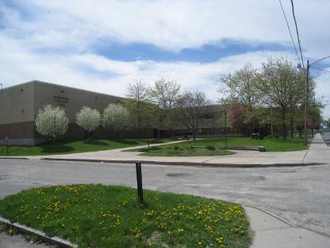

Prepared by:
Massachusetts Department of Public Health
Bureau of Environmental Health
Indoor Air Quality Program
August 2013

Background/Introduction
At the request of Mr. Cal Joppru, Pittsfield Public Health Department, the Massachusetts Department of Public Health (MDPH), Bureau of Environmental Health (BEH) provided assistance and consultation regarding indoor air quality (IAQ) concerns at the Morningside Community School (MCS), 100 Burbank Street, Pittsfield, Massachusetts. The request was prompted by a complaint from a parent regarding IAQ in the building. On May 10, 2013, a visit to conduct an assessment was made to the MCS by Michael Feeney, Director of BEH’s IAQ Program.
The school is a two-story brick building constructed in 1974. The building consists of large, open areas separated into “pods” by flexible barriers. Each pod is subdivided into eight classrooms. The building also has small rooms for specialized instruction, multipurpose rooms, a gymnasium, kitchen, cafeteria, library, music room, art room and office space. The classrooms on the first floor and all areas on the second floor of the MCS contain wall-to-wall carpet, original to building (i.e., > 30 years old). Windows throughout the building are openable; the window system is also original to the building. The roof is flat and was replaced in August of 2007.

Methods
Air tests for carbon monoxide, carbon dioxide, temperature and relative humidity were conducted with the TSI, Q-TRAK™, IAQ Monitor, Model 7565. Air tests for airborne particle matter with a diameter less than 2.5 micrometers were taken with the TSI, DUSTTRAK™ Aerosol Monitor Model 8520. BEH/IAQ staff also performed visual inspection of building materials for water damage and/or microbial growth.

Results
The school houses approximately 430 students in pre-kindergarten to grade 5 with approximately 90 staff members. Tests were taken during normal operations at the school and results appear in Table 1.

Discussion

Ventilation
It can be seen from Table 1 that carbon dioxide levels were above 800 parts per million (ppm) in 13 of 40 areas at the time of assessment, indicating adequate air exchange in two thirds of areas surveyed. It is important to note, however, that several classrooms had open windows and/or were empty/sparsely populated; each of these factors can result in reduced carbon dioxide levels. Carbon dioxide levels would be expected to increase with full occupancy and windows closed.
Mechanical ventilation is provided by a heating, ventilation and air-conditioning (HVAC) system that uses rooftop air-handling units (AHUs). The AHUs draw in fresh air through outdoor air intakes and distribute it via ceiling-mounted air diffusers. Return air is ducted back to AHUs via ceiling-mounted return vents. BEH/IAQ staff found one of the four rooftop AHUs deactivated at the time of assessment.
Several conditions of the HVAC system were observed suggesting a lack of proper maintenance and resultant poor filtration of air, including the following:
- Ceiling tiles around supply diffusers were soiled with dust/debris (Picture 1).
- The AHU in the second floor mechanical room had its filter doors open and was not operating (Picture 2).
- The interior of some AHUs on the roof could not be examined because the access panels were held in place with screws that were too corroded to be readily opened. This also indicates that the filters are unlikely to have been changed recently. Typically, filters in schools are changed two to four times a year.
- Gaps between filters were noted in the mechanical room AHU.
- Some AHUs appear to have wire mesh/metal filters in place of disposable filters (Picture 3). These filters were observed to be heavily caked with dirt, dust/debris, occluding them to a point where draw through the filter would be extremely limited.
In order for an AHU system to operate properly, air filters need to be changed and properly fitted. If the filter medium is not properly fitted, gaps can allow unfiltered air into the system and/or reduce the useful life of the unit. Disposable filters with an appropriate dust spot efficiency and similar cost can be installed. The dust spot efficiency is the ability of a filter to remove particulates of a certain diameter from air passing through the filter. Filters that have been determined by ASHRAE to meet its standard for a dust spot efficiency of a minimum of 40 percent would be sufficient to reduce many airborne particulates (Thornburg, D., 2000; MEHRC, 1997; ASHRAE, 1992). Pleated filters with a Minimum Efficiency Reporting Value (MERV) dust-spot efficiency of 9 or higher are recommended. Note that increasing filtration can reduce airflow (called pressure drop), which can subsequently reduce the efficiency of the unit due to increased resistance. Prior to any increase of filtration, each AHU should be evaluated by a ventilation engineer to ascertain whether it can maintain function with more efficient filters.
Note that the HVAC components are original equipment (i.e., > 30 years old). Function of equipment of this age is difficult to maintain, since compatible replacement parts are often unavailable. According to the American Society of Heating, Refrigeration and Air-Conditioning Engineers (ASHRAE), the service life for a unit heater, hot water or steam is 20 years, assuming routine maintenance of the equipment (ASHRAE, 1991). Despite attempts to maintain the units, the operational lifespan of the equipment has been exceeded. Maintaining the balance of fresh air to exhaust air will become more difficult as the equipment ages and as replacement parts become increasingly difficult to obtain.
BEH/IAQ staff found the exhaust vent on one AHU located within several feet of the fresh air intake. In this configuration, the exhaust may be drawn in by the air intake and pollutants can be distributed back into the building. The building code requires that pollutant sources must be ten feet away from and two feet above fresh air intakes (BOCA, 1993; SBBRS, 2011). An exhaust extension several feet above the fresh air intake may be needed to prevent exhaust entrainment.
At least half of the exhaust vents on the roof were deactivated at the time of assessment. The exhaust fan for the kitchen hood was found to be drawing minimally. The fan motor on the roof was producing a rattle noise, which can indicate worn/failing ball bearings in the motor or fan. Exhaust ventilation is necessary to remove water vapor and other normally occurring pollutants that accumulate within the building.
To maximize air exchange, the MDPH recommends that both supply and exhaust ventilation operate continuously during periods of occupancy. In order to have proper ventilation with a mechanical supply and exhaust system, the systems must be balanced to provide an adequate amount of fresh air to the interior of a room while removing stale air from the room. It is recommended that HVAC systems be re-balanced every five years to ensure adequate air systems function (SMACNA, 1994). The date of the last balancing was not available at the time of assessment.
Minimum design ventilation rates are mandated by the Massachusetts State Building Code (MSBC). Until 2011, the minimum ventilation rate in Massachusetts was higher for both occupied office spaces and general classrooms, with similar requirements for other occupied spaces (BOCA, 1993). The current version of the MSBC, promulgated in 2011 by the State Board of Building Regulations and Standards (SBBRS), adopted the 2009 International Mechanical Code (IMC) to set minimum ventilation rates. Please note that the MSBC is a minimum standard that is not health-based. At lower rates of cubic feet per minute (cfm) per occupant of fresh air, carbon dioxide levels would be expected to rise significantly. A ventilation rate of 20 cfm per occupant of fresh air provides optimal air exchange resulting in carbon dioxide levels at or below 800 ppm in the indoor environment in each area measured. MDPH recommends that carbon dioxide levels be maintained at 800 ppm or below. This is because most environmental and occupational health scientists involved with research on IAQ and health effects have documented significant increases in indoor air quality complaints and/or health effects when carbon dioxide levels rise above the MDPH guidelines of 800 ppm for schools, office buildings and other occupied spaces (Sundell et al., 2011). The ventilation must be on at all times that the room is occupied. Providing adequate fresh air ventilation with open windows and maintaining the temperature in the comfort range during the cold weather season is impractical. Mechanical ventilation is usually required to provide adequate fresh air ventilation.
Carbon dioxide is not a problem in and of itself. It is used as an indicator of the adequacy of the fresh air ventilation. As carbon dioxide levels rise, it indicates that the ventilating system is malfunctioning or the design occupancy of the room is being exceeded. When this happens, a buildup of common indoor air pollutants can occur, leading to discomfort or health complaints. The Occupational Safety and Health Administration (OSHA) standard for carbon dioxide is 5,000 parts per million parts of air (ppm). Workers may be exposed to this level for 40 hours/week, based on a time-weighted average (OSHA, 1997).
The MDPH uses a guideline of 800 ppm for publicly occupied buildings. A guideline of 600 ppm or less is preferred in schools due to the fact that the majority of occupants are young and considered to be a more sensitive population in the evaluation of environmental health status. Inadequate ventilation and/or elevated temperatures are major causes of complaints such as respiratory, eye, nose and throat irritation, lethargy and headache. For more information concerning carbon dioxide, please see Appendix A.
Temperature measurements ranged from 71° F to 80° F, which were mostly within the MDPH recommended comfort range in areas surveyed (Table 1). The MDPH recommends that indoor air temperatures be maintained in a range of 70° F to 78° F in order to provide for the comfort of building occupants. In many cases concerning indoor air quality, fluctuations of temperature in occupied spaces are typically experienced, even in a building with an adequate fresh air supply.
The relative humidity measured in the building ranged from 40 to 54 percent at the time of assessment, which was within the MDPH recommended comfort range (Table 1). The MDPH recommends a comfort range of 40 to 60 percent for indoor air relative humidity. It is important to note however, that relative humidity measured in many locations indoors exceeded the outdoor measurement of 46 percent (Table 1). This increase in relative humidity can indicate that the exhaust system is not operating sufficiently to remove normal indoor air pollutants (e.g., water vapor from respiration). Moisture removal is important since the sensation of heat conditions increases as relative humidity increases (the relationship between temperature and relative humidity is called the heat index). As indoor temperature rises, a higher relative humidity will make occupants feel hotter. If moisture is removed, the comfort of the individuals is increased. Removal of moisture from the air, however, can have some negative effects. The sensation of dryness and irritation is common in a low relative humidity environment. Low relative humidity is a very common problem during the heating season in the northeast part of the United States.

Microbial/Moisture Concerns
BEH/IAQ staff found no evidence of water damage attributable to roof or window leaks (such as stained ceiling tiles or damaged wall plaster). However, the ceiling tile system throughout the main floor was found to have significantly bowing tiles (Picture 4, Table 1). This suggests that there are chronic levels of water vapor/high relative humidity in the building.
One likely source of water vapor is the kitchen. As previously mentioned, the kitchen hood was found drawing minimal air (Picture 5), which would result in odors/water vapor accumulating in the building. Kitchen staff had portable fans operating to increase comfort (Picture 6). Use of fans in this manner directs water vapor into the cafeteria, which may result in moistened ceiling tiles. As noted previously, the rooftop exhaust fan connected to the kitchen hood was producing noise indicating worn or failed bearings, which would reduce the ability of the fan to draw air.
A water cooler was located over a carpeted area in an administration office. Water stains were found on the carpet around the cooler. Overflow of the water basin or spills that often occur can moisten carpeting, which can lead to mold growth. It is important that the catch basin of a water cooler be cleaned regularly as stagnant water can be a source of odors, and materials (i.e., dust) collected in the water can provide a medium for mold growth.
The US Environmental Protection Agency (US EPA) and the American Conference of Governmental Industrial Hygienists (ACGIH) recommend that porous materials, such as ceiling tiles and gypsum wallboard, be dried with fans and heating within 24 to 48 hours of becoming wet (US EPA, 2001; ACGIH, 1989). If not dried within this time frame, mold growth may occur. Once mold has colonized porous materials, they are difficult to clean and should be removed/discarded.
Plants were observed in some classrooms. Soil and drip pans can serve as a source of mold growth. Plants should be properly maintained and be equipped with drip pans. Plants should also be located away from the air stream of mechanical ventilation to prevent aerosolization of dirt, pollen or mold.
Standing water was observed on portions of the roof. Some roof drains are installed at a point higher than the level of the roof (Picture 7). The freezing and thawing of water during winter months can lead to roof leaks and subsequent water penetration into the interior of the building. Pooling water can also become stagnant, which can lead to mold and bacterial growth, and serve as a breeding ground for mosquitoes.

Other IAQ Evaluations
Indoor air quality can be negatively influenced by the presence of respiratory irritants, such as products of combustion. The process of combustion produces a number of pollutants. Common combustion emissions include carbon monoxide, carbon dioxide, water vapor and smoke (fine airborne particle material). Of these materials, exposure to carbon monoxide and particulate matter with a diameter of 2.5 micrometers (μm) or less (PM2.5) can produce immediate, acute health effects upon exposure. To determine whether combustion products were present in the school environment, BEH/IAQ staff obtained measurements for carbon monoxide and PM2.5.

Carbon Monoxide
Carbon monoxide is a by-product of incomplete combustion of organic matter (e.g., gasoline, wood and tobacco). Exposure to carbon monoxide can produce immediate and acute health affects. Several air quality standards have been established to address carbon monoxide and prevent symptoms from exposure to these substances. The MDPH established a corrective action level concerning carbon monoxide in ice skating rinks that use fossil-fueled ice resurfacing equipment. If an operator of an indoor ice rink measures a carbon monoxide level over 30 ppm, taken 20 minutes after resurfacing within a rink, that operator must take actions to reduce carbon monoxide levels (MDPH, 1997).
The American Society of Heating Refrigeration and Air-Conditioning Engineers (ASHRAE) has adopted the National Ambient Air Quality Standards (NAAQS) as one set of criteria for assessing indoor air quality and monitoring of fresh air introduced by HVAC systems (ASHRAE, 1989). The NAAQS are standards established by the US EPA to protect the public health from six criteria pollutants, including carbon monoxide and particulate matter (US EPA, 2006). As recommended by ASHRAE, pollutant levels of fresh air introduced to a building should not exceed the NAAQS levels (ASHRAE, 1989). The NAAQS were adopted by reference in the Building Officials & Code Administrators (BOCA) National Mechanical Code of 1993 (BOCA, 1993), which is now an HVAC standard included in the Massachusetts State Building Code (SBBRS, 2011). According to the NAAQS, carbon monoxide levels in outdoor air should not exceed 9 ppm in an eight-hour average (US EPA, 2006).
Carbon monoxide should not be present in a typical, indoor environment. If it is present, indoor carbon monoxide levels should be less than or equal to outdoor levels. On the day of assessment, outdoor carbon monoxide concentrations were non-detect (ND) (Table 1). Carbon monoxide levels measured in the school were also ND.
The kitchen uses a number of older gas-fueled cooking appliances, including the stove, which has continuously burning pilot lights. The kitchen is designed such that the products of combustion and cooking odors are to be drawn in and subsequently ejected from the building via a large exhaust hood. As noted previously, the exhaust hood was drawing weakly. While no carbon monoxide was measured during the assessment, the use of this type of stove would require that the exhaust hood operate continuously to vent pilot light emissions from the building.

Particulate Matter (PM2.5)
The US EPA has established NAAQS limits for exposure to particulate matter. Particulate matter (PM) is airborne solids that can be irritating to the eyes, nose and throat. The NAAQS originally established exposure limits to PM with a diameter of 10 μm or less (PM10). In 1997, US EPA established a more protective standard for fine airborne particulate matter with a diameter of 2.5 μm or less (PM2.5). The NAAQS has subsequently been revised, and PM2.5 levels were reduced. This more stringent PM2.5 standard requires outdoor air particle levels be maintained below 35 μg/m³ over a 24-hour average (US EPA, 2006). Although both the ASHRAE standard and BOCA Code adopted the PM10 standard for evaluating air quality, MDPH uses the more protective PM2.5 standard for evaluating airborne PM concentrations in the indoor environment.
Outdoor PM2.5 concentrations the day of assessment were measured at 10 μg/m³. PM2.5 levels measured inside ranged from 8 to 22 μg/m³ (Table 1). Both indoor and outdoor PM2.5 levels were below the NAAQS PM2.5 level of 35 μg/m³. Frequently, indoor air levels of particulates (including PM2.5) can be at higher levels than those measured outdoors. A number of mechanical devices and/or activities that occur in schools can generate particulate during normal operations. Sources of indoor airborne particulates may include but are not limited to particles generated during the operation of fan belts in the HVAC system, cooking in the cafeteria stoves and microwave ovens; use of photocopiers, fax machines and computer printing devices; operation of an ordinary vacuum cleaner and heavy foot traffic indoors.
During the course of the assessment, BEH/IAQ staff noted the strong odor of lawn mowing. Building maintenance staff were observed mowing the lawn adjacent to the building during school hours (Picture 8). Engine exhaust, pollen, dust, dirt and other pollutants from lawn mowing were likely entering the building through open windows. Lawn mowing can produce a significant number of respiratory irritants that may cause symptoms in individuals who have allergies or asthma.

Volatile Organic Compounds
Indoor air concentrations can be greatly impacted by the use of products containing volatile organic compounds (VOCs). VOCs are carbon-containing substances that have the ability to evaporate at room temperature. Frequently, exposure to low levels of total VOCs (TVOCs) may produce eye, nose, throat and/or respiratory irritation in some sensitive individuals. For example, chemicals evaporating from a paint can stored at room temperature would most likely contain VOCs. In an effort to identify materials that can potentially increase indoor VOC concentrations, BEH/IAQ staff examined classrooms for products containing these respiratory irritants.
Of note is the storage of musical instruments in the custodial storeroom (Picture 9). It was reported by school officials that students have ready access to the room to retrieve instruments. It is highly recommended that the custodial storeroom be secure and that students should not have access to this area used to store custodial cleaners and other chemicals.
The use of hand disinfectant dispensers in the school was observed and walls beneath were stained from the dispensers. Hand disinfectant contains ethyl alcohol and fragrances, both of which can be eye and respiratory irritants to some individuals (Betco Corporation, 2007; Birchwood Laboratories, Inc., 2007; B4 Brands by AMA, 2006; Georgia-Pacific Consumer Products, 2007). According to MDPH recommendations concerning the flu, protection from flu virus can be achieved by either washing your hands often with soap and water or using alcohol-based hand gel.
Several classrooms contained dry erase boards and related materials. Upon entering one classroom, a strong chemical odor was noted which was traced to an instructor utilizing dry erase board cleaner. Materials such as dry erase markers and dry erase board cleaners may contain VOCs, such as methyl isobutyl ketone, n-butyl acetate and butyl-cellusolve (Sanford, 1999), which can be irritating to the eyes, nose and throat.
Cleaning products were also found on countertops in some classrooms (Table 1). These products contain chemicals that can be irritating to the eyes, nose and throat of sensitive individuals. Cleaning products should be properly labeled and stored in an area inaccessible to children. In addition, a Material Safety Data Sheets (MSDS) should be available at a central location for each product in the event of an emergency. Consideration should be given to providing teaching staff with school issued cleaning products and supplies to prevent any potential for adverse chemical interactions between residues left from cleaners used by the facilities staff and those left by cleaners brought in by others.

Other Conditions
Other conditions that can affect indoor air quality were observed during the assessment. As previously mentioned, the classrooms on the first floor and all areas on the second floor contained wall-to-wall carpet installed in the 1970s. The average lifespan of carpeting is approximately 11 years; therefore, consideration should be given to planning for new flooring (Bishop, 2002). Disintegrating textiles can be a source of airborne particulates, which can be irritating to the eyes, nose and throat.
The gym locker rooms are not in use and have showers with open drains. In this condition, the floor drain traps are likely dry, which can allow for sewer gas to enter the locker room and be a source of irritating odors.
In several classrooms, items were observed on the floors, windowsills, tabletops, counters, bookcases and desks. The large number of items stored in classrooms provides a source for dusts to accumulate. These items (e.g., papers, folders, boxes) make it difficult for custodial staff to clean. Items should be relocated and/or be cleaned periodically to avoid excessive dust build up. In addition, these materials can accumulate on flat surfaces (e.g., desktops, shelving and carpets) in occupied areas and subsequently be re-aerosolized.
Fluorescent light bulbs were observed to be stored in a non-secure manner in the mechanical room (Picture 10). These bulbs contain mercury, and must be properly handled and stored in order to prevent breaks and mercury spills.

Conclusions/Recommendations
In view of the findings at the time of the assessment, the following recommendations are made for improving indoor air quality:
- Repair the kitchen hood. Operate the kitchen hood continuously to provide exhaust ventilation for stove pilot lights. Consideration should be given to replacing the stove with an automatic ignition system. Once the hood is repaired, refrain from using portable fans in the kitchen area.
- Repair all exhaust fans on the roof.
- Install properly-sized filters in AHUs. Change filters for air-handling equipment (e.g., univents, AHUs) as per the manufacturer’s instructions or more frequently if needed. Vacuum interior of units prior to activation to prevent the aerosolization of dirt, dust and particulates. Ensure filters fit flush in their racks with no spaces in between which might allow bypass of unfiltered air into the unit.
- Ensure all doors for AHUs close properly and that they can be opened for maintenance.
- Consider extending or moving exhaust vent away from fresh air intake of AHU to prevent entrainment of exhaust.
- Operate the HVAC system continuously during periods of occupancy to maximize air exchange.
- Clean air diffusers, exhaust/return vents and adjacent ceiling tiles periodically of accumulated dust/debris. If soiled ceiling tiles cannot be cleaned, they should be replaced.
- Use openable windows in conjunction with mechanical ventilation to facilitate air exchange. Care should be taken to ensure windows are properly closed at night and weekends to avoid the freezing of pipes and potential flooding.
- Consider adopting a balancing schedule of every 5 years for all mechanical ventilation systems, as recommended by ventilation industrial standards (SMACNA, 1994).
- Contact an HVAC engineering firm for an assessment of the ventilation system’s control system (e.g., controls, air intake louvers, thermostats). Based on the age, physical deterioration and availability of parts for ventilation components, such an evaluation is necessary to determine the operability and feasibility of repairing/replacing the equipment.
- Schedule lawn mowing after school hours.
- Seal floor drains in unused shower areas. Disconnect water service to showers and properly cut and cap plumbing as needed.
- For buildings in New England, periods of low relative humidity during the winter are often unavoidable. Therefore, scrupulous cleaning practices should be adopted to minimize common indoor air contaminants whose irritant effects can be enhanced when the relative humidity is low. To control for dusts, a high efficiency particulate arrestance (HEPA) filter equipped vacuum cleaner in conjunction with wet wiping of all surfaces is recommended. Avoid the use of feather dusters. Drinking water during the day can help ease some symptoms associated with a dry environment (throat and sinus irritations).
- Replace water-damaged ceiling tiles. Examine the area above and around these areas for mold growth. Disinfect areas of water leaks with an appropriate antimicrobial.
- Provide plants with drip pans and avoid over-watering. Examine drip pans periodically for mold growth. Disinfect with an appropriate antimicrobial where necessary.
- Clean debris from rooftop drains. Routinely inspect roof drains to prevent pooling of water. Reinstallation/adjustment of roof drains may be required for proper drainage.
- Clean carpeting annually or semi-annually in soiled high traffic areas as per the recommendations of the Institute of Inspection, Cleaning and Restoration Certification (IICRC). Copies of the IICRC fact sheet can be downloaded at: http://1.cleancareseminars.net/?page_id=185 (IICRC, 2005). Consider replacing carpet with non-porous flooring or carpet squares.
- Relocate or consider reducing the amount of materials stored in classrooms to allow for more thorough cleaning of classrooms. Clean items regularly with a wet cloth or sponge to prevent excessive dust build-up.
- Properly store and dispose of fluorescent light bulbs.
- Consider adopting the US EPA (2000) document, “Tools for Schools”, as an instrument for maintaining a good indoor air quality environment in the building. This document is available at: http://www.epa.gov/iaq/schools/index.html.
- Refer to resource manual and other related indoor air quality documents located on the MDPH’s website for further building-wide evaluations and advice on maintaining public buildings. These documents are available at: http://mass.gov/dph/iaq.

References
ACGIH. 1989. Guidelines for the Assessment of Bioaerosols in the Indoor Environment. American Conference of Governmental Industrial Hygienists, Cincinnati, OH.
ASHRAE. 1989. Ventilation for Acceptable Indoor Air Quality. American Society of Heating, Refrigeration and Air Conditioning Engineers. ANSI/ASHRAE 62-1989.
ASHRAE. 1991. ASHRAE Applications Handbook, Chapter 33 “Owning and Operating Costs”. American Society of Heating, Refrigeration and Air Conditioning Engineers, Atlanta, GA.
ASHRAE. 1992. Gravimetric and Dust-Spot Procedures for Testing Air-Cleaning Devices Used in General Ventilation for Removing Particulate Matter. American Society of Heating, Refrigeration and Air Conditioning Engineers. ANSI/ASHRAE 52.1-1992.
B4 Brands by AMA. 2006. Avant OriginalTM Instant Hand Sanitizer Materials Safety Data Sheet. B4 Brands by AMA., Nixa, MO.
BETCO Corporation. 2007. Clario Foaming Alcohol Instant Hand Sanitizer Material Safety Data Sheet. BETCO Corporation, Toledo, OH.
Birchwood Laboratories, Inc. 2007. Hand Wipe Take Alongs Materials Safety Data Sheet. Birchwood Laboratories, Inc., Eden Prairie, MN.
Bishop, J. & Institute of Inspection, Cleaning and Restoration Certification. 2002. A Life Cycle Cost Analysis for Floor Coverings in School Facilities.
BOCA. 1993. The BOCA National Mechanical Code/1993. 8th ed. Building Officials and Code Administrators International, Inc., Country Club Hill, IL.
Georgia-Pacific Consumer Products. 2007. Cormatic® High Capacity Instant Hand sanitizer Material Safety Data Sheet. Georgia- Pacific Consumer Products, Atlanta, GA.
IICRC. 2005. Carpet Cleaning FAQ 4 Institute of Inspection, Cleaning and Restoration Certification. Institute of Inspection Cleaning and Restoration, Vancouver, WA.
MDPH. 1997. Requirements to Maintain Air Quality in Indoor Skating Rinks (State Sanitary Code, Chapter XI). 105 CMR 675.000. Massachusetts Department of Public Health, Boston, MA.
MEHRC. 1997. Indoor Air Quality for HVAC Operators & Contractors Workbook. MidAtlantic Environmental Hygiene Resource Center, Philadelphia, PA.
OSHA. 1997. Limits for Air Contaminants. Occupational Safety and Health Administration. Code of Federal Regulations. 29 C.F.R 1910.1000 Table Z-1-A.
Sanford. 1999. Material Safety Data Sheet (MSDS No: 198-17). Expo Dry Erase Markers Bullet, Chisel, and Ultra Fine Tip. Sanford Corporation. Bellwood, IL.
SBBRS. 2011. Mechanical Ventilation. State Board of Building Regulations and Standards. Code of Massachusetts Regulations, 8th edition. 780 CMR 1209.0.
SMACNA. 1994. HVAC Systems Commissioning Manual. 1st ed. Sheet Metal and Air Conditioning Contractors’ National Association, Inc., Chantilly, VA.
Sundell. 2011. Sundell, J., H. Levin, W. W. Nazaroff, W. S. Cain, W. J. Fisk, D. T. Grimsrud, F. Gyntelberg, Y. Li, A. K. Persily, A. C. Pickering, J. M. Samet, J. D. Spengler, S. T. Taylor, and C. J. Weschler. Ventilation rates and health: multidisciplinary review of the scientific literature. Indoor Air, Volume 21: pp 191–204.
Thornburg, D. 2000. Filter Selection: a Standard Solution. Engineering Systems 17:6 pp. 74-80.
US EPA. 2000. Tools for Schools. Office of Air and Radiation, Office of Radiation and Indoor Air, Indoor Environments Division (6609J). EPA 402-K-95-001, Second Edition. http://www.epa.gov/iaq/schools/actionkit.html.
US EPA. 2001. “Mold Remediation in Schools and Commercial Buildings”. Office of Air and Radiation, Indoor Environments Division, Washington, DC. EPA 402-K-01-001. March 2001. Available at: http://www.epa.gov/mold/mold_remediation.html.
US EPA. 2006. National Ambient Air Quality Standards (NAAQS). US Environmental Protection Agency, Office of Air Quality Planning and Standards, Washington, DC. http://www.epa.gov/air/criteria.html.
Picture 1

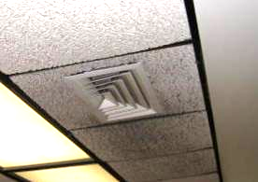

Soiling of ceiling tiles around fresh air supply diffuser

Picture 2

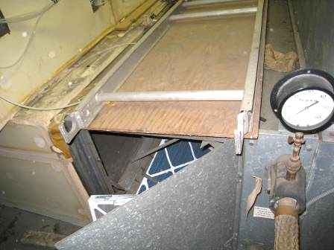

AHU with access doors open

Picture 3

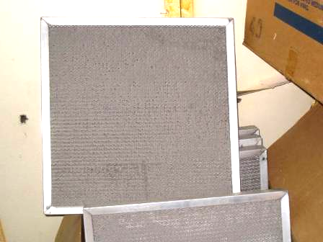

Wire mesh filters, note occlusion with dust/debris

Picture 4

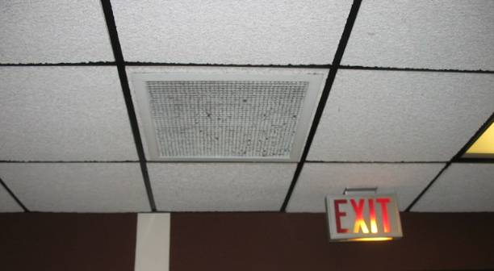

Bowing ceiling tiles

Picture 5

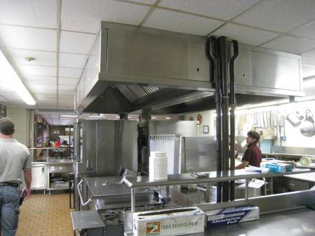

Kitchen hood

Picture 6

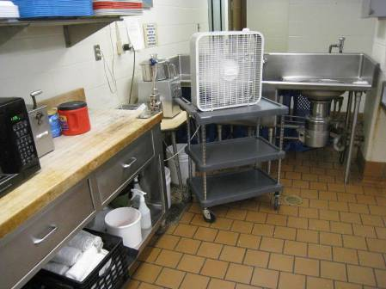

Portable fan in the kitchen

Picture 7

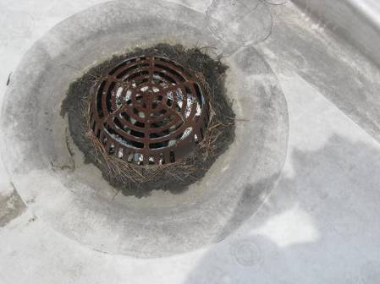

Roof drain installed at a point higher than level of roof

Picture 8

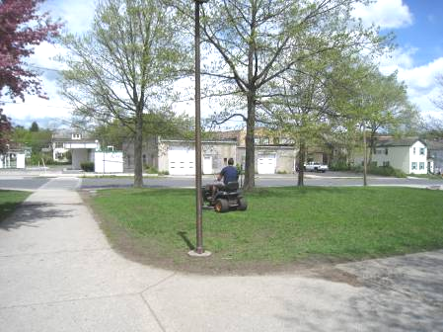

School staff mowing lawn during school hours

Picture 9

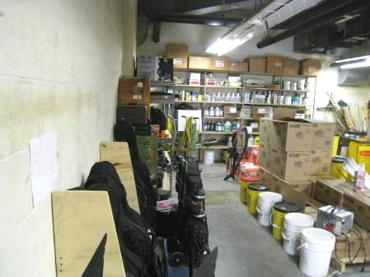

Musical instruments in the custodial storeroom

Picture 10

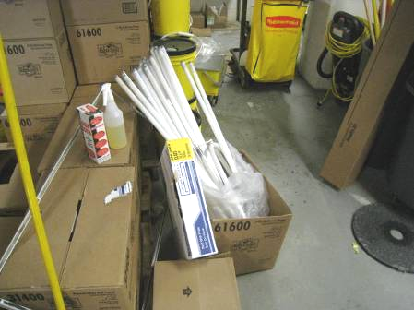

Freestanding fluorescent lights in storeroom
Location/ Room | Carbon Dioxide (ppm) | Carbon Monoxide (ppm) | Temp (°F) | Relative Humidity (%) | PM2.5  (µg/m³) | Occupants  in Room | Windows Openable | Ventilation |  | Remarks
 |  |  |  |  |  |  |  | Supply | Exhaust | Remarks
Background | 394 | ND | 75 | 46 | 10
Cafeteria | 719 | ND | 76 | 54 | 15 | 50+ | Y open | Y |  | Dry drains, CT-sag
Community room | 602 | ND | 75 | 53 | 16 | 0 | N | N | Y off | DO
Custodian | 591 | ND | 78 | 47 | 10 | 0 | N | N | Y off | Instruments, bulbs – chemicals, DO
Family Center | 861 | ND | 78 | 47 | 17 | 0 | N | Y | Y
Forest 1 | 760 | ND | 76 | 50 | 8 | 1 | Y | Y | Y | CT-sag, WB
Forest 2 | 784 | ND | 76 | 50 | 9 | 5 | Y | Y | Y | CT-sag, WB
Forest 3 | 815 | ND | 77 | 50 | 9 | 1 | Y | Y | Y | CT-sag, WB
Forest 4 | 772 | ND | 77 | 45 | 8 | 1 | Y | Y | Y | CT-sag
Gym | 805 | ND | 74 | 50 | 22 | 30+ |  | Y
Health | 1055 | ND | 79 | 47 | 12 | 2 | N | N | Y | Ajar CT
Library | 442 | ND | 76 | 44 | 9 | 1 | Y | Y | Y
Lincoln 1 | 690 | ND | 78 | 47 | 9 |  |  |  |  | PF
Lincoln 2 | 678 | ND | 77 | 47 | 9 | 20 | Y open | Y | Y
Lincoln 3 | 631 | ND | 77 | 48 | 9 |  | Y open | Y | Y
Lincoln 4 | 689 | ND | 77 | 48 | 8 | 15 | Y open | Y | Y
Lunchroom | 572 | ND | 80 | 44 | 8 | 3 | N | Y | Y
Maple 1 | 591 | ND | 77 | 45 | 8 | 21 | Y open | Y on | Y
Maple 2 | 719 | ND | 77 | 47 | 8 | 23 | Y open | Y on | Y
Maple 3 | 632 | ND | 77 | 47 | 10 | 10 | Y open | Y on | Y
Maple 4 | 739 | ND | 77 | 48 | 9 | 10 | Y open | Y on | Y
Music | 574 | ND | 76 | 40 | 9 | 0 | N | N | N
Music office |  |  |  |  |  |  |  |  |  | 2 WD-CT
Oak 1 | 576 | ND | 75 | 48 | 8 | 7 | Y open | Y | Y | WB
Oak 2 | 470 | ND | 75 | 46 | 8 | 22 | Y open | Y | Y | WB
Oak 3 | 492 | ND | 75 | 46 | 9 | 21 | Y open | Y | Y | WB
Oak 4 | 509 | ND | 75 | 46 | 8 | 24 | Y open | Y | Y | WB
Orchard 1 |  | ND | 78 | 44 | 9 | 0 | Y open | Y | Y
Orchard 2 | 588 | ND | 78 | 45 | 9 | 9 | Y open | Y | Y | WB
Orchard 3 | 619 | ND | 76 | 47 | 8 | 8 | Y open | Y | Y | WB
Orchard 4 | 563 | ND | 77 | 46 | 9 | 8 | Y open | Y | Y | WB
Parent Child Room | 768 | ND | 80 | 46 | 9 | 1 | N | Y | Y | PF, DO
Pine 1 | 824 | ND | 76 | 53 | 9 | 21 | Y open | Y | Y | CT-sag, WB
Pine 2 | 810 | ND | 76 | 52 | 9 | 21 | Y open | Y | Y | CT-sag, WB
Pine 3 | 759 | ND | 77 | 51 | 9 | 21 | Y open | Y | Y | CT-sag, WB
Pine 4 | 825 | ND | 71 | 51 | 9 | 20 | Y open | Y | Y | CT-sag, WB
Teacher’s Lounge | 494 | ND | 79 | 44 | 8 | 4 | Y open | Y | Y
Tyler 1 | 860 | ND | 77 | 52 | 10 | 6 | Y | Y | Y | TB, WB
Tyler 3 | 822 | ND | 79 | 49 | 8 | 1 | Y | Y | Y | WB, plants
Willow 1 | 954 | ND | 77 | 53 | 20 | 23 | Y open | Y | Y | CT-sag
Willow 2 | 858 | ND | 77 | 52 | 19 | 20 | Y open | Y | Y | TB, CT-sag
Willow 3 | 815 | ND | 78 | 50 | 14 | 24 | Y open | Y | Y | TB, CT-sag
Willow 4 | 864 | ND | 77 | 51 | 11 | 19 | Y open | Y | Y | WB, CT-sag

The service life is the median time during which a particular system or component of …[an HVAC]… system remains in its original service application and then is replaced. Replacement may occur for any reason, including, but not limited to, failure, general obsolescence, reduced reliability, excessive maintenance cost, and changed system requirements due to such influences as building characteristics or energy prices (ASHRAE, 1991).

