INDOOR AIR QUALITY ASSESSMENT

Morningside Community School
100 Burbank Street
Pittsfield, Massachusetts

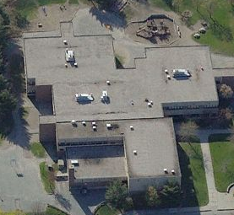

Prepared by:
Massachusetts Department of Public Health
Bureau of Environmental Health
Indoor Air Quality Program
August 2014

Background/Introduction
At the request of Ms. Gail Armstrong, Director of the Pittsfield Health Department, the Massachusetts Department of Public Health (MDPH), Bureau of Environmental Health (BEH) provided assistance and consultation regarding indoor air quality (IAQ) concerns at the Morningside Community School (MCS), 100 Burbank Street, Pittsfield, Massachusetts. The request was prompted by general air quality concerns in the building. On June 6, 2014, a visit to conduct an assessment was made to the MCS by Michael Feeney, Director of BEH’s IAQ Program and Kathleen Gilmore, Environmental Analyst/Regional Inspector for the BEH/IAQ Program.
The school is a two-story brick building constructed in 1974. The building consists of large, open classroom areas separated into “pods” by flexible barriers. Each pod is subdivided into eight classrooms. The building also has rooms for specialized instruction, multipurpose rooms, a gymnasium, kitchen, cafeteria, library, music room, art room and office space. The classrooms on the first floor and all areas on the second floor of the MCS contain wall-to-wall carpet, original to building (i.e., > 30 years old). Windows throughout the building are openable; the window system is also original to the building. The roof is flat and was replaced in August of 2007.
The BEH/IAQ program had previously visited the MCS on June 23, 2008 and May 10, 2013 to perform assessments to address concerns regarding indoor air conditions in the building. Reports were generated following both assessments and the documents are available at: www.mass.gov/dph/iaq or on request. There were numerous recommendations made following the MDPH 2013 assessment to improve IAQ conditions in the building. Appendix A contains a summary of actions taken by the MCS in response to recommendations made in that report.

Methods
Air tests for carbon monoxide, carbon dioxide, temperature and relative humidity were conducted with the TSI, Q-TRAK™, IAQ Monitor, Model 7565. Air tests for airborne particle matter with a diameter less than 2.5 micrometers were taken with the TSI, DUSTTRAK™ Aerosol Monitor Model 8520. BEH/IAQ staff also performed visual inspection of building materials for water damage and/or microbial growth.

Results
The school houses approximately 430 students in pre-kindergarten to grade 5 with approximately 90 staff members. Tests were taken during normal operations at the school and results appear in Table 1.

Discussion

Ventilation
It can be seen from Table 1 that carbon dioxide levels were below 800 parts per million (ppm) in 45 of 49 areas at the time of assessment, indicating adequate air exchange in most areas surveyed. It is important to note, however, that several classrooms had open windows and/or were empty/sparsely populated; each of these factors can result in reduced carbon dioxide levels. Carbon dioxide levels would be expected to increase with full occupancy and windows closed.
Mechanical ventilation is provided by three roof-top air-handling units (AHUs) (Picture 1). A fourth AHU located in a mechanical room provides ventilation for common areas (i.e. library, meeting rooms, administrative offices) of the building. The AHUs draw in fresh air through air intakes and distribute it via ceiling-mounted air diffusers (Picture 2). Return air is ducted back to AHUs via ceiling-mounted return vents (Picture 3). BEH/IAQ staff observed that one roof-top AHU was deactivated/non-functioning at the time of the assessment. Facilities staff reported that a HVAC firm had been contacted to assess the AHU and make repairs as needed.
As mentioned in the MDPH 2013 report, an exhaust vent was located within several feet of the fresh air intake (Picture 4). In this configuration, exhaust may be drawn in by the air intake and pollutants can be distributed back into the building. The building code requires that pollutant sources must be ten feet away from and two feet above fresh air intakes (BOCA, 1993; SBBRS, 2011). An exhaust extension several feet above the fresh air intake may be needed to prevent exhaust entrainment.
During the MDPH 2013 visit, BEH/IAQ had observed several conditions of the HVAC system which suggested a lack of proper maintenance resulting in poor filtration of air. Actions were taken to remediate these conditions following the assessment and are noted in Appendix A.
In 2013, BEH/IAQ staff also observed that the exhaust hood for the gas–fueled stove in the kitchen was not drawing air and that the associated roof-top exhaust vent was not functioning. Without adequate supply and exhaust ventilation, odors, moisture, excess heat and environmental pollutants can accumulate, leading to indoor air/comfort complaints. At the time of the June 6, 2014 visit, the exhaust hood and the attached roof-top vent had been repaired and it was reported that the exhaust hood operates continuously to vent pilot light emissions from the building.
The HVAC components are original equipment (i.e., > 30 years old). Function of equipment of this age is difficult to maintain, since compatible replacement parts are often unavailable. According to the American Society of Heating, Refrigeration and Air-Conditioning Engineers (ASHRAE), the service life for a unit heater, hot water or steam is 20 years, assuming routine maintenance of the equipment (ASHRAE, 1991). Despite attempts to maintain the units, the operational lifespan of the equipment has been exceeded. Maintaining the balance of fresh air to exhaust air will become more difficult as the equipment ages and as replacement parts become increasingly difficult to obtain.
To maximize air exchange, the MDPH recommends that both supply and exhaust ventilation operate continuously during periods of occupancy. In order to have proper ventilation with a mechanical supply and exhaust system, the systems must be balanced to provide an adequate amount of fresh air to the interior of a room while removing stale air from the room. It is recommended that HVAC systems be re-balanced every five years to ensure adequate air systems function (SMACNA, 1994). The date of the last balancing was not available at the time of assessment.
Minimum design ventilation rates are mandated by the Massachusetts State Building Code (MSBC). Until 2011, the minimum ventilation rate in Massachusetts was higher for both occupied office spaces and general classrooms, with similar requirements for other occupied spaces (BOCA, 1993). The current version of the MSBC, promulgated in 2011 by the State Board of Building Regulations and Standards (SBBRS), adopted the 2009 International Mechanical Code (IMC) to set minimum ventilation rates. Please note that the MSBC is a minimum standard that is not health-based. At lower rates of cubic feet per minute (cfm) per occupant of fresh air, carbon dioxide levels would be expected to rise significantly. A ventilation rate of 20 cfm per occupant of fresh air provides optimal air exchange resulting in carbon dioxide levels at or below 800 ppm in the indoor environment in each area measured. MDPH recommends that carbon dioxide levels be maintained at 800 ppm or below. This is because most environmental and occupational health scientists involved with research on IAQ and health effects have documented significant increases in indoor air quality complaints and/or health effects when carbon dioxide levels rise above the MDPH guidelines of 800 ppm for schools, office buildings and other occupied spaces (Sundell et al., 2011). The ventilation must be on at all times that the room is occupied. Providing adequate fresh air ventilation with open windows and maintaining the temperature in the comfort range during the cold weather season is impractical. Mechanical ventilation is usually required to provide adequate fresh air ventilation.
Carbon dioxide is not a problem in and of itself. It is used as an indicator of the adequacy of the fresh air ventilation. As carbon dioxide levels rise, it indicates that the ventilating system is malfunctioning or the design occupancy of the room is being exceeded. When this happens, a buildup of common indoor air pollutants can occur, leading to discomfort or health complaints. The Occupational Safety and Health Administration (OSHA) standard for carbon dioxide is 5,000 parts per million parts of air (ppm). Workers may be exposed to this level for 40 hours/week, based on a time-weighted average (OSHA, 1997).
The MDPH uses a guideline of 800 ppm for publicly occupied buildings. A guideline of 600 ppm or less is preferred in schools due to the fact that the majority of occupants are young and considered to be a more sensitive population in the evaluation of environmental health status. Inadequate ventilation and/or elevated temperatures are major causes of complaints such as respiratory, eye, nose and throat irritation, lethargy and headaches. For more information concerning carbon dioxide, please see Appendix B.
Temperature readings during the assessment ranged from 74° F to 77° F, which were within the MDPH recommended comfort range (Table 1). The MDPH recommends that indoor air temperatures be maintained in a range of 70° F to 78° F in order to provide for the comfort of building occupants. In many cases concerning indoor air quality, fluctuations of temperature in occupied spaces are typically experienced, even in a building with an adequate fresh air supply.
The relative humidity at the time of the assessment ranged from 43 to 49 percent (Table 1), which was within the MDPH recommended comfort range. The MDPH recommends a comfort range of 40 to 60 percent for indoor air relative humidity. Relative humidity levels in the building would be expected to drop during the winter months due to heating. The sensation of dryness and irritation is common in a low relative humidity environment. Low relative humidity is a very common problem during the heating season in the northeast part of the United States.

Microbial/Moisture Concerns
Several rooms in the building had water-damaged ceiling tiles (Table 1; Picture 5), which may stem from roof leaks or plumbing leaks. If repeatedly moistened, ceiling tiles can be a medium on which mold can grow. Water-damaged tiles should be replaced after a water leak is discovered and repaired.
The US Environmental Protection Agency (US EPA) and the American Conference of Governmental Industrial Hygienists (ACGIH) recommend that porous materials, such as ceiling tiles and gypsum wallboard, be dried with fans and heating within 24 to 48 hours of becoming wet (US EPA, 2001; ACGIH, 1989). If not dried within this time frame, mold growth may occur. Once mold has colonized porous materials, they are difficult to clean and should be removed/discarded.
Plants were observed in a few classrooms. Soil and drip pans can serve as a source of mold growth. Plants should be properly maintained and be equipped with drip pans. Plants should also be located away from the air stream of mechanical ventilation to prevent aerosolization of dirt, pollen or mold.

Other IAQ Evaluations
Indoor air quality can be negatively influenced by the presence of respiratory irritants, such as products of combustion. The process of combustion produces a number of pollutants. Common combustion emissions include carbon monoxide, carbon dioxide, water vapor and smoke (fine airborne particle material). Of these materials, exposure to carbon monoxide and particulate matter with a diameter of 2.5 micrometers (μm) or less (PM2.5) can produce immediate, acute health effects upon exposure. To determine whether combustion products were present in the school environment, BEH/IAQ staff obtained measurements for carbon monoxide and PM2.5.

Carbon Monoxide
Carbon monoxide is a by-product of incomplete combustion of organic matter (e.g., gasoline, wood and tobacco). Exposure to carbon monoxide can produce immediate and acute health affects. Several air quality standards have been established to address carbon monoxide and prevent symptoms from exposure to these substances. The MDPH established a corrective action level concerning carbon monoxide in ice skating rinks that use fossil-fueled ice resurfacing equipment. If an operator of an indoor ice rink measures a carbon monoxide level over 30 ppm, taken 20 minutes after resurfacing within a rink, that operator must take actions to reduce carbon monoxide levels (MDPH, 1997).
The American Society of Heating Refrigeration and Air-Conditioning Engineers (ASHRAE) has adopted the National Ambient Air Quality Standards (NAAQS) as one set of criteria for assessing indoor air quality and monitoring of fresh air introduced by HVAC systems (ASHRAE, 1989). The NAAQS are standards established by the US EPA to protect the public health from six criteria pollutants, including carbon monoxide and particulate matter (US EPA, 2006). As recommended by ASHRAE, pollutant levels of fresh air introduced to a building should not exceed the NAAQS levels (ASHRAE, 1989). The NAAQS were adopted by reference in the Building Officials & Code Administrators (BOCA) National Mechanical Code of 1993 (BOCA, 1993), which is now an HVAC standard included in the Massachusetts State Building Code (SBBRS, 2011). According to the NAAQS, carbon monoxide levels in outdoor air should not exceed 9 ppm in an eight-hour average (US EPA, 2006).
Carbon monoxide should not be present in a typical, indoor environment. If it is present, indoor carbon monoxide levels should be less than or equal to outdoor levels. On the day of assessment, outdoor carbon monoxide concentrations were non-detect (ND) (Table 1). Carbon monoxide levels measured in the school were also ND.

Particulate Matter (PM2.5)
The US EPA has established NAAQS limits for exposure to particulate matter. Particulate matter (PM) is airborne solids that can be irritating to the eyes, nose and throat. The NAAQS originally established exposure limits to PM with a diameter of 10 μm or less (PM10). In 1997, US EPA established a more protective standard for fine airborne particulate matter with a diameter of 2.5 μm or less (PM2.5). The NAAQS has subsequently been revised, and PM2.5 levels were reduced. This more stringent PM2.5 standard requires outdoor air particle levels be maintained below 35 μg/m³ over a 24-hour average (US EPA, 2006). Although both the ASHRAE standard and BOCA Code adopted the PM10 standard for evaluating air quality, MDPH uses the more protective PM2.5 standard for evaluating airborne PM concentrations in the indoor environment.
Outdoor PM2.5 concentrations the day of assessment were measured at 15 μg/m³. PM2.5 levels measured inside ranged from 2 to 10 μg/m³ (Table 1). Both indoor and outdoor PM2.5 levels were below the NAAQS PM2.5 level of 35 μg/m³. Frequently, indoor air levels of particulates (including PM2.5) can be at higher levels than those measured outdoors. A number of mechanical devices and/or activities that occur in schools can generate particulate during normal operations. Sources of indoor airborne particulates may include but are not limited to particles generated during the operation of fan belts in the HVAC system, cooking in the cafeteria stoves and microwave ovens; use of photocopiers, fax machines and computer printing devices; operation of an ordinary vacuum cleaner and heavy foot traffic indoors.

Volatile Organic Compounds
Indoor air concentrations can be greatly impacted by the use of products containing volatile organic compounds (VOCs). VOCs are carbon-containing substances that have the ability to evaporate at room temperature. Frequently, exposure to low levels of total VOCs (TVOCs) may produce eye, nose, throat and/or respiratory irritation in some sensitive individuals. For example, chemicals evaporating from a paint can stored at room temperature would most likely contain VOCs. In an effort to identify materials that can potentially increase indoor VOC concentrations, BEH/IAQ staff examined classrooms for products containing these respiratory irritants.
Numerous classrooms contained dry erase boards and related materials. In some areas, dry erase debris was accumulated on the marker tray. Materials such as dry erase markers and dry erase board cleaners may contain VOCs, such as methyl isobutyl ketone, n-butyl acetate and butyl-cellusolve (Sanford, 1999), which can be irritating to the eyes, nose and throat.
Hand sanitizer was observed in some areas (Table 1, Picture 6). Hand sanitizer products may contain ethyl alcohol and/or isopropyl alcohol which are highly volatile and may be irritating to the eyes and nose, and may also contain fragrances to which some people may be sensitive.
There are a photocopiers and a laminator in the building. Photocopiers can be sources of pollutants such as VOCs, ozone, heat and odors, particularly if the equipment is older and in frequent use. Both VOCs and ozone are respiratory irritants (Schmidt Etkin, 1992). Photocopiers and laminators should be kept in well ventilated rooms, and should be located near windows or exhaust vents.

Other Conditions
Other conditions that can affect indoor air quality were observed during the assessment. As mentioned in the MDPH 2013 report, the gym locker rooms are not in use and have showers and other floor drains. These drains are typically designed with traps to prevent sewer odors/gases from penetrating into occupied spaces. When water is poured into a trap, an air tight seal is created by the water in the U-bend section of the pipe. In order to maintain the watertight seal, water should be poured down the drain routinely (i.e. every other day) during the heating season or the drains should be sealed during the heating season. At the time of the 2014 assessment, the floor drains were open/not sealed and it was not known if a schedule was in place to regularly fill the drains with water. As the drains are no longer needed they should be permanently capped/sealed.
Also of note was a musty odor in a room adjacent to the library/media center. The odor was traced to the mechanical room with AHUs that service the library and other adjacent rooms. The AHUs provide air-conditioning during warm months. AHUs that provide air-conditioning require the installation of condensation drains to prevent water build up inside the casing and ductwork. The condensation drains for these units terminate above a floor drain that is connected to the building drainage system. Drains are usually designed with traps in order to prevent sewer odors/gases from penetrating into occupied spaces. When water enters a drain, the trap fills and forms a watertight seal. Without a periodic input of water (e.g., every other day), traps can dry, which breaking the watertight seal. Without traps wet, odors or other material can travel up the drain and enter the occupied space. The floor drain and condensation drain have traps. In the heating season, AHUs do not produce condensation, which dries the traps of the condensation drains. The AHUs were found to be drawing air into each unit through the condensation drains. This occurs because no water is produced by the AHUs to create a watertight seal in the condensation drain. With each condensation drain acting as a vacuum, odors from the floor drain without a water-sealed trap can draw into the AHUs and distributed to occupied areas in the building.
BEH/IAQ staff observed accumulated dust/debris on air diffusers, exhaust vents and personal fans (Picture 7). If exhaust/return vents are not functioning properly, backdrafting can occur, which can re-aerosolize accumulated dust particles. Re-activated supply vents can re-aerosolize dust accumulated on louvers and adjacent surfaces causing further irritation. Diffusers, vents and fans should be cleaned periodically in order to prevent dust/debris from being aerosolized and redistributed throughout the room.
In several classrooms, items were observed on the floors, windowsills, tabletops, counters, bookcases and desks. The large number of items stored in classrooms provides a source for dusts to accumulate. These items (e.g., papers, folders, boxes) make it difficult for custodial staff to clean. Items should be relocated and/or be cleaned periodically to avoid excessive dust build up. In addition, these materials can accumulate on flat surfaces (e.g., desktops, shelving and carpets) in occupied areas and subsequently be re-aerosolized.
BEH/IAQ staff observed exterior doors that had gaps and were ill-fitting and in some cases the weather-stripping had become worn or the door did not seal tightly allowing light to be seen through the gaps. These gaps can allow water, drafts, particulates and pests into the building. All exterior doors should be checked for light penetration, and repaired/replaced.

Conclusions/Recommendations
In view of the findings at the time of the assessment, the following recommendations are made for improving indoor air quality:
- Implement all the recommendations made in the previous May 10, 2013 MDPH assessment (Appendix A).
- Facilities management should work with an HVAC contractor to assess the non-functioning/deactivated roof-top AHU and make repairs as needed.
- Ensure that the media center mechanical room floor drain has water poured into in to maintain the seal of its trap regularly.
- Consider extending or moving exhaust vent away from fresh air intake of AHU to prevent entrainment of exhaust.
- Operate the HVAC system continuously during periods of occupancy to maximize air exchange.
- Use openable windows in conjunction with mechanical ventilation to facilitate air exchange. Care should be taken to ensure windows are properly closed at night and weekends to avoid the freezing of pipes and potential flooding.
- Consider adopting a balancing schedule of every 5 years for all mechanical ventilation systems, as recommended by ventilation industrial standards (SMACNA, 1994).
- For buildings in New England, periods of low relative humidity during the winter are often unavoidable. Therefore, scrupulous cleaning practices should be adopted to minimize common indoor air contaminants whose irritant effects can be enhanced when the relative humidity is low. To control for dusts, a high efficiency particulate arrestance (HEPA) filter equipped vacuum cleaner in conjunction with wet wiping of all surfaces is recommended. Avoid the use of feather dusters. Drinking water during the day can help ease some symptoms associated with a dry environment (throat and sinus irritations).
- Replace water-damaged ceiling tiles. Examine the area above and around these areas for mold growth. Disinfect areas of water leaks with an appropriate antimicrobial.
- Seal/cap floor drains in unused shower areas.
- Provide plants with drip pans and avoid over-watering. Examine drip pans periodically for mold growth. Disinfect with an appropriate antimicrobial where necessary.
- Provide plants with drip pans and avoid over-watering. Examine drip pans periodically for mold growth. Disinfect with an appropriate antimicrobial where necessary.
- Clean dry-erase marker trays of accumulated dust and debris regularly using a damp cloth.
- Clean air diffusers, exhaust/return vents and adjacent ceiling tiles periodically of accumulated dust/debris. If soiled ceiling tiles cannot be cleaned, they should be replaced.
- Relocate or consider reducing the amount of materials stored in classrooms to allow for more thorough cleaning of classrooms. Clean items regularly with a wet cloth or sponge to prevent excessive dust build-up.
- Repair gaps around the exterior doors with weather-stripping/sealant to prevent drafts, water penetration, and pest entry. Check for tightness by monitoring for light and/or drafts around doors.
- Consider adopting the US EPA (2000) document, “Tools for Schools”, as an instrument for maintaining a good indoor air quality environment in the building. This document is available at: http://www.epa.gov/iaq/schools/index.html.
- Refer to resource manual and other related indoor air quality documents located on the MDPH’s website for further building-wide evaluations and advice on maintaining public buildings. These documents are available at: http://mass.gov/dph/iaq.

References
ACGIH. 1989. Guidelines for the Assessment of Bioaerosols in the Indoor Environment. American Conference of Governmental Industrial Hygienists, Cincinnati, OH.
ASHRAE. 1989. Ventilation for Acceptable Indoor Air Quality. American Society of Heating, Refrigeration and Air Conditioning Engineers. ANSI/ASHRAE 62-1989.
ASHRAE. 1991. ASHRAE Applications Handbook, Chapter 33 “Owning and Operating Costs”. American Society of Heating, Refrigeration and Air Conditioning Engineers, Atlanta, GA.
BOCA. 1993. The BOCA National Mechanical Code/1993. 8th ed. Building Officials and Code Administrators International, Inc., Country Club Hill, IL.
MDPH. 1997. Requirements to Maintain Air Quality in Indoor Skating Rinks (State Sanitary Code, Chapter XI). 105 CMR 675.000. Massachusetts Department of Public Health, Boston, MA.
OSHA. 1997. Limits for Air Contaminants. Occupational Safety and Health Administration. Code of Federal Regulations. 29 C.F.R 1910.1000 Table Z-1-A.
Sanford. 1999. Material Safety Data Sheet (MSDS No: 198-17). Expo® Dry Erase Markers Bullet, Chisel, and Ultra Fine Tip. Sanford Corporation. Bellwood, IL.
SBBRS. 2011. Mechanical Ventilation. State Board of Building Regulations and Standards. Code of Massachusetts Regulations, 8th edition. 780 CMR 1209.0.
Schmidt Etkin, D. 1992. Office Furnishings/Equipment & IAQ Health Impacts, Prevention & Mitigation. Cutter Information Corporation, Indoor Air Quality Update, Arlington, MA.
SMACNA. 1994. HVAC Systems Commissioning Manual. 1st ed. Sheet Metal and Air Conditioning Contractors’ National Association, Inc., Chantilly, VA.
Sundell. 2011. Sundell, J., H. Levin, W. W. Nazaroff, W. S. Cain, W. J. Fisk, D. T. Grimsrud, F. Gyntelberg, Y. Li, A. K. Persily, A. C. Pickering, J. M. Samet, J. D. Spengler, S. T. Taylor, and C. J. Weschler. Ventilation rates and health: multidisciplinary review of the scientific literature. Indoor Air, Volume 21: pp 191–204.
US EPA. 2000. Tools for Schools. Office of Air and Radiation, Office of Radiation and Indoor Air, Indoor Environments Division (6609J). EPA 402-K-95-001, Second Edition. http://www.epa.gov/iaq/schools/actionkit.html.
US EPA. 2001. “Mold Remediation in Schools and Commercial Buildings”. Office of Air and Radiation, Indoor Environments Division, Washington, DC. EPA 402-K-01-001. March 2001. Available at: http://www.epa.gov/mold/mold_remediation.html.
US EPA. 2006. National Ambient Air Quality Standards (NAAQS). US Environmental Protection Agency, Office of Air Quality Planning and Standards, Washington, DC. http://www.epa.gov/air/criteria.html.
Picture 1

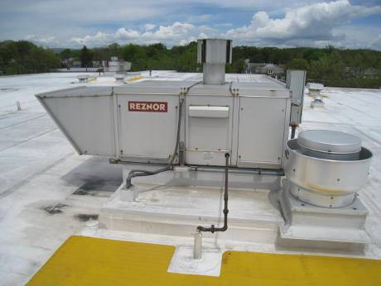

Roof-top AHU

Picture 2

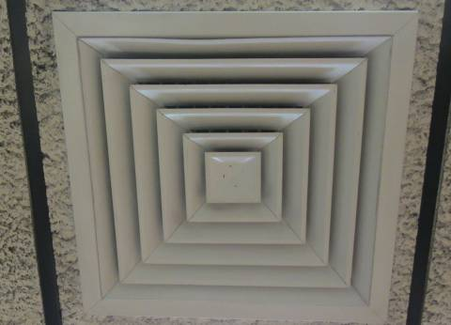

Ceiling-mounted supply diffuser
Picture 3

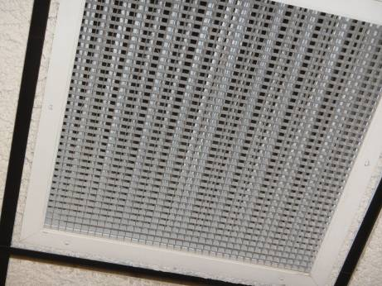

Ceiling-mounted return vent

Picture 4

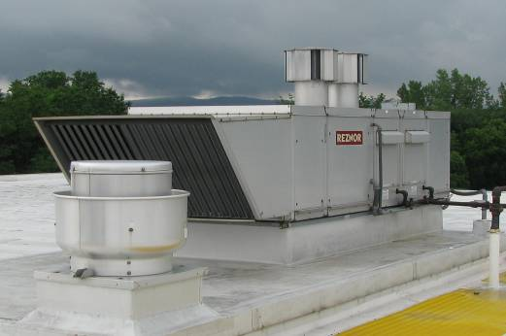

Exhaust vent in close proximity to AHU fresh air intake

Picture 5

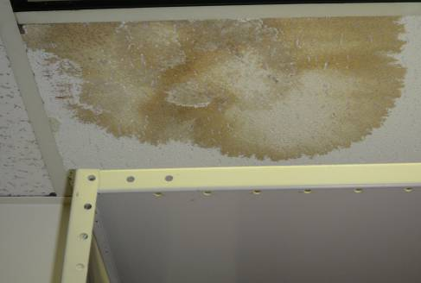

Water-damaged ceiling tile

Picture 6

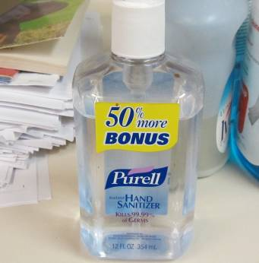

Hand sanitizer
Picture 7

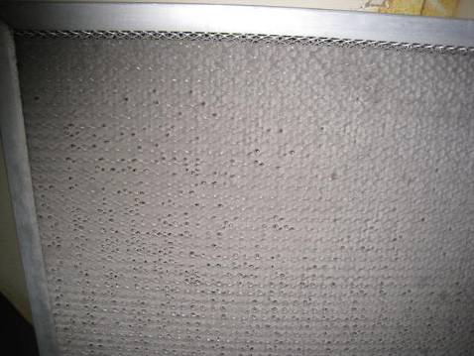

Exhaust vent occluded with dust and debris

Location | Carbon  Dioxide  (ppm) | Carbon Monoxide  (ppm) | Temp  (°F) | Relative  Humidity  (%) | PM2.5  (µg/m³) | Occupants  in Room | Windows  Openable | Ventilation |  | Remarks
 |  |  |  |  |  |  |  | Supply | Exhaust | Remarks
Background | 342 | ND | 69 | 73 | 15 |  |  |  |  | Cloudy, humid
Administration area | 775 | ND | 77 | 45 | 5 | 4 | N | Y | Y | PCs
Art Room | 467 | ND | 74 | 43 | 9 | 3 | Y  open | Y | Y | DEM
Audio/Storage Room | 450 | ND | 76 | 43 | 2 | 1 | Y | Y | Y | WD-CTs, CT ajar, laminator, hand sanitizer, boxes on floor, clutter
Cafeteria | 745 | ND | 74 | 44 | 6 | 80 | Y  open | Y | Y | Floor fans on
Child Home Program | 778 | ND | 77 | 46 | 5 | 5 | N | Y | Y | WD-CTs
Community Room | 720 | ND | 75 | 47 | 3 | 1 | N | Y | Y | DO, DEM, personal fan dirty
Conference Room 1 | 440 | ND | 76 | 43 | 3 | 1 | Y | Y | Y | DO, PC, microwave
Conference Room 2 | 421 | ND | 76 | 44 | 3 | 0 | Y | Y | Y | DO
Custodial Room | 774 | ND | 76 | 46 | 7 | 0 | N | Y | Y | DO
Family Center | 75 | ND | 74 | 45 | 3 | 3 | N | Y  open | Y
Forest 1 | 670 | ND | 77 | 44 | 4 | 11 | Y | Y  off | Y  off | Plant, DEM, clutter
Forest 2 | 731 | ND | 77 | 45 | 7 | 15 | Y | Y  off | Y  off | Plant, DEM, hand sanitizer, DEM, Clutter
Forest 3 | 726 | ND | 77 | 46 | 4 | 14 | Y | Y  off | Y  off | DEM, clutter
Forest 4 | 729 | ND | 77 | 46 | 2 | 15 | Y  open | Y | Y
Gym | 599 | ND | 76 | 49 | 5 | 0 | Y | Y | Y | DO
Gym Locker room (boy’s) | 788 | ND | 76 | 48 | 7 | 0 | N | Y | Y | DO, supply/exhaust vents dirty, WD-CTs, floor drains open
Gym Locker Room (girl’s) | 720 | NG | 75 | 44 | 7 | 0 | N | Y | Y | Floor drains open, sink drain pipe leaking into bucket
Health Center | 733 | ND | 76 | 48 | 3 | 3 | N | Y | Y | Dirty CTs and supply/exhaust vents
Library | 425 | ND | 75 | 43 | 2 | 0 | Y | Y | Y | WD-CTs, Dirty CTs and supply/exhaust vents
Lincoln 1 | 531 | ND | 75 | 47 | 5 | 0 | Y  open | 0 | Y | DEM
Lincoln 2 | 540 | ND | 75 | 46 | 4 | 3 | Y  open | Y | Y
Lincoln 3 | 490 | ND | 73 | 46 | 2 | 0 | Y  open | Y | Y | WD-CT, DEM, PF dirty, hand sanitizer
Lincoln 4 | 491 | ND | 75 | 46 | 2 | 0 | Y  open | Y | Y | Clutter
Maple 1 | 535 | ND | 76 | 45 | 3 | 3 | Y | Y | Y | PF dirty
Maple 2 | 550 | ND | 75 | 45 | 3 | 1 | Y  open | Y | Y
Maple 3 | 480 | ND | 75 | 45 | 3 | 0 | Y  open | Y | Y
Maple 4 | 460 | ND | 75 | 45 | 2 | 0 | Y  open | Y | Y
Music Room | 479 | ND | 75 | 47 | 4 | 0 | N | Y | Y
Oak 1 | 445 | ND | 77 | 43 | 5 | 6 | Y | Y  off | Y | Dirty supply/exhaust vents, clutter
Oak 2 | 478 | ND | 77 | 43 | 2 | 0 | Y  open | Y  off | Y | Dirty CTs and supply/exhaust vents, aquarium, several plants, DEM
Oak 3 | 450 | ND | 77 | 43 | 2 | 2 | Y  open | Y  off | Y  off | DEM, clutter
Oak 4 | 451 | ND | 77 | 44 | 3 | 0 | Y  open | Y  off | Y
Orchard 1 | 559 | ND | 75 | 46 | 2 | 0 | Y  open | Y  off | Y  off | Dirty CTs and supply/exhaust vents
Orchard 2 | 500 | ND | 75 | 43 | 3 | 0 | Y  Open | Y  off | Y
Orchard 3 | 470 | ND | 75 | 44 | 3 | 0 | Y | Y  off | Y  off
Orchard 4 | 480 | ND | 74 | 44 | 3 | 0 | Y | Y  off | Y  off | DEM
Parent Child Room | 431 | ND | 75 | 43 | 2 | 0 | Y  open | Y | Y
Pine 1 | 620 | ND | 76 | 45 | 3 | 0 | Y | Y | Y | WD-CTs, Personal fan dirty
Pine 2 | 641 | ND | 76 | 45 | 3 | 0 | Y | Y | Y
Pine 3 | 601 | ND | 76 | 45 | 3 | 0 | Y  open | Y | Y
Pine 4 | 618 | ND | 76 | 45 | 4 | 0 | Y  open | Y | Y | DEM
Principal’s Office | 550 | ND | 76 | 43 | 5 | 0 | Y | Y | Y | DO, WD-CT, PC, PF
Staff Lounge | 475 | ND | 76 | 43 | 5 | 6 | Y  open | Y | Y | DO, NC, refrigerator, microwave
Tyler 1 | 690 | ND | 77 | 46 | 4 | 1 | Y  open | Y | Y | NC, area rug, DEM, clutter
Tyler 2 | 550 | ND | 76 | 44 | 4 | 1 | Y open | Y | Y | NC
Willow 1 | 1010 | ND | 77 | 44 | 2 | 25 | Y | Y  off | Y  off
Willow 2 | 989 | ND | 77 | 46 | 4 | 27 | Y | Y  off | Y  off
Willow 3 | 1013 | ND | 77 | 46 | 4 | 22 | Y | Y  off | Y  off | Dirty supply/exhaust vents
Willow 4 | 1026 | ND | 77 | 43 | 2 | 23 | Y | Y | Y | PF dirty, PC

Actions on MDPH Recommendations
Morningside Community School
100 Burbank Street, Pittsfield, MA

The following is a status report of action(s) taken on recommendations made in the May 10, 2013 MDPH IAQ report (in bold) based on documents, photographs and observations of the MDPH BEH/IAQ staff during the June 6, 2014 assessment.
- Repair the kitchen hood. Operate the kitchen hood continuously to provide exhaust ventilation for stove pilot lights. Consideration should be given to replacing the stove with an automatic ignition system. Once the hood is repaired, refrain from using portable fans in the kitchen area.
- Action: The kitchen stove exhaust hood had been repaired and was drawing air.
- Repair all exhaust vents on the roof.
- Action: Completed. All roof-top exhaust vents had been repaired and were functioning.
- Install properly-sized filters in AHUs. Change filters for air-handling equipment (e.g., univents, AHUs) as per the manufacturer’s instructions or more frequently if needed. Vacuum interior of units prior to activation to prevent the aerosolization of dirt, dust and particulates. Ensure filters fit flush in their racks with no spaces in between which might allow bypass of unfiltered air into the unit.
- Action: Completed. Wire mesh filters were replaced with disposable pleated filters that fit flush in their racks. A maintenance schedule was in place to replace filters and vacuum the interior of AHUs prior to reactivation.
- Ensure all doors for AHUs close properly and that they can be opened for maintenance.
- Action: Completed. All AHU doors were repaired and able to be opened/closed properly.
- Consider extending or moving exhaust vent away from fresh air intake of AHU to prevent entrainment of exhaust.
- Action: Not completed. No action was taken on this recommendation.
- Operate the HVAC system continuously during periods of occupancy to maximize air exchange.
- Action: Completed.
- Clean air diffusers, exhaust/return vents and adjacent ceiling tiles periodically of accumulated dust/debris. If soiled ceiling tiles cannot be cleaned, they should be replaced.
- Action: Completed. A maintenance schedule had been put in place to routinely clean and/or replace ceiling tiles as needed.
- Use openable windows in conjunction with mechanical ventilation to facilitate air exchange. Care should be taken to ensure windows are properly closed at night and weekends to avoid the freezing of pipes and potential flooding.
- Action: Completed. School staff open windows as needed for temperature control and protocols are in place to ensure windows are closed at the end of school hours.
- Consider adopting a balancing schedule of every 5 years for all mechanical ventilation systems, as recommended by ventilation industrial standards (SMACNA, 1994).
- Action: It was not known at the time of the assessment if this recommendation had been implemented.
- Contact an HVAC engineering firm for an assessment of the ventilation system’s control system (e.g., controls, air intake louvers, thermostats). Based on the age, physical deterioration and availability of parts for ventilation components, such an evaluation is necessary to determine the operability and feasibility of repairing/replacing the equipment.
- Action: Not completed. An HVAC engineering firm had not been contracted to assess the system at the time of the 2014 assessment.
- Schedule lawn mowing after school hours.
- Action: Completed. Lawns are mowed after school hours.
- Seal floor drains in unused shower areas. Disconnect water service to showers and properly cut and cap plumbing as needed.
- Action: Partially completed. Shower plumbing pipes had been capped/sealed. Floor drains were found opened and had not been sealed. It was unknown at the time of the assessment if a schedule was in place to routinely fill floor drain pipes with water.
- For buildings in New England, periods of low relative humidity during the winter are often unavoidable. Therefore, scrupulous cleaning practices should be adopted to minimize common indoor air contaminants whose irritant effects can be enhanced when the relative humidity is low. To control for dusts, a high efficiency particulate arrestance (HEPA) filter equipped vacuum cleaner in conjunction with wet wiping of all surfaces is recommended. Avoid the use of feather dusters. Drinking water during the day can help ease some symptoms associated with a dry environment (throat and sinus irritations).
- Action: Completed. Cleaning is done on a routine basis and a HEPA filter vacuum is reportedly used.
- Replace water-damaged ceiling tiles. Examine the area above and around these areas for mold growth. Disinfect areas of water leaks with an appropriate antimicrobial.
- Action: It was reported that all water-damaged ceiling tiles have been removed/replaced following the 2010 assessment. At the time of the 2014 visit, water-damaged ceiling tiles were found throughout the building. Measures should be taken to identify the source of the water leaks and custodial staff should continue to replace tiles as needed.
- Provide plants with drip pans and avoid over-watering. Examine drip pans periodically for mold growth. Disinfect with an appropriate antimicrobial where necessary.
- Action: Numerous plants were found in one classroom. It was not known if drip pans are examined and disinfected as recommended.
- Clean debris from rooftop drains. Routinely inspect roof drains to prevent pooling of water. Reinstallation/adjustment of roof drains may be required for proper drainage.
- Action: Roof drains are examined and debris removed on a regular basis. No action had been taken to reinstall/adjust the height the roof drains.
- Clean carpeting annually or semi-annually in soiled high traffic areas as per the recommendations of the Institute of Inspection, Cleaning and Restoration Certification (IICRC).
- Action: Completed. Custodial staff had a maintenance schedule in place to clean carpets semi-annually.
- Relocate or consider reducing the amount of materials stored in classrooms to allow for more thorough cleaning of classrooms. Clean items regularly with a wet cloth or sponge to prevent excessive dust build-up.
- Action: Not completed. During the 2014 visit numerous classrooms were found to be cluttered with boxes, school supplies, and other materials on floors and shelving.
- Properly store and dispose of fluorescent light bulbs.
- Action: Completed. Fluorescent lights bulbs are stored in a locked cabinet.

The service life is the median time during which a particular system or component of …[an HVAC]… system remains in its original service application and then is replaced. Replacement may occur for any reason, including, but not limited to, failure, general obsolescence, reduced reliability, excessive maintenance cost, and changed system requirements due to such influences as building characteristics or energy prices (ASHRAE, 1991).

