INDOOR AIR QUALITY ASSESSMENT

Morningside Community School
100 Burbank Street
Pittsfield, Massachusetts 01201

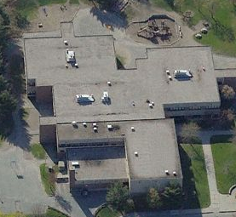

Prepared by:
Massachusetts Department of Public Health
Bureau of Environmental Health
Indoor Air Quality Program
October 2008
Background/Introduction
At the request of Mr. Thomas Simon, Co-Principal, Morningside Community School, the Massachusetts Department of Public Health (MDPH), Bureau of Environmental Health (BEH) provided assistance and consultation regarding indoor air quality concerns at Morningside Community School (MCS), 100 Burbank Street, Pittsfield, Massachusetts. The request was prompted by a complaint from a parent regarding the indoor air quality in the building.
On June 23, 2008, a visit to conduct an assessment was made to the MCS by Lisa Hébert, and James Tobin, Environmental Analysts/Inspectors in BEH’s Indoor Air Quality (IAQ) Program. During parts of the assessment, BEH staff were accompanied by Mr. Simon.
The school is a two-story brick building constructed in 1974. The building consists of large, open areas separated into “pods” by flexible barriers. Each pod is subdivided into eight classrooms. The building also has small rooms for specialized instruction, multipurpose rooms, a gymnasium, kitchen, cafeteria, library, music room, art room and office space. The classrooms on the first floor and all areas on the second floor of the MCS contain wall-to-wall carpet, original to building (i.e. 34 years old). The window system is original to the building and windows throughout the building are openable. The roof is flat and was replaced in August of 2007.

Methods
Air tests for carbon monoxide, carbon dioxide, temperature and relative humidity were conducted with the TSI, Q-TRAK™, IAQ Monitor, Models 7565 and 8551. Air tests for airborne particle matter with a diameter less than 2.5 micrometers were taken with the TSI, DUSTTRAK™ Aerosol Monitor Model 8520. BEH staff also performed visual inspection of building materials for water damage and/or microbial growth.

Results
The school houses approximately 430 students in pre-kindergarten to grade 5 with approximately 90 staff members. Tests were taken during normal operations at the school and results appear in Table 1.

Discussion

Ventilation
It can be seen from Table 1 that carbon dioxide levels were above 800 parts per million (ppm) in 4 of 50 areas at the time of the assessment, indicating adequate air exchange in the majority of areas surveyed. It is important to note, however, that several classrooms had open windows and/or were empty/sparsely populated; each of these factors can result in reduced carbon dioxide levels. Carbon dioxide levels would be expected to increase with full occupancy and windows closed.
Mechanical ventilation is provided by a heating, ventilation and air-conditioning (HVAC) system that consists of rooftop air-handling units (AHUs). The AHUs draw in fresh air through outdoor air intakes and distribute it via ceiling-mounted air diffusers. Return air is ducted back to AHUs via ceiling-mounted return vents. BEH staff found three of the four rooftop AHUs deactivated at the time of the assessment. One AHU had been taken offline for maintenance; however, it was unclear why the other two AHUs were not functioning. Additionally, the interior of one AHU exhibited dust accumulation as well as a small piece of cardboard debris. BEH staff were informed that univents were also present in the stairwells of the building.
BEH staff found the exhaust vent on one AHU located within several feet of the fresh air intake (Picture 1). In this configuration, the exhaust may be drawn in by the air intake and pollutants can be distributed back into the building. The building code requires that pollutant sources must be ten feet away from and two feet above fresh air intakes (BOCA, 1993; SBBRS, 1997). An extension several feet above the fresh air intake may be needed to prevent exhaust entrainment.
To maximize air exchange, the MDPH recommends that both supply and exhaust ventilation operate continuously during periods of school occupancy. In order to have proper ventilation with a mechanical supply and exhaust system, the systems must be balanced to provide an adequate amount of fresh air to the interior of a room while removing stale air from the room. It is recommended that HVAC systems be re-balanced every five years to ensure adequate air systems function (SMACNA, 1994). The date of the last balancing of these systems was not available at the time of the assessment.
The Massachusetts Building Code requires a minimum ventilation rate of 15 cubic feet per minute (cfm) per occupant of fresh outside air or have openable windows in each room (BOCA, 1993; SBBRS, 1997). The ventilation must be on at all times that the room is occupied. Providing adequate fresh air ventilation with open windows and maintaining the temperature in the comfort range during the cold weather season is impractical. Mechanical ventilation is usually required to provide adequate fresh air ventilation.
Carbon dioxide is not a problem in and of itself. It is used as an indicator of the adequacy of the fresh air ventilation. As carbon dioxide levels rise, it indicates that the ventilating system is malfunctioning or the design occupancy of the room is being exceeded. When this happens, a buildup of common indoor air pollutants can occur, leading to discomfort or health complaints. The Occupational Safety and Health Administration (OSHA) standard for carbon dioxide is 5,000 parts per million parts of air (ppm). Workers may be exposed to this level for 40 hours/week, based on a time-weighted average (OSHA, 1997).
The MDPH uses a guideline of 800 ppm for publicly occupied buildings. A guideline of 600 ppm or less is preferred in schools due to the fact that the majority of occupants are young and considered to be a more sensitive population in the evaluation of environmental health status. Inadequate ventilation and/or elevated temperatures are major causes of complaints such as respiratory, eye, nose and throat irritation, lethargy and headaches. For more information concerning carbon dioxide, consult Appendix A.
Temperature measurements in the MCS ranged from 73° F to 77° F, which were within the MDPH recommended comfort range in all of the areas surveyed (Table 1). The MDPH recommends that indoor air temperatures be maintained in a range of 70º F to 78º F in order to provide for the comfort of building occupants. In many cases concerning indoor air quality, fluctuations of temperature in occupied spaces are typically experienced, even in a building with an adequate fresh air supply.
The relative humidity measured in the building ranged from 60 to 78 percent at the time of the assessment, which was above the MDPH recommended comfort range in the majority of the areas surveyed (Table 1). The MDPH recommends a comfort range of 40 to 60 percent for indoor air relative humidity. It is important to note however, that relative humidity measured indoors exceeded outdoor measurements (range +1 - 11 percent). This increase in relative humidity can indicate that the exhaust system alone is not operating sufficiently to remove normal indoor air pollutants (e.g., water vapor from respiration). Moisture removal is important since the sensation of heat conditions increases as relative humidity increases (the relationship between temperature and relative humidity is called the heat index). As indoor temperature rises, the addition of more relative humidity will make occupants feel hotter. If moisture is removed, the comfort of the individuals is increased. Removal of moisture from the air, however, can have some negative effects. The sensation of dryness and irritation is common in a low relative humidity environment. Low relative humidity is a very common problem during the heating season in the northeast part of the United States.

Microbial/Moisture Concerns
Several potential sources of water damage and/or mold growth were observed. Numerous areas including classrooms and hallways had water-damaged ceiling tiles which can indicate leaks from either the roof or plumbing system (Picture 2; Table 1). Water-damaged ceiling tiles can provide a source of mold and should be replaced after a water leak is discovered and repaired.
A water cooler was located over a carpeted area in an administration office. Water stains were found on the carpet around the cooler. Overflow of the water basin or spills that often occur can moisten carpeting, which can lead to mold growth. It is important that the catch basin of a water cooler be cleaned regularly as stagnant water can be a source of odors, and materials (i.e., dust) collected in the water can provide a medium for mold growth.
The US Environmental Protection Agency (US EPA) and the American Conference of Governmental Industrial Hygienists (ACGIH) recommend that porous materials, such as ceiling tiles and gypsum wallboard, be dried with fans and heating within 24 to 48 hours of becoming wet (US EPA, 2001; ACGIH, 1989). If not dried within this time frame, mold growth may occur. Once mold has colonized porous materials, they are difficult to clean and should be removed/discarded.
Plants were observed in some classrooms. Soil and drip pans can serve as a source of mold growth. Plants should be properly maintained and be equipped with drip pans. Plants should also be located away from the air stream of mechanical ventilation to prevent aerosolization of dirt, pollen or mold.
BEH staff examined the exterior of the building to identify breaches in the building envelope that could provide a source of water penetration. Several potential sources were identified:
- Missing/damaged mortar and exterior brick (Picture 3);
- Exterior wall cracks (Picture 3);
- Missing/damaged caulking between brick and pebble board (Picture 4);
- Missing/damaged sealant between expansion joints (Picture 5);
- Exterior doors had damaged weather stripping and light could be seen penetrating through the spaces underneath the door from the outdoors; in particular, a metal door near the kitchen was rusted through creating large holes at the base of the door (Picture 6);
- Slanted concrete apron adjacent to the school directing water toward the building (Picture 7);
- Damaged scupper without supplemental gutter/downspout allowing water to empty against the exterior of the building and pool on the ground at the base of the building (Picture 8);
- Open spaces between pebble board wall at the base of the building and the sidewalk (Picture 9); and
- Plants/shrubbery growing in close proximity to the building, which can hold moisture against the building.
The aforementioned conditions represent potential water penetration sources. Over time, these conditions can undermine the integrity of the building envelope and provide a means of water entry into the building via capillary action through foundation concrete and masonry (Lstiburek & Brennan, 2001). The freezing and thawing action of water during the winter months can create cracks and fissures in the foundation. In addition, these breaches may provide a means for pests/rodents into the building.
Standing water was observed on portions of the roof (Picture 10). Roof drains were blocked by a build up of debris, which can prevent water from draining (Picture 11). The freezing and thawing of water during winter months can lead to roof leaks and subsequent water penetration into the interior of the building. Pooling water can also become stagnant, which can lead to mold and bacterial growth, and serve as a breeding ground for mosquitoes.
Terrariums were also observed in several classrooms (Picture 12). Terrariums should be properly maintained to ensure soil does not become a source for mold growth.

Other IAQ Evaluations
Indoor air quality can be negatively influenced by the presence of respiratory irritants, such as products of combustion. The process of combustion produces a number of pollutants. Common combustion emissions include carbon monoxide, carbon dioxide, water vapor and smoke (fine airborne particle material). Of these materials, exposure to carbon monoxide and particulate matter with a diameter of 2.5 micrometers (μm) or less (PM2.5) can produce immediate, acute health effects upon exposure. To determine whether combustion products were present in the school environment, BEH staff obtained measurements for carbon monoxide and PM2.5.

Carbon Monoxide
Carbon monoxide is a by-product of incomplete combustion of organic matter (e.g., gasoline, wood and tobacco). Exposure to carbon monoxide can produce immediate and acute health affects. Several air quality standards have been established to address carbon monoxide and prevent symptoms from exposure to these substances. The MDPH established a corrective action level concerning carbon monoxide in ice skating rinks that use fossil-fueled ice resurfacing equipment. If an operator of an indoor ice rink measures a carbon monoxide level over 30 ppm, taken 20 minutes after resurfacing within a rink, that operator must take actions to reduce carbon monoxide levels (MDPH, 1997).
The American Society of Heating Refrigeration and Air-Conditioning Engineers (ASHRAE) has adopted the National Ambient Air Quality Standards (NAAQS) as one set of criteria for assessing indoor air quality and monitoring of fresh air introduced by HVAC systems (ASHRAE, 1989). The NAAQS are standards established by the US EPA to protect the public health from six criteria pollutants, including carbon monoxide and particulate matter (US EPA, 2006). As recommended by ASHRAE, pollutant levels of fresh air introduced to a building should not exceed the NAAQS levels (ASHRAE, 1989). The NAAQS were adopted by reference in the Building Officials & Code Administrators (BOCA) National Mechanical Code of 1993 (BOCA, 1993), which is now an HVAC standard included in the Massachusetts State Building Code (SBBRS, 1997). According to the NAAQS, carbon monoxide levels in outdoor air should not exceed 9 ppm in an eight-hour average (US EPA, 2006).
Carbon monoxide should not be present in a typical, indoor environment. If it is present, indoor carbon monoxide levels should be less than or equal to outdoor levels. On the day of assessment, outdoor carbon monoxide concentrations were non-detect (ND) (Table 1). Carbon monoxide levels measured in the school were also ND.

Particulate Matter (PM2.5)
The US EPA has established NAAQS limits for exposure to particulate matter. Particulate matter is airborne solids that can be irritating to the eyes, nose and throat. The NAAQS originally established exposure limits to particulate matter with a diameter of 10 μm or less (PM10). According to the NAAQS, PM10 levels should not exceed 150 microgram per cubic meter (μg/m³) in a 24-hour average (US EPA, 2006). These standards were adopted by both ASHRAE and BOCA. Since the issuance of the ASHRAE standard and BOCA Code, US EPA established a more protective standard for fine airborne particles. This more stringent PM2.5 standard requires outdoor air particle levels be maintained below 35 μg/m³ over a 24-hour average (US EPA, 2006). Although both the ASHRAE standard and BOCA Code adopted the PM10 standard for evaluating air quality, MDPH uses the more protective PM2.5 standard for evaluating airborne particulate matter concentrations in the indoor environment.
Outdoor PM2.5 concentrations the day of the assessment were measured at 25 μg/m³. PM2.5 levels measured inside the school ranged from 16 to 39 μg/m³ (Table 1). With the exception of a classroom having indoor recess, both indoor and outdoor PM2.5 levels were below the NAAQS PM2.5 level of 35 μg/m³. Frequently, indoor air levels of particulates (including PM2.5) can be at higher levels than those measured outdoors. A number of mechanical devices and/or activities that occur in schools can generate particulate during normal operations. Sources of indoor airborne particulates may include but are not limited to particles generated during the operation of fan belts in the HVAC system, cooking in the cafeteria stoves and microwave ovens; use of photocopiers, fax machines and computer printing devices; operation of an ordinary vacuum cleaner and heavy foot traffic indoors.

Volatile Organic Compounds
Indoor air concentrations can be greatly impacted by the use of products containing volatile organic compounds (VOCs). VOCs are carbon-containing substances that have the ability to evaporate at room temperature. Frequently, exposure to low levels of total VOCs (TVOCs) may produce eye, nose, throat and/or respiratory irritation in some sensitive individuals. For example, chemicals evaporating from a paint can stored at room temperature would most likely contain VOCs. In an effort to identify materials that can potentially increase indoor VOC concentrations, BEH staff examined classrooms for products containing these respiratory irritants.
Several classrooms contained dry erase boards and related materials. Upon entering one classroom, a strong chemical odor was noted which was traced to an instructor utilizing dry erase board cleaner. Materials such as dry erase markers and dry erase board cleaners may contain VOCs, such as methyl isobutyl ketone, n-butyl acetate and butyl-cellusolve (Sanford, 1999), which can be irritating to the eyes, nose and throat.
Cleaning products were also found on countertops in some classrooms (Picture 13). Like dry erase materials, cleaning products contain VOCs and other chemicals that can be irritating to the eyes, nose and throat of sensitive individuals. Unlabeled/poorly labeled spray bottles were also observed in some classrooms. Products should be kept in their original containers, or should be clearly labeled as to their contents, for identification purposes in the event of an emergency. Further, material safety data sheets (MSDS) for all cleaning products must be available at a central location in the building.

Other Conditions
Other conditions that can affect indoor air quality were observed during the assessment. As previously mentioned, the classrooms on the first floor and all areas on the second floor contained wall-to-wall carpet installed in the building 34 years ago. The average lifespan of a carpet is approximately 11 years; therefore, consideration should be given to planning for new flooring (Bishop, 2002). Disintegrating textiles can be a source of airborne particulates, which can be irritating to the eyes, nose and throat.
In several classrooms, items were observed on the floors, windowsills, tabletops, counters, bookcases and desks. The large number of items stored in classrooms provides a source for dusts to accumulate. These items (e.g., papers, folders, boxes) make it difficult for custodial staff to clean. Items should be relocated and/or be cleaned periodically to avoid excessive dust build up. In addition, these materials can accumulate on flat surfaces (e.g., desktops, shelving and carpets) in occupied areas and subsequently be re-aerosolized causing further irritation.
A number of air diffusers, exhaust/return vents and adjacent ceiling tiles were occluded with dust and debris (Pictures 13 through 16). In addition, personal fans were observed to have accumulated dust/debris. Dust can be a source for eye and respiratory irritation. If exhaust vents are not functioning, backdrafting can occur, which can aerosolize dust particles. Re-activated personal fans can serve to distribute dust and debris.
Food products, appliances and containers were observed in classrooms. Rodent infestation may result from easy access to food and water in a building. Rodent infestation can result in indoor air quality related symptoms due to materials in their wastes. Mouse urine contains a protein that is a known sensitizer (US EPA, 1992). To prevent a rodent infestation, pathways/food sources should be eliminated. Food should be properly stored and clearly labeled. Food appliances should be routinely cleaned. Reuse of food containers (e.g., for art projects) is not recommended since food residue adhering to the container surface may serve to attract pests.
Fluorescent light bulbs were stored in the mechanical room (Picture 17). These bulbs contain mercury, and must be properly handled and stored in order to prevent breaks and mercury spills.
The art room contained two kilns. It was reported to BEH staff that the kilns were not presently in use and had not been operated in some time. Kiln exhaust may produce corrosive, hazardous and irritating materials including chlorine, sulfur dioxide and carbon monoxide. If the kilns are ever reactivated, measures should be taken to ensure that adequate dedicated local exhaust ventilation (McCann, 1985) is provided to ventilate these possible emissions from the interior of the building.
A washer/dryer hookup that was not in use was observed in one of the art rooms. The drain line for the washing machine was sealed with duct tape. The drain may have a dry trap, which can allow sewer gases/odors to migrate from the drain system into occupied space (Picture 18). Additionally, the penetration of the dryer vent through the wall is not properly sealed, which can provide pathways for rodents, drafts, dust and particulates to migrate into occupied areas.
Lastly, insect nests were observed in classrooms (Picture 19). Nests can contain bacteria and may also be a source of allergenic material. Nests should be placed in re-sealable bags to prevent aerosolization of allergenic material.

Conclusions/Recommendations
In view of the findings at the time of the assessment, the following recommendations are made for improving indoor air quality:
- Operate the HVAC system continuously during periods of occupancy to maximize air exchange.
- Use openable windows in conjunction with mechanical ventilation to facilitate air exchange. Care should be taken to ensure windows are properly closed at night and weekends to avoid the freezing of pipes and potential flooding.
- Change filters for air-handling equipment (e.g., univents, AHUs) as per the manufacturer’s instructions or more frequently if needed. Vacuum interior of units prior to activation to prevent the aerosolization of dirt, dust and particulates. Remove cardboard debris from interior of AHU. Ensure filters fit flush in their racks with no spaces in between allowing bypass of unfiltered air into the unit.
- Consider adopting a balancing schedule of every 5 years for all mechanical ventilation systems, as recommended by ventilation industrial standards (SMACNA, 1994).
- Consider extending or moving exhaust vent away from fresh air intake of AHU to prevent entrainment of exhaust.
- Contact an HVAC engineering firm for an assessment of the ventilation system’s control system (e.g., controls, air intake louvers, thermostats). Based on the age, physical deterioration and availability of parts for ventilation components, such an evaluation is necessary to determine the operability and feasibility of repairing/replacing the equipment.
- For buildings in New England, periods of low relative humidity during the winter are often unavoidable. Therefore, scrupulous cleaning practices should be adopted to minimize common indoor air contaminants whose irritant effects can be enhanced when the relative humidity is low. To control for dusts, a high efficiency particulate arrestance (HEPA) filter equipped vacuum cleaner in conjunction with wet wiping of all surfaces is recommended. Avoid the use of feather dusters. Drinking water during the day can help ease some symptoms associated with a dry environment (throat and sinus irritations).
- Replace water damaged ceiling tiles. Examine the area above and around these areas for mold growth. Disinfect areas of water leaks with an appropriate antimicrobial.
- Remove water-damaged carpet from under water cooler. Place plastic mats beneath water cooler.
- Provide plants with drip pans and avoid over-watering. Examine drip pans periodically for mold growth. Disinfect with an appropriate antimicrobial where necessary.
- Repair damaged brick and mortar and wall cracks on the exterior of the building.
- Consider re-pointing and waterproofing exterior walls to prevent water intrusion. This measure should include a full building envelope evaluation.
- Replace/repair missing/damaged caulking between brick and pebble board.
- Examine all expansion joint seals on the exterior wall system. Reseal all expansion joints with damaged, missing or eroded sealant.
- Install weather stripping around exterior doors to prevent drafts, water penetration and pest entry. Replace rusted exterior door.
- Reestablish concrete apron around school to have it slope away from the base of the building to prevent water pooling. Seal open spaces/seams between apron/sidewalk and building exterior wall to prevent water penetration.
- Repair/replace scupper on the exterior of the building. Install a gutter/downspout to direct water away from the building.
- Clear plants/shrubbery along exterior walls approximately 5-feet to prevent moisture impingement.
- Clean debris from rooftop drains. Routinely inspect roof drains to prevent pooling of water.
- Store cleaning products properly and out of reach of students. Ensure spray bottles are properly labeled. All cleaning products used at the facility should be approved by the school department with Material Safety Data Sheets (MSDS) available at a central location.
- Replace carpet with non-porous material or carpet squares.
- Clean carpeting annually or semi-annually in soiled high traffic areas as per the recommendations of the Institute of Inspection, Cleaning and Restoration Certification (IICRC). Copies of the IICRC fact sheet can be downloaded at: http://www.cleancareseminars.com/carpet_cleaning_faq4.htm (IICRC, 2005).
- Relocate or consider reducing the amount of materials stored in classrooms to allow for more thorough cleaning of classrooms. Clean items regularly with a wet cloth or sponge to prevent excessive dust build-up.
- Clean personal fans, air diffusers, exhaust/return vents and adjacent ceiling tiles periodically of accumulated dust. If soiled ceiling tiles cannot be cleaned, they should be replaced.
- Food should be properly stored and clearly labeled. Reuse of food containers is not recommended. Kitchen areas at the back of some classrooms should be maintained in a clean condition in order to prevent rodent infestation.
- Properly store and dispose of fluorescent light bulbs.
- Ensure that kilns have adequate local exhaust ventilation. Maintain equipment as needed.
- Cap abandoned washer drain line or ensure water is poured into the drains every other day (or as needed) to maintain the integrity of the traps.
- Seal any open holes/breaches in interior walls to prevent the migration of drafts, odors, particulates from wall cavities into occupied areas.
- Insect nest should be placed in re-sealable bag to prevent aerosolization of allergenic material.
- Consider adopting the US EPA (2000) document, “Tools for Schools”, as an instrument for maintaining a good indoor air quality environment in the building. This document is available at: http://www.epa.gov/iaq/schools/index.html.
- Refer to resource manual and other related indoor air quality documents located on the MDPH’s website for further building-wide evaluations and advice on maintaining public buildings. These documents are available at: http://mass.gov/dph/indoor_air.
References
ACGIH. 1989. Guidelines for the Assessment of Bioaerosols in the Indoor Environment. American Conference of Governmental Industrial Hygienists, Cincinnati, OH.
ASHRAE. 1989. Ventilation for Acceptable Indoor Air Quality. American Society of Heating, Refrigeration and Air Conditioning Engineers. ANSI/ASHRAE 62-1989
Bishop, J. & Institute of Inspection, Cleaning and Restoration Certification. 2002. A Life Cycle Cost Analysis for Floor Coverings in School Facilities.

BOCA. 1993. The BOCA National Mechanical Code/1993. 8th ed. Building Officials and Code Administrators International, Inc., Country Club Hill, IL.

IICRC. 2005. Carpet Cleaning FAQ 4 Institute of Inspection, Cleaning and Restoration Certification. Institute of Inspection Cleaning and Restoration, Vancouver, WA.

Lstiburek, J. & Brennan, T. 2001. Read This Before You Design, Build or Renovate. Building Science Corporation, Westford, MA. U.S. Department of Housing and Urban Development, Region I, Boston, MA
McCann, M. 1985. Health Hazards Manual for Artists. 3rd rev. ed. Lyons & Burford, Publishers, New York, NY.
MDPH. 1997. Requirements to Maintain Air Quality in Indoor Skating Rinks (State Sanitary Code, Chapter XI). 105 CMR 675.000. Massachusetts Department of Public Health, Boston, MA.
OSHA. 1997. Limits for Air Contaminants. Occupational Safety and Health Administration. Code of Federal Regulations. 29 C.F.R 1910.1000 Table Z-1-A.
Sanford. 1999. Material Safety Data Sheet (MSDS No: 198-17). Expo® Dry Erase Markers Bullet, Chisel, and Ultra Fine Tip. Sanford Corporation. Bellwood, IL.
SBBRS. 1997. Mechanical Ventilation. State Board of Building Regulations and Standards. Code of Massachusetts Regulations. 780 CMR 1209.0
SMACNA. 1994. HVAC Systems Commissioning Manual. 1st ed. Sheet Metal and Air Conditioning Contractors’ National Association, Inc., Chantilly, VA.

US EPA. 1992. Indoor Biological Pollutants. US Environmental Protection Agency, Environmental Criteria and Assessment Office, Office of Health and Environmental Assessment, research Triangle Park, NC. EPA 600/8-91/202 January 1992.

US EPA. 2000. Tools for Schools. Office of Air and Radiation, Office of Radiation and Indoor Air, Indoor Environments Division (6609J). EPA 402-K-95-001, Second Edition. http://www.epa.gov/iaq/schools/tools4s2.html
US EPA. 2001. “Mold Remediation in Schools and Commercial Buildings”. Office of Air and Radiation, Indoor Environments Division, Washington, DC. EPA 402-K-01-001. March 2001. Available at: http://www.epa.gov/iaq/molds/mold_remediation.html
US EPA. 2006. National Ambient Air Quality Standards (NAAQS). US Environmental Protection Agency, Office of Air Quality Planning and Standards, Washington, DC. http://www.epa.gov/air/criteria.html.
Picture 1

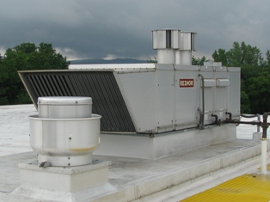

Exhaust in front of Fresh Air Intake

Picture 2

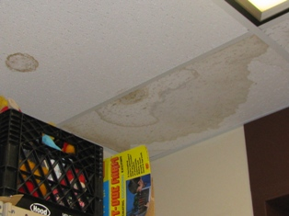

Water-damaged Ceiling Tiles

Picture 3

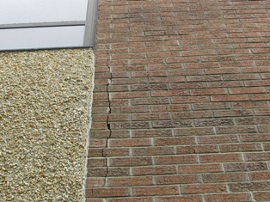

Damaged Brick and Mortar, Wall Cracks

Picture 4

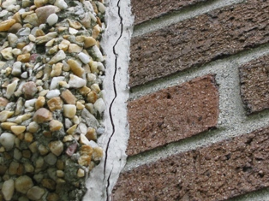

Damaged Caulking between Brick and Pebble Board

Picture 5

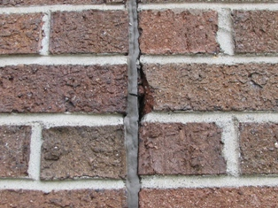

Damaged Expansion Joint Sealant

Picture 6

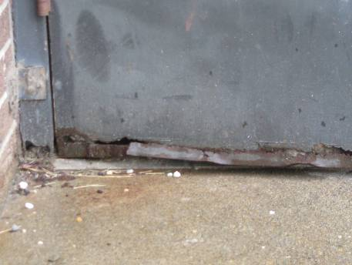

Rusted and Damaged Exterior Door

Picture 7

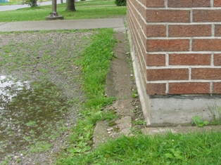

Sloped Apron Directs Water toward Building

Picture 8

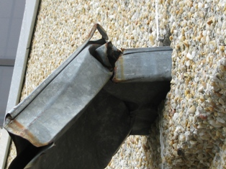

Damaged Scupper without Gutter/Downspout

Picture 9

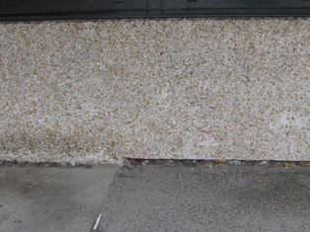

Open Space between Pebble Board and Sidewalk

Picture 10

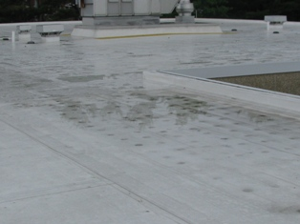

Standing Water on Roof

Picture 11

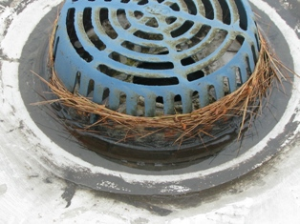

Debris Blocking Roof Drain

Picture 12

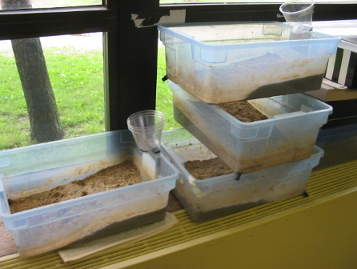

Terrariums in Classroom

Picture 13

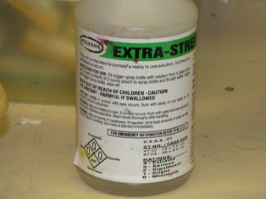

Cleaners found in Classrooms

Picture 14

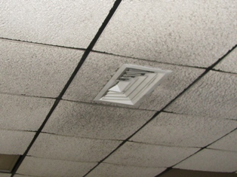

Air Diffuser and Ceiling Tiles occluded with Dust and Debris

Picture 15

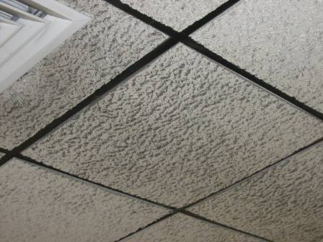

Dust and Debris on Ceiling Tiles

Picture 16

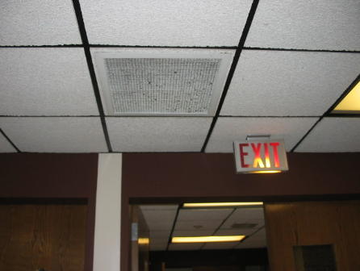

Heavy Accumulation of Debris on Exhaust Vent

Picture 17

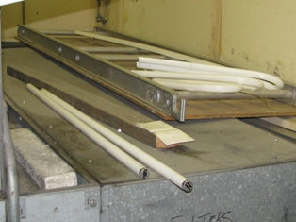

Fluorescent Light Bulbs stored in Mechanical Room

Picture 18

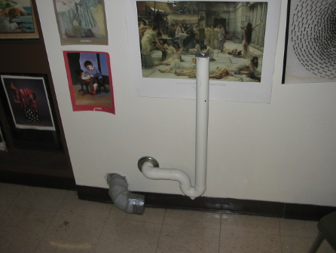

Abandoned Washer and Dryer Hookup

Picture 19

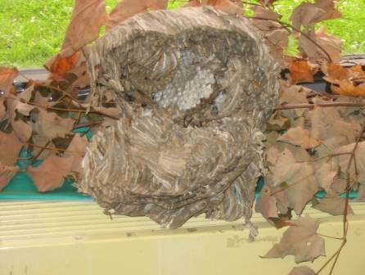

Insect Nest in Classroom

Location/ Room | Occupants  in Room | Temp  (°F) | Relative  Humidity  (%) | Carbon  Dioxide  (ppm) | Carbon Monoxide  (ppm) | PM2.5  (µg/m³) | Windows  Openable | Ventilation |  | Remarks
 |  |  |  |  |  |  |  | Supply | Exhaust | Remarks
Background |  | 75 | 67 | 398 | ND | 25
238 | 3 | 74 | 72 | 434 | ND | 28 | Y  4/4 open | Y  Off | Y  Off | PF, CD, mini fridge on carpet, plants
Art Office | 0 | 74 | 72 | 566 | ND | 31 | N | Y  Off | Y  Off | DO
Art Room | 1 | 74 | 68 | 408 | ND | 31 | Y  3/8 open | Y  Off | Y  Off | Cleaners, Dust/debris on CTs
Arts 1 | 4 | 73 | 78 | 407 | ND | 32 | Y | Y  Off | Y  Off, dust, debris | Space counter backsplash, kids running around, server, abandoned pipe
AV | 0 | 76 | 68 | 424 | ND | 19 | N | Y | Y | MT, WD CTs, laminator, space between sink and backsplash, microwave, server
Cafeteria  Kitchen | 4 | 77 | 66 | 443 | ND | 21 | Y  2/2 open | Y | Y | DO, WD CTs in dry storage area, gas stove
Cafeteria | 130 | 74 | 72 | 657 | ND | 24 | Y  5/12 open | Y  Off | Y  Off, dust, debris
Cherry | 7 | 76 | 66 | 483 | ND | 30 | Y  7/8 open | Y  Off | Y  Off | PF, CD, WD CTs, buckled CTs
Cherry | 8 | 76 | 71 | 486 | ND | 28 | Y  2/4 open | Y  Off | Y  Off | CD, PF, 10 WD CTs, Stove, Dishwasher, Dust/debris on CTs
Community Room | 1 | 74 | 70 | 438 | ND | 18 | N | Y  Off | Y  Off | Soda machine, refrigerator, micro
Co-Principal | 0 | 77 | 60 | 505 | ND | 24 | N | Y  Off | Y  Off | PF, water cooler located on carpet, carpet below cooler exhibits water damage, WD CTs, DEM
Forest 1 | 14 | 75 | 67 | 872 | ND | 26 | Y  1/4 open | Y  Off | Y  Off
Forest 2 | 17 | 75 | 68 | 827 | ND | 25 | Y  2/4 open | Y  Off | Y  Off
Forest 3 | 11 | 75 | 66 | 876 | ND | 27 | Y  4/4 open | Y  Off | Y  Off | DEM
Forest 4 | 14 | 75 | 66 | 814 | ND | 26 | Y  6/6 open | Y  Off | Y  Off | CD, Plants
Girls’ bathroom |  |  |  |  |  |  |  |  | Y | Dust accum.
Gym | 0 | 74 | 65 | 550 | ND | 18 | N | Y  Off | Y  Off
Kids’ Club | 0 | 74 | 72 | 410 | ND | 20 | N | Y  Off | Y  Off | DEM, refrigerator on carpet, microwave, Aqua, PF
Library | 0 | 75 | 63 | 423 | ND | 25 | Y  Open | Y  Off | Y  Off | PF, WD CTs
Linden 1 | 1 | 75 | 62 | 527 | ND | 23 | Y  5/6 open | Y  Off | Y  Off | PF, CD, spray cleaners
Linden 2 | 1 | 75 | 63 | 574 | ND | 24 | Y  2/4 open | Y  Off | Y  Off | CD
Linden 3 | 0 | 75 | 64 | 498 | ND | 24 | Y  2/4 open | Y  Off | Y  Off | CD, steam extraction machine and shampoo in classroom
Linden 4 | 20 | 75 | 64 | 622 | ND | 24 | Y  4/6 open | Y  Off | Y  Off | PF
Maple 1 | 1 | 76 | 67 | 624 | ND | 22 | Y  2/4 open | Y  Off | Y  Off | PF
Maple 2 | 1 | 76 | 65 | 616 | ND | 22 | Y  2/4 open | Y  Off | Y  Off | PF, Plants
Maple 3 | 18 | 76 | 66 | 623 | ND | 23 | Y  2/4 open | Y  Off | Y  Off | DEM, PF
Maple 4 | 17 | 77 | 66 | 726 | ND | 24 | Y  2/6 open | Y  Off | Y  Off | CD, PF
Music | 15 | 74 | 69 | 432 | ND | 20 | N | Y | Y | PF
Northwest Boys’ bathroom |  |  |  |  |  |  |  |  | Y  Dust, debris
Nurse’s Office | 4 | 75 | 64 | 617 | ND | 21 | N | Y  Off | Y  Off | PF
Oak 1 | 17 | 76 | 68 | 595 | ND | 23 | Y  2/2 open | Y  Off | Y  Off, dust, debris | DEM, PF, CD, Dust/debris on CT
Oak 2 | 19 | 77 | 67 | 617 | ND | 25 | Y  2/2 open | Y  Off | Y  Off, dust, debris | PF, Clutter, CD, Dust/debris on CT
Oak 3 | 0 | 77 | 66 | 569 | ND | 24 | Y  2/2 open | Y  Off | Y  Off | PF, DEM
Oak 4 | 19 | 77 | 66 | 567 | ND | 25 | Y  2/2 open | Y  Off | Y  Off, dust, debris | CD
Office | 0 | 76 | 62 | 680 | ND | 21 | N | Y | Y  In hall | Carpet
Office A | 0 | 74 | 68 | 541 | ND | 21 | N | N | Y  Off | DO, carpet, stuffed animals
Office B | 0 | 74 | 69 | 711 | ND | 21 | N | N | Y  Off | DO, Carpet
Orchard 1 | 17 | 75 | 68 | 647 | ND | 29 | Y  open | Y | Y | PF, DO, DEM, carpet
Orchard 2 | 17 | 75 | 67 | 588 | ND | 30 | Y  open | Y | Y | PF, DEM, carpet
Orchard 3 | 15 | 76 | 65 | 531 | ND | 28 | Y  open | Y | Y | PF, DEM, strong odor observed in room, dry erase remover being utilized by instructor
Orchard 4 | 17 | 76 | 63 | 538 | ND | 27 | Y | Y | Y | PFs, DEM
Parent Child Home Prog. | 2 | 74 | 70 | 560 | ND | 33 | N | Y  Off | Y  Off | WD CTs near heat sensor
Pine 1 | 16 | 74 | 72 | 696 | ND | 28 | Y | Y  Off | Y  Off, dust, debris | DEM
Pine 2 | 16 | 74 | 71 | 602 | ND | 26 | Y  2/4 open | Y  Off | Y  Off | PF, DEM, CD
Pine 3 | 24 | 74 | 71 | 669 | ND | 27 | Y  2/4 open | Y  Off | Y  Off | PF, DEM
Pine 4 | 9 | 75 | 71 | 724 | ND | 39 | Y | Y  Off | Y  Off | CD, Plants, Clutter
Room A | 2 | 77 | 60 | 581 | ND | 24 | N | Y  Off | Y  Off | WD CTs
School A | 0 | 75 | 65 | 422 | ND | 16 | N | Y  Off | Y  Off | DEM, DO
School Coord. Office | 3 | 76 | 62 | 585 | ND | 23 | N | Y  Off | Y  Off | DEM
Speech Room C | 0 | 76 | 67 | 440 | ND | 22 | N | Y | Y  Off | PF, Micro, mini fridge, cleaners
Willow 1 & 2 | 1 | 73 | 73 | 614 | ND | 29 | Y | Y  Off | Y  Off, dust, debris | PF, Aqua, Bee hives, leaves, Dirt in containers, Egg crates, DEM, cleaners, turtle, Plants, Exhaust above door
Willow 3 &4 | 6 | 74 | 66 | 711 | ND | 22 | Y  1/10 open | Y  Off | Y  Off

