INDOOR AIR QUALITY ASSESSMENT

Morse Institute Library
14 East Central Street
Natick, Massachusetts

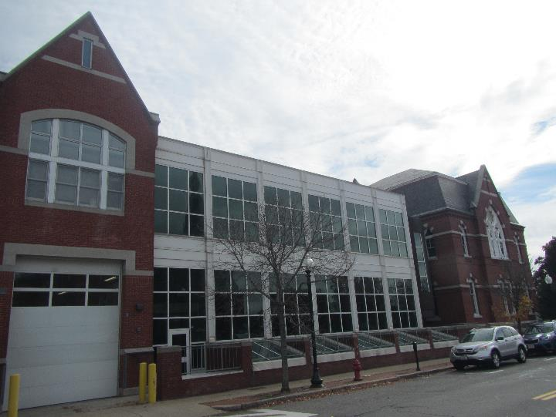

Prepared by:
Massachusetts Department of Public Health
Bureau of Environmental Health
Indoor Air Quality Program
November 2019

Background
Building: | Morse Institute Library (MIL)
Address: | 14 East Central Street, Natick, MA
Agency Contact: | Jason Homer, Library Director, MIL
Reason for Request: | General indoor air quality (IAQ) concerns
Date of Assessment: | October 22, 2019
Massachusetts Department of Public Health/Bureau of Environmental Health (MDPH/BEH) Staff Conducting Assessment: | Jason Dustin, Environmental Analyst/Inspector, IAQ Program
Building Description: | The MIL is located in a two-story brick building that was originally constructed in 1873. An addition was added in 1997.
Windows: | Some windows are openable.

Methods
Please refer to the IAQ Manual for methods, sampling procedures, and interpretation of results (MDPH, 2015).

Results
The following is a summary of indoor air testing results (Table 1).
- Carbon dioxide levels were below the MDPH guideline of 800 parts per million (ppm) in all but one area assessed indicating adequate air exchange. It should be noted that some areas were sparsely populated which can reduce carbon dioxide levels.
- Temperature was within the MDPH recommended range of 70°F to 78°F in all areas tested.
- Relative humidity was within the MDPH recommended range of 40% to 60% in all areas tested.
- Carbon monoxide levels were non-detectable (ND) in all areas tested.
- Fine particulate matter (PM2.5) concentrations measured were below the National Ambient Air Quality Standard (NAAQS) level of 35 micrograms per cubic meter (μg/m³) in all areas tested.
- Total Volatile Organic Compounds (TVOCs) were ND in all areas tested.

Discussion

Ventilation
A heating, ventilating, and air conditioning (HVAC) system has several functions. First it provides heating and, if equipped, cooling. Second, it is a source of fresh air. Finally, an HVAC system will dilute and remove normally occurring indoor environmental pollutants by not only introducing fresh air, but by filtering the airstream and ejecting stale air to the outdoors via exhaust ventilation. Even if an HVAC system is operating as designed, point sources of respiratory irritation may exist and cause symptoms in sensitive individuals.
The HVAC system at the MIL consists of large rooftop air handling units (AHUs) that draw in fresh air from intakes on the roof. Supply air is ducted to ceiling-mounted diffusers throughout the space (Picture 1). Air is brought back to the AHUs through return vents (Picture 2). Facilities personnel reported that the rooftop AHUs are under a contract for maintenance and regular filter changes. It was also reported that the MIL utilizes a stored ice system to assist with air conditioning.
To maximize air exchange, the MDPH recommends that both supply and exhaust ventilation operate continuously during periods of occupancy. In order to have proper ventilation with a mechanical supply and exhaust system, the systems must be balanced to provide an adequate amount of fresh air to the interior of a room while removing stale air from the room. It is recommended that HVAC systems be re-balanced every five years to ensure adequate air systems function (SMACNA, 1994).

Microbial/Moisture Concerns
BEH/IAQ staff noted that the Children’s area in the lower level of the MIL has efflorescence from water infiltration through the brick in the exterior wall near the skylights (Picture 3). Efflorescence is a characteristic sign of water damage to building materials such as brick, mortar, or plaster, but it is not mold growth. As moisture penetrates and works its way through mortar around brick, water-soluble compounds dissolve, creating a solution. As the solution moves to the surface of the brick or mortar, water evaporates, leaving behind white, powdery mineral deposits. This condition indicates that water from the exterior has penetrated into the building. Plaster and brick do not typically support mold growth because these materials are not carbon-based; however paint or debris/porous items near the walls that are moistened may become a mold-colonized. When present, efflorescence can be readily cleaned. Some of this water infiltration may also be the result of leaking skylights and damaged flashing in this area (Picture 4).
Water-damaged gypsum wallboard (GW) was noted at the intersection of the original building and the 1997 addition. GW is considered porous due to the paper backing on both sides and may become colonized with mold when exposed to chronic moisture. This area was noted to have dark staining which may indicate microbial growth (Picture 5).
Some water-damaged ceiling tiles were noted throughout the MIL (Picture 6). These tiles should be replaced after leaks are repaired. Other areas of the original building had water-damaged plaster ceilings (Picture 7). Plaster is not conducive to mold growth since it lacks a source of carbon.
Occupants reported that the office in the Children’s area was subjected to a water leak from a roof drain line in 2018. Carpeting in this area had water stains (Picture 8). The US Environmental Protection Agency (US EPA) and the American Conference of Governmental Industrial Hygienists (ACGIH) recommends that porous materials (e.g., wallboard, carpeting) be dried with fans and heating within 24 to 48 hours of becoming wet (US EPA, 2008; ACGIH, 1989). If porous materials are not dried within this time frame, mold growth may occur. Occupants also reported that this area experiences a sewer odor on occasion. Frequently sewer odors are the result of dry drain traps. This occurs when the water in the “P” trap of seldom used sinks/drains evaporates thereby allowing sewer gases to enter the occupied space. Regularly filling the traps with water will usually eliminate the sewer odors experienced.
Some areas of the MIL were noted to have soiled carpeting. Carpeting is considered a porous material so that if it is not cleaned and dried promptly, spills and water damage can be a source of microbial colonization and odors.
MIL staff reported that one of the large windows in the staff area on the second floor leaks during driving rain events (Picture 9). Occupants should avoid storing porous items in the vicinity of active leaks until repairs can be made.
Water coolers were noted directly on carpeting. These appliances may leak or spill which can cause water damage to the carpeting beneath the units.
Indoor plants were observed in some areas. Plants can be a source of pollen and mold, which can be respiratory irritants to some individuals. Plants should be properly maintained and equipped with drip pans and should be located away from air diffusers to prevent the aerosolization of dirt, pollen and mold.

Other Conditions
Exposure to low levels of total volatile organic compounds (TVOCs) may produce eye, nose, throat, and/or respiratory irritation in some sensitive individuals. To determine if VOCs were present, BEH/IAQ staff took measurements for TVOCs, which were all ND. Hand sanitizers, scented cleaning products, and dry erase materials were noted in some areas of the office space (Table 1). These products can cause irritation of the eyes, nose and respiratory system of some individuals.
Some areas have large amounts of accumulated items which can interfere with proper cleaning (Picture 10). Surfaces should be wet wiped and carpeting should be HEPA vacuumed regularly to avoid aerosolizing settled dust which can have irritant effects. Extreme low humidity in winter months can exacerbate this issue.
Some supply/exhaust diffusers were noted to be dusty (Picture 11). These should be regularly wet wiped to avoid aerosolizing the accumulated dust.
Most flooring is covered with carpet tile. The Institute of Inspection, Cleaning and Restoration Certification (IICRC), recommends that carpeting be cleaned annually (or semi-annually in soiled high traffic areas) (IICRC, 2012).

Conclusions/Recommendations
Based on the observations made during the visit, the following is recommended:
- Operate the HVAC system to provide for continuous fresh air ventilation during occupied hours.
- Due to the large amount of porous items (e.g., books), ensure that a protocol is in place to provide dehumidification through air conditioning or other methods during extended periods of high humidity/high dew points even during unoccupied hours.
- Repair leaks at the interface of the old building and new addition (outside Prunaret room) and replace any water-damaged GW in a manner consistent with the EPA guideline “Mold Remediation in Schools and Commercial Buildings” (US EPA, 2008).
- Replace any water-damaged ceiling tiles. Monitor the area for any new leaks and make any necessary repairs.
- Fix damaged exterior flashing in skylight of Children’s area and make any necessary repairs to stop water infiltration. Keep porous items away from any active leaks in this area.
- Repair water-damaged plaster; ensure that lead-safe practices are used if paint or plaster could contain lead.
- Repair any damaged/missing flashing or caulking that may be allowing water leaks in area of large window in second floor staff area.
- Replace water-damaged or soiled carpeting (e.g., Children’s area office). Consider replacing carpeting with carpet tiles.
- Properly maintain plants, including drip pans, to prevent water damage to porous materials. Plants should also be located away from air diffusers to prevent the aerosolization of dirt, pollen, and mold.
- Place waterproof trays under water coolers to avoid damage/microbial growth to carpeting.
- Regularly fill sink/drain traps in the Children’s area to avoid intermittent sewer odors. If odors persist, consult with a plumber to determine source of sewer odors.
- Reduce or eliminate the use of scented cleaners, hand sanitizers, and air fresheners.
- Regularly clean exhaust/supply vents of any accumulated dust.
- Wet wipe flat surfaces and HEPA vacuum carpeting daily.
- Refrain from storing accumulated items on flat surfaces as this will interfere with proper cleaning.
- Clean carpeting at least once per year according to IICRC recommendations (IICRC 2012).
- Continue to change filters for HVAC equipment 2-4 times a year. Continue to use pleated filters of MERV 8 (or higher), which are adequate in filtering out pollen and mold spores (ASHRAE, 2012), if these can be used with current equipment.
- Consider adopting a balancing schedule of every 5 years for all mechanical ventilation systems, as recommended by ventilation industrial standards (SMACNA, 1994).
- For buildings in New England, periods of low relative humidity during the winter are often unavoidable. Therefore, scrupulous cleaning practices should be adopted to minimize common indoor air contaminants whose irritant effects can be enhanced when the relative humidity is low. To control for dusts, a high efficiency particulate arrestance (HEPA) filter equipped vacuum cleaner in conjunction with wet wiping of all surfaces is recommended. Avoid the use of feather dusters. Drinking water during the day can help ease some symptoms associated with a dry environment (throat and sinus irritations).
- Refer to resource manuals and other related IAQ documents for further building-wide evaluations and advice on maintaining public buildings. Copies of these materials are located on the MDPH’s website: http://mass.gov/dph/iaq.

References

ACGIH. 1989. Guidelines for the Assessment of Bioaerosols in the Indoor Environment. American Conference of Governmental Industrial Hygienists, Cincinnati, OH.
ASHRAE. 2012. American Society of Heating, Refrigeration and Air Conditioning Engineers (ASHRAE) Standard 52.2-2012 -- Method of Testing General Ventilation Air-Cleaning Devices for Removal Efficiency by Particle Size (ANSI Approved).
IICRC. 2012. Institute of Inspection Cleaning and Restoration Certification. Institute of Inspection, Cleaning and Restoration Certification. Carpet Cleaning: FAQ. Retrieved from https://www.iicrc.org/general/custom.asp?page=SANSIIICRCS100.
MDPH. 2015. Massachusetts Department of Public Health. “Indoor Air Quality Manual: Chapters I-III”. Available at: http://www.mass.gov/eohhs/gov/departments/dph/programs/environmental-health/exposure-topics/iaq/iaq-manual/.
SMACNA. 1994. HVAC Systems Commissioning Manual. 1st ed. Sheet Metal and Air Conditioning Contractors’ National Association, Inc., Chantilly, VA.
US EPA. 2008. “Mold Remediation in Schools and Commercial Buildings”. Office of Air and Radiation, Indoor Environments Division, Washington, DC. EPA 402-K-01-001. September 2008. Available at: http://www.epa.gov/mold/mold-remediation-schools-and-commercial-buildings-guide

Picture 1
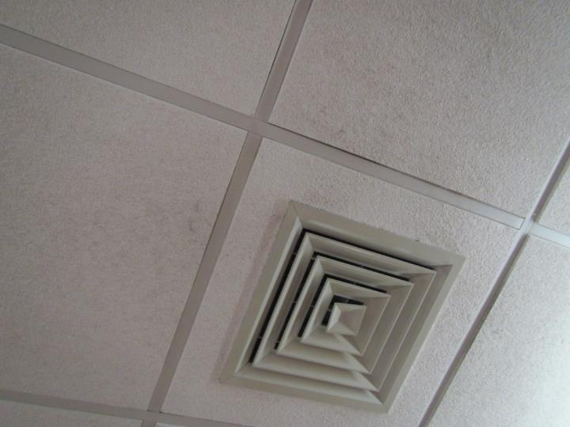
Ceiling-mounted supply air diffuser
Picture 2
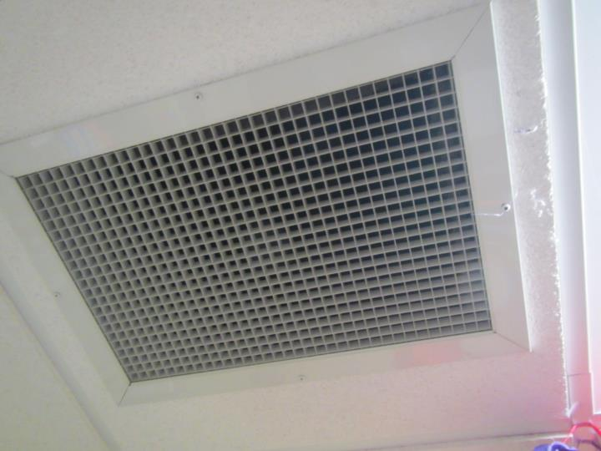
Return air vent
Picture 3
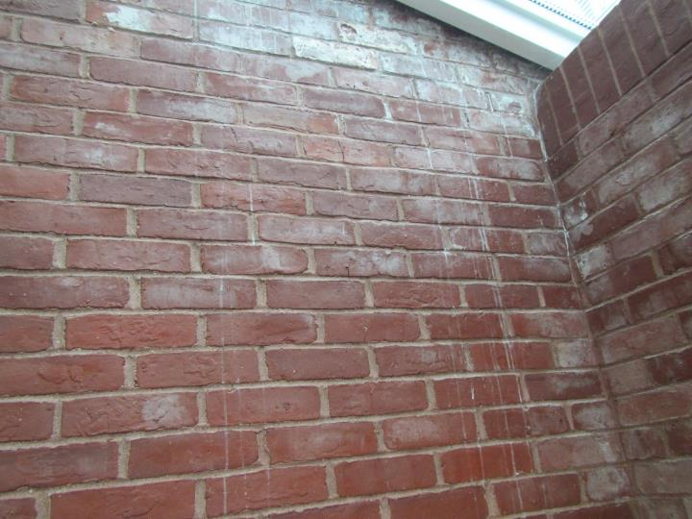
Efflorescence in brickwork of Children’s area
Picture 4
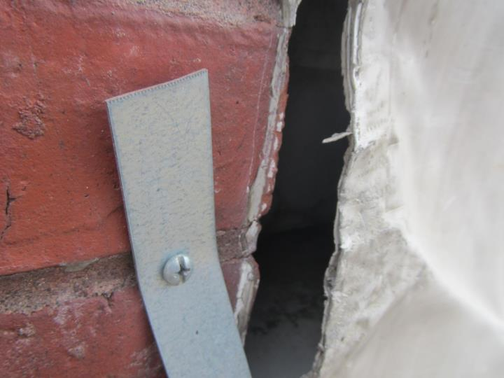
Damaged exterior flashing at base of skylight area
Picture 5
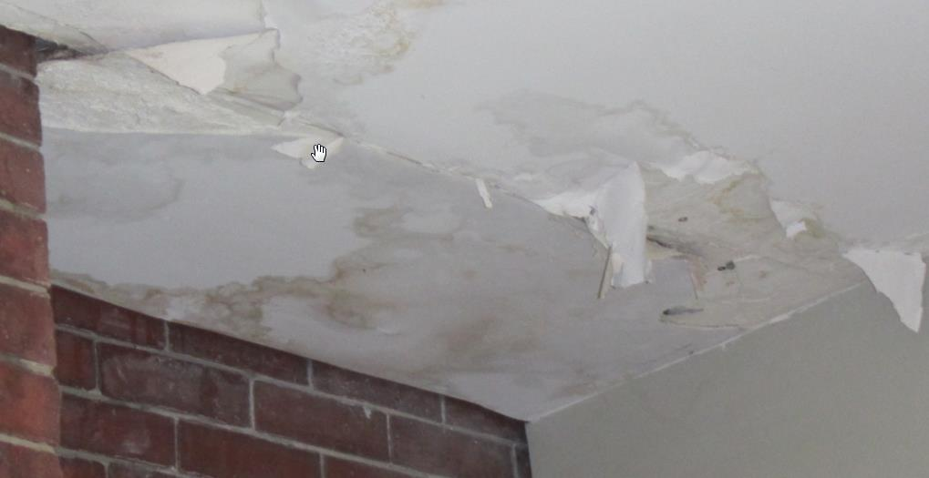
Water-damaged gypsum wallboard (note dark staining)
Picture 6
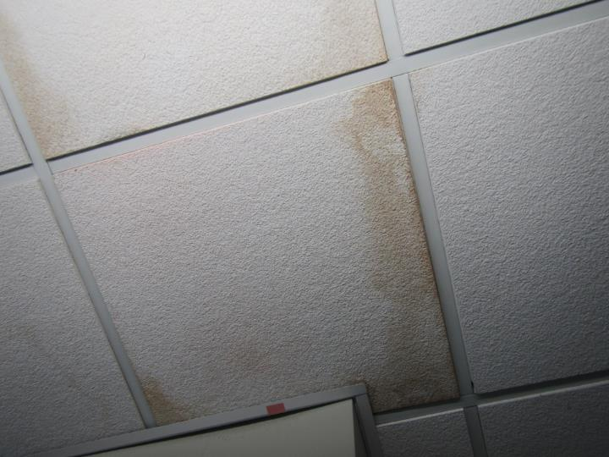
Water-damaged ceiling tiles
Picture 7
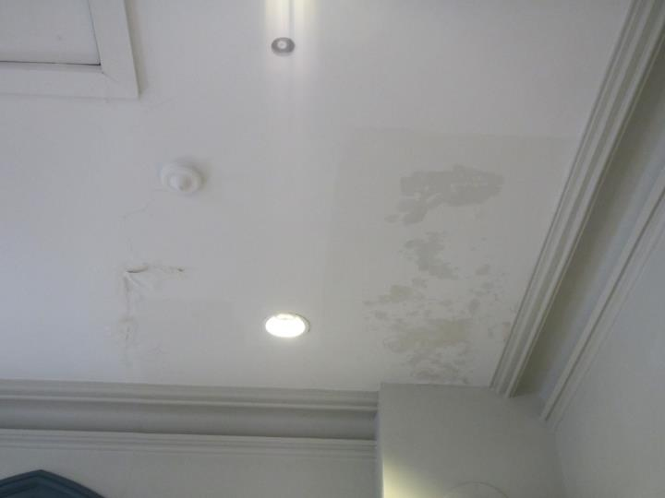
Water-damaged plaster ceiling
Picture 8
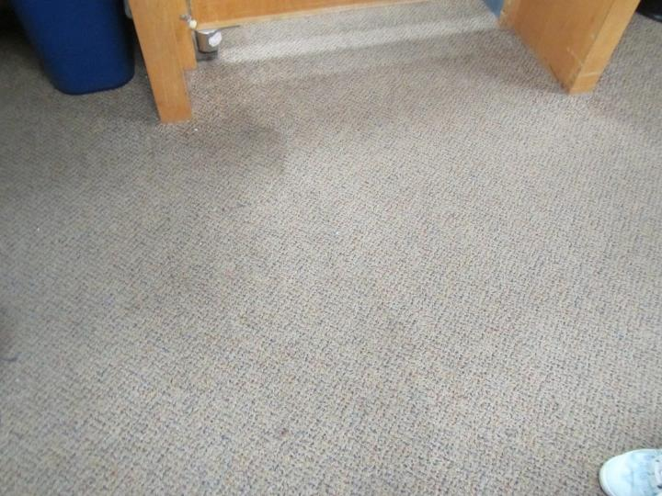
Water-damaged carpeting in Children’s area office
Picture 9
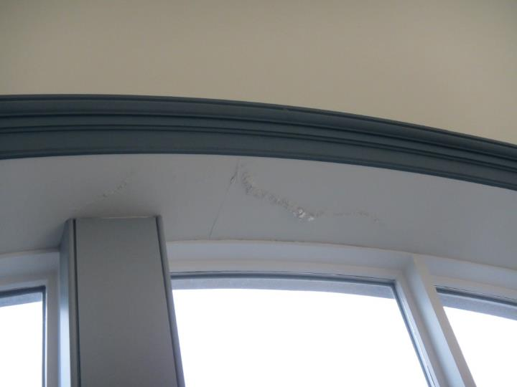
Water-damaged area above window
Picture 10
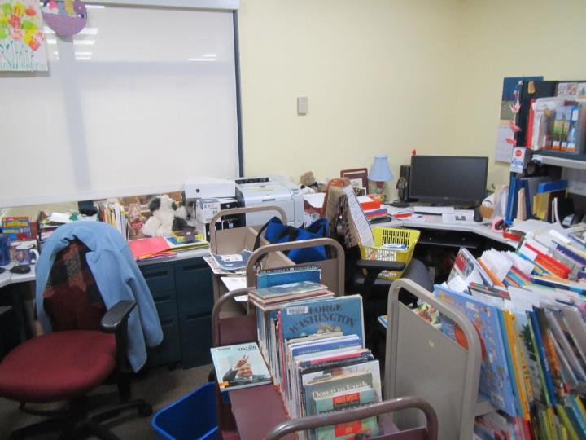
Accumulated items in office area
Picture 11
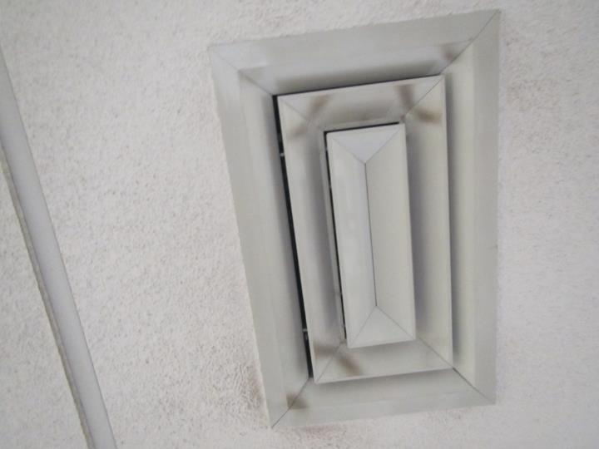
Supply air diffuser showing accumulated dust/debris

Location | Carbon  Dioxide  (ppm) | Carbon Monoxide  (ppm) | Temp  (°F) | Relative  Humidity  (%) | PM2.5  (µg/m³) | TVOC  (ppm) | Occupants  in Room | Windows  Openable | Ventilation |  | Remarks
 |  |  |  |  |  |  |  |  | Supply | Exhaust
Background (outside) | 415 | ND | 61 | 65 | 9 | ND | - | - | - | - | Overcast, windy
Children’s Area (lower level)
–skylight area (right) | 742 | ND | 70 | 55 | 1 | ND | 4 | N | Y | Y | Efflorescence on brick, water infiltration reported skylight/wall
-skylight area (left) | 758 | ND | 70 | 54 | 1 | ND | 2 | N | Y | Y | Carpet
New books | 766 | ND | 71 | 51 | 1 | ND | 11 | N | Y | Y | Carpet
Mysteries | 808 | ND | 72 | 50 | 1 | ND | 0 | N | Y | Y | UF, carpet
Biographies | 774 | ND | 72 | 49 | 1 | ND | 1 | N | Y | Y | UF, carpet
Craft room | 656 | ND | 71 | 50 | 1 | ND | 1 | N | Y | Y | NC, PF, CPs, porous items under sink
Story hour room | 673 | ND | 71 | 51 | 1 | ND | 1 | N | Y | Y | Ceiling tile ajar
Office | 746 | ND | 72 | 48 | 1 | ND | 1 | N | Y | Y | Reported roof drain leak/flood in 2018, WD carpet stains, reports of intermittent sewer odors, AI, water cooler on carpet
Main level
Large print | 632 | ND | 72 | 47 | 1 | ND | 0 | N | Y | Y | Carpet
Comics | 634 | ND | 72 | 48 | 1 | ND | 2 | N | Y | Y
Fiction | 641 | ND | 72 | 48 | 1 | ND | 0 | N | Y | Y
Paperbacks | 628 | ND | 72 | 49 | 1 | ND | 2 | N | Y | Y | UF, carpet, plants
DVD | 622 | ND | 72 | 48 | 1 | ND | 0 | N | Y | Y | Plant on carpet, UF
Morse Room | 661 | ND | 72 | 49 | 2 | ND | 4 | N | Y | Y | Carpet, floor vents
1C | 688 | ND | 72 | 49 | 1 | ND | 0 | N | Y | Y | DEM, floor vents
1B | 653 | ND | 72 | 49 | 1 | ND | 0 | N | Y | Y | NC, floor vents in cage, concrete dome
1A | 639 | ND | 72 | 48 | 1 | ND | 0 | N | Y | Y | Carpet, DEM, large windows
121 | 649 | ND | 71 | 50 | 1 | ND | 2 | Y | Y | Y | AI, DEM, carpet
Trustees | 633 | ND | 70 | 50 | 1 | ND | 2 | Y | Y | Y
122 | 676 | ND | 71 | 51 | 1 | ND | 1 | Y | Y | Y | Carpet, plants
123 | 771 | ND | 72 | 49 | 1 | ND | 0 | N | Y | Y | PF, carpet
126 | 667 | ND | 72 | 48 | 1 | ND | 0 | N | Y | Y | AI
Entrance | 731 | ND | 73 | 48 | 1 | ND | 1 | N | Y | Y | Carpet
Main desk | 651 | ND | 73 | 48 | 1 | ND | 4 | N | Y | Y | NC, PF
Circulation Annex | 673 | ND | 72 | 49 | 2 | ND | 2 | N | Y | Y
Bookmobile | 626 | ND | 71 | 49 | 2 | ND | 0 | N | Y | Y | HS
Second Floor
Prunaret room | 549 | ND | 72 | 47 | 1 | ND | 1 | N | Y | Y | Carpet
Staff area | 566 | ND | 71 | 48 | 1 | ND | 0 | N | Y | Y | Carpet, AI, heater, DEM, WD plaster ceiling
-Foyer outside Prunaret room | - | - | - | - | - | - | - | - | - | - | WD GW at interface of old/new buildings
Info area | 655 | ND | 72 | 48 | 1 | ND | 9 | Y | Y | Y | WD CTs x4, carpet soiled
Teen Room | 620 | ND | 72 | 46 | 1 | ND | 0 | Y | Y | Y | Carpet stains, WD CTs
Stacks 226 | 559 | ND | 72 | 47 | 1 | ND | 0 | Y | Y | Y
Staff | 607 | ND | 71 | 49 | 1 | ND | 3 | Y | Y | Y | Active window leaks, DEM, AI, carpet
Reference Hallway | 622 | ND | 71 | 50 | 1 | ND | 2 | N | Y | Y | CPs, solar glare, PF, WD CT, carpet

