DATA BRIEF
Released: January 2024
Health in the Commonwealth: Mortality, Premature Mortality, and Life Expectancy by Census Tract, 2012-2021

Background
The Registry of Vital Records and Statistics (RVRS) plays a vital role in providing data to improve people’s lives. RVRS registers life-changing events: birth of a child, marriage, divorce, and death. RVRS sits within the Office of Population Health at the Massachusetts Department of Public Health (MA DPH), underscoring our connection to the health of Massachusetts residents. While many people feel that death is too late of an endpoint for policy, targeted programs, or evaluation of healthcare delivery, examining who is dying and where can provide useful and valuable information on health in the Commonwealth.
Mortality and premature mortality (i.e., deaths before age 75) — how many people are dying — are useful and helpful statistics of population health but can be complex and challenging to apply to the individual. Life expectancy at birth (see Methods) — how long a person might expect to live — is a more readily grasped statistic for individual health but is less easily applied as a population-level statistic. Together, these measures can provide a better picture of those dying too soon in the Commonwealth.
While mortality rates, premature mortality rates (PMR), and life expectancy calculations are published statewide in the annual Massachusetts death reports, it is incredibly important to examine health data at the local and even neighborhood level; there are inequities in the social determinants of health within cities and towns that translate into health inequities.
This geographic specificity has its own challenges, as city and town sizes vary substantially. For example, Gosnold had an estimated 70 residents, while Boston had 675,647 in 2020. Census tracts allow us to compare more similarly sized population areas. They encompass anywhere from 2,000 to 8,000 residents and provide better specificity within large cities and towns. Analyzing data by census tract often leads to small number limitations, but aggregating data over several years can improve the stability of the numbers. This analysis pooled 10 years of mortality data to calculate mortality, premature mortality, and life expectancy at the census tract level to get a better picture of health in Massachusetts.
For this data brief, it is important to keep in mind that mortality and PMR are inversely related to life expectancy: higher mortality and PMR indicate worse health, while higher life expectancy indicates better health.

Place Matters
Key Finding #1: Large areas of the Commonwealth enjoy above-average health, while poorer health is concentrated in and immediately around cities.
In this analysis, Dukes County ranked first (i.e., had the best overall health) across mortality, PMR, and life expectancy, followed by Middlesex County and Nantucket. While Dukes and Nantucket Counties are relatively small (approximately 21,000 and 14,000 residents in 2020, respectively), Middlesex County is the largest county in the Commonwealth and home to 1.6 million residents, with some of the best health in the state. It is not a coincidence that these counties also had higher socioeconomic status and better health behaviors and other social determinants of health that promote health and well-being. On the lower end of the rankings overall were Hampden, Bristol, and Worcester Counties (Table 1).
Counties with large cities/towns tend to have lower ranking, as poor health seems to be concentrated in urban areas. For example, most census tracts in Springfield had higher mortality and PMR and lower life expectancy than Massachusetts overall and account for more than half of the census tracts with poor health in Hampden County. The city of Worcester and Worcester County were similar (Figures 1, 6, and 11; Tables 2-4; and Supplementary Tables S1-S3).
Table 1. Mortality, Premature Mortality, and Life Expectancy Rankings
by County, Massachusetts: 2012-2021
County | Rank
 | Overall | Mortality | Premature Mortality | Life Expectancy
Barnstable | 8 | 5 | 11 | 7
Berkshire | 5 | 6 | 8 | 5
Bristol | 13 | 13 | 13 | 13
Dukes | 1 | 1 | 1 | 2
Essex | 7 | 8 | 6 | 6
Franklin | 6 | 3 | 7 | 9
Hampden | 14 | 14 | 14 | 14
Hampshire | 9 | 10 | 5 | 10
Middlesex | 2 | 2 | 3 | 3
Nantucket | 3 | 7 | 2 | 1
Norfolk | 4 | 4 | 4 | 4
Plymouth | 11 | 11 | 9 | 12
Suffolk | 10 | 9 | 12 | 8
Worcester | 12 | 12 | 10 | 11

Key Finding #2: Even within cities and towns, health can change drastically by looking just a few blocks over. Some of these inequities may point to areas where people congregate to seek public health and human services.
The South End neighborhood of Boston has a census tract with the lowest PMR in the state, and also a tract with one of the highest PMRs in Boston. Suffolk County Tract 711.01, in the South End, had a PMR over seven times higher than its neighbor, Suffolk County Tract 706.00 (457.9 and 63.7 premature deaths per 100,000 residents, respectively: Supplementary Table S2). The higher PMR tract is where Boston Medical Center (formed from the merger of Boston University Medical Center Hospital and Boston City Hospital, the oldest municipal hospital in the country), Health Care for the Homeless, the Woods Mullen Shelter, and many other public health and social services are located. It is also the center of the region’s homelessness crises (commonly referred to as Mass and Cass). Those at risk and in need of shelter, substance use treatment, and other healthcare come to Mass and Cass to utilize these safety net services. Just three miles away sits the census tract with the highest PMR in the Commonwealth (Suffolk County Tract 9803.00; 1111.6 premature deaths per 100,000 residents), which includes Franklin Park, the Lemuel Shattuck Hospital, and the Pine Street Inn shelter (Figure 2; Supplemental Table S2).
On the Cape in Barnstable, Barnstable County Tract 153.00 residents have a life expectancy at birth of 74.8 years, while their neighbors six miles away, Barnstable County Tract 130.02 residents have a life expectancy at birth of 82.1 years (Supplemental Table S3). The lower life expectancy tract includes commercial shopping, the regional airport, and some apartment buildings, while the higher life expectancy tract is in the wealthier village of Osterville, which is home to country clubs and beach homes. While this may not be connected to any vulnerable group congregating and seeking public health or social services, a stark difference in health status within a town still reinforces the theme: place does matter.
In fact, researchers examined the association between life expectancy and census tract and found that life expectancy was hyper-local: 70.4%-96.8% of the difference in life expectancy in census tracts across the country was associated with census tracts, rather than counties or even states. Where we live has a huge impact on our health, from the accessibility of grocery stores with fresh produce to environmental hazards.,

History Matters
Key Finding #1: Many gateway cities are struggling with poor health.
Gateway cities are midsize cities that serve as the anchor of regional economies across Massachusetts. Gateway cities include Attleboro, Barnstable, Brockton, Chelsea, Chicopee, Everett, Fall River, Fitchburg, Haverhill, Holyoke, Lawrence, Leominster, Lowell, Lynn, Malden, Methuen, New Bedford, Peabody, Pittsfield, Quincy, Revere, Salem, Springfield, Taunton, Westfield, and Worcester. In decades past, these communities offered their residents a “gateway” to the American Dream via solid middle-class jobs, good public education, and vibrant community life. As these jobs have disappeared over time, residents have struggled with increasing living costs, often with less money to spend on stable and healthy housing and nutritious food, and with increases in crime and violence. All these factors lead to overall poor health.⁷
For example, more than two-thirds of census tracts in the gateway city of Lowell had overall mortality rates higher than Massachusetts overall, while comparably sized Cambridge had nearly two-thirds of census tracts with lower overall mortality rates compared to Massachusetts overall (Figure 1, Supplemental Table S1). The life expectancy in one Lowell census tract is 18.1 years lower than that in the highest life expectancy tract in Cambridge (Supplemental Table S3). What drives these stark differences? The social determinants of health include access to health care, education, high-paying job opportunities, and healthy built and natural environments. For example, according to the 2022 Greater Lowell Community Health Needs Assessment, just over a quarter of adults have a college education and the median household income was approximately $62,000. In comparison, in Cambridge, nearly four in five residents had a college education and the median household income was approximately $103,000., Additionally, according to the Massachusetts Department of Public Health Environmental Public Health Tracking Tool, children in Lowell tested positive for elevated blood lead levels at nearly three times the rate of children in Cambridge; exposure to lead occurs primarily through lead paint and drinking water traveling through lead pipes in older homes.
Key Finding #2: The health of residents of color depends on more than just place.
Inequities in health between residents of color and white residents point to the history of populations, where communities of color have been impacted by institutionalized racism, which manifests itself both in material conditions (i.e., differential access to quality education, stable and healthy housing, gainful employment, quality healthcare, and a clean environment) and access to power (i.e., differential access to information including one’s own history; resources including wealth and organizational infrastructure; and voice including voting rights, representation in government, and control of the media). The patterns of disease and health inequities we see are direct consequences of the ways marginalized groups have to live and work differently than groups of higher socioeconomic status.¹²
In Boston’s Dorchester neighborhood, Hispanic residents in Suffolk County Tract 915.00 had higher overall mortality than Hispanic residents statewide, whereas White non-Hispanic residents had similar mortality to White non-Hispanic residents statewide. Additionally, the Hispanic mortality rate in that census tract was nearly twice that of White non-Hispanic residents living there. While PMR was similar for Hispanic and White non-Hispanic residents, there was an 11.8-year life expectancy gap, with White non-Hispanic residents living longer (Figures 4, 5, 9, 10, 14, and 15; Tables S1-S3).
In Newton, findings were similar for Asian/Pacific Islander non-Hispanic residents in Middlesex County Tract 3739.00. Asian/Pacific Islander non-Hispanic residents in this tract had higher overall mortality and PMR and lower life expectancy than Asian/Pacific Islander non-Hispanic residents statewide. In contrast, their White non-Hispanic neighbors had better health than White non-Hispanic residents statewide. Additionally, mortality and PMR were roughly twice as high for Asian/Pacific Islander non-Hispanic residents compared to White non-Hispanic residents in this tract. There was an 11.1-year gap in life expectancy between these two groups, with White non-Hispanic residents living longer (Figures 2, 5, 7, 10, 12, and 15; Tables S1-S3).
In Milton, Black non-Hispanic residents of Norfolk County Tract 4161.02 had higher mortality and PMR than Black non-Hispanic residents statewide. In contrast, White non-Hispanic residents had better health than White non-Hispanic residents statewide. Additionally, mortality and PMR were roughly twice as high for Black non-Hispanic residents compared to White non-Hispanic residents, and there was an 8.3-year gap in life expectancy between the two groups, with White non-Hispanic residents living longer (Figures 3, 5, 8, 10, 13, and 15; Tables S1-S3).
In communities like Dorchester, for example, residential segregation and limited and under-resourced services limit residents’ opportunities for better health., According to County Health Rankings, certain Suffolk County neighborhoods experienced intentional disinvestment through Federal HOLC Redlining between 1935 and 1940.^{2,,} Research shows that this institutional racism has health impacts: redlining during the mid-20th century in Baltimore was associated with lower present-day life expectancy.
But moving to opportunity does not guarantee better health. Milton and Newton are two wealthy communities that have health-promoting characteristics. Still, these do not seem to be accessible to all residents of the community, reflecting the need for policies that target the systemic racism and roots of inequities, particularly in communities of color.
Key Finding #3: There are places where residents of color achieve better health.
For Black non-Hispanic residents, census tracts in Brockton and Randolph had better health, compared to Black non-Hispanic residents statewide and compared to their White non-Hispanic neighbors (Figures 3, 5, 8, 10, 13, and 15; Tables S1-S3). This could be partly due to the so-called healthy immigrant effect, immigrant health paradox, and the immigrant health advantage where immigrants are healthier than native-born residents of similar sociodemographic traits. Better health may also be due to lower smoking rates and the tight social networks that form when living in an immigrant community.¹⁷ Brockton and Randolph have large populations of Black immigrants, which might contribute to the better health seen in some of the census tracts.
For Hispanic residents, many census tracts in the neighborhood of East Boston, as well as tracts in neighboring Revere, Lynn, and Everett, had better health than Hispanic residents statewide and better health than their White non-Hispanic neighbors (Figures 4, 5, 9, 10, 14, and 15; Tables S1-S3). The healthy immigrant effect might also contribute to these health effects: East Boston, Revere, Lynn, and Everett have large populations of Hispanic immigrants.
More research is needed to explore the unique factors that promote the health of residents of color in these communities.

Conclusions
Place-based and historically based health inequities are widespread throughout the Commonwealth. It is important to investigate what is and is not working to promote the health of Commonwealth residents so that we all may achieve our best health.

Methods
Geocoded mortality data from 2012-2021 closed files were obtained from RVRS. Population estimates for 2012-2019 were obtained from the University of Massachusetts Donahue Institute and DPH; 2019 estimates were used for 2020 and 2021. Ten-year average annual age-adjusted mortality rates, age-adjusted premature mortality rates (PMR; i.e., death before age 75 years), and life expectancies at birth for Massachusetts residents were constructed at the census tract level. Age-adjusted rates are calculated by weighting the age-specific rates for a given year by the age distribution of the U.S. 2000 standard population. The weighted age-specific rates are then added to produce the adjusted rate for all ages combined. Life expectancy at birth — how long a person might expect to live if exposed throughout the rest of their life to the mortality rates observed at one particular period — was calculated using the Chiang II method, including the calculation of 95% confidence intervals for the life expectancies. 95% confidence intervals (CIs) were constructed for overall mortality and PMR following recommended methods by the Center for Disease Control: 1) the normal distribution method for tracts with a large number of deaths (i.e., at least 100 deaths) and 2) the Poisson distribution method for tracts with 5 to 99 deaths over the time period. CIs at the census tract were then compared to the CI for the state overall and assigned to lower, similar, and higher comparison categories. CIs for each racial/ethnic group at the census tract level were compared to the corresponding racial/ethnic group state CI and assigned to lower, similar, and higher comparison categories. Tables of the results are presented in the appendix and include county and city/town information, although not all census tracts fit within a single town’s boundaries. Rankings were determined by ranking the percentage of census tracts in a county with the lowest mortality, lowest PMR, and highest life expectancy. All analyses were conducted using SAS Studio. Data maps were generated using ArcGIS with county and city/town boundaries.
Note that data on American Indian/Alaska Native non-Hispanic residents is presented in Supplementary Tables S1-S3 but not in the brief narrative due to small numbers and relative sparsity of presentable census tracts. Note also that race/ethnicity data reflects what is collected on the death certificate and may, in some instances, reflect assumed race/ethnicity.

Acknowledgements
Special thanks to the efforts of the Registry of Vital Records and Statistics staff, who ensure complete, accurate, and timely data; and to the DPH Bureau of Climate and Environmental Health staff, who performed geocoding and assisted in constructing population denominator files.

Appendix
Table 2. Comparison¹ of Census Tract Mortality Rates by County, Massachusetts: 2012-2021
County | Census Tracts | Lower |  | Similar |  | Higher |  | Not Presented² | Rank
 | Number | Number | % | Number | % | Number | % | Number
Massachusetts | 1472 | 525 | 36% | 546 | 37% | 385 | 26% | 16 | N/A
Barnstable | 56 | 26 | 46% | 20 | 36% | 10 | 18% | 0 | 5
Berkshire | 39 | 16 | 41% | 11 | 28% | 12 | 31% | 0 | 6
Bristol | 125 | 21 | 17% | 46 | 37% | 58 | 46% | 0 | 13
Dukes | 4 | 3 | 75% | 1 | 25% | 0 | 0% | 0 | 1
Essex | 162 | 59 | 36% | 58 | 36% | 45 | 28% | 0 | 8
Franklin | 18 | 9 | 50% | 5 | 28% | 4 | 22% | 0 | 3
Hampden | 103 | 14 | 14% | 37 | 36% | 52 | 50% | 0 | 14
Hampshire | 36 | 10 | 28% | 18 | 50% | 6 | 17% | 2 | 10
Middlesex | 318 | 172 | 54% | 106 | 33% | 39 | 12% | 1 | 2
Nantucket | 5 | 2 | 40% | 3 | 60% | 0 | 0% | 0 | 7
Norfolk | 130 | 61 | 47% | 43 | 33% | 26 | 20% | 0 | 4
Plymouth | 100 | 24 | 24% | 34 | 34% | 42 | 42% | 0 | 11
Suffolk | 204 | 69 | 34% | 93 | 46% | 31 | 15% | 11 | 9
Worcester | 172 | 39 | 23% | 71 | 41% | 60 | 35% | 2 | 12

Table 3. Comparison¹ of Census Tract Premature Mortality Rates by County, Massachusetts: 2012-2021
County | Census Tracts | Lower |  | Similar |  | Higher |  | Not Presented² | Rank
 | Number | Number | % | Number | % | Number | % | Number
Massachusetts | 1472 | 490 | 33% | 556 | 38% | 406 | 28% | 20 | N/A
Barnstable | 56 | 13 | 23% | 31 | 55% | 11 | 20% | 1 | 11
Berkshire | 39 | 12 | 31% | 14 | 36% | 13 | 33% | 0 | 8
Bristol | 125 | 15 | 12% | 49 | 39% | 61 | 49% | 0 | 13
Dukes | 4 | 4 | 100% | 0 | 0% | 0 | 0% | 0 | 1
Essex | 162 | 58 | 36% | 59 | 36% | 45 | 28% | 0 | 6
Franklin | 18 | 6 | 33% | 7 | 39% | 5 | 28% | 0 | 7
Hampden | 103 | 12 | 12% | 32 | 31% | 58 | 56% | 1 | 14
Hampshire | 36 | 15 | 42% | 13 | 36% | 5 | 14% | 3 | 5
Middlesex | 318 | 175 | 55% | 110 | 35% | 32 | 10% | 1 | 3
Nantucket | 5 | 3 | 60% | 2 | 40% | 0 | 0% | 0 | 2
Norfolk | 130 | 66 | 51% | 42 | 32% | 22 | 17% | 0 | 4
Plymouth | 100 | 28 | 28% | 35 | 35% | 37 | 37% | 0 | 9
Suffolk | 204 | 41 | 20% | 100 | 49% | 51 | 25% | 12 | 12
Worcester | 172 | 42 | 24% | 62 | 36% | 66 | 38% | 2 | 10

NOTES: 1. Comparisons to residents overall were based on 95% confidence intervals (see Methods). 2. Rates and comparisons not calculated for tracts with fewer than 5 deaths.

Table 4. Comparison¹ of Census Tract Life Expectancy at Birth by County, Massachusetts: 2012-2021
County | Census Tracts | Lower |  | Similar |  | Higher |  | Not Presented² | Rank
 | Number | Number | % | Number | % | Number | % | Number
Massachusetts | 1472 | 403 | 27% | 501 | 34% | 544 | 37% | 24 | N/A
Barnstable | 56 | 11 | 20% | 23 | 41% | 21 | 38% | 1 | 7
Berkshire | 39 | 14 | 36% | 10 | 26% | 15 | 38% | 0 | 5
Bristol | 125 | 62 | 50% | 39 | 31% | 24 | 19% | 0 | 13
Dukes | 4 | 0 | 0% | 1 | 25% | 3 | 75% | 0 | 2
Essex | 162 | 46 | 28% | 55 | 34% | 61 | 38% | 0 | 6
Franklin | 18 | 5 | 28% | 7 | 39% | 6 | 33% | 0 | 9
Hampden | 103 | 53 | 51% | 35 | 34% | 14 | 14% | 1 | 14
Hampshire | 36 | 5 | 14% | 18 | 50% | 10 | 28% | 3 | 10
Middlesex | 318 | 38 | 12% | 88 | 28% | 189 | 59% | 3 | 3
Nantucket | 5 | 0 | 0% | 1 | 20% | 4 | 80% | 0 | 1
Norfolk | 130 | 23 | 18% | 42 | 32% | 65 | 50% | 0 | 4
Plymouth | 100 | 41 | 41% | 36 | 36% | 22 | 22% | 1 | 12
Suffolk | 204 | 38 | 19% | 85 | 42% | 68 | 33% | 13 | 8
Worcester | 172 | 67 | 39% | 61 | 35% | 42 | 24% | 2 | 11
NOTES: 1. Comparisons to residents overall were based on 95% confidence intervals (see Methods). 2. Life expectancy not calculated for tracts with fewer than 5 deaths or with no estimated population in a particular age group.

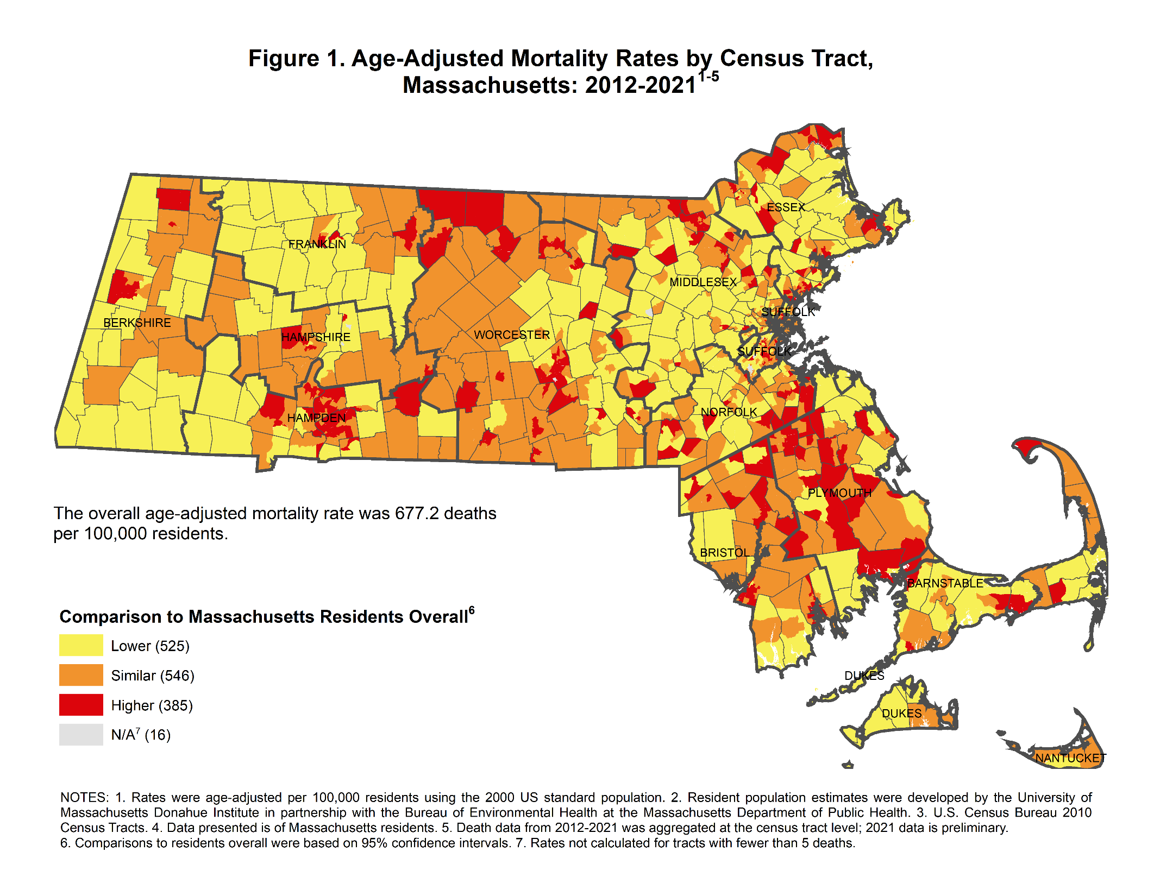
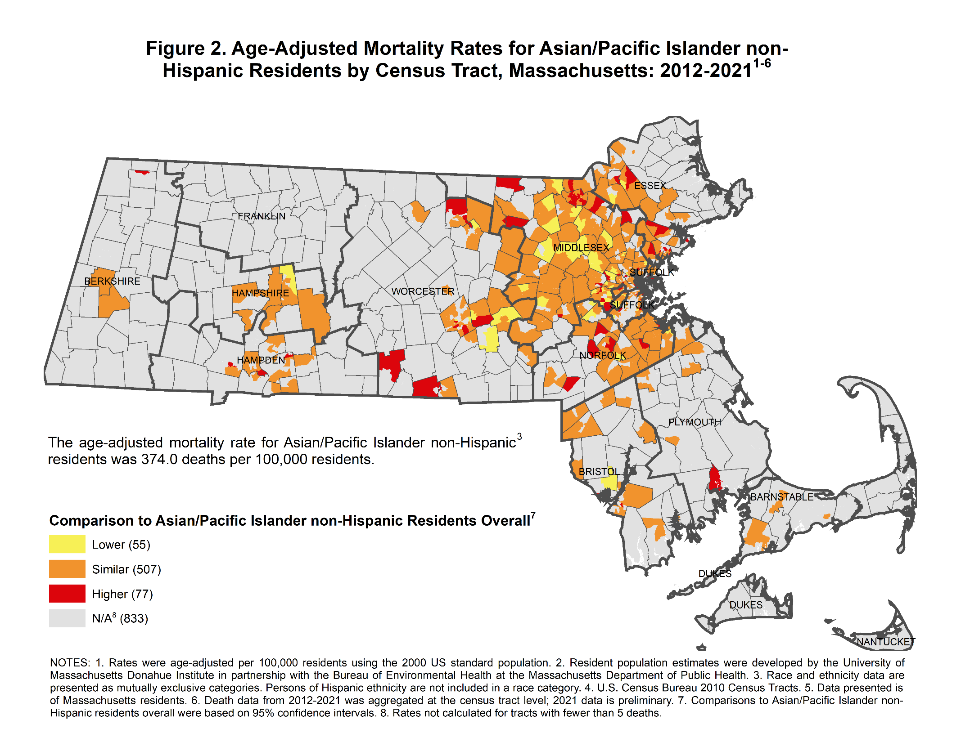
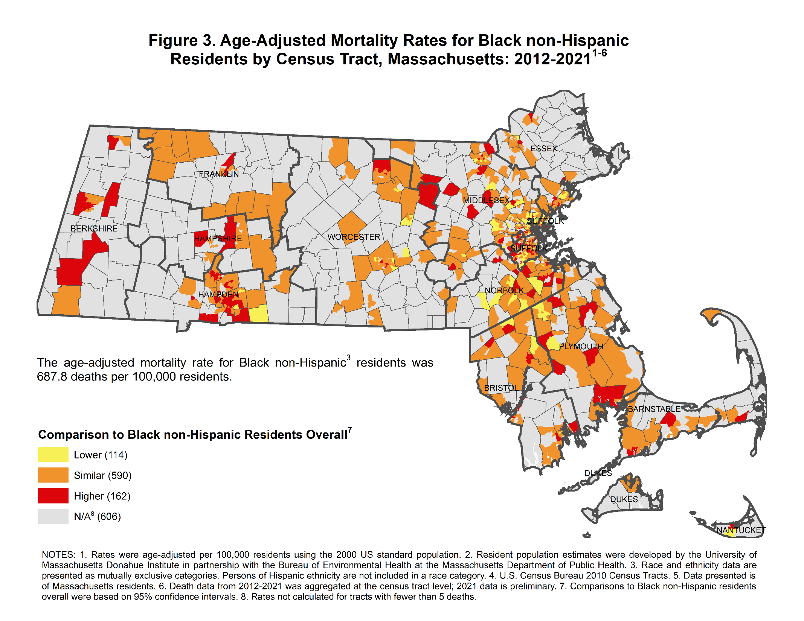
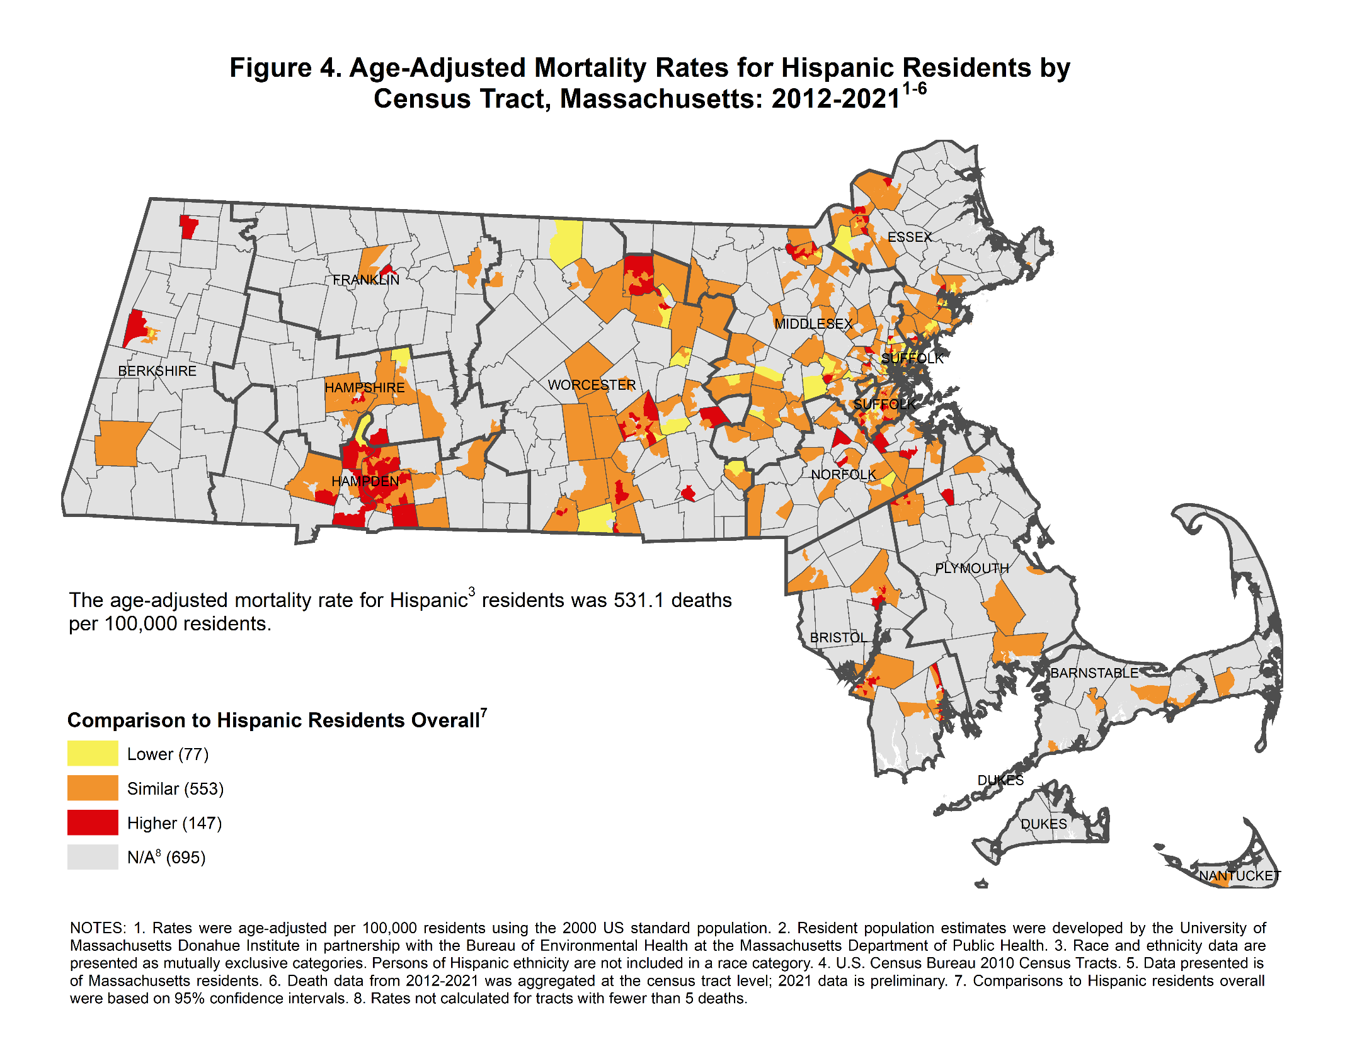
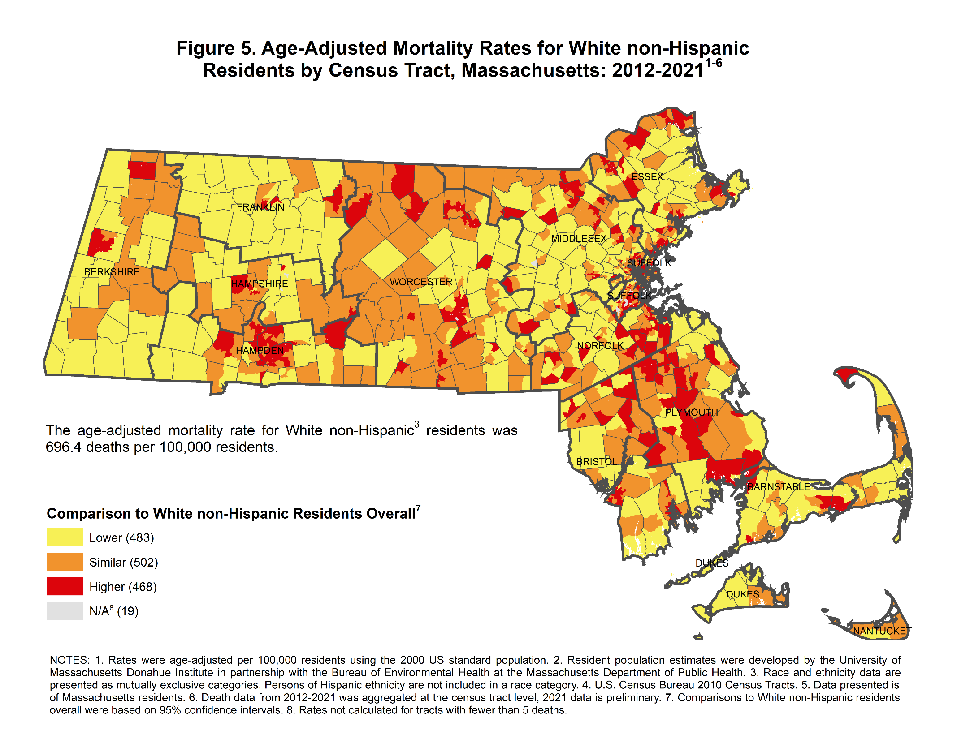
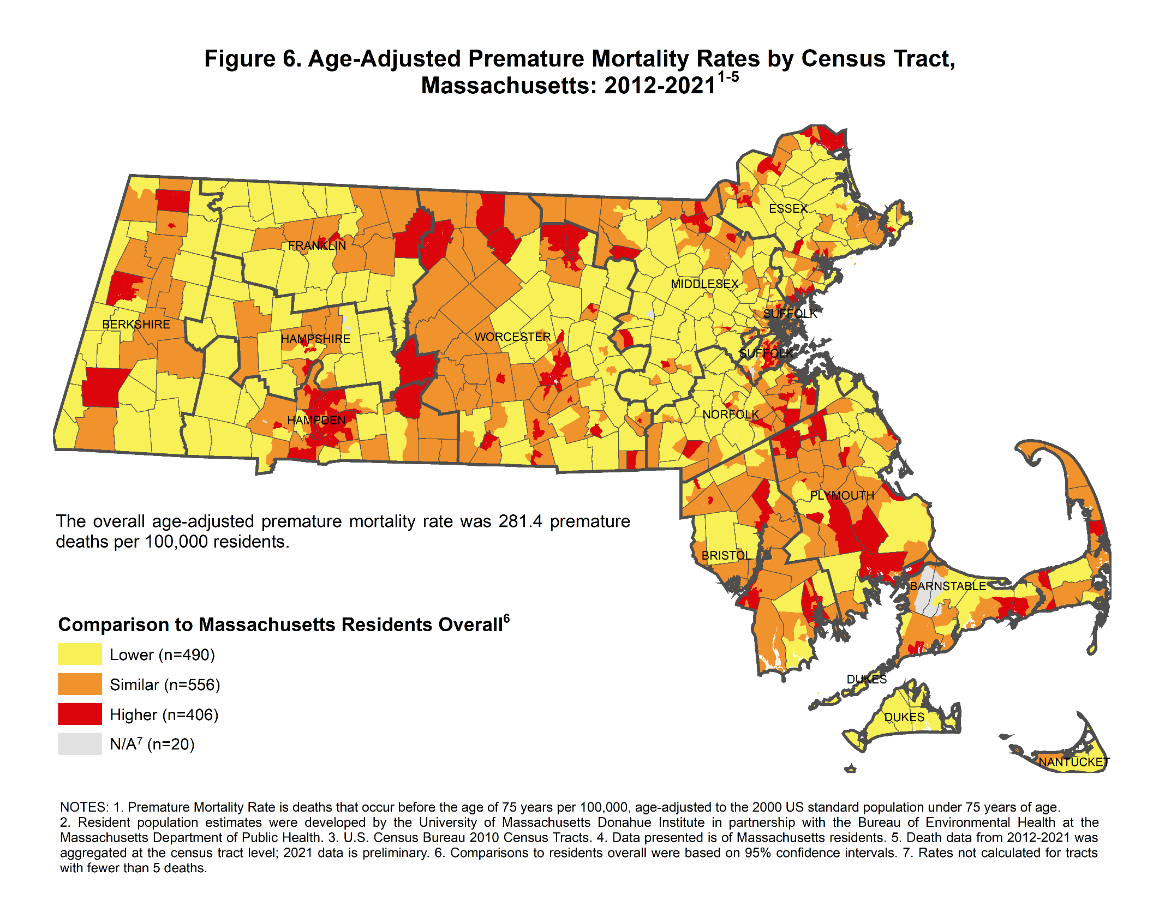
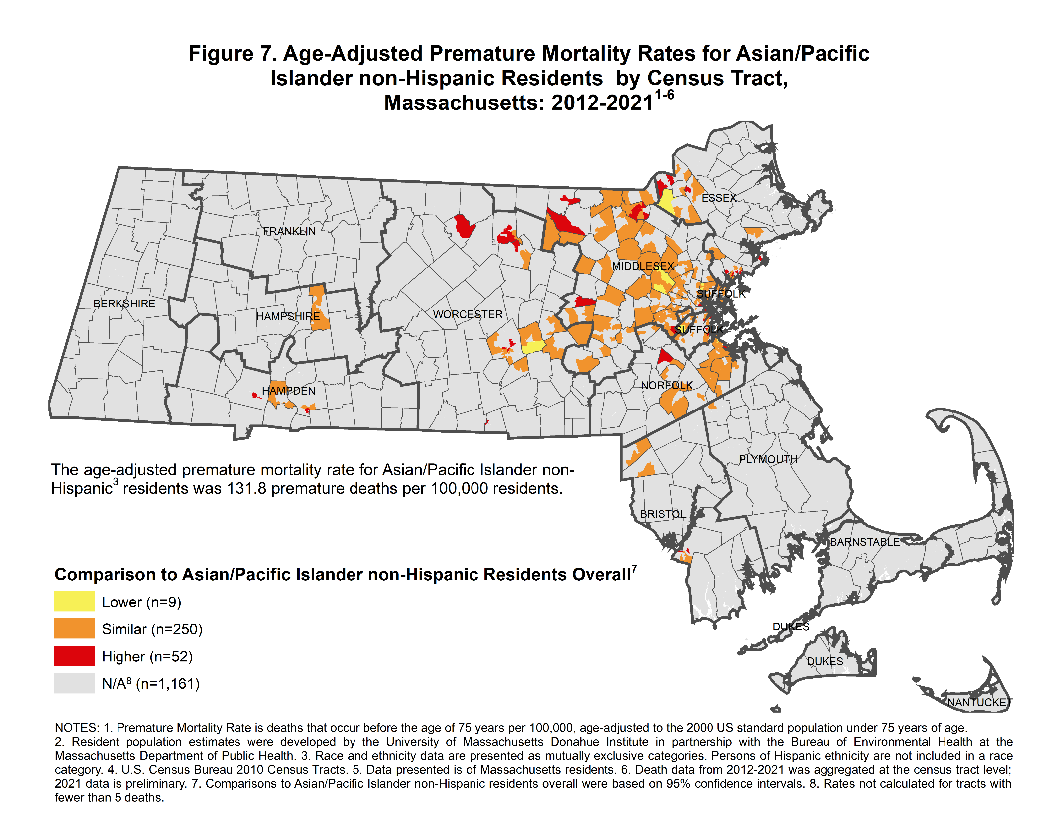
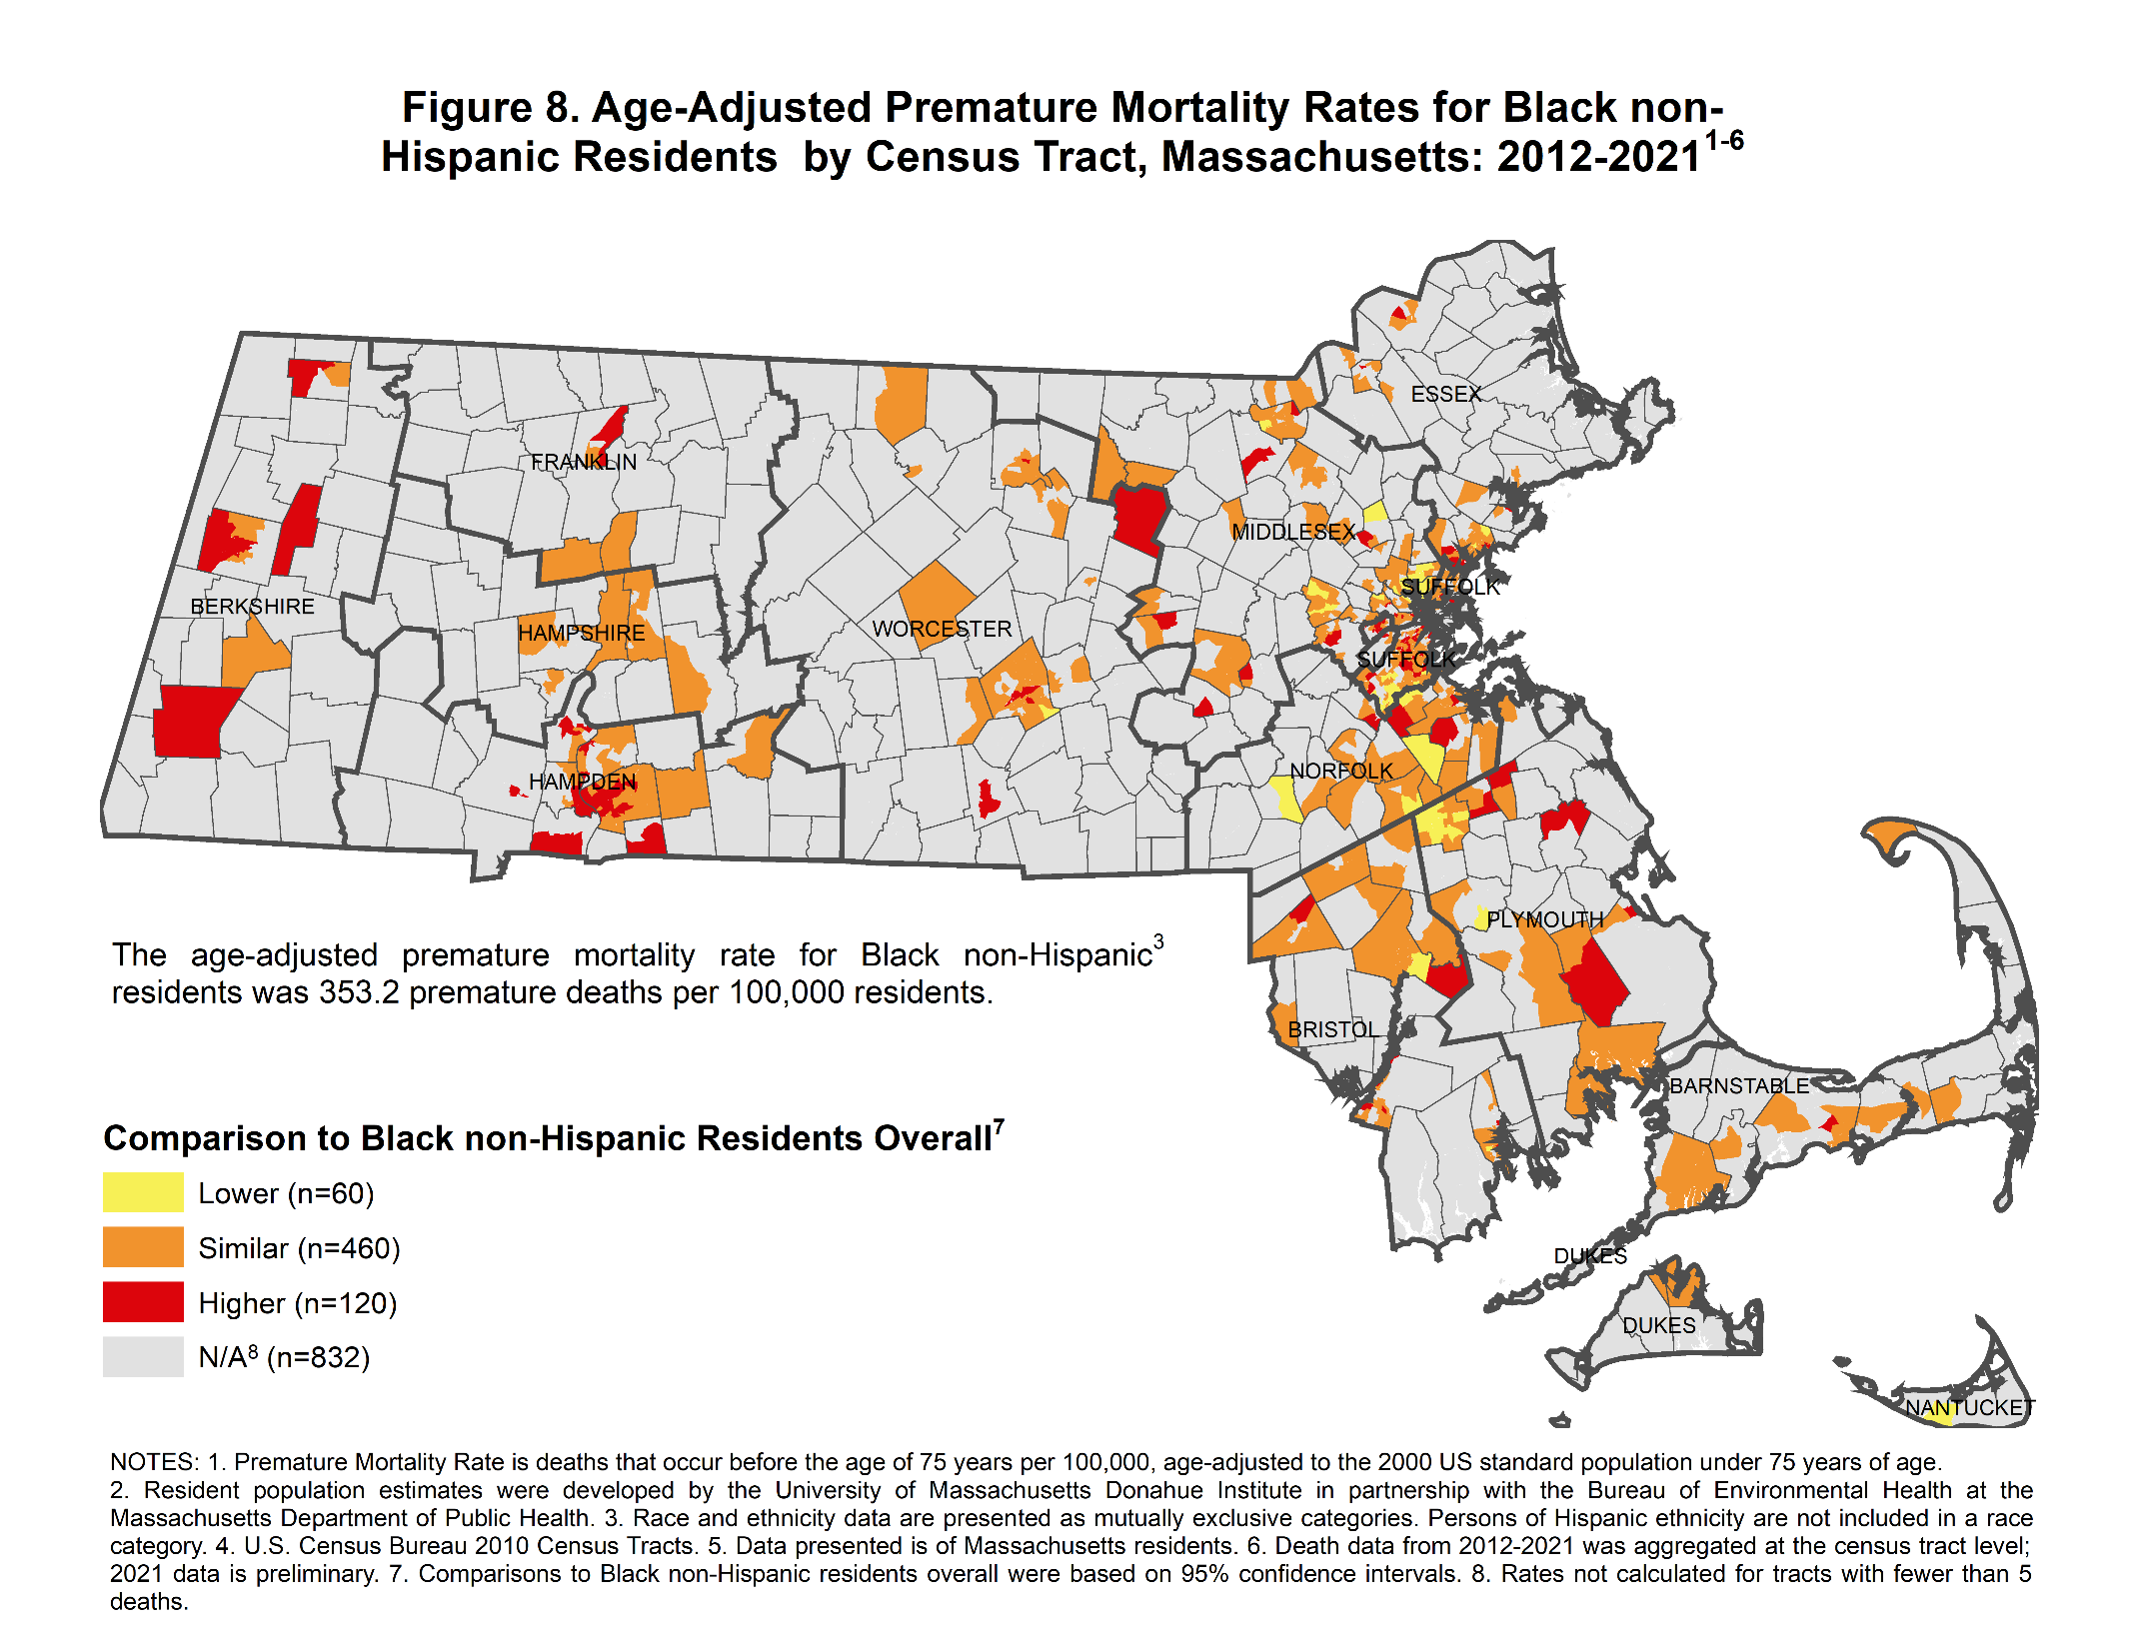
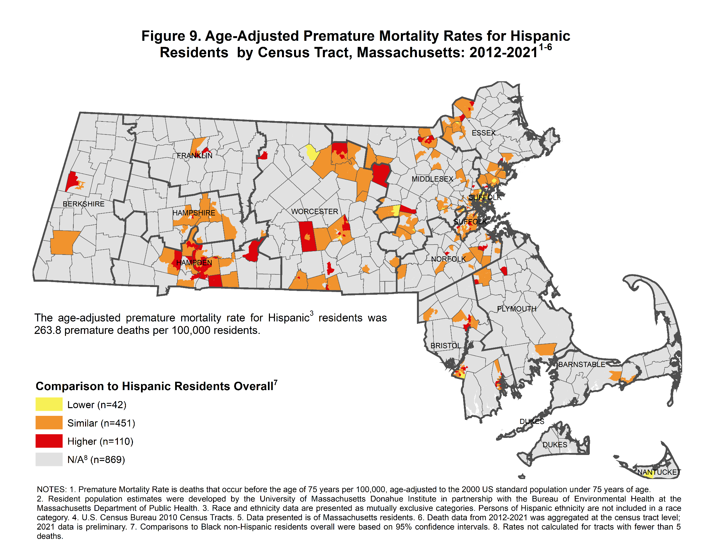
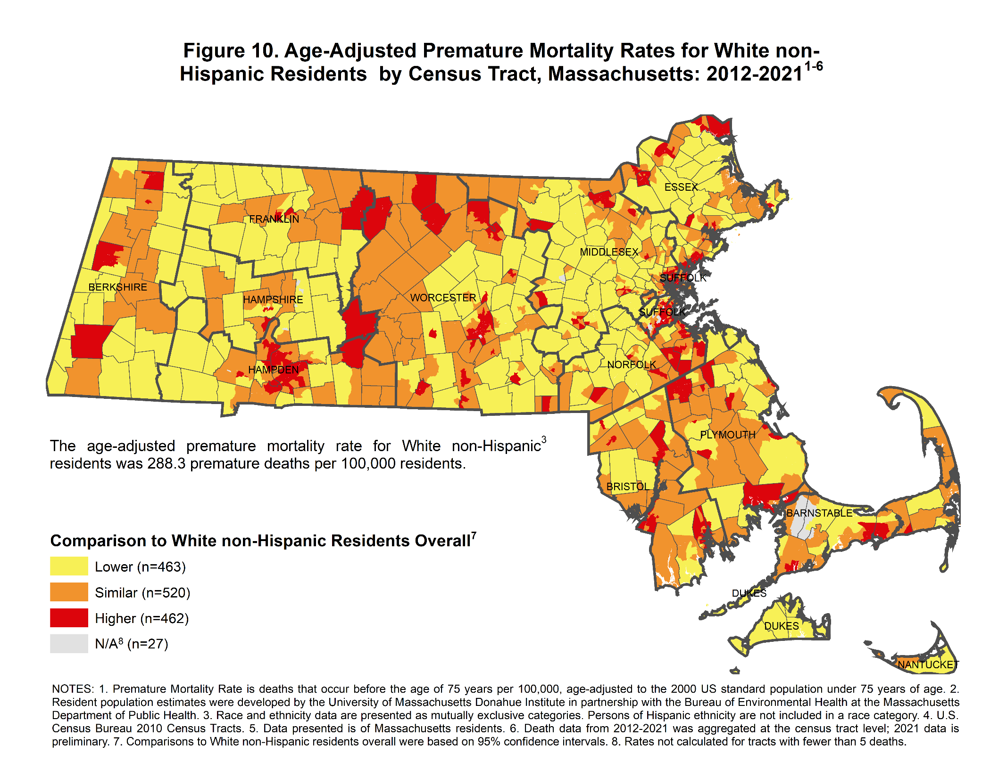
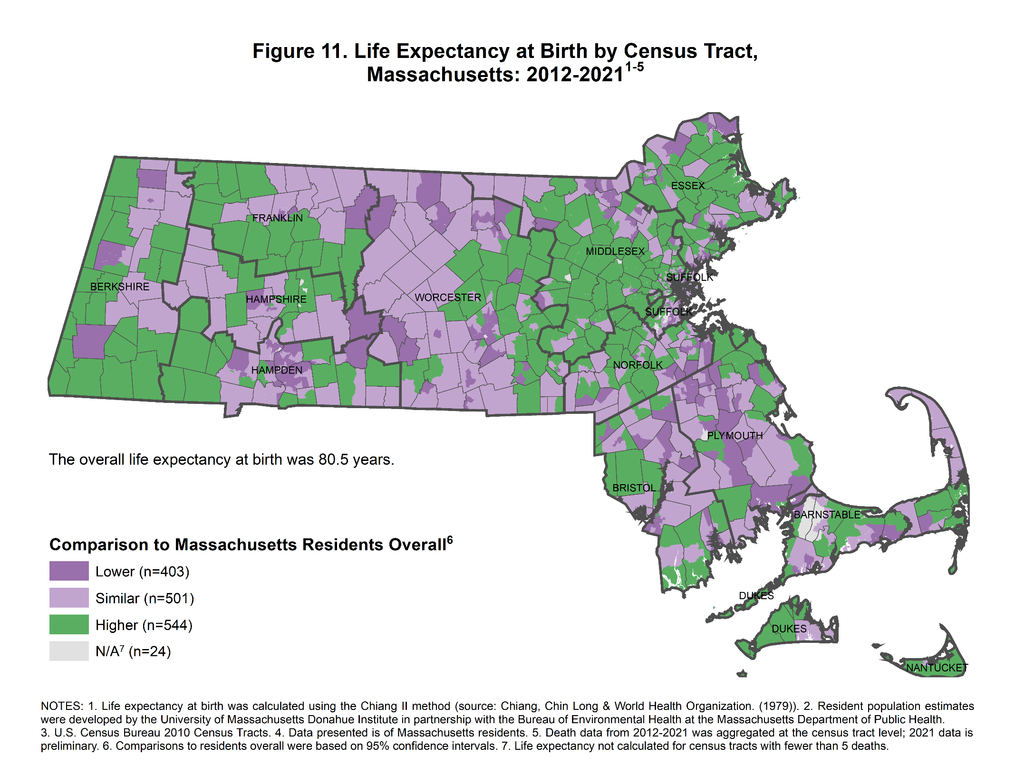
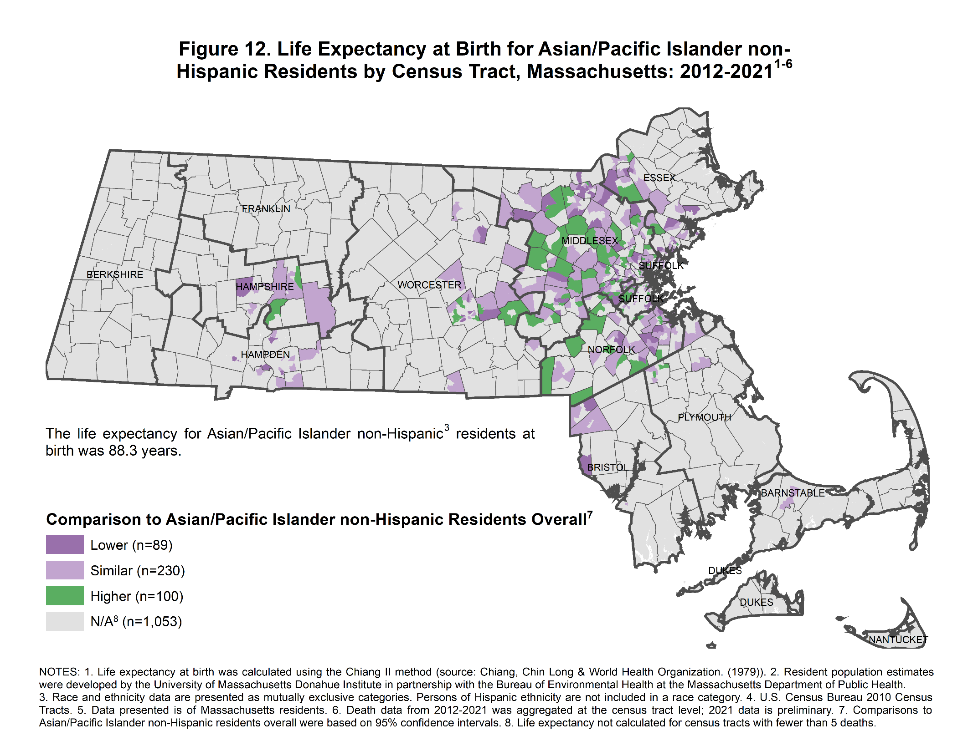
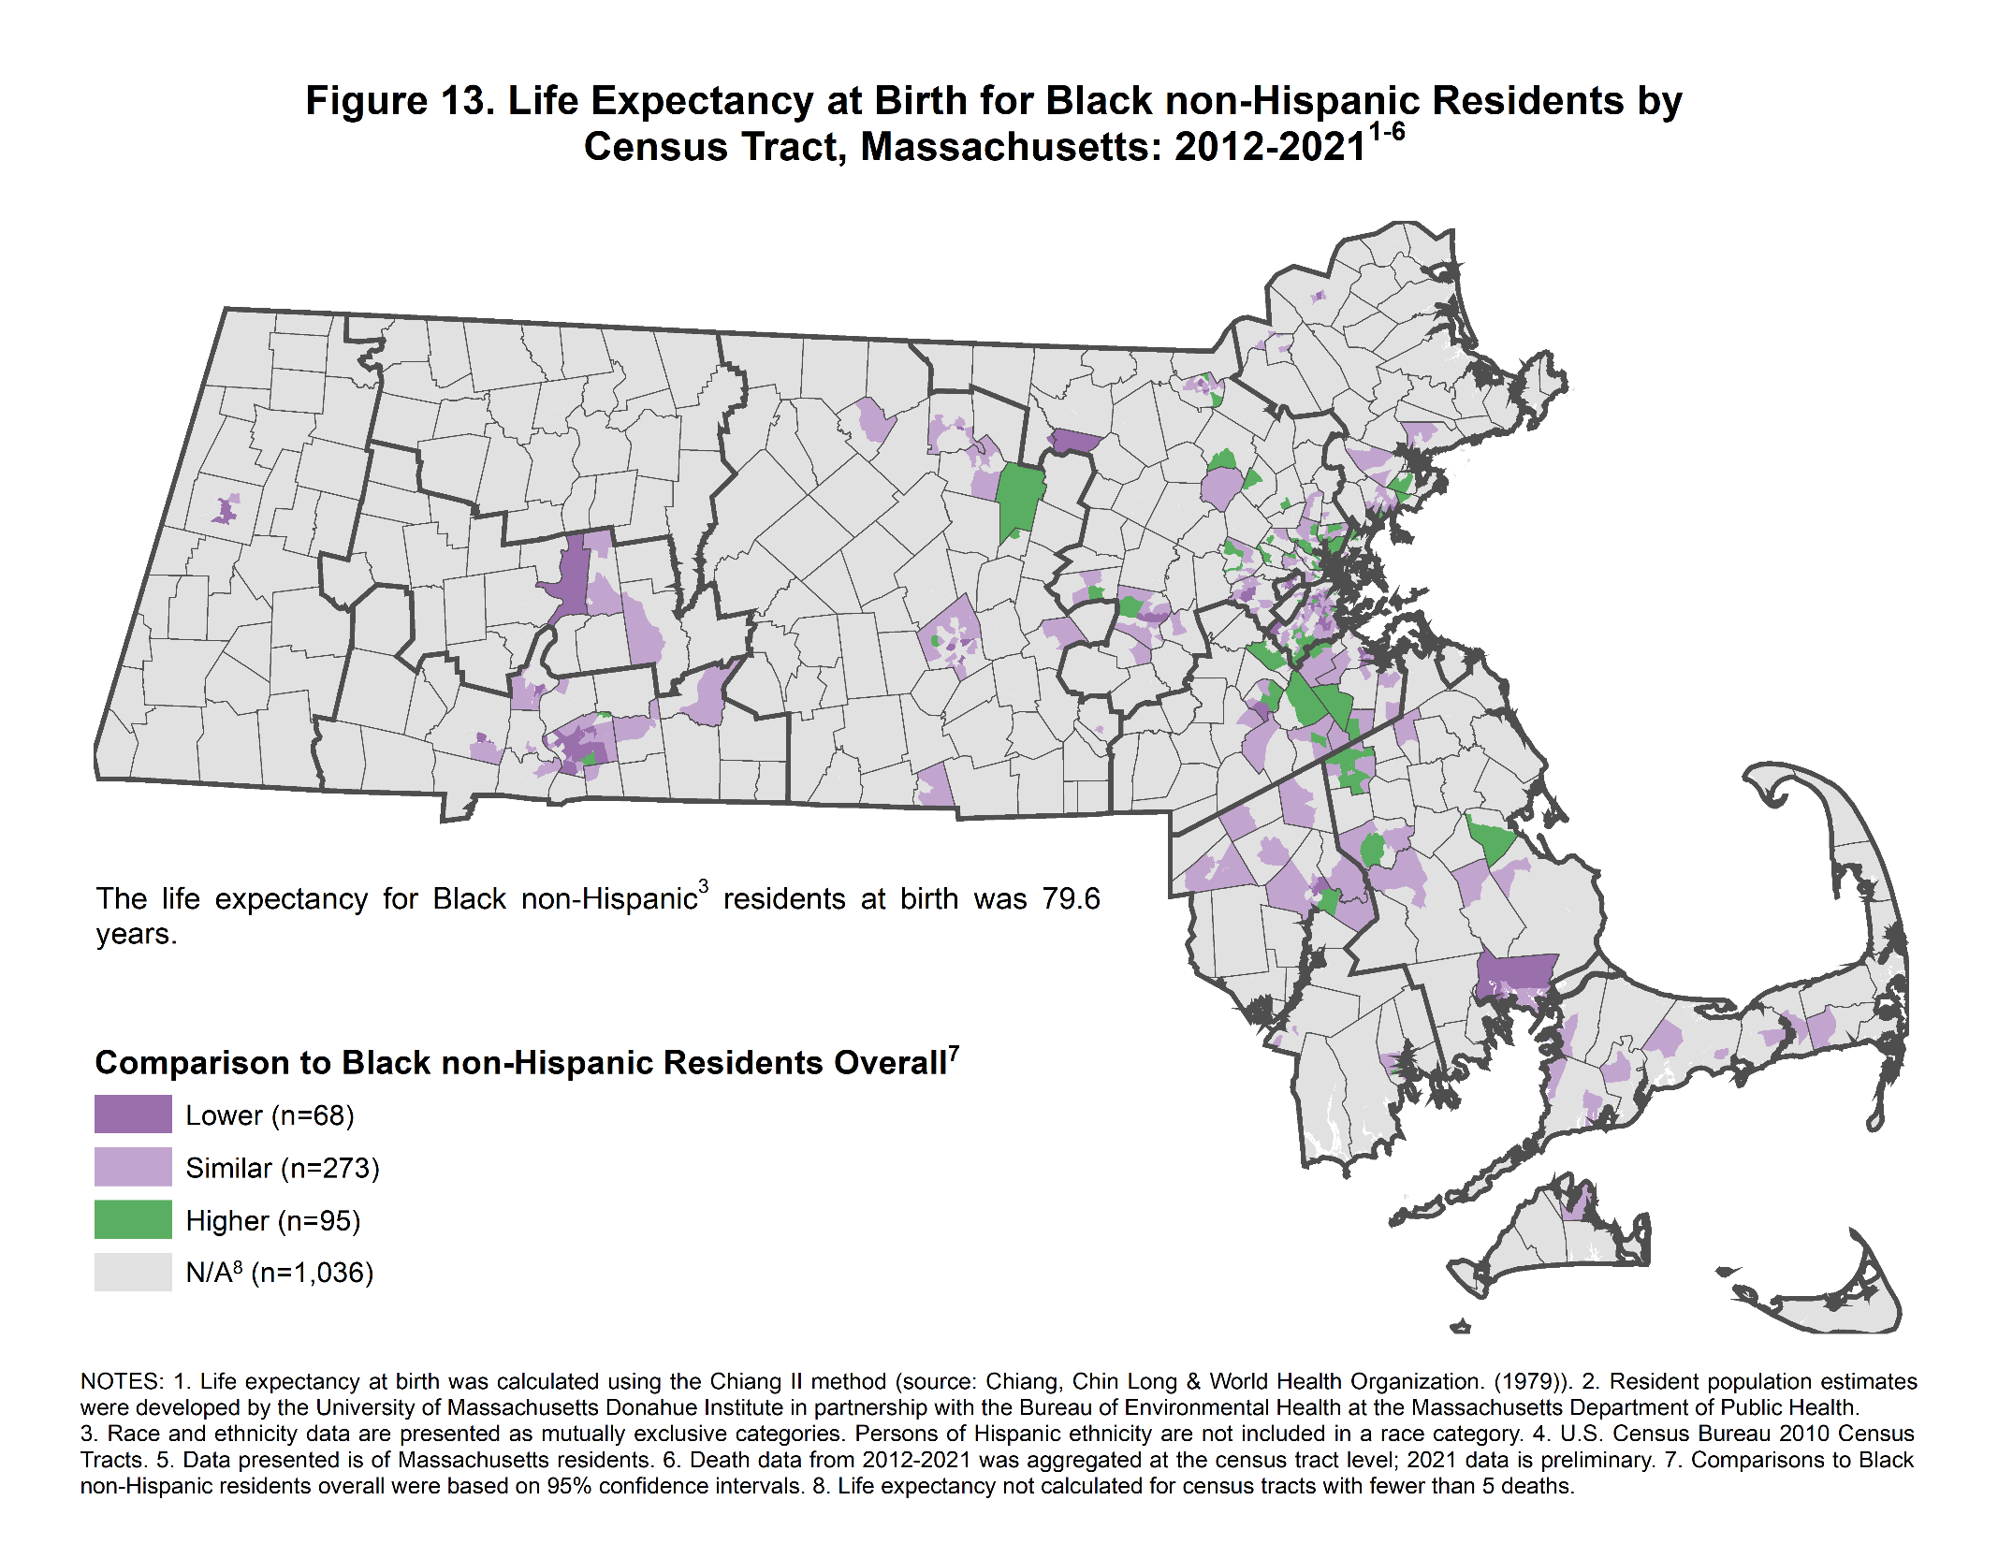
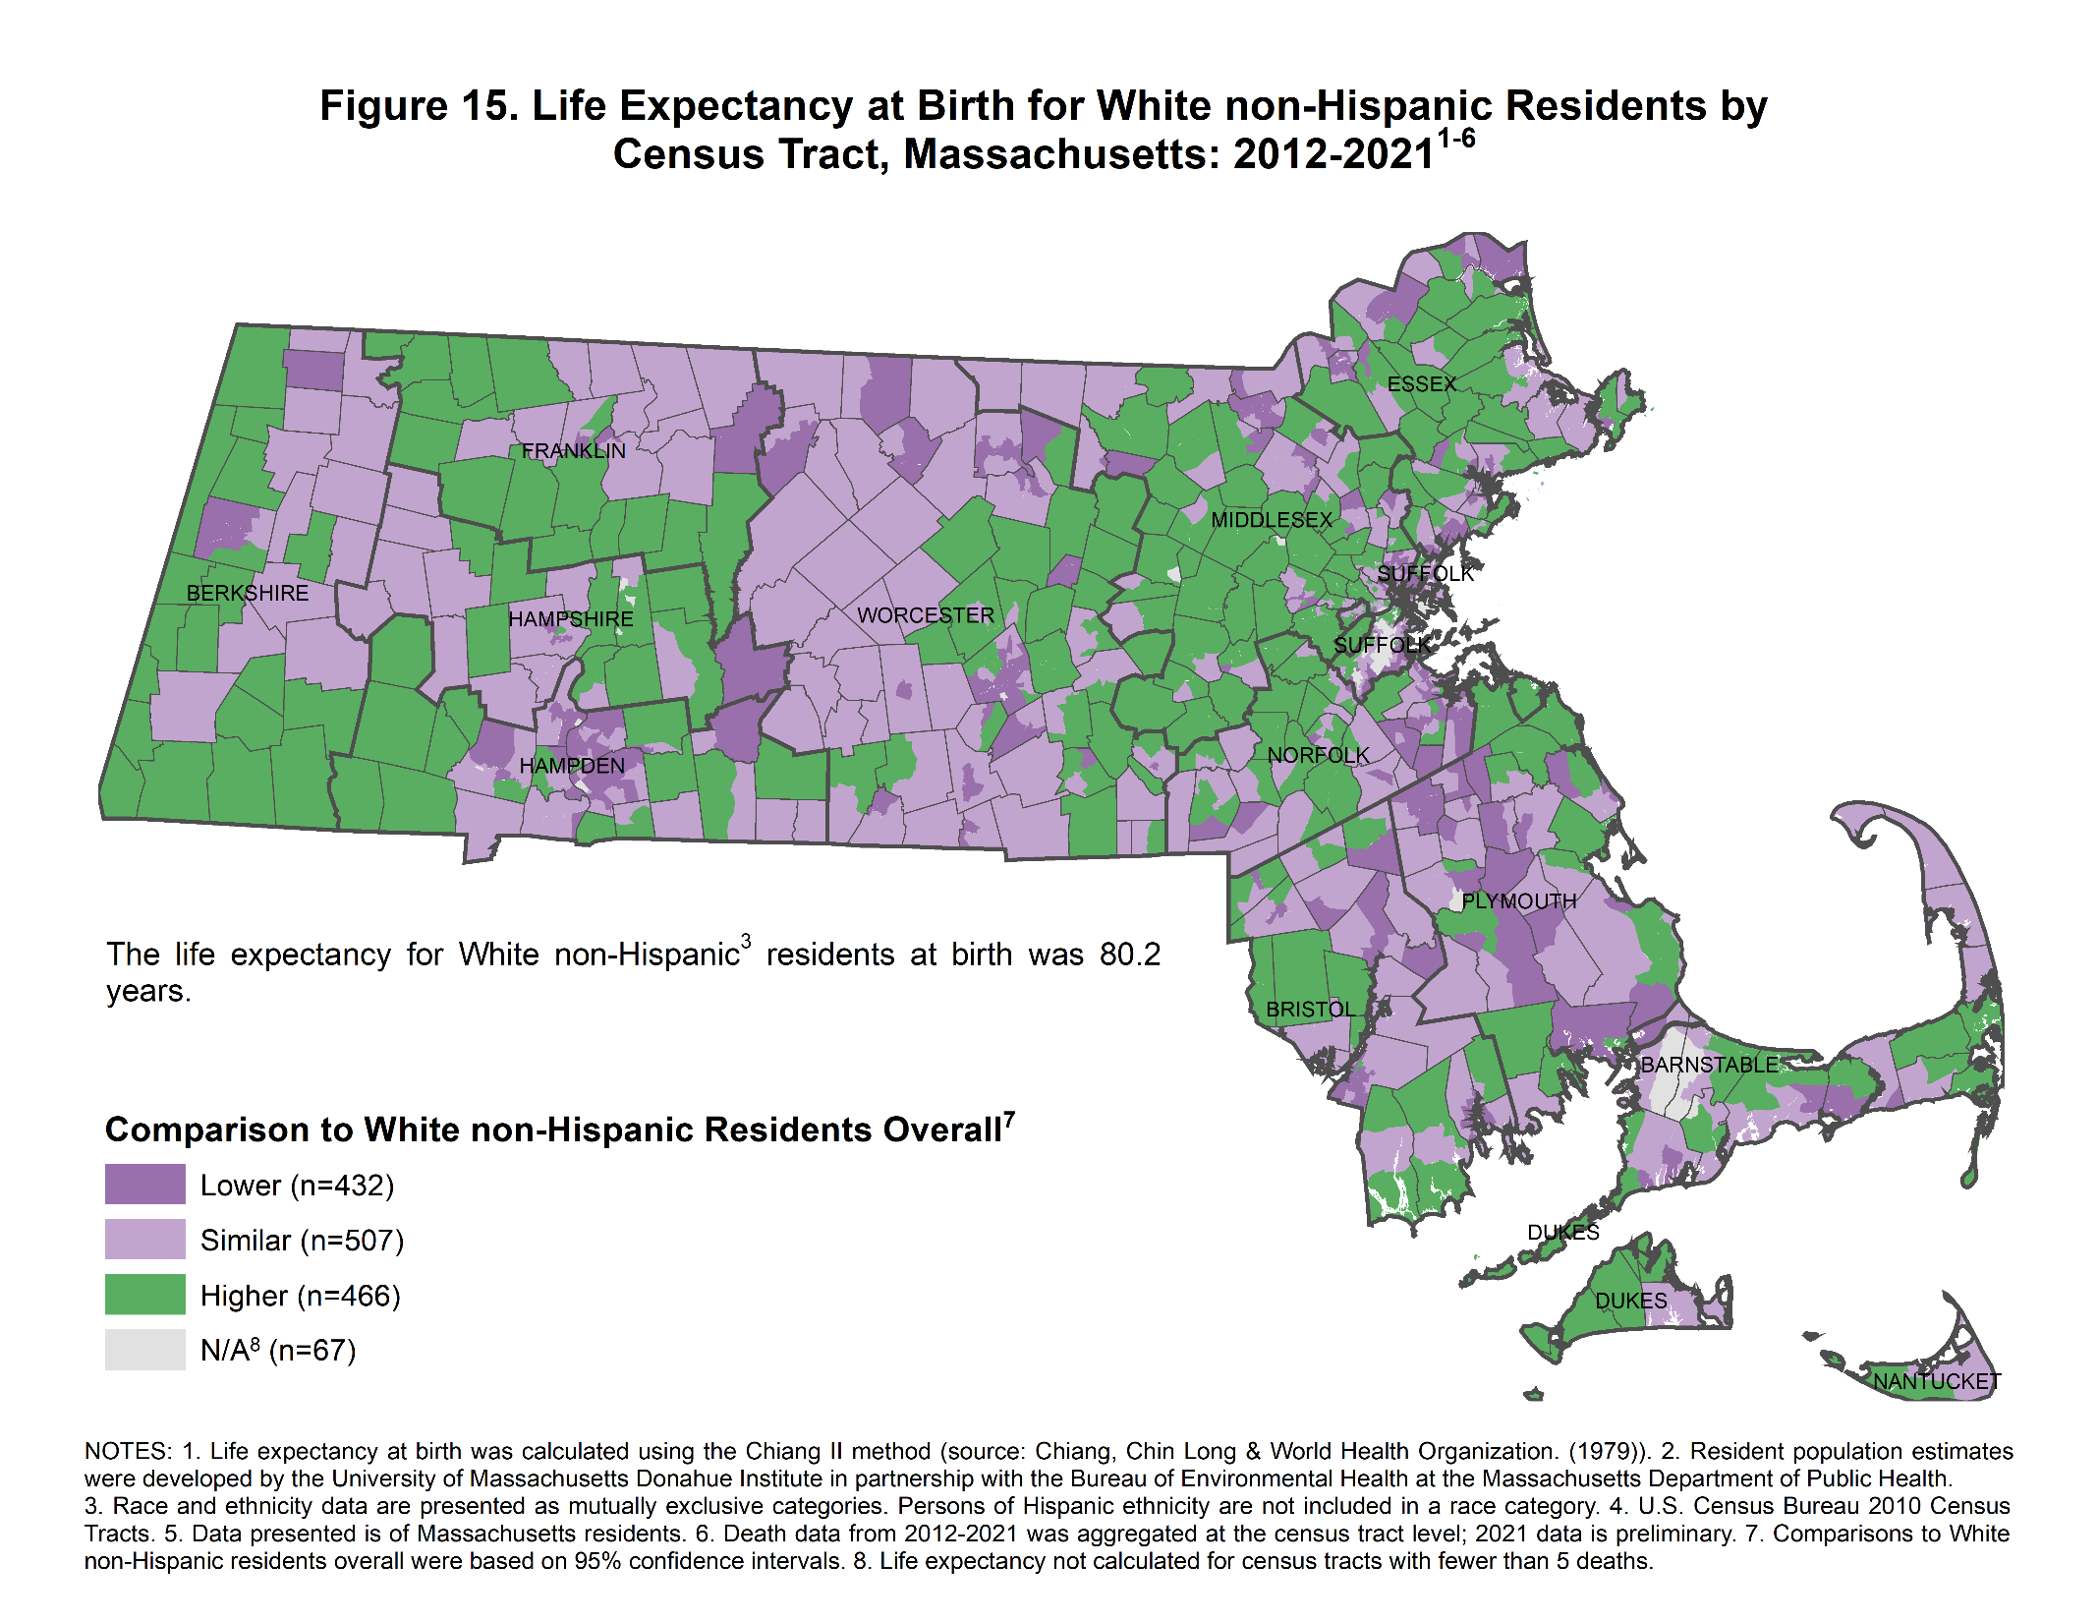

Strate S, Renski H, Peake T, Murphy JJ, Zaldonis P. Small area population estimates for 2011 through 2020. [White Paper]. Population Estimates Program, Economic and Public Policy Research, University of Massachusetts Donahue Institute. 2016.
Massachusetts. County Health Rankings & Roadmaps. Accessed November 9, 2023. https://www.countyhealthrankings.org/explore-health-rankings/massachusetts?year=2023.
Boing AF, Boing AC, Cordes J, Kim R, Subramanian SV. Quantifying and explaining variation in life expectancy at census tract, county, and state levels in the United States. Proc Natl Acad Sci U S A. 2020 Jul 28;117(30):17688-17694. doi: 10.1073/pnas.2003719117.
Lovasi GS, Johnson NJ, Altekruse SF, Hirsch JA, Moore KA, Brown JR, Rundle AG, Quinn JW, Neckerman K, Siscovick DS. Healthy food retail availability and cardiovascular mortality in the United States: a cohort study. BMJ Open. 2021 Jul 9;11(7):e048390. doi: 10.1136/bmjopen-2020-048390.
Brender JD, Maantay JA, Chakraborty J. Residential proximity to environmental hazards and adverse health outcomes. Am J Public Health. 2011;101 Suppl 1(Suppl 1):S37-S52. doi:10.2105/AJPH.2011.300183.
About the Gateway Cities. MassINC. 2023. Accessed August 9, 2023. https://massinc.org/our-work/policy-center/gateway-cities/about-the-gateway-cities/.
Broadbent P, Thomson R, Kopasker D, et al. The public health implications of the cost-of-living crisis: outlining mechanisms and modelling consequences. Lancet Reg Health Eur. 2023;27:100585. doi:10.1016/j.lanepe.2023.100585
Tello H, D’Entremont K, Clermont A, Goldberg D. 2022 Greater Lowell Community Health Needs Assessment. Tufts Medicine Lowell General Hospital; 2022. Accessed November 9, 2023. https://www.tuftsmedicine.org/sites/default/files/2023-11/2022-greater-lowell-community-health-needs-assessment-v6a_0.pdf.
Cambridge Health Alliance 2022 Regional Wellbeing Assessment: Cambridge Community Data Profile. Cambridge Health Alliance; 2022. Accessed November 9, 2023. https://drive.google.com/file/d/1SQqRqMxHUVgTrv6ckODDpVpqs4bS7Bdh/view.
Cambridge, Lowell. Massachusetts Environmental Public Health Tracking. Accessed December 22, 2023. https://matracking.ehs.state.ma.us/Environmental-Data/ej-vulnerable-health/environmental-justice.html
Krieger N. Proximal, distal, and the politics of causation: what's level got to do with it?. Am J Public Health. 2008;98(2):221-230. doi:10.2105/AJPH.2007.111278
Joshi A, Wilson LE, Pinheiro LC, Judd S, Akinyemiju T. Association of racial residential segregation with all-cause and cancer-specific mortality in the reasons for geographic and racial differences in stroke (REGARDS) cohort study. SSM Popul Health. 2023;22:101374. Published 2023 Mar 31. doi:10.1016/j.ssmph.2023.101374
Schwartz GL, Wang G, Kershaw KN, McGowan C, Kim MH, Hamad R. The long shadow of residential racial segregation: Associations between childhood residential segregation trajectories and young adult health among Black US Americans. Health Place. 2022;77:102904. doi:10.1016/j.healthplace.2022.102904
Joshi A, Wilson LE, Pinheiro LC, Judd S, Akinyemiju T. Association of racial residential segregation with all-cause and cancer-specific mortality in the reasons for geographic and racial differences in stroke (REGARDS) cohort study. SSM Popul Health. 2023;22:101374. Published 2023 Mar 31. doi:10.1016/j.ssmph.2023.101374
Schwartz GL, Wang G, Kershaw KN, McGowan C, Kim MH, Hamad R. The long shadow of residential racial segregation: Associations between childhood residential segregation trajectories and young adult health among Black US Americans. Health Place. 2022;77:102904. doi:10.1016/j.healthplace.2022.102904
Huang SJ, Sehgal NJ. Association of historic redlining and present-day health in Baltimore. PLoS One. 2022;17(1):e0261028. Published 2022 Jan 19. doi:10.1371/journal.pone.0261028.
Zheng H, Yu WH. Diminished Advantage or Persistent Protection? A New Approach to Assess Immigrants' Mortality Advantages Over Time. Demography. 2022;59(5):1655-1681. doi:10.1215/00703370-10175388
Strate S, Renski H, Peake T, Murphy JJ, Zaldonis P. Small area population estimates for 2011 through 2020. [White Paper]. Population Estimates Program, Economic and Public Policy Research, University of Massachusetts Donahue Institute. 2016.
1. Chiang CL, World Health Organization. Life table and mortality analysis / Chin Long Chiang. Published online 1979. https://apps.who.int/iris/handle/10665/62916
Xu J, Murphy SL, Kochanek KD, Arias E. Deaths: Final Data for 2019. National Center for Health Statistics. Published July 26, 2021. Volume 70(8). Accessed April 26, 2023. https://www.cdc.gov/nchs/data/nvsr/nvsr70/nvsr70-07-508.pdf.

