DEPARTMENT OF HEALTH & HUMAN SERVICES
Centers for Medicare & Medicaid Services 7500 Security Boulevard, Mail Stop 00-00-00 Baltimore, Mary land 2 1244- 1850
MS

MEDICARE-MEDICAID COORDINATION OFFICE

June 15, 20 18

Daniel Tsai
Assistant Secretary for MassHealth
Executive Office of Health and Human Services
One Ashburton Place, 11111 Floor
Boston , MA 02108

Dear Mr. Tsai:

On June 11, 2018, we executed an amendment to the three-way contracts for the One Care demonstration to extend the demonstration through December 31, 2019. The contract amendment confers through the revised demonstration end date of December 31, 20 19 all of the Medicare and Medicaid authorities and waivers originally established in the Memorandum of Understanding between the Centers for Medicare & Medicaid Services (CMS) and the Commonwealth of Massachusetts for the One Care demonstration.

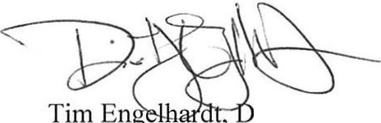Sincerely,

irector
Medicare-Medicaid Coordination Office
Centers for Medicare & Medicaid Services

