MEMORANDUM OF UNDERSTANDING
BETWEEN THE COMMONWEALTH OF MASSACHUSETTS
And the
ALLIANCE, AFSCME-SEIU LOCAL 509 (Units 8 & 10)
Regarding

Changes to Agency Fee Language in Collective Bargaining Agreement

The parties hereby agree to the following changes in Article 4 of the Commonwealth-SEIU Local 509 Units 8 and 10 2017-2019 Collective Bargaining Agreement.

ARTICLE 4
AGENCY FEE

Section 1

Each employee who elects not to join or maintain membership in the Union may voluntarily pay shall be required to pay as a condition of employment, beginning thirty (30) days following the commencement of his/her employment or the effective date of the Agreement, whichever is later, a service fee to the Union in any amount that is proportionally commensurate with the cost of collective bargaining and contract administration, but not to exceed the amount of periodic dues paid by employees who are members of the Union.

Any The agency fee shall be calculated in accordance with the provisions of Chapter 150E and regulations adopted there under and shall not include costs for the following activities:

1. Contributions to political candidates or political committees formed for a candidate or political party;

2. Publicizing of an organizational preference for a candidate for political office;

3. Efforts to enact, defeat, repeal or amend legislation unrelated to the wages, hours, standards of productivity and performance, and other terms and conditions of employment, and the welfare or the working environment of employees represented by the exclusive bargaining agent or its affiliates;

4. Contributions to charitable, religious or ideological causes not germane to its duties as the exclusive bargaining agent;

5. Benefits which are not germane to the governance or duties as bargaining agent, of the exclusive bargaining agent or its affiliates and available only to the members of the employee organization.

Section 2

This Article shall not become operative as to employees in any Statewide bargaining unit certified to the Union until this Agreement has been formally executed, pursuant to a vote of a majority of all employees in that bargaining unit present and voting.

Section 3

The Union shall reimburse the Employer for any expenses incurred as a result of being ordered to reinstate an employee terminated at the request of the Union for not paying the agency fee. The Union will intervene in and defend any administrative or court litigation concerning the propriety of such termination for failure to pay the agency fee. In such litigation the Employer shall have no obligation to defend the termination.

Section 4

Disputes between the parties concerning this Article shall be resolved in accordance with the grievance procedure contained in this Agreement.

In the event such a dispute is submitted to arbitration, the arbitrator shall have no power or authority to order the Employer to pay such service fee on behalf of any employee. If the arbitrator decides that an employee has failed to pay or authorize the payment of the service fee in accordance with this Article, the only remedy shall be the termination of the employment of such employee if the employee continues to refuse to pay or authorize payment of the required service fee after having sufficient time to do so.

Section 5 2

All members of the bargaining units shall be entitled to representation and to all the rights and benefits provided under this Agreement without regard to their membership, non-membership, or agency fee status within the Union or its affiliates.

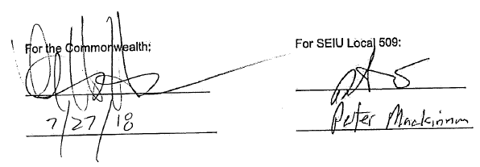

For the Commonwealth: For SEIU Local 509:

____________________________ __________________________

_____________________________ ___________________________

