**Background**

**INDOOR AIR QUALITY ASSESSMENT**

**Mount Wachusett Community College**

**444 Green Street**

**Gardner, MA**

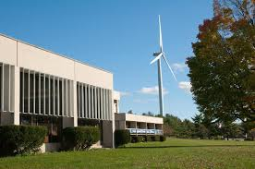

Prepared by:

Massachusetts Department of Public Health

Bureau of Environmental Health

Indoor Air Quality Program

November 2015

|  |  |
| --- | --- |
| **Building:** | Mount Wachusett Community College (MWCC) |
| **Address:** | 444 Green Street Gardner, MA |
| **Assessment Requested by:** | Robert LaBonte, VP Finance & Administration (MWCC) |
| **Date of Assessment:** | October 2, 2015 |
| **BEH/IAQ Staff Conducting Assessment:** | Michael Feeney, Director  Jason Dustin, Environmental Analyst |
| **Date of Building Construction:** | 1978 |
| **Reason for Request:** | Indoor air quality (IAQ) concerns re: active construction on campus |

**Building Description**

The building was originally built in 1978 and is mainly constructed of concrete. The office space is adjacent to active construction within the building as well as a new addition currently being constructed. This assessment focused on the Administration area closest to the ongoing construction. The current layout includes offices, open work areas, conference rooms, storage, mail, records/file rooms, common areas and hallways. Most areas of the space have reportedly undergone a recent asbestos remediation, in which ceiling tiles were removed. Windows in the building are unopenable.

# Methods/Results

Results appear in Table 1. Methods and indoor air related sampling information can be found in the IAQ Manual and Appendices for IAQ Reports that can be found at:

<http://www.mass.gov/eohhs/gov/departments/dph/programs/environmental-health/exposure-topics/iaq/iaq-rpts/general-appendices-for-iaq-reports.html>

# Discussion

## Ventilation

It can be seen from Table 1 that carbon dioxide levels were below 800 parts per million (ppm) in all areas tested, indicating adequate air exchange at the time of the assessment (Table 1). Fresh air is provided by air handling units (AHUs). Once air is filtered, it is heated or cooled and delivered to occupied areas via ducted supply diffusers. Some of these supply diffusers were noted to have dust/debris accumulation, which could become aerosolized (Picture 1). Return air is drawn into ducted ceiling-mounted vents and returned back to the AHUs. It was reported that the Administration area has a completely separate heating, ventilation and air conditioning (HVAC) system than that of the areas under active construction so there should be no direct entrainment concerns.

The HVAC system for the MWCC building is controlled by thermostats with two settings, *on* and *auto*. When the fan is set to *on,* the system provides a continuous source of air circulation and filtration. The *automatic* setting on the thermostat activates the HVAC system at a pre-set temperature. Once the pre-set temperature is reached, the HVAC system is deactivated. Therefore, no mechanical ventilation is provided until the thermostat re-activates the system. At the time of the assessment, the thermostat fan settings were in the preferred “on” position. As a result, the carbon dioxide levels were below the recommended 800 ppm in all areas tested. To maximize air exchange, the MDPH recommends that both supply and exhaust ventilation operate continuously during periods of occupancy.

## Temperature and Relative Humidity

Indoor temperature measurements at the time of the assessment ranged from 66°F to 70°F (Table 1), which were within or slightly below the MDPH recommended comfort range. Indoor relative humidity measurements at the time of the assessment ranged from 35 to 50 percent (Table 1), which were within the MDPH recommended comfort range in all but one area tested. The MDPH recommends a comfort range of 40 to 60 percent for indoor air relative humidity.

## Microbial/Moisture Concerns

In order for building materials to support mold growth, a source of water exposure is necessary. No evidence of water damage or mold growth on building materials was observed.

Plants were noted in some areas (Picture 2, Table 1). Plants can be a source of pollen and mold, which can be respiratory irritants to some individuals. Plants should be properly maintained and equipped with drip pans and should be located away from air diffusers to prevent the aerosolization of dirt, pollen and mold.

## Other IAQ Evaluations

Indoor air quality can be negatively influenced by the presence of respiratory irritants, such as products of combustion. The process of combustion produces a number of pollutants. Common combustion emissions include carbon monoxide, carbon dioxide, water vapor, and smoke (fine airborne particle material). Of these materials, exposure to carbon monoxide and particulate matter with a diameter of 2.5 micrometers (μm) or less (PM2.5) can produce immediate, acute health effects upon exposure. To determine whether combustion products were present in the indoor environment, BEH/IAQ staff obtained measurements for carbon monoxide and PM2.5.

### Carbon Monoxide

*Carbon monoxide should not be present in a typical, indoor environment*. If it *is* present, indoor carbon monoxide levels should be less than or equal to outdoor levels. On the day of the assessment, outdoor carbon monoxide concentrations were non-detect (ND) (Table 1). No measurable levels of carbon monoxide were detected inside the building (Table 1).

### Particulate Matter

Outdoor PM2.5 was measured at 7 μg/m3 (Table 1). PM2.5 levels measured indoors ranged from ND to 22 μg/m3 (Table 1), which were below the NAAQS PM2.5 level of 35 μg/m3. Although the PM2.5 level were below recommended levels at the time of the visit, consideration should be given to providing higher efficiency filters in the AHUs of occupied areas for the duration of construction. AHU manufacturer filter recommendations and pressure drop should be considered before increasing filter efficiency.

Shawmut Construction has installed several high-efficiency particulate arrestance (HEPA) air filtration scrubbers (Picture 3) throughout the occupied space as well as in the indoor areas under construction. These units help to filter out any construction-related particulate matter in the common areas of MWCC closest to construction. The HEPA units in the enclosed construction zones are being vented outdoors, which will provide negative pressure in these areas (Picture 4) and aid in preventing any pollutants from migrating into adjacent areas. Consideration should also be given to reducing the HVAC return capacity in areas closest to construction zones. This will slightly pressurize these occupied areas to further prevent pollutants from entering the space.

Shawmut Construction reported that the guidelines of daily HEPA vacuuming and wet wiping of occupied areas prior to the start of the work day are being performed. In addition, they’ve contracted with a consultant to perform continuous IAQ monitoring (Picture 5).

### Volatile Organic Compounds (VOCs)

In order to determine if VOCs were present, testing for total volatile organic compounds (TVOCs) was conducted. Outdoor TVOC concentrations were ND on the day of the assessment (Table 1). No measureable levels of TVOCs were detected in the building during the assessment (Table 1).

BEH/IAQ staff noted photocopiers, cleaners, dry erase materials, and hand sanitizer (Picture 6) at the time of the assessment. All of these have the potential to be irritants to the eyes, nose, throat and respiratory system of sensitive individuals.

## Other Conditions

Other conditions that can affect IAQ were observed during the assessment. In any major construction project, there are guidelines that should be followed to reduce the risk of construction related pollutants to occupants of the building. Two of the suggested guidelines are: "IAQ Guidelines for Occupied Buildings Under Construction" published by the Sheet Metal and Air Conditioning Contractors National Association, Inc. (SMACNA, 2007) and “Methods Used to Reduce/Prevent Exposure to Construction/Renovation Generated Pollutants in Occupied Buildings” (MDPH, 2006). Shawmut Construction and MWCC are aware of and are reportedly following these guidelines to mitigate any future exposure potential.

BEH/IAQ staff noted the presence of construction barriers, which are a recommended practice during active construction with occupied buildings. Some small tears and gaps in the plastic sheeting were observed during the assessment (Pictures 7 and 8). The contractor, Shawmut Design and Construction, reported that they have a dedicated carpenter who performs daily maintenance on the barriers to ensure their integrity.

Some gaps around doors leading to active construction were observed in common hallway areas/foyers (Picture 9 and 10). These gaps should be sealed with tight-fitting gaskets/door sweeps to prevent dust/pollutants from entering occupied space. Another recommendation made at the time of the visit was to provide a small inner foyer within the construction zone for doors leading directly to occupied space (Picture 11). This would essentially act as an air-lock to help reduce any periodic migration of pollutants each time the door is opened.

As reported by MWCC staff, the building experiences significant outdoor air infiltration through windows and doors during windy conditions. If outdoor construction occurs upwind from the building, construction pollutants and odors may enter the building through the windows or univent fresh air intakes. Both MWCC management and Shawmut are aware of these conditions and have taken further preventative measures to decrease the chance of exposure to building occupants. Setting up anti-idling zones for construction vehicles, closing AHU air intakes as needed, and wetting down areas during dust-generating activities are some of the strategies that were discussed. Another strategy discussed would be to limit any high pollutant-generating activities to unoccupied hours to as much extent as is feasible.

Some MWCC staff members have expressed concerns over incidents which occurred several months before this assessment. One reported incident related to the excavation of an area covered in concrete that created a noxious odor of decay in the building. As reported by MWCC staff and Shawmut construction personnel, the odor occurred after concrete was removed, exposing a layer of waterproofing. Typically, waterproofing material from the 1970’s consisted of an asphalt-based formulation, which consists of carbon. Rainwater with dissolved plant and soil (organic) matter can pass through the concrete to form a layer on top of the waterproofing. This layer of water and organic matter was in an oxygen deprived (anaerobic) condition. In this state, decaying organic matter did not receive sufficient oxygen to break down properly. Odors of this type generally contain sulfur compounds that can result in a noxious odor of decay, which some individuals may find irritating and/or nauseating. As reported by MWCC staff, the contractor mitigated the odor with ventilation, placing a layer of absorption material over the exposed waterproofing and removal of organic matter/media. This odor has not re-occurred since this initial incident and was not present during this assessment; therefore is unlikely to cause any long-term symptoms/irritation.

BEH/IAQ staff noted the roosting of pigeons at the base of fixed solar blinds immediately outside MWCC occupied areas (Picture 12). These areas are equipped with unit ventilators (univents), which draw fresh air from intake vents below the windows (Figure 1). Birds and bird wastes can be sources of allergens and microbial contamination. Any nesting materials and bird waste should be removed to avoid entrainment of these materials via nearby fresh air intake vents. The bases of the solar blinds should be fitted with bird spike strips to deter future roosting.

Most office areas in the MWCC space are covered with wall to wall carpeting. The Institute of Inspection, Cleaning and Restoration Certification (IICRC), recommends that carpeting be cleaned annually (or semi-annually in soiled high traffic areas) (IICRC, 2012). Some areas had carpeting that appeared worn and past it’s useful life.

In some areas, accumulation of items, including papers, boxes and personal items were found stored on desks, tables and counters. Decorative items, including plush and organic items were also observed. Large numbers of items provide a source for dusts to accumulate. These items make it difficult for custodial staff to clean. Items should be relocated and/or cleaned periodically to avoid excessive dust build up.

# Conclusions/Recommendations

In view of the findings at the time of the visit, the following recommendations are made:

1. Continue to implement the recommendations found in the following guidelines: "IAQ Guidelines for Occupied Buildings Under Construction" published by the Sheet Metal and Air Conditioning Contractors National Association, Inc. (SMACNA, 2007) and “Methods Used to Reduce/Prevent Exposure to Construction/Renovation Generated Pollutants in Occupied Buildings” (MDPH, 2006).
2. In any major renovation, communication with occupants is vital. MWCC and Shawmut Construction reportedly hold regular meetings with occupants and representatives. BEH/IAQ staff suggests continuing to meet and implement a written reporting system for building occupants to report odors and other construction-related issues that arise. This system can be effective to pin-point problem areas and address them in a timely manner.
3. Install an exhaust fan in a skylight window in the construction zone (Picture 13).
4. Limit high pollutant-generating activities to unoccupied hours to as much extent as is feasible.
5. Continue to follow guidelines of daily HEPA vacuuming and wet wiping prior to the start of MWCC occupied hours.
6. Any nesting materials and bird waste should be removed to avoid entrainment of these materials via nearby fresh air intake vents. The bases of the solar blinds should be fitted with bird spike strips to deter future roosting.
7. During unfavorable wind conditions, continue to take further preventative measures to decrease the chance of exposure to MWCC occupants. Setting up anti-idling zones for construction vehicles, closing AHU air intakes as needed, wetting down areas during dust-generating activities and other necessary strategies outlined in the above guidelines.
8. Seal any gaps around doors near construction zones with tight-fitting gaskets/door sweeps to prevent dust/pollutants from entering occupied space.
9. Continue to maintain the construction barriers daily to prevent the migration of pollutants to occupied areas.
10. Continue to run the HEPA air scrubbers in occupied areas to reduce fugitive particulate matter in occupied spaces. Also, any additional scrubbers added in the enclosed active construction areas should remain vented outside to maintain negative pressure within these areas. Regular filter changes and cleaning should be performed on the units.
11. As discussed, consider adding a small foyer (double door) to construction-side doors that lead directly to occupied space or common hallway areas.
12. Consider reducing return vent capacity in occupied areas closest to the active construction to provide for a slight positive pressure in these areas.
13. Continue to operate thermostats with fan set to “on” to achieve continuous air circulation/filtration and adequate fresh air supply during occupied hours.
14. Consideration should be given to providing for higher efficiency filters in the AHUs of occupied areas for the duration of construction. Consult with manufacturer recommendations regarding filter efficiency and pressure drop.
15. Regularly clean HVAC supply and return vents to remove any dust/debris accumulation, which could become aerosolized.
16. For buildings in New England, periods of low relative humidity during the winter are often unavoidable. Therefore, scrupulous cleaning practices should be adopted to minimize common indoor air contaminants whose irritant effects can be enhanced when the relative humidity is low. To control for dusts, a high efficiency particulate arrestance (HEPA) filter equipped vacuum cleaner in conjunction with wet wiping of all surfaces is recommended. Avoid the use of feather dusters. Drinking water during the day can help ease some symptoms associated with a dry environment (throat and sinus irritations).
17. Plants should be properly maintained and equipped with drip pans and should be located away from air diffusers to prevent the aerosolization of dirt, pollen and mold.
18. Avoid the accumulation of large numbers of items on flat surfaces. To prevent excessive dust build up, items should be relocated periodically to allow for cleaning.
19. Consider limiting the use of hand sanitizer, dry erase boards, air fresheners/deodorizers and cleaning products, which can cause eye, nose and throat irritations in sensitive individuals.
20. The Institute of Inspection, Cleaning and Restoration Certification (IICRC), recommends that carpeting be cleaned annually (or semi-annually in soiled high traffic areas) (IICRC, 2012). Also consider replacing any worn carpeting that is past its useful life.
21. Refer to resource manual and other related indoor air quality documents located on the MDPH’s website for further building-wide evaluations and advice on maintaining public buildings. These documents are available at <http://mass.gov/dph/iaq>.

# References

IICRC. 2012. Carpet Cleaning FAQ 4 Institute of Inspection, Cleaning and Restoration Certification. Institute of Inspection Cleaning and Restoration. Vancouver, WA.

MDPH. 2006. Methods Used to Reduce/Prevent Exposure to Construction/Renovation Generated Pollutants in Occupied Buildings. Boston, MA.

SMACNA. 2007. IAQ Guidelines for Occupied Buildings Under Construction. Sheet Metal and Air Conditioning Contractors National Association, Inc. Chantilly, VA.

**Picture 1**

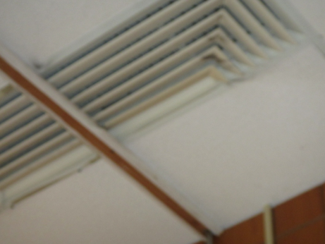

**Supply diffuser; note dust accumulation (arrow)**

**Picture 2**

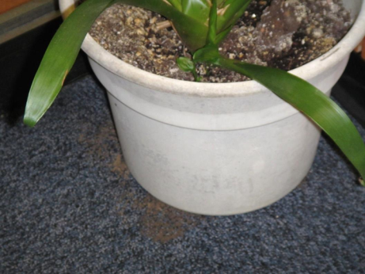

**Plant and soil debris on carpeting**

**Picture 3**

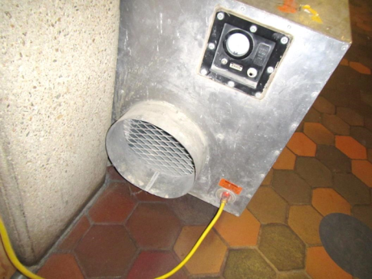

**HEPA air scrubber in common area of MWCC**

**Picture 4**

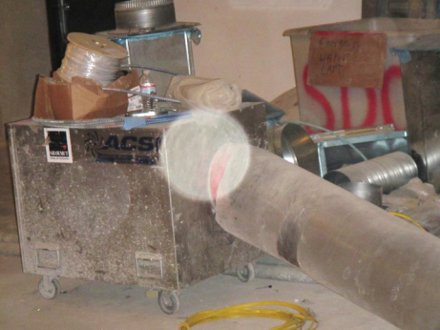

**HEPA air scrubber in construction zone being vented outdoors**

**Picture 5**

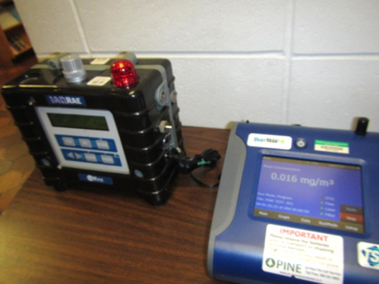

**Continuous indoor air monitoring equipment station**

**Picture 6**

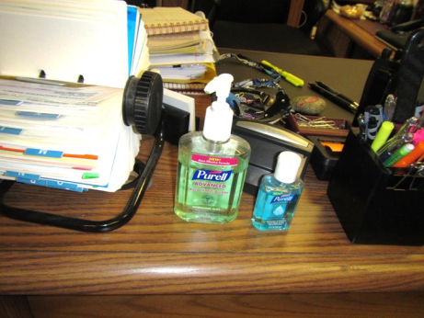

**Hand sanitizers containing fragrances**

**Picture 7**

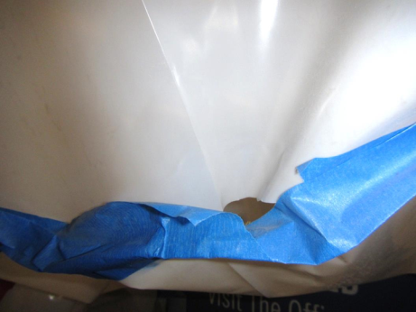

**Barrier showing small gap**

**Picture 8**

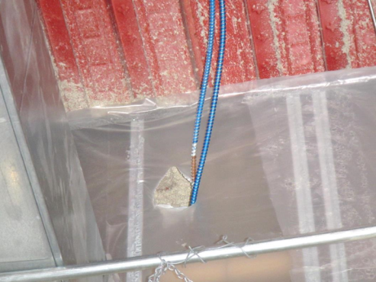

**Top of barrier showing small tears and gaps**

**Picture 9**

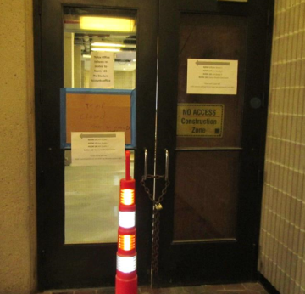

**Gaps in door leading to construction in common foyer (note light penetration)**

**Picture 10**

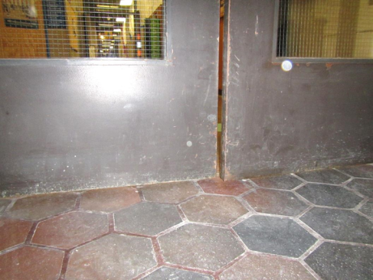

**Gaps in door in common foyer shared with construction access point**

**Picture 11**

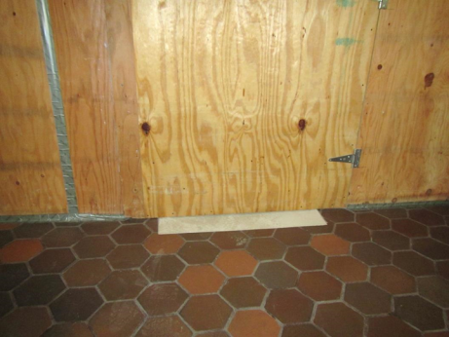

**Single door direct access to active construction in common hallway**

**Picture 12**

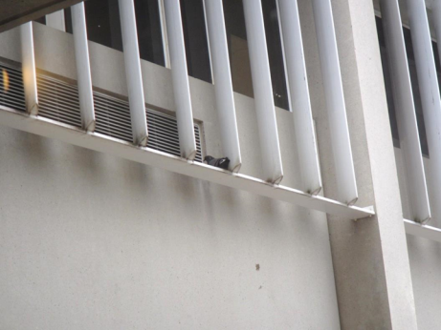

**Pigeon roosting on base of solar blinds near fresh air intake**

**Picture 13**

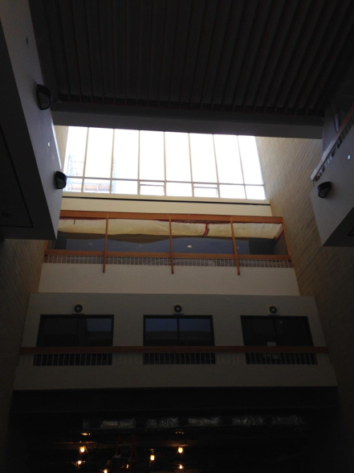

**Skylight windows in construction zone**

| Location | **Carbon**  **Dioxide**  **(ppm)** | **Carbon Monoxide**  **(ppm)** | **Temp**  **(°F)** | **Relative**  **Humidity**  **(%)** | **TVOCs**  **(ppm)** | **PM2.5**  **(µg/m3)** | **Occupants**  **in Room** | **Windows**  **Openable** | **Ventilation** | | | **Remarks** |
| --- | --- | --- | --- | --- | --- | --- | --- | --- | --- | --- | --- | --- |
| **Intake** | **Exhaust** | |
| Background (outside) | 384 | ND | 54 | 61 | ND | 7 |  |  |  | |  |  |
| Presidential Suite: Room 105 | 586 | ND | 66 | 50 | ND | 8 | 1 | N | Y | | Y | Carpet, plant |
| Reception | 591 | ND | 69 | 45 | ND | 8 | 2 | N | Y | | Y | HS, AF, plants |
| Admin Foyer | 507 | ND | 68 | 42 | ND | 13 | 2 | N | Y | | Y |  |
| Construction Tunnel | 463 | ND | 67 | 42 | ND | 22 | 2 | N | Y | | Y |  |
| Stairwell 1/high-top table area | 513 | ND | 67 | 42 | ND | 9 | 3 | N | Y | | Y |  |
| Admin Hallway | 519 | ND | 68 | 42 | ND | 5 | 2 | N | Y | | Y |  |
| Records Hall | 534 | ND | 68 | 41 | ND | 5 | 2 | N | Y | | Y |  |
| Door C Vestibule | 548 | ND | 66 | 40 | ND | 5 | 2 | N | Y | | Y |  |
| Financial Aid Hall | 543 | ND | 67 | 42 | ND | 12 | 3 | N | Y | | Y |  |
| Workforce Hall | 545 | ND | 69 | 42 | ND | 4 | 3 | N | Y | | Y |  |
| Career Services Foyer | 558 | ND | 67 | 42 | ND | ND | 3 | N | Y | | Y |  |
| Library Hall | 670 | ND | 68 | 42 | ND | 2 | 2 | N | Y | | Y | plant |
| Academic Affairs | 608 | ND | 70 | 41 | ND | ND | 3 | N | Y | | Y | HS, plants |
| 162 | 597 | ND | 70 | 42 | ND | 2 | 4 | N | Y | | Y | HS, PC, plants |
| 164 | 670 | ND | 69 | 41 | ND | 4 | 8 | N | Y | | Y | PC, carpet |
| 166 (records) | 606 | ND | 69 | 43 | ND | 2 | 6 | N | Y | | Y | HS, PF, plants |
| 166 (rear) | 613 | ND | 69 | 41 | ND | 1 | 5 | N | Y | | Y |  |
| Foyer | 441 | ND | 66 | 35 | ND | 3 | 2 | N | Y | | Y |  |