Mouth Guards
What are they and why are they important?

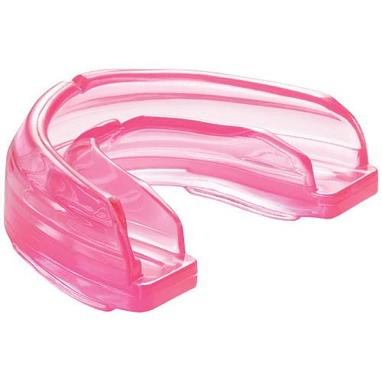

Oral Health in Massachusetts: A Fact Sheet
What Are Mouth Guards?
Mouth guards are specialized rubber-like devices that typically fit over the upper teeth and help prevent injury to the teeth, lips, cheeks, and tongue. When used during sports, mouth guards can help prevent tooth loss and may reduce the risk and severity of jaw fractures and concussions.

Facts about Mouth Guards:

- More than 5 million teeth are lost each year due to accidental injury.
- Mouth guard use prevents 200,000 oral-facial injuries per year.
- An athlete is 60 times more likely to suffer a dental injury while not wearing a mouth guard
- Only 49% of Massachusetts middle school students wear a mouth guard while playing team sports.

Who Should Wear a Mouth Guard?
In Massachusetts, mouth guards are mandated for all persons participating in football, field hockey, ice hockey, soccer, lacrosse, and wrestling. However, mouth guards are strongly recommended for all those participating in any sports where there may be a risk of injury to the jaw, teeth, or head.

Mouth guards are especially important for those who wear braces. Trauma to the face can cause damage to fixed orthodontic appliances and brackets. Mouth guards also provide a barrier between these devices and the soft tissues of the mouth lessening the risk of trauma and injury.

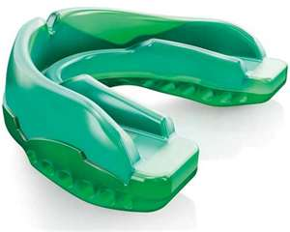

Types of Mouth Guards
There are three basic types of mouth guards that all provide protection with varying levels of cost and comfort. An ideal mouth guard is tear-resistant, comfortable, easy to clean, and does not inhibit breathing.
- Stock Mouth Guards
Stock mouth guards are inexpensive, standard sized guards that can be purchased at most sporting good stores. They come pre-formed and ready to wear, however some may find them slightly bulky and they may interfere with speech.

- Boil and Bite Mouth Guards
Boil and bite mouth guards are designed to be immersed in hot water and then shaped to the form of the teeth using the fingers or biting pressure. This type of mouth guard tends to be more comfortable than a stock mouth guard and provides a better fit when made properly. This type of guard can also be purchased over-the-counter at most sporting good stores.

- Custom Made Mouth Guards
Custom made mouth guards can be obtained from a dentist’s office. They are made in a dental office or at a dental laboratory from an impression of the teeth. This type of mouth guard is designed to specifically fit the user’s teeth.

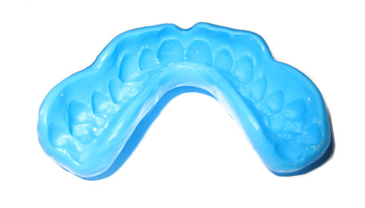

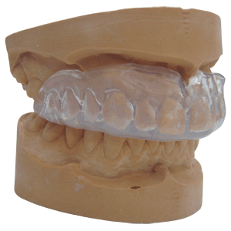

How to Care For A Mouth Guard

Before and after each use, mouth guards should be cleaned with cool, soapy water or a mouth rinse. Guards can also be cleaned using toothpaste and a soft-bristled toothbrush. Guards should also be checked for tears or any other kind of damage following each use. Damaged guards have the potential to cause oral irritation and can have a diminished effect. For this reason, damaged or worn out mouth guards should be replaced.

When not in use, clean mouth guards should be stored in plastic wrap or in a vented container. Athletes are encouraged to minimize handling of their mouth guards during games. Whenever the guard contacts the player’s hands, players are encouraged to rinse the guard off with water to reduce contamination.

Also, over time the user’s jaw size and tooth position may change causing the guard to no longer fit properly. This may require an updated guard to ensure maximum protection at all times. It is also recommended that all guards avoid contact with high temperatures, such as direct sunlight and hot water, to avoid possible distortion.

Remember…mouth guards should never be shared between players.
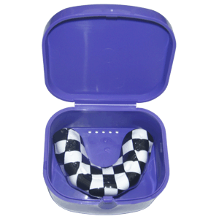



References

American Dental Association. "ADA: American Dental Association –
Mouthguards." ADA: American Dental Association – Home. <http://www.ada.org/2970.aspx#protector>.

“Grin and Wear It – Massachusetts Dental Society." Massachusetts
Dental Society. Web. 25 Mar. 2011.
<http://www.massdental.org/awarness/grin-and-wear-it.aspx?id=1160#>.

Massachusetts Department of Public Health Office of Oral Health.
The Status of Oral Disease in Massachusetts: The Great Unmet Need. Boston, MA: Commonwealth of Massachusetts, Department of Public Health Office of Oral Health, 2009.
.

For more information contact:
Massachusetts Department of Public Health
Office of Oral Health
250 Washington Street
Boston, MA 02108-4619
Oral.Health@state.ma.us



