Moving and Duplicate Family Records in CCFA
This guide will assist CCFA users on how to move family members and how to resolve duplicate records. There are many scenarios which may require moving a family member. In some instances, you may need to preserve the original relationship, such as in a shared custody scenario. If the second or destination family already exists in CCFA obtain the FID of the destination family before following the steps below. You can move the family member from the action drop down menu on the Family Details page. If the second or destination family does not yet exist in CCFA, you must move the parent first to create the new family. If you are moving only a child to a new family, you need to create the family in CCFA before moving the child. A family in CCFA MUST have a parent before any children can be added.

- Locate the family or person that needs to be moved.

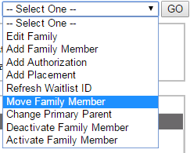
- On either the Family Details or Person Details page, select the “Move Family Member” from the action drop down.
  - If you are moving a parent:
    - And the person you are trying to move is the primary parent, you will need to select the “Change Primary Parent” option first.
    - Note: A person cannot be a primary parent in two families.
  - If you are moving a child:
    - First, make sure that all placements associated with that child are ended.
    - Please search for the child to prevent creating duplicates in CCFA.
- You will be redirected to the Move Family Member page. Complete the form (pictured below), including:
  - Select the family member to move.
  - Select the destination family.
    - If the destination family already exists, search using the FID. If you need to create a new family, check the box to “Create New Family”.
      - If you are creating a new family, you MUST move the parent first.
      - Be sure to note down the FID for the new family to ease moving other members.

  - Select the Relationship Type in the new family.
    - Note that there is an option to check “keep current family relationship” if needed.
  - Select an effective date.
    - When moving children, the effective date cannot overlap with any placements for that child.
    - If you select a date in the future, the move will be automatic.
  - Enter a comment
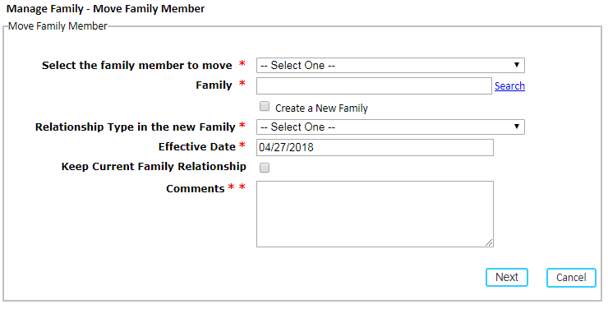
- Click “Next” to confirm the move. On “Save” you will be navigated to the Family Details page of the destination family.
- Repeat the steps for any other family members that need to be added.

In the case where a family has duplicate family members, you need to deactivate the most recent duplicate record. When adding children to families, be sure you are thoroughly searching CCFA for an existing record for the child. A good way to search is to use Date of Birth and at least one other field, such as first name. Searching using First Name, Last Name (child, not family), and Date of Birth will result in more accurate search results. This happens most often with DCF placements. To deactivate a family member follow the below steps:

- Access the Person Details page by clicking on the person’s name under the Summary section of the Family Details page.
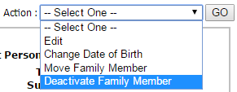
- Select “Deactivate Family Member” from the action drop down menu.
  - Note: you can also select this option directly from the Family Details page.

- You will be brought to the Manage Family page. Complete the form, including:
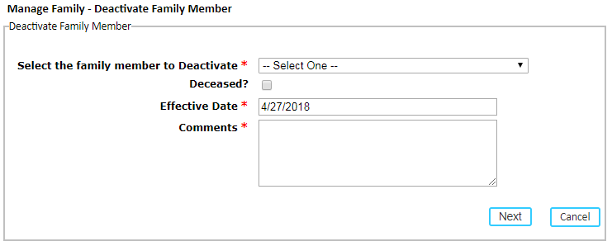
  - Select the family member to deactivate.
  - Check “deceased” option if appropriate.
  - Enter the Effective Date
    - When deactivating children, the effective date cannot overlap with any placements.
    - If you select a date in the future, the move will be automatic.
  - Enter a comment.

- Click “next” to confirm and save your changes.
  - Note: The family member will appear under the “Inactive Members” section of the Family Details page.

In the case where the entire family has been duplicated, select the family you want to deactivate. Then use the action dropdown to select “Edit Family” and change the status to “Inactive”. Please mention the word “duplicate” and the FID of the duplicate family record in the comments.

