MassHealth Program Advisory Committee (MPAC) and Payment Policy Advisory Board (PPAB) Meeting
  - Executive Office of Health and Human Services
  - April 10, 2026

Meeting Agenda
Time | Detail | Moderator
1-1:10 p.m. | Welcome | Mike Levine & Celia Segel
1:10-1:25 p.m. | Housekeeping  - Vote on 1.13.26 meeting notes | Sarah Nordberg
1:25-1:55 p.m. | FY27 Budget Update | Zhao Zhang
1:55-2:25 p.m. | Other updates  - Program Integrity  - ICE Information Sharing  - OB3 Outreach & Engagement | Zhao Zhang, Celia Segel
2:25 – 2:30 p.m. | Wrap-up, Q&A  Next meeting: July 13, 2026 10-11:30 a.m. | Sarah Nordberg

Housekeeping

Vote on Meeting Notes
Meeting notes from our 1/13/26 meeting were sent to you via email.

Please put your vote in the meeting chat. You may:
- Approve
- Deny
- Abstain
Approved meeting notes are posted on the MassHealth Program Advisory Committee webpage under the "Meeting Materials" tab.

FY27 Budget Update

Executive Summary: Key Features of Budget Proposal
- H.2 funds MassHealth at $22.701 billion gross / $9.299 billion net, preserving access to high quality services for members while taking necessary steps to put MassHealth on more sustainable footing
- MassHealth spending is driven by many of the same sector-wide trends as commercial health insurance and is, therefore, growing at a similarly unsustainable rate. Spending growth has been driven by a sharp increase in the cost per individual MassHealth member. Most recently, the three largest contributors to spending growth, when comparing 2025 to 2024, are prescription drugs (18% growth, representing 26% of total growth in per-member spending at MH), behavioral health services (18% growth, representing 17% of total growth in per-member spending at MH), and long-term services and supports for the state’s aging population (13% growth, representing 35% of total growth in per-member spending at MH).
- To bring FY27 spending down to proposed levels, MassHealth will continue to aggressively expand program integrity initiatives; institute a moratorium on all provider rate increases or program expansions not required by federal law; make targeted benefit reductions that bring MassHealth in line with peer states and commercial payors; and implement one-time measures that bridge to FY28, allowing time for policy development and stakeholder engagement.
- H.2 includes substantial savings initiatives, including:
  - Removing coverage for weight-loss GLP1s. This mirrors actions taken by California, Pennsylvania, and several other states.
  - Capping adult dental spending at $1,000 per member per year. Several states, such as Connecticut and Vermont, cap adult dental. There will continue to be no cap on pediatric dental benefits nor on adult members who are served by DDS.
  - Reducing funding for care management and eliminating the requirement that ACOs contract with Community Partner organizations. By aligning care management enrollment levels with peer states (approx. 8% of members per year vs. nearly 16% in MA today), ACOs will tailor these high-value programs to the greatest clinical need.
- Additionally, MassHealth will partner with stakeholders in developing new approaches to providing coverage to MassHealth members at a sustainable rate of spending growth, notably by building on and continuing the Personal Care Attendant (PCA) workgroup and convening a new Adult Day Health (ADH) workgroup and Adult Foster Care (AFC) workgroup.

MassHealth annual spend, gross and net (FY16-FY27 H.2)

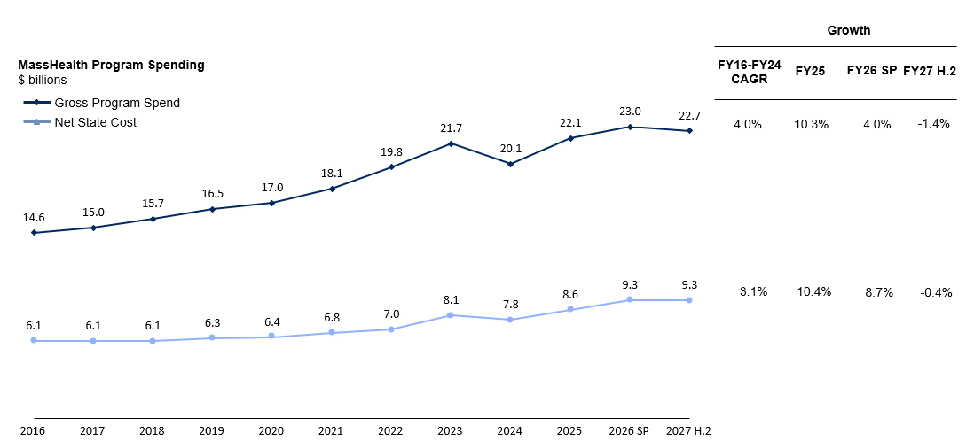
Notes:
Revenue numbers include EMAC for FY18-FY20
Revenue numbers include enhanced FMAP during COVID PHE for FY20-FY24
FY22 numbers exclude spending & revenue associated with ARPA HCBS
Spending numbers exclude ELD Choices spend

Updates

Federal Data Sharing

Background
- The U.S. Dept of Health and Human Services (HHS) has agreed to share the personal information of Medicaid enrollees with Immigration and Customs Enforcement (ICE) officials for immigration enforcement purposes.
- MassHealth objects this decision and has joined a lawsuit challenging it as unlawful.
- In Dec 2025, a court ruled that:
  - HHS may share certain information with ICE for immigration enforcement purposes; however, this only applies to people who are not lawfully residing in the U.S.
  - HHS is not allowed to share Medicaid information for citizens or individuals lawfully residing in the U.S.
- This lawsuit is ongoing, and HHS’s ability to share data may change in the future.
More information is available at: https://www.mass.gov/doc/your-personal-information-at-masshealth-flyer/download

Questions & Answers

Q1. Has HHS already shared my data with ICE?
MassHealth does not know if HHS has shared member data with ICE. Under the court ruling, HHS may share with ICE certain information about MassHealth members who are not lawfully residing in the U.S.

Q2. What personal information could HHS share with ICE?
Under the court’s ruling in December 2025, HHS cannot share any information about citizens and individuals residing lawfully in the U.S. HHS is allowed to share the following information about Medicaid enrollees who are not lawfully residing in the United States: citizenship and immigration status, address, phone number, date of birth, Medicaid ID.

Q3. Is my personal information at risk of being shared if I’m receiving care as a MassHealth member?
Under the court ruling, HHS cannot share information about citizens and individuals lawfully residing in the U.S. with ICE. For other members, who are not citizens or individuals lawfully residing in the U.S., HHS is only permitted to share basic biographical information, not sensitive health care information. Getting care does not change your risk of information being shared, because HHS cannot share information related to health care services you receive.

Q4. Is my personal information at risk of being shared if I apply for MassHealth?
If you decide to apply for MassHealth, you will be required to submit personal information as part of the eligibility determination process. MassHealth is required to share this information with HHS. Under the court ruling, if you are not lawfully residing in the U.S., HHS is allowed to share certain information about you with ICE.

Q5. I am currently a MassHealth member and am concerned about my personal information being shared with ICE. If I disenroll from MassHealth, will this prevent my information from being shared?
No. MassHealth is required to share the information you provided with HHS even if you disenroll. However, if you disenroll, you would not be required to update your information with MassHealth moving forward. If you are a MassHealth member, getting care does not change the likelihood of your information being shared.

OB3 Outreach & Engagement

Educate, JAN ‘26 – MAY ‘26

Key Information
- Nothing is changing right now – keep getting care
- Timeline of changes
- Impacted populations
- Ways to stay informed

Key Resources
- Stakeholder Website: Mass.gov/MassHealthFederalUpdates
- Overview Webinars for Stakeholders (800+ attendees)
- Coordination with Member Advisory Committee and Stakeholders
- Kickoff HCFA partnership & hold focus groups on messaging approach with members and providers (8 held in Feb/Mar)
- Member Website: Mass.gov/MassHealthMemberChanges
- Member webinars completed in early April (700+ attendees)

Outreach, JUNE ‘26 – DEC ‘26

Key Information
- How members prepare
- Overview of key process steps
- Tools and resources to support members

Key Resources
- Communications toolkit
- Direct member outreach (text, email, robocall, notices)
- Public webinars
- Assister trainings
- Updated websites
- CBO outreach events and assister supports through HCFA partnership

Act, JAN ‘27 Onward

Key Information
- Actions members need to take
- Member resources to get support
- Next steps if members lose coverage

Key Resources
- Direct member outreach at key steps
- Health plan and sister agency outreach
- Community events
- CBO Office Hours
- Enrollment Centers and Call Centers prepared to support members

Q&A, Housekeeping
Next Meeting: July 13, 2026 10-11:30 a.m.
Visit the MassHealth Program Advisory Committee webpage for information on the committee and upcoming meetings.

