Massachusetts Practice Review (MPR)
Brief Summary Report: May & June 2016 Reviews

Introduction
The Commonwealth uses the Massachusetts Practice Review (MPR), a qualitative case review protocol, to evaluate the quality of MassHealth Children’s Behavioral Health Initiative (CBHI) services delivered to children/youth under 21. The MPR utilizes trained reviewers to obtain a comprehensive picture of CBHI services delivered at the practice level. Reviewers examine the clinical record and interview multiple stakeholders, including the In-Home Therapy (IHT) or Intensive Care Coordination (ICC) service provider, the caregiver, the child/youth (if over 12), and other formal providers working with the child/youth and family. By triangulating responses from all informants, reviewers assess the extent to which practice is meeting established standards and best practices for the service under review. Reviewers then rate 12 specific practice Areas within larger Domains that reflect CBHI values and principles. Rating is done on a scale from 1 to 5, with 1 being adverse practice and 5 being exemplary/best practice. Reviewers are also asked to rate two Areas concerning child/youth and family progress to determine the extent to which improvements have been realized in relation to specific skill development, functioning, well-being, and quality of life.

This brief report summarizes findings from the third round of Fiscal Year 2016 MPR reviews conducted in May-June 2016. The care received by 45 children/youth enrolled in either ICC (N=42) or IHT (N=3) as the hub service from 25 randomly sampled providers across the state, including 22 CSAs and 3 IHT provider sites, was reviewed.

Provider Sampling/Youth Selection
ICC Provider Sampling
The MPR’s sampling model for ICC allows the state to evaluate practice delivered at all 32 CSAs in a given year by assigning each CSA 2 reviews. Twenty-one of the 32 CSAs were sampled this round, and the previous 11 were completed in the March-April 2016 review round. One additional ICC review was completed at a CSA that had been sampled during the March-April round but had not been completed in time for analysis. This report includes that data.
IHT Provider Sampling
No IHT providers were sampled for this round. However, three IHT reviews (from three unique providers) that began during the March-April 2016 round were completed in May-June and are included in this report’s analysis.
Youth Selection
Once providers were sampled, families were randomly selected at the IHT and ICC sites to be approached for consent to participate. In all, 63 families were approached; of these, 41 families consented and had completed reviews, 1 review had incomplete interviews, and 21 families declined to participate. The majority (57% or n=12 of youth/families approached) had anxiety about having “strangers” in their home and felt overwhelmed by the prospect of another task/responsibility added to their busy lives.

Results
Demographics
Table 1 summarizes select demographic characteristics of the children/youth reviewed in May-June 2016.
Table 1: Select Demographic Characteristics
 |  | N | %
Gender | Male | 28 | 62%
Race/Ethnicity | White | 22 | 49%
 | Latino/Hispanic | 11 | 24%
 | Biracial/Mixed | 8 | 18%
 | Black | 2 | 4.5%
 | Other | 2 | 4.5%
Age of Youth | 0-4 Years | 2 | 4.5%
 | 5-9 Years | 18 | 40%
 | 10-13 Years | 14 | 31%
 | 14-17 Years | 9 | 20%
 | 18-21 Years | 2 | 4.5%
English as Primary Language |  | 37 | 82%
Length of Enrollment (<12 months) |  | 37 | 82%
>1 BH Condition |  | 29 | 64%
Practice Domain Mean Scores
As shown in Table 2, MPR Practice Domain mean scores ranged from 3.16 to 3.58, with an overall mean score of 3.26. (The header for Table 3 shows the level of practice associated with each of the ratings from 1 to 5.)
Table 2: MPR Practice Domain Overall & Mean Scores
Domain | Min | Max | Mean | Standard Deviation
Practice Overall  -ICC  -IHT | 2.00  2.00  2.92 | 4.67  4.67  3.75 | 3.26  3.26  3.31 | .62  .64  .42
Domain1: Family Driven & Youth Guided  -ICC  -IHT | 1.75  1.75  2.88 | 4.75  4.75  3.75 | 3.21  3.21  3.21 | .72  .74  .47
Domain 2: Community-Based  -ICC  -IHT | 2.00  2.00  3.00 | 5.00  5.00  4.00 | 3.58  3.58  3.50 | .55  .56  .50
Domain 3: Culturally Competent  -ICC  -IHT | 1.50  1.50  2.50 | 4.50  4.50  4.00 | 3.16  3.13  3.50 | .74  .73  .87

Community-Based was the highest scoring Practice Domain with a mean score of 3.58, and also had the highest scoring Practice Area - Service Accessibility (3.89). The Family Driven & Youth Guided Domain had the next highest Practice Domain mean score of 3.21. This Domain contained both the second highest scoring Area - Youth & Family Engagement (3.56) and the two lowest - Transition (2.89) and Assessment (2.96). Culturally Competent had the lowest mean score of all Practice Domains (3.16), and contained the third lowest scoring Area - Cultural Sensitivity & Responsiveness (2.98).

Figure 1 illustrates the range of overall MPR Practice Domain mean scores for the youth/families reviewed.
Figure 1: Overall Practice Domain Mean Scores
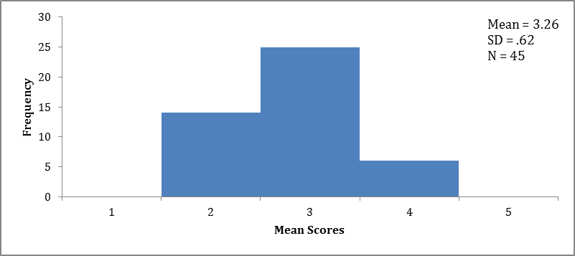

Of the youth reviewed, 13% (n=6) had overall case mean scores in the Good practice range, 56% (n=25) had mean scores in the Fair range, and 31% (n=14) in the Poor range.
Results by Practice Domain/Area
The following sections briefly summarize quantitative results across each MPR Practice Domain and the Areas within them.
Domain 1: Family Driven & Youth Guided
Figure 2 shows that practice in this domain was Good and consistently met established standards and best practices for 16% (n=7) of the youth/families reviewed. Practice was rated Fair or not consistently meeting established standards and best practices for 47% (n=21) of the cases reviewed, and Poor or not meeting minimal standards of practice for 33% (n=15) of the cases. Adverse practice was reported in this Domain for 4% (n=2) of the reviews.
Figure 2: Family Driven & Youth Guided Mean Scores
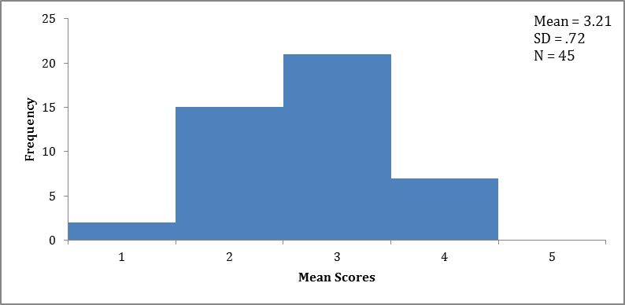

Table 3 below summarizes the mean scores and frequencies for each of the 8 Areas in this Practice Domain.

Table 3: Family Driven & Youth Guided
Mean Scores & Frequencies
Area |  | Mean | Frequencies (n) %*
 |  |  | Adverse  Practice  1 | Poor  Practice  2 | Fair  Practice  3 | Good  Practice  4 | Exemplary/  Best Practice  5
Assessment  -ICC  -IHT | 2.96  2.95  3.00 |  | (1) 2%  - 2%  - | (17) 38%  (16) 38%  (1) 33% | (12) 27%  (11) 26%  (1) 33% | (13) 29%  (12) 29%  (1) 33% | (2) 4%  (2) 5%
Service Planning  -ICC  -IHT | 3.22  3.26  2.67 |  | (1) 2%  (1) 2%  - | (9) 20%  (8) 19%  (1)33% | (18) 40%  (16) 38%  (2)67% | (13) 29%  (13)31 %  - | (4) 9%  (4) 10%  -
Service Delivery  -ICC  -IHT | 3.44  3.38  4.33 |  | -  -  - | (7) 16%  (7) 17%  - | (15) 33%  (15) 36%  - | (19) 42%  (17) 40%  (2) 67% | (4) 9%  (3) 17%  (1) 33%
Youth & Family Engagement  -ICC  -IHT | 3.56  3.52  4.00 |  | -  -  - | (6) 13%  (6) 14%  - | (13) 29%  (13) 31%  - | (21) 47%  (18) 43%  (3) 100% | (5) 11%  (5) 12%  -
Team Formation  -ICC  -IHT | 3.04  3.05  3.00 |  | (2) 4%  (2) 5%  - | (7) 16%  (6) 14%  (1) 33% | (25) 56%  (24) 57%  (1) 33% | (9) 20%  (8) 19%  (1) 33% | (2) 4%  (2) 5%  -
Team Participation  -ICC  -IHT | 3.24  3.29  2.67 |  | (1) 2%  (1) 2%  - | (7) 16%  (6) 14%  (1) 33% | (20) 44%  (18) 43%  (2) 67% | (14) 31%  (14) 33%  - | (3) 7%  (3)7%  -
Care Coordination  -ICC  -IHT | 3.31  3.33  3.00 |  | -  -  - | (10) 22%  (9) 21%  (1) 33% | (14) 31%  (13) 31%  (1) 33% | (18) 40%  (17) 40%  (1) 33% | (3) 7%  (3) 7%  -
Transition  -ICC  -IHT | 2.89  2.88  3.00 |  | (3) 7%  (3) 7%  - | (14) 31%  (13) 31%  (1) 33% | (16) 36%  (15) 36%  (1) 33% | (9) 20%  (8) 19%  (1) 33% | (3) 7%  (3) 7%  -
*Due to rounding of percentages, some Area totals may not equal 100%.

Domain 2: Community-Based
Figure 3 below indicates that practice was exemplary for 2% (n=1) of the youth/families reviewed. One-third (33% or n=15) received mean scores indicating that practice was Good or consistently met established standards and best practices. Practice was rated as Fair or not consistently meeting established standards and best practices 60% of the time (n=27). Poor practice or not meeting minimally established standards was reported for 4% (n=2) of the youth/families reviewed.
Figure 3: Community-Based Mean Scores
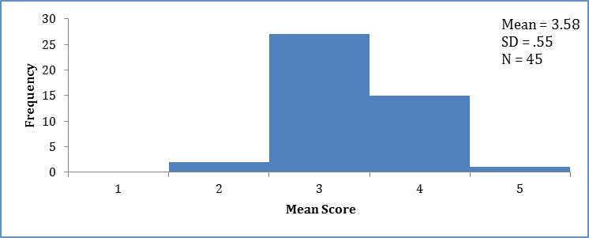

Table 4 summarizes the mean scores and frequencies for the two Areas in the Community-Based practice domain.
Table 4: Community Based Area Mean Scores & Frequencies
Domain/Area | Mean |  | Frequencies (n) %*
 |  |  | Adverse  Practice  1 | Poor  Practice  2 | Fair  Practice  3 | Good  Practice  4 | Exemplary/  Best Practice  5
Responsiveness  -ICC  -IHT |  | 3.27  3.29  3.00 | (1) 2%  (1) 2%  - | (7) 16%  (6) 14%  (1) 33% | (17) 38%  (16) 38%  (1) 33% | (19) 42%  (18) 43%  (1) 33% | (1) 2%  (1) 2%  -
Service Accessibility  -ICC  -IHT |  | 3.89  3.88  4.00 | -  -  - | (1) 2%  (1) 2%  - | (6) 13%  (6) 14%  - | (35) 78%  (32) 76%  (3) 100% | (3) 7%  (3) 7%  -
*Due to rounding of percentages, some Area totals may not equal 100%.
Domain 3: Culturally Competent
As indicated in Figure 4 on the next page, mean scores demonstrated Good practice related to the Culturally Competent Domain that consistently met established standards and best practices for 29% (n=13) of the youth/families reviewed. Fair practice was indicated 42% of the time (n=19), Poor practice 27% of the time (n=12), and Adverse practice for 2% (n=1) of the youth/families reviewed.

Figure 4: Culturally Competent Mean Scores
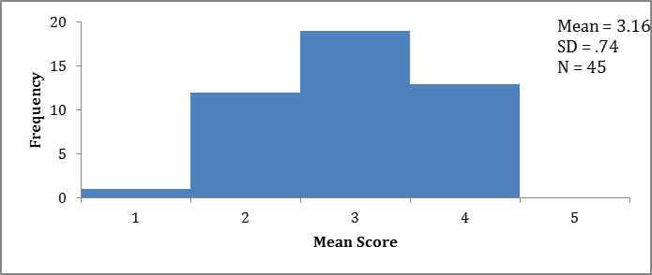

Table 5 summarizes mean score and frequencies for the Areas within this practice Domain.

Table 5: Culturally Competent Area
Mean Scores & Frequencies
Domain/Area | Mean | Frequencies (n) %*
 |  | Adverse  Practice  1 | Poor  Practice  2 | Fair  Practice  3 | Good  Practice  4 | Exemplary/  Best Practice  5
Cultural Awareness  -ICC  -IHT | 3.33  3.31  3.67 | -  -  - | (4) 9%  (4) 10%  - | (23) 51%  (22) 52%  (1) 33% | (17) 38%  (15) 36%  (2) 67% | (1) 2%  (1) 2%  -
Cultural Sensitivity & Responsiveness  -ICC  -IHT | 2.98  2.95  3.33 | (3) 7%  (3) 7%  - | (11) 24%  (10) 24%  (1) 33% | (17) 38%  (17) 40%  - | (14) 31%  (12) 29%  (2) 67% | -  -  -
*Due to rounding of percentages, some Area totals may not equal 100%.

Domain 4: Youth/Family Progress
Table 6 shows that overall mean scores for the Youth and Family Progress Domain ranged from 1.50 to 4.00, with an overall mean score of 3.07.
Table 6: Youth & Family Progress Domain Mean Scores
Domain | Min | Max | Mean | Standard Deviation
Domain 4: Youth/Family Progress  -ICC  -IHT | 1.50  1.50  3.50 | 4.00  4.00  4.00 | 3.07  3.01  3.83 | .79  .78  .29

As Figure 5 on the next page illustrates, 29% (n=13) of the youth/families reviewed had mean scores indicating Good progress was achieved since enrolling in IHT or ICC services. Thirty-six percent (n=16) demonstrated Fair progress, 33% (n=15) Little to No progress, and 2% (n=1) indicated worsening or declining condition.

Figure 5: Youth & Family Progress Mean Scores
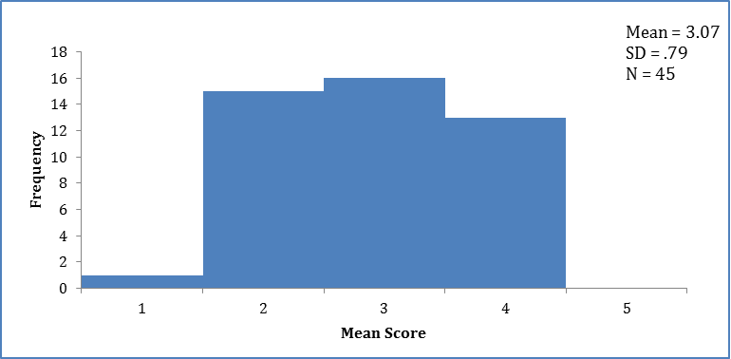

Table 7 summarizes the mean scores and frequencies for the youth and family progress Areas in this Domain. Adverse youth/family progress was noted for three families. The first family’s lack of progress can be attributed to overall poor practice, inclusive of a lack of culturally and linguistically competent services and supports. Youth from the other two families required a higher level of care, as both were hospitalized multiple times throughout service delivery and ultimately placed in residential treatment prior to the reviews.

Table 7: Youth & Family Progress Area
Mean Scores & Frequencies
Domain/Area |  | Mean |  | Frequencies (n) %*
 |  |  |  | Worsening or Declining Condition  1 |  | Little to No Progress  2 |  | Fair Progress  3 | Good  Progress  4 | Exceptional Progress  5
Youth Progress  -ICC  -IHT | 2.96  2.90  3.67 |  | (3) 7%  (3) 7%  - |  | (11) 24%  (11) 26%  - |  | (16) 36%  (15) 36%  (1) 33% |  | (15) 33%  (13) 31%  (2) 67% | -  -  -
Family Progress  -ICC  -IHT | 3.18  3.12  4.00 |  | -  -  - |  | (10) 22%  (10) 24%  - |  | (17) 38%  (17) 40%  - |  | (18) 40%  (15) 36%  (3) 100% | -  -  -
*Due to rounding of percentages, some Area totals may not equal 100%.

IHT Supplemental Questions
Table 8 on the next page summarizes responses to the eight supplemental questions added to the MPR protocol to ascertain whether care coordination delivered as part of the IHT service was adequate to the needs and circumstances of the 3 IHT enrolled youth/families who were reviewed this round. Although it is important to consider this data in the context of a very small number of cases reviewed, the findings remain valid. As reported in questions 1 and 2, all three youth/families indicated they did not need a CSA Wraparound care planning team as a result of involvement with state agency, providers, special education or a combination thereof. In question 3, reviewers agreed that 67% (n=2) of youth reviewed were receiving the amount and quality of care coordination their situation required. Also noteworthy was the need for coordination with school for 67% (n=2) of the youth/families. Reviewers agreed in 50% of the cases (n=1) that the IHT provider was in regular contact with the school. For those youth (n=2) that required coordination with other providers, reviewers agreed (50%) and agreed very much (50%) that regular contact had occurred. Finally, reviewers also agreed that state agency coordination and collaboration occurred for the two youth and families for which it was indicated.

Table 8: IHT Supplemental Questions
Question |  |  |  |  |  |  |  | Results
 |  |  |  |  |  |  |  | Response |  |  |  | (n) %
1. Youth needs or receives multiple services from the same or multiple providers AND needs a CSA Wraparound care planning team to coordinate services from multiple providers or state agencies, special education, or a combination thereof. |  |  |  |  |  |  |  | No |  |  |  | (3) 100%
2. Youth needs or receives services from state agencies, special education, or a combination thereof AND needs a CSA Wraparound care planning team to coordinate services from multiple providers or state agencies, special education, or a combination thereof. |  |  |  |  |  |  |  | No |  |  |  | (3) 100%
3. Youth is receiving the amount and quality of care coordination his/her situation requires.
Disagree Very Much  (n) %  – | Disagree  (n) %  – |  |  |  | Neither  (n) %  (1) 33% |  | Agree  (n) %  (1) 33% |  | Agree Very Much  (n) %  (1) 33%
- Has the youth previously been enrolled in ICC? |  |  |  |  |  |  |  | No |  |  |  | (2) 67%
5 a.) According to the CAREGIVER, has the IHT team ever discussed the option of ICC with the youth/family?* |  |  |  |  |  |  |  | Yes |  |  |  | (1) 50%
5 b.) According to the IHT Clinician, has the team ever discussed the option of ICC with the youth/family?* |  |  |  |  |  |  |  | Yes |  |  |  | (1) 50%
6 a.) Youth and family need the IHT provider to coordinate/ collaborate with school personnel. |  |  |  |  |  |  |  | Yes |  |  |  | (2) 67%
6 b.) If yes, the IHT is in regular contact with school personnel involved with the youth and family.*

Disagree Very Much  (n) %  – | Disagree  (n) %  – |  |  |  | Neither  (n) %  (1) 50% |  | Agree  (n) %  (1) 50% |  | Agree Very Much  (n) %  –
7 a.) Youth and family need the IHT provider to coordinate/ collaborate with other service providers (e.g. TM, OP, psychiatry, etc.) |  |  |  |  |  |  |  |  | Yes |  |  | (2) 67%
7 b.) If yes, the IHT is in regular contact with other providers (e.g. TM, OP, psychiatry, etc.) involved with the youth and family.*
Disagree Very Much  (n) %  – |  | Disagree  (n) %  – |  | Neither  (n) %  – |  | Agree  (n) %  (1) 50% |  |  |  | Agree Very Much  (n) %  (1) 50%
8 a.) Youth and family need the IHT provider to coordinate/collaborate with state agencies (e.g. DCF, DYS, DDS, etc.) |  |  |  |  |  |  |  |  | Yes |  | (2) 67%
8 b.) If yes, the IHT is in regular contact with state agencies (e.g. DCF, DYS, DDS, etc.) involved with the youth and family.*
Disagree Very Much  (n) %  – |  | Disagree  (n) %  – | Neither  (n) %  – |  |  | Agree  (n) %  (2) 100% |  |  |  | Agree Very Much  (n) %  –
*"Not applicable" responses changed the n used for calculating these percentages.
Discussion
Consistent with previous MPR reviews, overall Fair practice is indicated by the mean scores for the youth/families reviewed, as well as the distribution of cases along the Practice and Progress rating scales. Exemplary practice ratings were indicated in a small number of individual cases. Community-Based continues to be the highest scoring practice Domain, with Service Accessibility rated Good for the vast majority of cases. Family Driven and Youth Guided was the next highest scoring Domain, where Youth and Family Engagement remains strong and demonstrates the greatest number of exemplary ratings for any MPR practice Area. This Domain also contains the two poorest rated areas: Assessment and Transition. Additionally, ratings in the Area of Cultural Sensitivity and Responsiveness indicate the need for practice development. Progress improvements in areas including specific skill development, functioning, well-being, and quality of life were reported as Fair or Good for 69% of youth and 78% of families reviewed. Given the small number of IHT cases included in this report's analysis, it is difficult to draw any comparisons between the levels of care. The subsequent year-end MPR Summary Report will provide an opportunity to examine the quality of practice related to each service more closely, with consideration for patterns identifying practice strengths and opportunities for improvement.

Four reviews were carried over from the previous round and completed in May-June, but are not accounted for in May-June’s sampling.

