Massachusetts Practice Review (MPR)
Brief Summary Report: March & April 2016 Reviews

Introduction
The Commonwealth uses the Massachusetts Practice Review (MPR), a qualitative case review protocol, to evaluate the quality of MassHealth Children’s Behavioral Health Initiative (CBHI) services delivered to children/youth under 21. The MPR utilizes trained reviewers to obtain a comprehensive picture of CBHI services delivered at the practice level. Reviewers examine the clinical record and interview multiple stakeholders, including the In-Home Therapy (IHT) or Intensive Care Coordination (ICC) service provider, the caregiver, the child/youth (if over 12), and other formal providers working with the child/youth and family. By triangulating responses from all informants, reviewers assess the extent to which practice is meeting established standards and best practices for the service under review. Reviewers then rate 12 specific practice Areas within larger Domains that reflect CBHI values and principles. Rating is done on a scale from 1 to 5, with 1 being adverse practice and 5 being exemplary/best practice. Reviewers are also asked to rate two Areas concerning child/youth and family progress to determine the extent to which improvements have been realized in relation to specific skill development, functioning, well-being, and quality of life.

This brief report summarizes findings from the second round of FY16 MPR reviews conducted in March - April 2016. The care received by 37 children/youth enrolled in either ICC (N=19) or IHT (N=18) as the hub service from 18 randomly sampled providers across the state, including 10 CSAs and 8 IHT provider sites, was reviewed.

Provider Sampling/Youth Selection
ICC Provider Sampling
The MPR’s sampling model for ICC allows the state to evaluate practice delivered at all 32 CSAs in a given year by assigning each CSA 2 reviews. Eleven of the 32 CSAs were sampled this round, and the remaining 21 were assigned reviews for the May-June 2016 review round.
IHT Provider Sampling
Using data from the October 2015 Massachusetts Behavioral Health Access (MABHA) report, 7 IHT providers were randomly selected to participate in the March and April 2016 reviews. The MPR sampling process for IHT stratifies providers by volume so that providers with more youth enrolled in services have more reviews conducted. MABHA enrollment data showed similar enrollment rates, so 3 reviews were planned at each site. One additional IHT review was conducted at an IHT site that had been sampled during the October 2015 MPR round, but did not complete their review quota. This carry-over review increased the total number of IHT sites for March - April to 8.
Youth Selection
Once providers were sampled, families were randomly selected at the IHT and ICC sites to be approached for consent to participate. In all, 67 families were approached; of these, 37 families consented and had completed reviews, 3 reviews were postponed until a subsequent review round, 4 reviews had incomplete interviews, and 23 families declined to participate. The most commonly cited reason (48% or n=11 of youth/families approached) was anxiety about having “strangers” in their home and feeling overwhelmed by the prospect of another task/responsibility added to their busy lives.
Results
Demographics
Table 1 summarizes select demographic characteristics of the children/youth reviewed in March - April 2016.
Table 1: Select Demographic Characteristics
 |  | N | %
Gender | Male | 21 | 57%
Race/Ethnicity | White | 17 | 46%
 | Latino/Hispanic | 7 | 19%
 | Black | 5 | 13.5%
 | Biracial/Mixed | 5 | 13.5%
 | Asian | 1 | 3%
 | Native American | 1 | 3%
 | Other | 1 | 3%
Age of Youth | 5-9 Years | 11 | 30%
 | 10-13 Years | 14 | 38%
 | 14-17 Years | 10 | 27%
 | 18-21 Years | 2 | 5%
English as Primary Language |  | 32 | 86%
Length of Enrollment  (<12 months) |  | 28 | 76%
>1 BH Condition |  | 28 | 76%
Practice Domain Mean Scores
As shown in Table 2, MPR Practice Domain mean scores ranged from 3.32 to 3.85, with an overall mean score of 3.46. Mean scores were slightly higher for ICC than IHT across practice domains. (The header for Table 3 shows the level of practice associated with each of the ratings from 1 to 5.)
Table 2: MPR Practice Domain Overall & Mean Scores
Domain | Min | Max | Mean | Standard Deviation
Practice Overall  -ICC  -IHT | 2.42  2.83  2.42 | 4.58  4.33  4.25 | 3.46  3.58  3.31 | .55  .45  .60
Domain1: Family Driven & Youth Guided  -ICC  -IHT | 2.13  2.50  2.13 | 4.63  4.63  4.63 | 3.39  3.56  3.22 | .65  .58  .68
Domain 2: Community-Based  -ICC  -IHT | 3.00  3.00  3.00 | 5.00  5.00  5.00 | 3.85  3.92  3.78 | .54  .53  .55
Domain 3: Culturally Competent  -ICC  -IHT | 2.00  2.00  2.00 | 4.50  4.50  4.50 | 3.32  3.34  3.31 | .76  .76  .77
Community-Based was the highest scoring Practice Domain with a mean score of 3.85. The two practice Areas within this Domain were among the four highest scoring Areas - Responsiveness (3.76) and Service Accessibility (3.95). The Family Driven & Youth Guided Domain had the next highest Practice Domain mean score of 3.39. While two of the four highest scoring Areas - Service Delivery (3.73) and Youth and Family Engagement (3.95) - were in this Domain, so was the lowest scoring Area - Team Formation (3.14). Low scores in this Area plus two additional Areas within this Domain, Team Participation and Care Coordination, is in part reflective of Poor Practice ratings among the IHT cases reviewed this round (see Table 3). Culturally Competent had the lowest mean score of all Practice Domains (3.32).

Figure 1 illustrates the range of overall MPR Practice Domain mean scores for the youth/families reviewed.
Figure 1: Overall Practice Domain Mean Scores
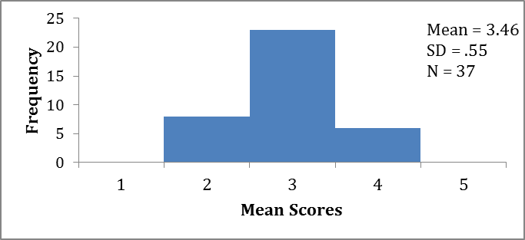

Of the youth reviewed, 16% (n=6) had overall case mean scores in the Good practice range, 62% (n=23) had mean scores in the Fair range, and 22% (n=8) in the Poor range.
Results by Practice Domain/Area
The following sections briefly summarize quantitative results across each MPR Practice Domain and the Areas within them.
Domain 1: Family Driven & Youth Guided
Figure 2 shows that practice in this domain was Good and consistently met established standards and best practices for 19% (n=7) of the youth/families reviewed. Practice was rated Fair or not consistently meeting established standards and best practices for 54% (n=20) of the cases reviewed, and Poor or not meeting minimal standards of practice for 27% (n=10) of the cases.
Figure 2: Family Driven & Youth Guided Mean Scores
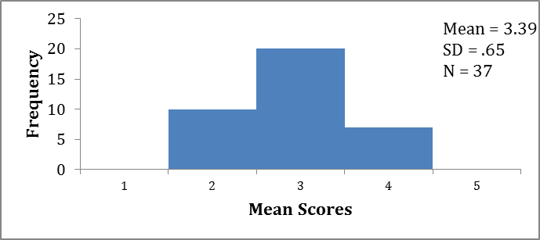

Table 3 below summarizes the mean scores and frequencies for each of the 8 Areas in this Practice Domain.

Table 3: Family Driven & Youth Guided
Mean Scores & Frequencies

Area |  | Mean | Frequencies (n) %*
 |  |  | Adverse  Practice  1 | Poor  Practice  2 | Fair  Practice  3 | Good  Practice  4 | Exemplary/  Best Practice  5
Assessment  -ICC  -IHT | 3.22  3.32  3.11 |  | -  -  - | (7) 19%  (3) 16%  (4) 22% | (16) 43%  (7) 37%  (9)50% | (13) 35%  (9) 47%  (4)22% | (1) 3%  -  - 6%
Service Planning  -ICC  -IHT | 3.22  3.21  3.22 |  | -  -  - | (6) 16%  (2) 11%  (4) 22% | (19) 51%  (11) 58%  (8) 44% | (10) 27%  (6) 32%  (4) 22% | (2) 5%  -  (2) 11%
Service Delivery  -ICC  -IHT | 3.73  3.79  3.67 |  | -  -  - | (2) 5%  (1) 5%  (1) 6% | (12) 32%  (5) 26%  (7)39% | (17) 46%  (10) 53%  (7) 39% | (6) 16%  (3)16%  (3)17%
Youth & Family Engagement  -ICC  -IHT | 3.95  3.74  4.17 |  | -  -  - | (3) 8%  (3) 16%  - | (9) 24%  (5) 26%  (4) 22% | (12) 32%  (5) 26%  (7) 39% | (13) 35%  (6) 32%  (7) 39%
Team Formation  -ICC  -IHT | 3.14  3.58  2.67 |  | (2) 5%  -  (2) 11% | (5) 14%  -  (5) 28% | (18) 49%  (10) 53%  (8) 44% | (10) 27%  (7) 37%  (3) 17% | (2) 5%  (2) 11%  -
Team Participation  -ICC  -IHT | 3.27  3.79  2.72 |  | (2) 5%  -  (2) 11% | (3) 8%  (1) 5%  (2) 11% | (16) 43%  (3) 16%  (13) 72% | (15) 41%  (14) 74%  (1) 6% | (1) 3%  (1) 5%  -
Care Coordination  -ICC  -IHT | 3.41  3.84  2.94 |  | (1) 3%  -  (1) 6% | (6) 16%  (2) 11%  (4) 22% | (11) 30%  (3) 16%  (8) 44% | (15) 41%  (10) 53%  (5) 28% | (4) 11%  (4) 21%  -
Transition  -ICC  -IHT | 3.22  3.21  3.22 |  | (1) 3%  (1) 5%  - | (7) 19%  (2) 11%  (5) 28% | (14) 38%  (9) 47%  (5) 28% | (13) 35%  (6) 32%  (7) 39% | (2) 5%  (1) 5%  (1) 6%
*Due to rounding of percentages, some Area totals may not equal 100%.

Domain 2: Community-Based
Figure 3 below indicates that practice was exemplary for 8% (n=3) of the youth/families reviewed. Just over half (51% or n=19) received mean scores indicating that practice was Good or consistently met established standards and best practices. Practice was rated as Fair or not consistently meeting established standards and best practices 41% of the time (n=15)
Figure 3: Community-Based Mean Scores
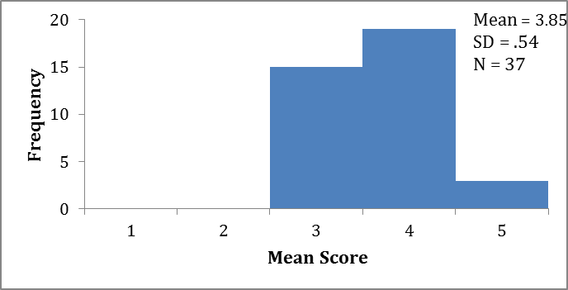

Table 4 summarizes the mean scores and frequencies for the two Areas in the Community-Based practice domain. This Domain was a noted strength this MPR review round, with mean scores for both Areas within this domain among the four highest scoring of all 14 MPR Areas.
Table 4: Community Based Area Mean Scores & Frequencies
Domain/Area | Mean |  | Frequencies (n) %*
 |  |  | Adverse  Practice  1 | Poor  Practice  2 | Fair  Practice  3 | Good  Practice  4 | Exemplary/  Best Practice  5
Responsiveness  -ICC  -IHT |  | 3.76  3.84  3.67 | -  -  - | -  -  - | (15) 41%  (7) 37%  (8) 44% | (16) 43%  (8) 42%  (8) 44% | (6) 16%  (4) 21%  (2) 11%
Service Accessibility  -ICC  -IHT |  | 3.95  4.00  3.89 | -  -  - | -  -  - | (7) 19%  (3) 16%  (4) 22% | (25) 68%  (13) 68%  (12) 67% | (5) 14%  (3) 16%  (2) 11%
*Due to rounding of percentages, some Area totals may not equal 100%.
Domain 3: Culturally Competent
As indicated in Figure 4 on the next page, mean scores demonstrated Good practice related to the Culturally Competent Domain that consistently met established standards and best practices for 43% (n=16) of the youth/families reviewed. Fair practice was indicated 32% of the time (n=12), and Poor practice 24% of the time (n=9).

Figure 4: Culturally Competent Mean Scores
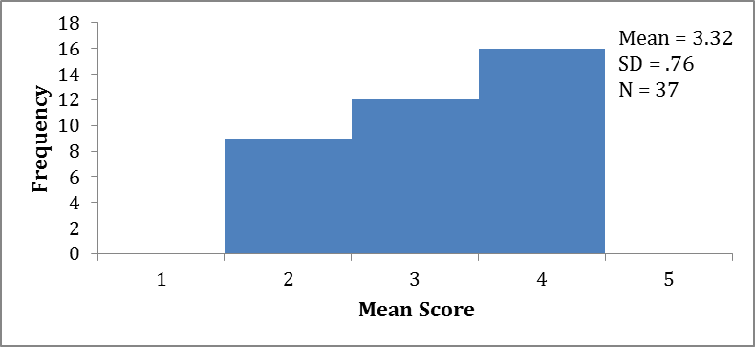

Table 5 summarizes mean score and frequencies for the Areas within this practice Domain.

Table 5: Culturally Competent Area
Mean Scores & Frequencies
Domain/Area | Mean | Frequencies (n) %*
 |  | Adverse  Practice  1 | Poor  Practice  2 | Fair  Practice  3 | Good  Practice  4 | Exemplary/  Best Practice  5
Cultural Awareness  -ICC  -IHT | 3.32  3.42  3.22 | (1) 3%  -  (1) 6% | (4) 11%  (1) 5%  (3) 17% | (14) 38%  (9) 47%  (5) 28% | (18) 49%  (9) 47%  (9) 50% | -  -  -
Cultural Sensitivity & Responsiveness  -ICC  -IHT | 3.32  3.26  3.39 | -  -  - | (7) 19%  (5) 26%  (2) 11% | (14) 38%  (6) 32%  (8) 44% | (13) 35%  (6) 32%  (7) 39% | (3) 8%  (2) 11%  (1) 6%
*Due to rounding of percentages, some Area totals may not equal100%.
Domain 4: Youth/Family Progress Mean Scores
Table 6 shows that overall mean scores for the Youth and Family Progress Domain ranged from 2.00 to 4.00, with an overall mean score of 3.23.
Table 6: Youth & Family Progress Domain Mean Scores
Domain | Min | Max | Mean | Standard Deviation
Domain 4: Youth/Family Progress  -ICC  -IHT | 2.00  2.00  2.00 | 4.00  4.00  4.00 | 3.23  3.29  3.17 | .58  .51  .66

As Figure 5 on the next page illustrates, 22% (n=8) of the youth/families reviewed had mean scores indicating Good progress was achieved since enrolling in IHT or ICC services. Sixty-two percent (n=23) demonstrated Fair progress, and 16% (n=6) Little to No progress.
Figure 5: Youth & Family Progress Mean Scores
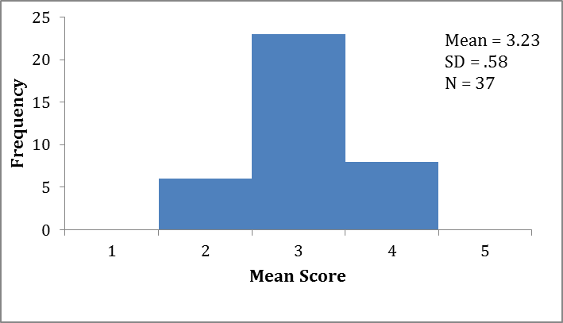

Table 7 summarizes the mean scores and frequencies for the youth and family progress Areas in this Domain.

Table 7: Youth & Family Progress Area
Mean Scores & Frequencies
Domain/Area |  | Mean |  | Frequencies (n) %*
 |  |  |  | Worsening or Declining Condition  1 |  | Little to No Progress  2 |  | Fair Progress  3 | Good  Progress  4 | Exceptional Progress  5
Youth Progress  -ICC  -IHT | 3.16  3.21  3.11 |  | (1) 3%  -  (1) 6% |  | (2) 5%  (1) 5%  (1) 6% |  | (24) 65%  (13) 68%  (11) 61% |  | (10) 27%  (5) 26%  (5) 28% | -  -  -
Family Progress  -ICC  -IHT | 3.30  3.37  3.22 |  | -  -  - |  | (5) 14%  (2) 11%  (3) 17% |  | (16) 43%  (8) 42%  (8) 44% |  | (16) 43%  (9) 47%  (7) 39% | -  -  -
*Due to rounding of percentages, some Area totals may equal >100%.

IHT Supplemental Questions
Table 8 on the next page summarizes responses to the eight supplemental questions added to the MPR protocol to ascertain whether care coordination delivered as part of the IHT service was adequate to the needs and circumstances of the 18 IHT enrolled youth/families who were reviewed this round. As reported in questions 1 and 2, the majority of cases did not indicate the need for a CSA Wraparound care planning team as a result of involvement with state agency, providers, special education or a combination thereof. In question 3, reviewers agreed that 28% (n=5) of youth reviewed were not receiving the amount and quality of care coordination their situation required. While some of those youth may have benefited from ICC, it cannot be interpreted to indicate that ICC would be appropriate for the majority of cases. Also noteworthy was the need for coordination with school for 94% (n=17) of the youth/families. Of those, reviewers were clear that for 41% (n = 7) of these youths, the IHT provider was not in regular contact with the school.

Table 8: IHT Supplemental Questions
Question |  |  |  |  |  |  |  | Results
 |  |  |  |  |  |  |  | Response |  |  |  | (n) %
1. Youth needs or receives multiple services from the same or multiple providers AND needs a CSA Wraparound care planning team to coordinate services from multiple providers or state agencies, special education, or a combination thereof. |  |  |  |  |  |  |  | No |  |  |  | (15) 83%
2. Youth needs or receives services from state agencies, special education, or a combination thereof AND needs a CSA Wraparound care planning team to coordinate services from multiple providers or state agencies, special education, or a combination thereof. |  |  |  |  |  |  |  | No |  |  |  | (12) 67%
3. Youth is receiving the amount and quality of care coordination his/her situation requires.
Disagree Very Much  (n) %  (1) 6% | Disagree  (n) %  (4) 22% |  |  |  | Neither  (n) %  (5) 28% |  | Agree  (n) %  (7) 39% |  | Agree Very Much  (n) %  (1) 6%
4 . Has the youth previously been enrolled in ICC? |  |  |  |  |  |  |  | No |  |  |  | (13) 72%
5 a.) According to the CAREGIVER, has the IHT team ever discussed the option of ICC with the youth/family?* |  |  |  |  |  |  |  | Yes |  |  |  | (8) 44%
5 b.) According to the IHT Clinician, has the team ever discussed the option of ICC with the youth/family? |  |  |  |  |  |  |  | Yes |  |  |  | (10) 56%
6 a.) Youth and family need the IHT provider to coordinate/ collaborate with school personnel. |  |  |  |  |  |  |  | Yes |  |  |  | (17) 94%
6 b.) If yes, the IHT is in regular contact with school personnel involved with the youth and family.*

Disagree Very Much  (n) %  (2) 12% | Disagree  (n) %  (5) 29% |  |  |  | Neither  (n) %  (4) 24% |  | Agree  (n) %  (6) 35% |  | Agree Very Much  (n) %  -
7 a.) Youth and family need the IHT provider to coordinate/ collaborate with other service providers (e.g. TM, OP, psychiatry, etc.) |  |  |  |  |  |  |  |  | Yes |  |  | (13) 72%
7 b.) If yes, the IHT is in regular contact with other providers (e.g. TM, OP, psychiatry, etc.) involved with the youth and family.*
Disagree Very Much  (n) %  - |  | Disagree  (n) %  (5) 38% |  | Neither  (n) %  (2) 15% |  | Agree  (n) %  (6) 46% |  |  |  | Agree Very Much  (n) %  -
8 a.) Youth and family need the IHT provider to coordinate/collaborate with state agencies (e.g. DCF, DYS, DDS, etc.) |  |  |  |  |  |  |  |  | No |  | (12) 67%
8 b.) If yes, the IHT is in regular contact with state agencies (e.g. DCF, DYS, DDS, etc.) involved with the youth and family.*
Disagree Very Much  (n) %  - |  | Disagree  (n) %  - | Neither  (n) %  (3) 50% |  |  | Agree  (n) %  (2) 33% |  |  |  | Agree Very Much  (n) %  (1) 17%
*"Not applicable" responses changed the n used for calculating these percentages.

Discussion
The Community-Based Domain continues to be the highest scoring practice Domain, with ratings for the majority of cases indicating Good, and for a small number of cases, Exemplary, practice. While pockets of Exemplary practice ratings were present in other Areas, such as Youth & Family Engagement and Service Delivery, the overall results of this MPR review round suggest that providers are delivering services with mixed consistency in adhering to established standards and best practices. Practice ratings were fairly comparable between IHT and ICC cases reviewed across Domains, except in the Areas of Team Formation, Team Participation, and Care Coordination, where a greater proportion of Poor or Adverse practice ratings were present among the IHT cases reviewed compared to ICC. This is consistent with findings from the IHT Supplemental questions noted above. Mean scores for the majority of youth/families reviewed, and the distribution of cases along the practice and progress rating scales, suggest Fair practice overall. Eighty-four percent of youth and families experienced good or fair progress, with only 16% experiencing little to no progress.

22 ICC cases were sampled, 3 were incomplete.
22 IHT cases were sampled, 3 were postponed and completed in May-June, and 1 was incomplete.

