Massachusetts Practice Review (MPR)
Report on FY15 Pilot Reviews - October 2015

Introduction

In FY14, the Commonwealth implemented the System of Care Practice Review (SOCPR) as part of its ongoing effort to evaluate the quality of care delivered to youth under 21 receiving MassHealth Children’s Behavioral Health Initiative (CBHI) services. The SOCPR uses a multiple case study methodology to learn how important System of Care (SOC) values and principles are operationalized at the practice level, where youth and families have direct contact with service providers. The results of five regionally-based reviews conducted with In-Home Therapy (IHT) and Intensive Care Coordination (ICC) providers using the SOCPR protocol were summarized in a series of reports disseminated throughout the year. A 2013-14 Statewide Summary Report discusses areas of strong performance for the system and providers to build upon, areas that should be the focus of system and provider improvement efforts, and recommendations to support overall quality improvement of CBHI services for youth and families.

Among the recommendations was creating a Massachusetts-specific version of the SOCPR protocol. Specifically, suggested changes included making the interview protocol more aligned with the best practice Wraparound process implemented by MassHealth for its CBHI services. Changes included questions that reflect the Wraparound principle of “family voice, family choice”, and adding/revising questions to better examine thoroughness of the assessment, care transitions and safety planning, and the impact of services on youth and family progress in specific areas like coping/self-management, social/emotional functioning, and well-being/quality of life.

Revisions to the protocol were made between June and August 2014, and pilot tests of the new protocol, called the Massachusetts Practice Review (MPR), occurred in October 2014 and June 2015. This report describes key protocol revisions and impressions from the MPR pilot test reviews, as well as plans for future MPR reviews using the new protocol and provider sampling procedures. System and provider quality improvement efforts as a result of SOCPR implementation are also briefly described.

Summary of Protocol Revisions

Through a series of meetings between EOHHS, MassHealth, selected SOCPR reviewers, and the Technical Assistance Collaborative (TAC), which is contracted by EOHHS to manage the quality of care review process, revisions were made to the SOCPR protocol’s practice domains to more closely align with Massachusetts’ SOC, as well as to the protocol’s structure and rating scale to facilitate ease of use and clearer scoring.

An important facet of the CBHI service system is the designation of the clinical HUB. The HUB provider maintains responsibility for coordinating care among all formal providers, natural supports, children/youth, and their families. The MPR was developed with this unique system in mind to both assess the quality of practice of the service being reviewed (IHT and/or ICC), and to explicitly assess whether the amount and quality of care coordination being conducted is appropriate to the child/youth’s needs or whether children/youth should be enrolled in a more intensive and coordinated level of care.

Additionally, modifications were made to the scoring process. The SOCPR required reviewers to individually score 41 separate Summative Questions, which were categorized into Domains, then Sub-Domains, and then, in some cases, Areas. CBHI leaders felt that rating similar questions was unnecessary and that an equal level of insight and clarity could be drawn by grouping familiar concepts together when scoring. Thus, the MPR only requires reviewers to rate 14 Areas, 12 of which assess the practice being delivered and 2 of which look at progress made by the youth and family since their enrollment in the service under review. Each Area is comprised of prompts or considerations for scoring, some of which were Summative Questions in the SOCPR.

The table in Appendix A compares the SOCPR Domains, Sub-Domains, Areas, and Summative Questions with the MPR’s 4 Domains and 14 Areas.

In addition, the SOCPR’s 7-point rating scale, used to indicate the extent to which practice is aligned with the SOC Principles represented by each domain, was modified to a 5-point rating scale tied to practice indicators which interpret ratings as either acceptable or in need of improvement for Domains 1-3.

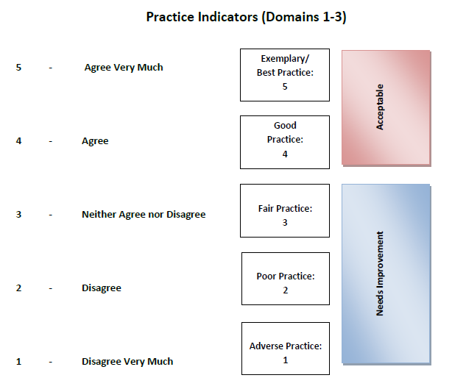
A separate 5-point rating scale was devised for use in rating Domain 4, which assesses youth and family progress since the provision of services began. Similarly, the scale is tied to child/family progress indicators which interpret ratings to indicate either favorable or unfavorable progress.

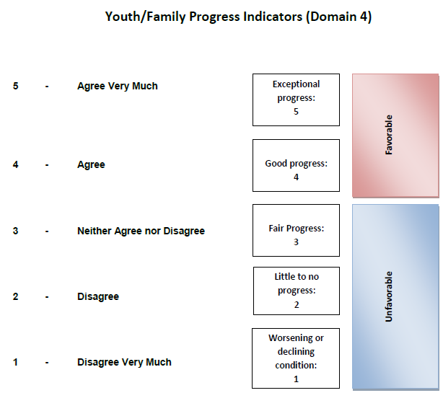

After completing two rounds of Pilot Reviews with the scales shown above, it was determined that they could be improved. Additional tweaks were made to help reviewers distinguish between the 5 options when assigning scores. The language of ‘Disagree Very Much’ to ‘Agree Very Much,’ a leftover from the SOCPR, is being discarded in future MPR reviews because it is not applicable when scoring Areas.

Additionally, the Acceptable/Needs Improvement boxes on the Practice Indicator Scale and the Favorable/Unfavorable boxes on the Child/Family Progress Indicator Scale are being removed from the protocol and used solely in data analysis and report writing. Lastly, new label definitions will be included in the Practice Indicator Rating Scale to improve rating consistency.

The updated rating scales will be utilized in MPR reviews beginning in FY16. The Practice Indicator Rating Scale can be found in Appendix B and the Youth/Family Progress Indicator Rating Scale can be found in Appendix C.

New Provider Sampling Procedures

Based on experience with the SOCPR, new provider sampling procedures were developed to ensure consideration for both provider volume and the number of youth reviewed per clinician. Also, given that the majority of reviews to date were of youth enrolled in IHT, and that recommendations for practice improvement focus mostly on the IHT provider system, sampling for reviews conducted in FY15 solely focused on youth enrolled in IHT using the methods described below.

Provider Capacity/Volume
Using data from the Massachusetts Behavioral Health Access (MABHA) report, all of the state’s IHT providers were sorted by their total capacity to ensure that high, medium, and low volume providers were reviewed. Each provider sampled had a minimum of two youth reviewed, with high volume providers having more reviews than low volume providers. The definitions volume definitions and number of youth reviewed at each volume level are indicated below in Table 1.

Table 1: Sampling Based on Provider Volume
Volume Category | Category Definition | # of Youth Reviewed per provider
High Volume | 100 or more youth | 4
Medium | 40-99 youth | 3
Low | 10-39 youth | 2

Number of Youth Reviewed per Clinician
For high and medium volume providers, clinicians had no more than one youth reviewed. As the SOCPR reviews indicated, there can be vast differences in service provision within the same organization. To that end, requiring that every family reviewed has a different clinician makes a lot of sense. Additionally, limiting the number of families a clinician has reviewed ensures that we are not over-burdening clinicians. An exception to the ‘no more than one family reviewed per clinician’ guideline was considered for low volume providers. These providers often have a very small group of IHT Clinicians and, depending on how many families decline, it may be impossible to conduct both reviews with separate clinicians.

Table 2 shows the demographics of children/youth involved in the SOCPR reviews compared with the MPR pilot reviews. Although differences with regard to race and age exist, chi-square tests revealed no statistically significant differences on any demographic characteristics reported.

Table 2: SOCPR & MPR Demographic Comparison
Characteristic | 2013/2014 SOCPR reviews | 10/14 & 6/15 MPR Pilot reviews
Male | 68% | 68%
White | 44% | 58%
Age 5-9 | 31% (plurality of cases) | 53%
English as primary language | 85% | 90%
Length of enrollment  (< 12mos) | 78% | 74%
> 1 BH diagnosis | 67% | 69%

October 2014 and June 2015 Pilot Reviews

The purpose of the October 2014 and June 2015 review cycles was two-fold: 1) to pilot test the new MPR protocol; and 2) to learn about IHT practice for the youth/families whose cases were reviewed.

For October, six low volume providers across the State were randomly selected to participate using data from the March 2014 MABHA report. However, one provider only had 2 youth enrolled in IHT at the time and neither family consented to participate. Thus, the care of 10 youth from 5 IHT providers was reviewed.

For June, one high volume provider and two medium volume providers were randomly selected to participate using the December 2014 MABHA report. A total of 10 reviews was planned for the June round, however the high volume provider was unable to obtain consent from a fourth family. Therefore, the care of 9 youth from 3 IHT providers was reviewed.

Given the small number of children/youth reviewed during the pilot (N=19) and that the purpose was primarily to test the newly revised protocol, quantitative data was not fully analyzed for these reviews. However, a brief summary of mean scores by MPR domain and overall is presented in Table 3.

Lower mean scores overall and for each of the domains for cases reviewed during the pilot are attributable, in part, to the new practice indicator rating scale, which uses a 5 as its highest rating rather than a 7 as in the SOCPR, and to the fact that the pilot included only IHT cases, where the most practice deficiencies were found in previous review cycles.

Table 3: MPR Domain Scores for Pilot Reviews
Domain | Min | Max | Mean | Standard Deviation
Overall | 1.86 | 4.64 | 3.31 | .81
Domain1: Family Driven & Youth Guided | 1.50 | 4.75 | 3.18 | .91
Domain 2: Community-Based | 2.50 | 5.00 | 3.95 | .77
Domain 3: Culturally Competent | 1.00 | 5.00 | 3.04 | 1.11
Domain4: Youth/Family Progress | 2.00 | 5.00 | 3.42 | .83

With respect to the utility of the revised protocol, after the October 2014 review, reviewers found that it required small refinements and adjustments, including minor additions to the demographic portion. Additionally, reviewers indicated that the printed interview protocol was not organized in a way that accommodated the flow of interview recording, so the ordering of materials in the printed protocol will be reorganized for FY16.

Conclusions/Next Steps

Given that the SOCPR process revealed the need for quality improvement particularly within the IHT provider system, the state spent Fiscal Year 15 focusing on implementing recommendations contained in the 2013-14 Statewide Summary Report in order to improve service delivery to youth and families receiving IHT. IHT Practice Guidelines were developed and disseminated to providers through a series of training workshops. These trainings introduced the Practice Guidelines and presented the key components of and considerations related to the Guidelines. Additional resources will be allocated to improving IHT practice in FY16, as an IHT Practice Profile will be developed and disseminated.

The MPR protocol piloted during these reviews will be implemented during 2015-2016. Three review rounds will be conducted in October 2015, March and June 2016. 120 cases will be reviewed. Findings from these reviews, as well as the status of quality improvement activities will be reported on and disseminated in Fall 2016.

Appendix A: Comparison of SOCPR and MPR
SOCPR | MPR
DOMAIN: Child-Centered & Family-Focused  Sub-domain: Individualized  Area: Assessment/Inventory  - A thorough assessment or inventory was conducted across life domains.  - The needs of the child and family have been identified and prioritized across a full range of life domains.  - The strengths of the child and family have been identified.  Area: Service Planning  - There is a primary service plan that is integrated across providers and agencies.  - The services plan goals reflect needs of the child and family.  - The service plan goals incorporate the strengths of the child and family.  - The service planning and delivery informally acknowledges/considers the strengths of the child and family.  Area: Types of Services/Supports  - The types of services, supports provided to the child and family reflect their needs and strengths.  Area: Intensity of Services/Supports  - The intensity of the services/supports provided to the child and family reflects their needs and strengths.  Sub-domain: Full Participation  - The child and family actively participate in the service planning process (initial plan & updates).  - The child and family influence the service planning process (initial plan & updates).  - The child and family understand the content of the service plan.  - The child and family actively participate in services.  - The formal providers and informal helpers participate in service planning (initial plan & updates).  Sub-domain: Care Coordination  - There is one person who successfully coordinates the planning and delivery of services and supports.  - Service plans and services are responsive to the emerging and changing needs of the child and family. | DOMAIN 1: Family-Driven & Youth-Guided  Area 1: Assessment  - Relevant data/information about the youth and family was diligently gathered through both initial and ongoing processes.  - The needs of the youth and family have been appropriately identified and prioritized across a full range of life domains.  - Actionable strengths of the youth and family have been identified and documented.  - The provider has explored natural supports with the family  - The written assessment provides a clear understanding of the youth and family.  Area 2: Service Planning  - The provider actively engages and includes the youth and family in the service planning process.  - The service plan goals logically follow from the needs and strengths identified in the comprehensive assessment.  - Service plans and services are responsive to the emerging and changing needs of the youth and family.  - An effective risk management/safety plan is in place for the youth/family.  Area 3: Service Delivery  - The interventions provided to the youth and family match their needs and strengths.  - The provider incorporates the youth’s and family’s actionable strengths into the service delivery process.  - The intensity of the services/supports provided to the youth and family match their needs.  - Service providers assist the youth and family in understanding the provider agency and the service(s) in which they are participating.  Area 4: Youth & Family Engagement  - The provider actively engages the youth and family in the ongoing service delivery process.  Area 5: Team Formation  - The provider actively engages and includes formal providers in the service planning and delivery process (initial plan and updates).  - The provider actively engages and includes natural supports in the service planning and delivery process (initial plan and updates).  Area 6: Team Participation  - Providers, school personnel or other agencies involved with the youth participate in service planning.  Area 7: Care Coordination  - The provider (i.e. IHT clinician, ICC) successfully coordinates service planning and the delivery of services and supports.  - The youth is receiving the level of care coordination his/her situation requires.  - The provider facilitates ongoing, effective communication among all team members, including formal service providers, natural supports (if desired by the family), and family members including the youth.  Area 8: Transition  - Care transitions and life transitions (e.g. from youth to adult system, from one provider to another, from one service to another, from hospital to home, etc.) are anticipated, planned for, and well coordinated.
DOMAIN: Community-Based  Sub-domain: Early Intervention  - As soon as the child and family began experiencing problems, the system clarified the child and family's needs.  - As soon as the child and family entered the service system, the system responded by offering the appropriate combination of services and supports.  Sub-domain: Access to Services  Area: Convenient Times  - Services are scheduled at convenient times for the child and family.  Area: Convenient Locations  - Services are provided within or close to the child and family’s home community.  - Supports are provided to the child and family to increase their access to service location(s). (Rate as “Does not Apply” if Summative rating #20 = +3)  Area: Appropriate Language  - Service providers verbally communicate in the primary language of the child/family.  - Written documentation regarding services/service planning is in the primary language of the child/family.  Sub-domain: Minimal Restrictiveness  - Services are provided in an environment that feels comfortable to the child and family.  - Services are provided in the least restrictive and most appropriate environment(s).  Sub-domain: Integration & Coordination  - There is ongoing two-way communication among and between all team members, including formal service providers, informal helpers (if desired by the family), and family members including child.  - There is a smooth and seamless process to link the child and family with additional services if necessary. | DOMAIN 2: Community-Based  Area 9: Responsiveness  - The provider responded to the referral (for its own service) in a timely and appropriate way.  - The provider made appropriate service referrals (for other services/supports) in a timely manner and engaged in follow-up efforts as necessary to ensure linkage with the identified services and supports.  Area 10: Service Accessibility  - Services are scheduled at convenient times for the youth and family.  - Services are provided in the location of the youth and family’s preference.  - Service providers verbally communicate in the preferred language of the youth/family.  - Written documentation regarding services/planning is provided in the preferred language of the youth/family.
DOMAIN: Culturally Competent  Sub-domain: Awareness  Area: Awareness of Child and Family’s Culture  - Service providers recognize that the child and family must be viewed within the context of their own cultural group and their neighborhood and community.  - Service providers know about the family's concepts of health and family.  - Service providers recognize that the family's culture (values, beliefs and lifestyle) influences the family's decision-making process.  Area: Awareness of Provider’s Culture  - Service providers are aware of their own culture (values, beliefs and lifestyles) and how it influences the way they interact with the child and family.  Area: Awareness of Cultural Dynamics  - Service providers are aware of the dynamics inherent when working with families whose culture (values, beliefs and lifestyle) may be different from or similar to their own.  Sub-domain: Sensitivity and Responsiveness  - Service providers translate their awareness of the family's culture (values, beliefs and lifestyle) into action.  - Services are responsive to the child and family's culture (values, beliefs and lifestyle).  Sub-domain: Agency Culture  - Service providers recognize that the family's participation in service planning and in the decision making process is impacted by their knowledge/understanding of the expectations of the agencies/programs/providers.  - Service providers assist the child and family in understanding/navigating the agencies they represent.  Sub-domain: Informal Supports  - Service planning and delivery intentionally includes informal sources of support for the child and family. | DOMAIN 3: Culturally Competent  Area 11: Cultural Awareness  - The service provider has explored and can describe the family’s beliefs, culture, traditions, and identity.  - Cultural differences and similarities between the provider and the youth/ family have been acknowledged and discussed, as they relate to the plan for working together.  Area 12: Cultural Sensitivity & Responsiveness  - The provider has acted on/incorporated knowledge of the family’s culture into the work.  - The provider has explored any youth or family history of migration, moves, or dislocation. If the youth or family has experienced stressful migration, moves, or dislocation, then those events inform the assessment of family’s strengths and needs and the treatment/care plan.  - The provider has explored any youth or family history of discrimination and victimization. If the youth or family has experienced discrimination or victimization, then the provider ensures that the treatment process is sensitive/responsive to the family’s experience.  - The provider has explored cultural differences within the family (e.g. intergenerational issues or due to couples having different backgrounds) and has incorporated this information into the understanding of the youth and family’s strengths and needs and the care/treatment plan).  - The provider helps the entire team understand and respect this family’s culture.
DOMAIN 4: Impact  Sub-domain: Improvement  38a. The services/supports provided to the child have improved his/her situation.  38b. The services/supports provided to the family have improved their situation.  Sub-domain: Appropriateness  39a. The services/supports provided to the child have appropriately met his/her needs.  39b. The services/supports provided to the family have appropriately met their needs. | DOMAIN 4: Youth/Family Progress  Area 13: Youth Progress  - Since the youth’s enrollment in the service being reviewed, he/she has developed improved coping or self-management skills.  - Since the youth’s enrollment in the service being reviewed, he/she has made progress in their social and/or emotional functioning at school.  - Since the youth’s enrollment in the service being reviewed, he/she has made progress in their social and/or emotional functioning in the community.  - Since the youth’s enrollment in the service being reviewed, he/she has made progress in their social and/or emotional functioning at home.  - Since the youth’s enrollment in the service being reviewed, there has been improvement in the youth’s overall well-being and quality of life.  Area 14: Family Progress  - Since the family’s enrollment in the service being reviewed, the parent/caregiver has made progress in their ability to cope with/manage their youth’s behavior.  - Since the family’s enrollment in the service being reviewed, there has been improvement in the family’s overall well-being and quality of life.

Appendix B: Practice Indicator Rating Scale
Practice Indicators (Domains 1-3)
Exemplary/  Best Practice:  5 | Consistently exceeds established standards of practice  Consistently meets established standards of practice  Does not consistently meet established standards of practice  Does not meet minimal established standards of practice  Practice is either absent or wrong, and possibly harmful. Or practices being used may be inappropriate, contraindicated, or performed inappropriately or harmfully
Good Practice:
4

Fair Practice:
3

Poor Practice:
2

Adverse Practice:
1

Appendix C: Youth/Family Progress Indicator Rating Scale
Youth/Family Progress Indicators (Domain 4)
Exceptional progress:
5

Good progress:
4

Fair Progress:
3

Little to no progress:
2

Worsening or declining condition:
1

