Charles D. Baker  Governor  Karyn E. Polito  Lieutenant Governor  Thomas A. Turco, III  Secretary of Public Safety and Security |  |  | Terrence Reidy  Undersecretary  Chief Robert J. Ferullo (Ret)  Interim Executive Director

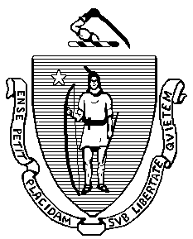 | Commonwealth of Massachusetts  Municipal Police Training Committee  “Training for Today, Planning for the Future” | 6 Adams Street  Randolph, MA 02368  Phone: (781) 437-0300  Fax: (781) 963-0235 | 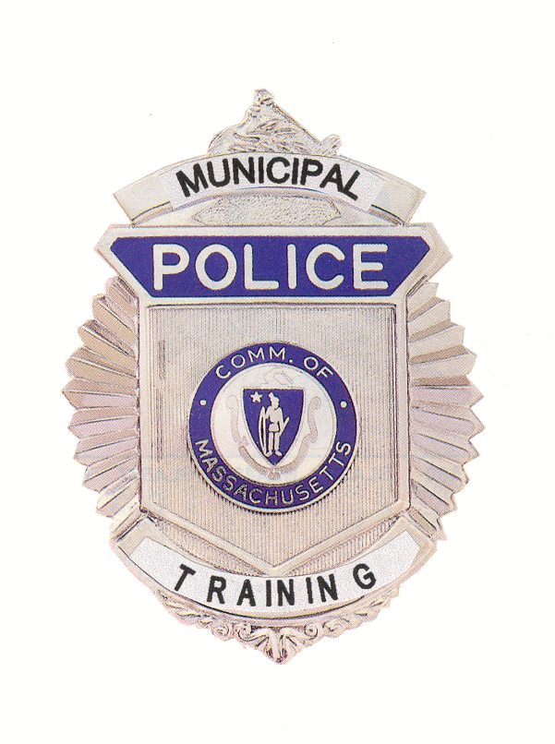

 | MEMORANDUM
TO: | Secretary of State  (delivered via email to regs@sec.state.ma.us)  Department of Administration and Finance  (delivered via email to melissa.andrade@state.ma.us)
FROM: | Chief Robert J. Ferullo (Ret.), Interim Executive Director  Municipal Police Training Committee
DATE: | July 17, 2020
RE: | Notice of Open Meeting

NOTICE OF OPEN MEETING

Under the provisions of G.L. c. 30A, the Municipal Police Training Committee will conduct an Open Meeting Wednesday, July 22, 2020 at 10:00 a.m. to be held virtually:

To view this meeting on computer, laptop, tablet or smartphone with speakers and microphone, use this link at the above date and time:
https://zoom.us/j/93477583483?pwd=eU0xM2RiTnZkZG40VWdPbk9FT0pEQT09

Dial in 1 929 436 2866 US
Meeting ID: 934 7758 3483
Password: 942103

RJF/lmk

