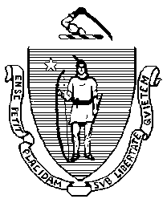
Commonwealth of Massachusetts Municipal Police Training Committee “Training for Today, Planning for the Future”

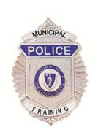
6 Adams Street
Randolph, MA 02368
Phone: (781) 437-0300
Fax: (781) 963-0235

Charles D. Baker
Governor

Karyn E. Polito
Lieutenant Governor

Daniel J. Bennett
Secretary of Public Safety and Security
Jennifer D. Queally
Undersecretary

Dan Zivkovich
Executive Director

MEMORANDUM

TO: Secretary of State (delivered via email to regs@sec.state.ma.us)
Department of Administration and Finance
(delivered via mail to melissa.andrade@state.ma.us)

FROM: Daniel R. Zivkovich, Executive Director
Municipal Police Training Committee

DATE: May 11, 2018

RE: Notice of Open Meeting

NOTICE OF OPEN MEETING
Under the provisions of G.L. c. 30A, the Municipal Police Training Committee will conduct an Open Meeting on Wednesday, May 16, 2018, to be held at the Randolph Regional Police Academy, 6 Adams Street, Randolph, Massachusetts, starting at 09:30 a.m.

DRZ

Posted on https://www.mass.gov/orgs/municipal-police-training-committee May 11, 2018

