Charles D. Baker  Governor  Karyn E. Polito  Lieutenant Governor  Thomas A. Turco, III  Secretary of Public Safety and Security |  |  | Terrence Reidy Undersecretary  Dan Zivkovich  Executive Director

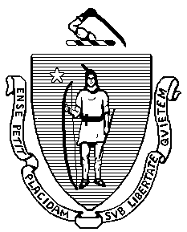 | Commonwealth of Massachusetts  Municipal Police Training Committee  “Training for Today, Planning for the Future” | 6 Adams Street  Randolph, MA 02368  Phone: (781) 437-0300  Fax: (781) 963-0235 | 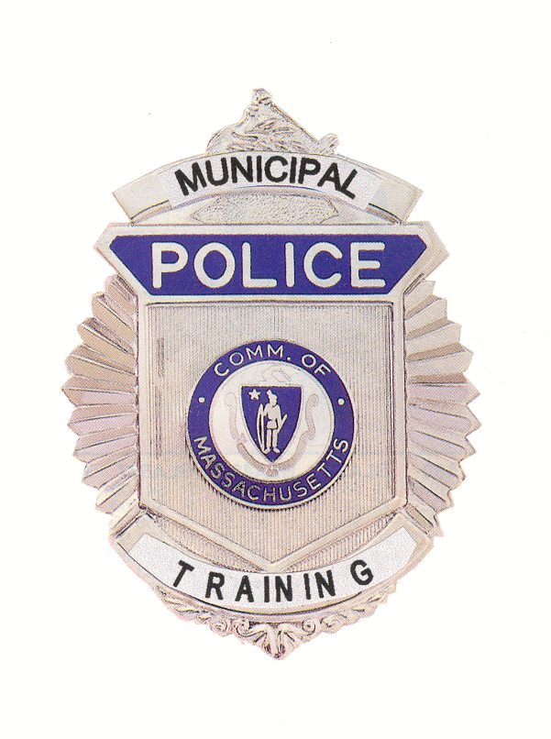

MEMORANDUM

TO: Secretary of State
(Delivered via email to regs@sec.state.ma.us)

Department of Administration and Finance
(Delivered via mail to melissa.andrade@state.ma.us)

FROM: Daniel R. Zivkovich, Executive Director
Municipal Police Training Committee

DATE: July 15, 2019

RE: Notice of Open Meeting

NOTICE OF OPEN MEETING

Under the provisions of G.L. c. 30A, the Municipal Police Training Committee will conduct an Open Meeting Wednesday, July 17, 2019 to be held at Western Mass Regional Police Academy, Bldg. 11, One Armory Square, Springfield, MA. The Standards Subcommittee will convene at 09:30 a.m., and the Committee of the Whole will convene at 10:00 a.m.

DRZ

