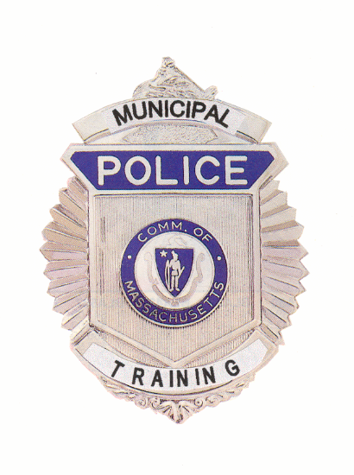

Municipal Police Training Committee
Monthly Meeting Agenda

Randolph Regional Police Academy
6 Adams Street, Randolph MA

Thursday September 26, 2019

9:00 a.m. – Police Standards Subcommittee Meeting to consider the following requests for officers to receive exemptions and waivers from training requirements:

Temporary waivers: Permanent exemptions:

Cody Chick | Barre PD | None
Patrick Gillespie | Barre PD
Edward Coffin | Townsend PD
Matthew Malone | Beverly PD

9:30 a.m. – Committee of the Whole – Welcome Chief Hicks, Chair

Review/Approval of Minutes from August 19, 2019 Chief Hicks

Police Standards
Standards Subcommittee
Consideration of officers’ requests for waivers and exemptions
from training requirements;

Report of results from recruit academy disciplinary appeals hearings

Updates to 550 CMR 3.00

Open Discussion for items not requiring votes

Statewide Firearms Coordinator Appointment Chief Ferullo (ret.)

Recruit Firearms Curriculum Chief Ferullo (ret.)

Specialized Training Agenda Chief Ferullo (ret.)

Executive Director’s Report

Recruit Officer training updates Marylou Powers

Reading academy director position update Chief Ferullo (ret.)

Southbridge Convention Center facility update Chief Ferullo (ret.)

Budget/Municipal Police Training Fund update Chief Ferullo (ret.)

FY20 training/strategic plan update Chief Ferullo (ret.)

Old Business (Items may be taken out of order)

Legislation affecting police training Chief Hicks

Reserve/Intermittent basic training hours and topics Chief Hicks

Executive director selection process pursuant to MGL c.6 §116 Chief Hicks

New Business (Items may be taken out of order)

National Guard Academy Program Update Chief Ferullo (ret.)

Discussion and approval of MPTC spending plan Chief Hicks

Joint Base Cape Cod Academy Wayne Sampson

* * *

