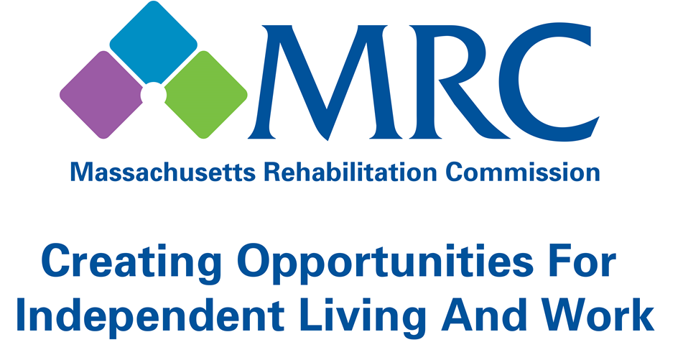

2016 ANNUAL REPORT

TABLE OF CONTENTS
Contents
Mission and Vision 2
Message from the Commissioner 3
Meet the MRC Senior Managers 4
MRC Program Results:
- Vocational Rehabilitation 5
- Vocational Rehabilitation Youth 7
- Community Living 9
- Disability Determination 10
Financial Statements 11
Consumer Liaison Information 13
Mission and Vision

Mission:
The Massachusetts Rehabilitation Commission (MRC) promotes equality, empowerment and independence of individuals with disabilities. These goals are achieved through enhancing and encouraging personal choice and the right to succeed in the pursuit of independence and employment in the community.

Vision:
The MRC provides comprehensive services to people with disabilities that maximize their quality of life and economic self-sufficiency in the community.

MESSAGE FROM THE COMMISSIONER

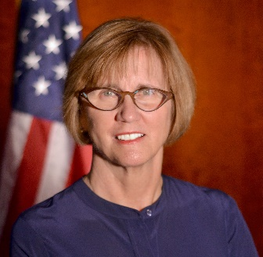
Dear Colleagues:

I am very honored to be the Commissioner of the Massachusetts Rehabilitation Commission (MRC) since March of 2015. Leading an agency that provides comprehensive services to people with disabilities, MRC is maximizing the quality of life and economic self-sufficiency of people throughout the Commonwealth.
It is with great pleasure I present our annual report for fiscal year 2016. During the year, MRC provided Vocational Rehabilitation services to 25,125 consumers and assisted 3,816 consumers in obtaining and maintaining competitive employment, provided community living services to 12,267 consumers to assist them in maintaining independence in the community, and processed over 90,000 eligibility claims for disability benefits for Massachusetts citizens with a 98% accuracy rate.
The MRC is proud of the strong collaborations we have established and maintained over the years with employers, providers, and other state agencies which contribute to these successes. These partnerships are critical in the work we do to achieve MRC’s mission. One of our highlights was completing our first statewide employer conference which was attended by approximately 200 employers. In FY16, we also expanded our public-private collaboration through job-driven training programs with employers such as Home Depot, CVS Health, Advance Auto Parts, Allied Barton, G4S Security, the Kraft Group, Lowe’s, among others. During FY2016, 380 MRC consumers achieved successful employment with these employers across the Commonwealth thanks to these efforts
I am committed to ensuring MRC promotes equality, empowerment and independence of individuals with disabilities. This goal can only be accomplished through enhancing and encouraging personal choice and the right to succeed in the pursuit of independence and employment in the community.


Sincerely,

Adelaide “Nicky” Osborne
Commissioner

MEET THE MRC SENIOR MANAGERS
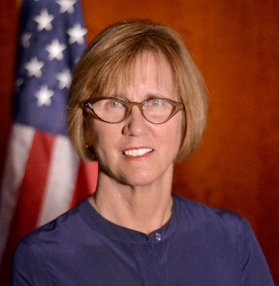 | Adelaide “Nicky” Osborne  Commissioner |  | Kasper M. Goshgarian  Deputy Commissioner
 | Richard Arcangeli  General Counsel |  | Josh Mendelsohn  Assistant Commissioner  Community Living Services
 | Joan  Phillips  Assistant Commissioner  Vocational Rehabilitation Services | 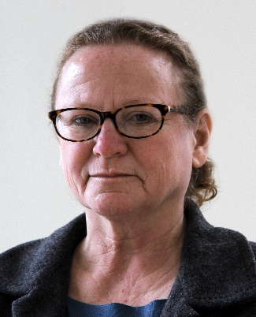 | Patricia  Roda  Assistant Commissioner  Disability Determination Services
MRC PROGRAM RESULTS

Vocational Rehabilitation: July 1, 2015 – June 30, 2016

VR: Competitive Employment in Massachusetts
The MRC successfully placed 3,816 individuals with disabilities into employment based on their choices, interests, needs and skills in FY16.

These rehabilitated employees earned $70.1 million in their first year of employment.

Estimated public benefits savings from individuals assisted by the MRC in MA were $28.6 million.

The returns to society based on increases in lifetime earnings range from $14 to $18 for each $1 invested in the MRC Vocational Rehabilitation program.

$5 is returned to the government through income taxes and reduced public assistance payments for every $1 invested in the MRC Vocational Rehabilitation program.

Average Hourly Wage: $13.18
Average Weekly Hours Worked: 26.8

VR: Facts at a Glance

Consumers Actively Receiving Services: 25,125
Consumers Enrolled in Training/Education Programs: 16,513
Consumers with Significant Disabilities Employed: 3,816
Consumers Employed with Medical Insurance: 95.9%
Consumers Satisfied with Services: 84.0%

ocational Rehabilitation: July 1, 2015 – June 30, 2016
MRC PROGRAM RESULTS

Who are our VR consumers
Psychiatric Disabilities: 40.0%
Learning Disabilities: 22.2%
Orthopedic Disabilities: 10.2%
Substance Abuse: 8.7%
Other Disabilities: 7.4%
Deaf and Hard of Hearing: 6.0%
Neurological Disabilities: 2.4%
Developmental Disabilities: 1.8%
Traumatic Brain Injury: 1.4%

Average Age: 33

Female: 46%
Male: 54%

White: 79.7%
Black: 17.6%
Hispanic: 11.8%
Asian/Pacific Islander: 3.4%
Native American: 1.0%

- “After trying some service jobs, MRC provided me with more training in other areas that I’m good in and through this training, I got a job doing pharmacy tech. I love it and the pay is excellent.”
- “I love my job and I look forward to continuing my work with the Kraft Group and becoming a full-time employee in the very near future. Many thanks again to the Kraft Group and the Massachusetts Rehabilitation Commission for this wonderful career opportunity."
– MRC Consumers

MRC PROGRAM RESULTS

Vocational Rehabilitation Youth services: July 1, 2015 – June 30, 2016

VR Youth Served (Ages 16-24)*
The Vocational Rehabilitation Program served 10,471 youth ages 16 to 24* during SFY16.

1,298 young consumers were placed in employment, with an average hourly wage of $11.58.

Employed young consumers worked an average of 26.7 hours per week.

During SFY2016, MRC served 2,897 high school students with disabilities through its VR Area Offices. MRC also initiated Pre-Employment Transition contracts with 20 vendors across the Commonwealth. These programs offer work-based learning experiences, job readiness and skills trainings, assistance with enrollment in post-secondary education and training programs, job exploration, and leadership/mentoring services to students with disabilities.

During SFY2016, MRC provided paid summer internship experiences for 436 young consumers across the Commonwealth through its Local Area Office Internship Program, CVS Health Summer Internship Program, and the Transitional Internship Program (TIP). These internships provide employment related skills and guidance, and references to facilitate permanent future employment opportunities.

VR Youth: Facts at a Glance

Youth Actively Receiving Services: 10,471
Youth Enrolled in Training/Education Programs: 7,654
Average Hourly Wage for Employed Youth: $11.58

* Age at application for MRC services.
MRC PROGRAM RESULTS

Vocational Rehabilitation Youth services: July 1, 2015– June 30, 2016

Who are our young VR consumers

Males: 59.1%
Females: 40.9%

Referral Source
688 Referral: 33.8%
Lead Education Agency: 20.1%
Transitional Advisory Council Assigned: 0.2%
Other Referral Source: 45.8%

Disability Profile
Sensory/Communicative: 4.9%
Physical/Mobility: 10.2%
Cognitive/Psychological: 84.9%
MRC PROGRAM RESULTS

Community Living: July 1, 2015– June 30, 2016

CL: Consumers Served
Independent Living Centers:* 5,887
Assistive Technology: 1,850
Home Care Services: 1,273
Brain Injury Services: 1,006
Waiver Unit Services: 597
Turning 22 Services: 591
Protective Services: 439
Housing Registry: 430
Supported Living Services: 194

CL: Services Purchased
Brain Injury Services: $30,500,000
Independent Living Centers: $ 7,730,106
Home Care Services: $ 4,650,773
IL Turning 22 Services: $ 2,058,663
Supported Living Services: $ 1,950,471
Assistive Technology: $ 1,853,712
Protective Services: $ 807,925
Housing Registry: $ 80,000

CL: Facts at a Glance

Total Consumers Actively Receiving Services: 12,267
Total Funds Expended: $49,640,740
Cost per Consumer Served: $4,047.00

* State funded services only.
MRC PROGRAM RESULTS

disability determination: october 1, 2015 – September 30, 2016

DDS: Supplemental Security Income (SSI)/Social Security Disability Insurance (SSDI)

DDS: SSI/ SSDI Claims Processed
Total Receipt of Cases: 91,337
Total Disposition of Cases: 91,657
Initial Claims Filed: 48,430
Initial Claims Disposed: 48,954
% Allowed: 41.2%
Continuing Disability Review Receipts: 30,682
Continuing Disability Review Dispositions: 23,595

DDS: Purchased Services
Consultative Examinations Purchased: 21,281
Consultative Examination Rate: 23.7%
Medical Evidence of Record Purchased: 79,476
Medical Evidence of Record Rate: 88.5%

DDS: MA Supplemental Security Income (SSI)/Social Security Disability Insurance (SSDI)
Total MA Population: 6.79M
MA SSI Recipients, 2015*: 188,051
MA SSDI Recipients, 2015*: 235,739
Annual SSI Benefits Paid: $1.20B
Annual SSDI Benefits Paid: $3.32B

*Most Recent Data available from Social Security Administration

DDS: Facts at a Glance

Total Medical Costs: $8,660,650
Total Budget: $50,350,907
Cost Per Case: $549.34
Total Disposition of SSI/SSDI Cases: 91,657
Accuracy of Initial Decisions: 98.6%
Federal Accuracy of Decision Standard: 90.6%

MRC FINANCIAL STATEMENTS

Sum for Federal FY: October 1, 2015– September 30, 2016

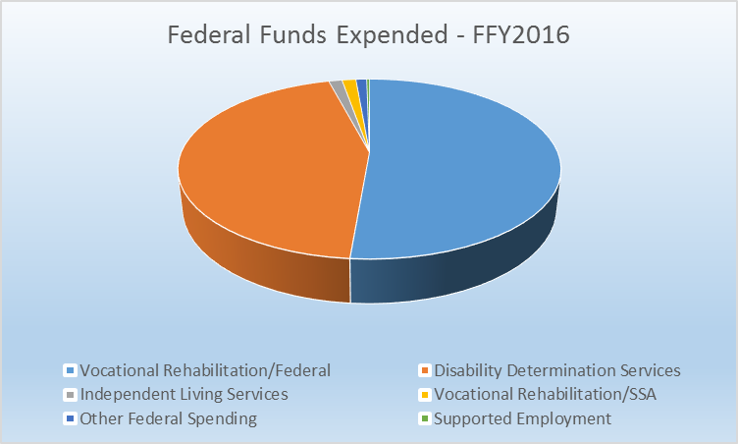
MRC FINANCIAL STATEMENTS

Sum for State FY: July 1, 2015 – June 30, 2016

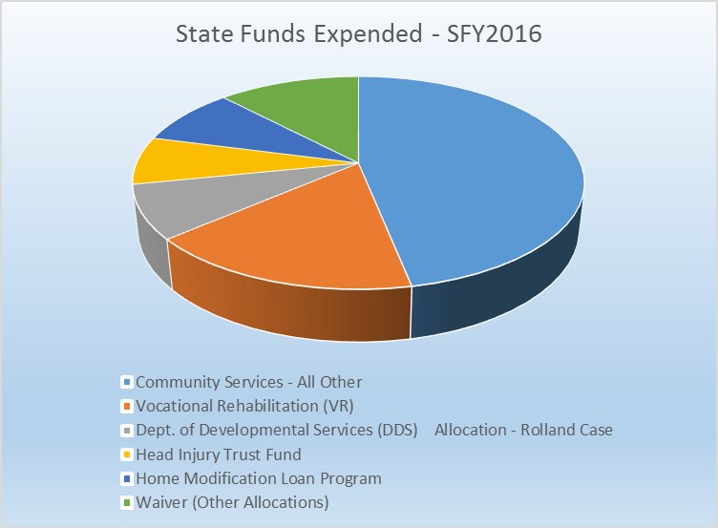

MRC CONSUMER LIAISON

The MRC has a staff member working within the Commissioner’s Office as an Ombudsperson who serves as a consumer liaison, primarily to address concerns regarding delivery of services and to answer a variety of disability-related questions. People who typically contact the Ombudsperson include consumers, family members, advocates, legislators and their aides, other state government personnel and MRC staff members.
The Ombudsperson provides information and referral services and assists callers to better understand the services offered by the MRC.
If a complaint is brought forward, the Ombudsperson promptly reviews the matter and works with consumers and MRC staff to find a solution. If this type of intervention does not bring about resolution, there is a formal appeal process. Mediation services are also available to MRC VR consumers.
The Ombudsperson assists consumers across all service programs and may be contacted by telephone at (617) 204-3603 or (800) 245-6543 (voice and TTY), through the agency website at www.mass.gov/mrc or by writing to the MRC Administrative Office in Boston.

The goal of our services is to promote dignity through employment and community living, one person at a time. We hope all citizens with disabilities in Massachusetts will have the opportunity to contribute as a productive member of their community and family as a result of services provided by the MRC.

Administrative Offices
600 Washington Street
Boston, MA 02111
617-204-3600 (voice)
800-245-6543 (toll free MA)
www.mass.gov/mrc

Find us on Facebook,
Follow us on Twitter, and
Connect with us on LinkedIn


Charles D. Baker
Governor

Karyn E. Polito
Lieutenant Governor

MaryLou Sudders
Secretary, Executive Office of
Health & Human Services

Adelaide Osborne
Commissioner, MRC

