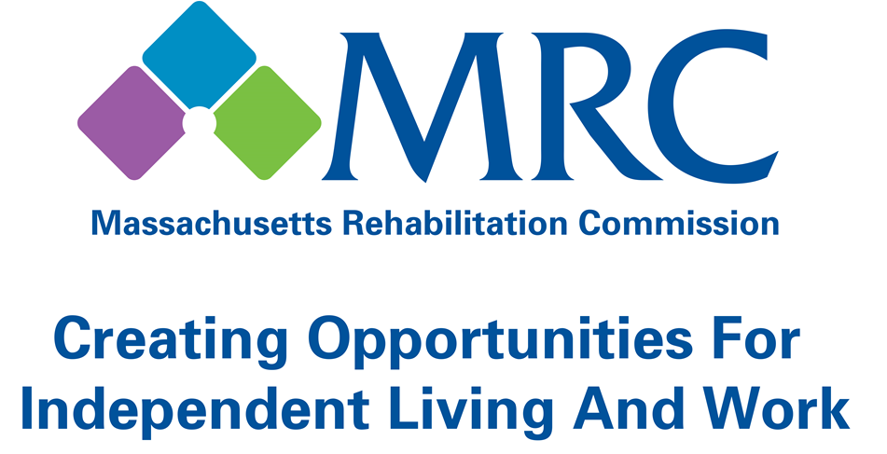

2017 ANNUAL REPORT

TABLE OF CONTENTS
Contents
Mission and Vision 2
Message from the Commissioner 3
Meet the MRC Senior Managers 4
MRC Program Results:
- Vocational Rehabilitation 5
- Vocational Rehabilitation Youth 7
- Community Living 9
- Disability Determination 10
Financial Statements 11
Consumer Liaison Information 13

Vision and Mission:
The Massachusetts Rehabilitation Commission (MRC) promotes equality, empowerment and independence of individuals with disabilities. These goals are achieved through enhancing and encouraging personal choice and the right to succeed or fail in the pursuit of independence and employment in the community.
Who We Serve:
The MRC provides comprehensive services to people with disabilities that maximize their quality of life and economic self-sufficiency in the community. All programs have their own intake criteria including financial, medical, and other eligibility requirements.
Mission and Vision
x
MESSAGE FROM THE COMMISSIONER

Dear Colleagues,
I want to express my gratitude and heartfelt appreciation for all of the MRC employees who have worked tirelessly to transform the lives of people with diverse needs living in the Commonwealth of Massachusetts. Over the past year the agency has seen drastic changes and continues to preserve through these changes and challenges with our heads held high.
My appointment as Commissioner has just begun, and I want to express my gratitude to previous Commissioner Nicky Osborne for creating new relationships and collaborations. We will continue to foster these relationships and provide new innovative and collaborative ideas resulting in an enhancement of our programs and services.
Change has become the new normal within our agency and we will remain solid to our values, continue to measure our performance, and instill a more inclusive and adaptable culture to our entire community. We will share our talents and skills with community partnerships and providers to allow people with diverse needs to live and work in their community of choice. Our enriched community will share accountability as we achieve successes for more and more consumers.
Collectively, all our efforts are part of a long term strategy designed to differentiate MRC as a strong and innovative agency known for its disability benefits, programs, and services nationwide. As your new Commissioner I am honored to be a part of MRC.

Sincerely,
Toni A. Wolf
Commissioner
MEET THE MRC SENIOR MANAGERS
 | Toni A.  Wolf  Commissioner |  | Kasper M. Goshgarian  Deputy Commissioner
 | Erik  Nordahl  General Counsel |  | Josh  Mendelsohn  Assistant Commissioner  Community Living Services
 | Joan  Phillips  Assistant Commissioner  Vocational Rehabilitation Services | 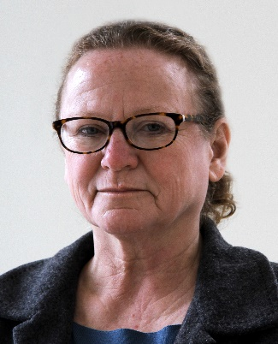 | Patricia  Roda  Assistant Commissioner  Disability Determination Services
MRC PROGRAM RESULTS

Vocational Rehabilitation: July 1, 2016 – June 30, 2017

VR: Competitive Employment in Massachusetts
The MRC successfully placed 3,973 individuals with disabilities into employment based on their choices, interests, needs and skills in FY17.

These rehabilitated employees earned $77.9 million in their first year of employment.

Estimated public benefits savings from individuals assisted by the MRC in MA were $29.8 million.

The returns to society based on increases in lifetime earnings range from $14 to $18 for each $1 invested in the MRC Vocational Rehabilitation program.

$5 is returned to the government through income taxes and reduced public assistance payments for every $1 invested in the MRC Vocational Rehabilitation program.

*based on Commonwealth Corporation Study.

Average Hourly Wage: $14.11
Average Weekly Hours Worked: 26.7

VR: Facts at a Glance

Consumers Actively Receiving Services: 27,028
Consumers Enrolled in Training/Education Programs: 17,685
Consumers with Significant Disabilities Employed: 3,973
Consumers Employed with Medical Insurance: 96.6%
Consumers Satisfied with Services: 86.0%

ocational Rehabilitation: July 1, 2015 – June 30, 2016
MRC PROGRAM RESULTS

Who are our VR consumers
Psychiatric Disabilities: 40.1%
Learning Disabilities: 22.8%
Orthopedic Disabilities: 9.9%
Substance Abuse: 8.3%
Other Disabilities: 7.0%
Deaf and Hard of Hearing: 5.9%
Neurological Disabilities: 2.4%
Developmental Disabilities: 2.3%
Traumatic Brain Injury: 1.3%

Average Age: 32.4

Female: 45.7%
Male: 54.3%

White: 79.2%
Black: 18.0%
Hispanic: 12.4%
Asian/Pacific Islander: 3.6%
Native American: 1.1%

- “It has been a great comfort and a blessing to me to have the Massachusetts Rehabilitation Commission in my corner over the years as I progressed along my vocational path. Thank you to all of my MRC counselors!”
- “I have frequent contact with my counselor and placement specialist. They both have added stability during my employment search up until I gained employment which both have offered me stability. It's one matter to garner employment and another to maintain it. Both are both very professional and dedicated to their profession. Thank you.”
- “The Massachusetts Rehabilitation Commission increases and improves the quality of life of any person they are dealing with. They educate, and promotes equality, empowerment and independence of the individual to our day to day activities.”
– MRC Consumers

MRC PROGRAM RESULTS

Vocational Rehabilitation Youth services: July 1, 2016 – June 30, 2017

VR Youth Served (Ages 16-24)*
The Vocational Rehabilitation Program served 9,685 youth ages 16 to 24* during SFY17.

862 young consumers were placed in employment, with an average hourly wage of $12.41.

Employed young consumers worked an average of 27 hours per week.

During SFY2017, MRC served 5,221 high school and post-secondary education students with disabilities aged 16 to 22 through its VR Area Offices. MRC also operated Pre-Employment Transition Service (Pre-ETS) contracts with 20 providers across the Commonwealth serving 824 students. These programs offer work-based learning experiences, job readiness and skills trainings, assistance with enrollment in post-secondary education and training programs, job exploration, and leadership/mentoring services to students with disabilities.

During SFY2017, MRC provided work-based learning experiences for 1,169 young consumers across the Commonwealth through its Local Area Office Internship Program, CVS Health Summer Internship Program, Pre-ETS Contracts, and Transitional Internship Program (TIP). These work-based learning experiences provide employment related skills and guidance, and references to facilitate permanent future employment opportunities.

VR Youth: Facts at a Glance

Youth Actively Receiving Services: 9,685
Youth Enrolled in Training/Education Programs: 7,583
Average Hourly Wage for Employed Youth: $12.41

* Age at application for MRC services.
MRC PROGRAM RESULTS

Vocational Rehabilitation Youth services: July 1, 2016 – June 30, 2017

Who are our young VR consumers

Males: 59.5%
Females: 40.5%

Referral Source
688 Referral: 35.6%
Lead Education Agency: 23.4%
Transitional Advisory Council Assigned: 0.4%
Other Referral Source: 40.6%

Disability Profile
Sensory/Communicative: 6.7%
Physical/Mobility: 6.8%
Cognitive/Psychological: 86.6%

MRC PROGRAM RESULTS

Community Living: July 1, 2016 – June 30, 2017

CL: Consumers Served
Independent Living Centers:* 6,383
Assistive Technology: 2,805
Home Care Services: 1,246
Brain Injury Services: 1,333
Waiver Unit Services: 635
Turning 22 Services: 545
Protective Services: 503
Housing Registry: 661
Supported Living Services: 173

CL: Services Purchased
Brain Injury Services: $30,236,939
Independent Living Centers: $ 7,518,420
Home Care Services: $ 4,323,126
IL Turning 22 Services: $ 3,469,936
Supported Living Services: $ 1,732,333
Assistive Technology: $ 1,981,950
Protective Services: $ 773,968
Housing Registry: $ 80,000

CL: Facts at a Glance

Total Consumers Actively Receiving Services: 14,284
Total Funds Expended: $50,116,672
Cost per Consumer Served: $3,509

* State funded services only.
MRC PROGRAM RESULTS

disability determination: october 1, 2016 – September 30, 2017

DDS: Supplemental Security Income (SSI)/Social Security Disability Insurance (SSDI)

DDS: SSI/ SSDI Claims Processed
Total Receipt of Cases: 79,557
Total Disposition of Cases: 87,054
Initial Claims Filed: 45,614
Initial Claims Disposed: 46,955
% Allowed: 41.3%
Continuing Disability Review Receipts: 17,031
Continuing Disability Review Dispositions: 22,539
Accuracy of Decisions: 96.2%

DDS: Purchased Services
Consultative Examinations Purchased: 19,688
Consultative Examination Rate: 22.6%
Medical Evidence of Record Purchased: 77,926
Medical Evidence of Record Rate: 89.5%

DDS: MA Supplemental Security Income (SSI)/Social Security Disability Insurance (SSDI) Summary
Total MA Population: 6.81M
MA SSI Recipients, 2016*: 186,783
MA SSDI Recipients, 2016*: 233,745
Annual SSI Benefits Paid: $1.19B
Annual SSDI Benefits Paid: $3.31B

*Most Recent Data available from Social Security Administration

DDS: Facts at a Glance

Total Medical Costs: $8,660,650
Total Budget: $47,645,563
Cost Per Case: $571.63
Total Disposition of SSI/SSDI Cases: 87,054
Accuracy of Initial Decisions: 96.2%
Federal Accuracy of Decision Standard: 90.6%

MRC FINANCIAL STATEMENTS

Sum for Federal FY: October 1, 2016 – September 30, 2017

Federal Funds Expended | FY 2017 | %
Vocational Rehabilitation | $ 59,974,906.22 | 52%
Disability Determine Services | $ 47,645,563.00 | 42%
Independent Living Services | $ 1,472,328.01 | 1%
Vocational Rehabilitation/SSA | $ 3,760,661.00 | 3%
Other Federal Spending | $ 1,468,120.52 | 1%
Supported Employment | $ 339,374.50 | 0%
Total | $ 114,660,953

MRC FINANCIAL STATEMENTS

Sum for State FY: July 1, 2016 – June 30, 2017

State Funds Expended | FY 2017 | %
Community Services- All other | $ 35,492,193.80 | 45%
Vocational Rehabilitation (VR) | $ 12,575,288.21 | 16%
Dept. of Departmental Services (DDS) Allocation - Rolland | $ 5,820,356.13 | 7%
Head Injury Trust Fund | $ 7,689,781.99 | 10%
Home Modification Loan Program | $ 6,500,000.00 | 8%
Waiver (Other Allocations) | $ 10,742,674.93 | 14%
Total | $ 78,820,295.06

MRC CONSUMER LIAISON

The MRC has a staff member working within the Commissioner’s Office as an Ombudsperson who serves as a consumer liaison, primarily to address concerns regarding delivery of services and to answer a variety of disability-related questions. People who typically contact the Ombudsperson include consumers, family members, advocates, legislators and their aides, other state government personnel and MRC staff members.
The Ombudsperson provides information and referral services and assists callers to better understand the services offered by the MRC.
If a complaint is brought forward, the Ombudsperson promptly reviews the matter and works with consumers and MRC staff to find a solution. If this type of intervention does not bring about resolution, there is a formal appeal process. Mediation services are also available to MRC VR consumers.
The Ombudsperson assists consumers across all service programs and may be contacted by telephone at (617) 204-3603 or (800) 245-6543 (voice and TTY), through the agency website at www.mass.gov/mrc or by writing to the MRC Administrative Office in Boston.

The goal of our services is to promote dignity through employment and community living, one person at a time. We hope all citizens with disabilities in Massachusetts will have the opportunity to contribute as a productive member of their community and family as a result of services provided by the MRC.

Administrative Offices
600 Washington Street 2nd Floor
Boston, MA 02111
617-204-3600 (voice)
800-245-6543 (toll free MA)
www.mass.gov/mrc

Find us on Facebook,
Follow us on Twitter, and
Connect with us on LinkedIn

Charles D. Baker
Governor

Karyn E. Polito
Lieutenant Governor

MaryLou Sudders
Secretary, Executive Office of
Health & Human Services

Toni a. wolf
Commissioner, MRC

