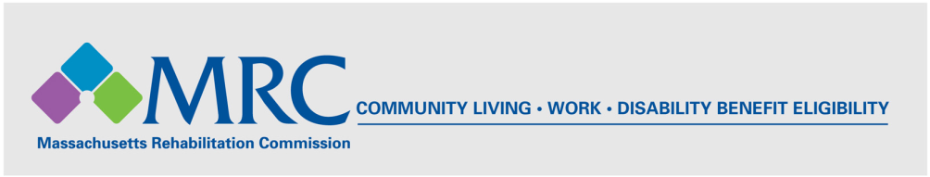

**MRC Autism Spectrum Disorder Fact Sheet**

**Autism Spectrum Disorder**

Autism Spectrum Disorder (ASD) is a [developmental disability](http://www.cdc.gov/ncbddd/developmentaldisabilities/facts.html) that can cause social, communication, and behavioral challenges. People with ASD may not appear visibly different from others, but they may communicate, interact, behave, and learn in ways that are different. The learning, thinking, and problem-solving abilities of people with ASD can range from very gifted to very challenged. Some individuals with ASD may require a high degree of assistance in their daily lives, while others may need much less.

As of 2014, a diagnosis of ASD includes several conditions that were formerly diagnosed separately. These include: Autistic Disorder, Pervasive Developmental Disorder Not Otherwise Specified (PDD-NOS), and Asperger Syndrome. These conditions are now all termed Autism Spectrum Disorder. The Centers for Disease Control (CDC), Autism and Developmental Disabilities Monitoring (ADDM) Network estimates that ASD is one of the fastest-growing developmental disabilities in the United States.

(See the Centers for Disease Control: <http://www.cdc.gov/ncbddd/autism/facts.html>)

**MRC and Autism Spectrum Disorder in FY 2015**

* In State Fiscal Year (SFY) 2015, the MRC served 1,704 individuals with Autism as a primary or secondary disability, constituting 6% of all consumers served by the MRC in this period.
* MRC consumers with Autism are predominately male (84.4%) and white (92.3%). This gender distribution is consistent with national findings, in that ASD is almost 5 times more common in males than females.
* Approximately 89% of consumers with Autism served by the MRC are under the age of 30.
* Regionally, the largest proportion of MRC consumers with Autism as a primary or secondary disability were in the North District (679, or 40%), followed by the South (572, or 34%) and the West (453, or 26 %).
* In SFY 2015, 1,130 consumers with ASD received training and education services from the MRC.
* In SFY 2015, a total of 184 consumers with ASD achieved successful employment outcomes (for 90+ days).
* Successfully employed consumers had an average hourly wage of $11.25 and worked an average of 23.3 hours/week, hourly consumer earnings ranged from $9 to $100 per hour.
* In 2015, the Asperger/Autism Network (AANE) delivered 6 staff trainings to nearly 120 MRC staff, and provided LifeMap coaching for 110 MRC consumers across the Commonwealth.
* MRC Vocational Rehabilitation and Independent Living staff were offered regular trainings on Autism Spectrum Disorder, covering the impact of Autism and Asperger on employment and independent living. Strategies and resources for enhancing success in life and work for individuals with Autism Spectrum Disorder were highlighted in the trainings.

**Signs and Symptoms of ASD from the Centers for Disease Control (CDC)**

ASD occurs in all racial, ethnic, and socioeconomic groups, but is almost five times more common among males than among females. The CDC estimates that about 1 in 68 children has been identified with Autism Spectrum Disorder (ASD). People with ASD often have problems with social, emotional, and communication skills. They might repeat certain behaviors and might not want to experience any change in their daily activities. Many people with ASD may also have different ways of learning, paying attention, or reacting to things. Signs of ASD begin during early childhood and typically last throughout a person’s life. Children or adults with ASD might:

* not point at objects to show interest (for example, not point at an airplane flying over)
* not look at objects when another person points at them
* have trouble relating to others or not have an interest in other people at all
* avoid eye contact and want to be alone
* have trouble understanding other people’s feelings or talking about their own feelings
* prefer not to be held or cuddled, or might cuddle only when they want to
* appear to be unaware when people talk to them, but respond to other sounds
* be very interested in people, but not know how to talk, play, or relate to them
* repeat or echo words or phrases said to them, or repeat words or phrases in place of normal language
* have trouble expressing their needs using typical words or motions
* not play “pretend” games (for example, not pretend to “feed” a doll)
* repeat actions over and over again
* have trouble adapting when a routine changes
* have unusual reactions to the way things smell, taste, look, feel, or sound
* lose skills they once had (for example, stop saying words they were previously using)

**Early Treatment for ASD from the Centers for Disease Control (CDC)**

There is currently no known cure for ASD. However, research shows that early intervention treatment services between birth and about 3 years of age may improve the development of a child with ASD. Interventions can include therapy to help a child talk, walk, and interact with others. The [Individuals with Disabilities Education Act (IDEA)](http://idea.ed.gov/) says that children under the age of 3 who are at risk of having developmental delays may be eligible for services, which are provided through early intervention systems in each state. Treatment for particular symptoms, such as speech therapy for language delays, often does not need to wait for a formal ASD diagnosis. (<http://www.cdc.gov/ncbddd/autism/facts.html>)