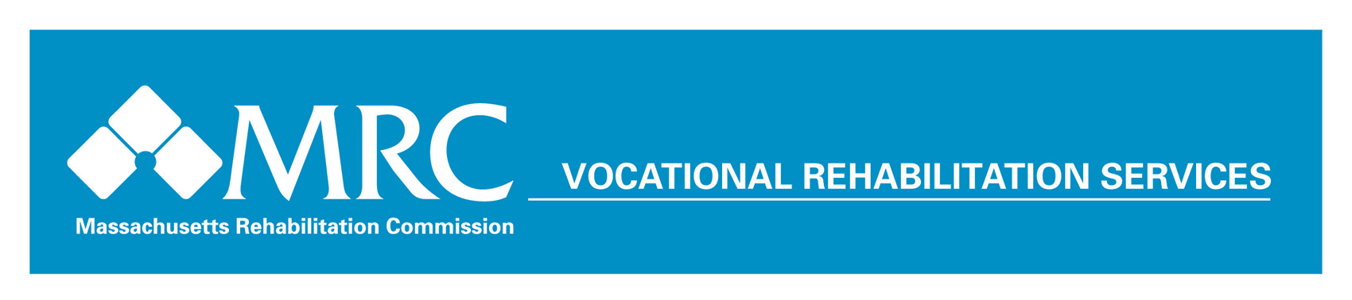

The MRC Good News Garage Donated Vehicle Program

Program Description
The Good News Garage (GNG) Donated Vehicle Program provides MRC vocational rehabilitation (VR) consumers with an opportunity for access to affordable transportation to get to work. Donated vehicles are secured, inspected, and delivered to consumers who have an active VR case with the MRC. The goal is to allow VR consumers to seek or maintain competitive employment and to achieve greater independence. The program is administered for the MRC by a vendor who has submitted a Request for Proposal (RFP) through an open bidding process. The current vendor is Ascentria Community Services (formerly Lutheran Social Services).

The Good News Garage Donated Car program is funded through federal re-allotment funds from the Rehabilitation Services Administration. In previous years, the program was funded by the ARRA program. Since its inception, the GNG program has enabled hundreds of MRC VR consumers to find or maintain employment opportunities by overcoming transportation barriers, and has provided MRC counselors with an additional tool for assisting consumers in achieving their employment goals.

How it Works
MRC VR counselors refer consumers to the Good News Garage Donated Car program. Applications are processed by Good News Garage program staff, and qualifying consumers are interviewed and assigned a vehicle upon final acceptance.

Qualifying consumers must be able to adequately maintain a vehicle over time and pay the cost of car insurance and excise taxes (which are relatively affordable as donated vehicles tend to be older). Seasonal and economic factors affect the amount of donated vehicles that are available to the program at any period.

The MRC oversees all program activity in collaboration with program staff. Good News Garage program staff secure all vehicles, manage delivery, handle inspections and warrantees, train consumers on car registration, inspection, and basic maintenance, and assist vehicle donors with securing their tax credits.

Donated vehicles are given an extensive 27 point safety check, and Good News Garage staff perform repairs and modifications such as repairs or upgrades to tires, brakes, transmissions, radiators, lights, wipers, and interiors.

2014 Program Results (based on the 2014 federal fiscal year)
# of MRC Consumers Served: 53
Average Mileage of Donated Vehicle: 125,000
Average Value of Vehicle: $5,225
Average Total Cost of Repairs: $1,850

For more information on the Good News Garage Donated Car Program, contact Olga Roy at 877-400-6065

Massachusetts Rehabilitation Commission Good News Garage Program

Car Donation Process
- The MRC provides VR counselors with training about program features, procedures, and application forms.
- Counselor provides program orientation and fills out application form with selected consumer.
- Consumer obtains photocopy of driver’s license.
- MRC Area Director is given application form for approval.
- MRC Area Office sends one copy of Directors’ approved form, completed application, and photocopy of driver’s license to MRC administrative offices and one copy to Good News Garage.
- Consumer acquires driver rating from Registry/Insurance Company.
- Good News Garage program staff contacts consumer to verify information/determine vehicle needs.
- Good News Garage sends copy of application forms for accepted consumers to AO. GNG makes every effort for a good match. However, GNG is not a car dealer. Donated vehicles are older, high mileage vehicles which do not get as good mileage as newer cars.
- Good News Garage plans training and education regarding car registration and care.
- Consumer contacts auto insurance company.
- Good News Garage finds vehicle match, confirms insurance & title paperwork.
- Consumer goes to insurance company & RMV (consumer covers costs to register and insure), calls Good News Garage to arrange vehicle pick-up.
- Consumer & Good News Garage meet at agreed to location in Massachusetts, and the car is delivered.
- Consumer can immediately bring vehicle to identified garage for inspection sticker or garage of own selection (the Good News Garage program will reimburse this cost).
- Good News Garage sends copy of vehicle registration form to MRC administrative offices.
- MRC administrative offices track program outcomes, execution, contracts, and consumer satisfaction.

Applicant Requirements
Applicants must fulfill all of the following requirements:
- They must be a client of the Massachusetts Rehabilitation Commission.
- They must have a written Individual Plan for Employment.
- They must need transportation for employment or retention of employment only.
- They must have no easy access to public transportation, not own a car, or have access to use of a car.
- They must have a valid Massachusetts driver’s license.
- They must have a good driving record.
- They must have the financial means to register and insure the car. If they fail this criteria, applicants must submit a new application when they are financially prepared.
- They must participate in the training program on care and maintenance and car registration.

Massachusetts Rehabilitation Commission, 600 Washington Street, 2nd Floor, Boston, MA 02111-1704
(617) 204-3600; (800) 245-6543; TTY 1-(617) 204-3863

