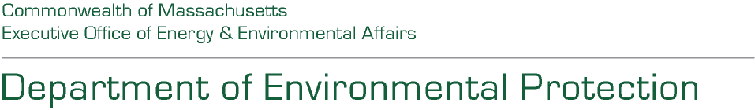100 Cambridge Street Suite 900 Boston Massachusetts 02114 Telephone 617-292-5500

Maura T. Healey, Governor Kimberley Driscoll, Lieutenant Governor

Rebecca L. Tepper, Secretary Bonnie Heiple, Commissioner

MS4 Grant

**Agency Document #:** [**BD-26-1045-BWR00-BWR01-120520**](https://www.commbuys.com/bso/external/bidDetail.sdo?docId=BD-26-1045-BWR00-BWR01-120520&external=true&parentUrl=close)

Question and Answer Document

September 26, 2025

On September 2, 2025, the Massachusetts Department of Environmental Protection (MassDEP) announced the FY26 Opportunity for the MS4 Municipal Assistance Grant Program (Grant Program). Answers to questions emailed in, as well as posed to MassDEP at a Zoom Pre-Application Meeting held on September 10, 2024 to are below. A copy of the video can be information can be found [on our website.](https://www.mass.gov/info-details/grants-financial-assistance-watersheds-water-quality#stormwater-ms4-municipal-assistance-grant-program-)

# Questions & Answers:

## Question 1:

Due to MS4 annual reports being due right before the grant application is due, can the grant application deadline be extended?

## Answer 1:

Yes, the application deadline has been extended by one week to October 10, 2025.

## Question 2:

What is the goal of having the towns work together?

## Answer 2:

The goal of encouraging towns to work together is to develop and share resources among as many permittees as possible to maximize the impact of the funding.

Question 3:

What are examples of Past Projects? 

Answer 3:

Examples of eligible projects can be found on page 2 of the RFR. A [list of past projects](https://www.mass.gov/doc/ms4-municipal-assistance-grant-prior-grant-projects/download) is also posted to our website.

## Question 4:

Is a partnership between a non-traditional MS4 permittee (i.e. not a municipality, but an institution) and a traditional MS4 permittee is eligible for funding for the MS4 Municipal Grant Assistance FY26 Grant Program?

## Answer 4:

No. An application involving a partnership between a non-traditional MS4 permittee that is not a municipality and a MS4 permittee that is a municipality, would not meet the eligibility requirements for this grant opportunity. In order to meet the eligibility requirements, an application must include two (2) or more municipalities that are subject to the 2016 Small MS4 General Permit.  Please see RFR section 1.D. (“Eligible Entities”) for additional information on this requirement.

**This information is available in alternate format. Please contact MassDEP 617-292-5000**

**TTY# MassRelay Service 1-800-439-2370**

**MassDEP Website: www.mass.gov/dep**