INCIDENT HIGHLIGHTS
DATE:
August 30, 2018
TIME:
3:00 p.m.
VICTIM:
67-year-old female crossing guard
INDUSTRY/NAICS CODE:
Elementary school / 611110
EMPLOYER:
Municipal school department
SAFETY & TRAINING:
Written safety program / training
SCENE:
Roadway in a residential area
LOCATION:
Massachusetts
EVENT TYPE:
Struck-by

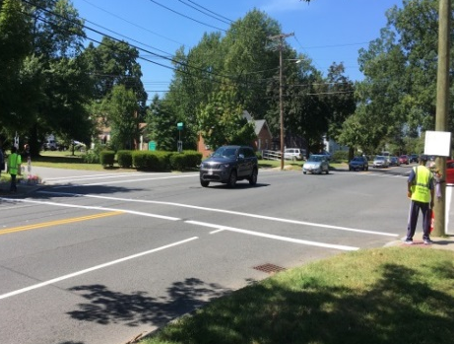

REPORT#: 18MA046 REPORT DATE: May 11, 2020
Municipal Crossing Guard Fatally Injured When Struck by a Car – Massachusetts

SUMMARY
On August 30, 2018, a 67-year-old municipal crossing guard died after being struck by a motor vehicle. At the time of the incident, the crossing guard was assisting students in getting across the roadway. READ THE FULL REPORT> (p.3)

CONTRIBUTING FACTORS
Key contributing factors identified in this investigation include:
- No crosswalk signage;
- Ineffective crosswalk roadway markings that were in poor condition; and
- Assigning crossing guards to unsignalized intersections without the appropriate traffic control measures. LEARN MORE> (p.6)

RECOMMENDATIONS
Massachusetts FACE Program concluded that, to help prevent similar occurrences, municipalities should:
- Ensure that, at a minimum, crosswalk traffic control signage meets the standards set forth in the Manual on Uniform Traffic Control Devices (MUTCD).
- Consider additional measures to ensure crosswalks at unsignalized intersections and mid-block locations are clearly visible to motorists.
- Develop and implement a comprehensive safety and health program that addresses hazard recognition and avoidance of unsafe conditions.
- Actively work towards reducing vehicle speed on local roadways. LEARN MORE> (p.6)
Fatality Assessment and Control Evaluation (FACE) Program

The Massachusetts Department of Public Health, in cooperation with the National Institute for Occupational Safety and Health (NIOSH), conducts investigations on the causes of work-related fatalities. The goal of this program, known as Massachusetts Fatality Assessment and Control Evaluation (Massachusetts FACE) is to prevent future fatal workplace injuries. Massachusetts FACE aims to achieve this goal by identifying and studying the risk factors that contribute to workplace fatalities, by recommending intervention strategies, and by disseminating prevention information to employers and employees.

NIOSH funded state-based FACE Programs currently include: California, Kentucky, Massachusetts, Michigan, New York, Oregon, and Washington.
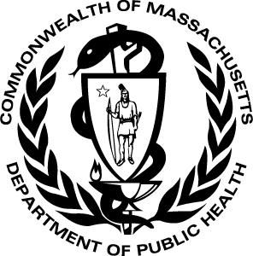
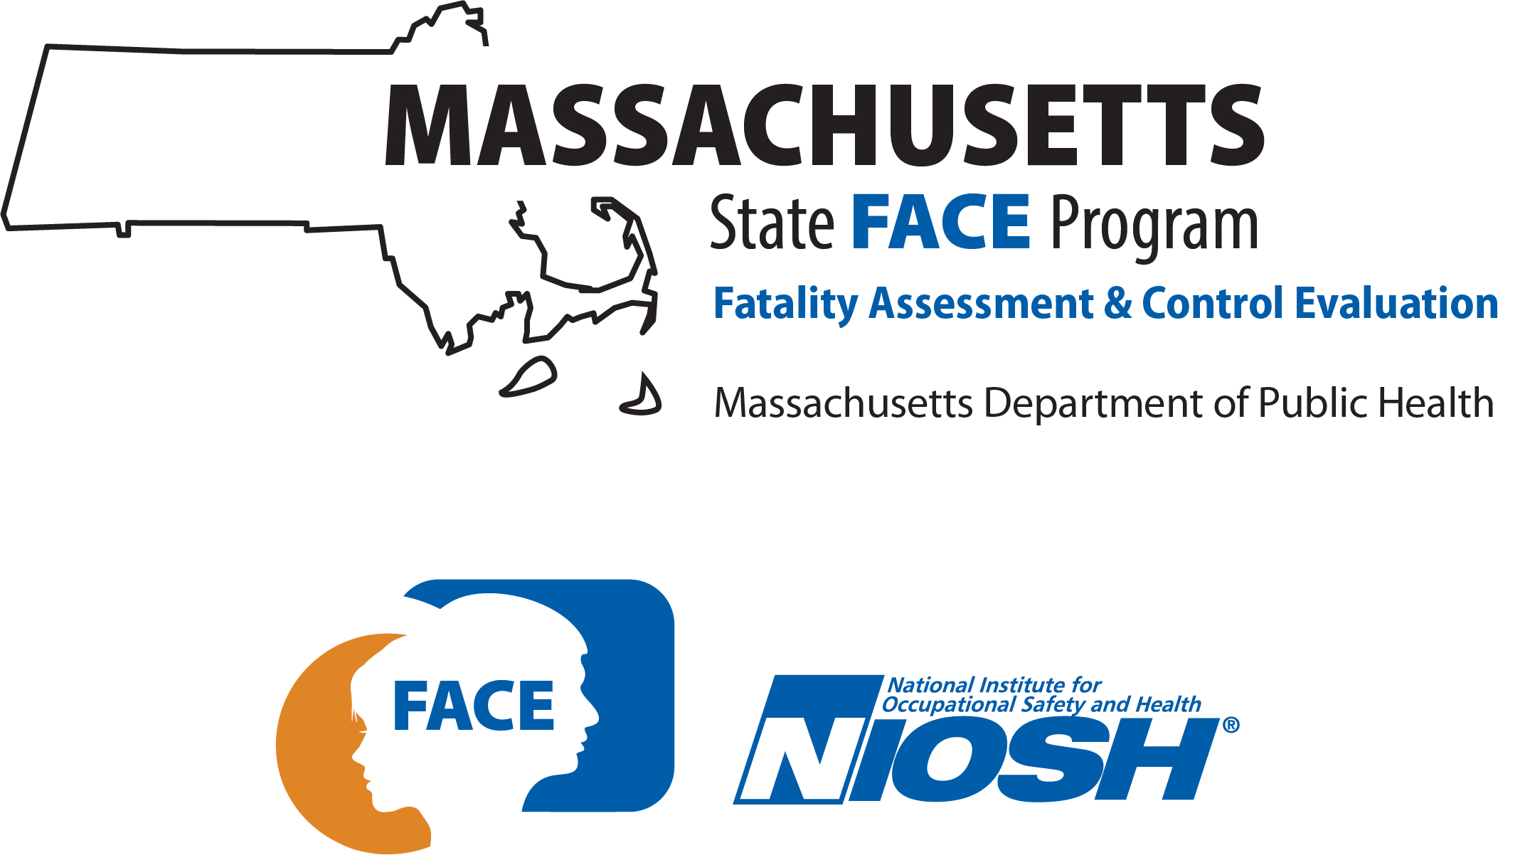

SUMMARY
On August 30, 2018, a 67-year-old, female, municipal crossing guard was fatally injured when struck by a passing motor vehicle. At the time of the incident, the crossing guard was assisting students in crossing the roadway. The crossing guard, with her STOP paddle held up, stepped off the curb and into the cross walk. She reached about the middle of the travel lane when she was struck by a motor vehicle, landing on the roadway. Witnesses of the incident placed a call for emergency medical services (EMS) and assisted the victim. EMS arrived quickly and the victim was transported to the hospital.

INTRODUCTION
On August 31, 2018, the Massachusetts FACE Program was notified by the Massachusetts Department of Labor Standards (DLS) about the death of a crossing guard after being struck by a motor vehicle. On September 5, 2018, representatives from the Massachusetts FACE Program and the DLS traveled to the municipal school department offices and met with multiple municipal representatives to discuss the incident. The incident location, police report, death certificate, and other information were reviewed.

EMPLOYER
The employer was a local municipal school department for a Massachusetts city with a population of more than 154,000 residents. The town was incorporated in the mid 1800’s. The victim worked as a crossing guard for the municipal school department. She was one of over 100 workers employed as crossing guards. Crossing guards typically worked two short shifts during the weekdays. The morning shift was one hour and 15 minutes long, starting at 7:30 a.m. and ending at 8:45 a.m. and the afternoon shift was one and a half hours long, starting at 2:30 p.m. and ending at 4:00 p.m. Most of the town’s non-management school employees had union representation, as did the crossing guard involved in this incident.

WRITTEN SAFETY PROGRAMS and TRAINING
At the time of the incident, the municipal school department had a safety and health program that included a manual for crossing guards. Mandatory annual training was provided to employees during the month of August at the beginning of the school year. The training was three hours long and consisted of classroom time, video, and then supervised on-the-job training. If the crossing guards were observed not following the proper procedures for crossing students, they were retrained.

WORKER INFORMATION
The victim was a 67-year-old, white, non-Hispanic, female municipal crossing guard employed by a local city school department. At the time of the incident, she had worked at the city’s school department for approximately five weeks. She did not have prior experience as a crossing guard. The day of the incident was her third day working alone without a mentor. She was the only crossing guard assigned to the intersection where the incident occurred.

WEATHER
The weather at the time of the incident was approximately 85 degrees Fahrenheit, 51% humidity, 7 mile per hour (mph) average north northwest wind speed, and mostly cloudy.¹ There was no precipitation on the day of the incident or a couple of days before the incident occurred. The weather on that day is not believed to have been a factor in this incident.

EQUIPMENT
The city provided the crossing guards with personal protective equipment (PPE) that included a stop paddle and an American National Standards Institute (ANSI) Class 2 compliant, high-visibility vest. The school department requires the use of these two pieces of PPE. If crossing guards wanted additional PPE, they had the option of purchasing items through the city contract. Crossing guards are provided with a new ANSI Class 2 vest annually and the stop paddles had to be inspected by the crossing guard supervisor to determine if it needed to be replaced.

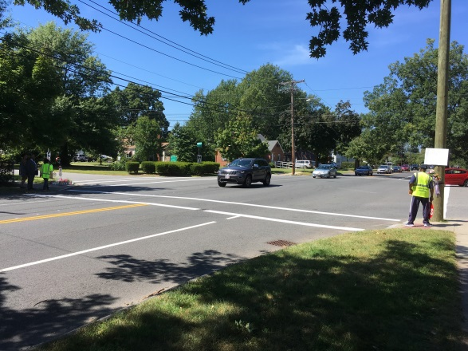
School is four blocks away
X
X
Figure 1 – Incident location. X marks victim location Figure 2 - Aerial view of incident location. X marks victim location and the
and the arrow indicates direction of travel of the vehicle. yellow arrow indicates vehicle travel direction. The red hexagons indicate stop signs for the side streets. The school is located four blocks away.

INCIDENT SCENE
The incident occurred in an area of the city that was primarily residential (Figure 1 and 2). The school closest to the crosswalks to which the victim was assigned was an elementary school for students in kindergarten through fifth grade. This school was located in a suburban setting and was primarily surrounded by single family houses. The roadway in front of the school was a side street that ran primarily in northeast and southwest directions and had two travel lanes, one lane for each direction of travel. The travel lanes were divided by a wide grass median island. The only roadway markings in this area were white painted crosswalks that consisted of two parallel lines with no center markings and stop lines at intersections with stop signs. There were no painted white fog lines or other painted solid lines to signal the edge of the roadway. This side street ran perpendicular to and crossed a main roadway.
The main roadway ran in the northwest and southeast directions. This roadway had one travel lane in each direction, double yellow lines that divided the travel lanes and white fog lines that created wide paved shoulders. The speed limit for the main roadway was an unmarked 30 miles per hour (mph), which is in accordance with Massachusetts General Laws, Chapter 90, Section 17, Speed Limits for a thickly settled or business district.
The victim’s assigned location was the unsignalized four-way intersection of the island-divided side street and the main roadway (Figure 3 and 4). This intersection was about four blocks from the school. Because the side street had a wide grass median island and the main roadway had wide paved shoulders, this resulted in a large intersection. At the intersection, stop signs were located only for the side street and both the side street and the main roadway had sidewalks separated from the roadway edges by grassy areas. On-street parking was allowed on both the side street and the main roadway. All of the painted crosswalks at the intersection were cracked and fading and in need of being repainted. There was no roadway signage warning motorists of the crosswalks across all four areas of the intersection (Figure 5).

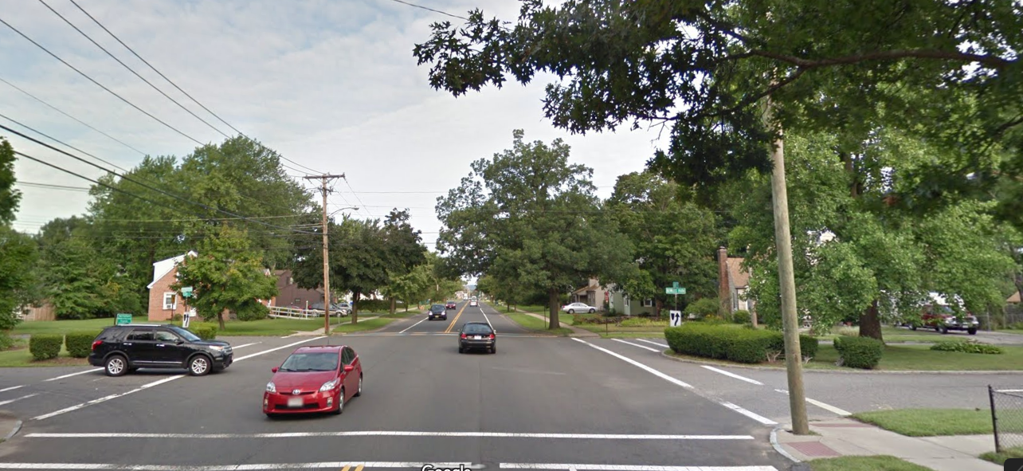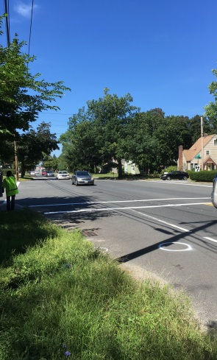
X
X
Figure 3 - Incident location. X marks victim location and the arrow indicates vehicle Figure 4 - Incident location. X marks
travel direction. victim’s assigned location.

INVESTIGATION
At the time of the incident, approximately 3:00 p.m., the crossing guard was at her assigned intersection location (Figure 4) and was about a half hour into the afternoon shift. The crossing guard lived close by and would walk to the assigned intersection for her shift. The first day of the school year was the Monday of the week the incident occurred. That Monday she was assigned with an experienced crossing guard at a different crossing location. The following day she was assigned to the incident intersection, which would be her regularly assigned location, to work alone. The incident occurred on the third day of her working alone, the Thursday of that week. It was reported in the local newspaper that her daughter was showing up at the assigned crossing location because her mom was new to the job.
The crossing guard was wearing the town provided ANSI Class 2 compliant high-visibility vest and was using the provided stop paddle. Two students walked up to the victim at the intersection in a northeast direction along the side street and needed to cross the main road. The crossing guard had the students stay on the sidewalk and then with the STOP paddle raised she stepped off the sidewalk and entered the roadway at the crosswalk location (Figure 6). She had walked in the crosswalk out to the middle of the travel lane closest to her, when she was struck by a motor vehicle traveling on the main road in a southeasterly direction. The victim landed in the roadway and the motorist stopped the car and stayed at the incident location.
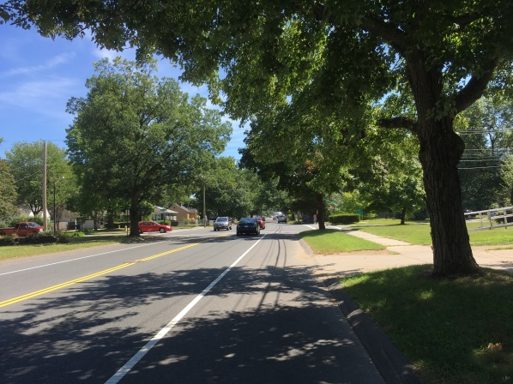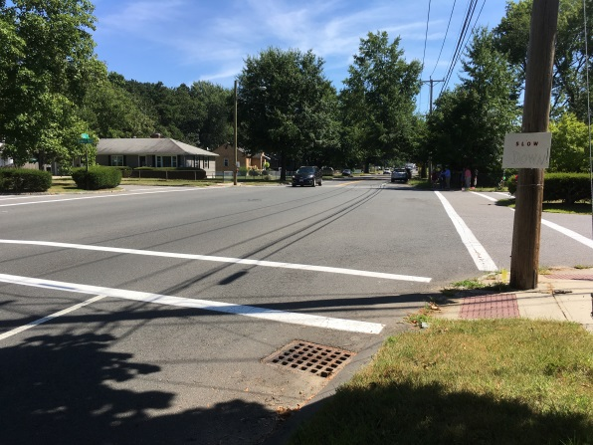
X
Figure 5 – Roadway leading up to the intersection. Note that Figure 6 – Incident location. X marks victim location and the arrow indicates
there is no signage warning motorists of the crosswalk ahead. vehicle travel direction.
The victim’s daughter immediately placed a call for EMS and stayed with her mother. Within minutes of the placed call, the police and EMS arrived. The victim was transported to a local hospital where she later died.

CAUSE OF DEATH
The medical examiner listed the cause of death as complications of multiple blunt force injuries of the head, torso, and extremities.

CONTRIBUTING FACTORS
Occupational injuries and fatalities are often the result of one or more contributing factors or key events in a larger sequence of events that ultimately result in the injury or fatality. The Massachusetts FACE Program identified the following contributing factors in this incident:
- No crosswalk signage;
- Ineffective crosswalk roadway markings that were in poor condition; and
- Assigning crossing guards to unsignalized intersections without the appropriate traffic control measures.

RECOMMENDATIONS/DISCUSSION
Recommendation #1: Municipalities should ensure that, at a minimum, crosswalk traffic control signage meets the standards set forth in the Manual on Uniform Traffic Control Devices.
Discussion: The U.S. Department of Transportation’s (DOT) Manual on Uniform Traffic Control Devices (MUTCD) sets forth the basic principles that govern the design and usage of traffic control signs and devices.² Part 7 of the MUTCD is specifically about traffic control devices within school areas and includes a section on crosswalk marking. Municipalities should follow the MUTCD minimum standards and guidelines to help ensure pedestrian safety as related to crosswalks. The MUTCD standards and guidelines help determine the appropriate number, location, and type of roadway markings and traffic control devices, including signs, and/or the need for crosswalks.

In this case, prior to the incident, no traffic control signage was present at the crosswalk locations. The least effective crosswalk roadway markings, which are two white parallel lines with no center lines, were being used and these markings were faded and cracked. Although at the time of the incident there were no cars parked on the roadway edge, on-street parallel parking was allowed within 20 feet of the crosswalk and on both sides of the roadway. This is prohibited by the MUTCD, Part 3 Figure 3B-21. Cars parked within 20 feet of a crosswalk could possibly contribute to a motorists’ decreased visibility of pedestrians in the crosswalks.
In order to make the crosswalk location safe for crossing guards, students, and other pedestrians using the crosswalk, and to make the area more visible to motorists, municipalities should ensure that permanent MUTCD compliant, fluorescent yellow-green signage are installed prior to and at all crosswalk locations and that painted crosswalks are highly visible and in good condition. Municipalities should also routinely review crosswalk signage for compliance with the MUTCD and routinely evaluate crosswalk roadway markings to ensure they are not faded and are in good condition.
To prohibit parking and standing of any motor vehicles within 20 feet of both sides of crosswalks, municipalities should install no parking and no stopping signs and roadway markings should be used to inform motorists of where they cannot park. In addition, municipalities should provide portable in-street pedestrian crossing signs to crossing guards. The use of portable in-street pedestrian crossing signs during the crossing guards’ shifts would give an added warning to motorists of crosswalk locations where students will be crossing the roadway. The crossing guards could put the in-street signs in the center of the roadway at the beginning of their shift and remove them at the end of their shift. This would help keep the signs conspicuous for motorists.
Recommendation #2: Municipalities should consider additional measures to ensure crosswalks at unsignalized intersections and mid-block locations are clearly visible to motorists.
Discussion: Crosswalks located at unsignalized intersections and mid-block locations (locations between intersections) present some additional design challenges when compared to crosswalk locations at signalized intersections. This is in part due to motorists often not expecting pedestrians to be crossing at these locations. Therefore, it is important to give motorists as much advanced notice as possible of crosswalks. Implementing additional traffic control devices at these locations will help keep crossing guards and pedestrians safe.
The following are some additional options to alert motorists that they are approaching a crosswalk and to help increase the visibility of crosswalks to motorists or indicate when a crosswalk is in use (not all apply to this incident):
- In-pavement roadway warning light systems: The lights for these systems are embedded in the roadway pavement along each side of the crosswalk and help improve visibility of the crosswalk.³
- Raised crosswalks: These bring the crosswalk within the roadway up to the level of the sidewalk. Raised crosswalks improve the visibility of the crosswalk and pedestrian, and act as a speed hump, resulting in reduced vehicle speeds.⁴
- Rectangular Rapid Flash Beacons (RRFB):⁴ These permanent crosswalk signs have flashing lights that are pedestrian-activated and should be used at unsignalized intersections and mid-block pedestrian crosswalks.
- Pedestrian Hybrid Beacons, also known as the High intensity Activated crossWalK (or HAWK): This pedestrian-activated light system should only be used at mid-block pedestrian crossings. The system consists of two red lights above a single yellow light for motorists, and a walk and don’t walk symbol for pedestrians.⁵
- Trim vegetation in the area to ensure that it is not blocking motorists’ views of the crosswalk, signs, or signals.
- In winter months, ensure that crosswalks are free of snow and ice so motorists can see them and ensure that sidewalks and curbs adjacent to crosswalks are clear so pedestrians and drivers do not have an obstructed view.
Recommendation #3: Municipalities should develop and implement a comprehensive safety and health program that addresses hazard recognition and avoidance of unsafe conditions.
Discussion: Having a municipality-wide safety and health program is an important part of keeping employees safe. A safety and health program should include the systematic identification, evaluation, and prevention or control of both general workplace hazards and the hazards of specific jobs and tasks. The core elements of an effective safety and health program are management leadership, worker participation, hazard identification and assessment, hazard prevention and control, education and training, and program evaluation and improvement.⁶ The program should outline safe work practices workers are expected to adhere to, specific safety protection for all tasks workers perform, how workers can identify and avoid hazards, and who workers should contact when safety and health issues or questions arise.⁶ The program should also include an explanation of the workers’ rights to protection in the workplace.
When developing a safety and health program, employers should start by performing a hazard analysis of all routine tasks performed by employees for potential hazards and incorporate information about any identified hazards and their controls into the program.⁷ When determining potential hazards associated with equipment, information in the manufacturer operator’s manual and on the equipment’s warning labels should be reviewed and incorporated into the safety and health program procedures. Employers should also use their employees’ expertise throughout the program development process by seeking employee input. Once the program is developed, employers should continue to seek employees’ input during the routine updating of the program. The program should be updated when safety concerns arise and when new equipment and tasks are introduced into the workplace.
Employers should ensure that they have fully and effectively implemented their safety and health program by routinely performing assessments of tasks and immediately addressing any observed unsafe conditions. As part of the program’s implementation, training should be provided to all employees on the program’s topics and procedures, and should also include hazard recognition and the avoidance of unsafe conditions. All training provided to employees should be documented. In this case, the safety and health program should include a section on crossing guard training.
In this case, one of the hazards crossing guards face while working is being struck by moving vehicles. Their work positions crossing guards in and around roadways, bringing them in close proximity to motor vehicle traffic, usually with no barriers between them and the moving vehicles. The safety and health program should outline the appropriate PPE crossing guards should be provided with to help ensure they’re visible to motorists while working along roadways. This includes, but isn’t limited to, the MUTCD recommended American National Standards Institute (ANSI) Class 2 high-visibility garments and STOP paddles, which the school department provided.^{2,8} In addition, because of the design and size of the unsignalized intersection involved in the incident, the municipality should consider assigning two crossing guards to this location.
The Massachusetts Department of Labor Standards (DLS) offers voluntary technical assistance and inspections for municipalities to proactively address workplace safety and health concerns. The DLS Workplace Safety and Health Program can be contacted at 508-616-0461 x9488 or email email safepublicworkplacemailbox@mass.gov.
The Massachusetts Department of Industrial Accidents (DIA) has grants available for providing workplace health and safety training to employers and employees. Any company covered by the Massachusetts Workers’ Compensation Insurance Law is eligible to apply for these grants. More information about these DIA grants can be found on their website at www.mass.gov/dia/safety.
Recommendation #4: Municipalities should actively work towards reducing vehicle speed on local roadways.
Discussion: Although it was reported that the vehicle that struck the victim was traveling at the speed limit, 30 mph, while visiting the incident location, it appeared that many of the passing vehicles were traveling faster than the speed limit. Research by the American Automobile Association (AAA) Foundation for Traffic Safety shows that a pedestrian struck by a vehicle traveling at 25 mph has a 25 percent risk of sustaining a serious or fatal injury, and the risk increases to 50 percent at 33 mph and 75 percent when the vehicle is traveling at 41 mph.⁹ Since vehicle speed affects the risk and severity of pedestrian crashes, reducing speeds can lower pedestrian deaths.¹⁰
One way to help reduce the number of pedestrians, including workers, being struck by vehicles and reduce the severity of injury if struck, is to lower the speed limit where feasible throughout a community. In order for the lower speed limit to be as effective as possible, the new lower speed limits should be implemented along with a community-wide outreach and education campaign and strict enforcement of the speed limits by the municipality.
Another proven way to slow vehicle speeds through an area is the use of traffic calming strategies. The U.S. Department of Transportation states that traffic calming uses a combination of measures that reduce the negative effects of motor vehicle use, alter driver behavior, and improve conditions for non-motorized street users. Traffic calming consists of physical design and other measures put in place on existing roads or incorporated into new roadways to reduce vehicle speeds and improve safety for pedestrians, including workers on foot, and cyclists.¹¹ Some examples of traffic calming include roadway vertical deflections (speed humps, speed tables, and raised intersections), horizontal lane shifts, and lane narrowing. These are all intended to reduce speed and enhance the street environment for non-motorists.¹¹
In 2016, the Municipal Modernization Bill was signed into law in Massachusetts.¹² This law included language allowing cities and towns to lower the default speed limit from 30 to 25 mph on municipal roads that are not state highways in thickly settled areas or business districts without requiring state approval. Boston, Massachusetts took advantage of this law and in 2017 reduced the city wide speed limit from 30 to 25 mph. There have been studies showing that lowering the speed limit throughout the city by 5 mph has resulted effective in motorists slowing down.^{13,14}

ADDITIONAL RESOURCES
MDPH. MA FACE Safety Alert: Protect the Crossing Guards that Protect Our Children. August 2015. https://www.mass.gov/doc/protect-the-crossing-guards-that-protect-our-children-85x11-pdf/download

MassDOT. Safe Routes to Schools. Crossing Guard Training Resources
https://www.mass.gov/service-details/safe-routes-to-school-enforcement

MA DLS. Recommendations for Crossing Guard Safety. January 2013.
https://www.mass.gov/files/documents/2016/08/xl/crossing-guard-safety-bulletin.pdf?_ga=2.89970075.1456646013.1572904125-84395715.1560363770

DISCLAIMER
Mention of any company or product does not constitute endorsement by the National Institute for Occupational Safety and Health (NIOSH). In addition, citations to websites external to NIOSH do not constitute NIOSH endorsement of the sponsoring organizations or their programs or products. Furthermore, NIOSH is not responsible for the content of these websites. All web addresses referenced in this document were accessible as of the publication date.

REFERENCES
1. Weather Underground. Weather History. Massachusetts: TWC Product and Technology LLC.
https://www.wunderground.com/history/daily/us/ct/windsor-locks/KBDL/date/2018-8-30

2. US DOT 2009. Manual on Uniform Traffic Control Devices (MUTCD), 2009 Edition, U.S. Department of Transportation, Federal Highway Administration. http://mutcd.fhwa.dot.gov/pdfs/2009/part7.pdf. Date accessed: 12/18/2018.

3. ATSSA 2006. Putting Safety in the Safe Routes to School Program. A School Administrator’s Guide. American Traffic Safety Services Association. www.roadsafetraffic.com/wp-content/uploads/2012/09/Putting-Safety-in-the-Safe-Routes-to-School-Program-ATSSA.pdf. Date accessed: 12/18/2018.

4. US DOT 2009. Rectangular Rapid Flash Beacons (RRFB). http://safety.fhwa.dot.gov/intersection/conventional/unsignalized/tech_sum/fhwasa09009/. Date accessed: 12/18/2018.

5. US DOT 2012. Pedestrian Hybrid Beacon. http://safety.fhwa.dot.gov/provencountermeasures/fhwa_sa_12_012.cfm. Date accessed: 12/18/2018.

6. OSHA. Recommended Practices for Safety and Health Programs. OSHA 3885. 2016. www.osha.gov/shpguidelines/. Date accessed: 12/18/2018.

7. OSHA. Job Hazard Analysis. Publication Number: 3071. www.osha.gov/Publications/osha3071.pdf. Date accessed: 12/18/2018.

8. ANSI/ISEA [2015]. American National Standard for high-visibility safety apparel. New York, NY: American National Standards Institute, ANSI/ISEA 107 -2015.

9. Tefft B. Impact speed and a pedestrian's risk of severe injury or death. Accident Analysis & Prevention, Volume 50, January 2013, Pages 871-878. www.sciencedirect.com/science/article/abs/pii/S000145751200276X. Date accessed: 12/18/2018.

10. Mead J, Zegeer C, and Bushell M. 2014. Evaluation of pedestrian-related roadway measures: a summary of available research. Report no. DTFH61-11-H-00024. Washington, DC: Federal Highway Administration.

11. US DOT 2019. Traffic Calming to Slow Vehicle Speeds.
www.transportation.gov/mission/health/Traffic-Calming-to-Slow-Vehicle-Speeds. Date accessed: 12/18/2018.

12. MA Municipal Modernization Bill 2016. An Act Modernizing Municipal Finance and Government. Chapter 218, Section 193-194. https://malegislature.gov/laws/Sessionlaws/Acts/2016/Chapter218. Date accessed: 12/18/2018.

13. Hu, W., Cicchino, J. 2019. Injury Prevention. Lowering the speed limit from 30 mph to 25 mph in Boston: effects on vehicle speeds. https://injuryprevention.bmj.com/content/early/2019/01/12/injuryprev-2018-043025. Date accessed: 12/18/2018.

14. Insurance Institute for Highway Safety (IIHS) 2018. City drivers slow down for lower speed limit in Boston. www.iihs.org/news/detail/city-drivers-slow-down-for-lower-speed-limit-in-boston. Date accessed: 12/18/2018.

