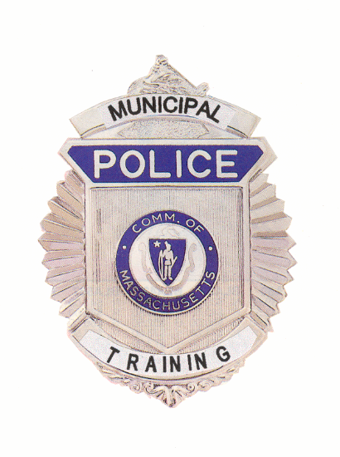

Municipal Police Training Committee
Monthly Meeting Agenda

Under the provisions of M.G.L. c. 30A, The Municipal Police Training Committee will hold the April monthly meeting as a virtual meeting on Friday, April 10, 2020. The Standards Committee will convene at 9:45 a.m. and the Committee as a whole will convene at 10:00 a.m.

To view this meeting on computer, laptop, tablet or smartphone with speakers and microphone, use this link at the above date and time: https://zoom.us/j/898490453?pwd=bExlaHYwQVp4WHdXeE1vRFBZNnVkQT09 By telephone dial 1-929 436 2866, at the prompt enter Meeting ID 898 490 453.

Friday, April 10, 2020

9:45 a.m. – Police Standards Subcommittee Meeting to consider the following requests for officers to receive exemptions and waivers from training requirements:

Temporary waivers: |  |  | Permanent exemptions:
Brower | Plympton |  | Goiner | Lowell
Messina | W. Stockbridge |  | Tepper | Westborough
Parker | Holden |  | Fitzpatrick | Stow
 |  |  | Fauteux | Carlisle

10:00 a.m. – Committee of the Whole – Welcome Chief Hicks, Chair

Review/Approval of Minutes from February 15, 2020 Chief Hicks

Police Standards Standards Subcommittee

Consideration of officers’ requests for waivers and exemptions
From training requirements;

Report of results from recruit academy disciplinary appeals hearings

Discussion of curriculum modification in light of COVID-19 issues

Open Discussion for items not requiring votes

Specialized Training Agenda Update Chief Ferullo (ret.)

Executive Director’s Report

Recruit Officer training updates Chief Ferullo (ret.)

Budget/Municipal Police Training Fund Update Chief Ferullo (ret.)

Additional Academy Class Discussion Chief Ferullo (ret.)

Old Business (Items may be taken out of order)

Executive director selection process pursuant to MGL c.6 §116 Chief Hicks

New Business (Items may be taken out of order)

Facilities Update Chief Ferullo (ret.)

FY2021 In-Service Training Discussion Chief Hicks

MPTC Staffing Issues and Positions Chief Ferullo (ret.)

Cambridge Request to Run Chief Ferullo (ret.)

COVID-19 Issues Chief Ferullo (ret.)

Other matters that may legally come before the committee

* * *

