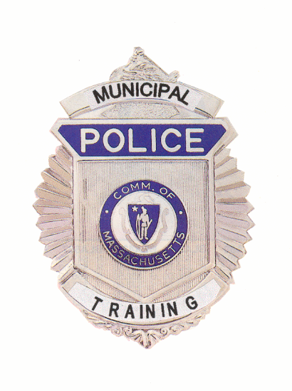

Municipal Police Training Committee
Monthly Meeting Agenda
July 22, 2020

Under the provisions of M.G.L. c. 30A, The Municipal Police Training Committee will hold the April monthly meeting as a virtual meeting on Wednesday July 22, 2020. The Standards Committee will convene at 9:00 a.m. and the Committee as a whole will convene at 10:00 a.m.

THIS MEETING WILL BE AUDIO AND VIDEO RECORDED

Under the provisions of G.L. c. 30A, the Municipal Police Training Committee will conduct an Open Meeting Wednesday, July 22, 2020 at 10:00 a.m. to be held virtually:

To view this meeting on computer, laptop, tablet or smartphone with speakers and microphone, use this link at the above date and time:

https://zoom.us/j/93477583483?pwd=eU0xM2RiTnZkZG40VWdPbk9FT0pEQT09

Dial in 1 929 436 2866 US
Meeting ID: 934 7758 3483
Password: 942103

AGENDA
Municipal Police Training Committee
Wednesday June 24, 2020

9:00 a.m. – Police Standards Subcommittee Meeting to consider the following requests for officers to receive exemptions and waivers from training requirements:

Temporary waivers: |  |  | Permanent exemptions:
Bencal | Beverly |  | Bacons | Adams
Collinge | Rutland |  | Derry | Sturbridge
Tubbs | Rowley |  | Rodriguez | Haverhill
 |  |  | Skinner | Chatham
 |  |  | Sullivan | UMASS Amherst
Other late filed waivers or exemptions
related to COVID-19 staffing issues.

10:00 a.m. – Committee of the Whole – Welcome Chief Hicks, Chair

Review/Approval of Minutes from June 24, 2020 Meeting Chief Hicks

Police Standards Standards Subcommittee

Consideration of officers’ requests for waivers and exemptions
From training requirements;

Update on recruit academy disciplinary appeals hearings

Update on revisions to 550 CMR 3.00

Open Discussion for items not requiring votes

Executive Director’s Report

Recruit Officer training updates Chief Ferullo (ret.)

Budget/Municipal Police Training Fund Update Chief Ferullo (ret.)

MPTC Staffing Update Chief Ferullo (ret.)

Basic Recruit Academy Schedule Chief Ferullo (ret.)

Facilities Update Chief Ferullo (ret.)

Acadis online/remote learning discussion Chief Ferullo (ret.)

Old Business (Items may be taken out of order)

New Business (Items may be taken out of order)

New Legislation Discussions Chief Hicks

Other matters that may legally come before the committee

* * *

