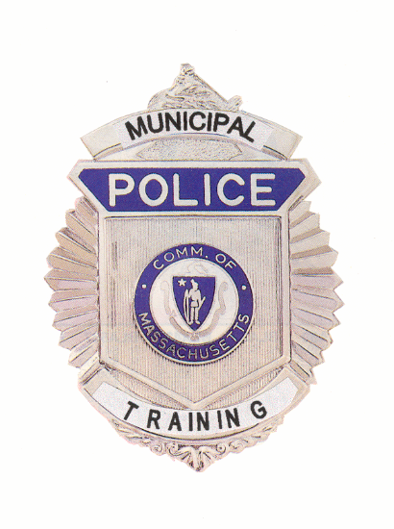

Municipal Police Training Committee
Monthly Meeting Agenda
August 19, 2020

Under the provisions of M.G.L. c. 30A, The Municipal Police Training Committee will hold the August monthly meeting as a virtual meeting on Wednesday, August 19, 2020. The Standards Committee will meet at 9:00 am, the Committee as a whole will convene at 10:00 a.m.

THIS MEETING WILL BE AUDIO AND VIDEO RECORDED

Under the provisions of G.L. c. 30A, the Municipal Police Training Committee will conduct an Open Meeting Wednesday, August 19, 2020 at 10:00 a.m. to be held virtually:

To view this meeting on computer, laptop, tablet or smartphone with speakers and microphone, use this link at the above date and time:

https://zoom.us/j/98719669118
Meeting ID: 987 1966 9118
Dial by your location +1 312 626 6799
AGENDA
Municipal Police Training Committee
Wednesday, August 19, 2020

9:00 a.m. – Police Standards Subcommittee will submit the following to the full committee to consider for exemptions or waivers of training requirements:

Temporary waivers: |  |  | Permanent exemptions:
 |  |  | Ilyas Abu | Littleton
 |  |  | Kerry Baxter | Carlisle
 |  |  | Kyle DiPirro | Yarmouth
 |  |  | Alex Goiner | Lowell
Other late filed waivers or exemptions  related to COVID-19 staffing issues. |  |  | Kevin Kirchdorfer | Shirley
 |  |  | Jesse Mabe | Yarmouth

10:00 a.m. – Committee of the Whole – Welcome Chief Hicks, Chair

Review/Approval of Minutes from July 22, 2020 Meeting Chief Hicks

Police Standards Standards Subcommittee

Consideration of officers’ requests for waivers and exemptions
From training requirements.

Update on recruit academy disciplinary appeals hearings

Update on revisions to 550 CMR 3.00

Open Discussion for items not requiring votes

Executive Director’s Report

Recruit Officer training updates Andrea Nardone

MPTC Staffing Update Chief Ferullo (ret.)

Basic Recruit Academy Schedule Andrea Nardone

Facilities Update Chief Ferullo (ret.)

Acadis online/remote learning update Chief Ferullo (ret.)

Old Business (Items may be taken out of order)

In Service Training Topics Chief Hicks

New Business (Items may be taken out of order)

New Legislation Discussions Chief Hicks

Request from Mass State Police to run ROC Captain McGinn Major Lyver

Request from Barnstable County to run ROC Director Carnes

Request from NECC to run ROC Exec Director Ferullo

Other matters that may legally come before the committee

* * *

