Charles D. Baker  Governor  Karyn E. Polito  Lieutenant Governor  Thomas A. Turco, III  Secretary of Public Safety and Security |  |  | Terrence Reidy  Undersecretary  Chief Robert J. Ferullo, Jr. ret.  Interim Executive Director

 | Commonwealth of Massachusetts  Municipal Police Training Committee  “Training for Today, Planning for the Future” | 6 Adams Street  Randolph, MA 02368  Phone: (781) 437-0300  Fax: (781) 963-0235 | 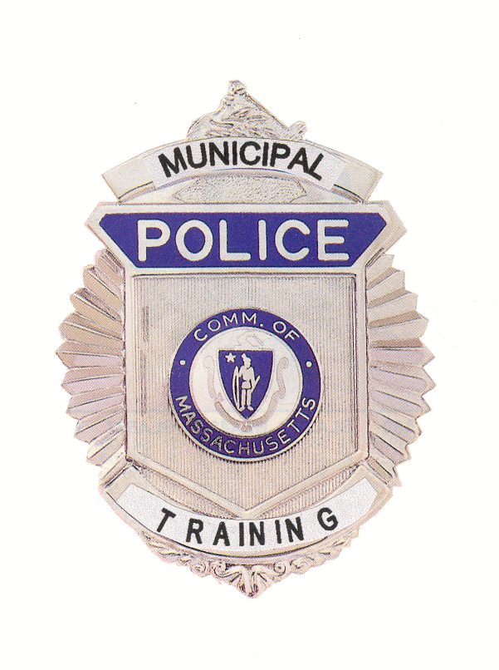

MEMORANDUM

TO: Secretary of State
(delivered via email to regs@sec.state.ma.us )
Department of Administration and Finance
(delivered via email to Melissa.andrade@state.ma.us )

FROM: Chief Robert J. Ferullo, Jr., (ret.)

Interim Executive Director
Municipal Police Training Committee

DATE: September 14, 2020

RE: Notice of Open Meeting (Revision)

Notice of Open Meeting

Under the provisions of M.G.L. c. 30A, The Municipal Police Training Committee will hold its monthly open meeting as a virtual meeting on Wednesday, September 16, 2020 at 10:00 am. The Standards Committee will convene at 9:30 am and the Committee as a whole will convene
at 10:00 am.

THIS MEETING WILL BE AUDIO AND VIDEO RECORDED
To view this meeting on computer, laptop, tablet or smartphone with speakers and microphone, use this link at the above date and time:
Join Police Standards Committee Zoom Meeting
Wednesday September 16, 2020 9:00 AM – 10:00 AM
https://zoom.us/j/95604159836?pwd=N0xHeWVlcWsvY25HYWcyUGJMTE0wQT09

Meeting ID: 956 0415 9836 / Passcode: 301673
Dial by your location: +1 929 436 2866 US / Meeting ID: 956 0415 9836
Join MPTC Committee Zoom Meeting
https://zoom.us/j/96282643423?pwd=Tm1BRjRhaUxDWjE2TFdGMVdVbmdxQT09
Meeting ID: 962 8264 3423/ Passcode: 385020
One tap mobile: +19294362866, 96282643423# US (New York) 13126266799, 96282643423# US +(Chicago)
Dial by your location: +1 929 436 2866 US (New York) / Meeting ID: 962 8264 3423
Find your local number: https://zoom.us/u/aeigAWXrJ6
Please contact Sheila Gallagher at sheila.gallagher@massgov at 781-437-0314 with any questions.

