Charles D. Baker  Governor  Karyn E. Polito  Lieutenant Governor  Thomas A. Turco, III  Secretary of Public Safety and Security |  |  | Terrence Reidy  Undersecretary  Chief Robert J. Ferullo (Ret)  Interim Executive Director

 | Commonwealth of Massachusetts  Municipal Police Training Committee  “Training for Today, Planning for the Future” | 6 Adams Street  Randolph, MA 02368  Phone: (781) 437-0300  Fax: (781) 963-0235 | 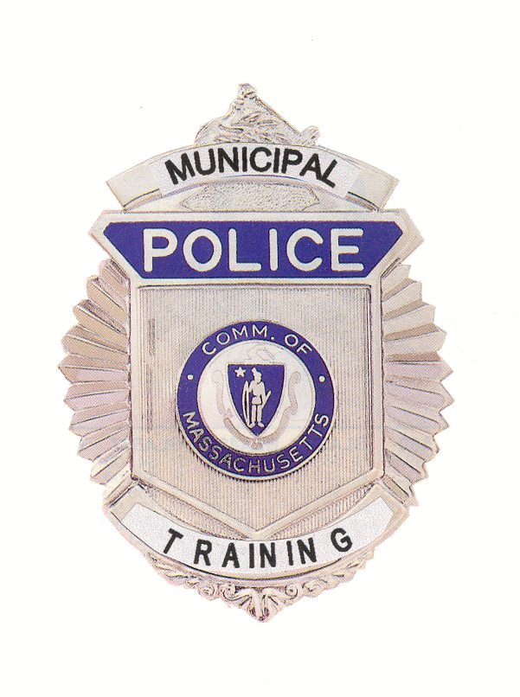

 | MEMORANDUM
TO: | Secretary of State  (delivered via email to regs@sec.state.ma.us)  Department of Administration and Finance  (delivered via email to melissa.andrade@state.ma.us)
FROM: | Chief Robert J. Ferullo (Ret.), Interim Executive Director  Municipal Police Training Committee
DATE: | August 7, 2020
RE: | Notice of MPTC Standards Subcommittee Hearing

NOTICE OF OPEN HEARING

Under the provisions of G.L. c. 30A, the Municipal Police Training Committee Standards Subcommittee will conduct an Open Meeting Wednesday, August 12, 2020 at 10:00 a.m., to be held virtually, for the sole purpose of hearing the dismissal appeal of Mohammed Islam from the Cambridge/Northeastern University Police Academy:

To view this meeting on computer, laptop, tablet or smartphone with speakers and microphone, use this link at the above date and time:

Topic: Islam Dismissal Appeal Cambridge/NU Academy
Time: Aug 12, 2020 10:00 AM Eastern Time (US and Canada)

Join Zoom Meeting
https://zoom.us/j/99654898619?pwd=YVVYc0JjYVZmZFkwU0FHTG1aamhpZz09

Meeting ID: 996 5489 8619
Passcode: 386429
Dial In – 1-312-626-6799

RJF/lmk

