Charles D. Baker  Governor  Karyn E. Polito  Lieutenant Governor  Thomas A. Turco, III  Secretary of Public Safety and Security |  |  | Terrence Reidy  Undersecretary  Chief Robert J. Ferullo, Jr. ret.  Interim Executive Director

 | Commonwealth of Massachusetts  Municipal Police Training Committee  “Training for Today, Planning for the Future” | 6 Adams Street  Randolph, MA 02368  Phone: (781) 437-0300  Fax: (781) 963-0235 | 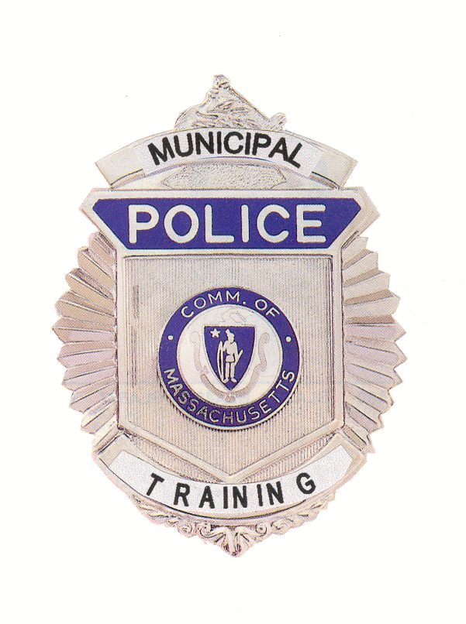

MEMORANDUM

TO: Secretary of State
(delivered via email to regs@sec.state.ma.us )
Department of Administration and Finance
(delivered via email to Melissa.andrade@state.ma.us )

FROM: Chief Robert J. Ferullo, Jr., (ret.)

Interim Executive Director
Municipal Police Training Committee

DATE: May 27, 2020

RE: Notice of Special Open Meeting
of Municipal Police Training Committee
____________________

Notice of Special Meeting

Under the provisions of M.G.L. c. 30A, The Municipal Police Training Committee will hold a special meeting as a virtual meeting on Friday May 29, 2020 at 9:00 a.m.

THIS MEETING WILL BE AUDIO AND VIDEO RECORDED

To view this meeting on computer, laptop, tablet or smartphone with speakers and microphone, use this link at the above date and time:

https://zoom.us/j/91570167292?pwd=RDVxQS8rdDUrUWkzQ1BjdmpHYlhPQT09

Meeting ID: 915 7016 7292
Password: 271332

Dial by your location: +1 929 436 2866 US
Meeting ID: 915 7016 7292
Password: 271332

Please contact Sheila Gallagher at sheila.gallagher@massgov at 781-437-0314 with any questions.

Agenda
Friday May 29, 2020

9:00 a.m. – Committee of the Whole – Welcome Chief Hicks, Chair

- Review of Status and Reopening of Academies Director Ferullo

- CMR Review AG O’Brien
- Other matters that may legally come before the committee.

* * *

